Analysis Report: Spectrum1
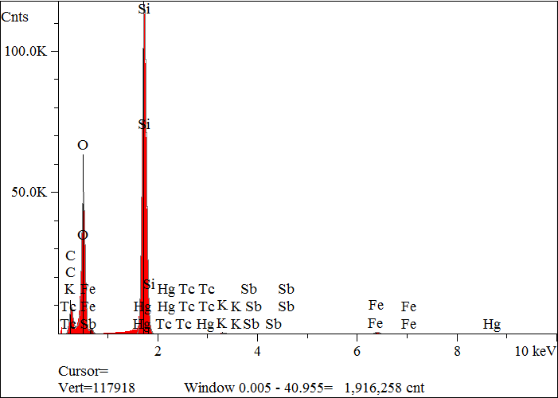
Elt. | Line | Intensity  (c/s) | Atomic  % | Conc | Units | Error  2-sig | MDL  3-sig
C | Ka | 416.08 | 29.464 | 19.618 | wt.% | 0.074 | 0.040
O | Ka | 2,226.40 | 44.514 | 39.481 | wt.% | 0.060 | 0.018
F | Ka | 59.82 | 1.317 | 1.387 | wt.% | 0.039 | 0.025
Si | Ka | 6,025.59 | 24.029 | 37.413 | wt.% | 0.034 | 0.009
K | Ka | 29.17 | 0.142 | 0.309 | wt.% | 0.008 | 0.017
Fe | Ka | 50.31 | 0.514 | 1.591 | wt.% | 0.021 | 0.036
Tc | La | 0.00 | 0.000 | 0.000 | wt.% | 0.000 | 0.000
Sb | La | 1.51 | 0.006 | 0.039 | wt.% | 0.017 | 0.039
Hg | Ma | 12.66 | 0.015 | 0.162 | wt.% | 0.007 | 0.020
 |  |  | 100.000 | 100.000 | wt.% |  |  | Total

kV 15.0
Takeoff Angle 35.0°
Elapsed Livetime 200.0

