Analysis Report: Spectrum1
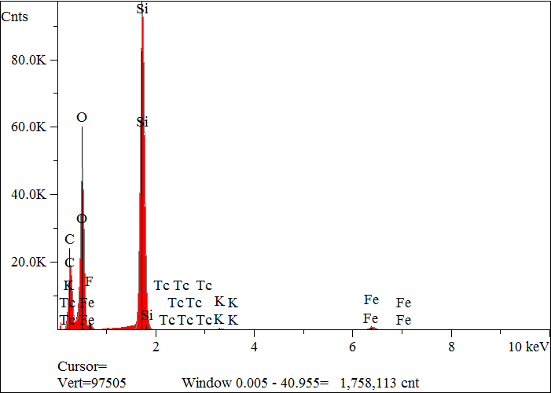
Elt. | Line | Intensity  (c/s) | Atomic  % | Conc | Units | Error  2-sig | MDL  3-sig
C | Ka | 851.06 | 40.893 | 29.339 | wt.% | 0.075 | 0.032
O | Ka | 2,112.63 | 40.254 | 38.470 | wt.% | 0.061 | 0.019
F | Ka | 44.56 | 0.887 | 1.006 | wt.% | 0.038 | 0.025
Si | Ka | 4,960.57 | 17.273 | 28.978 | wt.% | 0.029 | 0.009
K | Ka | 27.22 | 0.113 | 0.264 | wt.% | 0.007 | 0.015
Fe | Ka | 65.00 | 0.576 | 1.923 | wt.% | 0.021 | 0.031
Tc | La | 1.21 | 0.003 | 0.020 | wt.% | 0.009 | 0.025
 |  |  | 100.000 | 100.000 | wt.% |  |  | Total

kV 15.0
Takeoff Angle 35.0°
Elapsed Livetime 200.0

