Analysis Report: Spectrum1
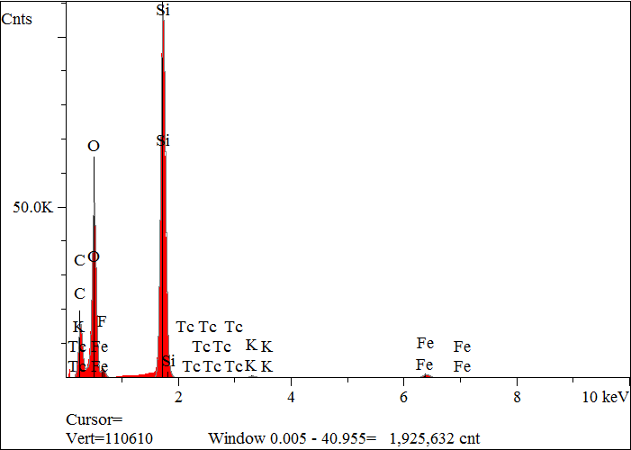
Elt. | Line | Intensity  (c/s) | Atomic  % | Conc | Units | Error  2-sig | MDL  3-sig
C | Ka | 692.27 | 36.508 | 25.378 | wt.% | 0.073 | 0.034
O | Ka | 2,276.59 | 41.603 | 38.523 | wt.% | 0.058 | 0.018
F | Ka | 72.88 | 1.412 | 1.553 | wt.% | 0.039 | 0.024
Si | Ka | 5,631.31 | 19.604 | 31.865 | wt.% | 0.030 | 0.009
K | Ka | 38.16 | 0.159 | 0.361 | wt.% | 0.008 | 0.015
Fe | Ka | 80.03 | 0.709 | 2.290 | wt.% | 0.022 | 0.032
Tc | La | 1.87 | 0.005 | 0.030 | wt.% | 0.008 | 0.025
 |  |  | 100.000 | 100.000 | wt.% |  |  | Total

kV 15.0
Takeoff Angle 35.0°
Elapsed Livetime 200.0

