Analysis Report: Spectrum1
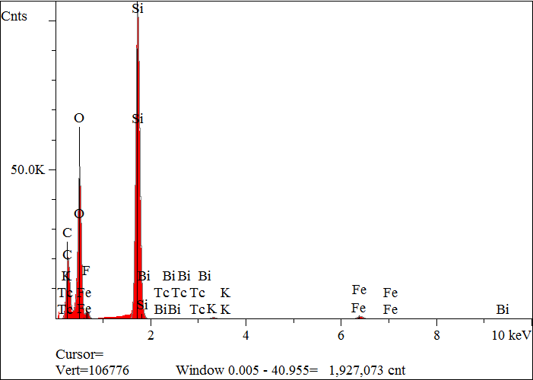
Elt. | Line | Intensity  (c/s) | Atomic  % | Conc | Units | Error  2-sig | MDL  3-sig
C | Ka | 917.35 | 40.798 | 29.179 | wt.% | 0.072 | 0.030
O | Ka | 2,262.09 | 39.596 | 37.724 | wt.% | 0.057 | 0.018
F | Ka | 80.12 | 1.446 | 1.636 | wt.% | 0.038 | 0.023
Si | Ka | 5,441.51 | 17.414 | 29.124 | wt.% | 0.028 | 0.008
K | Ka | 37.37 | 0.143 | 0.332 | wt.% | 0.007 | 0.014
Fe | Ka | 74.04 | 0.603 | 2.005 | wt.% | 0.020 | 0.030
Tc | La | 0.00 | 0.000 | 0.000 | wt.% | 0.000 | 0.000
Bi | Ma | 0.00 | 0.000 | 0.000 | wt.% | 0.000 | 0.000
 |  |  | 100.000 | 100.000 | wt.% |  |  | Total

kV 15.0
Takeoff Angle 35.0°
Elapsed Livetime 200.0

