Analysis Report: Spectrum1
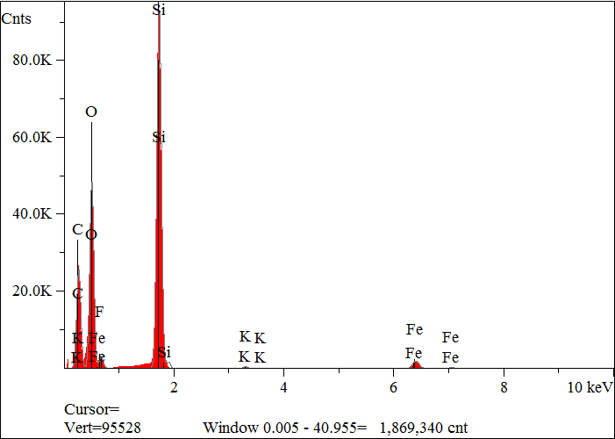
Elt. | Line | Intensity  (c/s) | Atomic  % | Conc | Units | Error  2-sig | MDL  3-sig
C | Ka | 1,230.13 | 45.333 | 33.068 | wt.% | 0.067 | 0.026
O | Ka | 2,285.17 | 38.429 | 37.341 | wt.% | 0.056 | 0.018
F | Ka | 9.97 | 0.170 | 0.196 | wt.% | 0.038 | 0.023
Si | Ka | 4,907.40 | 14.827 | 25.291 | wt.% | 0.026 | 0.008
K | Ka | 29.65 | 0.105 | 0.249 | wt.% | 0.006 | 0.013
Fe | Ka | 149.26 | 1.137 | 3.855 | wt.% | 0.025 | 0.028
 |  |  | 100.000 | 100.000 | wt.% |  |  | Total

kV 15.0
Takeoff Angle 35.0°
Elapsed Livetime 200.4

