Analysis Report: Spectrum1
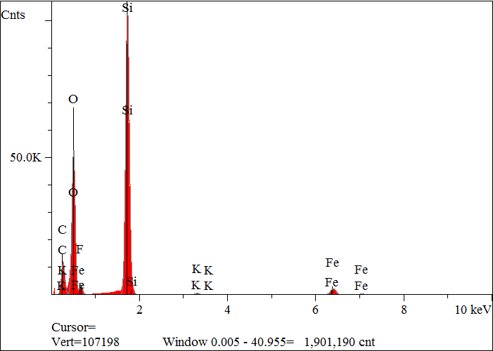
Elt. | Line | Intensity  (c/s) | Atomic  % | Conc | Units | Error  2-sig | MDL  3-sig
C | Ka | 575.03 | 32.844 | 22.092 | wt.% | 0.067 | 0.034
O | Ka | 2,443.08 | 44.532 | 39.900 | wt.% | 0.058 | 0.017
F | Ka | 17.02 | 0.344 | 0.366 | wt.% | 0.043 | 0.025
Si | Ka | 5,492.91 | 20.522 | 32.279 | wt.% | 0.031 | 0.009
K | Ka | 32.27 | 0.143 | 0.313 | wt.% | 0.007 | 0.015
Fe | Ka | 172.65 | 1.615 | 5.051 | wt.% | 0.030 | 0.032
 |  |  | 100.000 | 100.000 | wt.% |  |  | Total

kV 15.0
Takeoff Angle 35.0°
Elapsed Livetime 200.0

