Analysis Report: Spectrum1
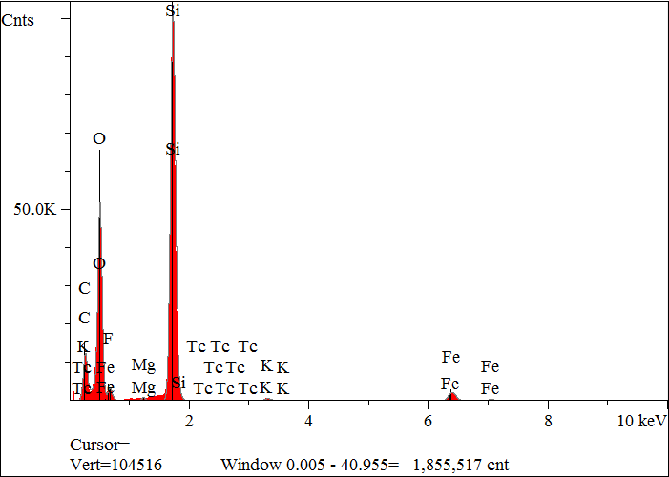
Elt. | Line | Intensity  (c/s) | Atomic  % | Conc | Units | Error  2-sig | MDL  3-sig
C | Ka | 538.23 | 32.456 | 21.699 | wt.% | 0.071 | 0.036
O | Ka | 2,297.61 | 43.662 | 38.883 | wt.% | 0.059 | 0.018
F | Ka | 52.91 | 1.096 | 1.159 | wt.% | 0.043 | 0.025
Mg | Ka | 36.06 | 0.183 | 0.247 | wt.% | 0.005 | 0.010
Si | Ka | 5,318.62 | 20.777 | 32.482 | wt.% | 0.031 | 0.009
K | Ka | 38.71 | 0.179 | 0.390 | wt.% | 0.008 | 0.015
Fe | Ka | 167.96 | 1.639 | 5.094 | wt.% | 0.031 | 0.034
Tc | La | 2.68 | 0.009 | 0.047 | wt.% | 0.011 | 0.027
 |  |  | 100.000 | 100.000 | wt.% |  |  | Total

kV 15.0
Takeoff Angle 35.0°
Elapsed Livetime 200.0

