Analysis Report: Spectrum1
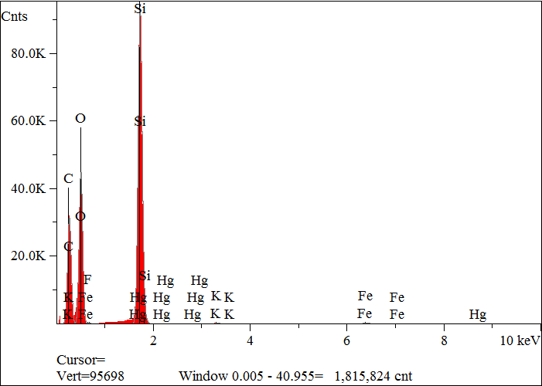
Elt. | Line | Intensity  (c/s) | Atomic  % | Conc | Units | Error  2-sig | MDL  3-sig
C | Ka | 1,481.42 | 49.852 | 37.858 | wt.% | 0.070 | 0.025
O | Ka | 2,069.70 | 35.928 | 36.345 | wt.% | 0.057 | 0.019
F | Ka | 0.00 | 0.000 | 0.000 | wt.% | 0.000 | 0.000
Si | Ka | 4,875.29 | 13.896 | 24.676 | wt.% | 0.025 | 0.008
K | Ka | 24.69 | 0.084 | 0.207 | wt.% | 0.006 | 0.012
Fe | Ka | 31.75 | 0.232 | 0.821 | wt.% | 0.015 | 0.027
Hg | Ma | 9.70 | 0.007 | 0.093 | wt.% | 0.005 | 0.015
 |  |  | 100.000 | 100.000 | wt.% |  |  | Total

kV 15.0
Takeoff Angle 35.0°
Elapsed Livetime 200.0

