Analysis Report: Spectrum1
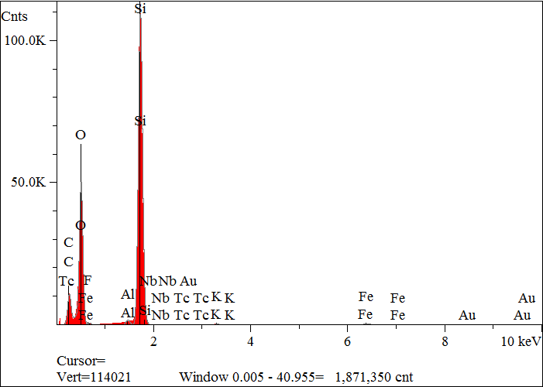
Elt. | Line | Intensity  (c/s) | Atomic  % | Conc | Units | Error  2-sig | MDL  3-sig
C | Ka | 477.91 | 31.856 | 21.587 | wt.% | 0.076 | 0.039
O | Ka | 2,234.67 | 44.573 | 40.235 | wt.% | 0.061 | 0.018
F | Ka | 0.00 | 0.000 | 0.000 | wt.% | 0.000 | 0.000
Al | Ka | 94.87 | 0.386 | 0.588 | wt.% | 0.006 | 0.009
Si | Ka | 5,820.66 | 22.628 | 35.856 | wt.% | 0.033 | 0.009
K | Ka | 22.48 | 0.106 | 0.235 | wt.% | 0.006 | 0.016
Fe | Ka | 41.55 | 0.413 | 1.301 | wt.% | 0.020 | 0.034
Nb | La | 10.42 | 0.038 | 0.199 | wt.% | 0.009 | 0.029
Tc | La | 0.00 | 0.000 | 0.000 | wt.% | 0.000 | 0.000
Au | Ma | 0.00 | 0.000 | 0.000 | wt.% | 0.000 | 0.000
 |  |  | 100.000 | 100.000 | wt.% |  |  | Total

kV 15.0
Takeoff Angle 35.0°
Elapsed Livetime 200.0

