Analysis Report: Spectrum1
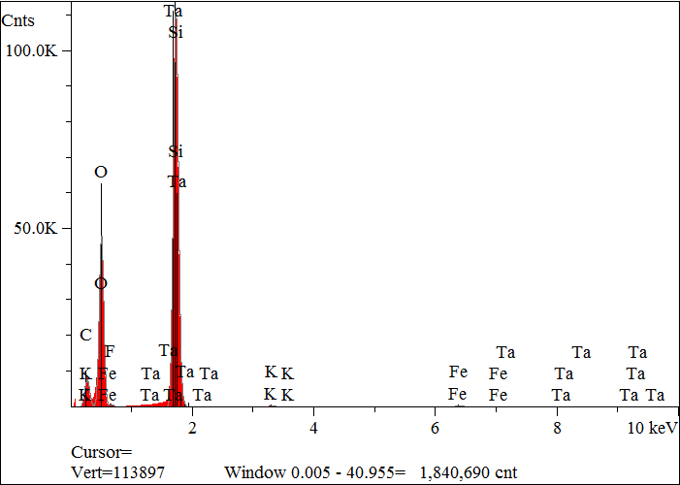
Elt. | Line | Intensity  (c/s) | Atomic  % | Conc | Units | Error  2-sig | MDL  3-sig
C | Ka | 398.83 | 28.979 | 19.907 | wt.% | 0.073 | 0.041
O | Ka | 2,245.09 | 51.072 | 46.732 | wt.% | 0.070 | 0.020
F | Ka | 0.00 | 0.000 | 0.000 | wt.% | 0.000 | 0.000
Si | Ka | 3,929.59 | 19.262 | 30.941 | wt.% | 0.090 | 0.011
K | Ka | 22.06 | 0.129 | 0.288 | wt.% | 0.009 | 0.020
Fe | Ka | 41.13 | 0.508 | 1.622 | wt.% | 0.025 | 0.042
Ta | La | 2.13 | 0.049 | 0.511 | wt.% | 0.074 | 0.207
 |  |  | 100.000 | 100.000 | wt.% |  |  | Total

kV 15.0
Takeoff Angle 35.0°
Elapsed Livetime 200.0

