Kindergarten Handwriting & Spelling Lesson
Target Letter: B/b (sound /b/)
Student Level: On-level

A. Standards (Georgia K ELA – sample alignment)
- Phonemic Awareness (K.F.PA.1): Demonstrate understanding of spoken words, syllables, and sounds (phonemes).
- Phoneme–Grapheme Correspondence (K.F.PWR.3): Know and apply grade-level phonics and word analysis skills in decoding words.
- Encoding/Spelling (K.F.PWR.4): Spell simple words phonetically, drawing on knowledge of sound–letter relationships.
- Handwriting (K.F.FL.1): Print many upper- and lowercase letters.

B. Objectives
By the end of this lesson, students will be able to:
- Sound: Identify and produce the /b/ sound in the beginning and ending position of spoken CVC words.
- Letter–Sound Link: Match the /b/ sound to the lowercase and uppercase letter b.
- Handwriting: Form lowercase b and uppercase B on writing lines using correct stroke sequence and starting point.
- Spelling/Application: Segment and spell simple CVC words with /b/ (e.g., bat, bag, cab, tab).

C. Materials
- Alphabet strip or letter cards for b and p
- Picture or word cards with CVC words using /b/: bat, bag, bug, cab, tab, bib
- Sound boxes (3-box Elkonin templates) on paper or whiteboard
- Individual whiteboards, dry-erase markers, and erasers
- Lined handwriting paper (with top, middle, bottom lines) or handwriting notebooks
- Pencils and crayons
- Pre-made dotted-line tracing sheets for lowercase b and uppercase B
- Chart paper or whiteboard for modeling
- Activities from Form D (Middle-Level) used in this lesson (must be listed):
  - Sound Spark
  - Magic Finger Write
  - Trace & Say
  - Say and Write
  - Word Build and Write

D. Scripted Lesson Plan

1. Review & Connect
💡 Explanation:
(Use the exact Form B explanation for Section 1 here.)
🗣️ Teacher: Today we are going to learn about a special letter that we use to write the /b/ sound. We will learn how it looks, how it sounds, and how to write it. Get your listening ears ready. Ready… Go.
👉 Teacher Does: Show lowercase b card and uppercase B card.
🗣️ Teacher: Look at this letter. This is lowercase b. Say “lowercase b.” Ready… Go.
💬 Child Response: Lowercase b.
🗣️ Teacher: Yes, lowercase b is the letter we use most often when we write words. It stands for the sound /b/. When we see this letter in a word, we usually say /b/.
🗣️ Teacher: Now look at this one. This is uppercase B. Say “uppercase B.” Ready… Go.
💬 Child Response: Uppercase B.
🗣️ Teacher: Uppercase B is the big letter we use at the beginning of names and at the start of sentences, and it also stands for the sound /b/. Lowercase b, /b/. Uppercase B, /b/. They both go with the same sound.

Activity: Sound Spark (Review & Connect)
🗣️ Teacher: Let’s play Sound Spark to warm up our ears for the /b/ sound. My turn first. When you hear a word that begins with /b/, you will quietly put your hand on your head. If it does not begin with /b/, keep your hands in your lap. My turn to say the words.
🗣️ Teacher: Listen: bat. Stretch it with me: /b/ /a/ /t/. Does bat start with /b/? Ready… Go.
💬 Child Response: Yes.
🗣️ Teacher: Yes, bat starts with /b/. We hear /b/ as the very first sound, so our hands go on our heads.
🗣️ Teacher: Listen: map. Stretch: /m/ /a/ /p/. Does map start with /b/? Ready… Go.
💬 Child Response: No.
🗣️ Teacher: Right, map starts with /m/, not /b/. Our lips close but the sound is /m/, a humming sound, not a quick /b/ sound, so hands stay in your lap.
🗣️ Teacher: Your turn to listen and move. Get ready.
- Word 1: bag
- Word 2: sun
- Word 3: bug
- Word 4: top
👉 Teacher Does: After each word, pause to check student movements.
🗣️ Teacher: Let’s check one together. For bug, stretch it: /b/ /u/ /g/. What is the first sound you hear? Ready… Go.
💬 Child Response: /b/.
🗣️ Teacher: Yes, /b/ is at the beginning of bug, so that word belongs to our new letter b.

2. Model, Explain & Engage
💡 Explanation:
(Use the exact Form B explanation for Section 2 here.)

Introduce Sound and Mouth Position
🗣️ Teacher: Now we will learn exactly how to make the /b/ sound. Watch my mouth. My turn. /b/, /b/, /b/.
👉 Teacher Does: Exaggerate mouth movements.
🗣️ Teacher: My lips start closed, then I pop them open with a quick little burst of air, /b/. My tongue stays behind my teeth. I also turn on my voice. Put your hand on your throat—this is your vocal box. My turn, /b/.
🗣️ Teacher: Your turn. Close your lips, get ready, and pop them open with your voice. Everyone say /b/. Ready… Go.
💬 Child Response: /b/.
🗣️ Teacher: Good. You should feel your lips pop and your vocal box buzz a little. That is the /b/ sound.
🤚 Gesture: (Teacher uses a “popping fist” gesture—closed fist that quickly opens—to represent the quick /b/ burst.)

Compare /b/ and /p/ (Commonly Confused Partner)
🗣️ Teacher: Remember that we said that the /b/ sound is a lot like the /p/ sound. Look at my mouth and listen to the sound of each one.
🗣️ Teacher: Ready. /b/.
🗣️ Teacher: Ready. /p/.
🗣️ Teacher: What’s different? Think… Ready… Go.
💬 Child Response: /b/ uses your voice, /p/ doesn’t.
🗣️ Teacher: Right. For the /b/ sound, my lips start closed, I pop them open, and my vocal box is ON—put your hand on your throat and feel it buzz: /b/. For the /p/ sound, my lips also start closed and I pop them open, but my vocal box is OFF—no buzzing—/p/.
🗣️ Teacher: Everyone put your hand on your vocal box and make the /b/ sound. Ready… Go.
💬 Child Response: /b/.
🗣️ Teacher: Now let’s make the /p/ sound. Hand on your vocal box. Ready… Go.
💬 Child Response: /p/.
🗣️ Teacher: Do you feel the buzzing for /b/?
💬 Child Response: Yes.
🗣️ Teacher: Right, /b/ is the “voice ON” sound. /p/ is “voice OFF.” That will help us tell them apart when we read and spell.
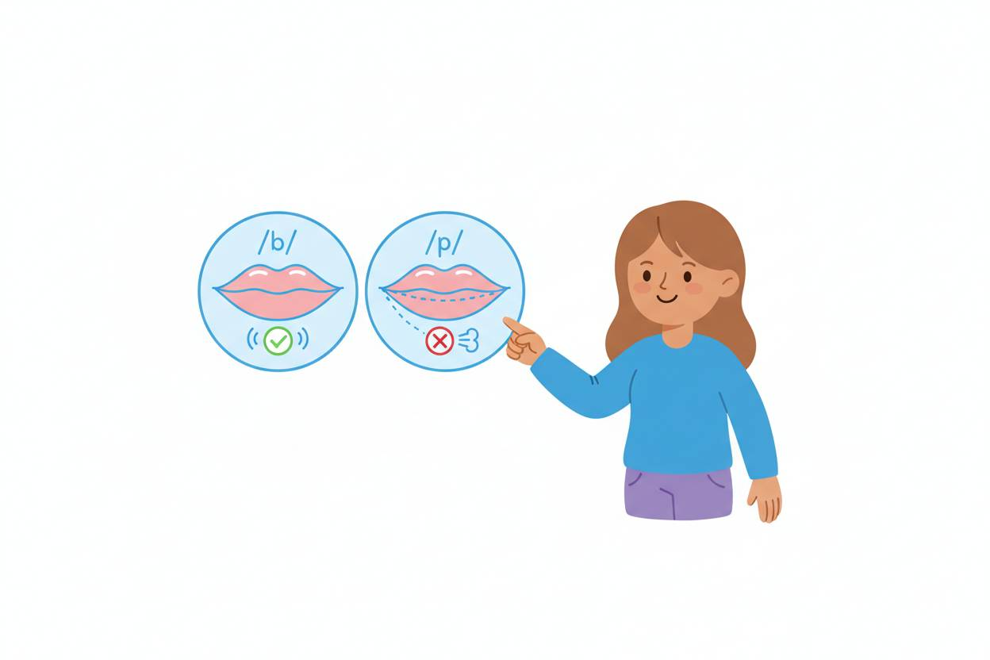

Connect Sound to Letter
👉 Teacher Does: Point to lowercase b on board.
🗣️ Teacher: This letter’s name is b, and it stands for the sound /b/. Say the letter name and sound with me: b, /b/. Ready… Go.
💬 Child Response: b, /b/.
👉 Teacher Does: Point to uppercase B.
🗣️ Teacher: This big letter’s name is B. It also stands for /b/. Say “uppercase B, /b/.” Ready… Go.
💬 Child Response: Uppercase B, /b/.

Model Letter Formation – Lowercase b
✏️ Verbal Cues:
(Insert the exact lowercase “b” verbal cues from Form F here, unchanged.)
🗣️ Teacher: Watch me. I’m going to write lowercase b. My turn, your eyes on my hand.
👉 Teacher Does: On lined board, slowly write lowercase b while saying the exact Form F verbal cues aloud.
🗣️ Teacher: Say it with me while I write another lowercase b. Ready… Go.
👉 Teacher Does: Writes a second b, pausing with each stroke so students can say each cue in sync.

Model Letter Formation – Uppercase B
✏️ Verbal Cues:
(Insert the exact uppercase “B” verbal cues from Form F here, unchanged.)
🗣️ Teacher: Now watch how I write uppercase B. My turn first. Eyes on my hand.
👉 Teacher Does: Writes uppercase B with the exact Form F verbal cues.
🗣️ Teacher: Let’s say the cues together while I write another uppercase B. Ready… Go.
👉 Teacher Does: Writes another B with students reciting the cues.

Activity: Magic Finger Write (quick whole-group engagement)
🗣️ Teacher: Let’s try Magic Finger Write in the air before we use our pencils. Hold up your pointer finger. Find the top, middle, and bottom lines on our pretend board in the air.
🗣️ Teacher: My turn first: I’ll sky-write lowercase b and say the cues. Watch.
👉 Teacher Does: Sky-writes lowercase b, saying the exact Form F cues.
🗣️ Teacher: Your turn to Magic Finger Write lowercase b with me. Remember to start it in the right place. Ready… Go.
👉 Teacher Does: Sky-writes again; children copy.
🗣️ Teacher: Now let’s Magic Finger Write uppercase B together. Say the cues as you write. Ready… Go.
👉 Teacher Does: Sky-writes uppercase B with cues.

3. Guided Practice
💡 Explanation:
(Use the exact Form B explanation for Section 3 here.)
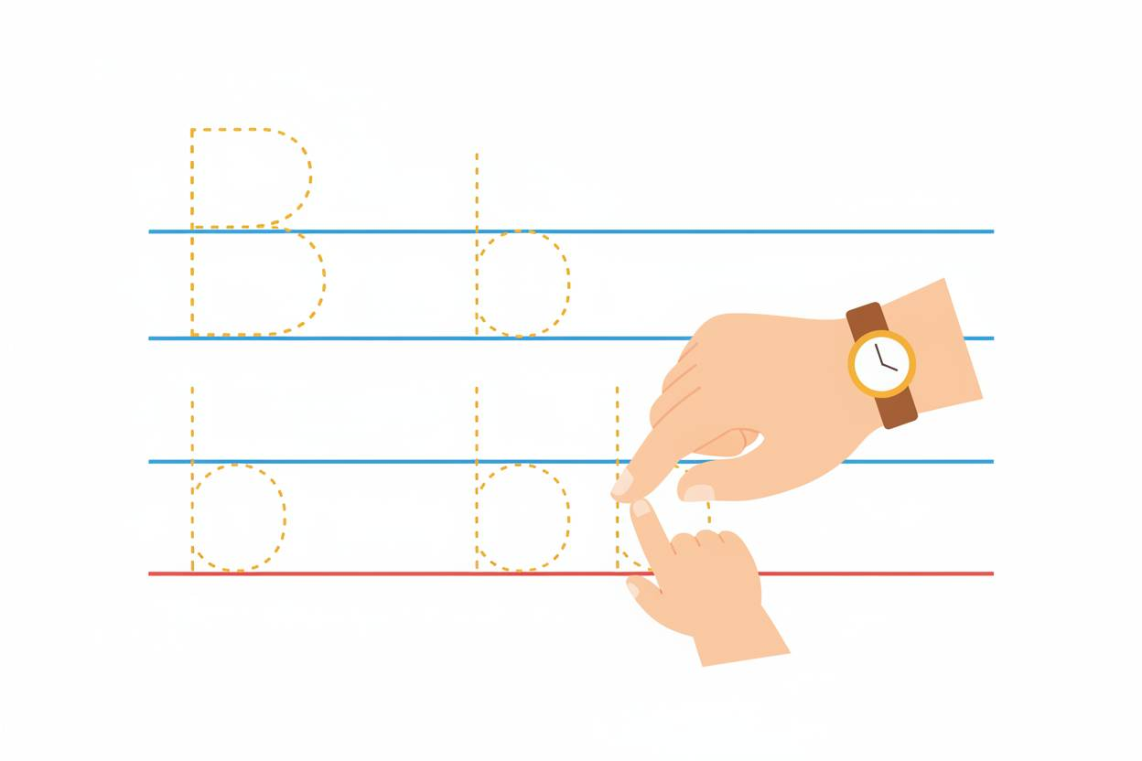

Activity 1: Trace & Say
🗣️ Teacher: Now we will practice with Trace & Say. Put your finger on the first lowercase b on your page. My turn to show you.
👉 Teacher Does: On document camera or chart, traces a dotted lowercase b while saying the exact lowercase b Form F cues.
🗣️ Teacher: Your turn to trace that same lowercase b and say the cues with me. Ready… Go.
👉 Teacher Does: Traces again while students trace and speak cues.
🗣️ Teacher: Let’s do two more lowercase b’s. Each time, trace and say the cues out loud so your mouth and hand work together. Ready… Go.
👉 Teacher Does: Moves through two more dotted lowercase b’s.
🗣️ Teacher: When we say the cues while we trace, it helps our brain remember the way the letter b is formed.

Corrective Feedback #1 – Reversals (b written like d)
Corrective Feedback: Some children may reverse b, starting with the circle and making it look like d.
🗣️ Teacher: I see some lowercase letters that look a little like d instead of b. You are close. Everyone, look up here. Some of you wrote this.
👉 Teacher Does: Writes lowercase d on the board.
🗣️ Teacher: This letter is d. It says /d/. We are writing b. This is b.
👉 Teacher Does: Writes lowercase b right next to d.
🗣️ Teacher: What is different about these two letters? Think quietly. Ready… Go.
💬 Child Response: The tall line comes first in b; the circle comes first in d.
🗣️ Teacher: Exactly. For b, we make the tall line down first, then the bubble. For d, the bubble comes first, then the tall line. Everyone trace b in the air with the cues, starting with the tall line. Ready… Go.
👉 Teacher Does: Sky-writes lowercase b.
🗣️ Teacher: Now fix any b’s on your page that started with the bubble instead of the tall line. Start with the tall line this time.

Activity 2: Say and Write (Lowercase & Uppercase)
🗣️ Teacher: Now we’ll do Say and Write. We will say the letter name and sound, then write it by ourselves. Get your pencil ready.
👉 Teacher Does: Points to first blank line.
🗣️ Teacher: My turn. I say, “lowercase b, /b/,” and then I write lowercase b using our cues in my head. Watch.
👉 Teacher Does: Writes lowercase b on board.
🗣️ Teacher: Your turn. Say “lowercase b, /b/,” then write one neat lowercase b on your paper. Ready… Go.
💬 Child Response: (while writing) lowercase b, /b/.
🗣️ Teacher: Check your b. Do you see the tall line first and then the bubble? That shows you followed the stroke order and made the correct lowercase b.
🗣️ Teacher: Let’s do that two more times. Each time say, “lowercase b, /b/,” then write it. Ready… Go.
👉 Teacher Does: Circulates, watching formation and giving quick support.
🗣️ Teacher: Now we’ll practice uppercase B. My turn first: “uppercase B, /b/.” Then I write uppercase B. Watch.
👉 Teacher Does: Writes uppercase B on board.
🗣️ Teacher: Your turn. Say, “uppercase B, /b/,” then write uppercase B on your paper. Ready… Go.
💬 Child Response: (while writing) Uppercase B, /b/.
🗣️ Teacher: Remember, uppercase B has the straight line and two bumps on the same side. That’s how we know it’s formed correctly.

Corrective Feedback #2 – Uppercase B with Only One Bubble or Wrong Side
Corrective Feedback: Some children may write uppercase B with only one bump or put a bump on each side.
🗣️ Teacher: I notice some uppercase B’s that are almost right. Everyone look up here. Some of us wrote this.
👉 Teacher Does: Writes a shape with a line down and one bump, or a line with a bump on each side.
🗣️ Teacher: That one is missing a bump, or the bumps are on both sides. Now watch the correct uppercase B.
👉 Teacher Does: Writes correct uppercase B next to the incorrect one.
🗣️ Teacher: What is different about these two? Ready… Go.
💬 Child Response: The real B has two bumps on the same side.
🗣️ Teacher: Yes. Uppercase B always has two bumps on the same side of the straight line. Everyone draw an uppercase B in the air with two bumps on the same side. Ready… Go.
👉 Teacher Does: Sky-writes uppercase B.
🗣️ Teacher: Now fix any uppercase B’s on your paper that only have one bump or have bumps on both sides. Make sure there are two bumps on the same side of the line.

4. Application
💡 Explanation:
(Use the exact Form B explanation for Section 4 here.)
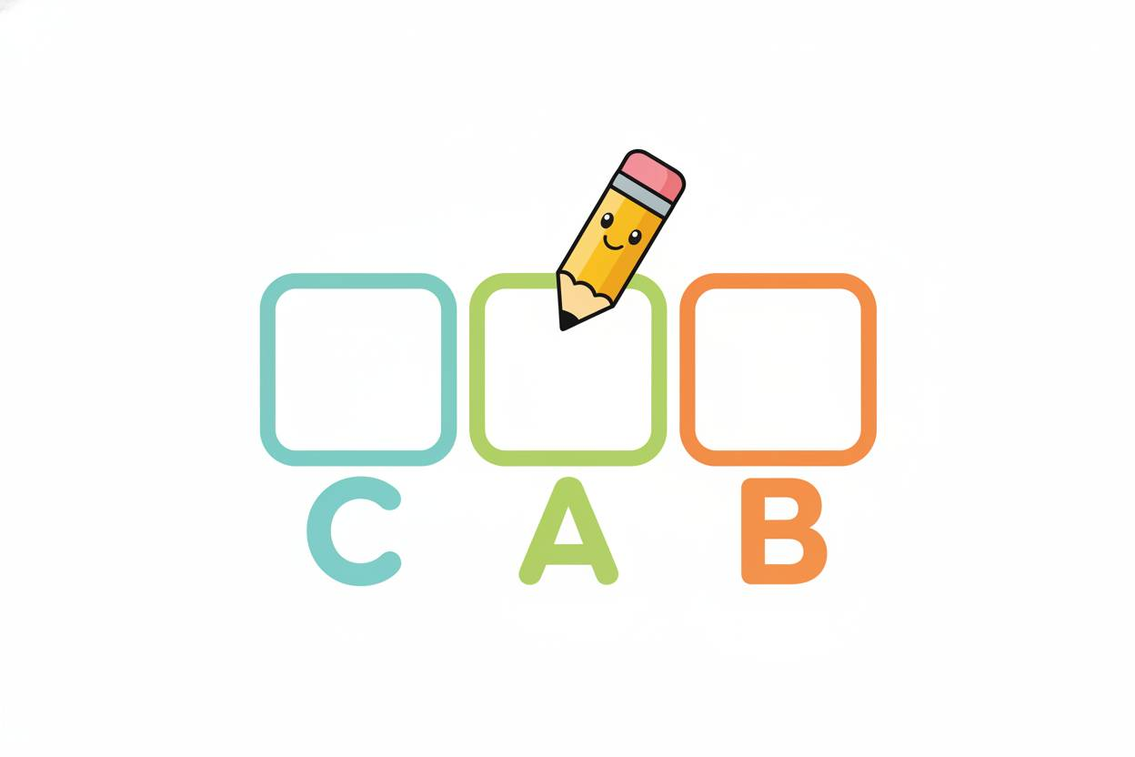

Teacher Think-Aloud – Word Build and Write (Model)
🗣️ Teacher: Now we will use our letter b to spell words. We’ll use Word Build and Write. My turn first. I will show you how my brain thinks. Listen to my thinking.
🗣️ Teacher: The word is cab. Say cab. Ready… Go.
💬 Child Response: cab.
🗣️ Teacher: First I stretch the sounds: /c/ /a/ /b/. I hear three sounds, so I need three boxes. Watch me put a sound in each box.
👉 Teacher Does: Draws three sound boxes on the board.
🗣️ Teacher: I listen for the beginning sound in cab: /c/ /a/ /b/. The beginning sound is /c/. I know the /c/ sound can be written with the letter c. I am going to write c in the first box.
👉 Teacher Does: Writes c in the first box.
🗣️ Teacher: Now I say the word again, cab, and move to the middle sound: /c/ /a/ /b/. The middle sound is /a/. I know /a/ is written with the letter a, our short a vowel, so I write a in the middle box.
👉 Teacher Does: Writes a in the second box.
🗣️ Teacher: Now I listen for the last sound in cab: /c/ /a/ /b/. The last sound is /b/. I feel my lips pop and my voice is on, /b/. That is our new letter b. I will write b in the last box.
👉 Teacher Does: Writes b in the third box.
🗣️ Teacher: Now I read my word: /c/ /a/ /b/, cab. I used c for /c/, a for /a/, and b for /b/. That’s how I use sounds in my head to choose the letters.

Activity: Word Build and Write (Student Practice)
🗣️ Teacher: Now it’s your turn to try Word Build and Write with me. Put your finger under your three boxes on your paper.

Word 1: bat
🗣️ Teacher: The word is bat. Say bat. Ready… Go.
💬 Child Response: bat.
🗣️ Teacher: Stretch the sounds: /b/ /a/ /t/. How many sounds? Ready… Go.
💬 Child Response: Three.
🗣️ Teacher: Yes, three sounds, so we will use our three boxes. What is the first sound in bat? /b/ /a/ /t/. Ready… Go.
💬 Child Response: /b/.
🗣️ Teacher: Right, /b/ is the beginning sound. /b/ is written with the letter b, so write b in the first box. Ready… Go.
👉 Teacher Does: Writes b in first box on board.
🗣️ Teacher: What is the middle sound in bat? /b/ /a/ /t/. Ready… Go.
💬 Child Response: /a/.
🗣️ Teacher: Yes, /a/ in the middle. We write that with the letter a. Write a in the middle box.
🗣️ Teacher: Last sound, /b/ /a/ /t/. What do you hear at the end? Ready… Go.
💬 Child Response: /t/.
🗣️ Teacher: Correct, /t/ is written with t. Write t in the last box. Now read your word with me: /b/ /a/ /t/, bat.

Word 2: bag
🗣️ Teacher: Next word, bag. Say bag. Ready… Go.
💬 Child Response: bag.
🗣️ Teacher: Stretch it: /b/ /a/ /g/. First sound? Ready… Go.
💬 Child Response: /b/.
🗣️ Teacher: Yes, /b/. Which letter stands for /b/? Ready… Go.
💬 Child Response: b.
🗣️ Teacher: Exactly, so write b in the first box. That tells us bag starts with the /b/ sound.
🗣️ Teacher: Middle sound: /b/ /a/ /g/. What do you hear? Ready… Go.
💬 Child Response: /a/.
🗣️ Teacher: Yes, /a/ again, so write a in the middle box.
🗣️ Teacher: Last sound: /b/ /a/ /g/. What do you hear at the end? Ready… Go.
💬 Child Response: /g/.
🗣️ Teacher: Right, /g/ is written with the letter g. Write g in the last box. Then read your word: /b/ /a/ /g/, bag.

Word 3: tab (ending /b/ focus)
🗣️ Teacher: Now we will use /b/ at the end of a word. The word is tab. Say tab. Ready… Go.
💬 Child Response: tab.
🗣️ Teacher: Stretch it: /t/ /a/ /b/. First sound? Ready… Go.
💬 Child Response: /t/.
🗣️ Teacher: Yes, /t/, write t in the first box. Middle sound? /t/ /a/ /b/. Ready… Go.
💬 Child Response: /a/.
🗣️ Teacher: Correct, write a in the middle box. Last sound: /t/ /a/ /b/. What do you hear at the end? Ready… Go.
💬 Child Response: /b/.
🗣️ Teacher: Yes, you should feel your lips pop and your voice buzz: /b/. That is our letter b. Write b in the last box. Now read your word: /t/ /a/ /b/, tab.

Quick Independent Try
🗣️ Teacher: I will give you one more word to try a little more on your own. The word is bib. Say bib. Ready… Go.
💬 Child Response: bib.
🗣️ Teacher: Stretch the sounds in your whisper voice, then write the letters in the boxes: /b/ /i/ /b/. Remember to listen for /b/ at the beginning and at the end and to write b for /b/. Ready… Go.
👉 Teacher Does: Circulates and supports as needed.
🗣️ Teacher: Let’s check bib together. First sound? Ready… Go.
💬 Child Response: /b/.
🗣️ Teacher: Yes, so we wrote b in the first box. Last sound? /b/ /i/ /b/. Ready… Go.
💬 Child Response: /b/.
🗣️ Teacher: Right, /b/ again, so we also wrote b in the last box. That shows we used our new letter b in two places in this word.

5. Wrap-Up
💡 Explanation:
(Use the exact Form B explanation for Section 5 here.)
🗣️ Teacher: Let’s remember what we learned about our new letter today. What sound does b say? Ready… Go.
💬 Child Response: /b/.
🗣️ Teacher: Yes, b stands for /b/. Our lips start closed, we pop them open, and our voice is on.
🗣️ Teacher: Show me in the air how to write lowercase b while you say the cues in your whisper voice. Ready… Go.
👉 Teacher Does: Sky-writes lowercase b.
🗣️ Teacher: Now show me uppercase B in the air with whisper cues. Ready… Go.
👉 Teacher Does: Sky-writes uppercase B.
🗣️ Teacher: Today you wrote lowercase b, uppercase B, and used b to spell words like bat, bag, and tab. Give your writing hand a little wiggle and say, “I can write b!” Ready… Go.
💬 Child Response: I can write b!

