 | Relevant from EDA | Streamline / Remove | Additions
Overall | Outcome Distribution  Outcome by Year  Top Respondents  Respondents by Year |  | Pycaret File
RQ1 | Shifterator (5.4.2, 5.4.3) - to demo vocab divergence between vio vs. no vio → motivation for RQ1  Fighting Words (5.5.1, 5.5.2) - to show distinctive vocab exists between outcomes → TF-IDF | Country Coefficient Table  Cross-entropy Loss  Predictive Probabilities for Metadata | Log Reg Coefficients [IA feedback]
RQ2 | Article Pairing (4.3) - to lead onto data leakage and Artile 41 removal  Importance (4.4)  Visualizations (5):  - ScatterText (5.2) - clusters of distinguishing terms suggest underlying thematic differences that NMF would cover  - Concordance (5.3) - provides contextual usage for specific key terms  - Shifterator (5.4): points to the thematic content that NMF would differentiate.  - Fighting Words (5.5) - provides a lens for interpreting themes.  Note to Nicha - Add sections for 5.4 and 5.5 if not mentioned by those under Sophie RQ1 | Find best-K (5 min) | NMF Topic Descriptor Words [IA feedback]
RQ3 | - Top Respondent (4.2) - to show exploration of respondent countries (East vs West)  - Outcome distribution (4.1) - to show severe class imbalance  - Article pairing (4.3) - to show limitations of Article 41 leakage  - ScatterText (5.2) and Shifterator (5.4) - anticipates words associated with violations (e.g, military) and foreshadow failure of eastern trained model  - N-gram change (5.1.2) - volatility hinted that geographic datasets are not stable across the corpus - justification for splitting the dataset geographically | Word count statistics (3.1-3.3)? → important to show data cleaning but not relevant to narrative of RQ3, maybe can cut down / briefly mention if it’s also not relevant to other RQs  Importance (4.4) - not relevant to RQ3 but keep as relevant to RQ2  Concordances (5.3) also not relevant for RQ3, but keep this as it’s relevant to RQ2.  Alternative to pycaret | Scatter Text E vs. W
RQ4 |  | Global PCA Chart | Focal Term Occurrences E vs. W  Concordances Focal Terms E vs. W
Conclusion |  |  | Legal Implications  Policy Implications  Ethical Implications  Future Work

To Do:
- AI usage statement [Amanda]
  - Note: We used Gemini 3 Flash & Pro, Claude Sonnet 4.6, and Gemini 2.5 Flash in Google Colab to generate code, conduct debugging, data analysis, perform research, draft and review our analytical findings. We are fully responsible for the content, accuracy, and quality of the final submitted work. All AI outputs were independently verified and synthesized by the group members.
- Pycaret markdown comments [Rini]
- Colab markdown file conversion
  - Open your final notebook in Google Colab.
  - Create a new code cell at the very bottom of your notebook.
  - Paste the following code and run it (making sure to insert your actual exact filename):
    - !jupyter nbconvert --to markdown [YOUR_NOTEBOOK_NAME].ipynb
  - Once the cell finishes running, click the Folder icon on the left sidebar to open the Files pane.
  - You should now see a new file named [YOUR_NOTEBOOK_NAME].md.
  - Click the three dots next to that new .md file and select Download
  - Important Note on Images: When you use nbconvert, any charts or plots generated by your code (like your Matplotlib or Seaborn graphs) will usually be saved into a newly created folder named [YOUR_NOTEBOOK_NAME]_files.
  - You must download this folder as well and keep it in the same directory as your .md file, because your Markdown file relies on that folder to display the images correctly on your GitHub site.
- Criteria check w/ AI BFs

Code for Scatter Text E vs. W
import scattertext as st
import pandas as pd

# Filter the dataframe for 'Eastern' and 'Western' clusters from df_rq4
df_scattertext_regional = df_rq4[df_rq4['cluster'].isin(['Eastern', 'Western'])].copy()

# Prepare the data for Scattertext
# We'll use 'law_text_clean' as the text column and 'cluster' as the category
corpus_regional = st.CorpusFromPandas(
df_scattertext_regional,
category_col='cluster',
text_col='law_text_clean', # Changed text_col to 'law_text_clean'
nlp=st.whitespace_nlp_with_sentences
).build()

# Create the Scattertext visualization comparing 'Eastern' vs. 'Western'
html_regional = st.produce_scattertext_explorer(
corpus_regional,
category='Eastern',
category_name='Eastern Cases',
not_category_name='Western Cases',
width_in_pixels=1000,
height_in_pixels=700,
metadata=df_scattertext_regional['title'], # Display case titles on hover
minimum_term_frequency=5 # Added parameter to reduce the number of terms
)

# 3. Save the HTML to a file
with open('article8_rq3.html', 'w') as f: # Changed filename to 'article8_rq3.html'
f.write(html_regional)

print("Interactive Scattertext visualization saved to 'article8_rq3.html'.")
print ("Open the HTML file through your own browser")

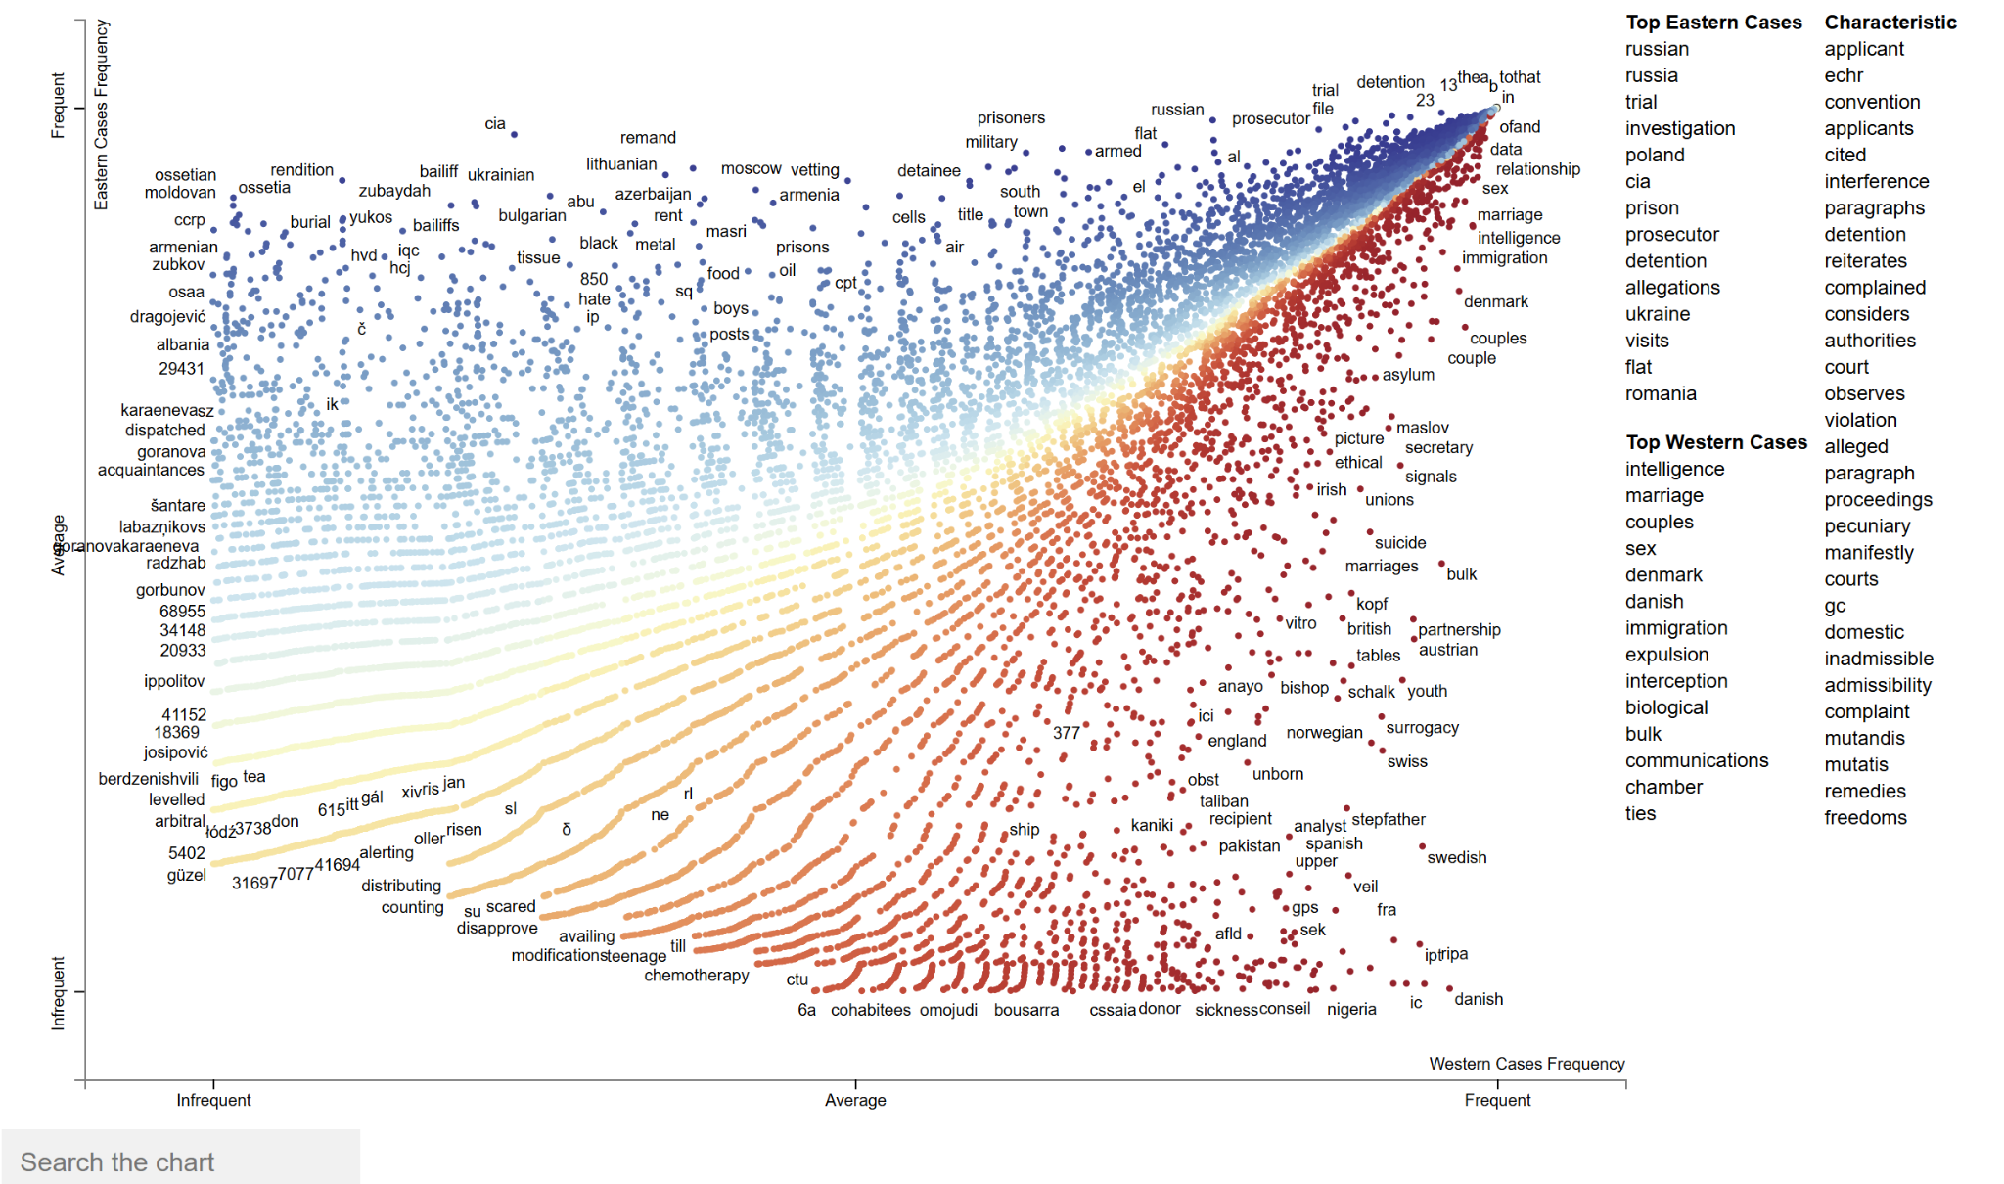

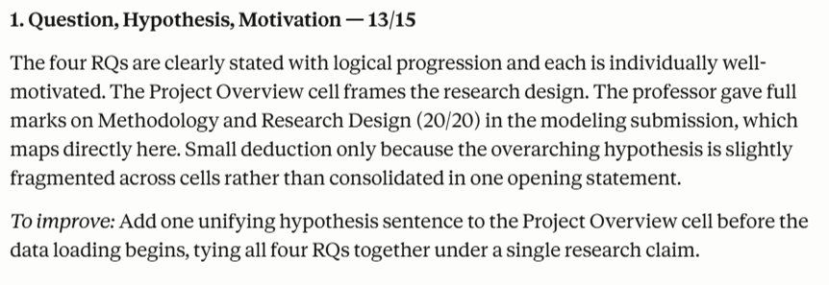
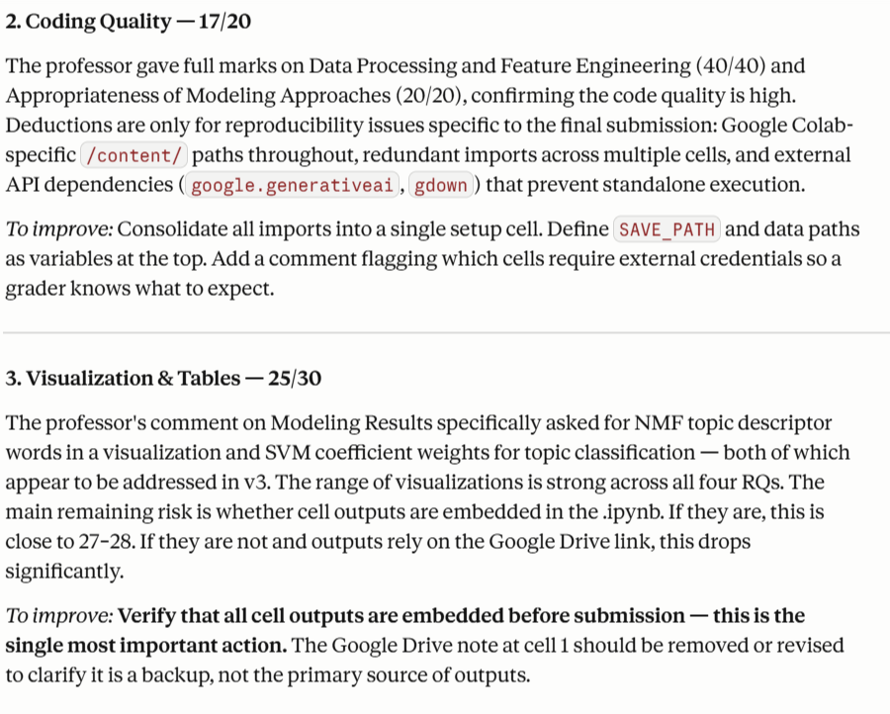

Nicha - Done

Rini -Done

Rini -Done

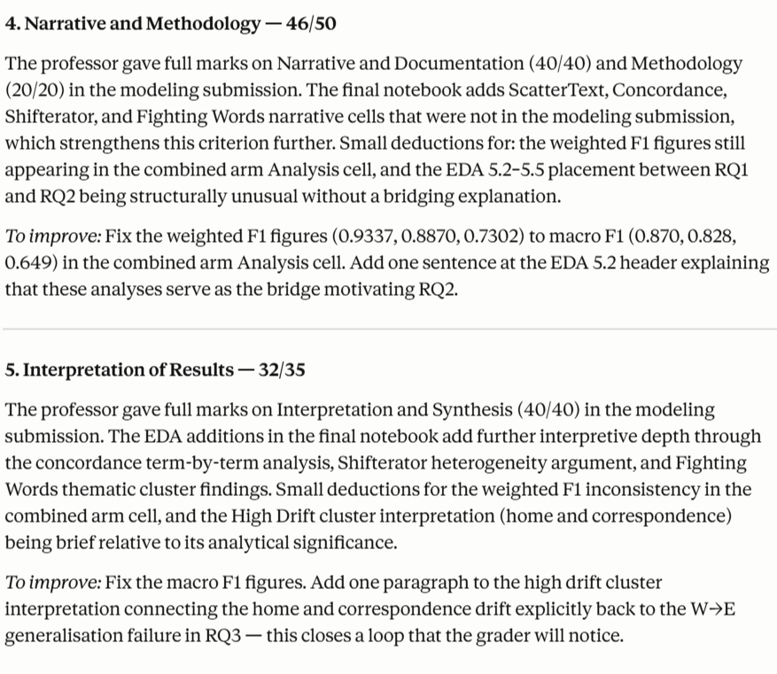

Nicha -done

Nicha -done

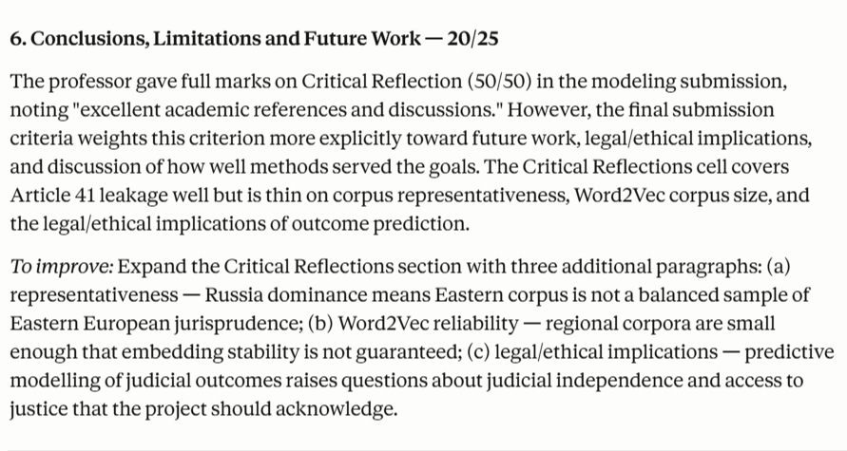

After sharing everything with Claude again it said “No additions needed”

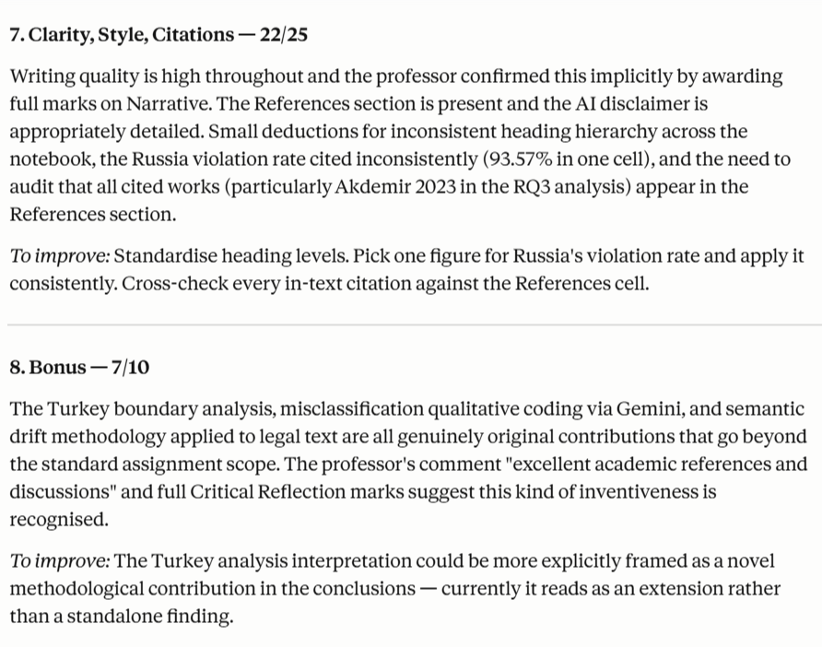

Rini - done

Nicha - done



