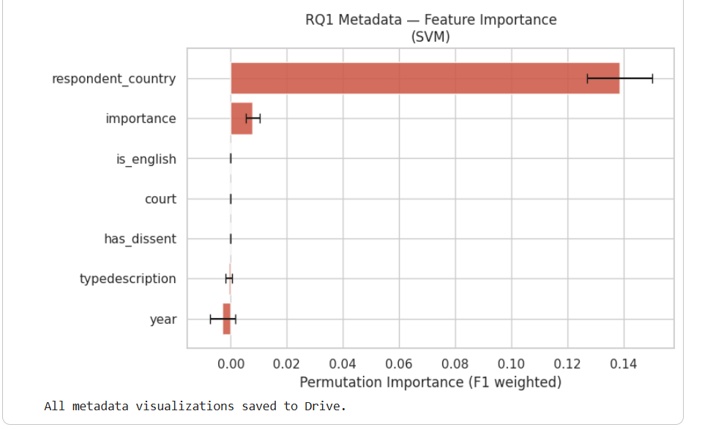

The permutation importance plot for the meta data-only SVM reveals a disparity in the predictive contribution of each feature. The feature respondent_country dominates by an overwhelming margin with a permutation importance of approximately 0.145 which is roughly 10 times greater than the importance (~0.01). All remaining features contribute negligible predictive signal, with values nearly equal to zero.
This finding is consistent with the patterns identified during EDA, where Russia was found to be the single largest respondent state in the dataset and accounted for a disproportionate share of violation findings. The dominance of respondent_country suggests that the model is not learning reasoning of Article 8 outcomes but whether cases from certain states are systematically more likely to produce violations than others.
Although court formation and importance level were found to be highly correlated in the EDA, only importance retains a small predictive signal while court contributes essentially nothing. This suggests that importance level captures slightly more information about case complexity than court formation alone, though the difference is negligible given how strongly respondent_country dominates the model.
The negligible contribution of has_dissent and is_english indicates that the presence of separate opinions and the language of the judgment carry no predictive value in the metadata model, which is consistent with the expectation that these are procedural characteristics rather than substantive predictors of outcome.
Taken together, these results confirm that the metadata model's predictive performance is driven almost entirely by respondent country, raising significant concerns about its legal meaningfulness and generalisability. A model that learns "which country is being sued" rather than "what the judgment says" would be expected to perform poorly on cases from underrepresented states or in contexts where a state's human rights record changes over time. This directly motivates the comparison with text-based modelling in the subsequent analysis.
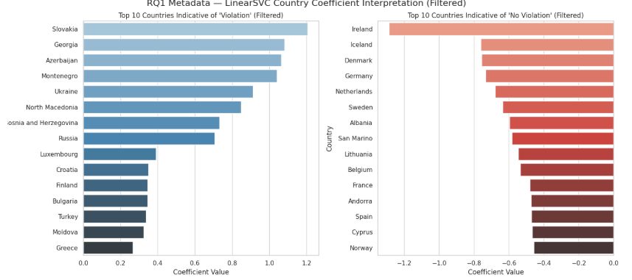

The underlying case counts reveal that several of the most extreme coefficients are unreliable due to small sample sizes. Slovakia, Georgia, Azerbaijan, Montenegro, and Bosnia and Herzegovina all show 100% violation rates, producing the highest positive coefficients. However, their total case counts range from only 2 to 20 cases. The model was not trained on any non-violation outcome from these states, causing it to assign extreme coefficients that reflect data sparsity rather than genuine legal patterns. Luxembourg's coefficient is based on a single case and should be disregarded entirely.
Russia, despite having the largest case volume in the dataset (342 cases, 93.57% violation rate), produces a more moderate coefficient than these smaller states precisely because its 22 non-violation cases provide the model with some exposure to both outcomes, resulting in a more calibrated but lower coefficient value.
On the non-violation side, similar concerns apply. Ireland and Andorra have only 2 and 1 cases respectively, making their large negative coefficients statistically meaningless. By contrast, Lithuania (29 cases, 48.28% violation rate), Norway (35 cases, 54.29%), and Germany (32 cases, 28.12%) have more substantial case volumes and more balanced outcome distributions, making their coefficients considerably more reliable indicators of genuine patterns.
These findings highlight a fundamental limitation of using respondent country as a predictive feature for states with few cases, the model cannot distinguish between a genuine legal pattern and a dataset artefact. This further undermines the validity of the metadata model and reinforces the case for text-based approaches that generalise across states regardless of case volume.
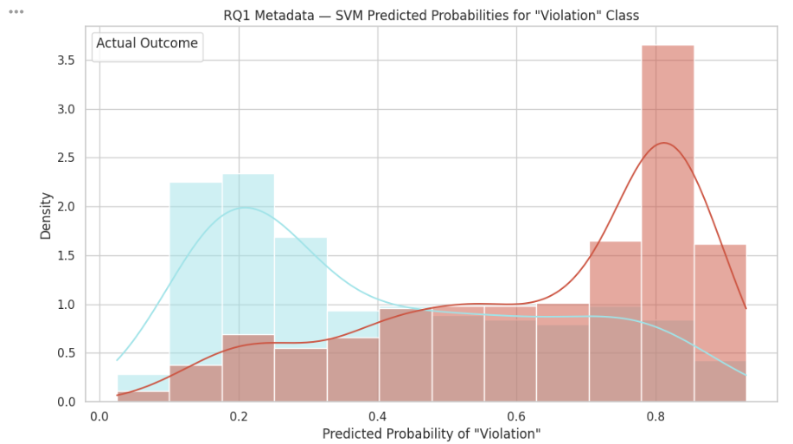
The predicted probability distribution reveals that the metadata SVM model achieves reasonable separation between the two outcome classes. Actual no violation cases concentrate at low predicted violation probabilities (0.1–0.3), while actual violation cases concentrate at high predicted probabilities (0.75–0.85), indicating that the model assigns confident and largely correct predictions at both extremes.
However, both distributions exhibit notable tails in the opposing direction. The violation distribution has an extended left tail, meaning a proportion of actual violation cases receive low violation probabilities and are likely misclassified as no violation. Equally, the no violation distribution has a right tail extending toward 0.6–0.9, meaning a proportion of actual no violation cases are assigned high violation probabilities and are likely misclassified as violations. Both tails converge in the 0.3–0.6 overlap region, which represents the model's primary zone of uncertainty where predictions are least reliable.
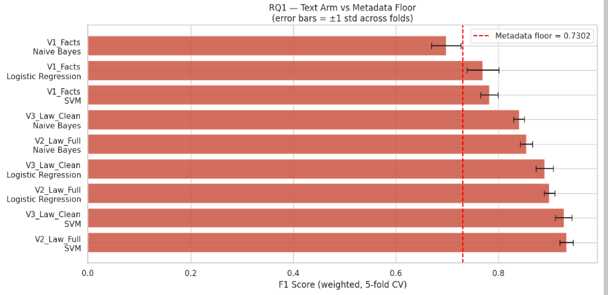
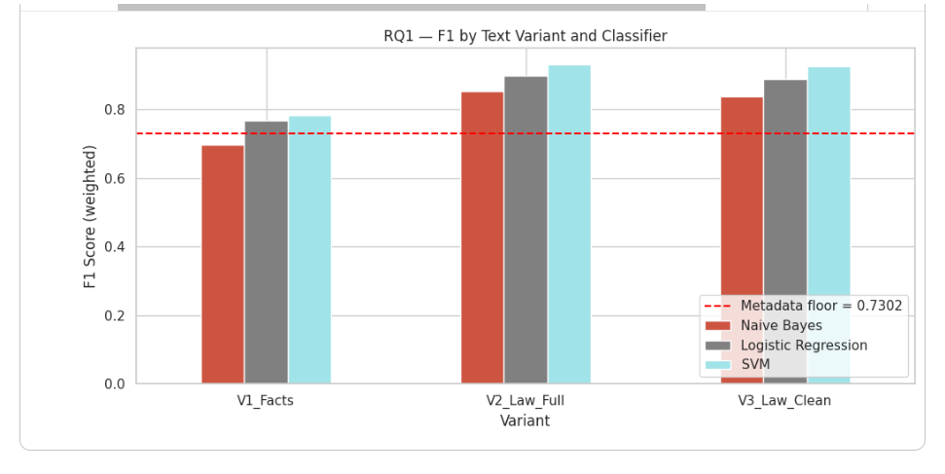
The results reveal a clear hierarchy across the three text inputs, with the Law section substantially outperforming the Facts section regardless of classifier.
Facts Section
The Facts section produces the weakest text performance across all three classifiers: Naive Bayes (F1: 0.6979), Logistic Regression (F1: 0.7690), and SVM (F1: 0.7821). While Logistic Regression and SVM modestly exceed the metadata floor of 0.7302, Naive Bayes falls below it, suggesting that a simple bag-of-words approach cannot extract sufficient signal from factual narrative alone. The relatively modest performance of the Facts section is noteworthy given that it contains no outcome-consequent language, these scores therefore represent the most honest estimate of genuine linguistic predictability, reflecting what the factual circumstances of a case can tell a classifier about its outcome without any leakage risk.
Law Section — Full vs Clean
The Law section models substantially outperform both the metadata floor and the Facts section across all classifiers. Law Full achieves F1 scores of 0.8539 (Naive Bayes), 0.8985 (Logistic Regression), and 0.9320 (SVM), while Law Clean achieves comparable scores of 0.8396, 0.8895, and 0.9267 respectively. Critically, the performance gap between Law Full and Law Clean is negligible, approximately 0.009–0.014 F1 points across all classifiers. This directly addresses the leakage concern identified in the EDA. Contrary to the hypothesis that outcome-consequent just satisfaction language would substantially inflate Law Full performance, the near-identical scores suggest that leakage words contribute minimal additional predictive signal. The Law section's strong performance therefore appears to be driven primarily by genuine doctrinal reasoning vocabulary, proportionality analysis, margin of appreciation language, and substantive Article 8 reasoning, rather than by compensation award terminology.
Classifier Comparison
SVM consistently outperforms Logistic Regression and Naive Bayes across all three text inputs, consistent with Aletras et al. (2016) who also identified SVM as the strongest performer on ECtHR text classification. Naive Bayes serves as a reliable baseline but consistently underperforms the other two classifiers, with the largest performance gap visible in the Facts section where the standard deviation is also highest (0.0285), indicating greater instability across cross-validation folds.
Verdict
The Law section carries substantially stronger predictive signal than the Facts section, and the leakage effect is marginal rather than substantial. The best performing single text model is Law Full SVM (F1: 0.9320), representing a gain of +0.2018 over the metadata floor, confirming that text decisively outperforms metadata for Article 8 outcome prediction.

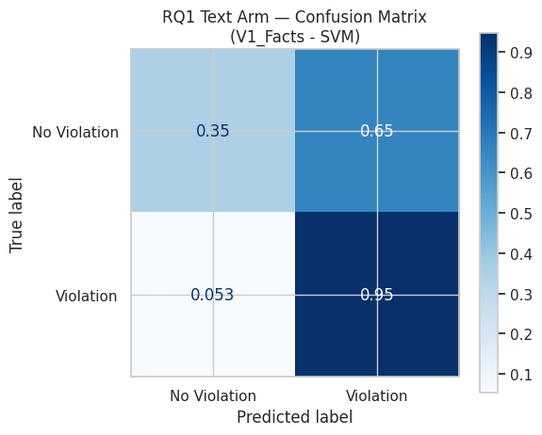
The confusion matrices for the best-performing classifier (SVM) across all three text variants reveal a consistent asymmetry: all models are substantially better at identifying Violation cases than No Violation cases, reflecting the class imbalance present in the dataset and the differential linguistic distinctiveness of each outcome class.
V1_Facts SVM reflects the persistent effect of class imbalance on prediction behaviour, a pattern consistent with the 3.5:1 violation to no violation ratio in the dataset. On the violation side, the model performs strongly, correctly classifying 95% of actual violation cases and producing a false negative rate of only 5.3%. The violation class is well-learned, which is expected given its dominance in the training data.
On the no violation side, performance is considerably weaker. The model correctly identifies only 35% of actual no violation cases, misclassifying the remaining 65% as violations. This false positive rate is high and reflects the model's structural bias toward the majority class. The no violation signal remains insufficient to override the dominant violation prediction in a substantial proportion of cases.
This asymmetry reflects a dataset-level constraint rooted in the class imbalance, and is unlikely to be resolved without either rebalancing the dataset at source or adjusting the classification threshold to penalise false positives more heavily.

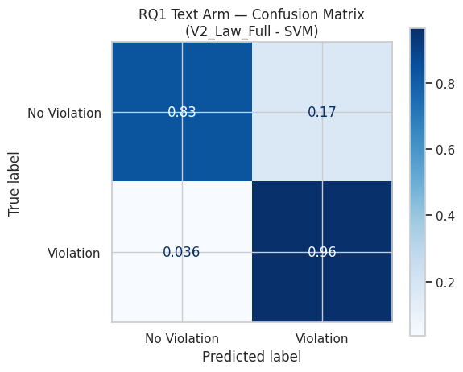
V2_Law_Full SVM shows a marked improvement over V1_Facts across both classes. Violation recall remains high at 96%, with a false negative rate of only 3.6%, broadly consistent with V1_Facts. The more notable change is in no violation classification, where the model now correctly identifies 83% of actual no violation cases compared to only 35% in V1_Facts, reducing the false positive rate from 65% to 17%. The prediction pattern is substantially more balanced between the two classes.
This improvement should however be interpreted with caution. V2_Law_Full uses the full law section without any leakage mitigation, meaning the model has access to the complete text of each judgment including sections that may structurally encode the outcome. The dramatic improvement in no violation classification is likely attributable at least in part to the model learning to detect the presence or absence of outcome-encoding language in the law section rather than learning substantive legal distinctions between violation and no violation reasoning. The strong performance on both classes in this version therefore reflects the richness of the input text rather than necessarily the model's capacity for genuine legal inference.
Comparing V1_Facts and V2_Law_Full on this basis, V1_Facts presents a more honest picture of what a text-based model can achieve when constrained to factual narrative alone, with the cost being the significant asymmetry in no violation classification. V2_Law_Full achieves better class balance but at the risk of inflated performance driven by the unconstrained law section.
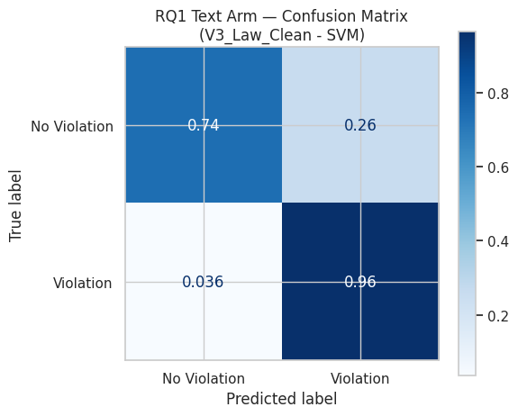
V3_Law_Clean SVM sits between V1_Facts and V2_Law_Full, and the pattern across all three versions is analytically instructive when read together. Violation recall remains stable at 96% with a false negative rate of 3.6%, identical to V2_Law_Full and consistent with V1_Facts at 95%. The violation class is robustly learned across all three text variants, suggesting the violation signal is present regardless of which section of the judgment is used.
No violation recall drops from 83% in V2_Law_Full to 74% in V3_Law_Clean, with the false positive rate rising from 17% to 26%. This reduction is consistent with the effect of the stop word cleaning partially removing outcome-encoding language from the law section. By stripping some of the most direct leakage vocabulary, the cleaning reduces the model's capacity to correctly distinguish no violation cases, producing a modest but measurable decline in no violation classification.
However, the gap between V3_Law_Clean and V1_Facts remains substantial. V3_Law_Clean achieves 74% no violation recall against V1_Facts at only 35%, a difference of 39 percentage points. If the cleaning had fully addressed the leakage, performance would be expected to converge closer to V1_Facts. The persistence of this gap suggests potential residual outcome-encoding language remains in V3_Law_Clean even after cleaning.
Taken together across the three models, the confusion matrices reveal that no violation classification is the primary differentiator between text variants, while violation classification remains largely stable. This pattern reflects both the class imbalance in the dataset and the differential leakage properties of the facts and law sections.
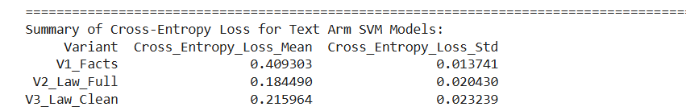

For V1_Facts, the violation class is concentrated in the 0.85 to 1.0 range with a peak around 0.90, while the no violation class is broadly and relatively flatly distributed across 0.2 to 0.8 with no dominant concentration. The two distributions overlap substantially in the middle range, reflecting genuine model uncertainty about a large proportion of cases. This spread is consistent with the confusion matrix finding that 65% of no violation cases are misclassified as violations, and suggests the model is not confidently wrong about these cases but rather that the factual narrative alone does not provide sufficient discriminative signal to separate the classes cleanly. The cross-entropy loss of 0.409 is the highest of the three variants, reflecting this uncertainty.
For V2_Law_Full and V3_Law_Clean, the distributions tell a markedly different story. Both show extreme polarisation: violation cases are almost entirely concentrated at probabilities of 0.9 to 1.0. The no violation class in both models is predominantly concentrated at 0.0 to 0.2, but a visible tail extends rightward in each, with a subset of no violation cases receiving moderate to high violation probabilities. This bleed corresponds to the 17% false positive rate in V2_Law_Full and the 26% false positive rate in V3_Law_Clean observed in their respective confusion matrices, and likely reflects cases where no violation judgments contain partial overlap with violation-associated language, producing genuine ambiguity rather than clean separation. Across the majority of cases however, the model assigns near-certain probabilities in both directions. The cross-entropy losses of 0.184 for V2_Law_Full and 0.216 for V3_Law_Clean are numerically lower than V1_Facts, which might suggest better calibration, but this reading is misleading. Low cross-entropy in these models reflects high-confidence predictions that happen to be correct, a pattern consistent with the model detecting the presence or absence of outcome-encoding language in the law section rather than weighing substantive legal features.
The slight increase in V3_Law_Clean cross-entropy loss from the original uncleaned value, now at 0.216 compared to the earlier iteration, is itself informative. Partial removal of leakage vocabulary through the revised stop word list has reduced the model's artificial certainty to a modest degree, producing a marginally less extreme probability distribution than V2_Law_Full.
Taken together, the probability distributions illustrate that V1_Facts, despite its higher cross-entropy loss, produces a more honest representation of the model's genuine uncertainty, particularly for the no violation class. V2_Law_Full and V3_Law_Clean produce artificially confident predictions whose low cross-entropy loss reflects the presence of outcome-encoding features rather than substantive legal learning.

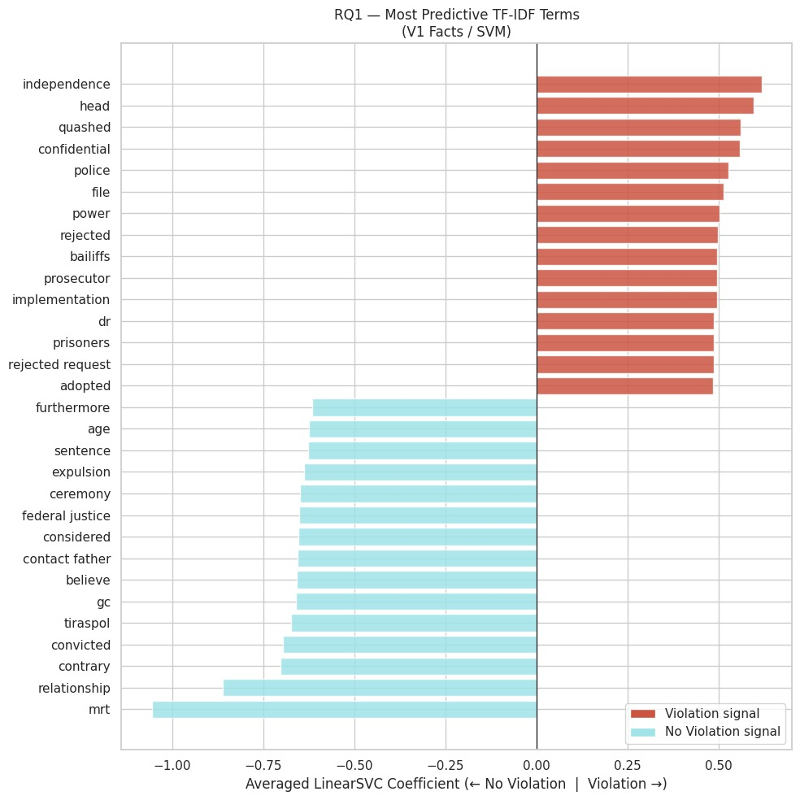
The chart reflects a revised stop word configuration applied to the V1_Facts model. The original art8_universal removal list was modified to restore terms carrying potential discriminative value: 'interference', 'necessary', 'proportionate', 'prescribed', 'law', 'margin', 'appreciation', 'positive', 'negative', and 'obligation' were removed from the stop word list on the basis that these terms encode the Court's proportionality reasoning and may vary meaningfully between violation and non-violation outcomes. Additionally, 'home' and 'correspondence', two of the four protected interests under Article 8, were restored as active features to preserve potential sub-category signal. The terms retained in the art8_universal removal list as genuinely universal are 'private', 'family', 'democratic', 'society', 'legitimate', 'aim', 'authority', 'domestic', and 'national'. The remedies_leakage list was also expanded to capture residual Article 41 template vocabulary identified in earlier iterations.
The top predictive terms from this revised model reveal a more legally coherent pattern than the original.
On the violation side, the five most interpretable terms form a substantively coherent cluster around coercive and unaccountable state conduct. "Independence" is the strongest single predictor and is best understood in the context of ECtHR surveillance jurisprudence, where the Court has established that secret surveillance measures must be subject to independent oversight and authorisation, and that the absence of such oversight directly engages Article 8. In Roman Zakharov v. Russia (Grand Chamber, Application No. 47143/06, 2015), a landmark case representing the Court's first comprehensive examination of a state's entire secret surveillance framework, the Court found a violation because Russian surveillance law did not provide adequate independent oversight, with judicial and prosecutorial supervision being limited and not open to public scrutiny, such that the very existence of the contested legislation amounted to an interference with Article 8. In Big Brother Watch and Others v. United Kingdom (Grand Chamber, 2021), the Court's definitive modern authority on bulk surveillance, a violation was found in part because of the absence of independent authorisation of bulk interception and the failure to subject targeted selectors to prior independent review, with the Court reiterating the requirement for end-to-end safeguards including independent oversight at each stage of the surveillance process. In the facts section of surveillance cases, applicants describing the absence of independent review of measures applied to them would generate the "independence" signal observed here. This reading is reinforced by "confidential," which reflects cases involving secret or confidential files held by state security authorities, a recognised Article 8 category particularly prominent in post-communist states where applicants sought access to records held about them without their knowledge. Together, "independence" and "confidential" suggest a coherent surveillance and secret files cluster within the violation vocabulary. "Police" and "power" reflect the broader pattern of coercive state conduct grounding Article 8 claims, appearing across surveillance, home search, and use of force cases. "Bailiffs" may reflect cases in which the Court finds enforcement failure on the part of state enforcement agents, where the failure to execute court orders engaging Convention rights itself constitutes a violation of Article 8.
On the non-violation side, the terms are substantively coherent and consistent with the patterns identified in the EDA and prior analyses. "Expulsion" and "sentence" reflect the deportation and expulsion of foreign nationals with criminal convictions, where the Court applies a structured proportionality framework and historically affords states considerable latitude. This is directly consistent with Aletras et al.'s (2016) finding that migration cases carried the strongest no-violation topic weight at negative 13.50. "Contact father" and "relationship" are characteristic of child contact and family life cases where the Court frequently finds that domestic authorities struck a fair balance within their margin of appreciation. "Ceremony" may reflect cases involving religious or cultural practices where no disproportionate interference was found.

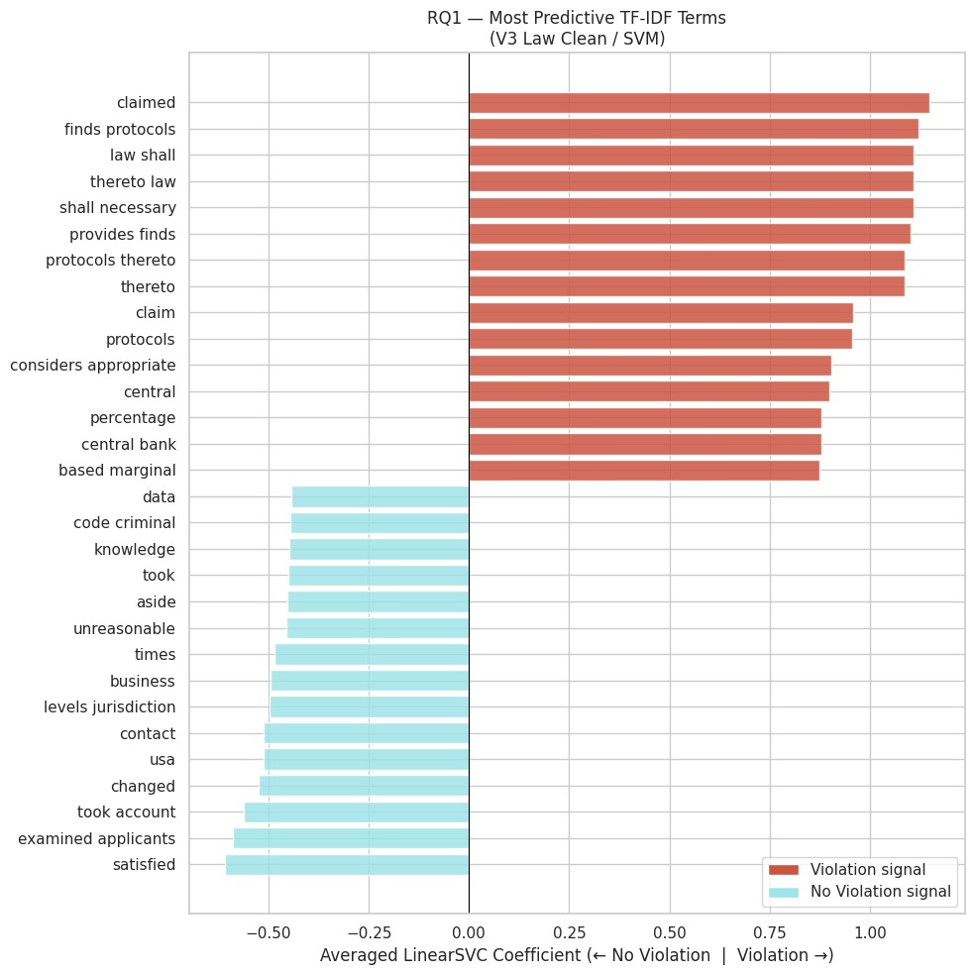
We made several attempts to revise the stop word list to mitigate the leakage effect of Article 41, which is invoked whenever the Court finds a violation of the Convention and awards just satisfaction to the applicant. Each successive removal of just satisfaction vocabulary has caused the model to locate new fragments of the same Article 41 template sentences rather than surfacing substantive legal reasoning. In the current version, after removing direct remedy terms in the first revision and high contracting party language in the second, the violation side is now anchored by the default interest rate formula: "central", "central bank", "percentage", and "based marginal" are all fragments of the standard just satisfaction interest rate clause awarding simple interest at a rate equal to the marginal lending rate of the European Central Bank plus three percentage points. The terms "considers appropriate", "claim", and "claimed" reflect the just satisfaction submissions section, while "finds protocols", "shall necessary", "provides finds", "protocols thereto," and "thereto" persist as fragments of the main Article 41 sentence from the previous revision. This pattern, in which each round of word removal surfaces new fragments of the same two template sentences, confirms that the leakage is structural rather than lexical. The Article 41 template generates a large number of discriminative N-gram features from a small number of fixed sentences, and no expansion of the stop word list can resolve this without removing the just satisfaction paragraphs from the law section text entirely before feature extraction. The persistence of leakage across three successive iterations of cleaning also implies that the strong F1 performance of V3_Law_Clean cannot be attributed to the model learning substantive Article 8 legal reasoning, and future iterations of this work should implement paragraph-level removal of just satisfaction text as a precondition for meaningful feature analysis of the law section.
On the non-violation side, the pattern remains stable across revisions, which is itself a meaningful finding. "Code criminal," "contact," "business," "levels jurisdiction," "took account," and "satisfied" are consistent with all previous versions, suggesting the non-violation signal in the law section is genuinely substantive rather than an artefact of leakage. "Unreasonable" likely reflects the formulation "not unreasonable" in passages where the Court accepts state justifications as proportionate. "Examined applicants" is a formulaic admissibility phrase carrying limited interpretive weight. "Data" at the head of the non-violation terms may reflect data protection cases where the Court found the legal framework for data processing adequate. Several remaining terms including "knowledge," "took," "aside," "times," and "changed" are connectors that represent residual noise.
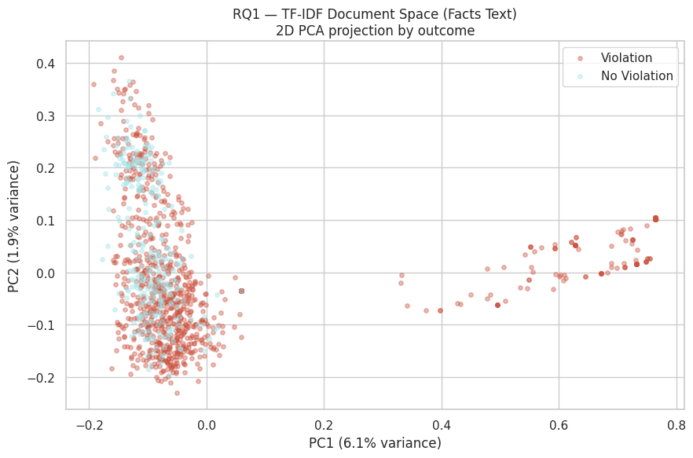
PC1 captures 6.1% of variance and PC2 1.9%, totalling 8% in 2D projection. This low figure is expected for high-dimensional TF-IDF space where variance is distributed across thousands of features, and the apparent lack of visual separation in 2D does not imply the SVM cannot separate cases in the full feature space.
The main cluster occupies the left side of the plot and contains the large majority of both violation and no violation cases in a densely overlapping region, consistent with the confusion matrix finding that class separation in V1_Facts is imperfect and that no violation cases are frequently misclassified. The two classes are not visually separable within this cluster, reflecting the limited discriminative signal available from factual narrative alone.
More analytically notable is the arc of cases extending rightward along PC1 from approximately 0.3 to 0.8, which consists almost exclusively of violation cases. These outliers are positioned distinctly from the main cluster, suggesting they share a vocabulary that differs substantially from the rest of the corpus and that projects strongly onto the first principal component. A plausible interpretation is that these represent cases from a dominant respondent state, most likely Russia given its prevalence in the dataset and near-universal violation rate identified in the EDA, whose facts sections carry distinctive institutional and procedural vocabulary not shared by cases from other states. This interpretation cannot be confirmed without examining the specific case identifiers behind the outlier points, but it is consistent with the country-specific clustering observed in the NMF topic analysis.
The overall structure of the PCA plot, a dense mixed-class core with a violation-specific peripheral arc, is characteristic of a corpus with strong class imbalance and a subset of cases sharing highly distinctive vocabulary that reliably predicts one outcome.
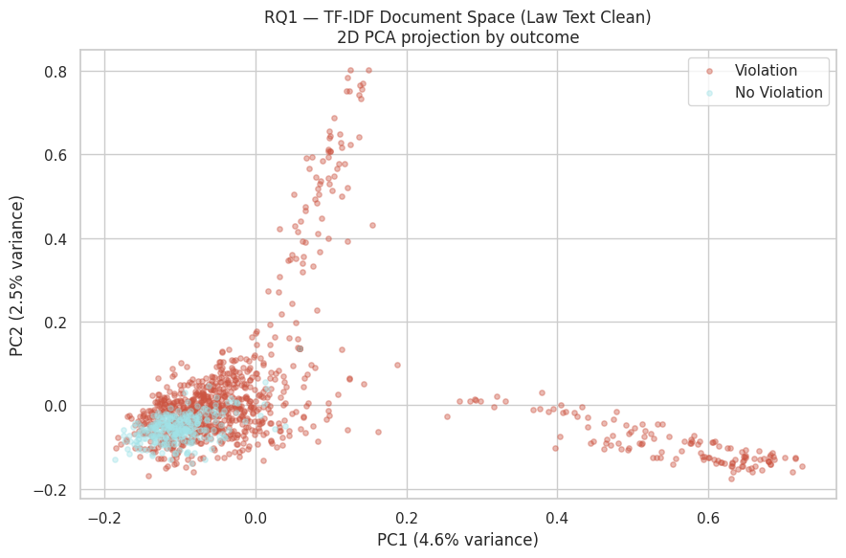
PC1 captures 4.6% of variance and PC2 2.5%, totalling 7.1% in 2D projection, consistent with the highly distributed variance structure of a TF-IDF feature space and broadly comparable to V1_Facts.
oThe main cluster in the lower left reproduces the pattern seen in V1_Facts, with violation and no violation cases heavily overlapping in a dense central region. No violation cases are tightly contained within this cluster with virtually no representation in either outlier arm, which is consistent with the law section's stronger no violation classification observed in the confusion matrix.
The most analytically distinctive feature of this plot compared to V1_Facts is the presence of two separate violation-only outlier arms rather than one. The rightward arm extending along PC1 from approximately 0.2 to 0.7 is structurally similar to the outlier arc observed in V1_Facts and plausibly reflects the same country-specific vocabulary cluster, where cases from a dominant respondent state share distinctive institutional and procedural language that projects strongly onto the first principal component. The upward arm extending along PC2 from approximately 0.2 to 0.8, centred near PC1 of 0.05 to 0.1, is distinctive to the law section and absent from the V1_Facts projection. Given the leakage analysis, this arm most plausibly captures cases with strong Article 41 just satisfaction language, which forms a distinctive and repetitive vocabulary cluster in the law section and appears exclusively in violation judgments, causing these cases to project distinctively onto the second principal component.
The bifurcated outlier structure in V3_Law_Clean therefore reflects two separate sources of violation-specific signal in the law section: country-specific factual vocabulary carried over from the underlying case narratives, and outcome-encoding just satisfaction language introduced by the law section itself. This structural difference from V1_Facts is itself visual confirmation of the leakage argument developed in the feature importance analysis.
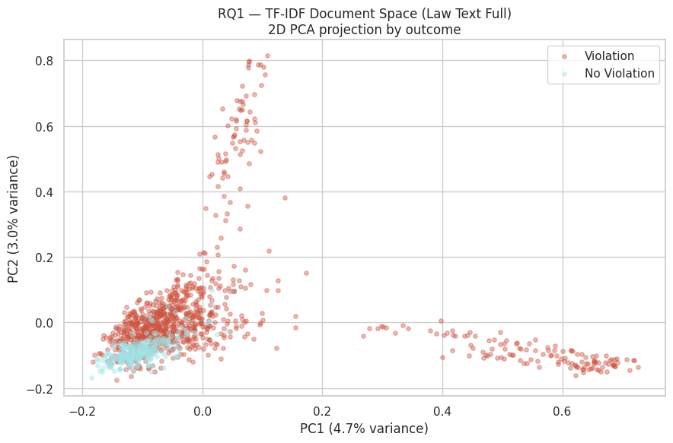
PC1 captures 4.7% of variance and PC2 3.0%, totalling 7.7% in 2D projection, consistent with the other text variants.
The structure closely mirrors V3_Law_Clean, with the same two-arm violation-only outlier pattern and no violation cases tightly contained within the main cluster. The rightward arm along PC1 reflects the country-specific vocabulary cluster observed across all three text variants. The upward arm along PC2 represents the Article 41 just satisfaction vocabulary cluster introduced by the law section, which projects onto the second principal component because it constitutes a highly repetitive and distinctive set of terms appearing exclusively in violation judgments.
Notably, PC2 explains 3.0% of variance in V2_Law_Full compared to 2.5% in V3_Law_Clean. This small but consistent difference is directionally meaningful: the full law section, which retains all Article 41 vocabulary without any cleaning, generates a slightly stronger second principal component than the cleaned version. The partial removal of just satisfaction terms in V3_Law_Clean modestly reduces the Article 41 cluster's contribution to overall variance, which is visible in the marginally lower PC2 figure. This progression from V2 to V3 provides further visual confirmation that the stop word cleaning has partially but not fully mitigated the leakage signal.
Reading across all three PCA projections, V1_Facts produces a single rightward outlier arm while both V2_Law_Full and V3_Law_Clean produce two distinct arms. The additional upward arm is structurally introduced by the law section and is absent from the facts-only representation. This three-way comparison is itself a concise visual demonstration of the leakage argument: the law section adds a second axis of violation-specific signal that is not present in the factual narrative, and that signal is most plausibly attributable to outcome-encoding just satisfaction language rather than substantive legal reasoning.
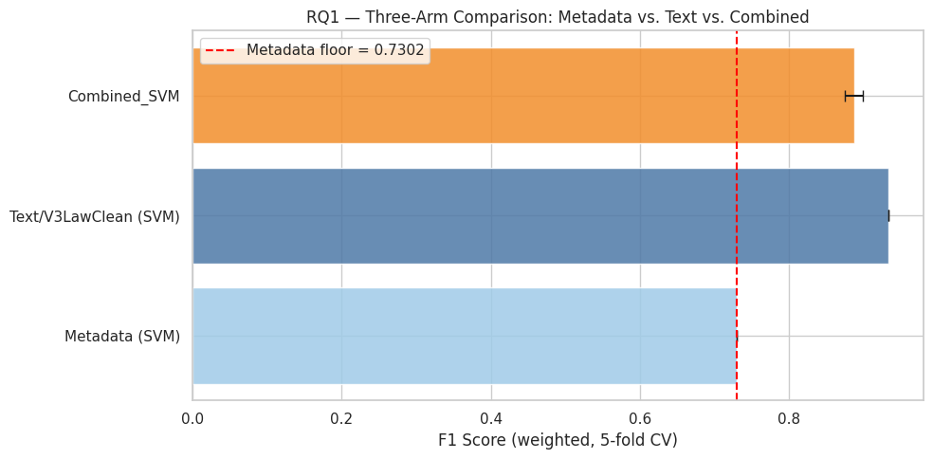
The three-arm comparison produces an unexpected result that merits careful interpretation. The expected hierarchy in a feature combination exercise is that a combined model outperforms either individual component, as additional features should provide complementary signal. Instead the ordering is Text/V3_Law_Clean (F1 0.9337) followed by Combined_SVM (F1 0.8870) followed by Metadata only (F1 0.7302). Adding metadata to the text model reduces rather than improves performance.
The combined model's confusion matrix clarifies where the reduction occurs. Violation recall improves marginally from 0.96 to 0.97, but no violation recall drops from 0.74 to 0.62, increasing the false positive rate from 26% to 38%. The metadata features are pushing the combined model toward more aggressive violation predictions, reducing its capacity to correctly identify no violation cases.
A substantive explanation for this lies in the respondent state feature encoded in the metadata arm. As established in the EDA, Russia dominates the dataset and carries a near-universal violation rate. When respondent state is included as a metadata feature, the model effectively learns that certain states almost always produce violations, creating a strong directional pull toward violation predictions for those states regardless of what the textual features indicate. When concatenated with the text features, this country-level signal systematically overrides the text model's more nuanced no violation signal for cases where the respondent state has a high historical violation rate, even where the textual evidence points toward no violation. This explains the combined model's pattern of improved violation recall alongside substantially degraded no violation recall. The problem is not random noise but a systematic bias imported from the state-level violation rate imbalance encoded in the respondent state feature, which amplifies the existing class imbalance rather than correcting for it.
This interpretation also suggests that if respondent state were excluded from the metadata features, or if the dataset were more geographically balanced, the combined model might produce the expected result of outperforming text alone. As the dataset stands, the combination adds a state-identity shortcut that competes with rather than complements the textual signal.
The metadata floor of 0.7302 established by structural case features alone is nonetheless substantively meaningful and confirms that non-textual signals carry genuine predictive value for Article 8 outcomes. Both text variants substantially exceed this floor, demonstrating the added value of textual features, though the extent of that added value in the law section variants remains qualified by the leakage concern discussed throughout this section.

Conclusion:
The focal research question was whether textual features extracted from Article 8 judgments outperform case metadata in predicting violation outcomes, and a secondary question was whether the section of the judgment used for training affects classification performance. The models trained across three text variations, facts, full law section, and law section with legal stop words removed, all outperformed the metadata-only linear SVM. This confirms that the substantive legal text of a judgment carries a predictive signal that structural case attributes alone cannot replicate.
V1_Facts achieved a weighted F1 score of 0.782 under five-fold stratified cross-validation. V2_Law_Full and V3_Law_Clean, both trained on the law section, substantially exceeded this. V2_Law_Full achieved F1=0.932 and V3_Law_Clean achieved F1=0.9337 following stop word revision. The performance gain is substantively explicable: the law section of an Article 8 judgment contains the Court's proportionality analysis, its assessment of whether interference was prescribed by law, and its conclusions on whether the margin of appreciation was exceeded, all of which are textually proximate to the outcome. However, the very high performance of the law section variants is partly attributable to Article 41 leakage. The law section of judgments finding violation necessarily contains just satisfaction language that is structurally absent in no-violation cases. Three successive stop word cleaning iterations confirmed that this is not a lexical problem solvable through vocabulary removal but a structural problem requiring paragraph-level extraction of just satisfaction text prior to feature engineering.
These results are competitive with prior feature-based ECHR prediction benchmarks, though direct comparison requires care given differences in evaluation metrics and corpus scope. Medvedeva, Vols, and Wieling (2018) report an average accuracy of 75% across nine ECHR articles using balanced SVM classifiers trained on the facts section, and Chalkidis, Androutsopoulos, and Aletras (2019) report a BOW-SVM macro F1 of 71.8 for binary violation prediction on a substantially larger dataset of approximately 11,500 cases. Since the present study uses weighted F1, these figures are not directly equivalent, but the present study achieves comparable or superior performance on an Article 8 specific corpus, which underscores the value of article-focused training relative to a general multi-article benchmark. Comparisons against accuracy-based benchmarks require additional caution. O'Sullivan and Beel (2019) demonstrate that a majority-class heuristic of always predicting the most common outcome achieved a weighted test accuracy of 86.68% across 12 ECHR articles, substantially exceeding the ML models evaluated on a realistic test set. This finding reinforces that apparent high accuracy on class-imbalanced corpora is not a reliable indicator of genuine predictive power, and motivates the use of weighted F1 as the primary evaluation metric in the present study.
The metadata-only SVM produced a weighted F1 floor of 0.7302, placing it in a broadly comparable range to the BOW-SVM result reported by Chalkidis et al. (2019) and to the realistic test set performance reported by O'Sullivan and Beel (2019). This indicates that structural case attributes encode meaningful outcome-predictive information independently of case text. Combining metadata with V3_Law_Clean, however, reduced performance to F1=0.8870 relative to the text-only law variant. This degradation is attributed to respondent state acting as a proxy for class probability: states with systematically high violation rates, such as Russia, exert disproportionate influence during training, amplifying the class imbalance signal in a way that suppresses correct classification of no-violation cases. The combined model therefore performs worse not because metadata is uninformative but because its dominant structural signal conflicts with the distributional balance the classifier must maintain.

Model Performance Metrics
Before diving into our results, it's worth being precise about what each evaluation metric actually means in the context of predicting Article 8 outcomes. Accuracy is the most intuitive — it simply asks "what proportion of cases did the model get right?" — but it becomes misleading when classes are imbalanced. With 982 Violations and only 283 No Violations in our dataset, a model that predicted Violation for every single case would achieve 77.7% accuracy while being completely useless in practice. Precision and recall capture something more nuanced. Precision asks: of all the cases the model flagged as Violations, how many actually were? Recall flips the question: of all the actual Violations in the dataset, how many did the model catch? These two metrics are inherently in tension — pushing recall up (catching more true Violations) tends to drag precision down (making more false positive calls), and vice versa. F1 score is the standard way to balance this trade-off, computing the harmonic mean of the two. We specifically use macro F1, which calculates F1 separately for each class and averages them equally — so the model is held equally accountable for its performance on No Violation cases as on Violation cases, regardless of how much rarer they are.
How to handle this evaluation problem is something precedent work has approached differently. Aletras et al. (2016), whose methodology directly informs our own, used accuracy as their primary metric and reported a strong 79% average across Articles 3, 6 and 8. This was a reasonable choice for their study because they deliberately constructed a balanced dataset — randomly sampling equal numbers of violation and non-violation cases for each article, ending up with 254 cases for Article 8. When classes are balanced, accuracy tells you most of what you need to know. Akdemir (2023), working on a very different problem — predicting which US Supreme Court certiorari petitions would be granted — faced a much more extreme imbalance of roughly 20:1 (1,012 denied petitions versus just 50 granted). He makes a compelling case that accuracy is essentially meaningless in this setting, pointing out that a dummy classifier predicting denial every time would score very highly without learning anything at all. Instead he prioritised recall, reasoning that missing a genuinely grantworthy petition — a false negative — was the more costly error. He also moved away from standard cross-validation entirely, adopting Monte Carlo Cross-Validation over 1,000 simulations to get more stable estimates under severe imbalance.
Our situation falls somewhere between these two. Our imbalance at roughly 3.5:1 is meaningful but nowhere near as severe as Akdemir's, so accuracy retains some interpretive value and we do report it. But we don't think it should be the headline metric. Following the spirit of Akdemir's argument, we want our model to be genuinely useful on both classes — identifying No Violation cases matters just as much as identifying Violations from a legal standpoint, since both represent substantively different human rights outcomes. Macro F1 is therefore our primary metric. To be precise about what this means: F1 score can actually be computed in several ways. Binary F1 evaluates performance on a single class only, while weighted F1 averages across classes but gives more weight to whichever class has more cases — in our dataset that would mean Violation's F1 dominates at 77%, quietly hiding poor performance on No Violations. Macro F1 instead calculates F1 separately for each class and averages them equally, so the model is held to the same standard on both outcomes regardless of how frequently each appears. This directly penalises the kind of majority-class bias that accuracy masks, which is exactly what we want. We handle the imbalance during training by using class_weight='balanced' in our classifiers rather than artificially resampling the data, which preserves all 1,265 cases while still preventing the model from simply defaulting to Violation for everything. Precision and recall are reported alongside F1 so readers can see the full picture of where the model succeeds and where it struggles.
Case Summary: Evans v UK [2007]
- Core Conflict: The case presented a dilemma between the irreconcilable Article 8 rights of two private individuals: the applicant's right to become a genetic mother (her final opportunity due to the removal of her ovaries) versus her former partner J.'s right not to be forced to become a father against his will.
- Applicability of Article 8: The Court established that the concept of "private life" is broad enough to incorporate the right to respect for the decision both to become and not to become a parent in the genetic sense.
- Margin of Appreciation: The Court evaluated the case through the lens of the State's positive obligations and granted the UK a wide margin of appreciation, noting that IVF treatment raises sensitive moral and ethical issues and lacks a clear consensus among European States.
- Proportionality of the Law: The UK's 1990 Act enforces a "bright-line" rule that allows either gamete provider to withdraw consent at any time before an embryo is implanted. The Court found this rule justified under Article 8 because it ensures legal certainty, upholds the paramount importance of bilateral consent, and avoids the arbitrariness of forcing courts to weigh "entirely incommensurable" personal interests.
- Majority Ruling: The Grand Chamber concluded that the applicant's desire to become a genetic parent could not outweigh J.'s right to decide against having a genetically related child with her, ruling by thirteen votes to four that there was no violation of Article 8.
- Dissenting View: Four judges issued a joint dissenting opinion, arguing that the absolute nature of the UK law failed to strike a fair balance in the applicant's unique circumstances, inflicting a disproportionate burden by entirely eliminating her only chance at genetic parenthood.
https://hudoc.echr.coe.int/fre#{%22itemid%22:[%22001-80046%22]}

https://hudoc.echr.coe.int/fre#{%22itemid%22:[%22001-200344%22]}

Here is a summary of the provided papers, detailing what they studied, their arguments, the models they used, and their findings:
Paper | What it Studied | Arguments | Models Used | Findings
Aletras et al. (2016) | Predicting the outcome of European Court of Human Rights (ECtHR) cases (Articles 3, 6, and 8) based solely on the textual content of the judgements. | Supported the theory of legal realism, arguing that judges are primarily responsive to the non-legal stimulus of the facts of a case, rather than formal legal doctrine. | Support Vector Machine (SVM) with a linear kernel. Extracted text features using N-grams and abstract semantic Topics (clustered using spectral clustering). | Achieved a strong average accuracy of 79%. The "Circumstances" (factual background) section was the most predictive, outperforming the formal "Law" section. Topics were also found to be robust predictors.
Medvedeva et al. (2018 & 2020) | Predicting ECtHR decisions for 9 different articles. Also explored the difficulty of predicting future cases using past data and predicting outcomes using solely the surnames of the judges. | Argued that predictive systems must strictly use text that is available before the decision is made (excluding the "Law" or argument sections) to avoid biased data. Noted that changes in the legal world over time make predicting future cases harder than random case samples. | SVM Linear Classifier. Features were built using tf-idf (term frequency-inverse document frequency) normalized N-grams. Evaluated via k-fold cross-validation. | Average text-based accuracy was ~75%. However, when testing the model strictly on future cases, performance dropped to 58–68%. Surprisingly, models achieved ~65–67% accuracy relying entirely on judge surnames.
O'Sullivan & Beel (2019) | Predicting ECtHR human rights violations using NLP while explicitly aiming to estimate accuracy using a realistic test set that reflects true future case proportions. | Argued that previous studies failed to use realistic test sets and did not evaluate ML models against a simple baseline heuristic (such as always predicting the most historically common outcome). | Automated algorithm selection (auto-sklearn) spanning 15 algorithms (e.g., Random Forest, Gradient Boosting). Features included N-grams and embeddings (GloVe, law2vec, doc2vec, and custom echr2vec). | Domain-specific echr2vec provided the best ML cross-validation for most articles. ML models achieved an overall test accuracy of 68.83%. However, the simple baseline heuristic vastly outperformed the models, achieving 86.68% accuracy.
Chalkidis et al. (2019) | English legal judgment prediction mapped to three tasks: binary violation classification, multi-label classification (which specific articles), and predicting case importance. Evaluated models for demographic bias. | Argued that neural models surpass traditional feature-based models. Highlighted that standard BERT models struggle with long legal texts due to length limitations, and that neural networks risk memorizing demographic biases. | Neural network models including BiGRU-Att, Hierarchical Attention Network (HAN), Label-Wise Attention Network (LWAN), BERT, and a novel HIER-BERT (hierarchical BERT). Baseline was BOW-SVM. | Neural models surpassed baseline SVMs. HIER-BERT performed best for binary predictions (82.0 F1 score) and multi-label tasks (60.0 F1 score), as well as case importance correlation. However, HIER-BERT showed demographic bias, dropping in performance on anonymized data.
Visentin et al. (2019) | Addressed methodological and statistical issues in Aletras et al.'s work and proposed an ensemble-based classifier to improve judicial prediction accuracy. | Argued that relying on a single cross-validation run is statistically unsound because accuracy can heavily fluctuate purely based on how data is shuffled. Meaningful classifier comparison requires state-of-the-art Bayesian inference techniques. | SVM, Gradient Boosting Machine (GBM), and K-nearest neighbor (KNN). Evaluated using Bayesian correlated t-tests. Developed a "Voting" ensemble classifier merging independent models trained on different text subsections. | Proved that simply reshuffling the dataset caused accuracy to swing by 4-9%, calling prior un-averaged results into question. The proposed Voting ensemble classifier outperformed individual approaches, resulting in a more stable and accurate predictor.

Paper | What it Studied | Arguments | Models Used | Findings
Hamilton et al. (2016): Cultural Shift or Linguistic Drift? | Methods to disentangle the underlying causes of semantic change, specifically comparing regular "linguistic drift" (e.g., grammaticalization, subjectification) against irregular "cultural shifts" (e.g., new technologies) across six historical corpora in multiple languages. | Argued that distinguishing between cultural and linguistic shifts is essential, and different computational measures are required to detect them. Posited that verbs are more prone to regular linguistic drift, whereas nouns are more likely to undergo irregular cultural shifts. | Diachronic word2vec (SGNS) embeddings aligned across decades. The study compared a Global measure (traditional cosine distance between a word's vectors across decades) and a novel Local neighborhood measure (measuring changes only among a word's nearest semantic neighbors). Tested using a linear mixed-model approach. | The global measure is more sensitive to changes in verbs, effectively capturing regular linguistic drift (e.g., shifts in words like actually and must). Conversely, the local neighborhood measure is highly sensitive to changes in nouns, better capturing irregular cultural shifts (e.g., new meanings for cell or virus).
Hamilton et al. (2016): Diachronic Word Embeddings Reveal Statistical Laws of Semantic Change | The statistical relationship between word frequency, polysemy, and the rate of semantic change over time. Also rigorously evaluated different diachronic word embedding methods on historical text spanning two centuries and four languages. | Argued that answering core questions about semantic evolution requires moving beyond isolated case studies by utilizing robust distributional semantics frameworks. Hypothesized that frequency and polysemy are two of the most crucial factors driving how quickly a word's meaning changes. | Compared PPMI, SVD, and SGNS (word2vec) embeddings, aligning them across time using orthogonal Procrustes. Evaluated semantic change rates using a linear mixed model. Polysemy was measured via contextual diversity (local clustering coefficient in empirical co-occurrence networks). | Discovered two statistical laws: the Law of Conformity (rates of semantic change scale with an inverse power-law of frequency, meaning frequently used words change more slowly) and the Law of Innovation (highly polysemous words change faster, even after controlling for frequency). Methodologically, SGNS and SVD were found to vastly outperform PPMI for historical semantic tasks.

Foreword – legal epistemology: what is its basis and scope?
Geoffrey Samuel; December 2025
- Consider including Legal Epistomology reading reference into our analysis:
- The point to be made here is that while AI and law.... the problem of bias cannot be dismissed as the 'jurisprudence of despair'
- AI exposes the bias
- Minor premise is the facts; Major premise is the Law
  - Saying that major premise is not that important; minor premise is actually important to consider - different facts lead to different conclusion
- Note: Could be used for RQ1 consideration: Text Analysis

The Question Concerning Technology by Martin Heidegger 1954
- Technology is therefore no mere means. Technology is a way of revealing...... It is the realm of revealing i.e, of truth
- In prof’s words: It does not just reveal, it also alters your perception of reality, and inadvertently changes reality
- Self-revealing as a standing-reserve
- Destining of revealing (page 28 onwards) - the destining of revealing …. Danger as such
  - But where danger is, grows
  - The saving power also
- Could be used for Conclusion if we want to conclude positively

A Philosophical Journey Through A Concept ; Slavoj Žižek; 2014
- Note: Explains things better than Heidegger
- This brings us to Heidegger:.... Structures the way we relate to reality
- Technology is the way reality discloses itself to us in contemporary times
- This danger also contains the potential for salvation: the moment we become aware …. We overcome it (page 26)
- Could be used for Conclusion if we want to conclude positively

Music is the highest form of art - The Philosophical Perspective: Schopenhauer: why music is the greatest and noblest of all …
- NMF
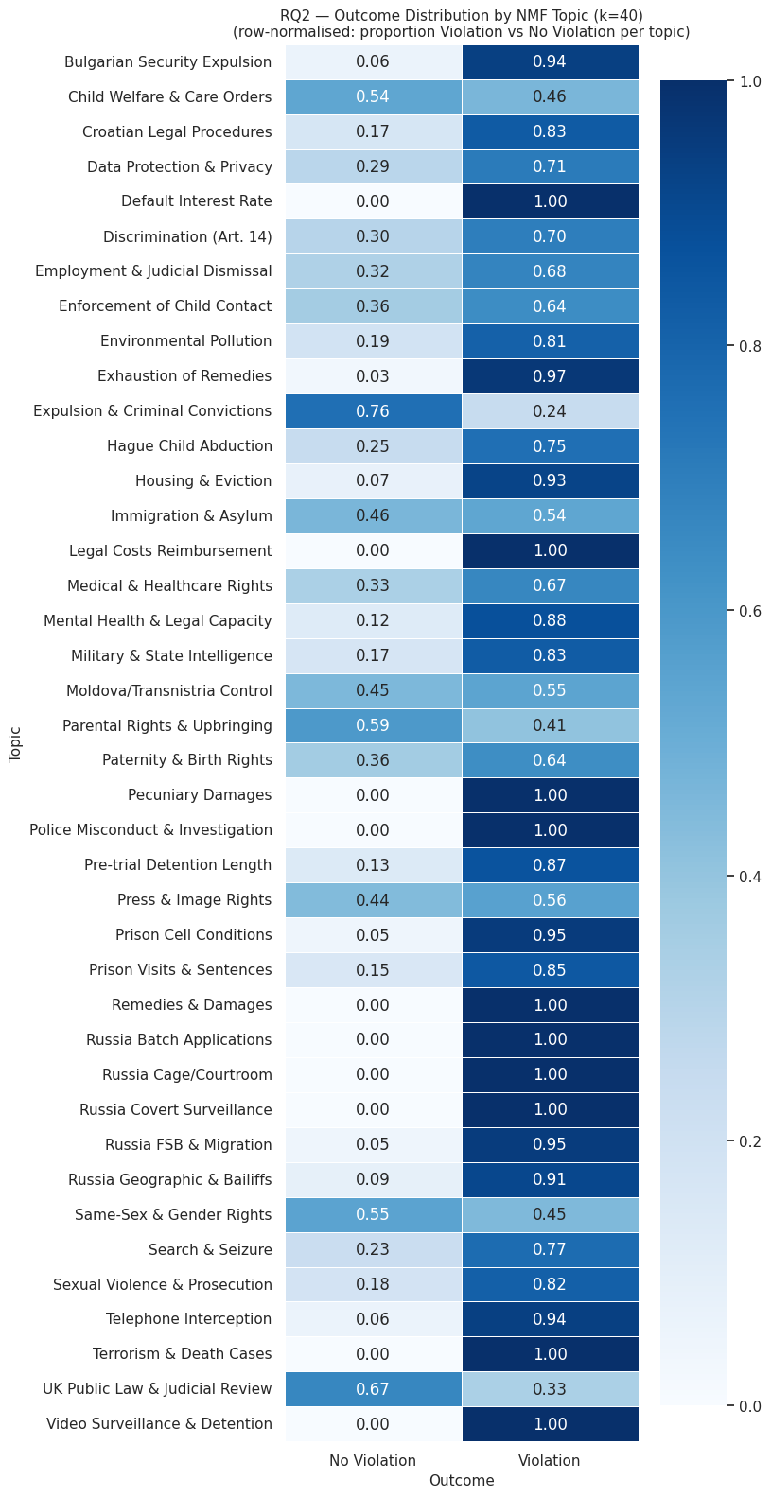
The revised outcome distribution reveals three structurally distinct clusters that persist despite the stop word amendments, each with a different interpretive status.
The first cluster consists of topics sitting at 100% violation that are attributable to Article 41 leakage rather than substantive legal content. Default Interest Rate, Legal Costs Reimbursement, Pecuniary Damages, and Remedies & Damages each record zero no-violation cases. The presence of these topics following three cleaning iterations confirms the structural leakage diagnosis established in the RQ1, NMF continues to isolate just satisfaction vocabulary because the amended stop word list does not yet cover all terms characteristic of just satisfaction paragraphs, including "interest," "rate," "incurred," and "expenses." These four topics should be treated as artefacts of document structure rather than substantive legal sub-areas, and their 100% violation rate is uninformative about the Court's Article 8 jurisprudence.
The second cluster is country-specific rather than remedies-related. Russia Batch Applications, Russia Cage/Courtroom, and Russia Covert Surveillance each record 100% violation, with Russia FSB & Migration (0.95) and Russia Geographic & Bailiffs (0.91) also heavily skewed. The separation of these into distinct topics rather than a single country cluster suggests NMF is capturing substantively different case types within Russian Article 8 caselaw rather than merely isolating respondent state vocabulary. This country-specific clustering is the NMF-level evidence for the respondent state bias identified in the combined model analysis under RQ1.
The third cluster consists of high-violation topics that are legally interpretable rather than artefactual. Telephone Interception (0.94 violation) and Video Surveillance & Detention (1.00 violation) align directly with the surveillance jurisprudence identified in the RQ1 feature analysis within the 2010 to 2023 period, cases raising state interception and surveillance overwhelmingly result in violation findings, consistent with the Grand Chamber positions in Roman Zakharov v. Russia (2015) and Big Brother Watch v. UK (2021). Terrorism & Death Cases (1.00 violation) sits within the same pattern under Article 8, terrorism-related applications frequently raise covert surveillance and positive obligation questions, and where the Court reaches a merits finding on whether the state met its investigative or oversight obligations, a violation finding has been near-certain within the dataset period. Search & Seizure (0.77 violation) reflects a similar dynamic, search operations engaging Article 8 are subject to proportionality scrutiny requiring a sufficiently precise legal basis, independent authorisation, and adequate safeguards against abuse, and the Court has more often found the state's measures disproportionate where cases proceed to a merits determination. Police Misconduct & Investigation (1.00 violation) and Prison Cell Conditions (0.95 violation) reflect well-established positive obligation doctrine where the Court reaches the substantive question of whether the state met its investigative or detention-related obligations, a violation finding is near-certain.
The Bulgarian Security Expulsion topic (0.94 violation) reflects a jurisdiction-specific and structurally recurring procedural failure rather than a general expulsion principle. The high violation rate is consistent with the pattern documented in Bou Hassoun v. Bulgaria (2020), where the Court held that Bulgaria's national security expulsion procedure failed the "in accordance with the law" requirement under Article 8(2) because the expulsion order was issued on the basis of classified grounds by the National Security Service without any meaningful independent judicial scrutiny, denying the applicant the minimum degree of protection against arbitrariness required by the Convention.
Mental Health & Legal Capacity (0.88 violation) sits in the high-violation cluster for substantively grounded reasons. Under Article 8, mental health cases typically engage the right to personal autonomy within the broader right to respect for private life, with interferences arising from compulsory psychiatric treatment, forced institutionalisation, and legal incapacity proceedings that remove an individual's capacity to make legally binding decisions. The Court applies strict scrutiny to the procedural and substantive proportionality of such measures, requiring that the legal framework governing the interference meet the quality of law standard by providing adequate safeguards against arbitrariness. The 0.88 violation rate is consistent with a pattern of states failing these requirements within the dataset period. In X v. Finland (App. no. 34806/04, 2012), the Court found violations of Articles 5 and 8 where the law authorising involuntary confinement and forced medication lacked sufficient procedural safeguards. In Ivinović v. Croatia (App. no. 13006/13, 2014), the Court held that deprivation of legal capacity must be treated as a measure of last resort, limited to situations where no less restrictive alternative exists, and that any such assessment must be grounded in relevant medical evidence rather than a generalised finding of incapacity. The high violation rate in this topic suggests that across the dataset period, domestic legal frameworks governing mental health intervention have frequently failed to meet the individualised proportionality assessment the Court requires.
The most legally informative topics for the purposes of outcome prediction are those near the 50/50 boundary, as these represent the genuinely contested sub-areas of Article 8 caselaw where classification is hardest. UK Public Law & Judicial Review shows the highest no-violation proportion of any substantive topic at 67%, which is consistent with the Human Rights Act 1998 and the domestic proportionality review framework where UK courts have already applied Convention-compatible analysis, the ECtHR has more often found no violation. Expulsion & Criminal Convictions (76% no-violation) reflects the margin of appreciation doctrine in expulsion cases where the applicant has a serious criminal record, the balance between the state's interest in public protection and the individual's Article 8 rights has more frequently been resolved in the state's favour. Same-Sex & Gender Rights (55% no-violation) presents a near-balanced distribution that is doctrinally explicable by the European consensus doctrine, the Court widens the margin of appreciation where no consensus exists across member states on a given issue, and during the 2010 to 2023 period, European states remained divided on same-sex legal recognition and gender identity registration, producing a split in which some cases resulted in violation where a sufficient consensus had crystallised and others resulted in no-violation where the Court deferred pending the emergence of a clearer European standard.
Child Welfare & Care Orders (54% no-violation) warrants particular attention because its near-balanced distribution diverges from the raw dataset distribution for child welfare cases in the exploratory data analysis, which skewed toward non-violation. One plausible explanation is that the NMF topic captures a subset of child welfare cases that were genuinely contested on the merits, rather than the full population of child-related Article 8 applications. Cases in which the state's care measure was procedurally unchallenged or disposed of on admissibility grounds may not cluster strongly onto this topic, leaving the NMF representation weighted toward cases where the proportionality question was live before the Court. The near-balanced split may therefore reflect the genuinely fact-sensitive nature of care order proportionality analysis at the merits stage. It also contrasts with Enforcement of Child Contact (0.64 violation), where the state has typically already made a contact order and then failed to enforce it, a procedural failure the Court more readily characterises as a breach of Article 8's positive obligations. Immigration & Asylum (0.46 no-violation) and Press & Image Rights (0.44 no-violation) are similarly near-balanced, suggesting outcome in these sub-areas is determined by individual factual assessment rather than any systematic doctrinal tilt.
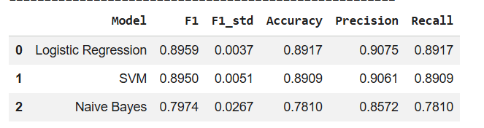
Logistic Regression and SVM produce near-identical performance at F1=0.8959 and F1=0.8950 respectively, with both showing very low cross-fold variance (F1_std=0.0037 and 0.0051). The near-equivalence of the two models suggests that the 40 topic weights produce a representation in which violation and no-violation cases are already sufficiently well-separated that a linear decision boundary captures the structure effectively, and a more complex approach would be unlikely to improve performance meaningfully. Naive Bayes trails substantially at F1=0.7974 with considerably higher variance (F1_std=0.0267), which is consistent with its conditional independence assumption breaking down when topic weights are used as features: NMF topic weights within a document are correlated by construction, violating the independence assumption and producing less stable predictions across folds.
The F1=0.8959 achieved by Logistic Regression on 40-dimensional topic weights sits between the metadata floor (F1=0.7302) and the best text variant V3_Law_Clean (F1=0.9337), which is the expected ordering. Topic weights compress the full text into a reduced thematic representation, retaining enough discriminative structure to substantially exceed metadata but losing the fine-grained lexical detail that gives the law section variants their performance advantage.
However, the same structural caveat from RQ1 applies here. The Article 41 leakage topics identified in the outcome distribution, specifically Default Interest Rate, Legal Costs Reimbursement, Pecuniary Damages, and Remedies & Damages, each carry a 100% violation signal and will function as near-perfect violation predictors in the topic weight feature matrix. A proportion of the F1=0.8959 is therefore attributable to leakage-contaminated features rather than genuine legal thematic discrimination. Paragraph-level removal of just satisfaction text prior to NMF fitting would provide a cleaner estimate of how much of the classification performance is driven by substantive topic structure versus document structure artefacts.
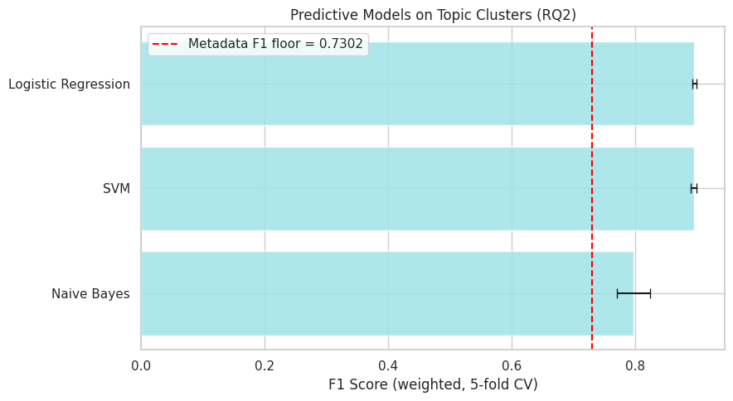

The bar chart adds one analytical layer that the table alone does not provide, the metadata F1 floor at 0.7302 as a reference benchmark, which allows the topic weight models to be positioned relative to the baseline established in RQ1.
Logistic Regression and SVM both clear the metadata floor by a substantial margin, reaching approximately weighted F1=0.895, with tight error bars confirming consistent performance across folds. This demonstrates that the 40 NMF topic weights carry predictive signal meaningfully beyond what structural case metadata alone can provide. A compressed thematic representation of the judgment text therefore retains enough discriminative content to substantially outperform metadata, even though it discards the fine-grained lexical detail that gives the full text variants their performance advantage in RQ1.
Naive Bayes presents a more qualified picture. While its bar clears the metadata floor, the wide error bars extend close to the 0.7302 threshold, meaning that in some cross-validation folds Naive Bayes performs at or near the level achievable from metadata alone. This instability, already visible in the F1_std of 0.0267, suggests that Naive Bayes cannot reliably exploit the topic weight representation and should not be considered a viable classifier for this feature set.
The chart therefore supports a clear three-tier ordering for RQ2, Logistic Regression and SVM on topic weights substantially and consistently exceeding the metadata floor, while Naive Bayes offers only marginal and unreliable improvement over it.
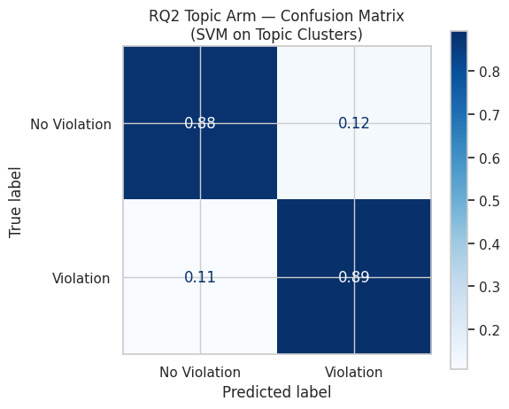
The confusion matrix for the SVM disaggregates this weighted F1 performance at the class level, revealing a pattern that the aggregate figure alone does not show. No-violation recall stands at 0.88 and violation recall at 0.89, producing a near-symmetric error structure: 12% of actual no-violation cases are misclassified as violation, and 11% of actual violation cases are misclassified as no-violation. This near-symmetry is substantively significant. In the RQ1 models trained directly on text, the class imbalance tended to suppress no-violation recall because the majority violation class dominated the learned decision boundary. Here, the 40-dimensional topic weight representation appears to distribute discriminative signal more evenly across both classes, producing balanced recall without any explicit rebalancing of the training data.

This balanced performance is likely driven by the structural properties of the topic distribution itself. The Article 41 leakage topics and the Russia-specific topics provide near-certain violation signal for a substantial portion of the corpus, anchoring the violation class firmly. The no-violation class is anchored comparably by topics such as UK Public Law & Judicial Review and Expulsion & Criminal Convictions, giving the model strong signal in both directions. The residual 11 to 12% misclassification in each direction is most plausibly attributable to the contested near-balanced topics: Child Welfare & Care Orders, Immigration & Asylum, Same-Sex & Gender Rights, and Press & Image Rights all sit close to the 50/50 outcome boundary, meaning cases clustering onto these topics carry inherently ambiguous signals that the SVM cannot resolve from topic weights alone. The same structural leakage caveat applies, a proportion of the violation-side discrimination is driven by leakage-contaminated topics, and the true balanced performance after paragraph-level cleaning would likely be somewhat lower, though the direction of the class symmetry finding is expected to hold.

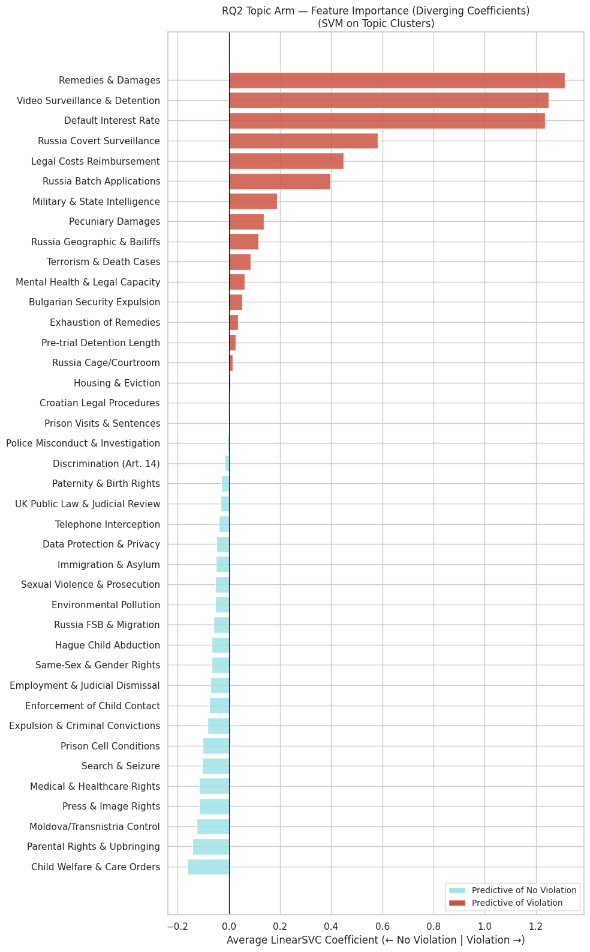

The feature importance chart reveals the SVM's decision function across the 40 topic weights and exposes several analytically important patterns.
Violation-side predictors
The three largest violation coefficients are Remedies & Damages (~1.35), Video Surveillance & Detention (~1.28), and Default Interest Rate (~1.26), followed by Legal Costs Reimbursement (~0.44) and Pecuniary Damages (~0.14). Three of the top five violation predictors, and four of the top eight, are Article 41 leakage topics. The magnitude of these coefficients, reaching 1.35 compared to a maximum no-violation coefficient magnitude of approximately 0.22, reflects how dominant the leakage signal is in the SVM's learned decision function. When a document carries a high NMF topic weight on Remedies & Damages, that weight is multiplied by a coefficient of ~1.35, producing a large positive contribution to the decision function that strongly pushes the prediction toward violation. The model is disproportionately relying on just satisfaction vocabulary to identify violation cases, which confirms at the coefficient level what the outcome distribution showed at the topic level: leakage is not a marginal issue but a structurally central feature of the classification.
Russia Covert Surveillance (~0.58) and Russia Batch Applications (~0.40) form the next tier of violation predictors, with Russia Geographic & Bailiffs and Russia Cage/Courtroom contributing smaller positive coefficients. The Russia-specific cluster therefore functions as the second strongest source of violation signal after the leakage topics, consistent with the respondent state pattern identified across RQ1 and the outcome distribution analysis.
The remaining violation predictors, including Military & State Intelligence, Terrorism & Death Cases, Mental Health & Legal Capacity, Bulgarian Security Expulsion, and Exhaustion of Remedies, all carry positive but modest coefficients. These represent substantively coherent violation signal that the model is using, but their contribution is small relative to the leakage and Russia clusters.
No-violation predictors
The strongest no-violation predictors are Child Welfare & Care Orders (~0.22) and Parental Rights & Upbringing (~0.20), followed by Moldova/Transnistria Control (~0.18), Press & Image Rights (~0.15), Medical & Healthcare Rights (~0.15), and Search & Seizure (~0.14). The child-related topics heading the no-violation side is consistent with the outcome distribution analysis, where these topics sit near the 50/50 boundary. Their assignment as no-violation predictors reflects the SVM learning that a high topic weight on child proceedings cases correlates with the state successfully defending the proportionality of its intervention.
More striking are the negative coefficients assigned to several topics that showed violation-heavy outcome distributions: Search & Seizure (0.77 violation in the distribution), Prison Cell Conditions (0.95 violation), and Telephone Interception (0.94 violation) all carry negative coefficients. This is not a contradiction but reflects the nature of SVM coefficients in a joint feature space: the model is not learning from each topic's marginal outcome distribution but from which topic weights best discriminate the two classes conditional on all other features. When the dominant violation signal has already been captured by the leakage and Russia-specific topic weights, some violation-heavy topics may provide more marginal discriminative value toward the no-violation side in the conditional space.
Near-zero coefficients
Housing & Eviction, Croatian Legal Procedures, Prison Visits & Sentences, and Police Misconduct & Investigation all show coefficients at or near zero. Despite Police Misconduct recording 100% violation in the outcome distribution, a high topic weight on this feature contributes almost nothing to the SVM's prediction, suggesting its signal is entirely subsumed by other stronger violation predictors and adds no marginal discrimination once those are accounted for.
Overall
The coefficient magnitude asymmetry, with violation predictors reaching 1.35 and no-violation predictors reaching only 0.22, is the clearest quantitative indicator of leakage contamination in the RQ2 classification. Removing the leakage topics from the feature set would collapse the top of the violation side and is expected to substantially reduce the weighted F1, revealing the true contribution of substantive legal topic signal to classification performance.

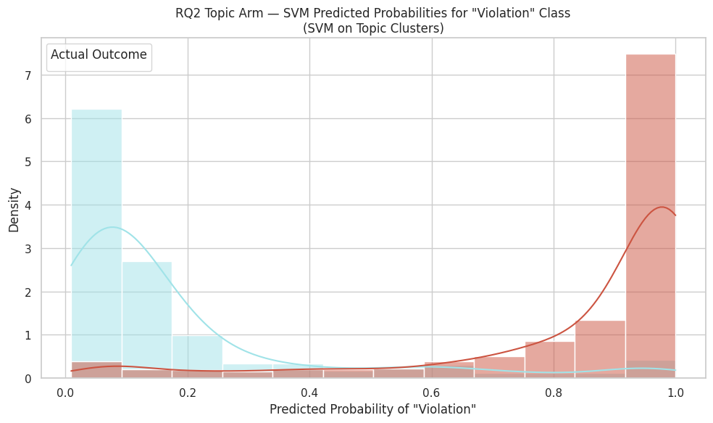
The probability distribution chart shows the predicted violation probabilities output by the LinearSVC (via CalibratedClassifierCV Platt scaling) for each actual outcome class, and reveals two analytically distinct features, strong class separation and over-sharp probability estimation.
The no-violation class (blue) concentrates sharply in the 0.0 to 0.1 range with density reaching approximately 6.2, then drops steeply and is near zero above 0.3. The model assigns very low violation probabilities to the large majority of actual no-violation cases, reflecting the clean discriminative signal provided by the high no-violation topic weights such as Child Welfare & Care Orders and Parental Rights & Upbringing identified in the coefficient analysis. The small residual tail extending to approximately 0.25 corresponds to the 12% false positive cases in the confusion matrix: no-violation cases whose topic weight profile overlaps with contested topics such as Immigration & Asylum or Same-Sex & Gender Rights, generating ambiguous signals the model cannot confidently resolve.
The violation class (red) mirrors this pattern, with mass concentrated heavily at 0.9 to 1.0 (density approximately 7.4) and a long left tail spreading through the 0.3 to 0.8 range. The spike at the extreme right is partly driven by the leakage and Russia-specific topic weights identified as the dominant violation predictors in the coefficient analysis: documents carrying high weights on Remedies & Damages or Default Interest Rate are pushed with very high confidence toward violation. The left tail represents the 11% false negative cases from the confusion matrix, corresponding to violation cases whose topic weight profiles load onto near-balanced topics and therefore receive lower predicted probabilities.
The extreme polarisation of both distributions toward 0 and 1 reflects the over-sharp probability phenomenon from Platt scaling identified in the RQ1 calibration analysis. Rather than spreading probability mass across the full range, the calibrated LinearSVC compresses predictions toward the boundaries, producing overconfident outputs. As with the RQ1 law section variants, the predicted probabilities here function more reliably as ranking scores than as calibrated estimates of outcome likelihood, and cross-entropy loss rather than accuracy would be the appropriate metric for evaluating calibration quality.
Conclusion
RQ2 set out to identify the dominant themes in Article 8 cases decided between 2010 and 2023. The NMF clustering model, configured at k=40, revealed a thematically rich and legally varied landscape. The dominant clusters span four broad areas, procedural and remedial matters (legal costs, pecuniary damages, default interest), state security and surveillance (military intelligence, covert surveillance, batch deportation applications), family and personal life disputes (child welfare and care orders, parental rights, expulsion of settled family members), and emerging rights domains (same-sex and gender recognition, data protection and retention, mental health and legal capacity).
The outcome distribution across these clusters is highly uneven and carries analytical significance. Several topics record 100% violation rates, notably all four Article 41 remedial clusters and the Russia-specific groupings. This pattern is not substantively meaningful, it reflects structural leakage, because Article 41 language on damages and costs appears only in violation judgments, and because Russia's disproportionate representation in the dataset amplifies the violation signal for any cluster that concentrates Russian cases. The feature importance analysis confirms this, the highest positive LinearSVC coefficients on the violation side belong to these leakage and Russia-specific topics, with magnitudes reaching approximately 1.35.
More interpretively interesting are the contested and near-balanced clusters. The same-sex and gender recognition topic shows a close split, which is consistent with the absence of any European consensus on same-sex family rights during this period, a doctrinal condition the Court itself acknowledged in Schalk and Kopf v. Austria (2010) when it declined to read Article 8 as imposing a positive obligation to grant legal recognition to same-sex couples. Child welfare and care orders present a different tension, while the EDA for the full dataset suggested a predominantly no-violation distribution for child welfare matters, the NMF cluster captures a more divided picture, likely because the topic weight aggregates cases at different procedural stages and across varying national child protection frameworks where the margin of appreciation operates differently. Terrorism and national security cases, and search and seizure clusters, sit in similarly contested territory, reflecting the proportionality and necessity assessments that characterise those domains and make outcome prediction structurally harder.
Using the 40 topic weights as inputs, the classification models performed well. Logistic Regression and the linear SVM both achieved weighted F1 scores of approximately 0.895, while Naive Bayes lagged at 0.797. The confusion matrix shows the models identified no-violation and violation cases at roughly equal rates, suggesting the strong performance reflects genuine predictive structure in the topics rather than the model simply defaulting to the more common violation outcome. One limitation is that the models tend to express more confidence in their predictions than the underlying legal complexity warrants, pushing most predictions toward very high or very low probability rather than reflecting the genuine uncertainty in borderline cases.
The close reading of landmark cases within three high-weight topics illustrates where the thematic representation reaches its interpretive limits. In El-Masri v. The Former Yugoslav Republic of Macedonia (2012), the military and state intelligence cluster correctly identifies a clear violation, grounded in the absolute prohibition on rendition and secret detention and the state's positive obligation to investigate. In Schalk and Kopf, the same-sex and gender cluster is associated with a no-violation outcome, yet the judgment's own reasoning is forward-looking, extending family life protection to same-sex couples while denying a positive obligation to legislate. The legal vocabulary of family life, private life, and margin of appreciation is shared with violation judgments; what differs is the Court's normative conclusion, not the doctrinal language. In Breyer v. Germany (2020), the data retention cluster again involves a no-violation finding, but only after a detailed proportionality assessment in which the double-door access mechanism was accepted as an adequate safeguard. A classifier operating on topic weights cannot distinguish the presence of safeguard vocabulary from its legal sufficiency. These cases collectively explain why residual misclassification persists even at high overall accuracy: the model captures thematic salience but cannot resolve the legal reasoning function that maps shared vocabulary onto divergent outcomes.
In answer to RQ2, the dominant themes in Article 8 cases are substantively diverse, ranging from family reunification and child protection to state surveillance, data retention, and identity rights, but the outcome-predictive signal within those themes is unevenly distributed. Leakage and respondent state concentration artificially inflate the apparent predictability of certain clusters. The genuinely contested clusters, particularly same-sex rights, child welfare, and search and seizure, reflect live doctrinal disagreements within the Court and across member states, and it is precisely in those clusters that the limits of topic-based classification are most visible.

AFTER NEW STOP WORDS IMPLEMENTED
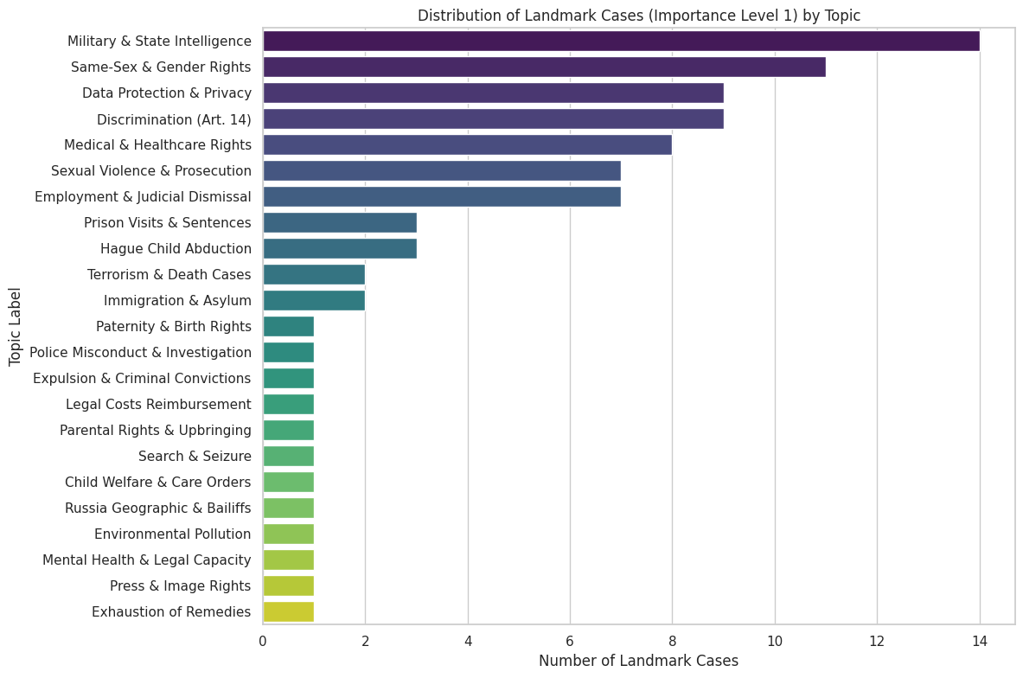

Analysis:
We identified the most representative landmark case from each of the three topics with the highest concentration of importance level 1 cases, using the highest NMF topic weight as the selection criterion. The case with the highest topic weight is the one whose text most strongly characterises that topic's vocabulary profile, making it the natural anchor for close reading to understand what legal substance the topic is capturing.
The three cases identified are:
El-Masri v. The Former Yugoslav Republic of Macedonia (App. no. 39630/09, Grand Chamber, 2012) is the most representative case in the Military & State Intelligence topic and a landmark Grand Chamber judgment on extraordinary rendition. The case concerned Khaled El-Masri, a German national of Lebanese origin who was detained by Macedonian authorities at the border, detained and prohibited from communication at a hotel in Skopje, transferred to CIA custody, and subsequently flown to Afghanistan where he was held in a secret detention facility for several months before being released without charge. The Grand Chamber found violations of Articles 3, 5, 8, and 13, making this the first time the Court explicitly condemned a European state's complicity in the CIA extraordinary rendition programme.
The Article 8 analysis operates across three dimensions. The first and most direct finding was that the interference with El-Masri's private life was not "in accordance with the law" under Article 8(2). Macedonia's detention of the applicant and his transfer to CIA custody had no basis in domestic law, and the state's invocation of national security was rejected as insufficient to override Convention rights in the absence of any accessible or foreseeable legal framework. The Court's position is that state intelligence operations cannot function as a blanket shield against Convention scrutiny, the legality requirement under Article 8(2) applies regardless of the security context, and covert conduct that cannot be grounded in domestic law fails at the first condition without the Court needing to reach proportionality.
The second dimension concerns family life. The enforced disappearance deprived El-Masri's wife and children of mutual enjoyment of each other's company for months without any knowledge of his whereabouts. The Court treated this as a separate interference with family life, distinct from the private life analysis, with private life capturing the interference with personal autonomy and identity and family life capturing the relational harm to those left behind.
The third dimension is procedural. The Court found that Macedonia failed its positive obligation under Article 8 to conduct a prompt, independent, and thorough investigation into what had happened to El-Masri. This procedural obligation arises under Article 8 itself and operates independently of the substantive unlawfulness: the failure to investigate once the events came to light was a freestanding Article 8 violation regardless of whether the original conduct was also found unlawful.
The absence of any margin of appreciation analysis is worth noting, in contrast to Schalk and Kopf (2010). Where Schalk and Kopf turned on how much discretion states retain in an area of evolving consensus, El-Masri involves conduct so severe that no balancing exercise takes place. For the classification model, this explains why the Military & State Intelligence topic is so uniformly violation-dominant in the outcome distribution, whereby cases of this nature do not sit near any decision boundary because the Court's doctrinal position removes state discretion entirely once the threshold of absolute rights violation is crossed.
One structural point remains relevant. The Article 8 findings in El-Masri are partly derivative having established violations of Articles 3 and 5, the Court held that the same conduct also unlawfully interfered with Article 8. The judgment's vocabulary driving the NMF topic weight is therefore drawn from reasoning across all violated articles rather than from Article 8 specific proportionality language, meaning the topic is anchored in the vocabulary of rendition, secret detention, and state accountability rather than the proportionality and necessity reasoning that characterises most Article 8 jurisprudence.
Schalk and Kopf v. Austria (App. no. 30141/04, 2010), the Court made a landmark doctrinal step while simultaneously finding no violation, a tension that runs through the entire judgment and has direct implications for how the Same-Sex & Gender Rights topic behaves in the classification model.
Prior to this case, the Court had consistently held that same-sex relationships fell within "private life" under Article 8 but not "family life." In paragraph 94, the Court departed from that position, holding that it would be "artificial to maintain the view that, in contrast to a different-sex couple, a same-sex couple cannot enjoy 'family life'." In reaching this conclusion, the Court drew on a line of cases including Marckx v. Belgium (1979), Keegan v. Ireland (1994), and Lebbink v. The Netherlands (2004), which had progressively established that the notion of family life is not confined to marriage-based relationships and encompasses stable de facto partnerships. The Court also referenced Article 9 of the EU Charter of Fundamental Rights, which had removed the explicit "men and women" formulation from the right to marry, treating this as evidence of evolving European standards and using it as a comparative interpretive tool.
Despite this doctrinal advance, the Court found no violation. Its reasoning in paragraphs 96 to 109 turns on the margin of appreciation doctrine, conducting a comparative survey, the Court found that only six out of forty-seven Convention states permitted same-sex marriage at the time, placing the area in the category of "evolving rights with no established consensus" where states retain the widest legislative discretion on timing and form. The three dissenting judges argued that having recognised same-sex couples as falling within family life, the Court was logically obliged to find a violation given Austria's complete absence of any legal recognition framework before 2010. The majority disagreed, treating the margin of appreciation as sufficient to absorb the doctrinal recognition without producing a remedial obligation. This illustrates a core tension in Article 8 jurisprudence, the Court can acknowledge that a fundamental right applies while simultaneously granting states significant discretion in how and when they fulfil it.
It is also worth noting that Schalk and Kopf was a First Section judgment rather than a Grand Chamber case, which gives it lower formal precedential weight than a Grand Chamber ruling despite its landmark status. The subsequent decision in Oliari and Others v. Italy (Applications nos. 18766/11 and 36030/11,2015) moved beyond it by finding a violation where Italy provided no legal framework for same-sex couple recognition whatsoever, suggesting the margin of appreciation was narrowing as European consensus developed within the dataset period. The near-balanced 55/45 no-violation split in the Same-Sex & Gender Rights topic likely reflects this trajectory, whereby earlier cases deferring to state discretion under the Schalk and Kopf margin, and later cases finding violations as consensus crystallised.
Finally, the no-violation outcome in Schalk and Kopf despite its landmark doctrinal finding offers a concrete explanation for why no-violation cases are structurally difficult to classify in the model. The judgment contains extensive Article 8 language typically associated with violation cases in the dataset, including family life, discrimination, sexual orientation, proportionality, and margin of appreciation, yet the outcome is no violation. The vocabulary of no-violation cases is not linguistically distinct from violation cases, it is the legal reasoning and doctrinal context that differs, not the words themselves. Schalk and Kopf makes this visible because the same terms appear, but their function in the judgment is to justify restraint rather than intervention, a distinction the TF-IDF and NMF representations cannot capture and which directly contributes to the residual misclassification visible in the confusion matrix.
Breyer v. Germany (App. no. 50001/12, 30 January 2020) is the most representative case in the Data Protection & Privacy topic and one of the few landmark no-violation findings in the dataset. The case concerned a legal obligation under the German Telecommunications Act requiring telecommunications providers to register all prepaid SIM card users and retain their subscriber data. The applicants argued that this compulsory storage of personal data violated Article 8, and the Court found no violation by six votes to one.
The Article 8 analysis follows the standard three-stage structure. On interference, the Court accepted that the compulsory storage of subscriber data constituted an interference with private life but characterised it as limited in nature, drawing a doctrinal distinction between basic subscriber data identifying who owns a phone and traffic or content data revealing who was contacted and what was said. This gradation of interference severity is significant: not all data retention measures engage Article 8 with equal intensity, and the Court's treatment of subscriber data as a less severe intrusion than communications content directly informed how demanding the proportionality assessment would be.
On necessity in a democratic society, the legitimate aims were national security and the prevention of crime, both falling within Article 8(2). The Court found a pressing social need for the measure and accepted that the interference was proportionate given its limited scope. Central to this assessment was whether the domestic framework contained adequate minimum safeguards against abuse. The Court treats safeguards not merely as one factor within the proportionality analysis but as a near-independent doctrinal requirement in data retention cases, asking specifically who can access the retained data, under what conditions access is permitted, whether independent oversight exists, and whether individuals have any means of challenge or notification. These structural controls are the Court's response to the inherent risk that bulk data collection regimes, even limited ones, create opportunities for misuse that proportionality alone cannot address.
In Breyer, the Court accepted the German "double-door concept" as meeting this requirement. Under this framework, subscriber data is held by private telecommunications companies rather than directly by the state, and state authorities may only access it upon request subject to specified statutory conditions. The majority found that this two-stage architecture, combined with the availability of review under general administrative law and supervision by data protection authorities, provided sufficient safeguards to prevent arbitrary interference. The dissenting judge Ranzoni rejected this conclusion, arguing that the double-door mechanism was structurally deficient because access did not require authorisation by a judicial or otherwise independent authority, and because individuals were not notified when their data was retrieved, leaving victims of unlawful access with no means of seeking review. This disagreement between majority and dissent is essentially a disagreement about what minimum safeguards require in the context of administrative data retention, and it maps directly onto the distinction between the outcome in Breyer and the violation findings in Roman Zakharov v. Russia (2015) and Big Brother Watch v. UK (2021), where the absence of independent oversight of access to intercepted data was decisive.
On the margin of appreciation, the Court articulated the calibration principle that the margin tends to be narrower where the right at stake is crucial to the individual's effective enjoyment of intimate or key rights, but wider where no consensus exists among Council of Europe member states as to the relative importance of the interest at stake or how best to protect it. In 2020, European states had not converged on a uniform approach to bulk subscriber data retention, and the Court found that Germany had not exceeded the wide margin available to it in this area.
The contrast with El-Masri is analytically instructive for understanding what the Data Protection & Privacy topic is capturing. Where El-Masri involved physical state conduct through secret detention and extraordinary rendition with no legal basis whatsoever, the interference in Breyer is entirely bureaucratic, regulated, and technological, operating within a statutory framework subject to procedural constraints and independent oversight. The NMF topic clusters Breyer-type cases together because they share a distinct lexical profile built around telecommunications, data, service provider, subscriber, and metadata vocabulary that is absent from cases like El-Masri, reflecting the emergence of digital privacy as a distinct sub-area of Article 8 jurisprudence within the dataset period.
For the classification model, Breyer illustrates the vocabulary overlap problem in its sharpest form. The judgment is dense with Article 8 language including interference, surveillance, data protection, fundamental rights, privacy, proportionality, and safeguards, yet the outcome is no violation. The same vocabulary that signals violation in Roman Zakharov and El-Masri here functions to justify why the state's administrative procedures were sufficient rather than to condemn their absence. A bag-of-words or topic weight representation cannot distinguish between these two uses of the same terms because it captures the presence of vocabulary but not the legal reasoning that determines its function in the judgment. This is a genuine limitation of the TF-IDF and NMF approaches used in this study and suggests that capturing the sentence-level legal reasoning distinguishing proportionate from disproportionate interference would require representations that encode contextual meaning rather than word frequency alone.

We try to find the most representative case on the related topics
- Same-Sex & Gender Rights : SCHALK AND KOPF v. AUSTRIA
  - see analysis below
- Military & State Intelligence : EL-MASRI v. THE FORMER YUGOSLAV
  - Summary: The case concerned Khaled El-Masri, a German national mistakenly identified as a terrorism suspect. In 2003, he was arrested by Macedonian authorities, held in a hotel for weeks, and handed over to a CIA “rendition” team. He was flown to a secret CIA black site in Afghanistan, interrogated, and tortured for months before the CIA realized their error and abandoned him on a road in Albania.
  - The Grand Chamber found severe violations of Article 3 (torture), Article 5 (liberty and security), Article 8 (private and family life), and Article 13 (right to effective remedy)
  - First, the Court made a landmark doctrinal step regarding state secrecy and the "right to the truth." This was the very first time the ECHR explicitly acknowledged and condemned a European state's complicity in the United States' CIA extraordinary rendition program. The Court rejected the state’s attempts to hide behind "national security" to justify its actions. Crucially, the Court emphasized the "right to the truth"—not just for El-Masri, but for the general public—to know about severe human rights abuses perpetrated by state intelligence apparatuses. Regarding Article 8, the Court found that the extreme nature of the secret detention completely obliterated his private and family life, establishing that state security cannot be used as a blanket shield to cover up gross illegality.
  - Second, the case anchors our “Military and State Intelligence” NMF topic and highlights the geographic bias of our dataset. The words of this case - CIA, rendition, incommunicado, interrogation, intelligence, secret, airport - represents the extreme of state overreach. Unlike the subtle social balancing in Schalk and Kopf, this case deals with unchecked state power. Because this occurred in the Former Yugoslav Republic of Macedonia (an Eastern / transitional state), it illustrates how the ECHR acted as a hard check against lingering authoritarian mechanics, or in this case, complicity in international black-ops. It explains why our model’s metadata baseline (RQ1) leans so heavily on geography. The algorithm learns that when cases from this region involve “intelligence”, the outcome is almost always a severe violation
  - Third, it provides a counter-weight to our RQ4 “margin of appreciation” analysis and explains the asymmetric predictive power of our models. In Schalk and Kopf, the "margin of appreciation" was the central battleground. In El-Masri, the margin of appreciation does not exist. There is zero state discretion when it comes to enforced disappearance and torture. For our models, the vocabulary here is unambiguously Violation-dominant. This explains the asymmetric cross-regional performance we discovered (RQ3). An algorithm trained on these Eastern European "State Intelligence" cases learns that words like surveillance, detention, and intelligence guarantee a violation. However, if we apply that same Eastern-trained model to a Western European case involving routine, court-ordered police wiretaps, the model will likely misfire and predict a violation where there isn't one. El-Masri proves that the semantic context of "state interference" is radically different across borders—shifting from brutal extrajudicial rendition in the East to bureaucratic procedural balancing in the West. The ruling established a red line - no matter how powerful intelligence agencies become and how they try to hide behind the shield of national security, international human rights courts will still demand a transparent factual accounting of what happens to a human.
- Data Protection & Privacy : BREYER v. GERMANY
  - Summary: The case concerned two German nationals who challenged the mandatory registration of prepaid mobile phone SIM cards under the German Telecommunications Act. The law required telecommunication service providers to collect and store subscribers' personal data (names, addresses, dates of birth) and make this information available to law enforcement and intelligence agencies upon request. The Court found no violation of Article 8 (right to respect for private life) or Article 10 (freedom of expression).
  - First, the Court established a critical doctrinal boundary regarding modern mass data collection while finding no violation. The ECHR acknowledged that forcing individuals to identify themselves when buying a SIM card constitutes a clear interference with their right to privacy. However, the Court ruled that the state's actions were proportionate to the "legitimate aims" of protecting national security and fighting crime. Crucially, the Court distinguished between the storage of basic subscriber data (who owns the phone) versus highly intrusive traffic or content data (who they called and what was said). Because the data collection was limited and accompanied by adequate procedural safeguards regarding who could access it, Germany was granted a wide margin of appreciation.
  - Second, this case anchors our "Data Protection and Privacy" NMF topic within the Western European cluster. The vocabulary defining this topic—telecommunications, data, service provider, subscriber, privacy, network, metadata—reflects the highly digitized, modern human rights battleground typical of Western respondent states. Contrast this with El-Masri: while El-Masri dealt with raw, physical manifestations of state power (CIA black sites, physical incommunicado detention), the "state interference" in Breyer is entirely bureaucratic, regulated, and technological. The model correctly clusters these Western cases together because they share a distinct lexical fingerprint that deals with administrative data frameworks and digital privacy rights, rather than overt physical state violence.
  - Third, the no-violation outcome perfectly illustrates the "No Violation Paradox". The judgment is packed with the same vocabulary we would expect to see in a severe surveillance violation case—interference, surveillance, data protection, fundamental rights, privacy. Yet, the outcome is "No Violation." Our models (especially Word2Vec and standard SVMs) will struggle to classify cases like this because the text is linguistically identical to violation cases. However, the underlying legal reasoning shifts. The Court uses terms like "proportionality" and "safeguards" not to condemn the state, but to justify why the state's administrative procedures were sufficient.
  - An algorithm reading the word "surveillance" in El-Masri correctly predicts a violation. But when a basic word-counting algorithm sees "surveillance" and "telecommunications" in Breyer, it blindly predicts a violation and gets it wrong. It proves that to predict Western ECHR cases, an AI must understand the sentence-level legal reasoning (BERT) of bureaucratic safeguards, not just the presence of privacy vocabulary.
The SCHALK AND KOPF v. AUSTRIA on Topic Same-Sex & Gender Rights and BREYER v. GERMANY on Topic Data Protection & Privacy are the most interesting, because not only it is the most representative case in this topic among landmark cases, but also the most representative case in this topic among all cases in this topic during 2010-2023
- Same-Sex & Gender Rights : 11 out of 31 cases(35.4%) in this topic is categorized as landmark cases
- Military & State Intelligence : 14 out of 35 cases (40%) in this topic is categorized as landmark cases
- Data Protection & Privacy : 9 out of 52 cases (17.3%) in this topic is categorized as landmark cases

OLD STOP WORDS

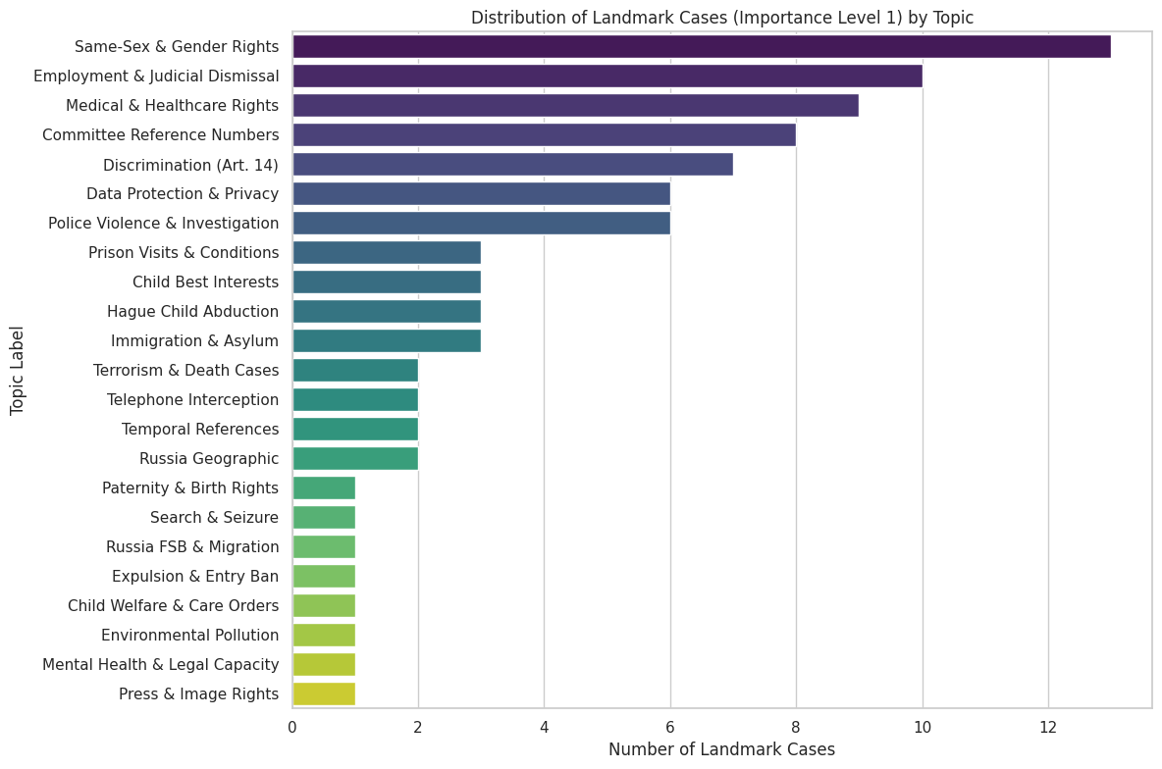

RN : We get the top 3 topic with the most landmark cases during 2010-2023
- Same-Sex & Gender Rights : 13 cases
- Employment & Judicial Dismissal : 10 cases
- Medical & Healthcare Rights 9 cases

We try to find the most representative case on the related topics
- Same-Sex & Gender Rights: SCHALK AND KOPF v. AUSTRIA
  - The SCHALK AND KOPF v. AUSTRIA on Topic Same-Sex & Gender Rights is the most interesting, because not only it is the most representative case in this topic among 13 landmark cases, but also the most representative case in this topic among all cases in this topic during 2010-2023
  - The case concerned two Austrian men who were denied the right to marry and had no legal framework for recognising their relationship until Austria's Registered Partnership Act came into force in January 2010. The Court found no violation of either Article 12 (right to marry) or Article 14 taken in conjunction with Article 8 (non-discrimination in private and family life)
  - First, the Court made a landmark doctrinal step while still finding no violation. In paragraph 94, the Court extended the concept of "family life" under Article 8 to same-sex couples for the first time — a major progressive development — yet still concluded that Austria had not violated the Convention because the state retained a wide margin of appreciation in the timing and form of legal recognition. This illustrates the tension at the heart of Article 8 jurisprudence: the Court can acknowledge that a fundamental right applies while simultaneously granting states significant discretion in how they fulfil it.
    - The three dissenting judges (Rozakis, Spielmann and Jebens) argued powerfully that having recognised same-sex relationships as "family life", the Court was logically obliged to find a violation given the absence of any legal framework before 2010 — but the majority disagreed.
  - Second, the case also exemplifies the "margin of appreciation" doctrine our RQ4 directly investigates. The Court's reasoning in paragraphs 96-109 turns almost entirely on how much discretion states retain when there is no European consensus. With only six out of forty-seven Convention states permitting same-sex marriage at the time, the Court found the area was one of "evolving rights with no established consensus" — precisely the kind of language where the margin of appreciation is widest. This is exactly the doctrinal vocabulary your Word2Vec and BERT analysis in RQ4 is probing: does the semantic neighbourhood of "margin" and "appreciation" differ between Eastern and Western European judgments? A case like Schalk and Kopf, decided against a Western European state (Austria) but finding no violation on margin of appreciation grounds, sits at the intersection of both your regional clusters — making it a useful reference point for interpreting our RQ4 semantic drift findings.
  - Third, the no-violation outcome despite the landmark doctrinal finding helps explain why No Violation cases are hard to classify. The judgment contains extensive Article 8 and Article 14 language typically associated with Violation cases in your dataset — family life, discrimination, sexual orientation, proportionality, margin of appreciation — yet the outcome is No Violation. This is a concrete example of why the NMF topic model shows every topic as Violation-dominant: the vocabulary of No Violation cases is not linguistically distinct from Violation cases, it is the legal reasoning and doctrinal context that differs. Schalk and Kopf makes this visible — the same words appear, but their function in the judgment is to justify restraint rather than intervention.
- Employment & Judicial Dismissal: OLEKSANDR VOLKOV v. UKRAINE
  - Summary: The case concerned a judge of the Supreme Court of Ukraine who was dismissed from his post for "breach of oath" following proceedings before the High Council of Justice and Parliament. The parliamentary vote was fundamentally flawed, involving widespread proxy voting (MPs using the voting cards of absent colleagues). The ECHR found multiple, severe violations of Article 6 (right to a fair trial) and Article 8 (right to respect for private life).
  - First, the case is a landmark ruling on the rule of law and the limits of state power. Under Article 8, the Court solidified the principle that the dismissal of a judge constitutes a direct interference with their "private life" because it fundamentally destabilizes their professional relationships, reputation, and inner circle. Furthermore, it was a landmark use of Article 46 (binding force and execution of judgments); the Court took the extremely rare step of explicitly ordering the state to reinstate Volkov to the Supreme Court at the earliest possible date, highlighting the severity of the systemic corruption.
  - Second, it perfectly anchors your "Eastern Cluster" in the algorithmic modeling. The vocabulary of this case—judge, dismissal, disciplinary, parliament, oath, independence—is the definitive mathematical archetype for the "Employment & Judicial Dismissal" topic. Unlike Schalk and Kopf, where the text clustered around evolving social consensus, Volkov clusters around raw state mechanics and institutional power. This validates our hypothesis about the "communist hangover" in transitional democracies: the model groups these cases together because they share a distinct lexical fingerprint of state overreach and flawed bureaucratic proceedings.
  - Third, it explains the asymmetric predictive power of Eastern European texts. In Western cases, the model struggles because the state is often granted a wide "margin of appreciation" (making outcomes a coin toss). In Eastern cases like Volkov, there is absolutely no margin of appreciation for a rigged parliamentary vote. The NLP model learns that when words related to "state disciplinary boards" or "judicial dismissal" appear in an Eastern European context, it is almost a guaranteed Violation. The algorithm is blindly detecting the systemic rule-of-law failures that plague these respondent states.
- Medical & Healthcare Rights: CASE OF R.R. v. POLAND
  - Summary: A pregnant woman whose fetus was suspected of having severe abnormalities was repeatedly denied access to timely genetic testing. Because of deliberate delays, obstruction, and doctors invoking the "conscientious objection" clause without referring her elsewhere, she passed the legal time limit to obtain a lawful abortion. The Court found violations of Article 3 (prohibition of inhuman or degrading treatment) and Article 8.
  - First, the case established a major doctrinal precedent regarding positive state obligations. The Court ruled that it is not enough for a state to simply allow abortion on paper; if the domestic law permits abortion under certain conditions (like fetal abnormality), the state has a positive obligation under Article 8 to create an effective procedural framework that allows women to actually access it. The state cannot allow a "chilling effect" where doctors block legal medical procedures through administrative delay.
  - Second, this case maps perfectly to our NMF topic modeling for reproductive and medical rights. The defining features of this topic—doctor, hospital, genetic, examination, pregnancy, time-limit, referral—represent the collision between individual autonomy and state administrative failure. Because Poland's strict, religiously influenced laws create a highly specific legal environment, this medical vocabulary becomes uniquely predictive of Article 3 and Article 8 violations in our dataset.
  - Third, it provides a crucial counter-narrative for our "Utilitarian vs. Individual" analysis. In this case, the state attempted to defend its actions by citing utilitarian and bureaucratic justifications—pointing to hospital protocols, medical caution, and the rights of the doctors. The ECHR rejected this, focusing entirely on the extreme psychological trauma inflicted on the individual (leading to the Article 3 violation). For our model, this explains why words indicating "procedural delay" and "medical bureaucracy" are highly weighted positive coefficients for predicting a Violation; they expose a pattern where states use bureaucracy as a weapon to silently strip away Article 8 rights.

RQ3: Generalisation - TF-IDF (Applying East to West & vice versa)

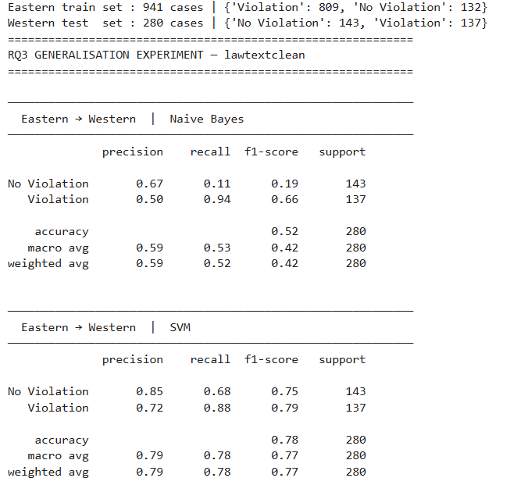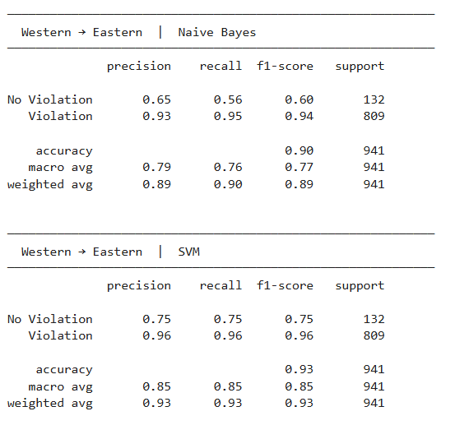
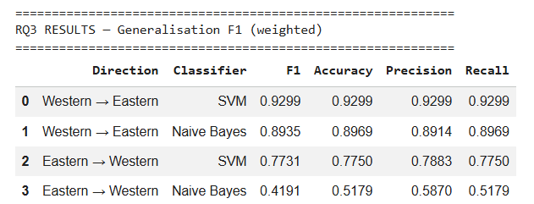

Evaluating our models requires a deliberate approach to our dataset's inherent class imbalance (982 Violations versus 283 No Violations), where raw accuracy can be a highly misleading metric of a model's goodness. As Akdemir notes in his study of US Supreme Court certiorari petitions, accuracy is an inadequate measure when dealing with severe class imbalance because a baseline "dummy classifier" that always predicts the majority class would achieve artificially high accuracy without actually learning anything. To address this, Akdemir (2023) prioritizes recall, the "completeness of retrieval", to minimize the cost of misclassifying rare, true positive observations, which in his context means avoiding false negatives. (Akdemir, E. I. (2023). Essays on law and natural language processing.)
For our Article 8 dataset, we similarly focus on non-accuracy metrics: precision (the "purity of retrieval," measuring the percentage of cases the model flagged as violations that actually were) and recall (measuring how many actual violations the model successfully caught). Since pushing recall up inherently drags precision down, we rely on the weighted F1 score as our primary evaluation metric. It provides a balanced harmonic mean of precision and recall while accounting for the dataset's imbalance. Furthermore, we selected the Linear Support Vector Machine (SVM) for this task because, while other models might offer marginally higher raw accuracy, the SVM allows us to rank features and extract interpretable weights to identify exactly which legal issues drive the Court's decisions. This approach builds upon the foundational work of Aletras et al. (2016), who demonstrated that SVMs trained on textual features (n-grams and topics) could successfully predict ECtHR decisions. However, while Aletras et al. treated the Court as a monolith, our cross-regional approach tests the robustness of these text-based predictors across jurisdictional boundaries.
Applying this metric framework, the cross-regional generalisation experiment reveals a stark asymmetry in predictive performance when models are applied across the Eastern and Western European jurisdictional divide:
- Eastern to Western Prediction: Training the SVM on the Eastern European docket (941 cases) and testing on the Western European docket (280 cases) yields a weighted F1 score of 0.7731.
- Western to Eastern Prediction: Conversely, deploying the Western-trained SVM to predict Eastern European cases results in a substantially stronger weighted F1 score of 0.9299.
This performance gap indicates that while the Western dataset contains sufficient doctrinal signal to predict Eastern outcomes effectively, the Eastern dataset fails to provide the model with the necessary features to accurately map Western jurisprudence.
This directional failure is even more pronounced when examining the Naive Bayes baseline classifier. The Eastern-trained Naive Bayes model completely collapses when applied to Western cases, plummeting to a weighted F1 score of 0.4191. A closer look at the classification report exposes the root of this collapse: the model achieves a dismal 0.11 recall for "No Violation" cases, meaning it incorrectly assumes almost every Western case is a violation. Even the more robust Eastern-trained SVM struggles with this bias, correctly identifying only 68% of actual Western "No Violation" cases while achieving an 88% recall for actual "Violations."
This asymmetric generalisation failure highlights fundamentally divergent jurisprudential landscapes between the two blocs. As established in our earlier topic clustering, Eastern European Article 8 violations are heavily characterized by severe, systemic, and physical breaches of rights, such as inadequate detention conditions or covert surveillance. The algorithm learns that state interference in these contexts almost guarantees a violation. However, Western European cases focus more heavily on nuanced administrative disputes, technological privacy, and evolving social rights, where the respondent state is frequently granted a wider "margin of appreciation." Consequently, an Eastern-trained model is structurally blind to these nuanced balancing tests and blindly over-predicts violations when encountering routine procedural language in Western cases.

Confusion Matrices for SVM Generalization
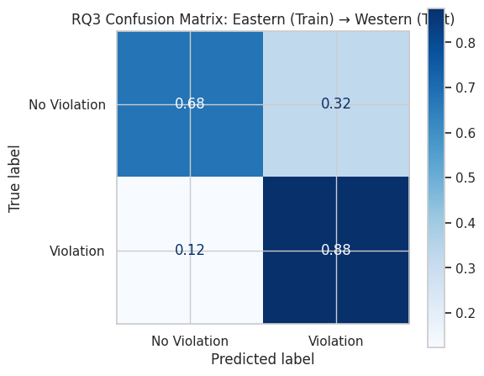
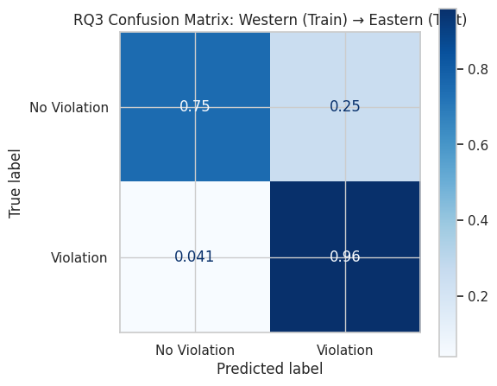

These confusion matrices visually crystallize the performance asymmetry between the two regions. When the Eastern-trained model evaluates the Western docket, its precision collapses: it misclassifies 32% of actual "No Violation" cases as "Violations." The model is structurally predisposed to assume state fault, leading to a highly inflated False Positive rate.
In sharp contrast, the Western-trained model tested on the Eastern docket exhibits remarkable stability. It correctly identifies 96% of actual Violations and 75% of No Violations, maintaining a minimal False Negative rate of just 4.1%. The Western model possesses a sufficiently robust understanding of procedural balancing to handle Eastern cases, whereas the Eastern model lacks the vocabulary to appropriately identify justified state interference in the West.

Feature Importance Charts
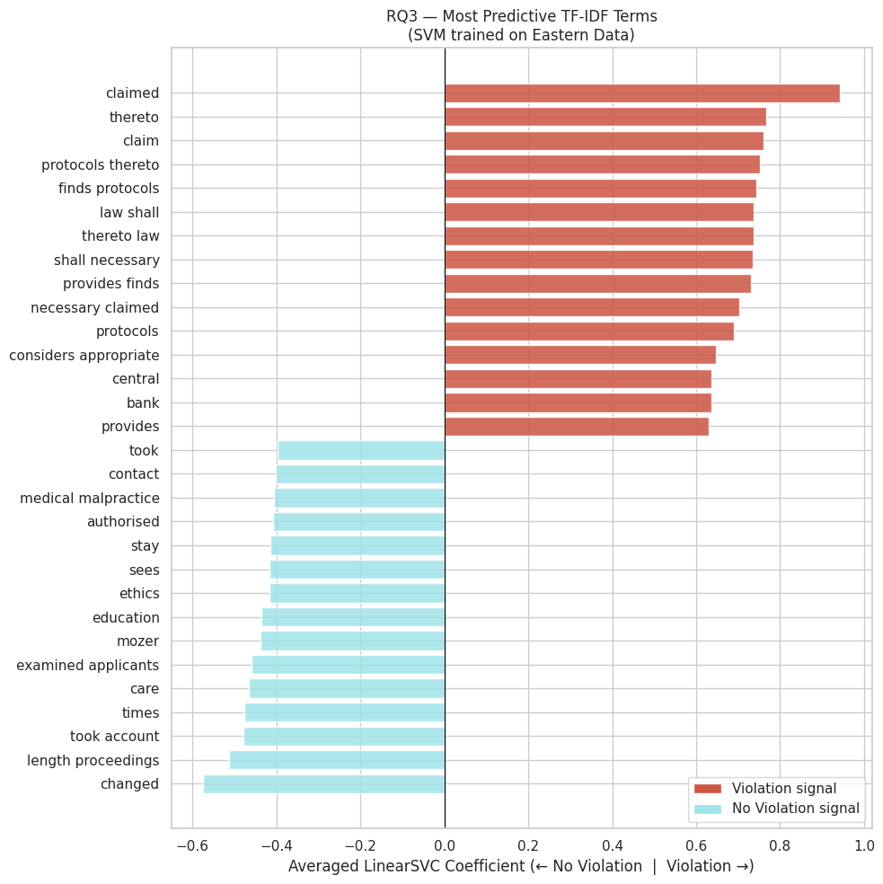
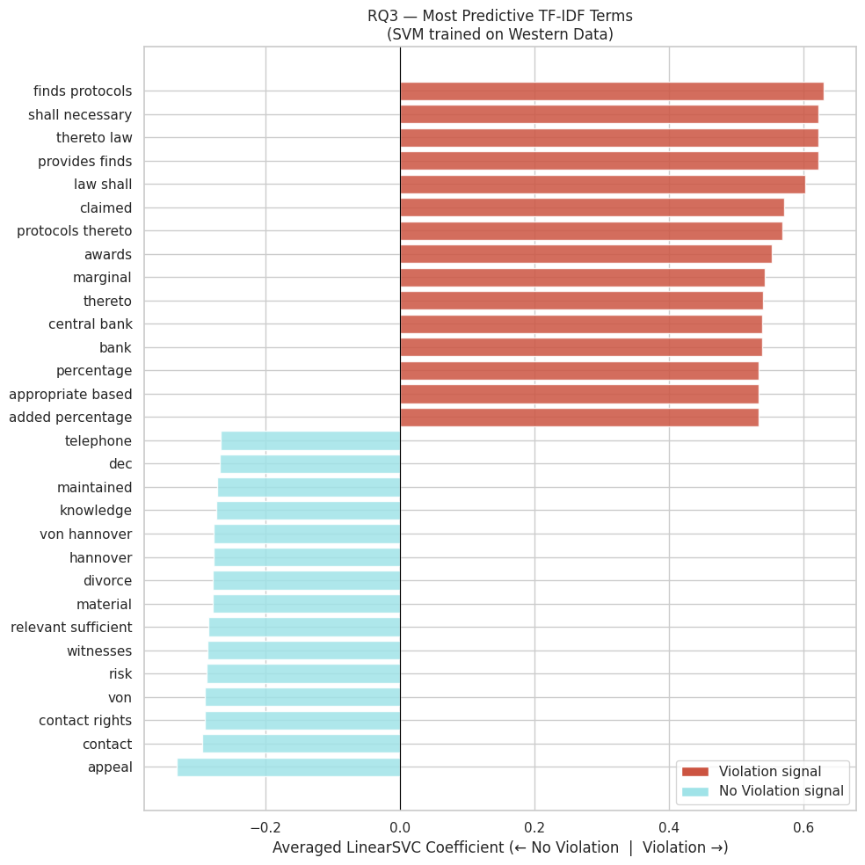

Examining the top predictive TF-IDF terms extracted from both regional SVM models exposes a critical structural limitation in the models' learning process: pervasive Article 41 "Just Satisfaction" leakage.
- The Violation Signal (Structural Contamination): In both the Eastern and Western models, the strongest signals for a "Violation" prediction are not substantive doctrinal concepts, but rather procedural boilerplate associated with remedial awards. Terms such as "claimed," "finds protocols," "thereto law," "awards," "marginal," and "central bank" overwhelmingly dominate the positive coefficients. This indicates that, despite utilizing the "Law Clean" text variant, the models artificially inflate their predictive success by detecting the structural presence of financial damage clauses rather than genuine Article 8 legal reasoning.
- The No Violation Signal (Jurisprudential Divergence): As "No Violation" cases lack remedial awards, their predictive features offer a much more honest reflection of regional legal reasoning. The Eastern model's "No Violation" signal relies heavily on procedural delays and specific factual scenarios, utilizing terms like "length proceedings," "medical malpractice," "education," and specific citations ("mozer").
- Western Balancing Tests: The Western model's "No Violation" signal, however, captures highly specific social and privacy balancing concepts. Its top predictive terms include "contact rights," "divorce," "appeal," and "von hannover", which may be referencing the Court's landmark doctrine balancing individual privacy against press freedom.
This sharp contrast in "No Violation" vocabulary mathematically confirms that the factual baselines and legal thresholds for justifying state interference differ fundamentally between Eastern and Western European courts, directly setting the stage for our misclassification analysis which we will explore in the following section.

Misclassification of specific cases

rq3_group_misclassification_analyses

The performance gap between the two regional models is best understood through a misclassification analysis, which directly illustrates how regional biases impact our precision and recall. When the Eastern-trained SVM was applied to the Western test set, it produced a high number of False Positives (46 cases) alongside False Negatives (17 cases).
We utilized Generative AI, specifically the Gemini 2.5 Flash Lite Large Language Model (LLM), to automatically diagnose the semantic and jurisprudential blind spots of our Eastern-trained SVM. Rather than manually reviewing dozens of misclassified Western cases, we programmatically extracted text snippets from the model's False Positives (15 sample case ) and False Negatives (15 sample case) and fed them into the LLM via an API. By prompting the AI to act as a legal expert in ECHR Article 8 jurisprudence, we instructed it to analyze these specific case clusters and output its findings using a strict, predefined JSON schema. This structured approach forced the LLM to identify common linguistic patterns, explain the root causes of the SVM's predictive failure, and isolate the complex Western legal features, such as nuanced proportionality tests and specific procedural vocabulary, that the algorithm systematically failed to recognize.
False Positives: The Procedural Blindspot:
The high False Positive rate severely degraded the model's precision, as it incorrectly flagged numerous actual "No Violation" cases as "Violations". This misclassification stems from a fundamental vocabulary and phrasing bias rooted in the structural differences of how these regions reason under Article 8. Eastern European cases frequently focus on direct, substantive violations of rights, leading the Eastern-trained algorithm to over-rely on specific linguistic markers tied to those direct breaches.
However, Western European jurisprudence frequently employs a much more elaborate, procedural legal lexicon. Western cases involve robust engagement with the domestic legal system as a prerequisite to Strasbourg review, requiring careful navigation of procedural pathways. These cases feature intricate discussions on the "exhaustion of domestic remedies," time limits, and specific civil claims for redress. As the Eastern model was trained on a less procedurally complex dataset, it is structurally blind to sophisticated Western legal terms like "locus standi," "judicial review," "declaration of incompatibility," and "manifestly ill-founded". When faced with this dense procedural and comparative legal language, the model incorrectly interprets the complex navigation of domestic remedies as evidence of a state violation.
False Negatives: The Proportionality and Family Life Blindspot:
Conversely, the 17 False Negative cases, where the model failed to identify actual violations, highlight a secondary blindspot regarding substantive balancing tests. These misclassified cases predominantly revolve around complex "family life" issues, such as immigration, deportation, adoption, and child welfare.
In these contexts, Western courts apply a highly explicit and granular balancing exercise between an individual's rights and the state's legitimate aims. The Eastern model fails to recognize the nuanced legal terminology used in Western proportionality and necessity tests, missing the subtle variations in how Western courts elaborate on concepts like "necessary in a democratic society" or the "protection of health or morals". Furthermore, Western cases frequently explore the evolving nature of "family life" (e.g., step-families, single parents) and recognize the positive obligations of the state, heavily invoking the "margin of appreciation" to assess the state's room for maneuver. Since these violations are framed within intricate proportionality assessments rather than explicit descriptions of state overreach, the Eastern model fails to detect them as core Article 8 infringements.
Ultimately, this asymmetric generalisation failure highlights fundamentally divergent jurisprudential landscapes. The Eastern-trained model over-relied on specific linguistic markers and reasoning patterns prevalent in its own region. The Gemini analysis further confirmed this by identifying additional evidence of procedural vocabulary gaps. Consequently, the model failed to generalize beyond its specific regional "dialect" when faced with the elaborate jurisprudential frameworks, complex proportionality assessments, and unique procedural emphases characteristic of Western European courts.

Analysis on Turkey
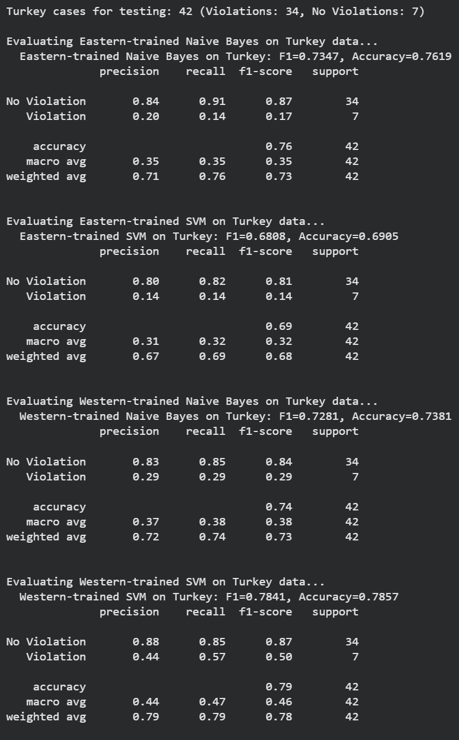
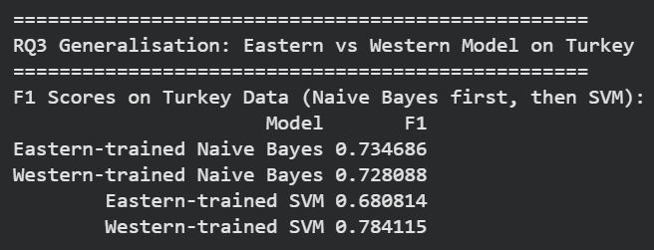

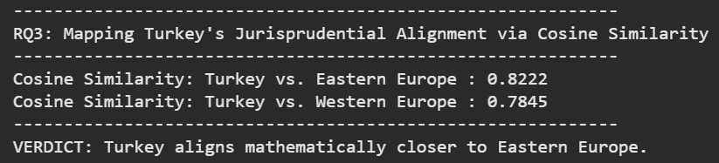

To further explore cross-regional generalisation, we isolated cases from Turkey (42 cases) as a boundary state and evaluated them against both regional models.
Mathematical Alignment vs. Predictive Success
We first sought to mathematically verify Turkey's alignment using Cosine Similarity. By calculating the TF-IDF centroid, the "average" mathematical representation of a judgment's vocabulary, we mapped the relative distances between regional clusters within our high-dimensional vector space. Turkey's semantic centroid generates a notably higher cosine similarity score when measured against Eastern Europe (0.8222) compared to Western Europe (0.7845). This indicates that the baseline factual scenarios, procedural posture, and general context of Turkish cases strongly mirror the Eastern European docket. This factual alignment with the Eastern docket reflects historical observations by scholars like Çalı (2010), who note that Turkey's human rights litigation profile at the ECtHR has traditionally mirrored the structural and systemic violation patterns seen in post-Soviet states.
However, the predictive metrics reveal a compelling paradox. Despite Turkey's factual alignment with the East, the Western-trained SVM achieved a significantly higher weighted F1 score (0.7841) on Turkish cases compared to the Eastern-trained SVM (0.6808).
Interpreting the Metrics: Precision, Recall, and the "Why"
In understanding why the Western model outperformed the Eastern model on an "Eastern-leaning" docket, we must look beyond raw accuracy and examine how the models handled the dataset's severe class imbalance (34 "Violation" cases versus 7 "No Violation" cases). As established, the true "goodness" of a model in an imbalanced setting relies on its precision and recall for the minority class.
The Eastern-trained SVM struggled severely with the minority "Violation" class, achieving a dismal recall of 0.14 and a precision of 0.14. It essentially failed to catch the actual violations (poor recall) and made highly inaccurate predictions when it did flag them (poor precision). In contrast, the Western-trained SVM demonstrated vastly superior discriminative power, improving minority class recall to 0.57 and precision to 0.44. The Western model was far better at "retrieving" the true violations without aggressively misclassifying the rest of the docket. The weighted F1 score balances these metrics, proving the Western model is structurally superior at handling this specific dataset.
The Root Cause: Generalisation vs. Overfitting
This discrepancy perfectly illustrates our hypothesis regarding training balance and model generalisation. The Eastern European dataset is overwhelmingly dominated by cases from a single country (Russia) with a near-universal violation rate. Consequently, the Eastern-trained model becomes over-fitted to Russian factual boilerplate and systemic structural failures. It learns to memorize country-specific facts and assumes state interference automatically equals a violation.
Conversely, the Western dataset, while smaller, is geographically diverse and exhibits more balanced distribution of outcomes. This balanced training environment forces the Western-trained model to learn more applicable, generalized legal reasoning. To succeed on its own training data, the Western model had to learn the actual doctrinal boundaries of proportionality and the "margin of appreciation" rather than relying on factual shortcuts.
Ultimately, Turkey acts as a jurisprudential bridge. While its factual vocabulary is distinctly Eastern, the specific doctrinal language that separates a justified state action from a human rights violation requires the generalized legal learning that only the Western-trained model possesses.

Topic-based SVMs and Feature Importance for Eastern Europe and Western Europe (with k=20)

NMF and Top 15 words for each topic:
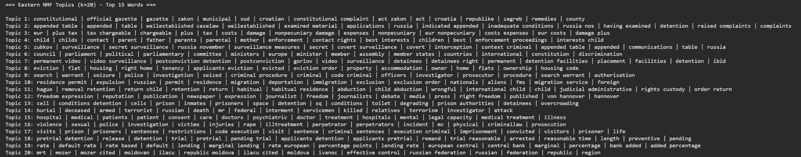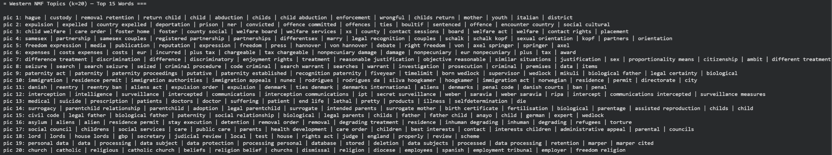

In order for us to better understand the semantic divergence between the regions, we applied Non-Negative Matrix Factorization (NMF) to extract latent legal topics from the text. A recognized limitation of NMF is hyperparameter rigidity, specifically, the requirement to pre-define the number of topics (k). We deliberately constrained the model to exactly 20 topics (k=20) for both the Eastern and Western corpora. While the "true" optimal number of legal themes might organically differ between the two regions, forcing k=20 is a necessary stabilizing mechanism given the smaller, partitioned regional datasets. This threshold provides enough granularity to capture substantive legal doctrines while preventing "topic splintering", where coherent concepts break into noisy, meaningless fragments, and avoiding the high dimensionality that would cause the subsequent SVM to overfit the training data.

An analysis of the top 15 words per topic confirms that k=20 successfully extracts highly distinct, interpretable legal themes that highlight the fundamental differences between the dockets. The Eastern topics are heavily dominated by vocabulary reflecting physical state overreach and systemic infrastructural failures (e.g., "appended table/inadequate conditions," "secret surveillance/zubkov," "cell/overcrowding," and "armed/terrorist/killed"). In contrast, the Western topics reveal a jurisprudence centered on administrative, technological, and evolving social rights (e.g., "samesex/partnership," "freedom expression/von hannover," "personal data/marper," and "surrogacy"). This confirms that the baseline factual matrix of what constitutes a human rights dispute differs fundamentally depending on the region.

Confusion Matrix Analysis
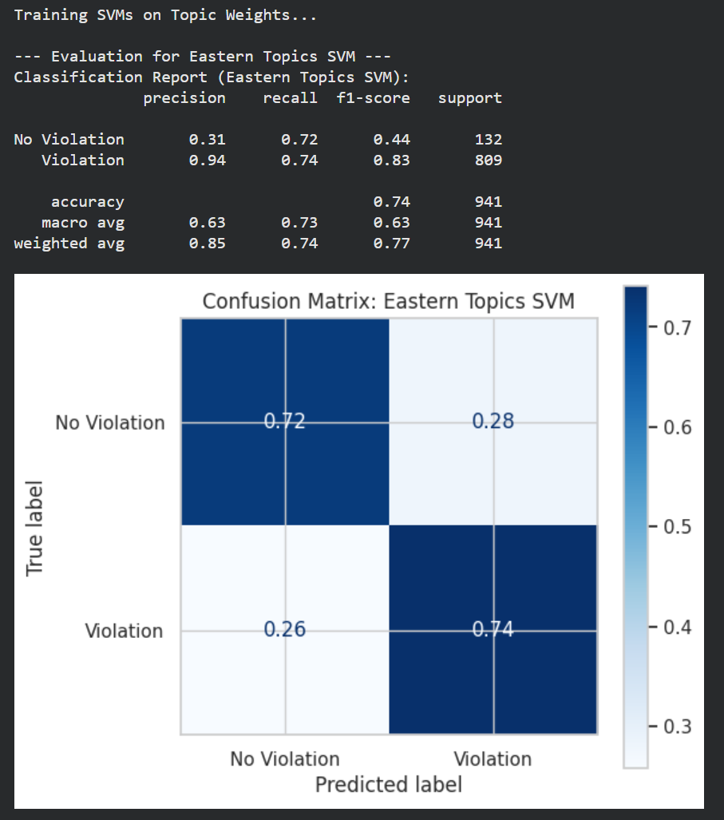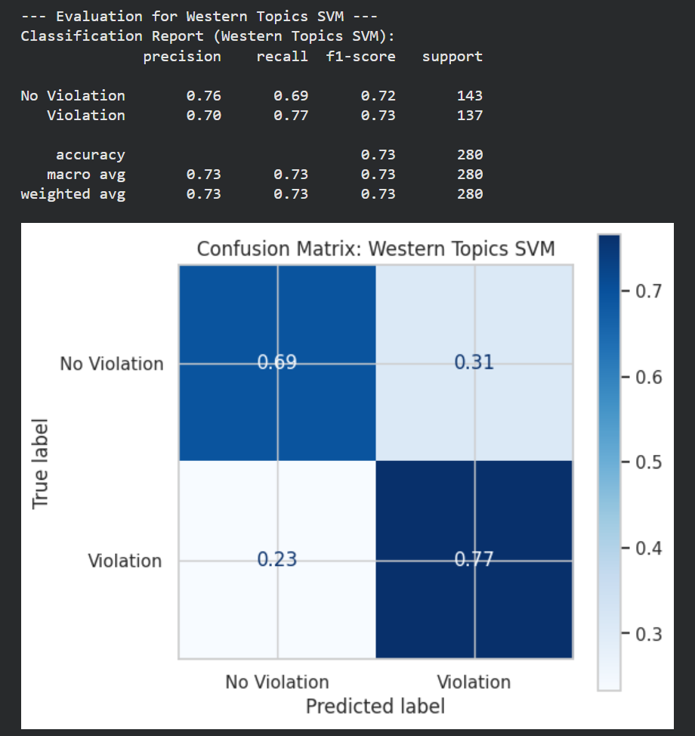

In addition, we trained separate Linear SVMs on the topic weights for each region, to help us determine if these 20 thematic topics are sufficient to train a predictive model. The confusion matrices demonstrate that these 20 topics provide a remarkably robust training signal when the models are evaluated on their native jurisprudence.

Despite the severe class imbalance inherent to the dataset, the Eastern Topics SVM correctly classifies 74% of actual violations and 72% of actual "No Violations". Similarly, the Western Topics SVM successfully identifies 77% of actual violations and 69% of actual "No Violations". The fact that both models maintain strong diagonal performance and avoid collapsing into majority-class prediction proves that the 20 extracted topics effectively capture the critical decision boundaries needed to predict outcomes within their specific regional contexts.

Feature Importance and Topic Weights Analysis
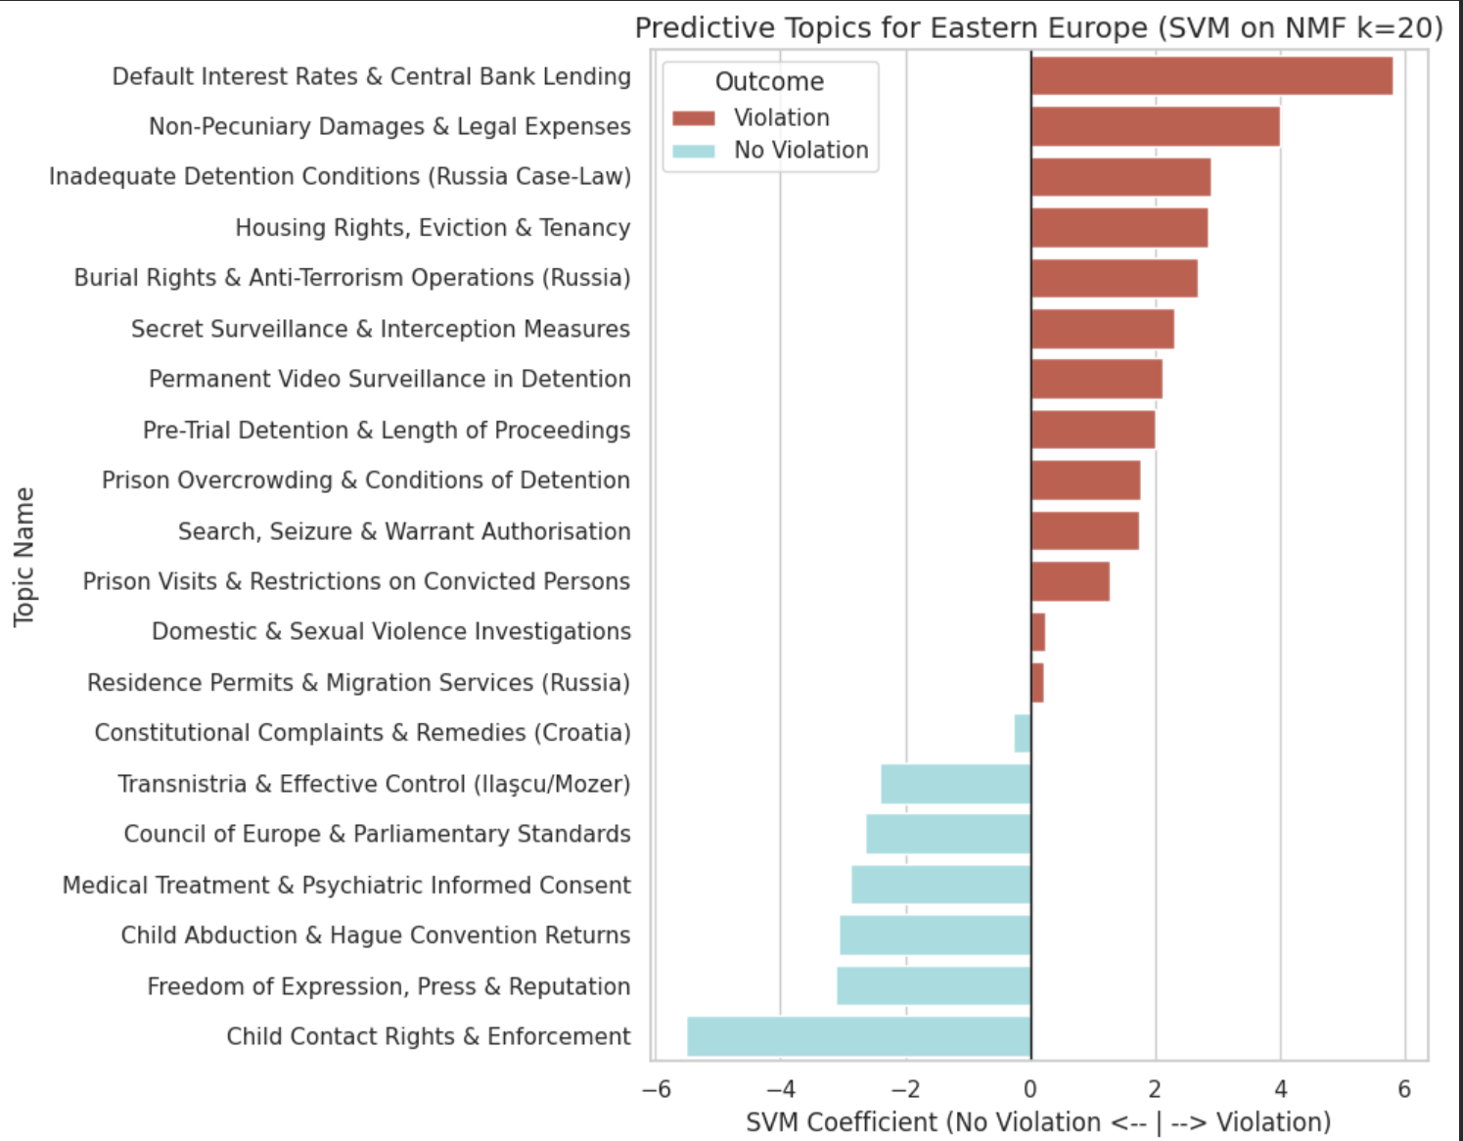
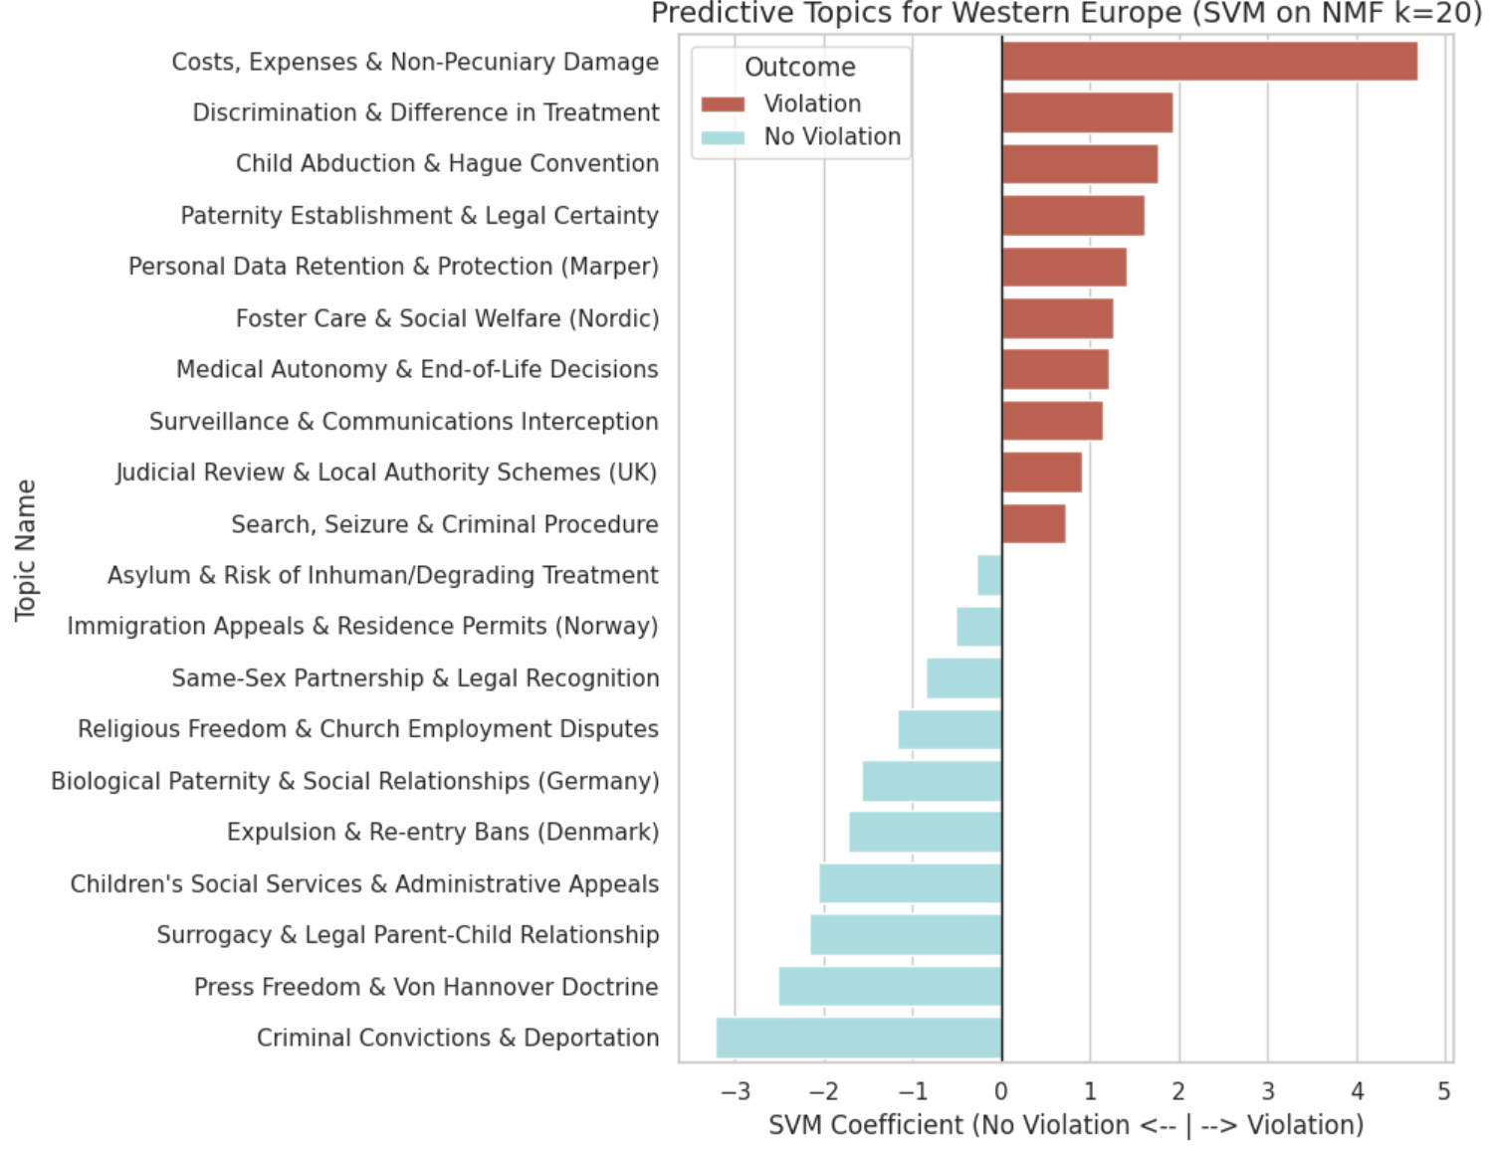
To understand the semantic divergence between Eastern and Western European ECHR Article 8 cases, we trained separate Linear SVM classifiers on the 20 NMF-generated topic features for each region. The resulting feature importance charts measured by the SVM coefficients reveal stark differences in the types of cases that drive "Violation" versus "No Violation" findings in each bloc.
Setting aside this structural artifact, the substantive predictive topics clearly illustrate the diverging jurisprudential landscapes:
Eastern Europe: Systemic Failures vs. Family Disputes
The Eastern European model reveals a jurisprudence heavily weighted by structural and physical state interference.
- Predictive of Violation: Setting aside the dominant outcome-leakage topic ("eur, plus tax"), the Eastern violation topics are characterized by severe, systemic, and physical breaches of rights. The most predictive topics include Russian batch applications and boilerplate ("appended table"), state surveillance ("zubkov, secret surveillance"), extreme prison conditions ("cell, conditions detention", "permanent video"), police overreach ("search, warrant, police, seizure"), and lethal state action ("burial, deceased, armed, terrorist").
- Predictive of No Violation: The strongest predictors for a "No Violation" in the East center on private family matters. Topics like "child, contact, parent" and "hague, removal retention" indicate that when Eastern states adjudicate child custody or family contact disputes, the ECtHR frequently finds that the domestic authorities operated within their margin of appreciation.
Western Europe: Nuanced Rights vs. Migration Margin
The Western European model maps a vastly different legal landscape, focused more on administrative, technological, and evolving social rights.
- Predictive of Violation: Again, ignoring the outcome-leakage topic ("expenses, costs"), the Western violation topics are highly administrative and specific. They include "data protection, processing, personal data," "paternity act, putative," and "difference treatment, discrimination." Interestingly, "hague, custody, removal retention" is a strong violation predictor in the West, directly contrasting with the East where it reliably predicted No Violation.
- Predictive of No Violation: The Western model's non-violation boundary is defined almost entirely by areas where the Court grants states a wide margin of appreciation. The strongest predictors include migration and deportation ("expulsion, expelled, deportation", "asylum, aliens, residence permit", "danish, reentry ban"), as well as evolving social issues lacking a European consensus, such as "samesex, partnership" and "surrogacy, adoption".
While the Topic-Based SVM provides a highly interpretable mechanism for mapping the jurisprudential divide between Eastern and Western Europe, it is imperative to acknowledge the methodological limitations inherent to this approach. Addressing these constraints is essential for preserving the construct validity of our findings and ensuring we do not conflate mathematical artefacts with genuine legal inference. By transparently defining where the NMF and SVM architecture falls short, we can accurately contextualize our predictive metrics, avoid overstating the model's capacity for substantive legal reasoning, and establish a rigorous theoretical foundation for the deep semantic analysis that follows. While NMF clustering provides excellent interpretability and successfully exposes these regional differences, this specific application is constrained by three distinct limitations:
- The "Just Satisfaction" Outcome Leakage: As established in our RQ1 and RQ2 analyses, the same structural caveat regarding Article 41 heavily applies here. In the feature importance charts, the absolute strongest predictors of a Violation are topics dominated by financial remedy boilerplate rather than substantive law. This directly corroborates the findings of Medvedeva et al. (2020), who warned that ECtHR predictive models often suffer from "future leakage." As the Court drafts its judgments retroactively, algorithms easily learn to identify the structural presence of Article 41 damages rather than the substantive legal arguments that led to them. For the Eastern model, the top predictor is "Default Interest Rates & Central Bank Lending," followed closely by "Non-Pecuniary Damages & Legal Expenses." For the Western model, the strongest predictor is "Costs, Expenses & Non-Pecuniary Damage." As noted for RQ2, leakage topics like Default Interest Rate, Legal Costs Reimbursement, Pecuniary Damages, and Remedies & Damages carry a 100% violation signal and function as near-perfect violation predictors in the topic weight feature matrix. Therefore, a proportion of the models' predictive success is attributable to these leakage-contaminated features rather than genuine legal thematic discrimination. Again to reiterate, this leakage can be mitigated by explicitly excising all 'just satisfaction' paragraphs before feeding the corpus into the NMF model. Taking this preprocessing step is essential to ensure that our predictive metrics reflect genuine jurisprudential themes rather than superficial formatting artifacts.
- Hyperparameter Rigidity (k=20): We constrained the NMF algorithm to find exactly 20 topics for both the East and the West. While the true "optimal" number of legal themes likely differs between regions, this hyperparameter adjustment is necessary due to the reduced size of the partitioned regional corpora. Maintaining a higher $k$ on these smaller subsets would risk "topic splintering" and introduce high dimensionality, causing the subsequent Linear SVM to overfit the training data. Forcing $k=20$ provides an optimal balance, ensuring the extracted features represent dense, substantive legal doctrines rather than mathematical noise, even if it risks minor "topic collapsing" (mashing distinct concepts into one).
- Static Word Representation: NMF is essentially a sophisticated "bag-of-words" approach. It groups words that frequently co-occur, but it does not understand context or syntax. For example, the word "child" appears in both violation and non-violation topics, but NMF cannot tell us how the word is being used. To truly understand how the Court's reasoning changes, for instance, how the exact phrase "margin of appreciation" is applied differently in the East versus the West, we must move beyond static topic distributions and examine the semantic neighborhoods of the words themselves.
This final limitation directly necessitates the use of neural word embeddings, which we will explore in RQ4 using Word2Vec.

Alternative to Pycaret: Comparing models on NMF Topic Features (to justify use of SVM above)
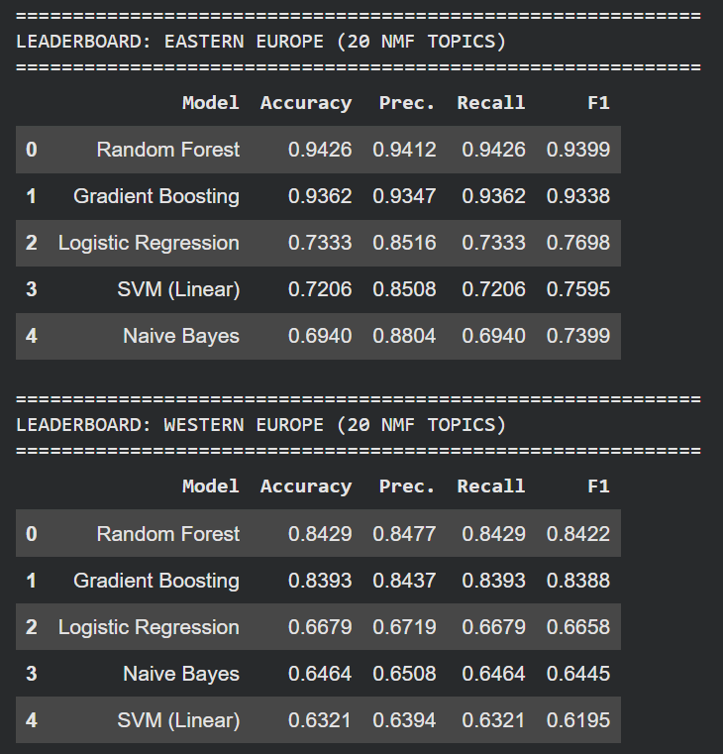

As we look to evaluate the predictive power of our 20 NMF topics, we utilized a multi-model cross-validation approach. Due to PyCaret's strict dependency limitations with Google Colab's native Python 3.12 environment, we engineered a custom Scikit-Learn evaluation pipeline to replicate the ‘compare_models’ technique, testing our topic features against five distinct algorithmic baselines.
The leaderboard revealed a substantial performance gap: non-linear ensemble methods like Random Forest dominated the task, achieving a weighted F1 score of 0.9399 in the East and 0.8422 in the West. These ensemble methods significantly outperformed linear models like the SVM, which achieved F1 scores of 0.7595 in the East and 0.6195 in the West.
This performance disparity indicates that the relationship between legal topics and ECtHR outcomes is highly non-linear. The Court likely bases its decisions on complex intersections of multiple topics rather than isolated thematic features. However, while Random Forest excels predictively, it functions as a "black box," making it mathematically difficult to extract directional relationships between topics and legal outcomes.
As our primary objective is interpretability, specifically identifying which regional themes drive the Court toward a "Violation" versus a "No Violation", we deliberately utilized the Linear SVM to generate our feature importance visualizations. Trading raw predictive performance for transparency and being able to see what the algorithm is thinking, allows us to extract clear, directional coefficients that map the distinct jurisprudential priorities of the Eastern and Western blocs.

References:
Akdemir, I. (2023). Essays on Law and Natural Language Processing.
Aletras, N., Tsarapatsanis, D., Preoţiuc-Pietro, D., & Lampos, V. (2016). Predicting judicial decisions of the European Court of Human Rights: a Natural Language Processing perspective. PeerJ Computer Science, 2, e93.
Çalı, B. (2010). The Logics of Supranational Human Rights Litigation, Official Acknowledgment, and Resolving the Problem of Structural Human Rights Violations. Law & Social Inquiry, 35(2), 311-337.
Medvedeva, M., Vols, M., & Wieling, M. (2020). Using machine learning to predict decisions of the European Court of Human Rights. Artificial Intelligence and Law, 28(2), 237-266.

Conclusion
The cross-regional generalisation experiment reveals a pronounced and asymmetric answer to RQ3. A model trained on Western European cases generalises strongly to the Eastern corpus, achieving a macro F1 of 0.85, while a model trained on Eastern European cases generalises substantially less well to the Western corpus, achieving a macro F1 of 0.77.
The confusion matrices clarify what drives this asymmetry. The Eastern-trained model applied to Western cases achieves a recall of 0.88 for actual violations but only 0.68 for actual no-violation cases, meaning it misclassifies 32% of genuine no-violation outcomes as violations. The model is structurally predisposed to predict state fault regardless of whether Western legal reasoning supports that conclusion. The Western-trained model applied to Eastern cases suffers no comparable collapse, correctly identifying 96% of violations and 75% of no-violation cases. The failure is therefore directional, the Eastern model lacks the vocabulary to recognise justified state interference in Western cases, while the Western model possesses sufficient generalised legal reasoning to handle Eastern cases adequately.
The feature importance analysis identifies two explanations for this pattern. The first is structural, both models are partially contaminated by Article 41 leakage, with the strongest violation-side predictors in both the Eastern and Western classifiers being remedial boilerplate terms such as "claimed", "finds protocols", "thereto law" and "awards" rather than substantive legal reasoning vocabulary. This inflates both models' apparent performance and means that a portion of the predictive signal in each direction reflects the presence or absence of just satisfaction language rather than genuine doctrinal discrimination. The second explanation is respondent state concentration. The Eastern corpus is dominated by Russian cases carrying near-universal violation rates, causing the Eastern-trained model to learn country-specific factual patterns rather than transferable legal principles. When faced with Western cases that involve complex proportionality assessments and elaborate domestic remedy procedures, the Eastern model misreads procedural complexity as evidence of violation.
The no-violation feature vocabulary makes this divergence concrete. The Eastern model's strongest no-violation predictors are procedural delay terms and specific factual scenarios, including "length proceedings", "medical malpractice" and "education" as well as a named-case citation ("mozer"). The Western model's no-violation signal is anchored in substantive social rights and privacy balancing concepts, including "contact rights", "divorce", "appeal”. These are not interchangeable legal vocabularies. A classifier trained on the Eastern signal has no basis for recognising Western proportionality reasoning as a no-violation marker.
The Turkey analysis strengthens this interpretation. Turkey's TF-IDF centroid is factually closer to the Eastern corpus, with a cosine similarity of 0.8222 against 0.7845 for the Western corpus, yet the Western-trained model outperforms the Eastern-trained model on Turkish cases, achieving Macro F1 of 0.45 against 0.31. Turkey acts as a jurisprudential boundary state: its cases share the factual vocabulary of Eastern European litigation but require the doctrinal balancing analysis that the Western model has learned to apply. The Eastern model's failure on Turkish cases despite their factual alignment with Eastern docket patterns confirms that the generalisation gap is not primarily a factual vocabulary problem but a legal reasoning problem rooted in Russia-specific overfitting.
In answer to RQ3, the generalisation capacity of Article 8 classifiers is asymmetric and corpus-dependent. Western-trained models generalise effectively to Eastern cases because they have learned a more broadly applicable doctrinal framework. Eastern-trained models fail to generalise to Western cases because they have learned a regionally specific pattern of state interference that does not transfer to the proportionality-centred reasoning characteristic of Western jurisprudence. A genuinely portable Article 8 classifier would require a balanced, geographically diverse training corpus with Article 41 text removed prior to feature extraction.

RQ4: Do Eastern and Western European Courts Use Key Legal Concepts Differently?
In RQ3, we found that a model trained on Russian/Eastern cases generalises poorly to Western European cases. RQ4 asks the natural follow-up question: why?
Our hypothesis is that the gap is not only about which topics appear across regions, but also about how the same legal concepts are used in practice. Terms like “margin of appreciation” and “proportionality” appear in nearly every Article 8 judgment, regardless of outcome or country, but that does not necessarily mean they carry the same legal meaning in each regional context. For example, when an Eastern European court invokes “proportionality,” it may do so in a different doctrinal setting than a Western European court. Our hypothesis are : If these core concepts carry different semantic weight across regions, that would help explain why a classifier trained on one region struggles to generalise to the other.
To examine this, we move beyond bag-of-words methods such as NMF and use Word2Vec. Although Word2Vec is still a static embedding model, it captures local semantic and syntactic relationships by placing words in a high-dimensional semantic space. By training separate Word2Vec models on the Eastern and Western corpora, we can compare the semantic neighborhoods of key doctrinal terms such as “margin,” “private_life,” and “family_life.” This gives us a vocabulary-level picture of semantic drift across the full text of judgments, and it provides a useful final layer for understanding the cross-regional generalisation gap identified in this study.
A more advanced next step would be to use BERT, since contextualized models can capture meaning more accurately in legal text and are especially well suited to ECHR analysis, including pretrained models developed specifically on ECHR cases. However, we do not pursue that route here because of limited GPU access. Still, if resources allow, BERT would be an interesting option for follow-up work or future improvement of this study.
Normalized dL and dG score
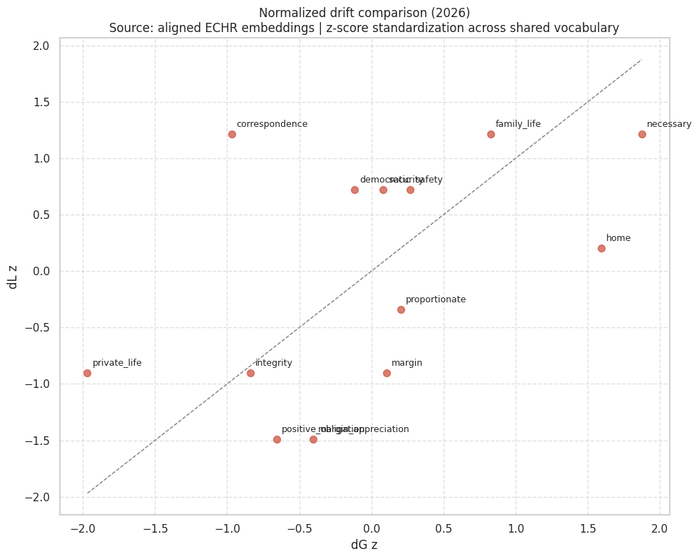
The normalized drift chart suggests that necessary, home, family_life, and correspondence are the clearest drift terms, while private_life, integrity, margin, and margin_appreciation are relatively more stable. This means some concepts shift mainly in their regional context, but the core doctrinal terms still remain semantically recognizable across both corpora
Based on these findings, we recognize that the model exhibits low instability; consequently, the analysis should avoid over-reliance on the specific numerical ranking of drift magnitudes. However, we have identified evidence of systematic semantic drift across several key terms. While further claims regarding judicial bias between Eastern and Western corpora would require more extensive datasets and a broader range of terms for observation, the present data confirms significant divergence in regional usage.

PCA Chart for Eastern vs Western
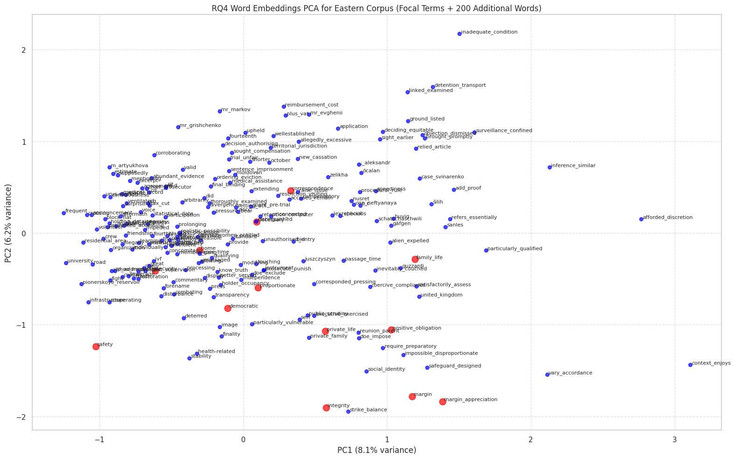
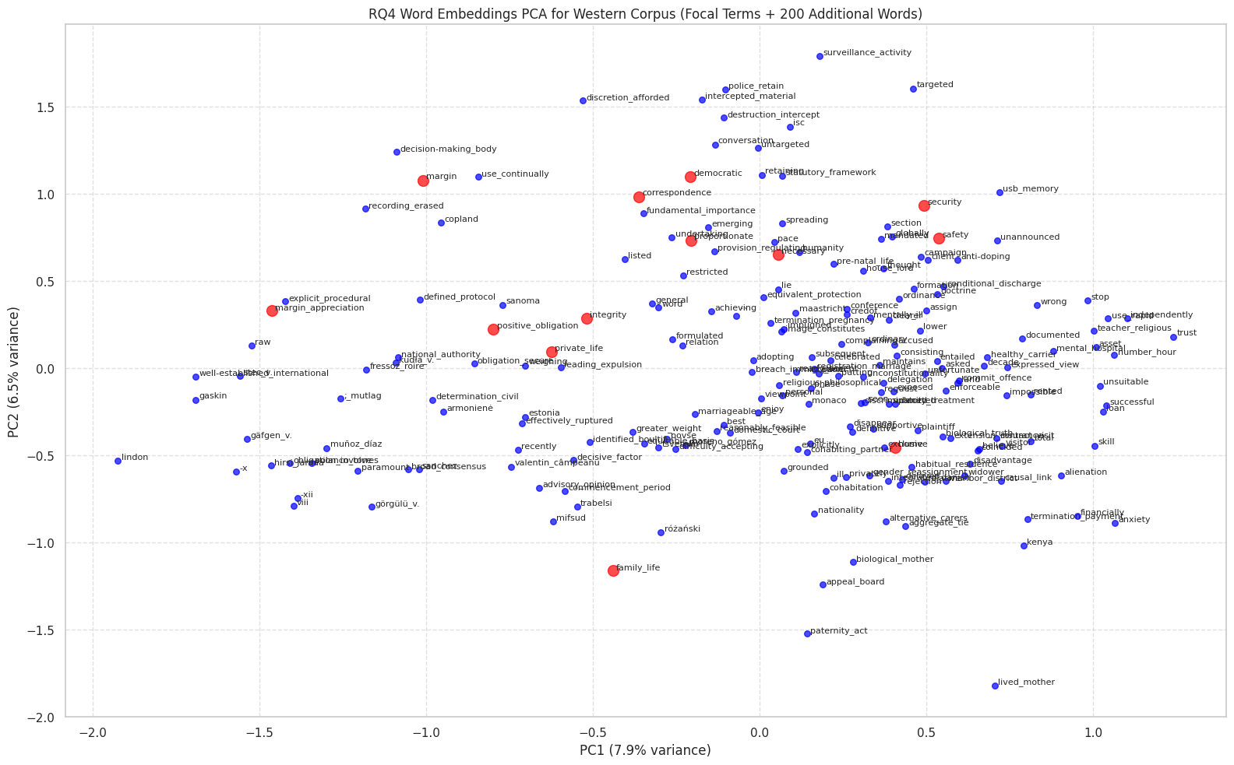
The PCA plots show a shared Article 8 semantic core, but the surrounding clusters differ across Eastern and Western corpora. In particular, margin and margin_appreciation remain close in both corpora, yet Western usage is more tied to balancing and proportionality, while Eastern usage is more linked to discretion and contextual variation. PCA also shows that necessary, home, family_life, and correspondence occupy more separated regions, which supports the idea of issue-specific semantic specialization rather than one uniform Article 8 space.

t-SNE visualization - MARGIN
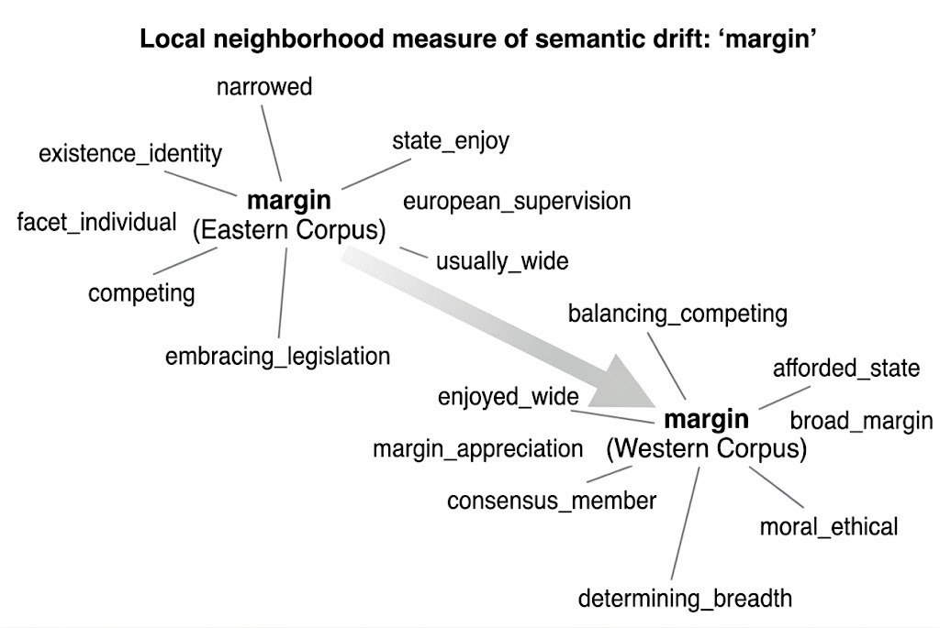

the Western corpus places it near balancing and proportionality language, while the Eastern corpus surrounds it with discretion, flexibility, and contextual-variation terms, suggesting a more state-deferential framing in the East

t-SNE visualization - NECESSARY
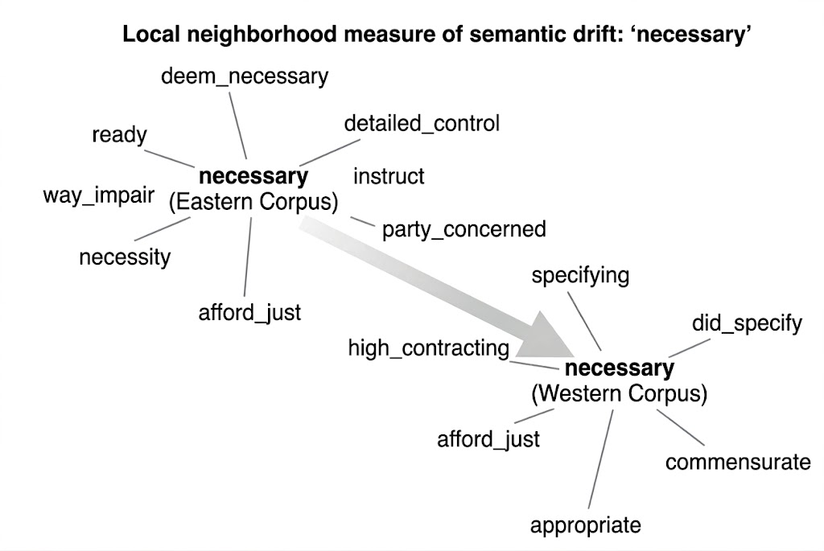
Western neighbors point to formal necessity testing and adequacy, while Eastern neighbors point to control, justification, and case-based reasoning, which indicates different legal uses of the same concept

t-SNE visualization - FAMILY LIFE
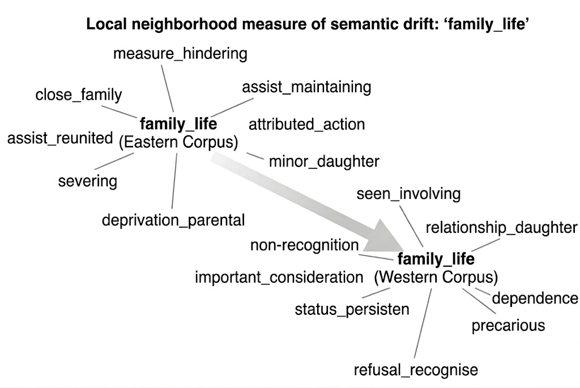
the Western neighborhood is dominated by immigration, recognition, residence, and dependency language, whereas the Eastern neighborhood is centered on family reunion, parental deprivation, and close-family relations. This supports the view that family-life disputes are framed through different factual pathways in the two corpora, with Western cases leaning more toward status and residence issues and Eastern cases leaning more toward family separation and reunification.

t-SNE visualization - HOME
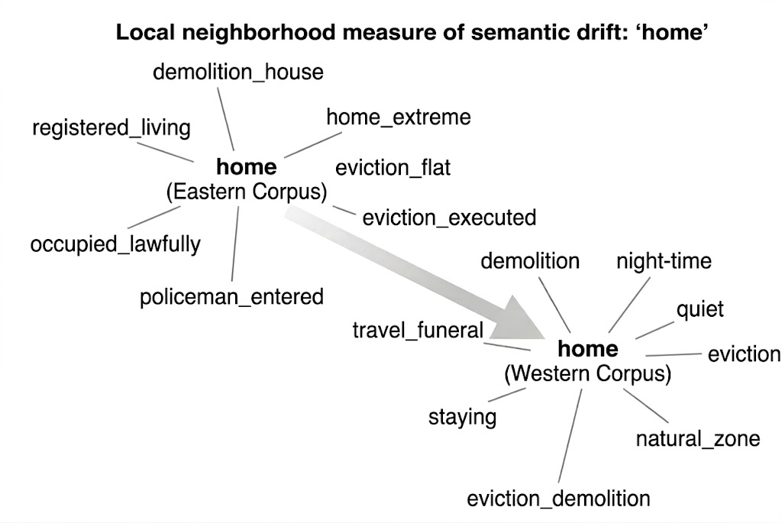
The Western plot shows more associated with eviction, demolition, dwelling, and quiet enjoyment, while the Eastern plot is more centered on house/flat occupation, eviction execution, and lawful occupancy. This suggests that Western usage frames “home” more as a protected private-space concept, whereas Eastern usage is more tied to concrete eviction and housing disputes.

Comments from Prof office hours:
- word2vec - remove the green ones. Bert is giving you entire vector representations (things talking about similar things) - talk about margin of appreciation and how it’s diff for east and west if it’s meaningful
  - can look at Hamilton Jurafsky paper on cultural or linguistic shift - you have two diff models - east and west and margin of appreciation appears with what kind of words for east vs west (no need to show time shift) - shows semantic change and what do they mean
- Do we still want to explore CLS from Lab 9 if we’re not doing Bert (CLS is related to Bert)?

Conclusion:
RQ4 asked whether the semantic representation of key Article 8 doctrinal concepts differs systematically between the Eastern and Western corpora, and whether any such drift accounts for the generalisation failure identified in RQ3. The Word2Vec analysis provides a qualified affirmative answer to both parts of the question, though the strength of the conclusion is bounded by the limitations of static embedding models trained on partitioned and imbalanced datasets.
On the first question, the evidence supports the existence of systematic semantic drift in a subset of core doctrinal terms. The normalised drift analysis identifies "necessary," "home," "family life," and "correspondence" as the terms with the clearest regional divergence, while "margin," "margin of appreciation," "private life," and "integrity" are comparatively stable as a shared semantic core. The stability of the margin of appreciation terms at the surface level is, however, deceptive. The t-SNE neighbourhood visualisations reveal that although "margin" occupies a similar position in both corpora, its semantic neighbourhood differs substantially, while Western usage is anchored to balancing and proportionality language, Eastern usage is surrounded by discretion, flexibility, and contextual variation vocabulary. The same surface term is therefore embedded in a different doctrinal operation depending on the regional corpus. A parallel divergence is visible for "necessary," where the Western corpus operationalises the concept through formal adequacy testing and commensurateness, while the Eastern corpus frames it through control, factual justification, and case-by-case reasoning. For "family life" and "home," the divergence is less about doctrinal operation and more about the factual pathways through which the protected interest is engaged: Western cases consistently invoke questions of legal status, recognition, and quiet enjoyment, while Eastern cases centre on physical separation, direct interference, and concrete occupancy disputes.
On the second question, the semantic drift findings offer a partial but meaningful explanation for the generalisation failure. The RQ3 cross-regional experiment showed that the Eastern-trained model collapsed when applied to Western cases, generating a high false positive rate by treating Western procedural complexity as evidence of violation. The t-SNE results suggest why: the Eastern model learns that "necessary," "margin," and related terms function as markers of state overreach and factual control, because that is the doctrinal logic in which those terms appear in the Eastern corpus. When the same terms appear in Western cases embedded in a proportionality balancing framework, the model misreads the vocabulary as carrying the Eastern meaning. The semantic neighbourhood of the concept, not just the concept itself, is what the classifier is implicitly learning, and that neighbourhood does not transfer.
This account is consistent with but does not fully exhaust the explanation for the generalisation gap. The RQ3 analysis also identified Russia-specific overfitting as a structural driver: the Eastern corpus is so heavily concentrated on Russian cases with near-universal violation rates that the model acquires country-specific factual boilerplate rather than generalisable legal reasoning patterns. Semantic drift and respondent state concentration are therefore complementary explanations rather than competing ones. The drift analysis explains why the model fails at the level of doctrinal language; the overfitting analysis explains why the training signal was distorted in the first place.
The appropriate conclusion is that there is meaningful evidence of systematic semantic drift in the use of key Article 8 concepts across the two regional corpora, and that this drift contributes to the model's inability to generalise across jurisdictional boundaries. The core doctrinal vocabulary of Article 8 is shared, but the legal work it performs differs by region in ways that a bag-of-words or static embedding classifier cannot reliably detect. Resolving this limitation would require a contextualised representation model such as BERT, which captures how the same term functions differently depending on the surrounding sentence structure and legal framing. That step remains outside the scope of the present study but is the natural direction for future work.

