An In-Depth Analysis on

Educational and Career Goals



Muhammed Rinief

Advisor: Mr. Sahabzada Betab Badar

Department of Computer Science and Information Technology
Jain (Deemed-to-be) University

This report is submitted for the course of
Fundamentals of Computer Applications (24BCA1C05)

Jain University, Bengaluru November 2024
Declaration

I hereby declare that, except where explicit reference is made to the work of others, this report is the original work of my team and myself. The contents of this report have not been submitted, in whole or in part, for consideration towards any other degree, diploma, or qualification at this or any other institution.

All sources of information and assistance have been appropriately acknowledged, and the work has been conducted in accordance with academic and ethical standards. The report reflects the collective effort of my team and myself, demonstrating our research, analysis, and conclusions related to the subject matter.

Muhammed Rinief
USN No: 24BCAR0369
Department of Computer Science and Information Technology,
Jain (Deemed-to-be) University, Bengaluru.

Acknowledgements

I express my deepest sense of gratitude to the management of our university for giving us an opportunity to do this project. I extend my heartfelt thanks to Mr. Sahabzada Betab Badar, for his invaluable guidance and encouragement throughout the course of this project. His constructive feedback and support were instrumental in shaping the outcome. I am immensely grateful to my teammates for their cooperation, dedication, and commitment. Each member’s unique contribution played a significant role in the success of this project. Lastly, I sincerely appreciate the efforts of all the respondents who participated in our survey. Their input provided us with valuable insights that enriched our analysis and findings. Thank you to everyone who contributed to the success of this endeavor.

Abstract

This report analyzes various factors influencing education and career choices among students. The study employed a structured survey to collect data from participants, examining various factors and their effect on students’ decision making. The survey was conducted using google forms and the analysis was done with the help of various functionalities of Microsoft Excel such as formulas, tables and charts. This report highlights critical insights into the educational and professional decision-making process of students, offering valuable recommendations for targeted skill-building programs, career counseling initiatives, and strategies to bridge the gap between education and employability.

Table of Contents

List of Figures………………………………………………………………………….….......vii
List of Tables…..……………………………………………………………………………..viii
List of Formulas………………………………………………………………………………..ix
Glossary………………………………………………………………………………………....x
Introduction 1
1.1 Objective 1
1.2 Organization 2
1.3 Contribution 3
Data Organization 4
2.1 Data Description 4
2.2 Technical Description 10
2.3 Workflow Diagram: 14
Data Analysis 15
3.1 Correlation Between Confidence and Skill 15
3.2 Correlation Between Gender and Post-Degree Choices. 25
3.3 Correlation Between Gender and External Influence 30
3.4 Correlation Between Confidence and Personal Interest 34
3.5 Charts used: 44
Inferences & Key Insights 48
4.1 Correlation Between Confidence and Skill 48
4.2 Correlation Between Gender and Post-Degree Choices 52
4.3 Correlation Between Gender and External Influence 55
4.4 Correlation Between Confidence and Personal Interest 57

Conclusion 60
References 61

List of Figures

Figure 1: Project Workflow Diagram 14
Figure 2: Line Chart - Confidence and Skill 24
Figure 3: Column Chart - Gender and Field of Work 28
Figure 4: Column Chart - Gender and Higher Education 29
Figure 5: Stacked Bar Chart - Gender and External Influences 33
Figure 6: Line Chart - Personal Interest and Confidence Levels 43
Figure 7: Inference - Pie Chart - Confidence and Skill (YES) 48
Figure 8: Inference - Pie Chart - Confidence and Skill (SOMEWHAT) 49
Figure 9: Inference - Pie Chart - Confidence and Skill (NO) 50
Figure 10: Inference - Combo Chart - Confidence and Skill 51
Figure 11: Inference - 100% Stacked Bar Chart - Gender and Further Education 52
Figure 12: Inference - 100% Stacked Bar Chart - Gender and Field of Work 53
Figure 13: Inference - 100% Stacked Bar Chart - Gender and Post-Degree Choices 54
Figure 14: Inference - Pie Charts - Gender and External Influence 55
Figure 15: Inference - Bar Chart – Personal Interest and Confidence Levels 57

List of Tables

Table 1: Confidence and Skill Alignment 16
Table 2: Confidence and Skill: SUM - Before 17
Table 3: Confidence and Skill: SUM - After 17
Table 4: Confidence and Skill: UNIQUE - Before 19
Table 5: Confidence and Skill: UNIQUE - After 19
Table 6: Confidence and Skill: SORT - Before 21
Table 7: Confidence and Skill: SORT - After 21
Table 8: Confidence and Skill: COUNTIFS – Before 23
Table 9: Confidence and Skill: COUNTIFS - After 23
Table 10: Gender and Post-Degree Goals 25
Table 11: Gender and Post-Degree Goals: COUNTIFS – Before 27
Table 12: Gender and Post-Degree Goals: COUNTIFS – After 27
Table 13: Gender and External Influence 30
Table 14: Gender and External Influence: COUNTIFS – Before 32
Table 15: Gender and External Influence: COUNTIFS – Before 32
Table 16: Confidence and Personal Interest 34
Table 17: Confidence and Personal Interest: SUM - Before 36
Table 18: Confidence and Personal Interest: SUM - After 36
Table 19: Confidence and Personal Interest: UNIQUE - Before 38
Table 20: Confidence and Personal Interest: UNIQUE - After 38
Table 21: Confidence and Personal Interest: SORT - Before 40
Table 22: Confidence and Personal Interest: SORT - After 40
Table 23: Confidence and Personal Interest: COUNTIFS - Before 42
Table 24: Confidence and Personal Interest: COUNTIFS – After 42

List of Formulas

Formula 1: Confidence and Skill: SUM – Syntax 16
Formula 2: Confidence and Skill: SUM – Example Usage 17
Formula 3: Confidence and Skill: UNIQUE - Syntax 18
Formula 4: Confidence and Skill: UNIQUE Example Usage 18
Formula 5: Confidence and Skill: SORT - Syntax 20
Formula 6: Confidence and Skill: SORT - Example Usage 20
Formula 7: Confidence and Skill: COUNTIFS - Syntax 22
Formula 8: Confidence and Skill: COUNTIFS - Example Usage 22
Formula 9: Gender and Post-Degree Goals: COUNTIFS - Syntax 26
Formula 10: Gender and Post-Degree Goals: COUNTIFS - Example Usage 26
Formula 11: Gender and External Influence: COUNTIFS - Syntax 31
Formula 12: Gender and External Influence: COUNTIFS - Example Usage 31
Formula 13: Confidence and Personal Interest: SUM - Syntax 35
Formula 14: Confidence and Personal Interest: SUM – Example Usage 35
Formula 15: Confidence and Personal Interest: UNIQUE - Syntax 37
Formula 16: Confidence and Personal Interest: UNIQUE – Example Usage 37
Formula 17: Confidence and Personal Interest: SORT - Syntax 39
Formula 18: Confidence and Personal Interest: SORT – Example Usage 39
Formula 19: Confidence and Personal Interest: COUNTIFS - Syntax 41
Formula 20: Confidence and Personal Interest: COUNTIFS – Example Usage 41

Glossary

Career Aspirations^{[4, 10, 25, 51]}: Long-term goals or plans related to an individual’s professional life.

Career Counseling^{[30, 61]}: Guidance provided to individuals to help them choose or navigate career paths.

Correlation^{[2]}: A statistical measure that describes the relationship between two variables.

Data Cleaning^{[11]}: The process of preparing raw data by removing inconsistencies, errors, or irrelevant responses.

Dataset^{[2, 4, 9, 12, 18, 37]}: A collection of data gathered through the survey and prepared for analysis.

Demographics^{[4]}: Characteristics of survey respondents such as age, gender, and educational background.

External Influences^{[30, 31, 32, 33, 55, 60]}: Factors such as recommendations from family, friends, or professionals that affect educational or career decisions.

Likert Scale^{[7, 8, 9, 10, 45]}: A scale commonly used in surveys to measure attitudes or responses, typically ranging from "Strongly Disagree" to "Strongly Agree.

Respondent^{[4]}: A participant who provides answers to the survey questions.

Skill Alignment^{[1]}: The degree to which an individual’s abilities match the requirements of their educational degree or career goals.

Statistical Tools^{[12]}: Techniques and software (e.g., Excel) used to analyze survey data.

Survey Data^{[2, 10, 14, 31, 35]}: Information collected from respondents using structured questionnaires.

Chapter 1

Introduction

1.1 Objective

Education and career choices are pivotal decisions that shape an individual’s future, reflecting a blend of personal aspirations, societal influences, and skill sets. This report delves into the factors that influence these decisions among students, with a particular emphasis on gender-based trends, skill alignment, confidence levels, and long-term aspirations. By understanding these dynamics, we can uncover patterns and challenges that affect students’ paths towards higher education and professional success. This report presents key findings that shed light on the educational and professional decision-making processes of students. It provides actionable recommendations to foster targeted skill-building programs, counseling initiatives, and address the critical gap between education and employability, ensuring that students are better prepared to achieve their aspirations in a competitive and evolving world.

1.2 Organization

This report is structured to present the analysis of educational and career goals in a clear and logical manner. The organization ensures that each section contributes to a comprehensive understanding of the study's findings and implications.
The report begins with an Introduction that outlines the objectives, scope, and significance of the study, establishing the context for the research.
The Data Organization section explains the processes used for collecting, cleaning, and preparing survey data. This ensures transparency in the methodology and the reliability of the dataset.
The Data Analysis section examines key trends and relationships identified in the survey, such as correlations between gender, skill alignment, and confidence levels. Visual representations, including charts and tables, are used to effectively communicate findings.
The Inferences and Key Insights section interprets the results of the analysis, highlighting significant observations and patterns. This section provides an understanding of how various factors influence students' educational and career decisions.
The report ends with a Conclusion that summarizes the findings, discusses their implications, and suggests potential directions for further exploration. A References section is included to document the sources and tools utilized.
This structure ensures that the report flows logically from context to findings, allowing the reader to engage with the research in a meaningful way.

1.3 Contribution

In this project, my primary contributions revolved around analyzing external influences, personal interest, and their impact on confidence and decision-making in education and career choices. By examining how external recommendations and alternative degree considerations differ across genders, I highlighted significant trends that demonstrate the role of societal and personal influences on students' decisions.
My analysis also delved into the relationship between personal interest and confidence levels. The findings revealed that students who chose their degrees based on personal interest exhibited notably higher confidence in achieving their career goals compared to those who did not. This insight underscores the importance of aligning academic pursuits with personal motivations to foster greater engagement and self-assurance.
Additionally, I explored how gender impacts receptiveness to external guidance, revealing that female respondents were more influenced by external recommendations and more open to exploring alternative pathways, while male respondents exhibited greater independence and commitment to their initial choices.
Through these contributions, I was able to provide key insights into the interplay between external influences, personal interest, and confidence, offering valuable implications for enhancing career counseling strategies and fostering student empowerment in educational and career planning.

Chapter 2

Data Organization

2.1 Data Description
The data collected in this study is based on a structured survey designed to explore factors influencing students’ education and career choices. The dataset comprises responses to 20 multiple-choice and scale-based questions, capturing demographic details, motivational factors, skill alignment, and career aspirations. Below is a breakdown of the data:

Demographics:
Name: Open-ended input capturing the respondent's name (optional, depending on anonymity settings).
Gender: Categorical variable with options (Male, Female, prefer not to say).
Age: Numerical data capturing the respondent's age.

2.1.2 Degree Choice Influences:

Primary Influence: Multiple-choice responses identifying the most significant factor influencing the degree choice (e.g., Passion for the subject, Career opportunities).
Personal Interest: Binary choice (Yes, No) indicating whether the choice was based on personal interest.
Job Market Impact: Likert-scale variable assessing the degree of influence from job market demand (Very much, Somewhat, Not at all).
Recommendations: Binary choice (Yes, No) indicating whether recommendations from others influenced the decision.
Alternative Consideration: Binary choice (Yes, No) indicating if the respondent considered other degree programs.

2.1.3 Skill Alignment and Development:

Skill Alignment: Responses to whether the respondent’s skills align with their degree (Yes, No, Somewhat).
Skill Development: Binary choice (Yes, No) indicating active engagement in skill development activities outside the curriculum.
Extracurricular Participation: Frequency scale (Regularly, Occasionally, not at all) regarding participation in field-related activities.

2.1.4 Career Confidence and Aspirations:

Confidence in Employment: A 5-point Likert scale (1 – Not confident at all to 5 – Very confident) measuring employment confidence.
Preferred Career Path: Categorical data indicating post-graduation plans (e.g., Employment, Entrepreneurship, Further education).
Field Alignment: Multiple-choice (Yes, No, Maybe) indicating plans to work in the same field as the degree.
Work Location Preference: Categorical variable capturing preference for post-graduation work location (Home country, Abroad, No preference).
Further Education Plans: Multiple-choice (Yes, No, Maybe) capturing intentions to pursue further education.

2.1.5 Influences and Career Priorities:

Biggest Career Influence: Multiple-choice identifying the primary influence on career goals (e.g., Family, Professors, Friends, Media, Self).
Work-Life Balance Importance: Likert scale (1 – Not important to 5 – Very important) assessing the priority of work-life balance.
Degree Preparation: Responses on whether the degree prepares them for their career (Yes, No, Somewhat).
Career Goal Confidence: A 5-point Likert scale measuring confidence in achieving career goals.

2.1.6 Key Features:

Question Format: Predominantly multiple-choice and Likert scale questions for quantitative analysis, with 2 open-ended fields (Name and Age).
Focus Areas: This dataset addresses personal, academic, and career-oriented aspects, making it ideal for analyzing trends in education and career decision-making.

2.2 Technical Description

This survey data was collected and analyzed using structured techniques to ensure accuracy and relevance. Below is a detailed technical description, highlighting the use of pivot tables for advanced data analysis.

2.2.1 Data Collection Methodology
Survey Platform:
The data was collected using Google Forms, a user-friendly online platform for creating structured questionnaires with a variety of response formats (e.g., multiple-choice, Likert scale, and open-ended).
Question Design:
The survey contained 20 questions designed to capture demographic information, educational influences, career aspirations, skill alignment, and confidence levels.
Responses were designed to generate both categorical data (e.g., gender, career influence) and ordinal data (e.g., Likert-scale questions measuring confidence or importance).
Target Audience:
The survey targeted students, aiming to uncover patterns in educational choices and career planning.

2.2.2 Data Processing Tools
Platform for Analysis:
The data collected via Google Forms was exported to Microsoft Excel for organization, cleaning, and analysis.
Data Cleaning and Preparation:
56 rows of data were reviewed to identify and remove incomplete or invalid responses.
Data was organized into structured tables, where each row represents a respondent, and each column represents a survey question

2.2.3 Data Analysis Techniques
Statistical Tools Used:
Various functionalities in Microsoft Excel were leveraged, including:
Formulas: For aggregation and computation, such as calculating response frequencies, percentages, and averages.
Conditional Formatting: To highlight patterns and trends in the data.
Charts and Graphs: Used for visualizing key findings:
Bar charts to represent career influences and field alignment.
Pie charts for proportions, such as confidence in job preparedness.
Line charts for trends in ordinal data, such as confidence ratings or importance of work-life balance.

2.2.4 Output Presentation
Visualization:
The processed data is represented through clear, visually appealing charts and graphs, providing insights into:
Influences on career and education choices.
Patterns in confidence, skill development, and aspirations.

2.3 Workflow Diagram:

The workflow diagram presented in this report illustrates the step-by-step process followed in the collection, analysis, and interpretation of survey data. It provides a visual representation of the sequence of tasks, tools, and methods used from the initial survey creation to the final reporting of findings. The diagram outlines the logical flow of the entire process, ensuring clarity in the approach taken to gather insights into the factors influencing students' education and career choices.

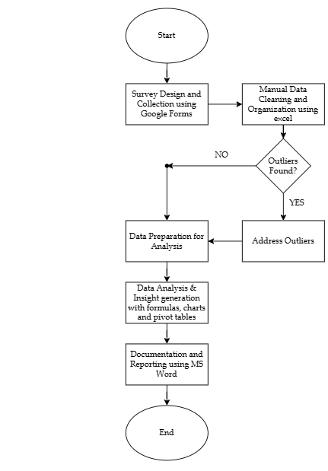
Figure 1: Project Workflow Diagram

Chapter 3

Data Analysis

3.1 Correlation Between Confidence and Skill
This section examines the relationship between students’ confidence levels and the alignment of their skills with their current degree. The goal is to determine how skill alignment impacts students’ confidence in gaining employment in their field after graduation and achieving their overall career goals.

The analysis categorizes students into three groups based on their reported skill alignment (“Yes”, “Somewhat” and “No”) and compares their confidence levels. This allows us to identify trends and insights into how perceived skill readiness influences career confidence.
To explore this topic, the following questions from the survey were tackled:
Do you feel your skills align with your current degree?
How confident are you in gaining employment in your field after graduation?
How confident are you about achieving your career goals?

The responses recorded were summarized as follows:

Table 1: Confidence and Skill Alignment
Firstly, the confidence level of each respondent regarding gaining employment and achieving career goals was summed up and stored in a different column.
This table was created using the following functions:

SUM :

The SUM function in Excel is used to calculate the total of two or more numbers, either from individual cells or a range of cells. It’s one of the most basic and widely used functions for arithmetic operations.[1]

The syntax of the SUM function is:
=SUM(number1, [number2], …)

Formula 1: Confidence and Skill: SUM – Syntax

number1: The first value or cell reference to include in the sum.

number2, ...: Additional values or cell references (optional).

Here, we use the SUM function to combine employment and career goal confidence - to measure the total confidence for each respondent as ‘Sum of Confidence levels’ in column G as:
=SUM(E2, F2)

Formula 2: Confidence and Skill: SUM – Example Usage

Table 2: Confidence and Skill: SUM - Before

When SUM function is applied to certain cells, the values in these cells are summed up. Then the autofill feature is used to apply the same function across a whole column.
Table 3: Confidence and Skill: SUM - After

The sum of the values is then displayed in column G titled ‘Sum of confidence levels.’
UNIQUE :

The UNIQUE function in Excel is used to extract distinct or unique values from a list or range of data, removing duplicates. This function is particularly useful when working with large datasets, as it helps summarize information efficiently by showing only the unique entries.[4]

The basic syntax of the UNIQUE function is:

=UNIQUE(array, [by_col], [exactly_once])

Formula 3: Confidence and Skill: UNIQUE - Syntax

array: The range of cells or array from which you want to extract unique values (mandatory).

by_col: A logical value (TRUE or FALSE).
FALSE (default): Extracts unique values row by row.
TRUE: Extracts unique values column by column.

exactly_once: A logical value (TRUE or FALSE).
FALSE (default): Returns all unique values.
TRUE: Returns only values that appear exactly once in the range.

Here, we use the UNIQUE function to remove duplicate values from the ‘Sum of Confidence levels’ column (i.e., column G) as:
=UNIQUE(G2:G57)

Formula 4: Confidence and Skill: UNIQUE Example Usage

Table 4: Confidence and Skill: UNIQUE - Before

When UNIQUE function is applied to the range of cells - G2 to G57, it scans the range of cells and identifies all the distinct values – 8, 10, 7, 9, 6, 5.

Table 5: Confidence and Skill: UNIQUE - After

The distinct values are then displayed as the output in a new column or row depending on how the function is applied. Here the values are displayed in the new column I, which has been titled Confidence.

SORT :

SORT returns a sorted array of the elements in an array or range. The returned array is the same shape as the provided array argument.[3]

The basic syntax of the SORT function is:

=SORT(array,[sort_index],[sort_order],[by_col])

Formula 5: Confidence and Skill: SORT - Syntax

array (Required): The range, or array to sort

[sort_index] (Optional): A number indicating the row or column to sort by

[sort_order] (Optional): A number indicating the desired sort order; 1 for ascending order (default), -1 for descending order

[by_col] (Optional): A logical value indicating the desired sort direction; FALSE to sort by row (default), TRUE to sort by column.

Here, we use the SORT function to sort the values from the ‘Sum of Confidence levels’ column (i.e., column I) in ascending order:

=SORT(I2:I7)

Formula 6: Confidence and Skill: SORT - Example Usage

Table 6: Confidence and Skill: SORT - Before

When SORT function is applied to the range of cells - I2 to I7, it scans the range of cells and sorts them in ascending order.

Table 7: Confidence and Skill: SORT - After

The values are then displayed as the output in the same column. Here the values are displayed in column I, which has been titled Confidence.

COUNTIFS :

The COUNTIFS function applies criteria to cells across multiple ranges and counts the number of times all criteria are met.[2]

The basic syntax of the COUNTIFS function is:

Formula 7: Confidence and Skill: COUNTIFS - Syntax
criteria_range1 (Required): The first range in which to evaluate the associated criteria.
=COUNTIFS(criteria_range1, criteria1, [criteria_range2, criteria2]…)

criteria1 (Required): The criteria in the form of a number, expression, cell reference, or text that define which cells will be counted.

criteria_range2, criteria2, ... (Optional): Additional ranges and their associated criteria. Up to 127 range/criteria pairs are allowed.

Here, we use the COUNTIFS function to count the number of occurrences of distinct values in a row, based on multiple criteria:

=COUNTIFS(A2:A57, “Yes”, B2:B57, C2)
Formula 8: Confidence and Skill: COUNTIFS - Example Usage

Table 8: Confidence and Skill: COUNTIFS – Before

When COUNTIFS function is applied to the range of cells - A2 to A57 & B2 to B57, it scans the range of cells and counts all values that satisfy the given criteria. Then the autofill feature is used to apply the same function across a whole column.

Table 9: Confidence and Skill: COUNTIFS - After

The values are then displayed as the output in a new column or row depending on how the function is applied. Here the values are displayed in the new column D.

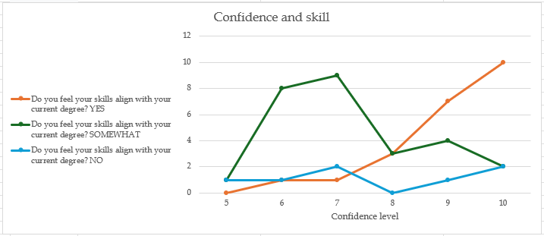
Figure 2: Line Chart - Confidence and Skill

The Table was then visualized with the help of a Line Chart. [5] This chart was used so it would be easy to visualize the change in responses as the confidence level varies. Line graphs are a powerful tool to analyze continuous data in a very simplistic manner.

3.2 Correlation Between Gender and Post-Degree Choices.

This section analyzes the relationship between gender and the students’ decisions regarding their educational and career aspirations, specifically focusing on two aspects, their interest in pursuing further education after completing their current degree and their intent to work in the same field as their current degree.
The analysis categorizes students into three groups based on their interest in pursuing further education (“Yes”, “Maybe” and “No”) and their intent to work in the same field (“Yes”, “Maybe” and “No”). This allows us to identify trends and insights into how gender influences their interest in further education and intent to work in the same field.

To explore this topic, the following questions from the survey were tackled:
Do you plan to work in the same field as your degree?
Do you intend to pursue further education

Gender | Do you plan to work in the same field as your degree? YES | Do you plan to work in the same field as your degree? MAYBE | Do you plan to work in the same field as your degree? NO | Do you intend to pursue further education? Yes | Do you intend to pursue further education? Maybe | Do you intend to pursue further education? No
Male | 12 | 14 | 8 | 16 | 14 | 4
Female | 14 | 8 | 0 | 14 | 8 | 0
Table 10: Gender and Post-Degree Goals

The function used to calculate data in this table is:

COUNTIFS :

The COUNTIFS function applies criteria to cells across multiple ranges and counts the number of times all criteria are met.[2]

The basic syntax of the COUNTIFS function is:
=COUNTIFS(criteria_range1, criteria1, [criteria_range2, criteria2]…)

Formula 9: Gender and Post-Degree Goals: COUNTIFS - Syntax
The COUNTIFS function syntax has the following arguments:

criteria_range1 (Required): The first range in which to evaluate the associated criteria.

criteria1 (Required): The criteria in the form of a number, expression, cell reference, or text that define which cells will be counted.

criteria_range2, criteria2, ... (Optional): Additional ranges and their associated criteria. Up to 127 range/criteria pairs are allowed.

Here, we use the COUNTIFS function to count the number of occurrences of distinct values in a row, based on multiple criteria:
=COUNTIFS(A2:A57, M2, B2:B57, “Yes”)

Formula 10: Gender and Post-Degree Goals: COUNTIFS - Example Usage
Table 11: Gender and Post-Degree Goals: COUNTIFS – Before
When COUNTIFS function is applied to the range of cells - A2 to A57 & B2 to B57, it scans the range of cells and counts all values that satisfy the given criteria. Then the autofill feature is used to apply the same function across a whole column.

Table 12: Gender and Post-Degree Goals: COUNTIFS – After
The values are then displayed as the output in a new column or row depending on how the function is applied. Here the values are displayed in the new column N. The rest of the table was completed using the auto-fill feature.

The COUNTIFS function is used here as it applies criteria to cells across multiple ranges and counts the number of times all criteria are met. This allows us to count responses which fulfill multiple criteria, which are in this case gender and response type.
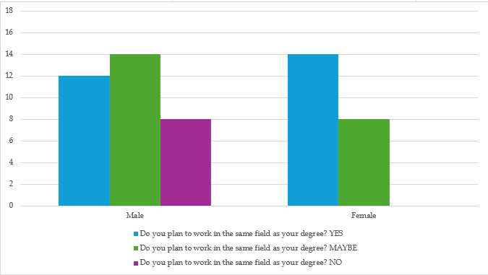
Figure 3: Column Chart - Gender and Field of Work

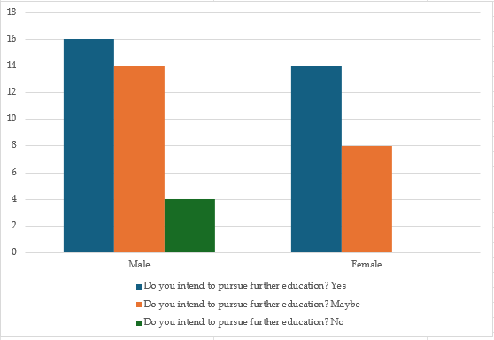
Figure 4: Column Chart - Gender and Higher Education
The clustered column chart type was chosen for both charts because it provides a clear and intuitive way to compare values across different categories, making the data easier to interpret.[5]

3.3 Correlation Between Gender and External Influence

This topic explores how gender influences the degree to which external factors impact students' choice of degree programs. By analyzing survey data, the study aims to identify any significant gender-based differences in how external influences shape academic decisions, providing insights into the role of gender in educational choices and the potential need for targeted support in career counseling.

To explore this topic, the following questions from the survey were tackled:
Was your degree choice influenced by recommendations from others?
Did you consider any alternative degree programs?

The responses for these questions were summarized in a table using formulas:

Gender | Was your degree choice influenced by recommendations from others? YES | Was your degree choice influenced by recommendations from others? NO | Did you consider any alternative degree programs? YES | Did you consider any alternative degree programs? NO
Male | 13 | 21 | 16 | 18
Female | 13 | 9 | 13 | 9
Table 13: Gender and External Influence
The formula used to calculate data in this table is
COUNTIFS :

The COUNTIFS function applies criteria to cells across multiple ranges and counts the number of times all criteria are met.[2]

The basic syntax of the COUNTIFS function is:
=COUNTIFS(criteria_range1, criteria1, [criteria_range2, criteria2]…)

Formula 11: Gender and External Influence: COUNTIFS - Syntax
The COUNTIFS function syntax has the following arguments:

criteria_range1 (Required): The first range in which to evaluate the associated criteria.

criteria1 (Required): The criteria in the form of a number, expression, cell reference, or text that define which cells will be counted.

criteria_range2, criteria2, ... (Optional): Additional ranges and their associated criteria. Up to 127 range/criteria pairs are allowed.

Here, we use the COUNTIFS function to count the number of occurrences of distinct values in a row, based on multiple criteria:

=COUNTIFS(A2:A57, M2, B2:B57, “Yes”)

Formula 12: Gender and External Influence: COUNTIFS - Example Usage

Table 14: Gender and External Influence: COUNTIFS – Before
When COUNTIFS function is applied to the range of cells - A2 to A57 & B2 to B57, it scans the range of cells and counts all values that satisfy the given criteria. Then the autofill feature is used to apply the same function across a whole column.

Table 15: Gender and External Influence: COUNTIFS – Before
The values are then displayed as the output in a new column or row depending on how the function is applied. Here the values are displayed in the new column N.
The rest of the table was completed using the auto-fill feature.
The COUNTIFS function is used here as it applies criteria to cells across multiple ranges and counts the number of times all criteria are met. This allows us to count responses which fulfill multiple criteria, which are in this case gender and response type.
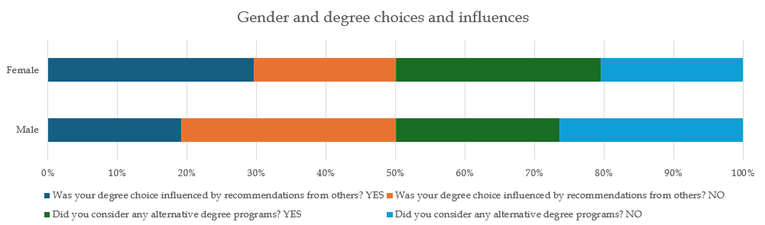
Figure 5: Stacked Bar Chart - Gender and External Influences
The Table was then visualized with the help of a 100% stacked bar chart. [5] This chart was used so it would be easier to visualize and compare the ratios of responses of each gender as comparing counts using a clustered chart would be less helpful due to the uneven distribution of male and female responses.

3.4 Correlation Between Confidence and Personal Interest
This topic examines how students' personal interest in their chosen degree program influences their confidence in achieving career goals and succeeding in their field of study. By analyzing survey data, this study seeks to identify any significant relationships between a student's level of interest in their subject and their self-assurance regarding future career prospects. The findings can provide insights into the importance of passion and personal motivation in fostering confidence, which may inform strategies for improving student engagement and career readiness.

To explore this topic, the following questions from the survey were tackled:
How confident are you in gaining employment in your field after graduation?
How confident are you about achieving your career goals?
Did you choose this degree based on personal interest?

The responses for these questions were summarized in a table using various formulas:

CONFIDENCE LEVEL | Did you choose this degree based on personal interest? YES | Did you choose this degree based on personal interest? NO
5 | 2 | 0
6 | 6 | 4
7 | 7 | 5
8 | 5 | 1
9 | 10 | 2
10 | 14 | 0
Table 16: Confidence and Personal Interest
The Confidence Levels of responses were calculated by adding the corresponding values of the 2 confidence-based questions to get a value on a scale of 1-10.

3 formulas were required to create this table with the help of the autofill feature.
This table was created using the following functions:
SUM :

The SUM function in Excel is used to calculate the total of two or more numbers, either from individual cells or a range of cells. It’s one of the most basic and widely used functions for arithmetic operations.[1]

The syntax of the SUM function is:
=SUM(number1, [number2], …)

Formula 13: Confidence and Personal Interest: SUM - Syntax
number1: The first value or cell reference to include in the sum.

number2, ...: Additional values or cell references (optional).

Here, we use the SUM function to combine employment and career goal confidence - to measure the total confidence for each respondent as ‘SUM of Confidence levels’ in column M as:
=SUM(D2, E2)

Formula 14: Confidence and Personal Interest: SUM – Example Usage
Table 17: Confidence and Personal Interest: SUM - Before
When SUM function is applied to the columns D and E, the values in these columns are summed up.

The sum of the values is then displayed in column M - ‘SUM of confidence levels.’
Table 18: Confidence and Personal Interest: SUM - After

UNIQUE :
The UNIQUE function in Excel is used to extract distinct or unique values from a list or range of data, removing duplicates. This function is particularly useful when working with large datasets, as it helps summarize information efficiently by showing only the unique entries.[4]

The basic syntax of the UNIQUE function is:
=UNIQUE(array, [by_col], [exactly_once])

Formula 15: Confidence and Personal Interest: UNIQUE - Syntax
array: The range of cells or array from which you want to extract unique values (mandatory).

by_col: A logical value (TRUE or FALSE).
FALSE (default): Extracts unique values row by row.
TRUE: Extracts unique values column by column.

exactly_once: A logical value (TRUE or FALSE).
FALSE (default): Returns all unique values.
TRUE: Returns only values that appear exactly once in the range.

Here, we use the UNIQUE function to remove duplicate values from the ‘SUM of Confidence levels’ column (i.e., column M) as:
=UNIQUE(M2:M57)

Formula 16: Confidence and Personal Interest: UNIQUE – Example Usage
Table 19: Confidence and Personal Interest: UNIQUE - Before
When UNIQUE function is applied to the range of cells - M2 to M57, it scans the range of cells and identifies all the distinct values – 8, 10, 7, 9, 6, 5.

Table 20: Confidence and Personal Interest: UNIQUE - After
The distinct values are then displayed as the output in a new column or row depending on how the function is applied. Here the function is displayed in the new column N, which has been titled CONFIDENCE LEVEL.

SORT :

SORT returns a sorted array of the elements in an array or range. The returned array is the same shape as the provided array argument.[3]

The basic syntax of the SORT function is:
=SORT(array,[sort_index],[sort_order],[by_col])

Formula 17: Confidence and Personal Interest: SORT - Syntax
array (Required): The range, or array to sort

[sort_index] (Optional): A number indicating the row or column to sort by

[sort_order] (Optional): A number indicating the desired sort order; 1 for ascending order (default), -1 for descending order

[by_col] (Optional): A logical value indicating the desired sort direction; FALSE to sort by row (default), TRUE to sort by column.

Here, we use the SORT function to sort the values from the ‘SUM of Confidence levels’ column (i.e., column M) in ascending order:
=SORT(I2:I57))

Formula 18: Confidence and Personal Interest: SORT – Example Usage
Table 21: Confidence and Personal Interest: SORT - Before
When SORT function is applied to the range of cells - M2 to M7, it scans the range of cells and sorts them in ascending order.

Table 22: Confidence and Personal Interest: SORT - After
The values are then displayed as the output in the same column. Here the function is displayed in column M, which has been titled CONFIDENCE LEVELS.

COUNTIFS:

The COUNTIFS function applies criteria to cells across multiple ranges and counts the number of times all criteria are met.[2]

The basic syntax of the COUNTIFS function is:
=COUNTIFS(criteria_range1, criteria1, [criteria_range2, criteria2]…)

Formula 19: Confidence and Personal Interest: COUNTIFS - Syntax
The COUNTIFS function syntax has the following arguments:

criteria_range1 (Required): The first range in which to evaluate the associated criteria.

criteria1 (Required): The criteria in the form of a number, expression, cell reference, or text that define which cells will be counted.

criteria_range2, criteria2, ... (Optional): Additional ranges and their associated criteria. Up to 127 range/criteria pairs are allowed.

Here, we use the COUNTIFS function to count the number of occurrences of distinct values in a row, based on multiple criteria:
=COUNTIFS(A2:A57, “Yes”, B2:B57, C2)

Formula 20: Confidence and Personal Interest: COUNTIFS – Example Usage

Table 23: Confidence and Personal Interest: COUNTIFS - Before
When COUNTIFS function is applied to the range of cells - A2:A57 & B2:B57, it scans the range of cells and counts all values that satisfy the given criteria.
Then the autofill feature is used to apply the same function across a whole column.

Table 24: Confidence and Personal Interest: COUNTIFS – After

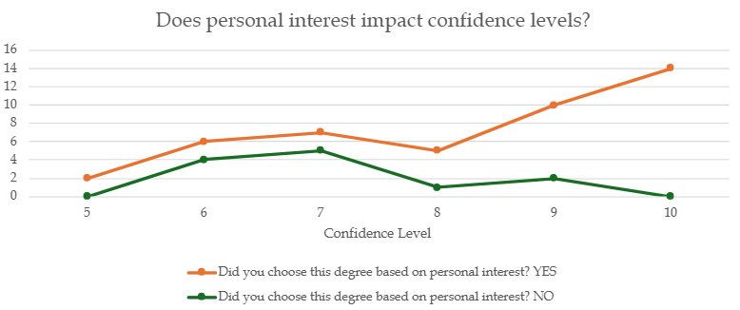
Figure 6: Line Chart - Personal Interest and Confidence Levels

The Table was then visualized with the help of a Line Chart. [5]
This particular chart was used so it would be easy to visualize the change in responses as the confidence level varies. Line graphs are a powerful tool to analyze continuous data in a very simplistic manner.

3.5 Charts used:

3.5.1 Pie and doughnut charts

Data that's arranged in one column or row on a worksheet can be plotted in a pie chart.[5] Pie charts show the size of items in one data series, proportional to the sum of the items. The data points in a pie chart are shown as a percentage of the whole pie.

3.5.2 Bar chart

Data that's arranged in columns or rows on a worksheet can be plotted in a bar chart.[5] Bar charts illustrate comparisons among individual items. In a bar chart, the categories are typically organized along the vertical axis, and the values along the horizontal axis.

3.5.2.1 Types of bar charts

Clustered bar and 3-D clustered bar A clustered bar chart shows bars in 2-D format. A 3-D clustered bar chart shows bars in 3-D format; it doesn’t use a depth axis.

Stacked bar and 3-D stacked bar Stacked bar charts show the relationship of individual items to the whole in 2-D bars. A 3-D stacked bar chart shows bars in 3-D format; it doesn’t use a depth axis.

100% stacked bar and 3-D 100% stacked bar A 100% stacked bar shows 2-D bars that compare the percentage that each value contributes to a total across categories. A 3-D 100% stacked bar chart shows bars in 3-D format; it doesn’t use a depth axis.

3.5.3 Column chart

Data that’s arranged in columns or rows on a worksheet can be plotted in a column chart.[5] A column chart typically displays categories along the horizontal (category) axis and values along the vertical (value) axis, as shown in this chart:

3.5.3.1 Types of column charts

Clustered column and 3-D clustered column A clustered column chart shows values in 2-D columns. A 3-D clustered column chart shows columns in 3-D format, but it doesn’t use a third value axis (depth axis). Use this chart when you have categories that represent:
Ranges of values (for example, item counts).
Specific scale arrangements (for example, a Likert scale with entries like Strongly agree, Agree, Neutral, Disagree, Strongly disagree).
Names that are not in any specific order (for example, item names, geographic names, or the names of people).

Stacked column and 3-D stacked column A stacked column chart shows values in 2-D stacked columns. A 3-D stacked column chart shows the stacked columns in 3-D format, but it doesn’t use a depth axis. Use this chart when you have multiple data series and you want to emphasize the total.

100% stacked column and 3-D 100% stacked column A 100% stacked column chart shows values in 2-D columns that are stacked to represent 100%. A 3-D 100% stacked column chart shows the columns in 3-D format, but it doesn’t use a depth axis. Use this chart when you have two or more data series and you want to emphasize the contributions to the whole, especially if the total is the same for each category.

3-D column 3-D column charts use three axes that you can change (a horizontal axis, a vertical axis, and a depth axis), and they compare data points along the horizontal and the depth axes. Use this chart when you want to compare data across both categories and data series.

3.5.4 Line chart
Data that's arranged in columns or rows on a worksheet can be plotted in a line chart.[5] In a line chart, category data is distributed evenly along the horizontal axis, and all value data is distributed evenly along the vertical axis. Line charts can show continuous data over time on an evenly scaled axis, so they're ideal for showing trends in data at equal intervals, like months, quarters, or fiscal years.

3.5.4.1 Types of line charts

Line and line with markers Shown with or without markers to indicate individual data values, line charts can show trends over time or evenly spaced categories, especially when you have many data points and the order in which they are presented is important. If there are many categories or the values are approximate, use a line chart without markers.

Stacked line and stacked line with markers Shown with or without markers to indicate individual data values, stacked line charts can show the trend of the contribution of each value over time or evenly spaced categories.

100% stacked line and 100% stacked line with markers Shown with or without markers to indicate individual data values, 100% stacked line charts can show the trend of the percentage each value contributes over time or evenly spaced categories. If there are many categories or the values are approximate, use a 100% stacked line chart without markers.
3-D line 3-D line charts show each row or column of data as a 3-D ribbon. A 3-D line chart has horizontal, vertical, and depth axes that you can change.

Chapter 4

Inferences & Key Insights

4.1 Correlation Between Confidence and Skill

4.1.1 Confidence in Gaining Employment and Achieving Career Goals

Figure 7: Inference - Pie Chart - Confidence and Skill (YES)
The data reveals a clear correlation between skill alignment and confidence in securing employment. Students who reported that their skills align with their degree (Yes) exhibited significantly higher levels of confidence in gaining employment. These respondents rated their confidence, on average, at around 4.5/5. This suggests that when students feel prepared and equipped for the workforce, their confidence in securing a job is much higher.

The pattern observed in confidence related to career goals mirrors the trend seen in employment confidence. Students who felt their skills aligned with their degree were significantly more confident in achieving their long-term career goals, with an average confidence rating of 4.1/5. These students believe that their educational background has equipped them with the necessary skills and knowledge to succeed in their chosen careers.

Figure 8: Inference - Pie Chart - Confidence and Skill (SOMEWHAT)
In contrast, students who indicated "Somewhat" alignment displayed moderate confidence (around 3.5/5) in gaining employment, reflecting a more cautious approach. Although these students felt they were somewhat ready for employment, they likely perceived gaps in their skills that led to a more reserved outlook on their job prospects.
With regards to achieving their career goals, those who indicated "Somewhat" alignment showed moderate confidence levels (4.0/5), again reflecting a certain level of optimism despite recognizing that there might be gaps in their skills. These students likely believe they can still achieve their career goals, albeit with some additional effort or training.

Figure 9: Inference - Pie Chart - Confidence and Skill (NO)
Students who reported "No" alignment with their degree showed the lowest levels of confidence in gaining employment, with an average confidence rating of 2.5/5. This group’s uncertainty about their skills likely contributed to a lower sense of preparedness, which is reflected in their diminished confidence levels.
Similarly, Students with "No" skill alignment displayed the lowest confidence in achieving their career goals, with an average rating of 3.0/5. This group likely feels that their lack of alignment between their degree and skills might hinder their ability to reach their career aspirations.

4.1.2 Insights
Figure 10: Inference - Combo Chart - Confidence and Skill
The analysis clearly demonstrates a positive correlation between skill alignment and confidence levels. Students who feel their skills align with their degree are significantly more confident in both securing employment and achieving their long-term career goals. In contrast, those with partial or no skill alignment show reduced confidence, highlighting the importance of skills that directly correspond to career expectations.

4.2 Correlation Between Gender and Post-Degree Choices

4.2.1 Pursuing Further Education

Figure 11: Inference - 100% Stacked Bar Chart - Gender and Further Education
The data reveals a distinct gender-based pattern in the decision to pursue further education. A greater proportion of female respondents expressed a definite interest in pursuing higher studies compared to their male counterparts. This trend indicates that females tend to view further education as an important step for career advancement or personal growth. On the other hand, males were more likely to respond with "Maybe" or "No," suggesting that they are relatively less inclined toward further academic pursuits. This may reflect an eagerness among male students to enter the workforce sooner or pursue alternative career pathways.

4.2.2 Working in the Same Field

Figure 12: Inference - 100% Stacked Bar Chart - Gender and Field of Work
When it comes to plans for working in the same field as their degree, the responses from both genders were more evenly distributed. However, females were slightly more likely to give a definitive "Yes" than males, demonstrating a stronger inclination to align their career with their educational background. Males, on the other hand, leaned more toward "Maybe," suggesting flexibility or uncertainty in committing to a career directly tied to their degree.

4.2.3 Insights

Figure 13: Inference - 100% Stacked Bar Chart - Gender and Post-Degree Choices
This analysis highlights key gender differences in career and educational priorities. Female respondents appear to adopt a more structured approach to their academic and professional goals, emphasizing further education and consistency in their field of study. In contrast, male respondents display greater openness to exploring diverse career paths or entering the job market without additional qualifications.

4.3 Correlation Between Gender and External Influence

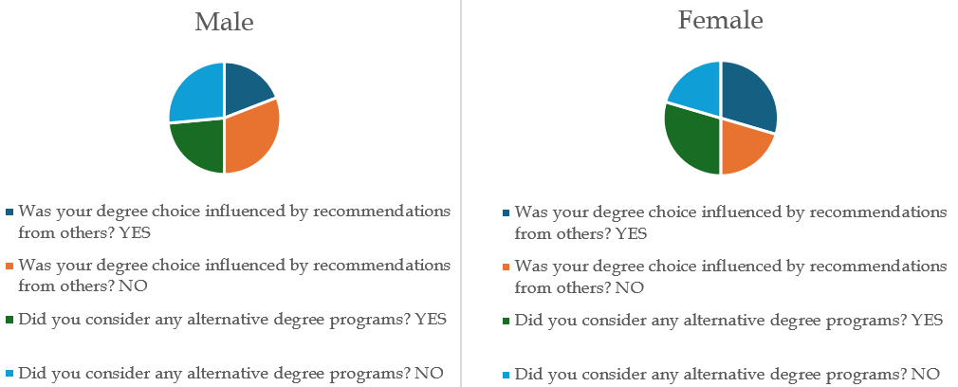
Figure 14: Inference - Pie Charts - Gender and External Influence

4.3.1 External Influence and Degree Choice

The data reveals a distinct gender-based pattern on the influence of others on degree choice. A greater proportion of female respondents were influenced by others in their degree choice. This trend indicates that females are more receptive of outside influence for their degree choice. On the other hand, males were more likely to respond with "No," suggesting that they are relatively less inclined to be influenced by recommendations

When it comes to considering alternative degree programs, the responses follow the same trend as the earlier question. Female respondents were more likely to explore other options, suggesting greater openness or flexibility in their academic choices, possibly influenced by factors like career alignment or external guidance. Male respondents, in contrast, showed less inclination to reconsider their degree choices, indicating stronger confidence or commitment to their initial selection.

4.3.2 Insights
This analysis highlights key gender differences in career and educational priorities. Female respondents are more likely to be influenced by recommendations and show greater openness to considering alternative degree programs, reflecting flexibility and receptiveness to external input. In contrast, males are less influenced by recommendations and more committed to their initial choices, indicating confidence and independence in decision-making.

4.4 Correlation Between Confidence and Personal Interest

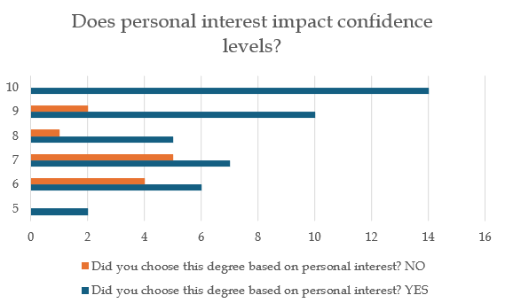
Confidence Level
Figure 15: Inference - Bar Chart – Personal Interest and Confidence Levels

4.4.1 Confidence and Personal Interest

The data suggests a strong correlation between confidence levels and choosing a degree based on personal interest. Respondents who selected their degree based on personal interest tend to exhibit higher confidence levels. For instance:
- At confidence levels 9 and 10, a significant majority of students chose their degree based on personal interest (10 and 14 respondents, respectively), with few or no respondents who did not base their choice on personal interest.
Conversely, those who did not choose their degree based on personal interest generally report lower confidence levels. For example:
- At confidence levels 5 and 6, no respondents or only a few (0 and 4, respectively) reported not basing their choice on personal interest.

This trend highlights the positive impact of aligning degree choices with personal interests on students' confidence in their academic and career paths. Encouraging students to pursue degrees aligned with their passions could foster greater confidence and engagement.

4.4.2 Insights

Students who chose their degree based on personal interest exhibit higher confidence levels, particularly at levels 9 and 10. In contrast, those who did not base their choice on personal interest show lower confidence, with no respondents reaching the highest levels. This highlights the importance of aligning degree choices with personal passions to boost confidence and career assurance.

Chapter 5

Conclusion
This study provides an in-depth analysis of the factors influencing students' educational and career decisions, with a particular focus on skill alignment, gender-based trends, personal interest, and confidence levels. The findings underscore the critical role that personal interest and skill alignment play in fostering confidence and shaping career aspirations. Students who reported strong alignment between their skills and chosen degree demonstrated higher levels of confidence in achieving both employment and long-term career goals.

Gender-based trends revealed distinct patterns, with female respondents more inclined toward further education and alignment with their field of study, whereas male respondents showed greater openness to exploring diverse career paths or entering the workforce sooner. These insights highlight the varying motivations and strategies students employ when navigating educational and professional landscapes.
Additionally, the analysis identified the influence of external factors, such as recommendations and societal expectations, which were more pronounced among female respondents. This underscores the importance of tailored career counseling and mentorship programs to address these influences and support informed decision-making.

Overall, this study emphasizes the need for targeted interventions to bridge the gap between education and employability, such as skill-building initiatives, enhanced career counseling, and programs that encourage students to pursue degrees aligned with their interests. By addressing these gaps, institutions can better prepare students for the challenges of an evolving job market, fostering a generation of confident, skilled, and adaptable professionals.

References

[1] Microsoft. (n.d.). SUM function. Microsoft Support. Retrieved November 25, 2024, from https://support.microsoft.com/en-gb/office/sum-function-043e1c7d-7726-4e80-8f32-07b23e057f89
[2] Microsoft. (n.d.). COUNTIFS function. Microsoft Support. Retrieved November 25, 2024, from https://support.microsoft.com/en-gb/office/countifs-function-dda3dc6e-f74e-4aee-88bc-aa8c2a866842
[3] Microsoft. (n.d.). SORT function. Microsoft Support. Retrieved November 25, 2024, from https://support.microsoft.com/en-us/office/sort-function-22f63bd0-ccc8-492f-953d-c20e8e44b86c
[4] Microsoft. (n.d.). UNIQUE function. Microsoft Support. Retrieved November 25, 2024, from https://support.microsoft.com/en-us/office/unique-function-c5ab87fd-30a3-4ce9-9d1a-40204fb85e1e
[5] Microsoft. (n.d.). Available chart types in Office. Microsoft Support. Retrieved November 25, 2024, from https://support.microsoft.com/en-us/office/available-chart-types-in-office-a6187218-807e-4103-9e0a-27cdb19afb90

