Normalization
Booking_receipt(booking_id, passenger_full_name, passenger_passport_number, flight_number, departure_airport_name, departure_city, arrival_airport_name, arrival_city, airline_name, seat_numbers, ticket_price) The seat_numbers column stores a comma-separated list (e.g. "12A, 12B") when a booking covers several passengers on the same reservation.
1)
The table violates the 1NF format, since the seat_numbers column contains multiple values in a single cell, for example, “12A, 12B”. Because of this, the table is also not in 2NF or 3NF formats, since for a table to be in 2NF it must be in 1NF, and the same applies to 3NF.

2)
To convert the table to 1NF, the seat_numbers column must contain only one value in each cell. This is the table before conversion to the 1NF format.
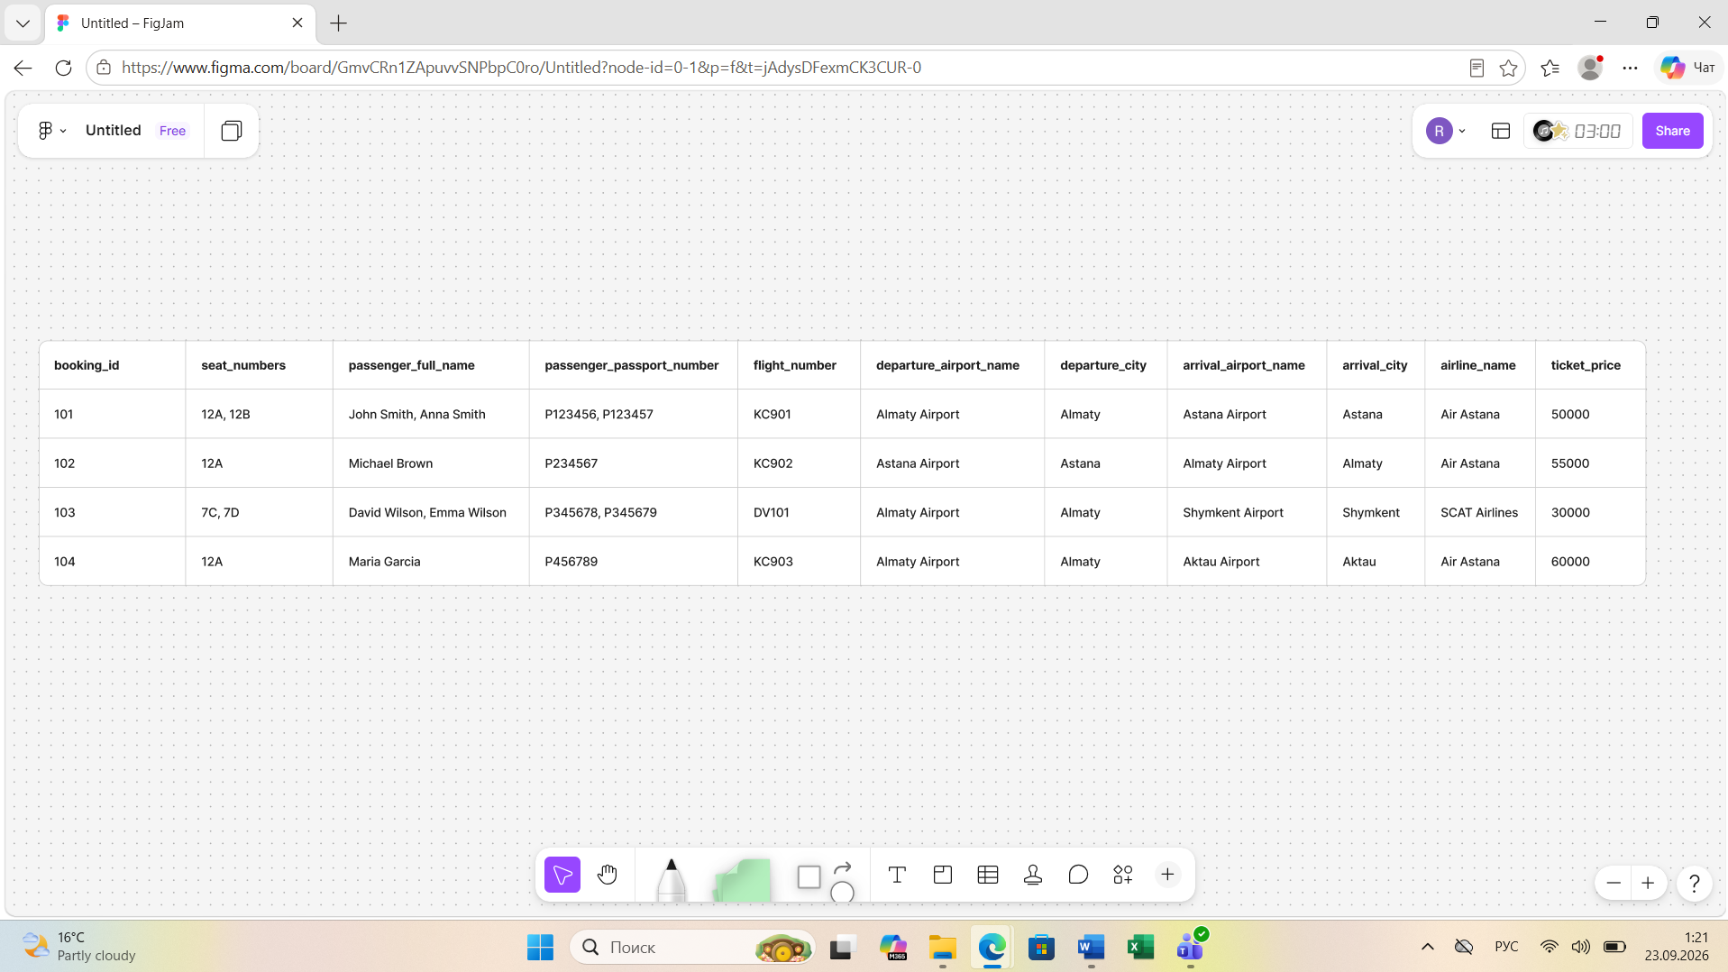

This is the table after the transformation.
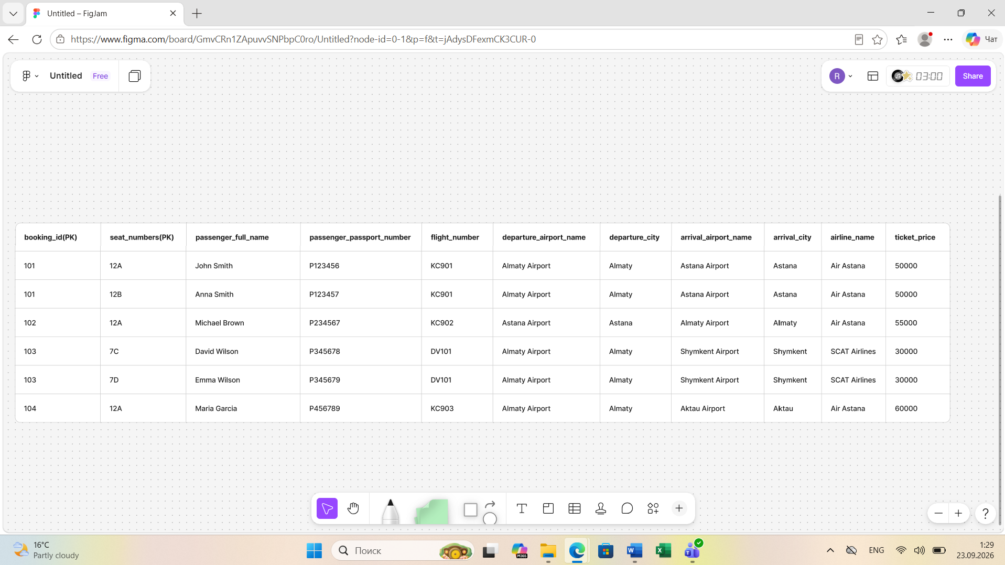
The 2NF means that a table must be in 1NF and every non-key attribute must depend on the whole primary key, not only on part of it. In our example, the primary key of the 1NF table is the composite key (booking_id, seat_number). Therefore, we need to decompose the table to remove the partial dependencies.
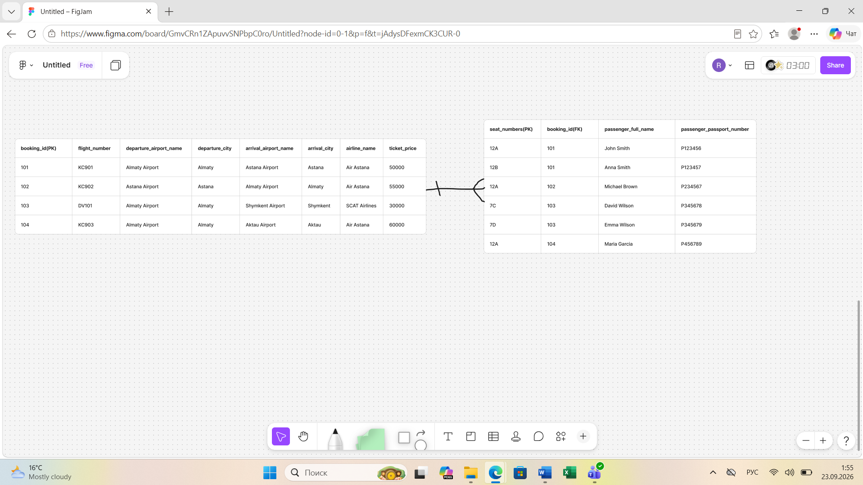
The 3NF means that a table must be in 2NF and every non-key attribute must depend only on the primary key, not on another non-key attribute. In our example, some attributes still depend on other non-key attributes, so we need to decompose the tables to remove the transitive dependencies.
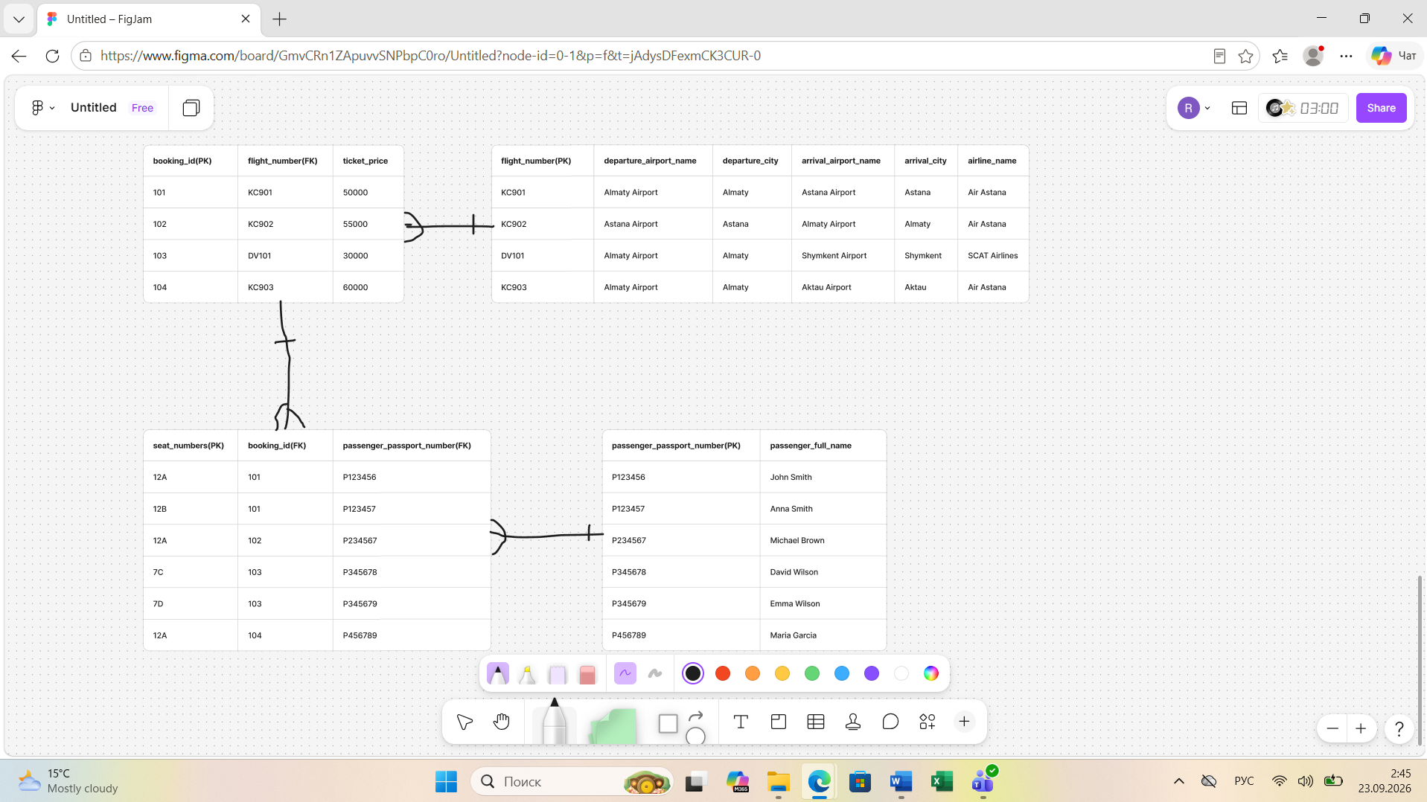
3)
booking_id -> flight_number, ticket_price;
flight_number -> departure_airport_name, departure_city, arrival_airport_name, arrival_city, airline_name;
passenger_passport_number -> passenger_full_name.
4)
The Flights table is in 1NF because all attributes contain atomic values, with no repeating groups or multi-valued fields. It is also in 2NF because it is in 1NF and its primary key consists of a single attribute, so partial dependencies cannot exist. Finally, it is in 3NF because there are no transitive dependencies between non-key attributes.
Primary Key: flight_id
Functional dependency:
flight_id → sch_departure_time, sch_arrival_time, departing_airport_id, arriving_airport_id, departing_gate, arriving_gate, airline_id, act_departure_time, act_arrival_time, created_at, updated_at
Therefore, the Flights table is in 3NF.

