Laboratory work 5
- Add a CHECK constraint to passenger table to provide that passengers must be at least 10 years old.
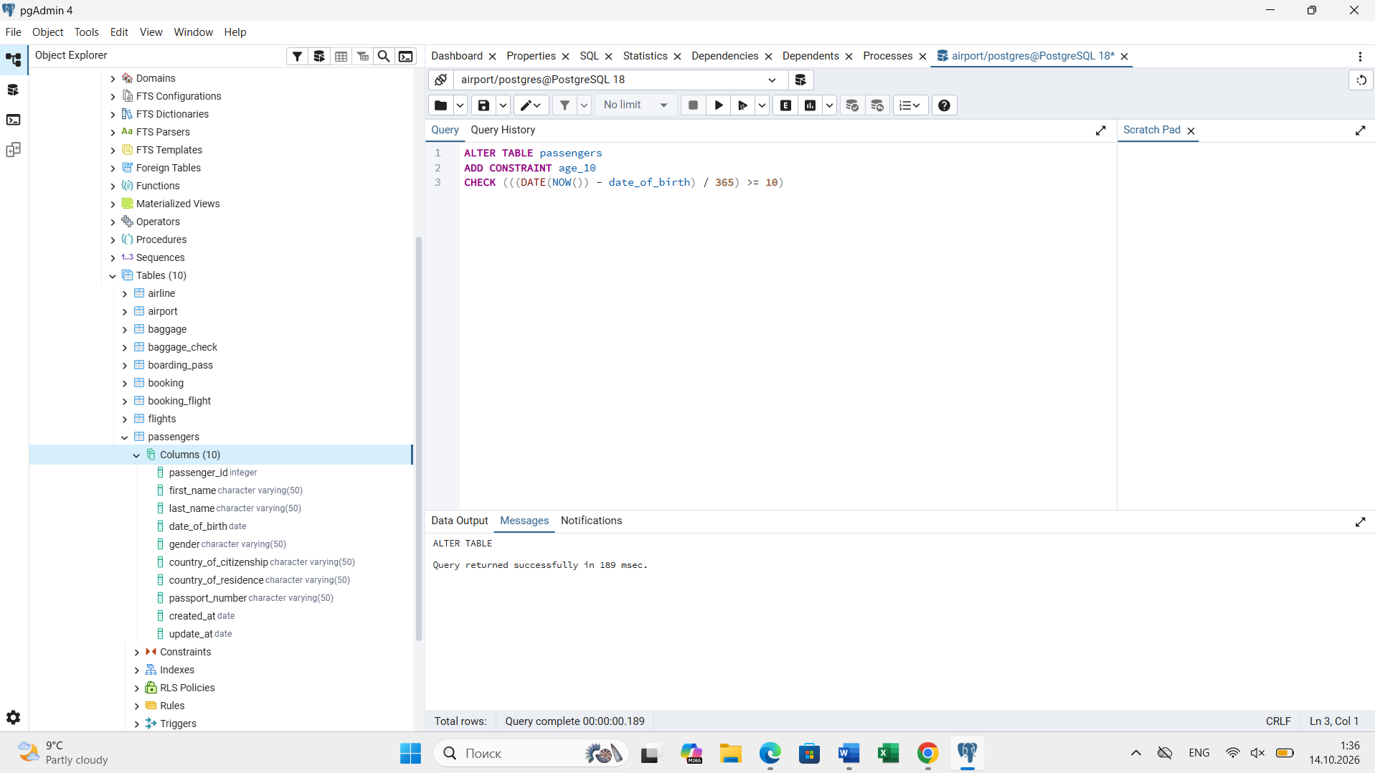
- Add a CHECK constraint to accept values in booking price not more than 50000tg and less than 0tg.
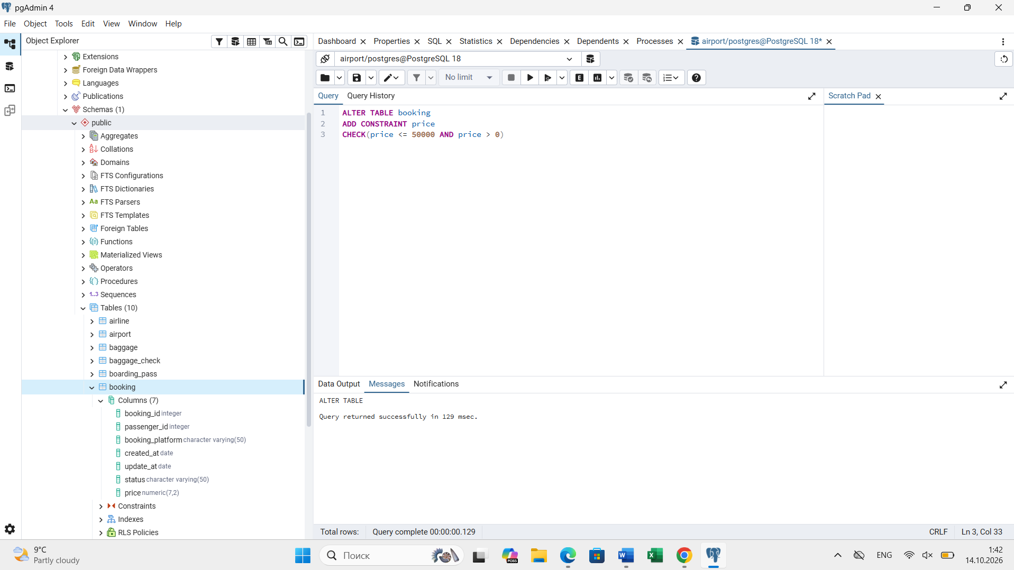
- Add a CHECK constraint to accept the luggage weight between 1 and 23 kg.
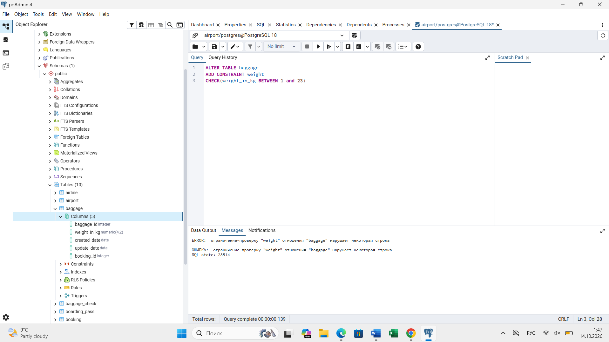
- Add a CHECK constraint to ensure that all values in airport_name must have at least 10 characters.
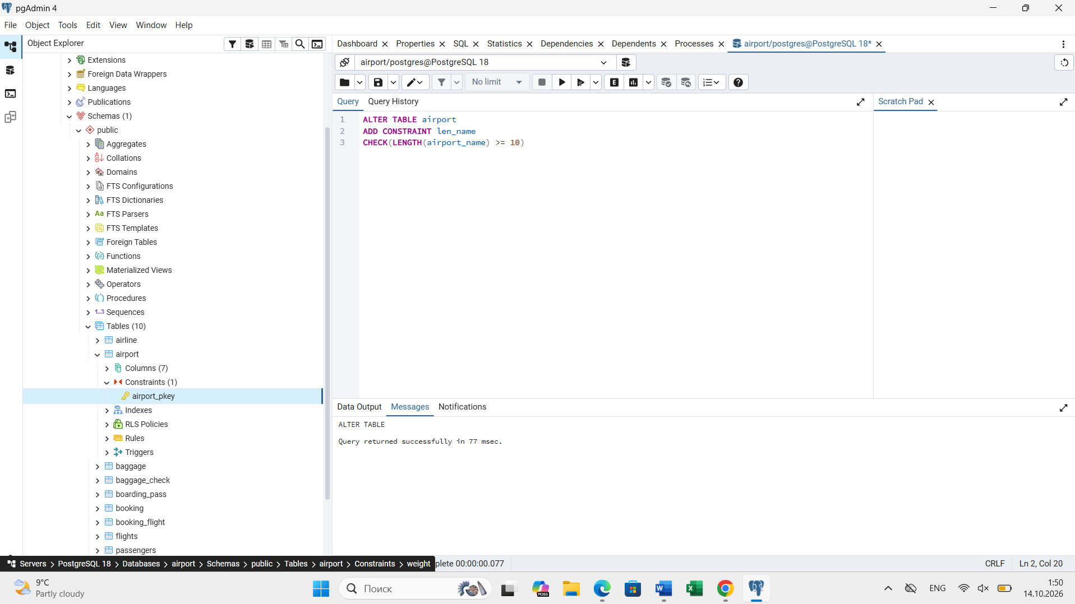
- Add UNIQUE constraint to some columns in each table in database.
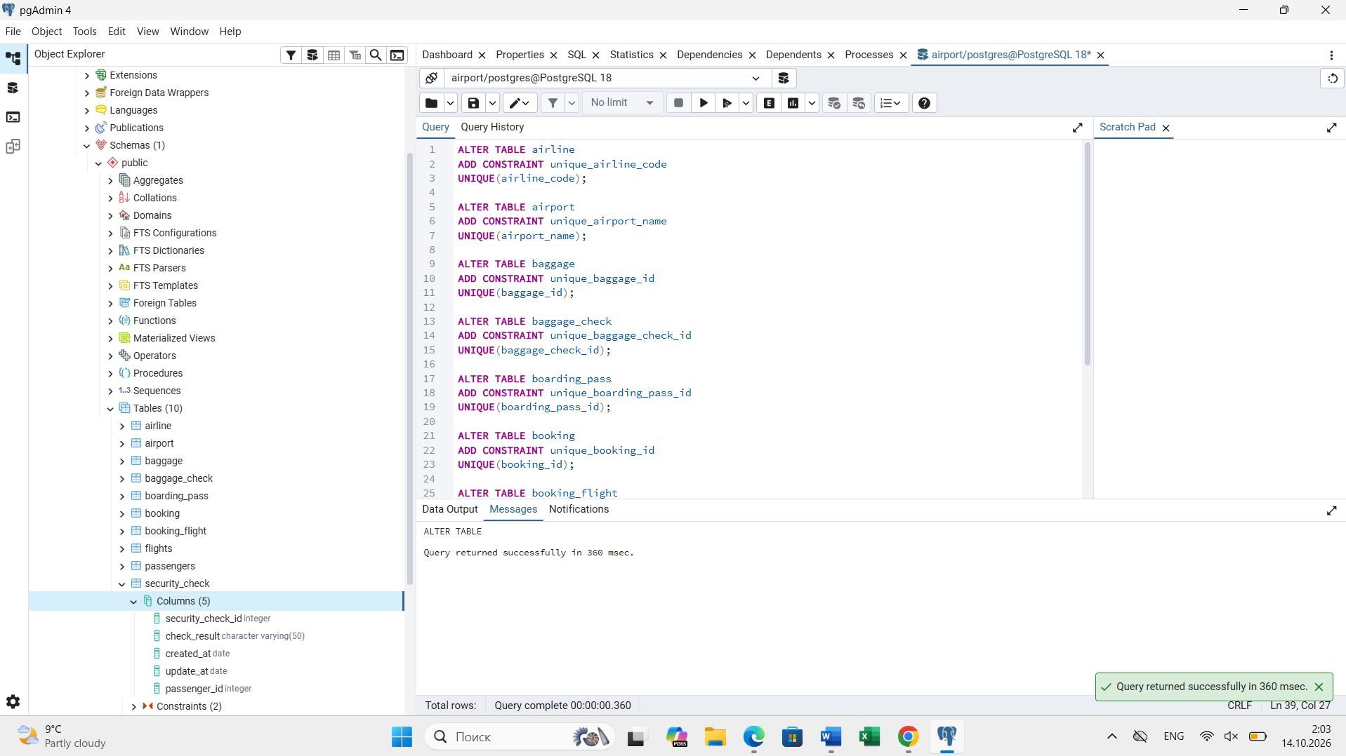
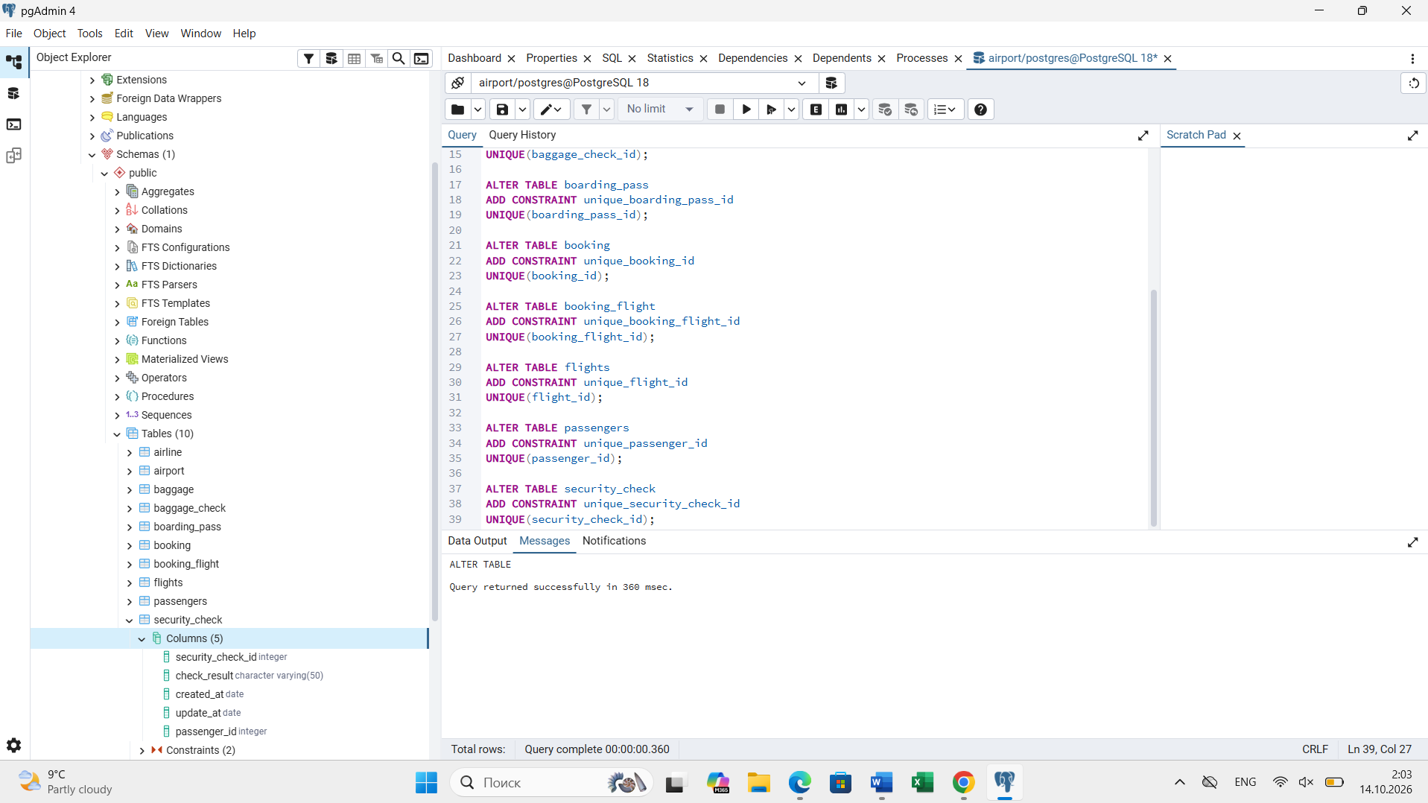
- Add a CHECK constraint to ensure that male passengers must be at least 18 years old and female passengers must be 19 years old.
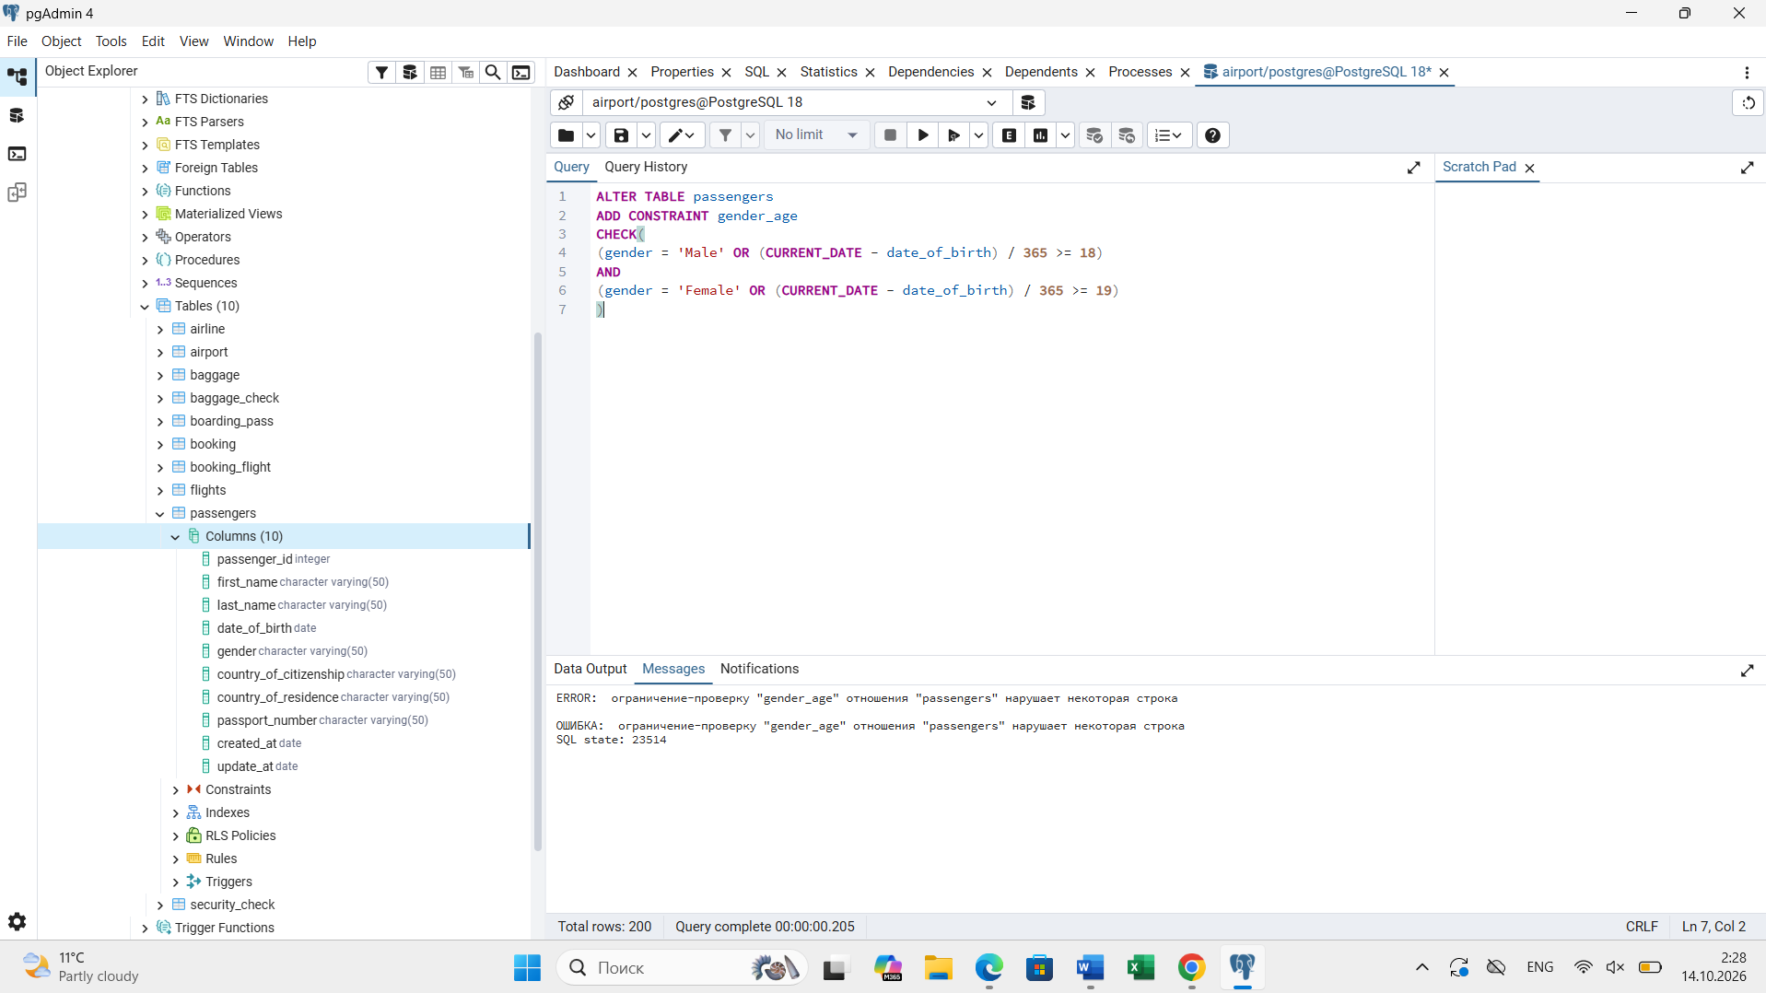
- Add a CHECK constraint to add rule as follow (use column country_of_citizenship):
- Passengers from Kazakhstan must be at least 18 years old.
- Passengers from France must be at least 17 years old.
- Passengers from other countries must be at least 19 years old.

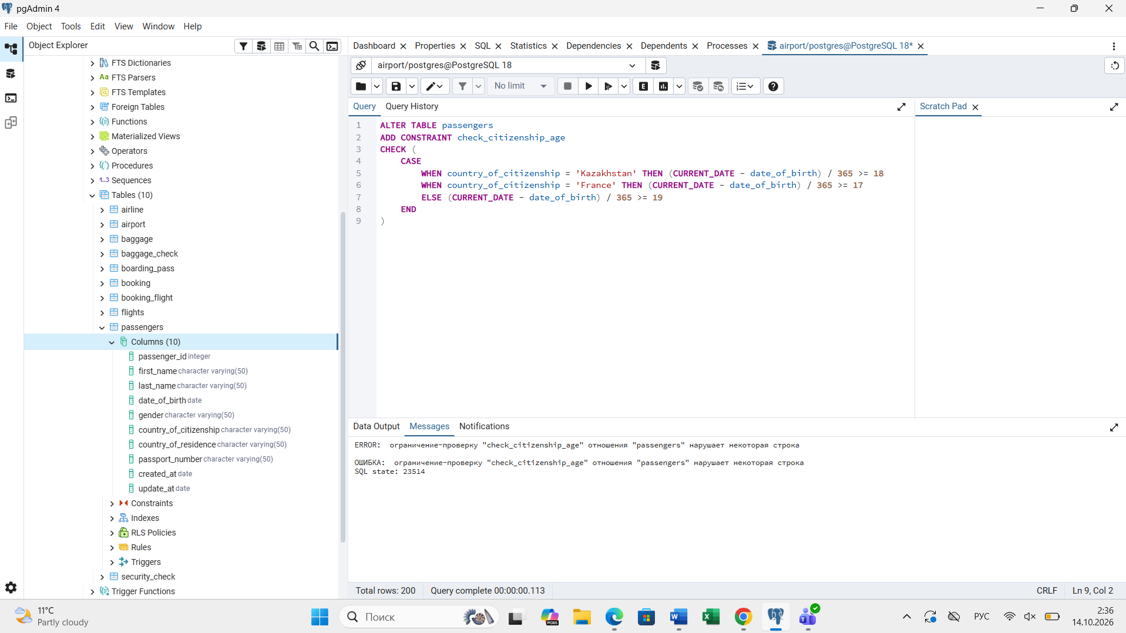
- Add a ticket_discount column to table booking and a CHECK constraint to apply some discount based on ticket price and created time: the constraint applies a 5% discount for tickets created after 2024-01-01, and 10% discount for tickets created before 2024-01-01.
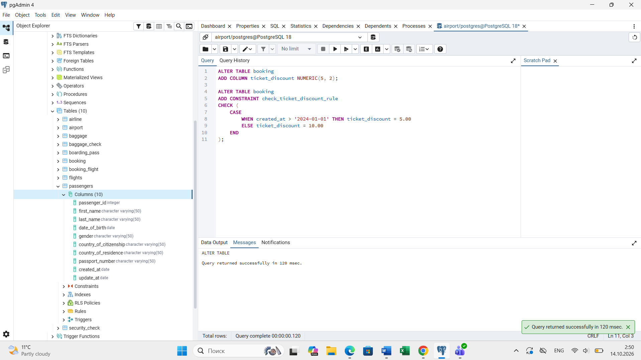
- Modify the booking table so that the booking status column has a default value of 'Confirmed'. Then insert a new booking without specifying booking status.
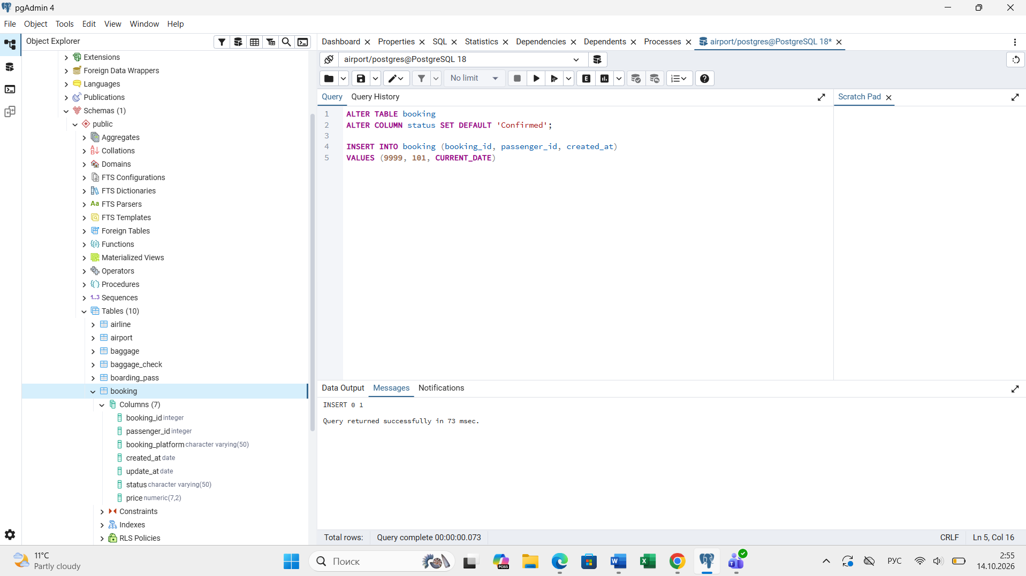
- Modify the appropriate date column in the database so that when a new record is inserted, the date is automatically set to the current date.
