**Project Report: Customer Success Platform**

1. **Introduction**

The Customer Success Platform project aimed to develop a comprehensive system that automates communication processes and enhances transparency within our system. By integrating Microsoft authentication via Auth0, the platform enables stakeholders to access and interact with project data seamlessly. This report outlines the project's objectives, implementation details, and user manual for effective utilization of the platform.

1. **Project Overview**

The project focuses on three main components: user authentication and registration, CRUD operations for project charter sections, and role-based management. Additionally, functionalities such as email notifications and document export ensure efficient communication and documentation within the platform.

1. **Implementation Details**
   1. **Registration and Login with Microsoft using Auth0**

**Description:**

* Implemented user authentication and registration functionalities from scratch to ensure a seamless onboarding process for users.
* Integrated Microsoft authentication via Auth0, allowing users to log in using their existing Microsoft accounts securely.

**Functionality:**

* Developed a user-friendly registration interface where users can create new accounts by providing basic information or authenticate using their Microsoft credentials.
* Utilized Auth0's authentication service to handle Microsoft login, ensuring secure authentication and seamless user experience.
* Implemented encryption techniques to store user information securely in the database, protecting user privacy and data integrity.
  1. **CRUD for each section of Project Charter**

**Description:**

* Developed CRUD functionality for all 15 sections of the Customer Success Platform, enabling users to manage project charter details effectively.
* Each section corresponds to a specific aspect of project management, providing users with granular control over project information.

**Functionality:**

* Created intuitive interfaces for each project charter section, allowing users to create, read, update, and delete project details effortlessly.
* Implemented validation mechanisms to ensure data accuracy and consistency, preventing unauthorized modifications to project information.
* Integrated error handling mechanisms to provide informative feedback to users in case of invalid inputs or system errors, enhancing user experience and system reliability.
  1. **Role-Based Management**

**Description:**

* Defined distinct roles for Admin, Auditor, Project Manager, and other stakeholders to manage access permissions effectively.
* Implemented role-based functionalities to ensure appropriate access control and data protection within the platform.

**Functionality:**

* Admins have full access privileges, including the ability to create, update, read, and delete projects and their sections.
* Auditors can view project details, assign project managers, add stakeholders, and access the Audit History table for tracking project changes.
* Project Managers have permissions to manage project charter details for assigned projects, allowing them to update project information as needed.
* Other stakeholders have read-only access to view project details relevant to their roles, ensuring data confidentiality and integrity.
  1. **Email Notification System**

**Description:**

* Integrated email notification functionality to inform stakeholders about updates and changes within the platform in real-time for the audit history.
* Developed triggers for project update notifications to keep stakeholders informed about relevant developments.

**Functionality:**

* Implemented email notification triggers to send on click notifications to stakeholders when project updates occur.
* Integrated email sending services with error handling mechanisms to ensure reliable delivery of notifications, minimizing the risk of missed updates**.**
  1. **Export as a Document**

**Description:**

* Implemented functionality to export project details in a predefined format, facilitating easy documentation and sharing of project information.
* Tested the export feature with CRUD operations to ensure accuracy and compatibility.

**Functionality:**

* Integrated document generation libraries to generate PDF documents containing project details in a standardized format. On click on the generate pdf button.
* Implemented error handling mechanisms to handle edge cases and ensure reliable document generation and download.
  1. **Technologies Used**

**Description:**

* The Customer Success Platform utilizes a modern stack of technologies and tools to ensure scalability, security, and usability.

**Technologies:**

Frontend Development:

* React.js: Used for building interactive user interfaces with reusable components.
* JavaScript (ES6+): Provides the core functionality and interactivity of the frontend.
* TailWind CSS: Used for structuring and styling the user interface elements.
* Monday UI: For the Frontend UI

Backend Development:

* Ruby on Rails (RoR): Chosen for its rapid development capabilities and robust framework for building RESTful APIs.
* PostgreSQL: Used as the primary relational database management system (RDBMS) for storing and managing project data.
* Auth0: Integrated for implementing secure authentication and authorization mechanisms, including Microsoft authentication.

**Other Technologies:**

* Git: Employed for version control and collaborative development, ensuring seamless code management and integration.

**Functionality:**

* The frontend technologies enable the creation of a dynamic and intuitive user interface, enhancing user experience and engagement.
* Ruby on Rails, along with PostgreSQL, forms the backbone of the backend infrastructure, providing robustness and scalability to handle project data effectively.
* Integration with Auth0 ensures secure authentication and seamless access control, enhancing platform security and user trust.

1. **User Manual**

**Registration and Login:**

Steps:

1. Visit the platform's Home page.
2. Choose between creating a new account or logging in using your Microsoft account via Auth0.
3. Fill in the required registration details or authenticate using your Microsoft credentials.
4. Upon successful registration/login, you'll be redirected to the platform dashboard according to role default is client.

**CRUD Operations:**

Steps:

1. Navigate to the relevant section of the platform corresponding to the project details you wish to manage.
2. Use the provided interface to create, read, update, or delete project details as required according to your roles.
3. Ensure to save changes after making updates to ensure data integrity.

**Role-Based Management:**

Steps:

1. Users are assigned roles based on their responsibilities within the project.
2. Admins have full access to create, update, read, and delete projects and their sections.
3. Auditors can view project details, assign project managers, and add stakeholders.
4. Project Managers have access to manage project charter details for assigned projects.
5. Other stakeholders have read-only access to view project details relevant to them.

**Email Notification System:**

Steps:

1. Email notifications are sent to stakeholders when auditor clicks on send mail.
2. Notifications include a summary of changes of audit history updated table.

**Export as a Document:**

Steps:

1. Navigate to the export section of the in the your project.
2. In that page you will get the generate pdf button.

**5.UI Images**

**1. Home page**

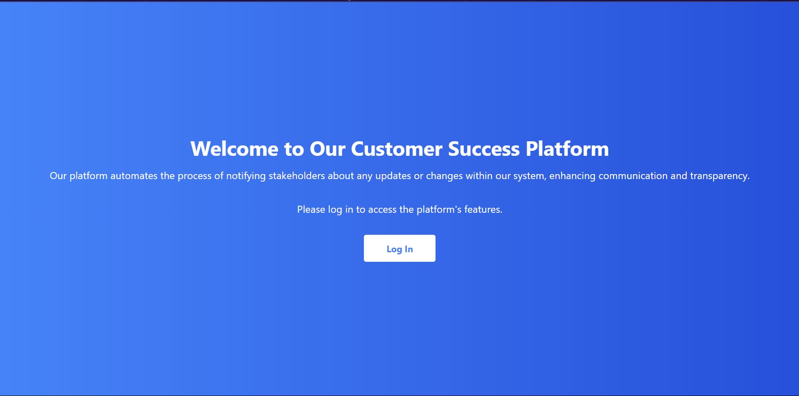

**2.Log in and Register auth0 interface.**

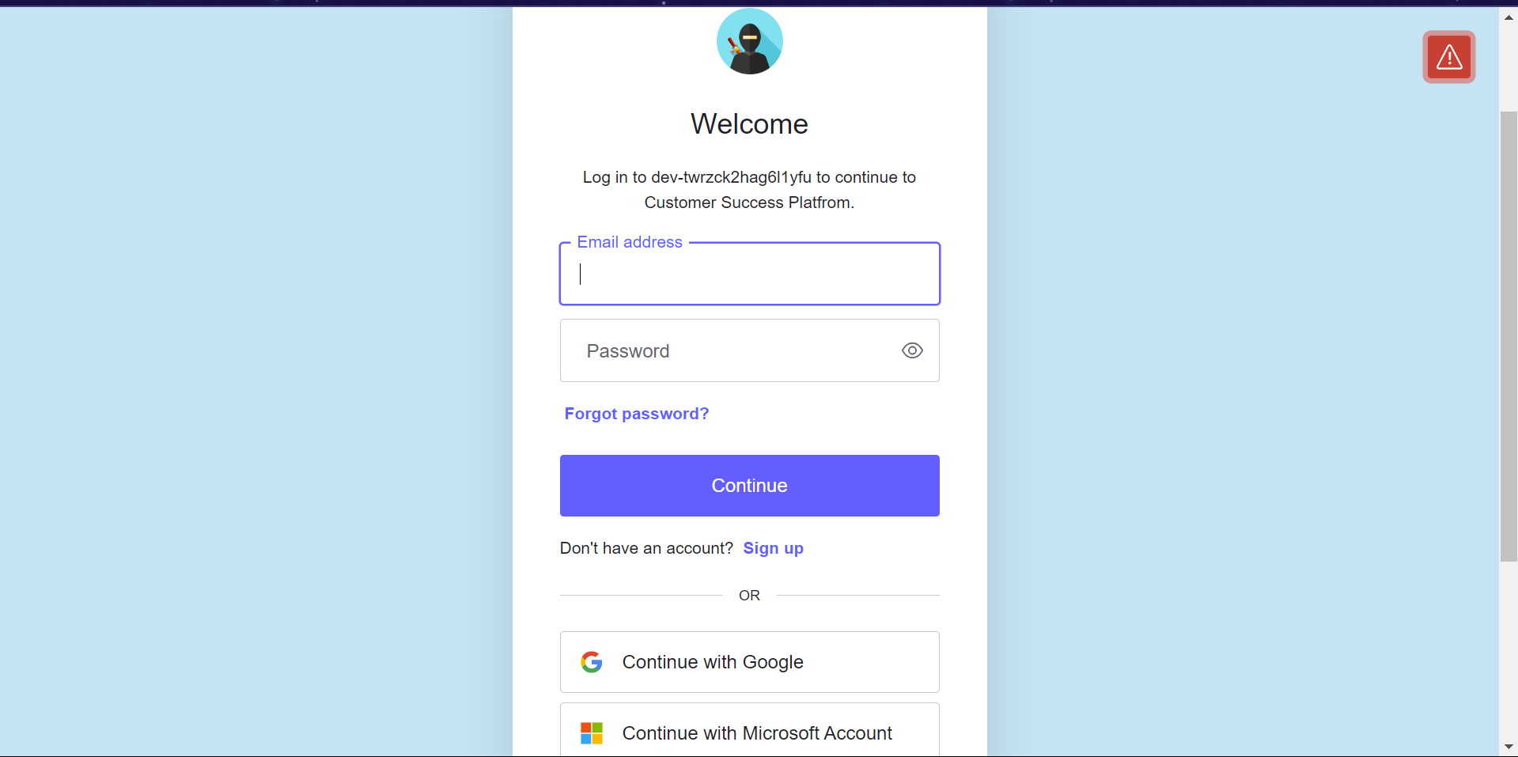

**3.Dashboard : Admin only has access to the users page where he/she can assign roles.**

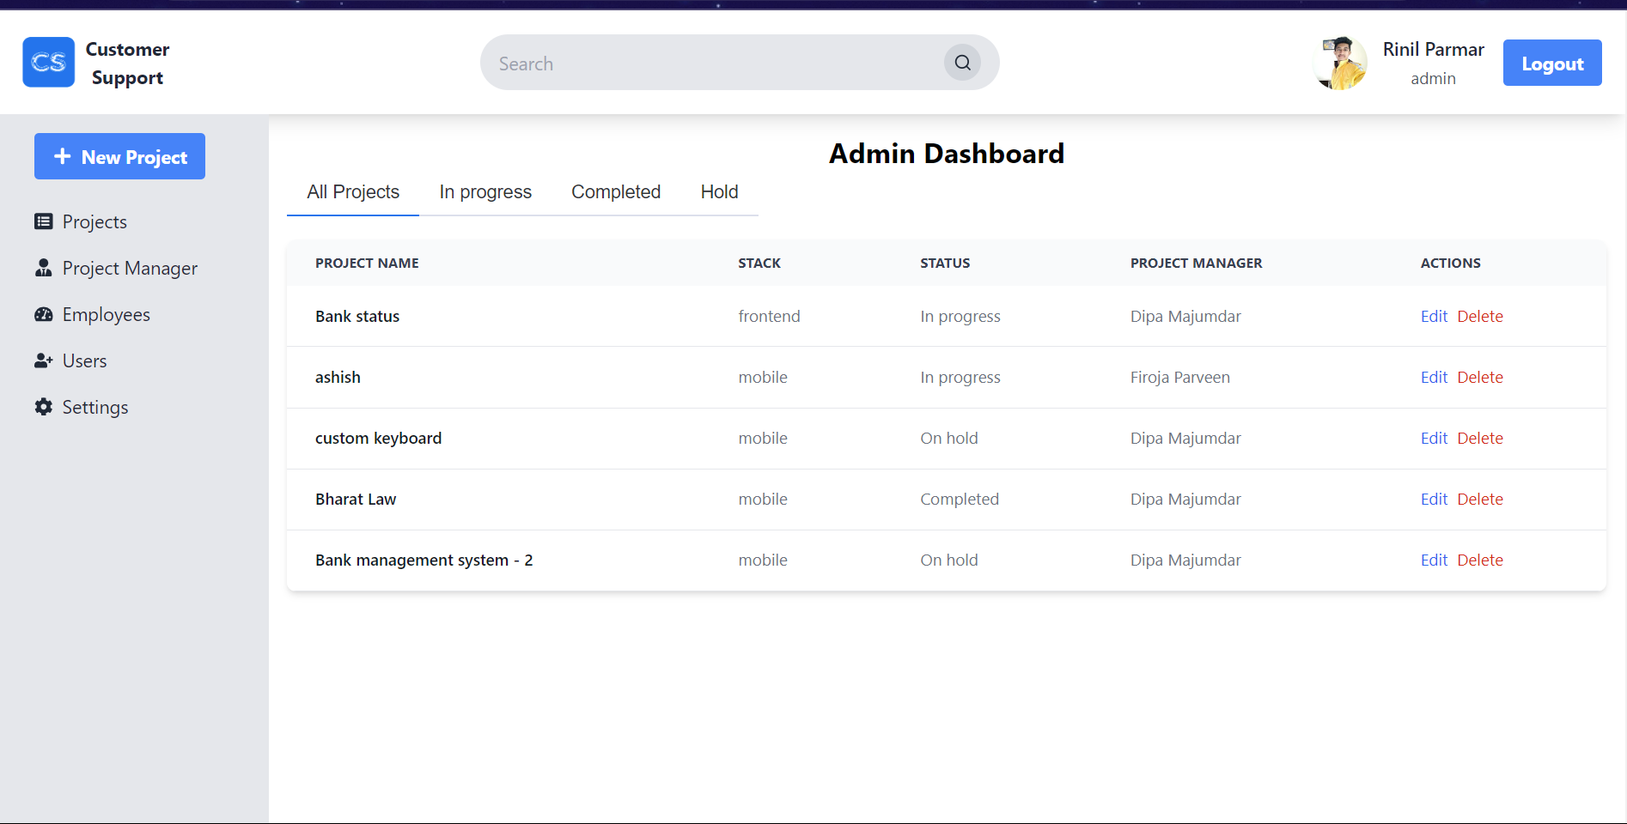

**4.Dashboard for other roles have limited access**

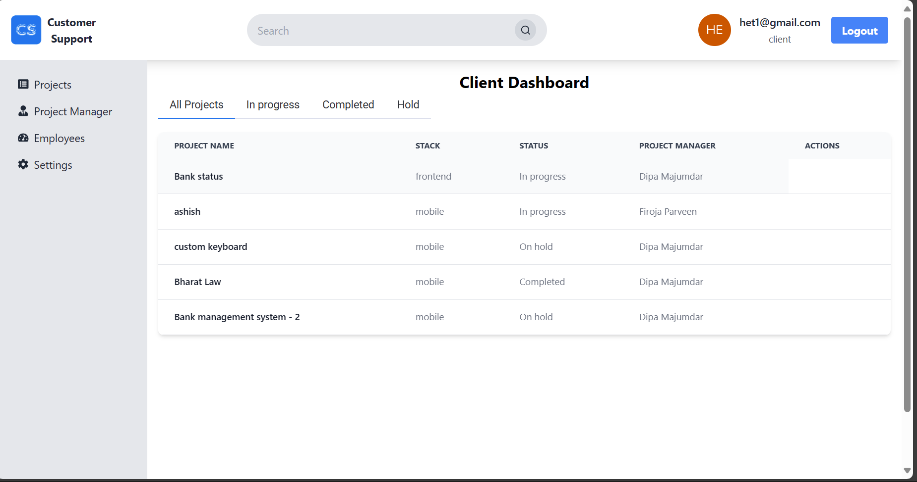

**I changed role client to auditor it don’t have access to Users page.**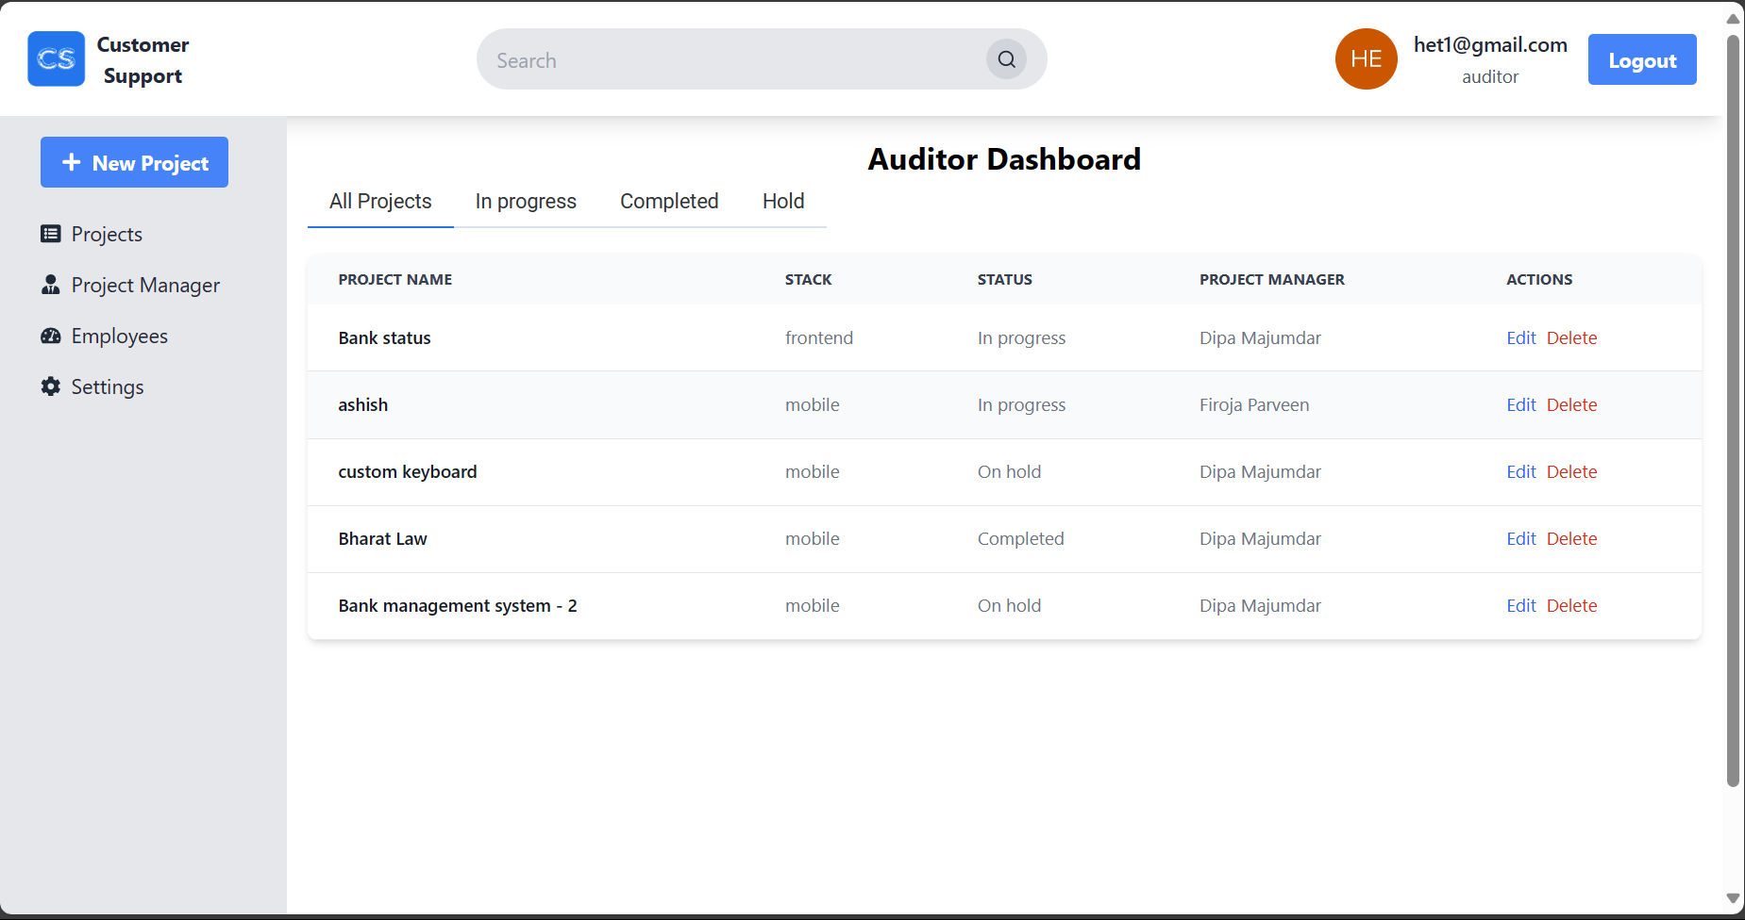

**5.New Project and Client details:**

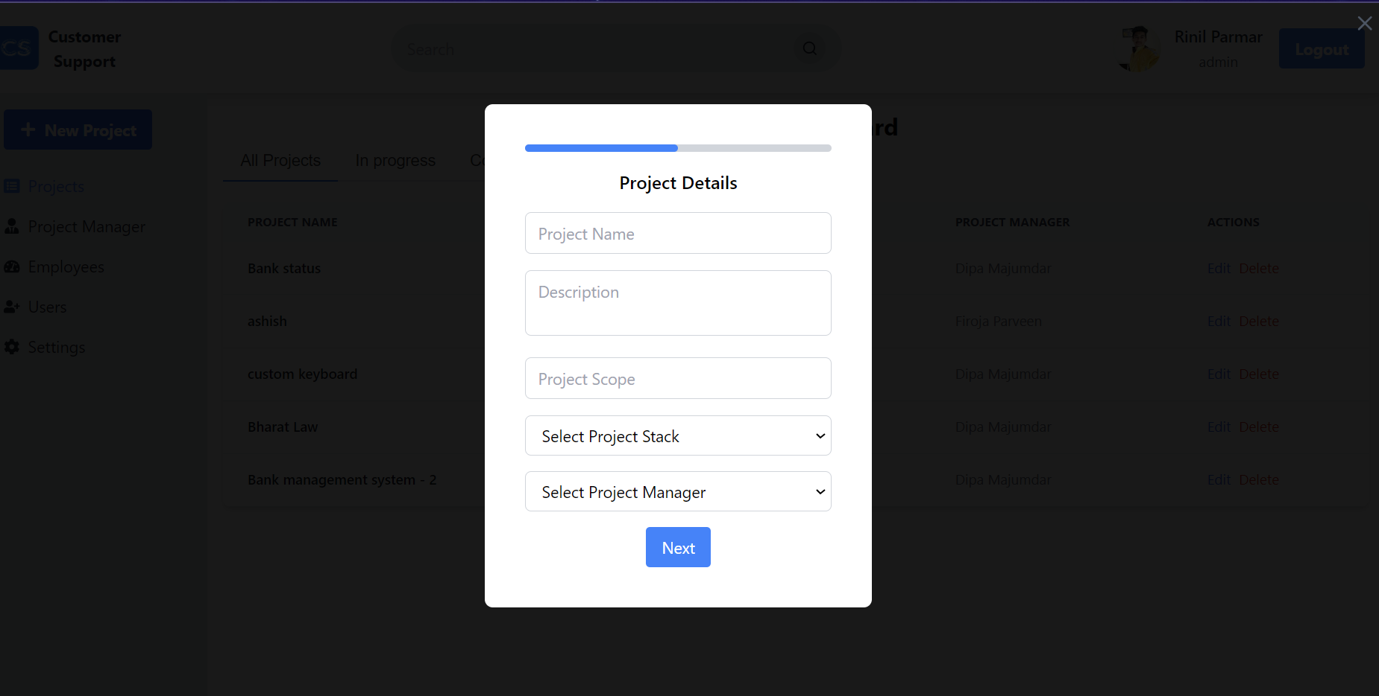

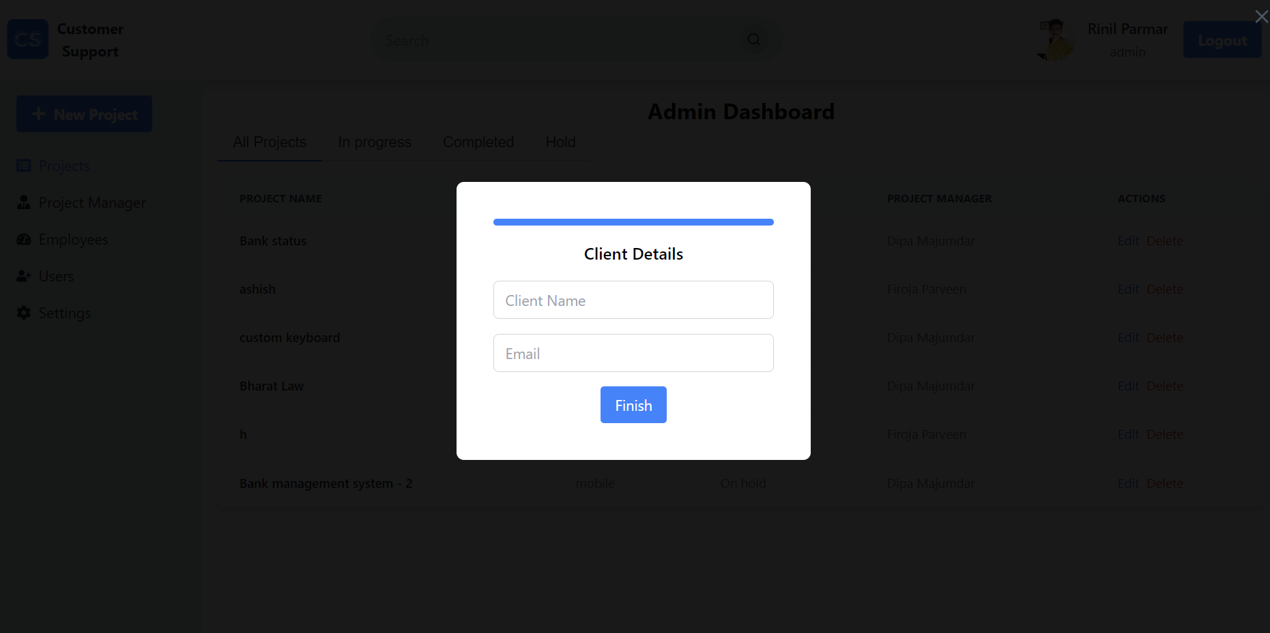

**6.Projects page**

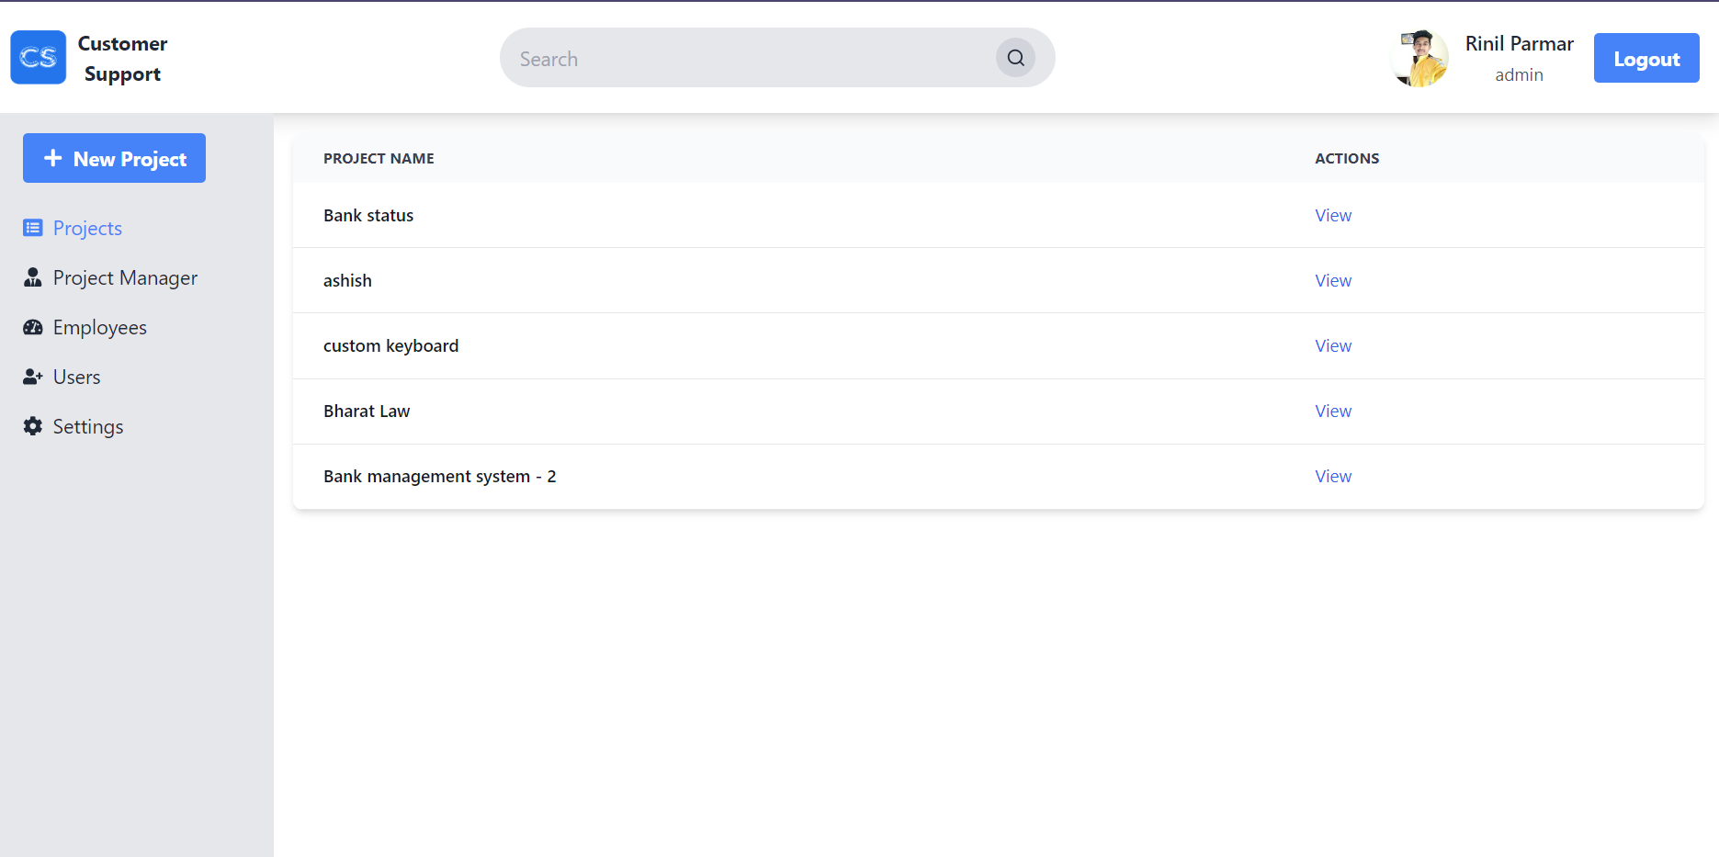

**7.Bharat Law Project details**

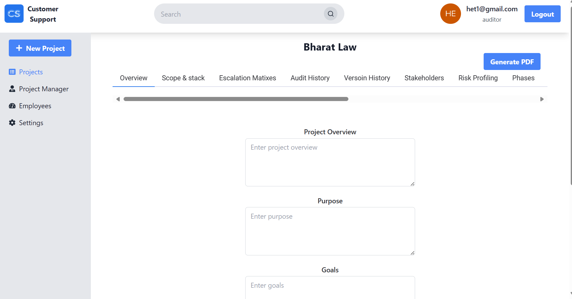

**8.Auditor has access to audit history and stakeholders. And also create project, overview and stacks.**

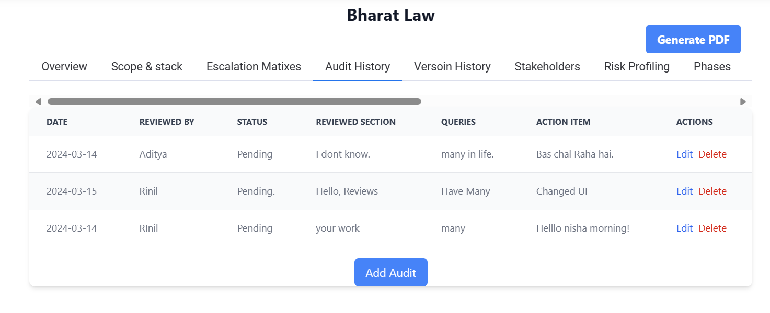

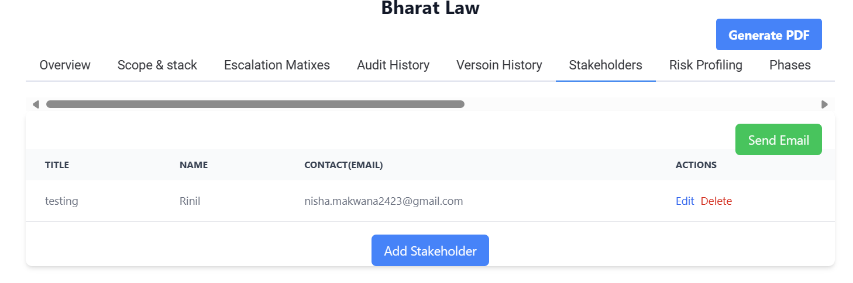

**9.Auditor don’t have access to other project details**

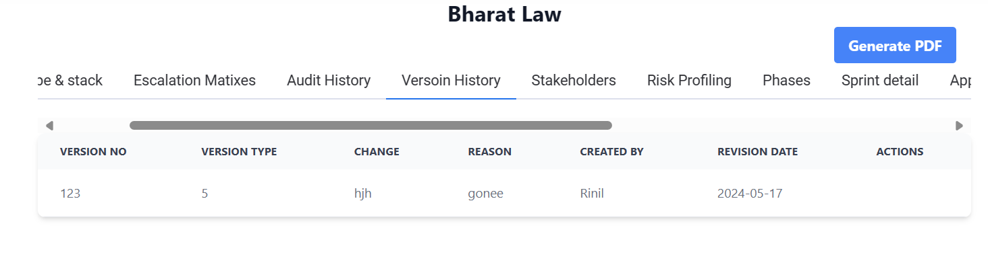

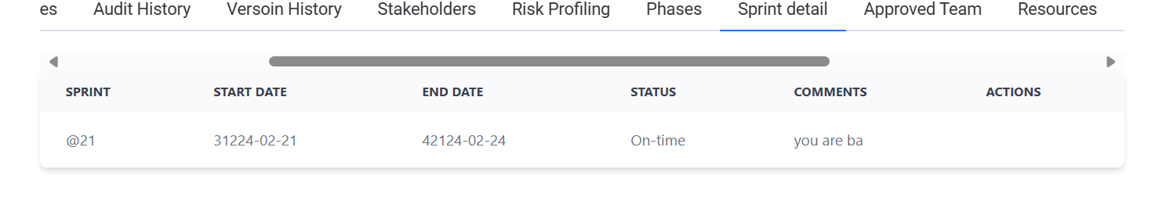

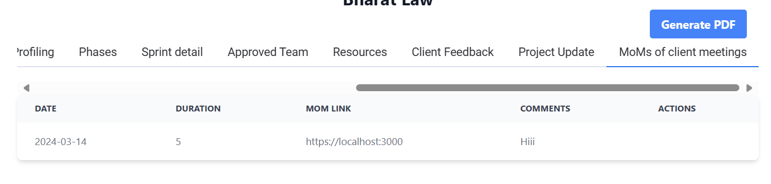

**10.Users page (only admin can access): admin can give access to register users.**

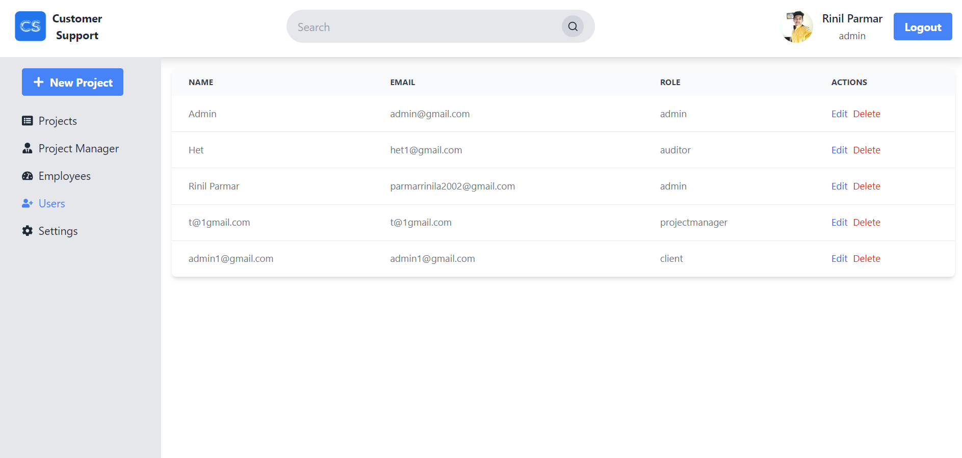

**11.Admin can assign roles**

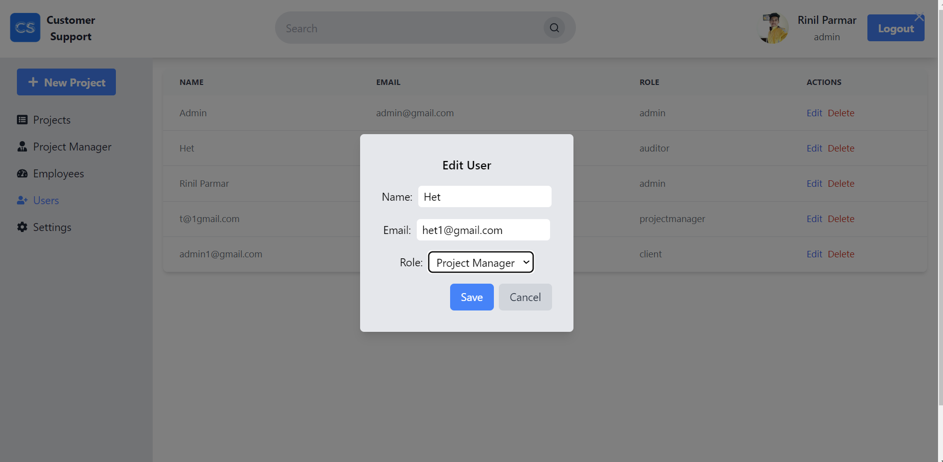

**12.Project manger can not add new project.**

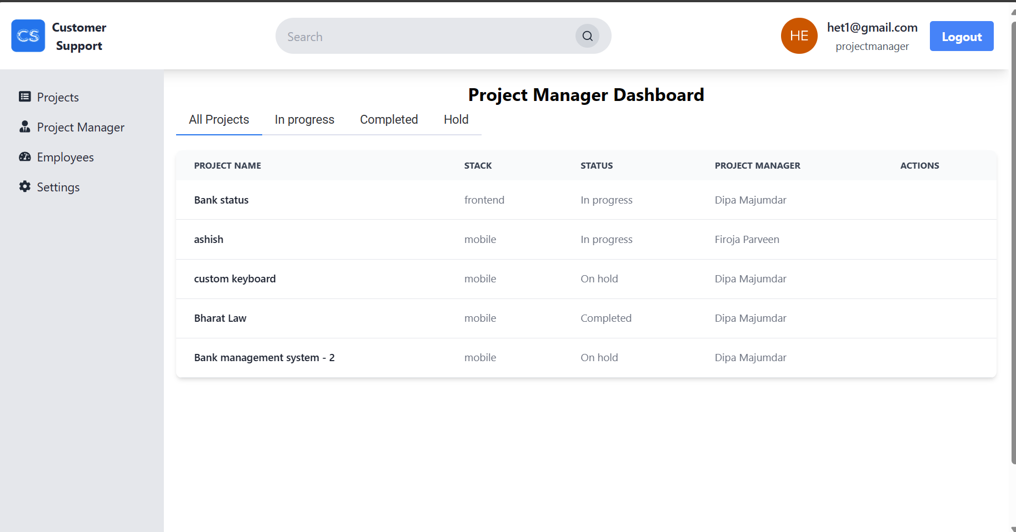

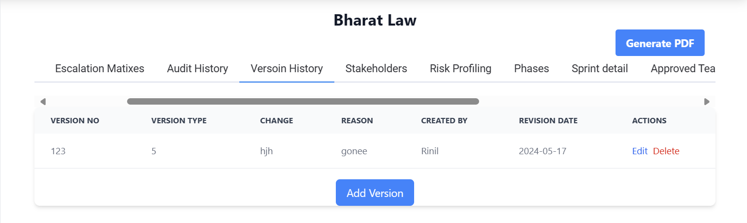

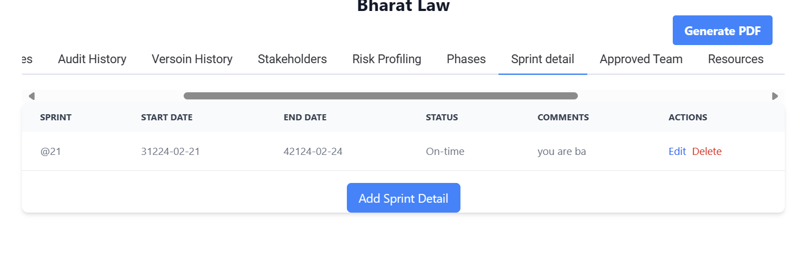

**13.Client/ Stack holders has view only access to all. But he/she can generate pdf.**

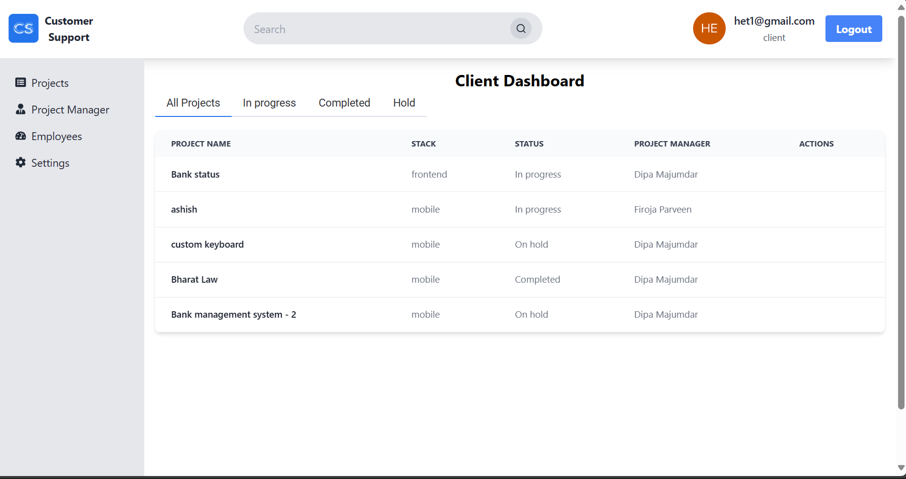

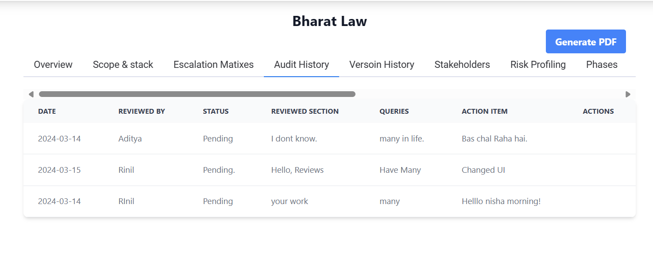

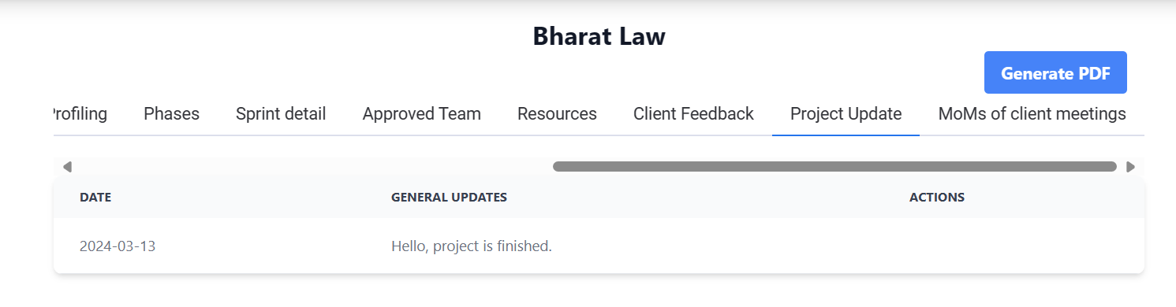

1. **Conclusion**

The Customer Success Platform project successfully achieved its objectives of automating communication processes and enhancing transparency within the system. By implementing user authentication, role-based management, email notifications, and document export functionalities, the platform provides a robust solution for managing project data efficiently.