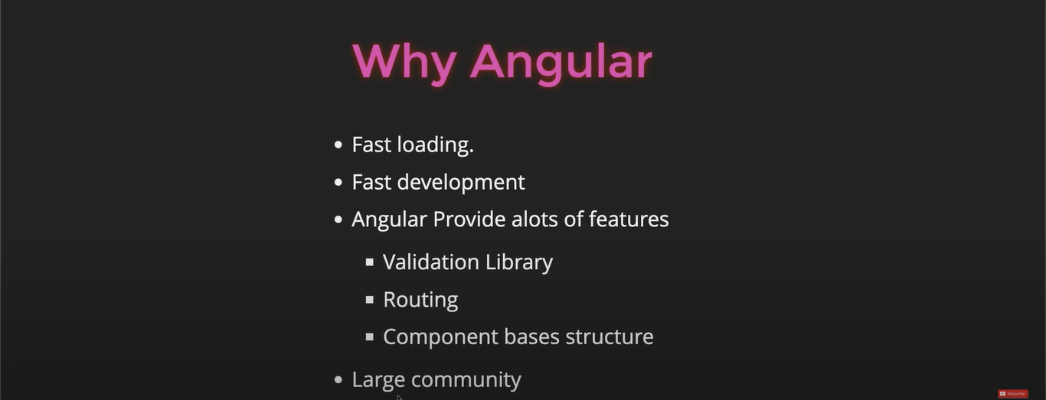

**Important -> In angular inside the class we can not use the variable we can only use the properties but there is a way to use variable inside the class is you can use only variable inside class inside the function not the outside the function.**

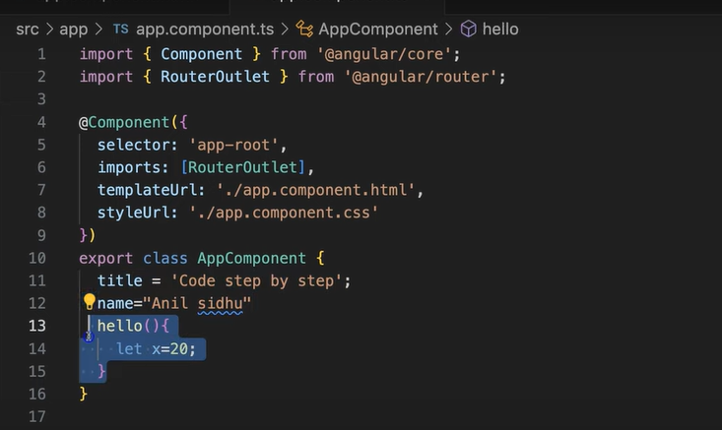

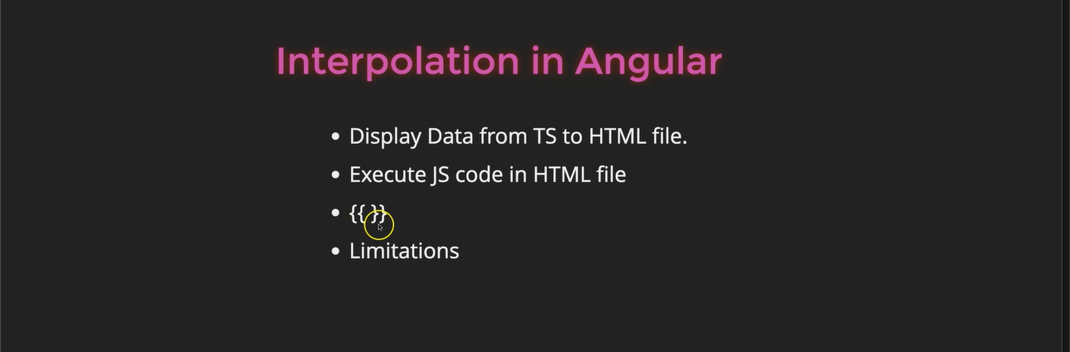

**Interpolation -> it is a way to bind data from the your component to the Html template**

**Advantages and limitation of interpolation -> You can perform many js operation inside the interpolation but few things not perform inside the interpolation (Note- you can not declare new variable inside the interpolation and u can not perform increament and decreament operation ).**

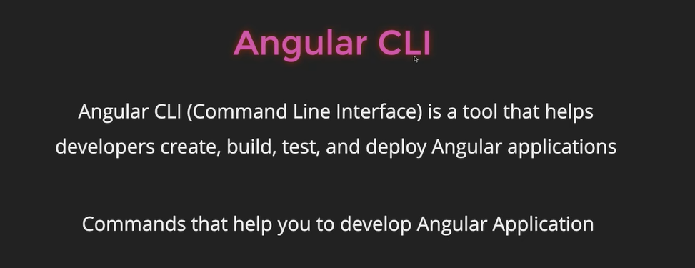

**Component ->** A component is a building block of an Angular application that combines HTML, logic, and styles to create a reusable part of the UI.