**ASSIGNMMENT:- 1**

**1) Install Power BI Desktop and share the final screenshot of the report view page which appears when power desktop starts.**

**Screenshot:**

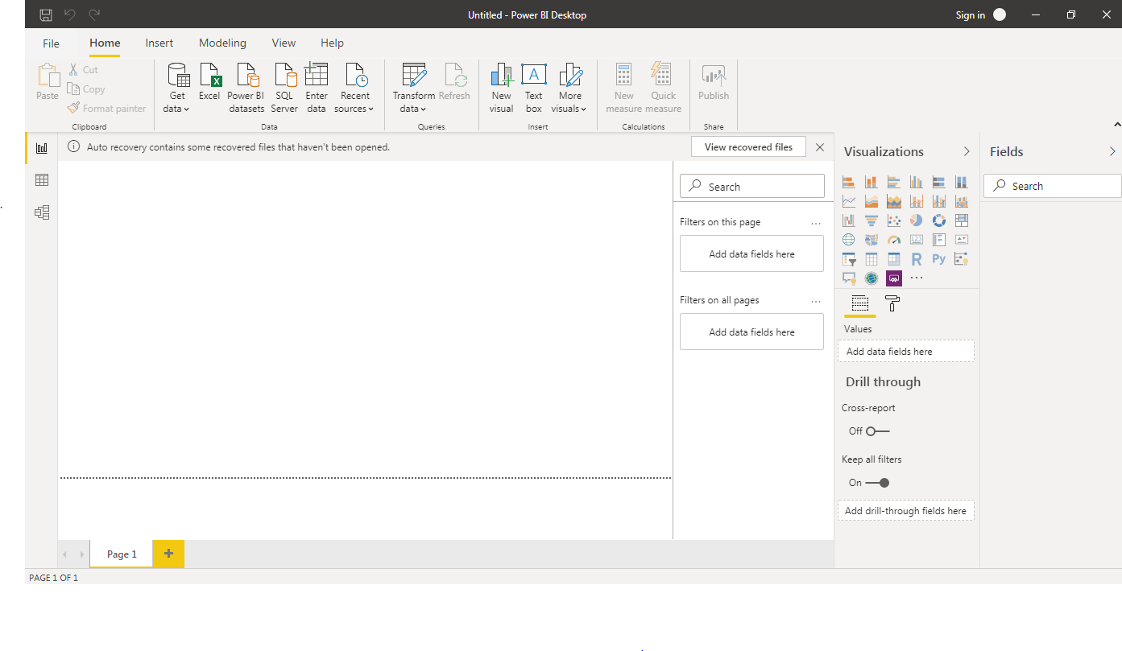

**2)Prepare a document and with the following screenshot**

**REPORT VIEW**



**DATA VIEW**

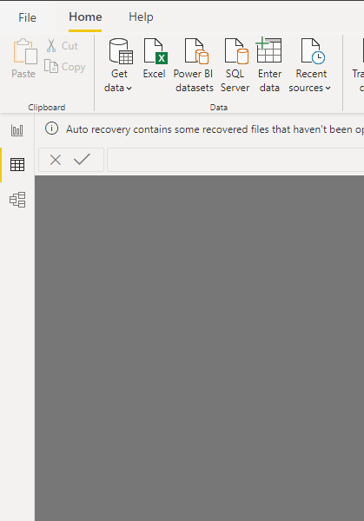

**MODEL VIEW**

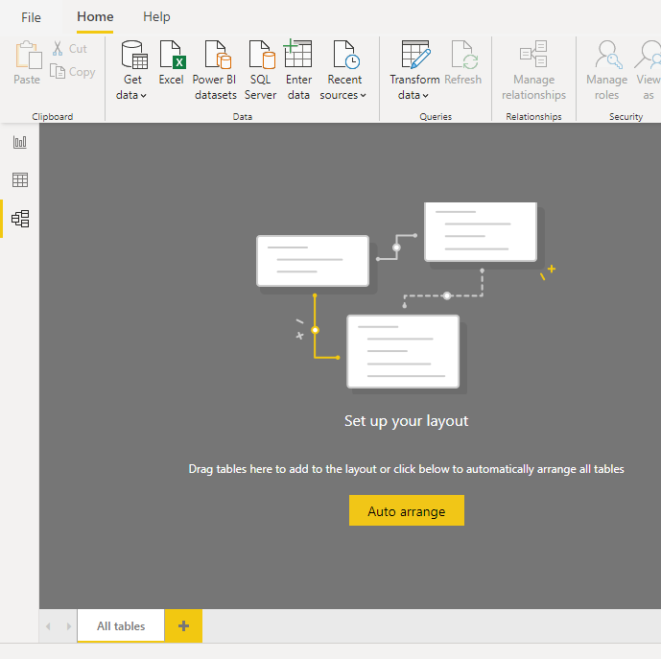

**POWER QUERY EDITOR**

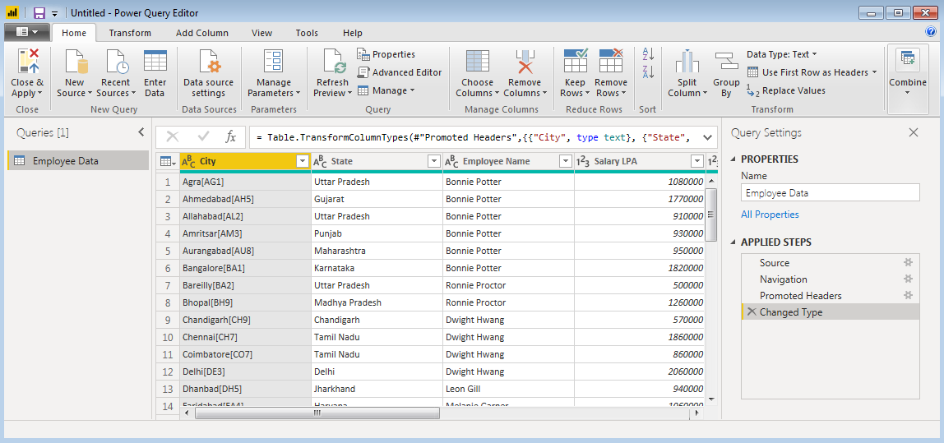

**ADVANCE EDITOR**

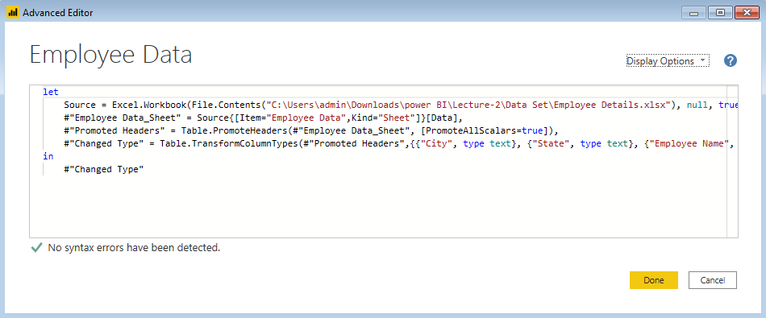

**3) Prepare a document with details of the following along with their price**

**Power BI Desktop**

Power BI Desktop is a free application you install on your local computer that lets you connect to, transform, and visualize your data. With Power BI Desktop, you can connect to multiple different sources of data, and combine them (often called modeling) into a data model. This data model lets you build visuals, and collections of visuals you can share as reports, with other people inside your organization. Most users who work on business intelligence projects use Power BI Desktop to create reports, and then use the Power BI service to share their reports with others.

The most common uses for Power BI Desktop are as follows:

* Connect to data
* Transform and clean that data, to create a data model
* Create visuals, such as charts or graphs, that provide visual representations of the data
* Create reports that are collections of visuals, on one or more report pages
* Share reports with others by using the Power BI service

**Power BI Pro**

Publish content to app workspaces, share dashboards, subscribe to dashboards and reports, share with users who have a Pro license

**Price :- Rs 660 monthly price per user**

**Power BI Premium**

 Power BI Premium subscription, you and your organization's users get access to:

* Greater scale and performance
* Flexibility to license by capacity
* Unify self-service and enterprise BI
* Extend on-premises BI with Power BI Report Server
* Support for data residency by region (Multi-Geo)
* Share data with anyone without purchasing a per-user license

**Price :- Rs 3,30,190 monthly price per dedicated cloud compute and storage resource with annual subcription**