**Mini Project Report**

**Analysis of measured and simulated data from Photovoltaic system for UK and Madrid (Spain) countries**

**MSc Applied in Data Science**

**Research Methods (EL4166)**

**University of Central Lancashire**

**Date: 2nd August 2021**

**Declaration**

I hereby acknowledge that the report is original and has not been plagiarized by any university. I completed all the work with the assistance of a few helpful tools.

**Word count: 2100**

**Date of Submission: 2nd August 2021**

**Table of Contents**

**1. Introduction 4**

1.1. Aim and Objectives 4

1.2. Structure of the report 4

**2. Literature review 5**

2.1. Theoretical Background 5

**3. Methodology 5**

**4. Data and Tools 6**

4.1. Available data 6

**5. Data Analysis 6**

**6. Simulation 10**

**7. Results and Discussions 11**

**8. Conclusion 11**

**9. Appendix 12**

**10. References 12**

1. **Introduction**

The rising energy requirements due to rapid advancement in technology and industrialization has led to the search of a reliable source of energy for the future re which is environmentally friendly. In this project two countries such as UK and Madrid (Spain) are brought to focus which have embraced solar energy through photovoltaic systems. The two countries are the project focuses on the performance of the Photovoltaic system in both countries due to different technological applications of the systems and the different prevailing weather conditions. All the solar trackers are most important for the appropriate choice of the components for the installation purpose of the "solar photovoltaic systems (PV)". The actual ability to track all the changeable positions dynamically is boosting the energy gaining values of the PV systems with the actual amount of the percentage of 20 to 30.

* 1. **Aim and Objectives**

The aim of this report to compare the data analysis of solar system which are installed in Madrid and UK.

The aims of this projects are as follows:

1. Find the total monthly output of the two trackers with the help of monitored data.
2. Measure the monthly output for the PV tracking system(the two trackers) in Preston with use of PVWatts calculator.
3. Same as like point number 2 but the difference only this for Spain (Madrid)
4. Plot the graph with the results 1,2,3 points which are mention above.
5. Plot the graph with the corresponding monthly solar radiation data on the plane of the trackers.
6. Estimate the yearly energy yield in KWh/KWP for points 1,2 and 3 which are mentioned above.
7. Discuss the accuracy with which the output of the systems can be simulated.
8. Give a comparison of performance of Photovoltaic systems in United Kingdom With those in Madrid.
   1. **Structure of the report**

The introduction segment provides a brief description of the given topic. The literature review portion is explained what is the study scope of this report had been done. The methodology section provides the actual values of all the data that are very important for completing the project plan. In the data and tools and data analysis sections, all the data that are selected from the database and all the graphs and comparison data for showing the difference between the two countries are described. In the conclusion part, all the data that are described in the comprehensive report are described shortly.

1. **Literature review**

Spanish policymakers encouraged the development of sustainable energy, focusing particularly on photovoltaic solar energy, as part of European policies aimed at introducing a less environmentally harmful and more diverse energy paradigm [1,13]. Spain, as one of the European states with the largest number of hours of ultraviolet irradiance, has ideal climate results of high concentrated solar energy generation. As a result, the state has placed a strong emphasis on this kind of sustainable power [6,15]. However, as the cost of solar panels has decreased, this innovation has become one of the most appealing to developers, which is yet another factor that the state deems [9,10]. For a tracking system the orientation of panel best to track the sunlight to get more generation.

* 1. **Theoretical Background**

Theoretical background very necessary for knowing the both trackers description of panels, panel orientation and performance. So basically, this tracker horizontal and vertical panel orientation is mattered to generate the more power with PV solar system which can be measured with KWH.

1. **Methodology**

In this project the methodology is that we gather data for UK and Madrid using different sources like internet. And that data should be simulated using PVWatts or Excel sheet. But the output will be considered when we show some graphical and statistical output.

From that graphical and statistical data, we perform optimization which system is better for installation of solar PV system. The results will be shown using plotting and calculation must be done using data gathered. At the end when we get all the output this will be the time for optimization. The basic purpose of this Report to compare and selection of best solar PV system.

Once optimization is achieved the aim of this project is achieved. Optimization is increased by increase in stability and performance of tracking system using best possible orientation of solar panels.

1. **Data and Tools**
   1. **Available data**

The desired comparison of the working performance of the photovoltaic tracking system between the various countries such as the UK and Madrid will be analyzed with the help of the various types of tools like **excel sheet, Simulink** and **PV Watts software**. The datasets for the UK, which is already given and for the Spain (Madrid) which is taken from internet.

1. **Data Analysis**

The monitored photovoltaic system dataset is holding day wise energy generation data for both the trackers. The dataset is of 12 months (entire year). The collected dataset has been available in csv file. To calculate the month wise energy data for both the trackers, data analysis related formula has been written. Afterwards for all 12 months and total energy generation at the end of a year has been derived in kwh.

|  |  |  |
| --- | --- | --- |
| **Month** | **Energy per inverter|IG 60(1) (# 1)** | **Energy per inverter|IG 60(2) (# 2)** |
| **January** | 159.28 | 138.1 |
| **February** | 428.5 | 382.29 |
| **March** | 329.51 | 352.73 |
| **April** | 561.41 | 507.45 |
| **May** | 1105.16 | 1125.31 |
| **June** | 1121.22 | 1112.27 |
| **July** | 995.09 | 988.73 |
| **August** | 484.34 | 480.62 |
| **September** | 462.57 | 480.33 |
| **October** | 380.21 | 405.85 |
| **November** | 114.99 | 206.66 |
| **December** | 103.78 | 113.25 |
| **Total** | **6246.06** | **6293.59** |

**Table 1: Monthly analysis of monitored energy yield data for two trackers**

By following the url <https://pvwatts.nrel.gov/>, the dataset has been collected by selecting the appropriate location from the solar data resource site map. To get a price value, rate 0.09 $/kwh has been kept and rate type kept as commercial. Remaining all the parameters kept as default. The results has been downloaded for monthly data analysis. For two trackers, the energy data related information has been found in AC System Output(kWh) and DC Array Output(kWh). Apart from that, the report has generated Solar Radiation (kWh/m^2/day), Plane of Array Irradiance (W/m^2), and Value ($) data for further analysis.

|  |  |  |  |  |  |
| --- | --- | --- | --- | --- | --- |
| Month | AC System Output(kWh) | Solar Radiation (kWh/m^2/day) | Plane of Array Irradiance (W/m^2) | DC array Output (kWh) | Value ($) |
| 1 | 112.1144 | 1.081954 | 33.54057 | 120.09 | 10.09 |
| 2 | 149.4673 | 1.585394 | 44.39103 | 158.8556 | 13.45 |
| 3 | 257.162 | 2.452686 | 76.03327 | 271.2526 | 23.14 |
| 4 | 402.9855 | 4.069644 | 122.0893 | 422.6498 | 36.27 |
| 5 | 512.5684 | 5.146496 | 159.5414 | 536.7088 | 46.13 |
| 6 | 480.321 | 5.029634 | 150.889 | 503.4147 | 43.23 |
| 7 | 505.7954 | 5.221362 | 161.8622 | 529.8408 | 45.52 |
| 8 | 463.1451 | 4.755108 | 147.4083 | 485.0532 | 41.68 |
| 9 | 332.0954 | 3.443094 | 103.2928 | 348.665 | 29.89 |
| 10 | 228.9105 | 2.258342 | 70.00861 | 241.6692 | 20.6 |
| 11 | 130.9961 | 1.311716 | 39.35147 | 139.6106 | 11.79 |
| 12 | 78.86875 | 0.765716 | 23.7372 | 85.64382 | 7.1 |
| Total | 3654.43 | 37.12115 | 1132.145 | 3843.454 | 328.89 |

**Table 2: Monthly analysis of photovoltaic system data for two trackers at UK**

The way dataset has been collected in above section for UK, by following the similar type of approach the dataset has been collected for the spain madrid as well. Again the dataset is holding similar types of parameters for all 12 months.

|  |  |  |  |  |  |
| --- | --- | --- | --- | --- | --- |
| Month | AC System Output(kWh) | Solar Radiation (kWh/m^2/day) | Plane of Array Irradiance (W/m^2) | DC array Output (kWh) | Value ($) |
| 1 | 280.773 | 2.776213 | 86.06261 | 294.5543 | 25.27 |
| 2 | 325.5695 | 3.608619 | 101.0413 | 340.7643 | 29.3 |
| 3 | 519.3677 | 5.325717 | 165.0972 | 542.2378 | 46.74 |
| 4 | 551.8545 | 5.821287 | 174.6386 | 576.2074 | 49.67 |
| 5 | 598.0317 | 6.377273 | 197.6955 | 624.49 | 53.82 |
| 6 | 638.2589 | 7.156058 | 214.6817 | 666.2685 | 57.44 |
| 7 | 681.254 | 7.5701 | 234.6731 | 710.9833 | 61.31 |
| 8 | 625.0112 | 6.836609 | 211.9349 | 652.2502 | 56.25 |
| 9 | 464.6575 | 5.079939 | 152.3982 | 485.4774 | 41.82 |
| 10 | 388.3343 | 4.075349 | 126.3358 | 406.2103 | 34.95 |
| 11 | 293.1414 | 3.067426 | 92.02278 | 307.0417 | 26.38 |
| 12 | 202.1272 | 1.980051 | 61.38158 | 213.3273 | 18.19 |
| Total | 5568.381 | 59.67464 | 1817.963 | 5819.813 | 501.14 |

**Table 3: Monthly analysis of photovoltaic system data for two trackers at Spain**

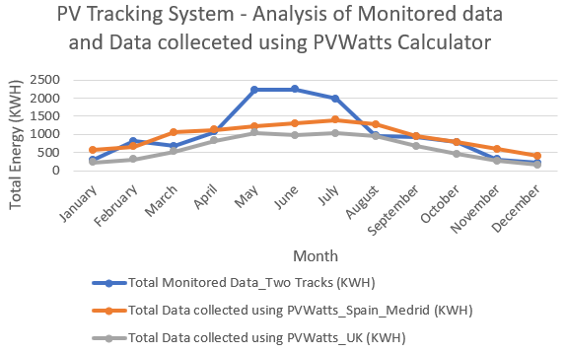

**Image 1: Result comparison between monitored photovoltaic system output and that collected using PVWatts calculator for preston campus UK and Madrid in Spain**

The graphical analysis of the photovoltaic system energy dataset for the monitored dataset along with that monitored using PVWatts calculator. The graph is for the purpose of analyzing the total energy generated by both the trackers. The energy value monitored during the months of may, june, and july are the heighest among all with 2230.48 kwh, 2233.49 kwh, and 1983.82 kwh. The average total energy generation by combining both the tracker is 10475.21 kwh at the end of a year.

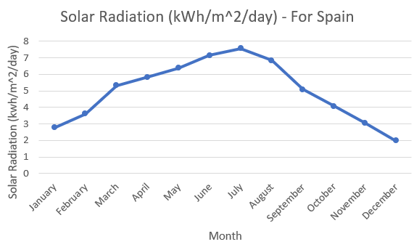

**Image 2 : Solar radiation data visualization month wise for Spain**

The solar radiation data month wise for Spain has been shown in figure 1. It varies in the range 1.98 kWh/m^2/day in december month to 7.55 kWh/m^2/day in july month. The total amount of solar ration in a year observed as 59.67 kWh/m^2/day and average solar radiation per month is 4.97 kWh/m^2/day.

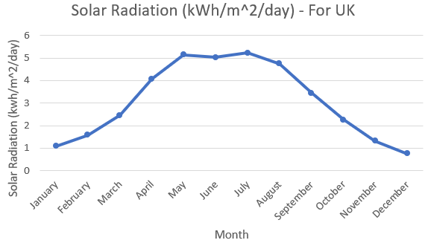  
**Image 3: Solar radiation data visualization month wise for UK**

The solar radiation data month wise for UK has been shown in figure 1. It varies in the range 0.76 kWh/m^2/day in december month to 5.22 kWh/m^2/day in july month. The total amount of solar ration in a year observed as 37.12 kWh/m^2/day and average solar radiation per month is 3.09 kWh/m^2/day.

**Estimation of the annual energy yield**

The global formula to estimate the electricity generated in output of a photovoltaic system is:

**E = A * r * H * PR**

**Where, E = Energy (kWh)  
 A = Total solar panel Area (m2)  
 r = solar panel yield or efficiency(%)   
 H = Annual average solar radiation on tilted panels (shadings not included)  
 PR = Performance ratio, coefficient for losses (range between 0.5 and 0.9, default value = 0.75)**

For spain, total solar panel area is 93.31 m^2 with default efficiency parameter as 16%, and annual average radiation as 59.67 khw/m^2. The value chosen for PR is 0.5. As per the above equation, energy yield estimation after a year is 5345.646 kwh. On the other hans, the value of area under cover with solar panel is 98.44 m^2, solar panel yield is 16%, annual average radiation as 37.12, and performance value as 0.5. The estimated yield value after a year is 3508.25 kwh.

1. **Simulation**

Using above data, we can easily do simulation. In figure 6 there is simulation shown for solar panel and load also connect to measure each solar panel voltage.

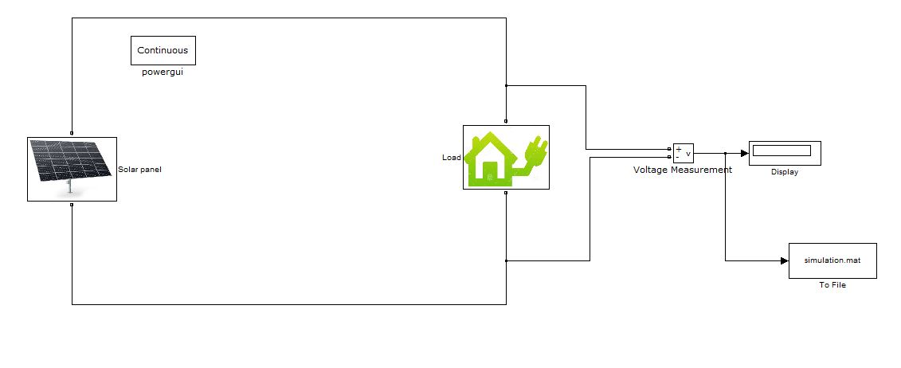

**Image 6: Simulation (source: Simulink)**

From this solar panel power transmitted to load which is measured by voltage measurement. And the data will be displayed at display for showing the voltage rating of a solar panel. The .mat file use for transferring the data from Simulink to .mat file. As in the code it is mentioned .mat file is loaded, and we can get output result of this simulation.

1. **Results and Discussions**

**In Accuracy with which the output of the systems to simulate**

A system may have been financed on the basis of its output, and so the user needs to measure the output and compare to the claims for the system.The complexity and performance of such system can be determined by measuring the accuracy of the measurements to be made. The collected monthly values of power generation, solar radiation, and Plane of Array Irradiance have become the normal way of disseminating the performance of a Photo Voltaic system, and a comparison with monitored dataset is becoming crucial to assess the data values.

With the only one tracker to measure AC System output in KWH, the measured energy with PVWatts calculator at Spain is 5568.38 kwh. Whereas, the estimated yield energy as per the equation of E = A * r * H * PR is 5345.64 kwh. The accuracy can be determined by measuring the difference between the actual observed value and the generated yield value. As per that observayion, accuracy score is 96%. On the other hand for UK, the total amount of energy at the end of a year calcumated using PVWatts calculator is 3654.43 kwh and the calculated estimated yield is 3508.25 kwh. In this case also, the observed accuracy is 96%.

1. **Conclusion**

**Performance comparison between PV tracking systems in the UK and Spain**

In this conclusion I am discussing regarding performance camparison between PV tracking systmes of UK and Spain. Which is described below:

The PV tracking system in UK and spain both are two tracker system. The performance can be compared between both on the parameters as system energy generation (kwh), solar radiation (kWh/m^2/day), Plane of Array Irradiance (W/m^2), and total cost ($). The values measured both bothe places are by keeping default parameters. The total amount of energy generated by each of two trackers at Spain are 5568.38 kwh and 5819.81 kwh respectively. On the other hand, the energy generated at UK by each of two tracker is 3654.43 kwh and 3843.45 kwh. Total amount of solar radiation at spain is 59.67 kWh/m^2/day and at UK is 37.12 kWh/m^2/day. In July month, heighest amount of energy has been produced at bothe the places and by each trackers. Whereas, in december month, lowest amount of energy generation has been discovered. Total amount of energy generated at the end of a year at spain is 11388.19 khw and the energy generated at UK is 7497.88 khw. This means, amount of energy generated at spain is 51.88 % heigher that that observed at UK.

1. **Appendix**

By comparing these two data the optimum system is the UK and Madrid. Using above discussion, I have attached some link which is based on my work. Where I have uploaded my excel work for calculation.

Link: <https://github.com/Rinkesh3161/Research-method>

1. **References**
2. Avril, S., Mansilla, C., Busson, M., Lemaire, T. (2012) Financial assessment and efficiency analysis of public interest for photovoltaic energy in five selected countries. Policy on Energy.
3. Bailera, M.; Lisbona, P. (2018) Renewable energy in Spain: predicting electricity surpluses and evaluating power-to-gas.
4. Cambium, L.(2019) Whose self-sufficiency? Energy dependency in Spain from 1939. Energy Policy.
5. Consumer Sector Residence en Espalier. (2013)
6. Energy Nan electronics reports on energy supply in Europe and Ireland.Available.online:https://www.sciencedirect.com/science/article/pii/S1876610217307142
7. Escondido, R., Suarez, R., Sandra, J.J. (2019) Field assessment of thermal comfort conditions and energy performance of social housing.
8. FACTORIES EMISION DE CO2 Y COEFICIENTES DE PASO A ENERGY PRIMARIA DEL SECTOR EDIFICIOS EN.
9. Gomez, A.; Dopazo, C.; Fueyo, N. (2016) The Spanish energy bubble is an example of the “cost of not doing” energy preparation.
10. Green, M.A. (2005) Short Communication: Associations between price and performance for photovoltaic modules in 2004.
11. Green, M.A. (2005) A look back at the first 50 years of silicon photovoltaic cells.
12. INE base/Industrial, (2020) Energy y Construction/Industrial Energy.
13. Intertek Testing & Certification Ltd, (2012), The Household Electricity Survey is a study that looks at how much electricity is used in An investigation into the use of electrical products in the home.
14. Kumar Sahu, (2015) B. A study on global solar PV energy developments and policies with special focus on the top ten solar PV power producing countries.
15. Perlin, J. (2013). A History of Photovoltaic. A. Achieving Blue Growth through maritime spatial planning.
16. [mad9]Sanchez-Duran, R., Barbancho, J., Luque, J. (2019) Solar Energy Production for a De-carbonization Scenario in Spain