2) Find total transaction value for each transaction type by Quarter in 2018

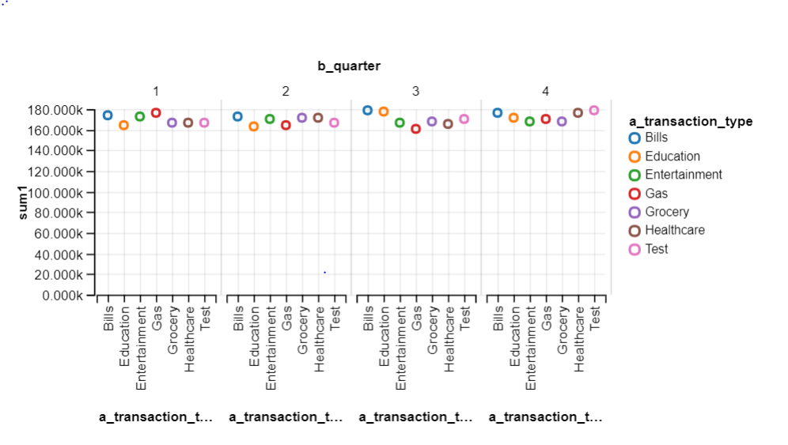

select sum(a.transaction_value) as sum1,a.transaction_type,b.quarter

from CDW_SAPP_F_CREDIT_CARD a join CDW_SAPP_D_Time b

on a.transaction_id = b.transaction_id

group by b.quarter,a.transaction_type;

1) Find the top 20 zip codes(hint: branch_zip) by total transaction value

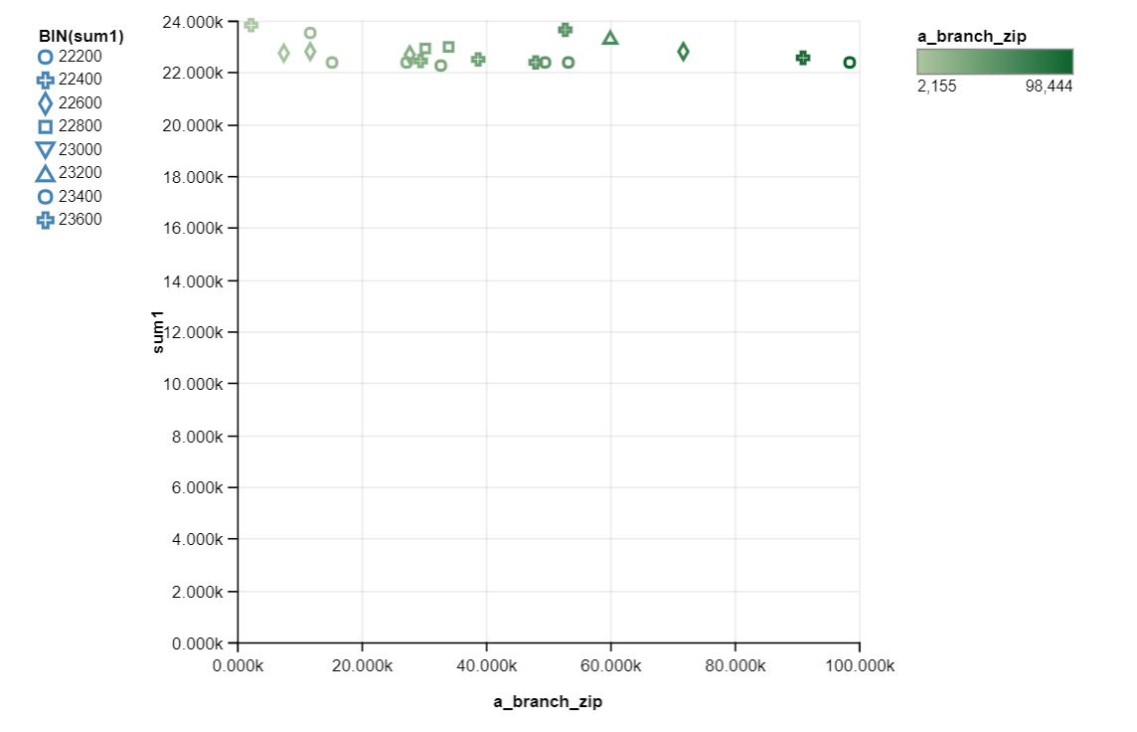

select a.branch_zip,sum(b.transaction_value) as sum1

from CDW_SAPP_D_BRANCH a join CDW_SAPP_F_CREDIT_CARD b

on a.branch_code = b.branch_code

group by a.branch_zip

order by sum1 desc

limit 20