**Q-1) Write a Java program to print "Hello, World!" to the console.**

**Program:**

public class HelloWord {

public static void main(String[] args) {

System.out.println("Hello , Word!");

}

}

**Output:** 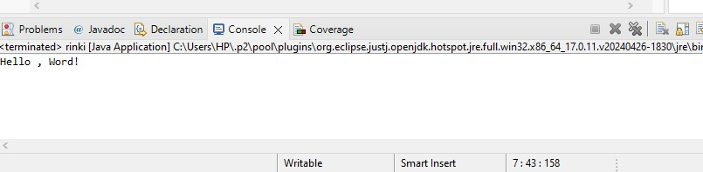

**Q-2)** **Write a program to find the sum of two numbers entered by the user.**

**Program:**

import java.util.Scanner;

public class SumOfTwoNumbers {

public static void main(String[] args) {

Scanner s = new Scanner(System.in);

System.out.println("Enter first number: ");

double num1 = s.nextDouble();

System.out.println("Enter second number: ");

double num2 = s.nextDouble();

double sum = num1 + num2;

System.out.println("Sum: " + sum);

s.close();

}

}

**Output** 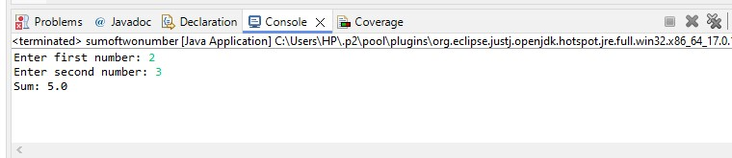

**Q-3) Write a Java program to check whether a given number is even or odd.**

**Program:**

import java.util.Scanner;

public class home {

public static void main(String[] args) {

Scanner s = new Scanner(System.in);

System.out.print("Enter a number: ");

int number = s.nextInt();

if (isEven(number)) {

System.out.println(number + " is even.");

} else {

System.out.println(number + " is odd.");

}

s.close();

}

public static boolean is Even(int num) {

return num % 2 == 0;

}

}

**Output:** 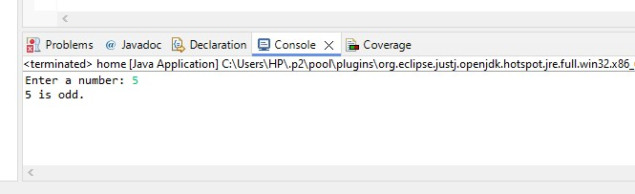

**Q-4) Write a program to calculate the factorial of a number using recursion.**

**Program:**

public class Factorialnumber {

public static void main(String[] args) {

int number = 8;

System.out.println("Factorial of " + number + ": " + factorial(number));

}

static int factorial(int n) {

if (n == 0)

return 1;

else

return n * factorial(n - 1);

}

}

**Output:** 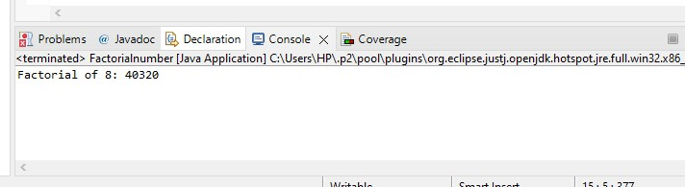

**Q-5) Write a java program to find greatest of 2 numbers.**

**Program:**

import java.util.Scanner;

public class GreatestOfTwoNumbers {

public static void main(String[] args) {

Scanner s = new Scanner(System.in);

System.out.print("Enter first number: ");

int num1 = s.nextInt();

System.out.print("Enter second number: ");

int num2 = s.nextInt();

int max = num1 > num2 ? num1 : num2;

System.out.println("The greatest number is: " + max);

s.close();

}

}

**Output:** 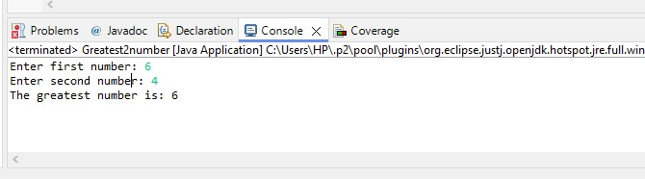

**Q-6)** **Write a program to implement a basic calculator that takes input as a string expression and evaluates it.**

**Program:**

import java.util.Scanner;

public class EvaluateCalcutor {

public static void main(String[] args) {

// TODO Auto-generated method stub

Scanner sc = new Scanner(System.in);

System.out.println("Enter expression to evaluate:");

String expression = sc.nextLine();

try {

double result = evaluateExpression(expression);

System.out.println("Result: " + result);

} catch (Exception e) {

System.out.println("Error: " + e.getMessage());

}

}

public static double evaluateExpression(String expression) throws Exception {

String operator = "";

int operatorIndex = -1;

for (int i = 0; i < expression.length(); i++) {

if (expression.charAt(i) == '+' || expression.charAt(i) == '-' ||

expression.charAt(i) == '*' || expression.charAt(i) == '/') {

operator = String.valueOf(expression.charAt(i));

operatorIndex = i;

break;

}

}

if (operatorIndex == -1) {

}

double operand1 = Double.parseDouble(expression.substring(0, operatorIndex));

double operand2 = Double.parseDouble(expression.substring(operatorIndex + 1));

switch (operator) {

case "+":

return operand1 + operand2;

case "-":

return operand1 - operand2;

case "*":

return operand1 * operand2;

case "/":

if (operand2 == 0) {

throw new ArithmeticException("Division by zero is not allowed");

}

return operand1 / operand2;

default:

throw new IllegalArgumentException("Invalid operator: " + operator);

}

}

}

**Output:** 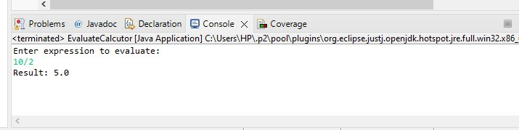

**Q-7)** **Write a Java program to check if a given number is even or odd.**

**Program:**

import java.util.Scanner;

public class home {

public static void main(String[] args) {

Scanner s = new Scanner(System.in);

System.out.print("Enter a number: ");

int number = s.nextInt();

if (isEven(number)) {

System.out.println(number + " is even.");

} else {

System.out.println(number + " is odd.");

}

s.close();

}

public static boolean is Even(int num) {

return num % 2 == 0;

}

}

**Output:** 

**Q-8) Create a Java program that compares two numbers and prints the larger one.**

**Program:**

import java.util.Scanner;

public class CompareNumbers {

public static void main(String[] args) {

int num1 = 15;

int num2 = 10;

if (num1 > num2) {

System.out.println(num1 + " is larger than " + num2);

} else if (num2 > num1) {

System.out.println(num2 + " is larger than " + num1);

} else {

System.out.println("Both numbers are equal.");

}

}

}

**Output:** 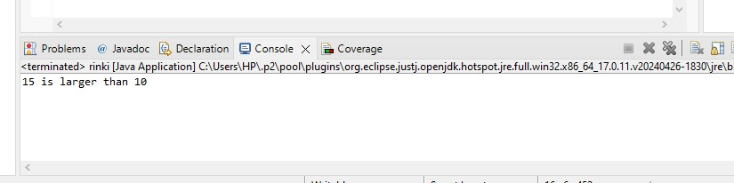

**Q-9) Write a Program to Array.**

**Program:**

public class hello {

int empcode;

String city;

String name;

hello (int empcode, String city, String name)

{

this.empcode=empcode;

this.city=city;

this.name=name;

}

public String toString()

{

return empcode +" " + city +" "+name;

}

public static void main(String[] args)

{

hello h=new hello(456,"Rinki","mumbai");

System.out.println(h);

}

}

**Output:**

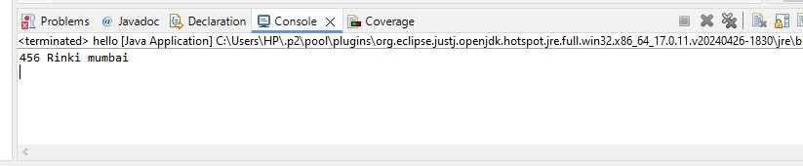

**Q-10) Write a program to Array List**

**Program:**

import java.util.*;

public class List {

public static void main(String[] args) {

// TODO Auto-generated method stub

ArrayList<String> colorlist = new ArrayList<String>(2);

colorlist.add("Red");

colorlist.add("Blue");

for(String value: colorlist)

{

System.out.println("Value form arraylist:"+value);

}

Object[] obj = colorlist.toArray();

for(Object value2: obj)

{

System.out.println("Value from array:"+ value2);

}

}

}

**Output:** 