Q.1)     Write a program that takes a student's score as input and outputs the corresponding grade based on the following scale:

A: 90-100

B: 80-89

C: 70-79

D: 60-69

F: 0-59

**Program**:

**import** java.util.Scanner;

**public** **class** Correspondinggrade {

**public** **static** **void** main(String[] args) {

// **TODO** Auto-generated method stub

Scanner sc = **new** Scanner(System.***in***);

System.***out***.print("Enter the student's score (0-100): ");

**if** (sc.hasNextDouble()) {

**double** score = sc.nextDouble();

String grade = *getGrade*(score);

**if** (grade.equals("Invalid score")) {

System.***out***.println("Please enter a valid score between 0 and 100.");

} **else** {

System.***out***.println("The grade is: " + grade);

}

} **else** {

System.***out***.println("Please enter a numeric value.");

}

sc.close();

}

**public** **static** String getGrade(**double** score) {

**if** (score >= 90 && score <= 100) {

**return** "A";

} **else** **if** (score >= 80 && score <= 89) {

**return** "B";

} **else** **if** (score >= 70 && score <= 79) {

**return** "C";

} **else** **if** (score >= 60 && score <= 69) {

**return** "D";

} **else** **if** (score >= 0 && score <= 59) {

**return** "F";

} **else** {

**return** "Invalid score";

}

}

**Output:** 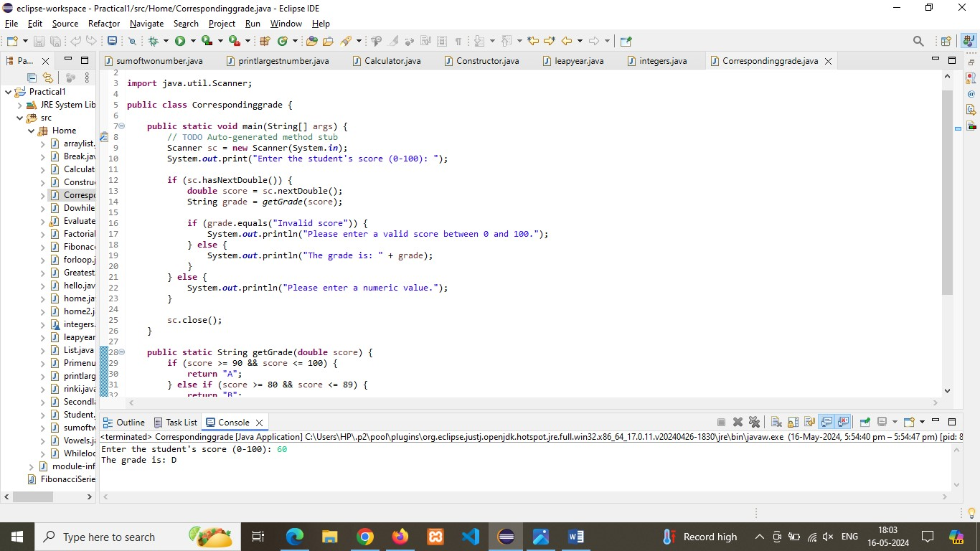

Q.2)  Write a program to check if a given year is a leap year. (A year is a leap year if it is divisible by 4 but not by 100, or it is divisible by 400.)

**Program:**

**import** java.util.Scanner;

**public** **class** leapyear {

**public** **static** **boolean** isLeapYear(**int** year) {

**if** ((year % 4 == 0 && year % 100 != 0) || (year % 400 == 0)) {

**return** **true**;

} **else** {

**return** **false**;

}

}

**public** **static** **void** main(String[] args) {

// **TODO** Auto-generated method stub

Scanner sc = **new** Scanner(System.***in***);

System.***out***.print("Enter a year: ");

**int** year = sc.nextInt();

**if** (*isLeapYear*(year)) {

System.***out***.println(year + " is a leap year.");

} **else** {

System.***out***.println(year + " is not a leap year.");

}

sc.close();

}

**Output:**

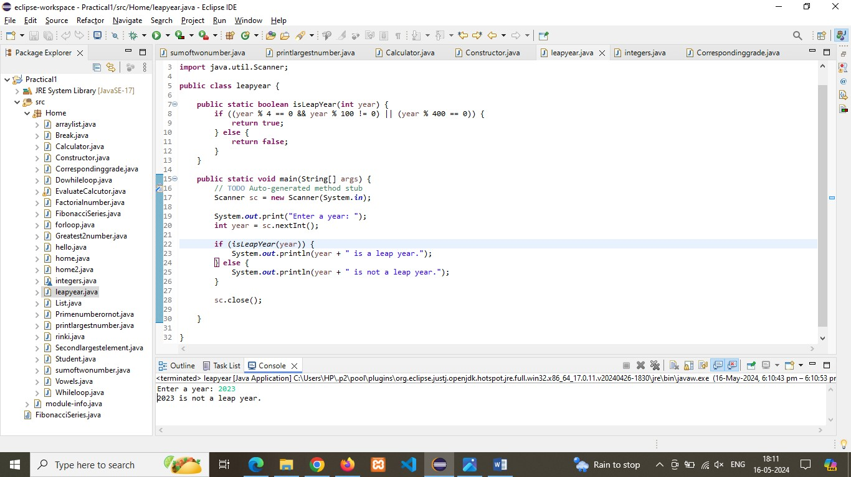

Q.3) Write a program that takes an integer as input and checks if it is positive, negative, or zero.

**Program:**

**import** java.util.Scanner;

**public** **class** Checknumber {

**public** **static** **void** main(String[] args) {

// **TODO** Auto-generated method stub

Scanner scanner = **new** Scanner(System.***in***);

System.***out***.print("Enter an integer: ");

**if** (scanner.hasNextInt()) {

**int** number = scanner.nextInt();

**if** (number > 0) {

System.***out***.println("The number is positive.");

} **else** **if** (number < 0) {

System.***out***.println("The number is negative.");

} **else** {

System.***out***.println("The number is zero.");

}

} **else** {

System.***out***.println("Please enter a valid integer.");

}

scanner.close();

}

}

**Output:** 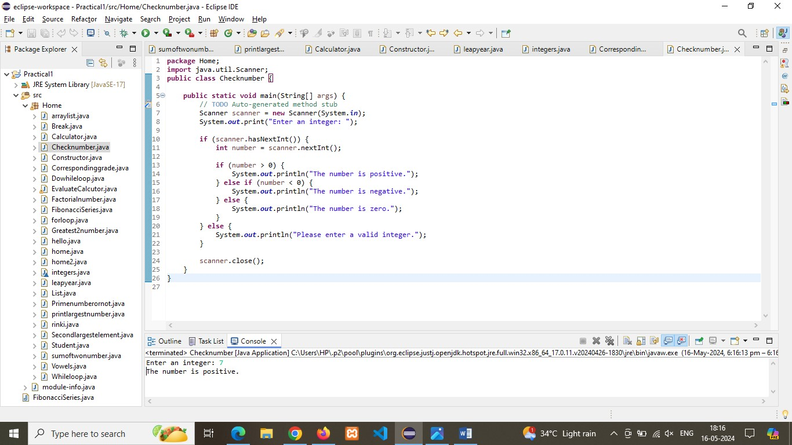

Q.4) Write a program that prints numbers from 1 to 10 using a loop.

**Program:**

**public** **class** Printnumber {

**public** **static** **void** main(String[] args) {

// **TODO** Auto-generated method stub

**for** (**int** i = 1; i <= 10; i++) {

System.***out***.println(i);

}

}

}

**Output:** 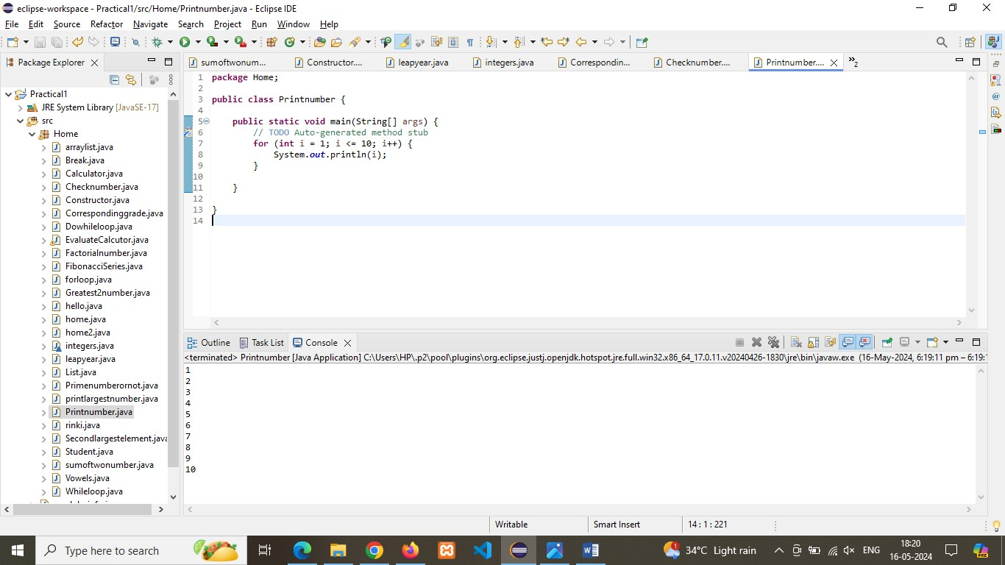

Q.5) Write a program that takes an integer N as input and calculates the sum of entered numbers.

**Program:**

**import** java.util.Scanner;

**public** **class** Sumofnumber {

**public** **static** **void** main(String[] args) {

// **TODO** Auto-generated method stub

Scanner sc = **new** Scanner(System.***in***);

System.***out***.print("Enter the number of integers to sum (N): ");

**if** (sc.hasNextInt()) {

**int** N = sc.nextInt();

**int** sum = 0;

System.***out***.println("Enter " + N + " numbers:");

**for** (**int** i = 1; i <= N; i++) {

**if** (sc.hasNextInt()) {

**int** number = sc.nextInt();

sum += number;

} **else** {

System.***out***.println("Invalid input. Please enter an integer.");

sc.next(); // Clear the invalid input

i--; // Decrement i to retry this iteration

}

}

System.***out***.println("The sum of the entered numbers is: " + sum);

} **else** {

System.***out***.println("Invalid input. Please enter an integer for N.");

}

sc.close();

}

}

**Output:** 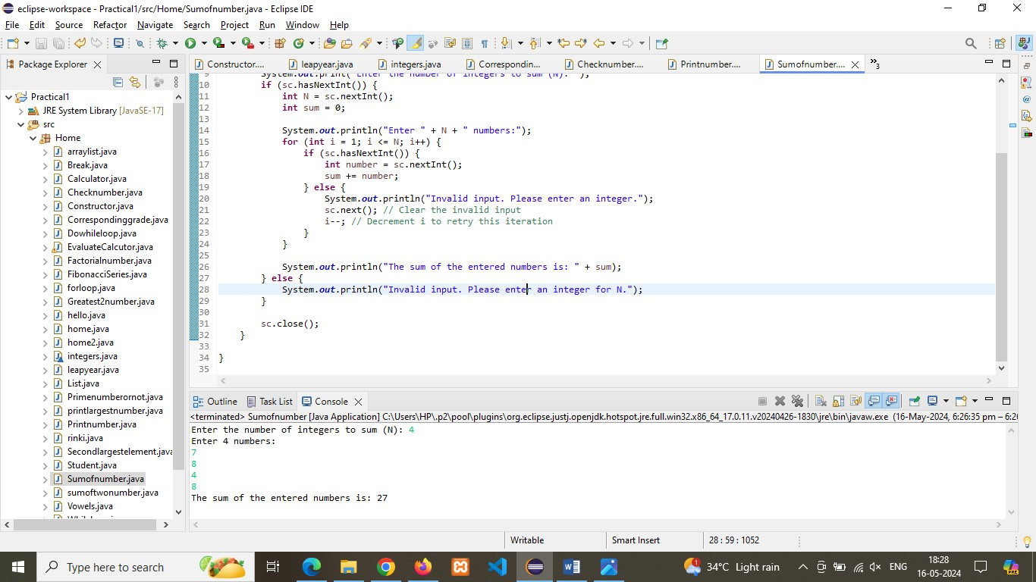

Q.6) Write a program that takes an integer as input and prints its multiplication table up to 10.

**Program:**

**import** java.util.Scanner;

**public** **class** Multiplecationtable {

**public** **static** **void** main(String[] args) {

// **TODO** Auto-generated method stub

Scanner scanner = **new** Scanner(System.***in***);

System.***out***.print("Enter an integer: ");

**if** (scanner.hasNextInt()) {

**int** number = scanner.nextInt();

System.***out***.println("Multiplication table of " + number + ":");

**for** (**int** i = 1; i <= 10; i++) {

System.***out***.println(number + " x " + i + " = " + (number * i));

}

} **else** {

System.***out***.println("Invalid input. Please enter a valid integer.");

}

scanner.close();

}

}

**Output:** 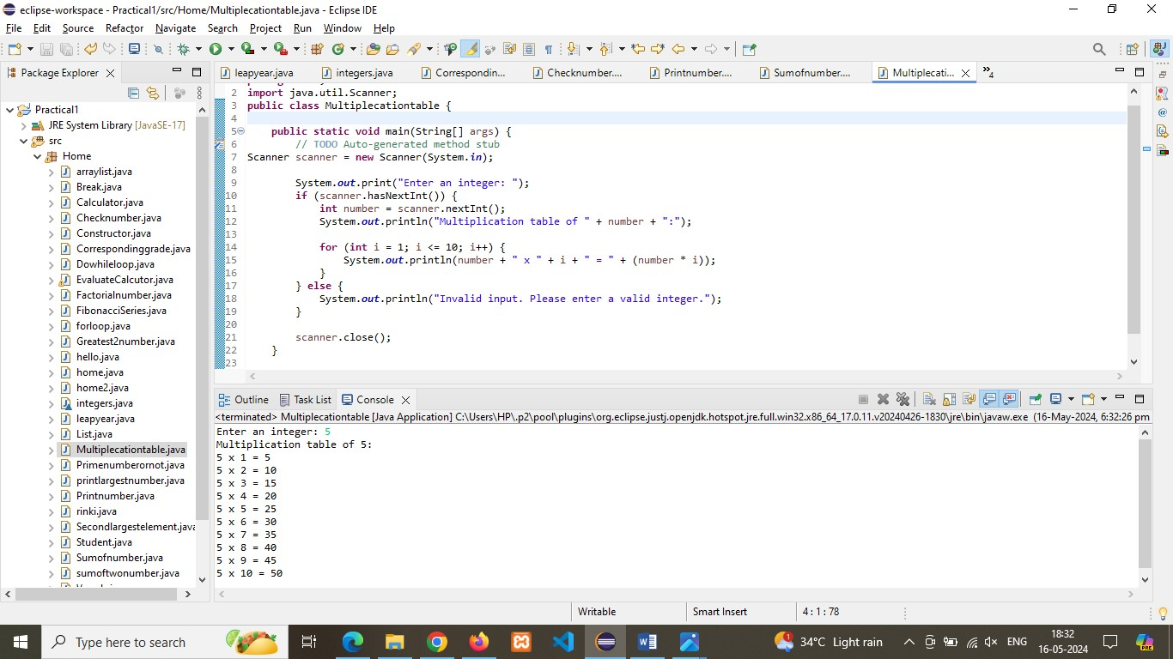

Q.7) Write a program that takes a positive integer as input and prints its digits in reverse order.

**Program:**

**import** java.util.Scanner;

**public** **class** reversedigit {

**public** **static** **void** main(String[] args) {

// **TODO** Auto-generated method stub

Scanner sc = **new** Scanner(System.***in***);

System.***out***.print("Enter a positive integer: ");

**if** (sc.hasNextInt()) {

**int** number = sc.nextInt();

**if** (number < 0) {

System.***out***.println("Please enter a positive integer.");

} **else** {

System.***out***.println("The digits in reverse order are:");

**while** (number > 0) {

**int** digit = number % 10;

System.***out***.print(digit);

number /= 10;

}

System.***out***.println(); }

} **else** {

System.***out***.println("Invalid input. Please enter a valid positive integer.");

}

sc.close();

}

}

**Output:** 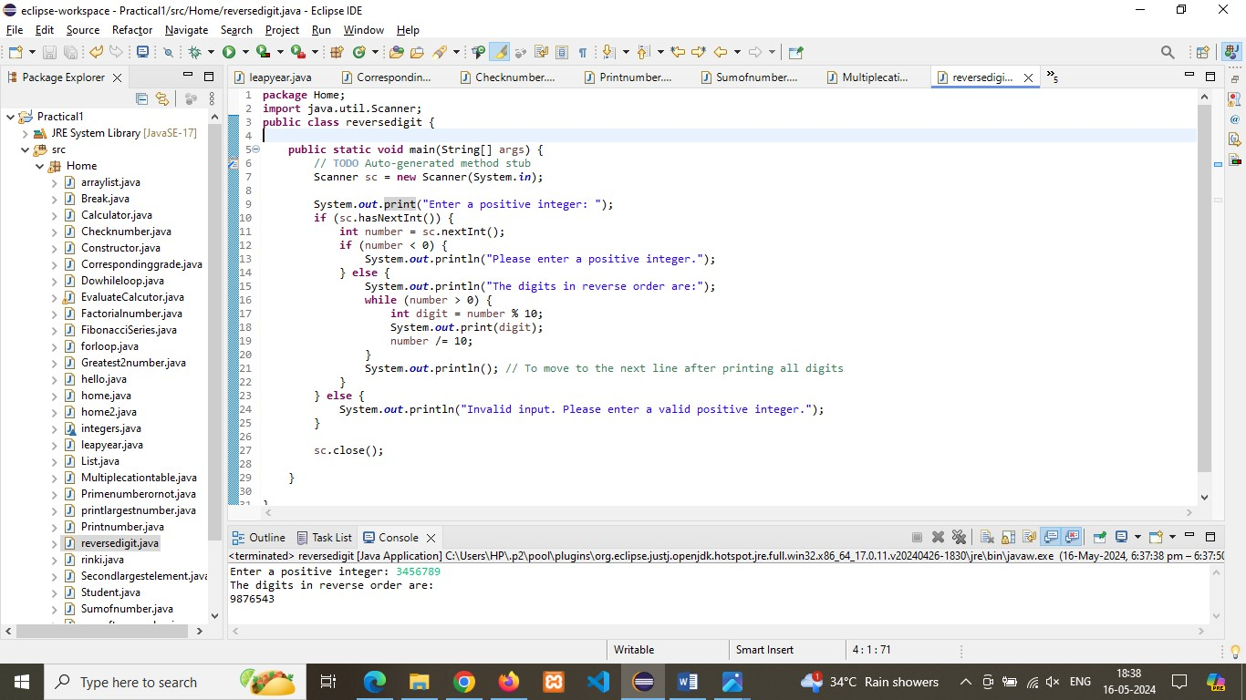

Q8) Create a class Animal with a method makeSound() that prints "Some generic animal sound". Create another class Dog that extends Animal and overrides the makeSound() method to print "Bark". Write a main method to demonstrate calling the makeSound() method on an Animal reference holding a Dog object.

**Program:**

**public** **class** Animal {

**public** **void** makeSound() {

System.***out***.println("Some generic animal sound");

}

**public** **static** **void** main(String[] args) {

Animal animal = **new** Dog();

animal.makeSound();

// This will call the makeSound() method of Dog

}

}

**class** Dog **extends** Animal {

@Override

**public** **void** makeSound() {

System.***out***.println("Bark");

}

}

**Output:** 