**Q1) Perform the following tasks:**

a. Create Student table with following attributes (STUDENT_ID , FIRST_NAME, LAST_NAME, PHONE_NUMBER, MARKS, COURSE_ID).

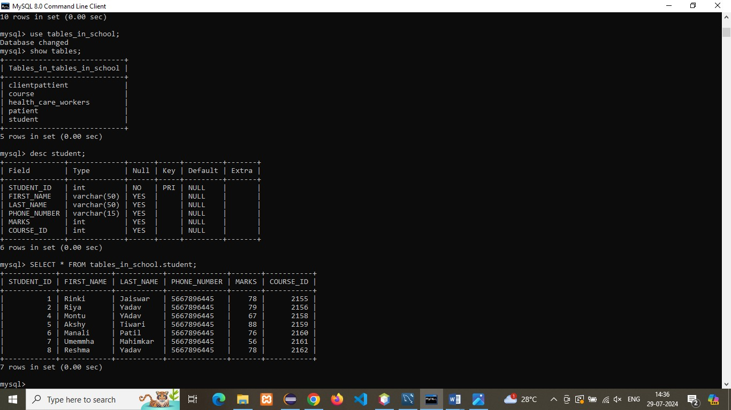

b. Create Course table with following attributes (COURSE_ID, COURSE_NAME).

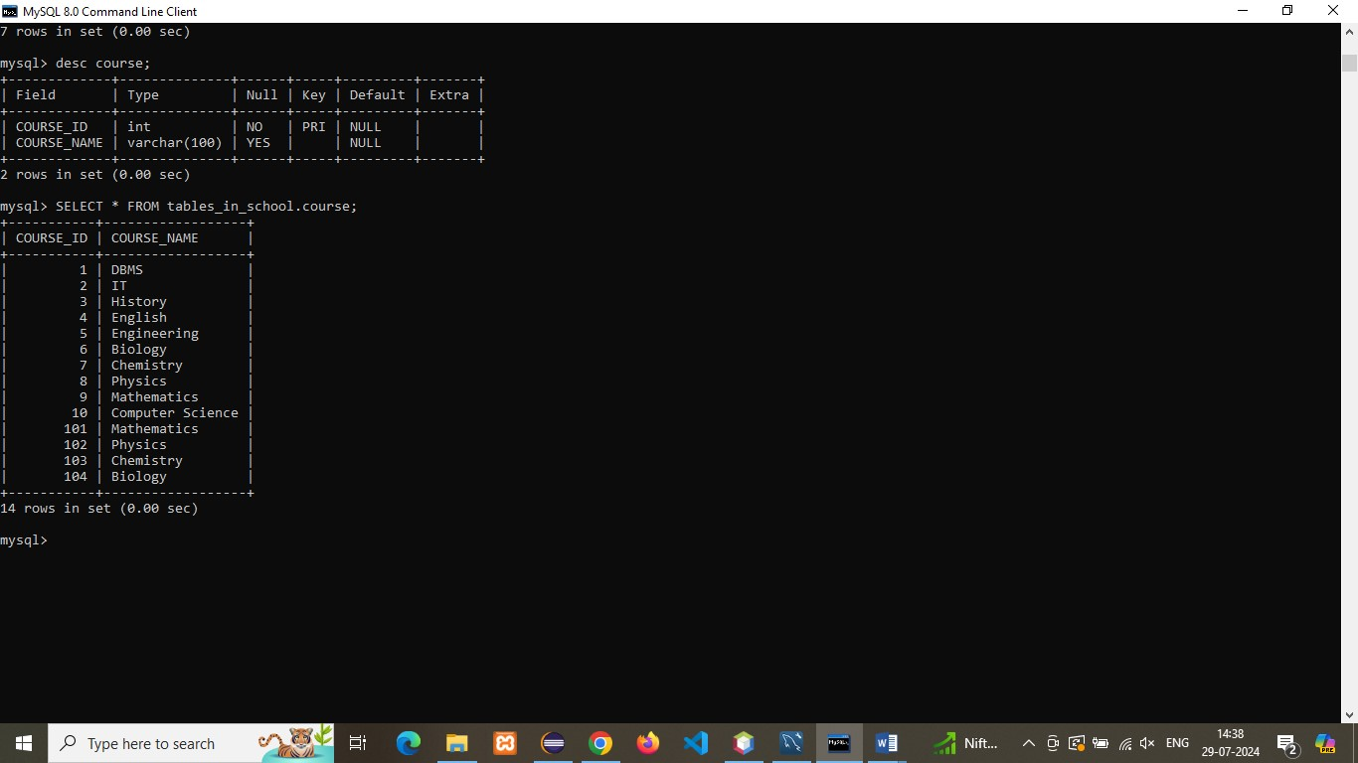

c. Write a SQL statement to insert 8 records with your own value into the tables.

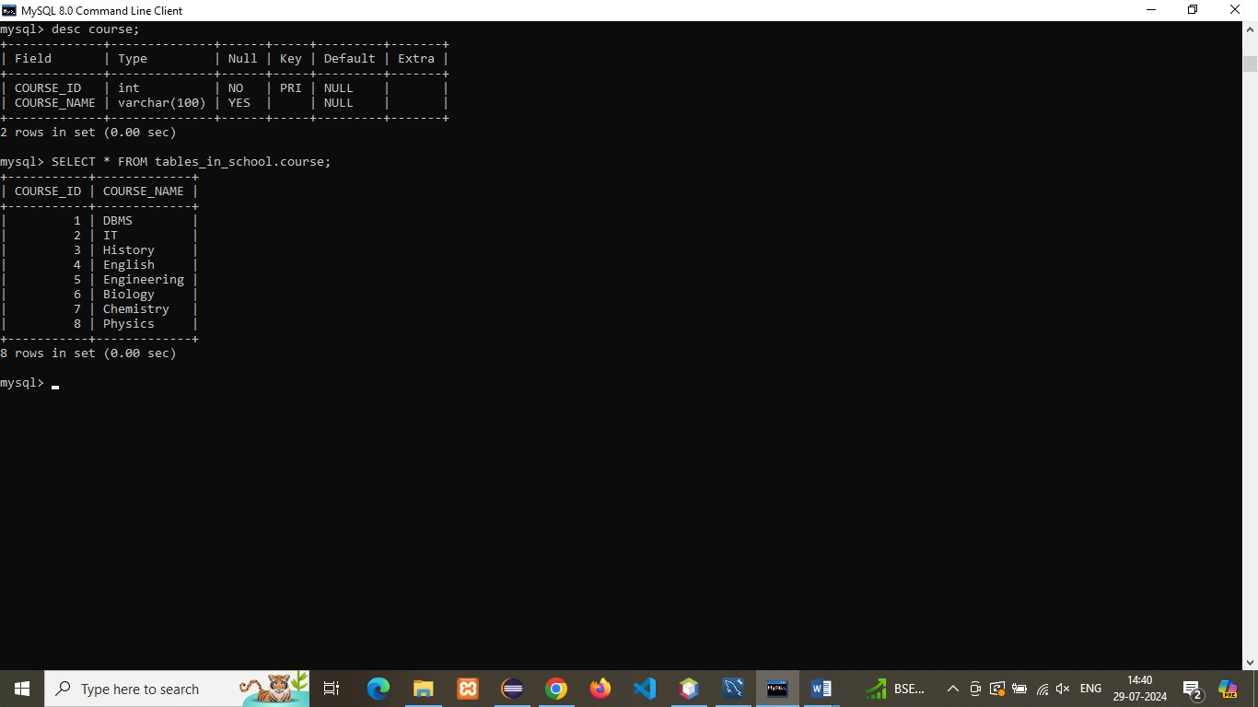

d. Write a query to get the number of students with the same course.

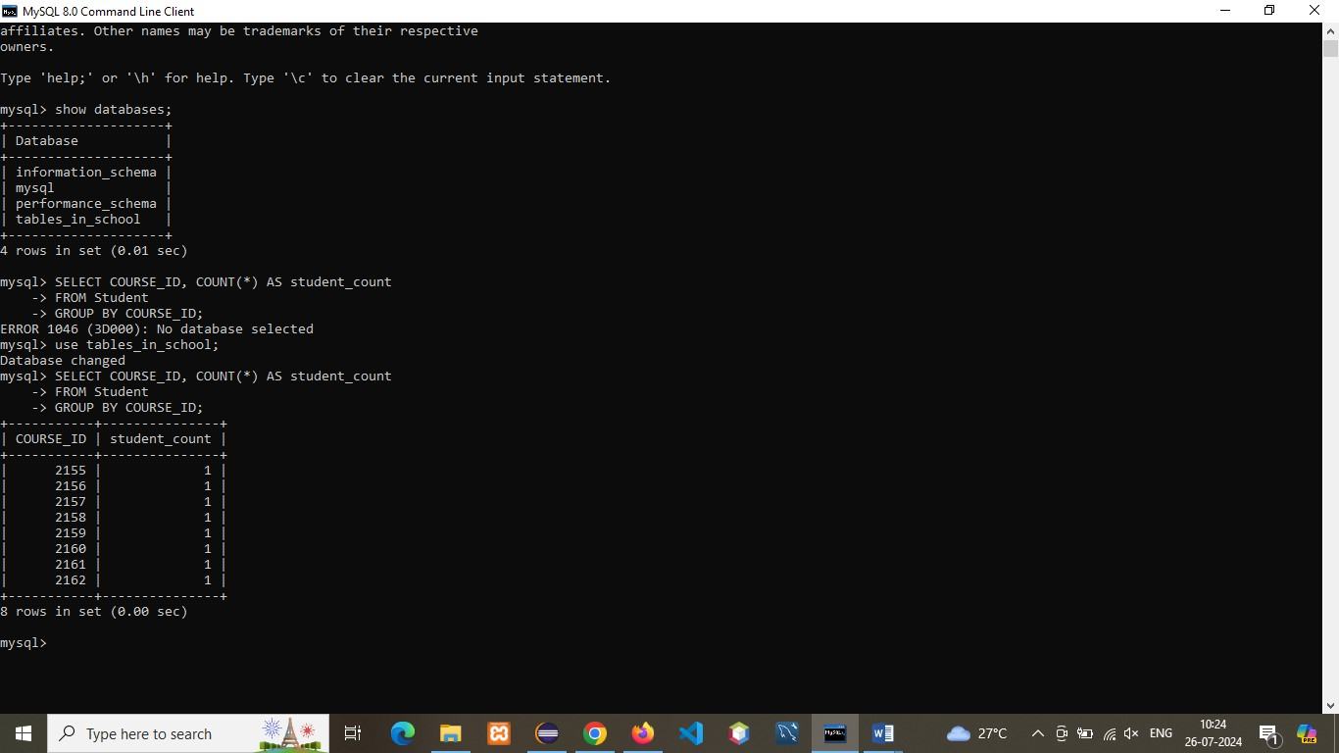

f. Write a query to get the student name, course name and marks of the students.



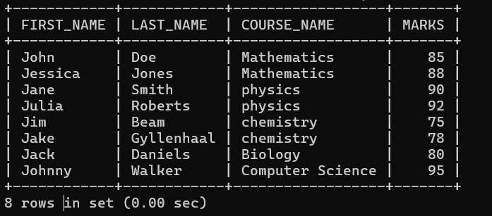

g. Write a query to get the Average marks of students course wise.

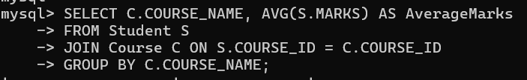

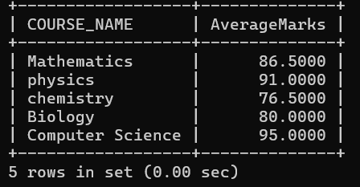

**Q-2)  Create database for hospital management system & Perform the following tasks:**

a. Create HEALTH CARE WORKERS table with following attributes (EMPLOYEE_ID , FIRST_NAME, LAST_NAME,EMAIL, PHONE_NUMBER, HIRE_DATE, SALARY, DESIGNATION). 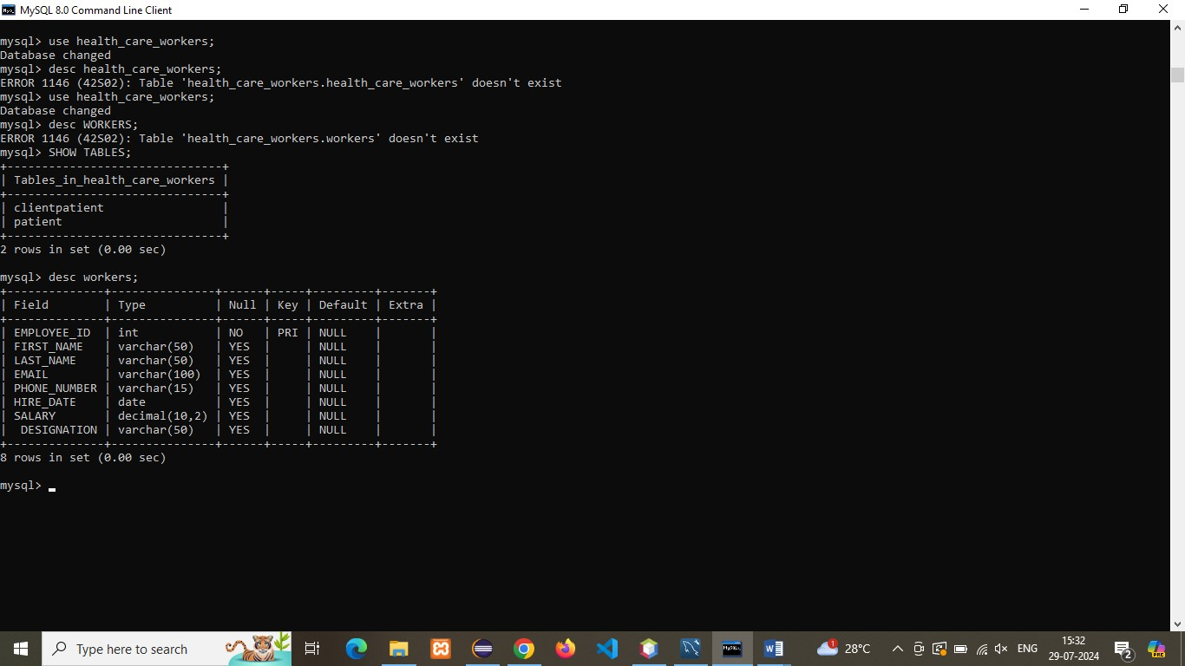

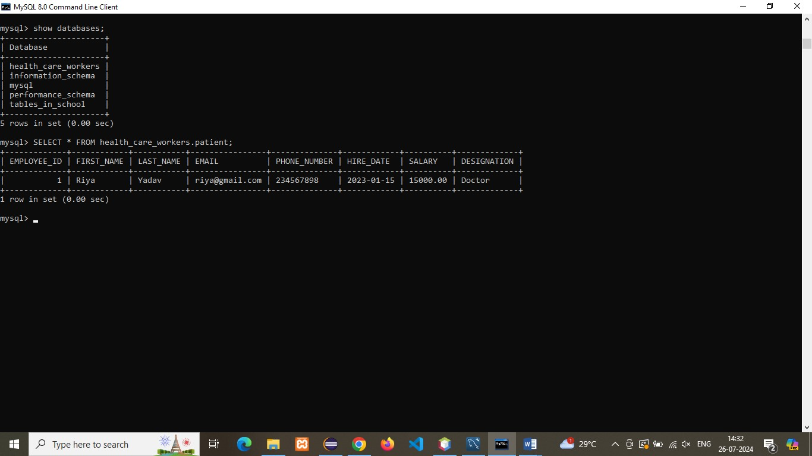

b. Create PATIENT table with following attributes (PATIENT_ID,NAME, PHONE_NUMBER).

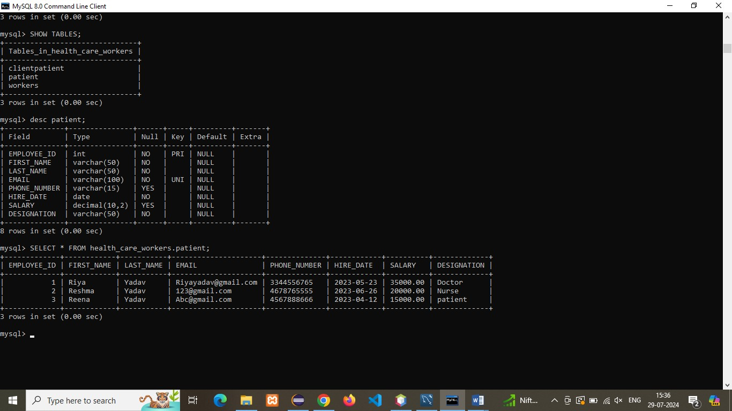

c. Write a SQL statement to insert 10 records with your own value into the tables.

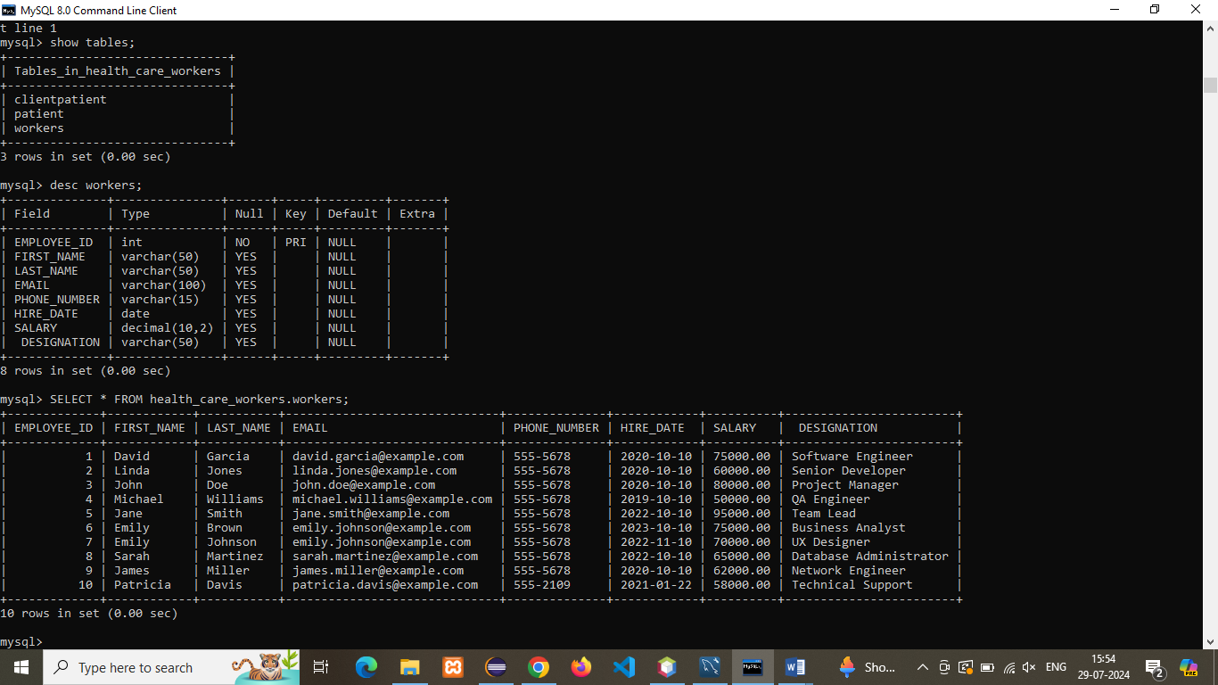

d. Write a query to get the names (first_name, last_name),Designation, salary.

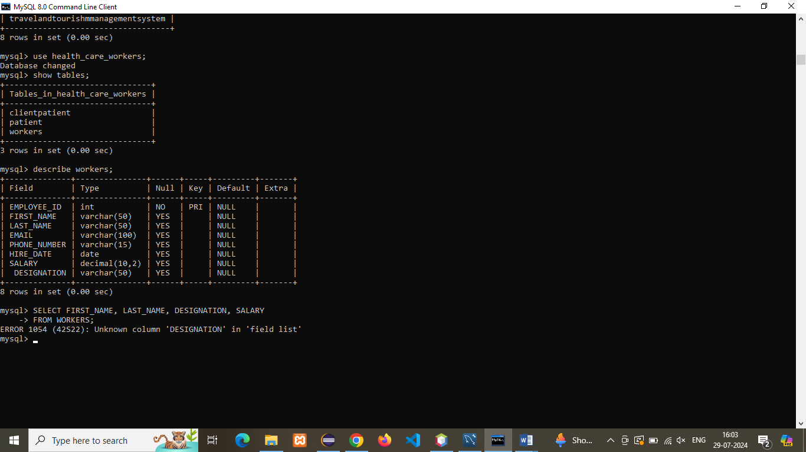

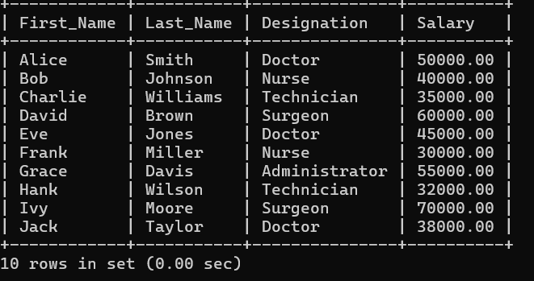

e. Write a query to get the number of employees with the same Designation.

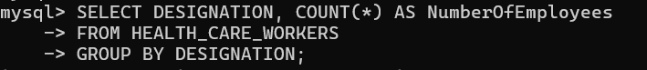

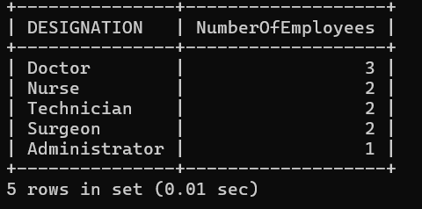

f. Write a query to get employee name who are getting salary more than 10000.

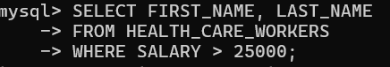

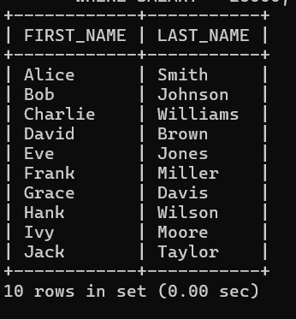

g. Fetch HEALTH CARE WORKERS name using their employee id.

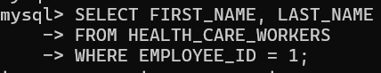

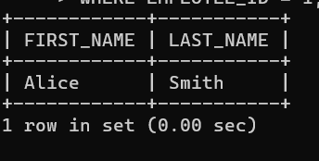

**3. Consider two tables, customers and orders, with the following structures:**

Customers Table: customer_id (Primary Key) first_name Last_name

Orders Table: order_id (Primary Key) customer_id (Foreign Key) order_date Total_amount

Write an SQL query to retrieve the first and last names of customers along with the order date and total amount of their orders.

Use an INNER JOIN to connect the two tables.

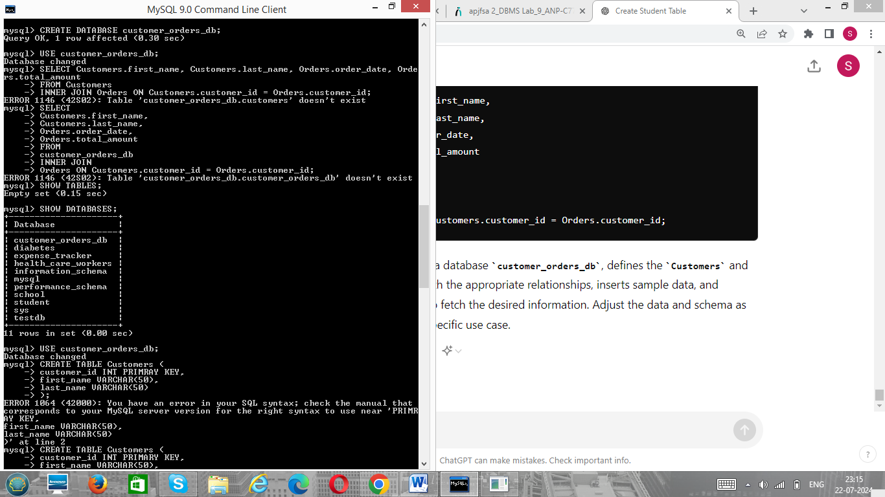

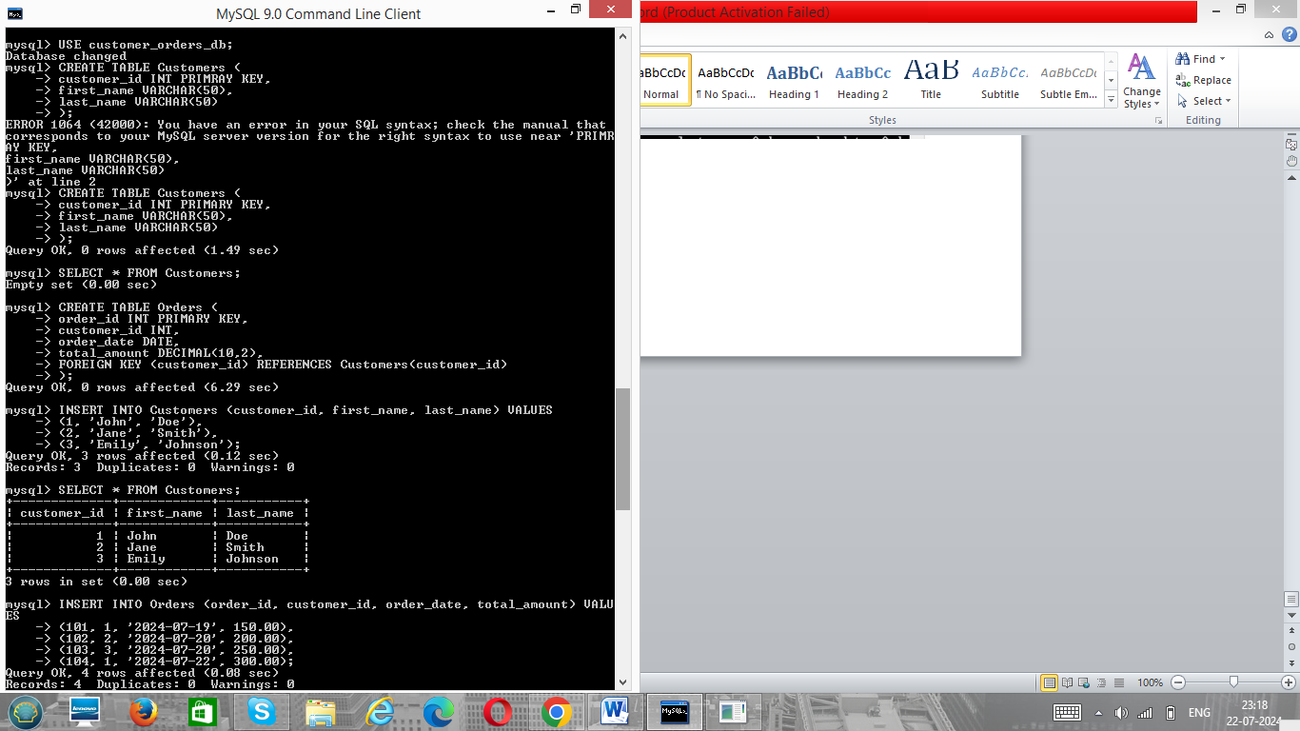

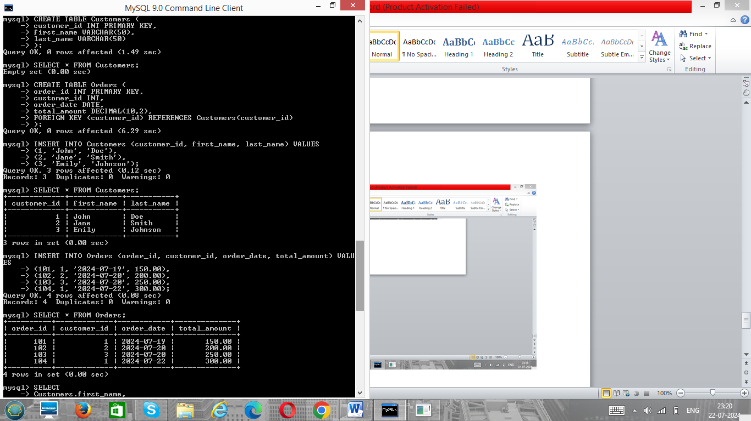

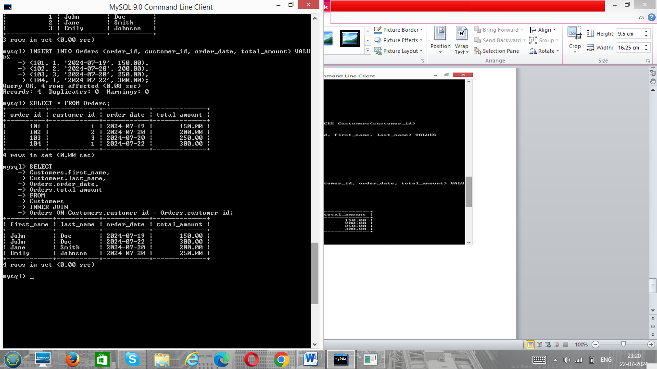

**4. Consider two tables, departments and employees, with the following structures:**

Departments Table: department_id (Primary Key) department_name

Employees Table: employee_id (Primary Key) first_name last_name department_id (Foreign Key)

Write an SQL query to retrieve a list of all departments and the names of employees who belong to each department. Use a LEFT JOIN to include departments that have no employees.

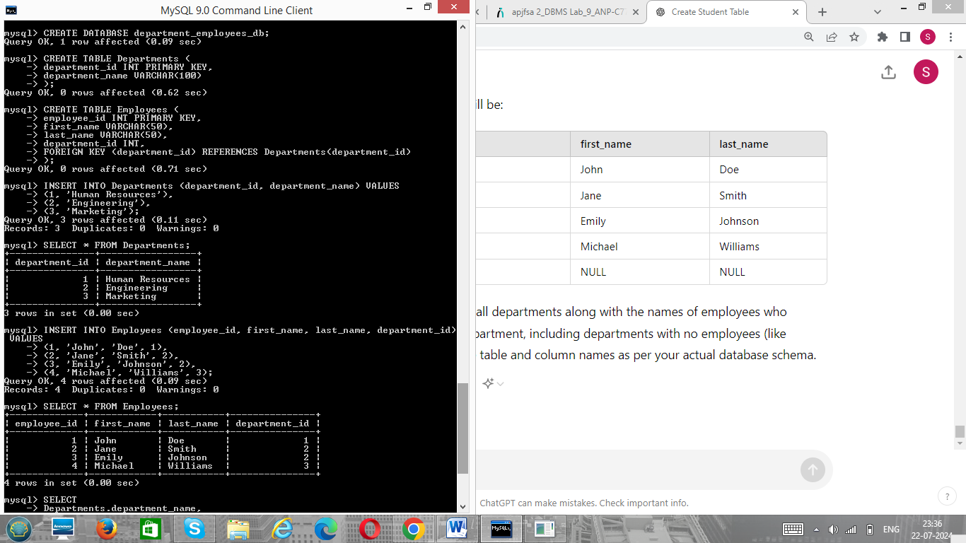

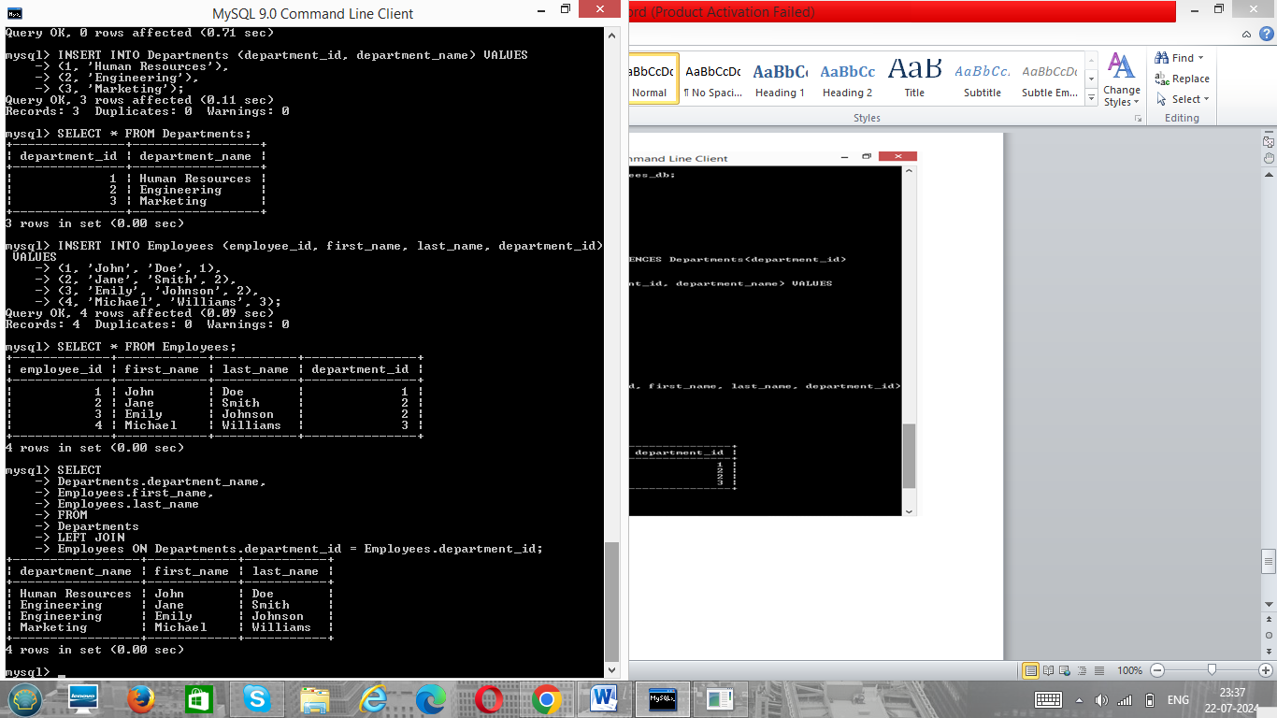

**5. Write a program to show  JDBC connection with MYSQL and perform the following operations:**

Create table Customer with following fields:

Custno, Custame,Custaddress,Phoneno, City, Pincode, Country

Insert 5 records in Customer table.

a.     Insert values

b.    Delete values

c.     update city name Shimla to Shilong.

d.    Show table in the console

**Output:**

**package** travel.Travelandtourishmmanagementsystem;

**import** java.sql.Connection;

**import** java.sql.DriverManager;

**import** java.sql.ResultSet;

**import** java.sql.SQLException;

**import** java.sql.Statement;

**public** **class** JDBC {

**public** **static** **void** main(String[] args) {

// Database connection details

String url = "jdbc:mysql://localhost:3306/Travelandtourishmmanagementsystem";

String username = "root";

String password = "rinki";

Connection connection = **null**;

Statement statement = **null**;

**try** {

// Load the MySQL JDBC driver

Class.*forName*("com.mysql.cj.jdbc.Driver");

// Establish the connection

System.***out***.println("Connecting to the database...");

connection = DriverManager.*getConnection*(url, username, password);

System.***out***.println("Connected to the database!");

// Create a statement object to perform operations

statement = connection.createStatement();

// Create the Customer table

System.***out***.println("Creating table...");

String createTableSQL = "CREATE TABLE IF NOT EXISTS Customer ("

+ "Custno INT PRIMARY KEY, "

+ "Custname VARCHAR(50), "

+ "Custaddress VARCHAR(100), "

+ "Phoneno VARCHAR(15), "

+ "City VARCHAR(50), "

+ "Pincode VARCHAR(10), "

+ "Country VARCHAR(50))";

statement.executeUpdate(createTableSQL);

System.***out***.println("Table created.");

// Clear existing records

System.***out***.println("Clearing existing records...");

String clearTableSQL = "DELETE FROM Customer";

statement.executeUpdate(clearTableSQL);

System.***out***.println("Existing records cleared.");

// Insert records into the Customer table

System.***out***.println("Inserting records into the table...");

String insertSQL = "INSERT INTO Customer (Custno, Custname, Custaddress, Phoneno, City, Pincode, Country) VALUES "

+ "(1, 'John Doe', '123 Elm Street', '555-1234', 'New York', '10001', 'USA'), "

+ "(2, 'Jane Smith', '456 Oak Street', '555-5678', 'Los Angeles', '90001', 'USA'), "

+ "(3, 'Jim Brown', '789 Pine Street', '555-8765', 'Chicago', '60001', 'USA'), "

+ "(4, 'Emily Davis', '321 Maple Street', '555-4321', 'Houston', '77001', 'USA'), "

+ "(5, 'Michael Wilson', '654 Birch Street', '555-6789', 'Phoenix', '85001', 'USA')";

statement.executeUpdate(insertSQL);

System.***out***.println("Records inserted.");

// Delete a record from the Customer table

System.***out***.println("Deleting a record...");

String deleteSQL = "DELETE FROM Customer WHERE Custno = 5";

statement.executeUpdate(deleteSQL);

System.***out***.println("Record deleted.");

// Update city name from Shimla to Shilong

System.***out***.println("Updating city name...");

String updateSQL = "UPDATE Customer SET City = 'Shilong' WHERE City = 'Shimla'";

statement.executeUpdate(updateSQL);

System.***out***.println("City name updated.");

// Show the Customer table in the console

System.***out***.println("Retrieving records...");

String selectSQL = "SELECT * FROM Customer";

ResultSet resultSet = statement.executeQuery(selectSQL);

**while** (resultSet.next()) {

**int** custNo = resultSet.getInt("Custno");

String custName = resultSet.getString("Custname");

String custAddress = resultSet.getString("Custaddress");

String phoneNo = resultSet.getString("Phoneno");

String city = resultSet.getString("City");

String pincode = resultSet.getString("Pincode");

String country = resultSet.getString("Country");

System.***out***.println("Custno: " + custNo + ", Custname: " + custName + ", Custaddress: " + custAddress

+ ", Phoneno: " + phoneNo + ", City: " + city + ", Pincode: " + pincode + ", Country: " + country);

}

} **catch** (ClassNotFoundException e) {

System.***out***.println("MySQL JDBC driver not found.");

e.printStackTrace();

} **catch** (SQLException e) {

System.***out***.println("Error connecting to the database.");

e.printStackTrace();

} **finally** {

// Close the statement and connection

**try** {

**if** (statement != **null**) {

statement.close();

}

**if** (connection != **null**) {

connection.close();

}

} **catch** (SQLException e) {

e.printStackTrace();

}

}

}

}

