

NBCC Pharmacy Server Setup  
2025 Programmer Analyst Team  
March 20, 2025

CONTENTS

INTRODUCTION 3

INSTALLING VISUAL STUDIO CODE 4

INSTALLING VISUAL STUDIO 7

SETTING UP FRONTEND 9

SETTING UP BACKEND 13

SETTING UP MSSQL DB 19

CONFIGURING IIS 21

# INTRODUCTION

Welcome to **NBCC PharmTech System!** This server setup guide is designed to help you configure and modify the **PharmTech** server. This guide is intended for more tech savvy individuals who understand how to navigate a computer well.

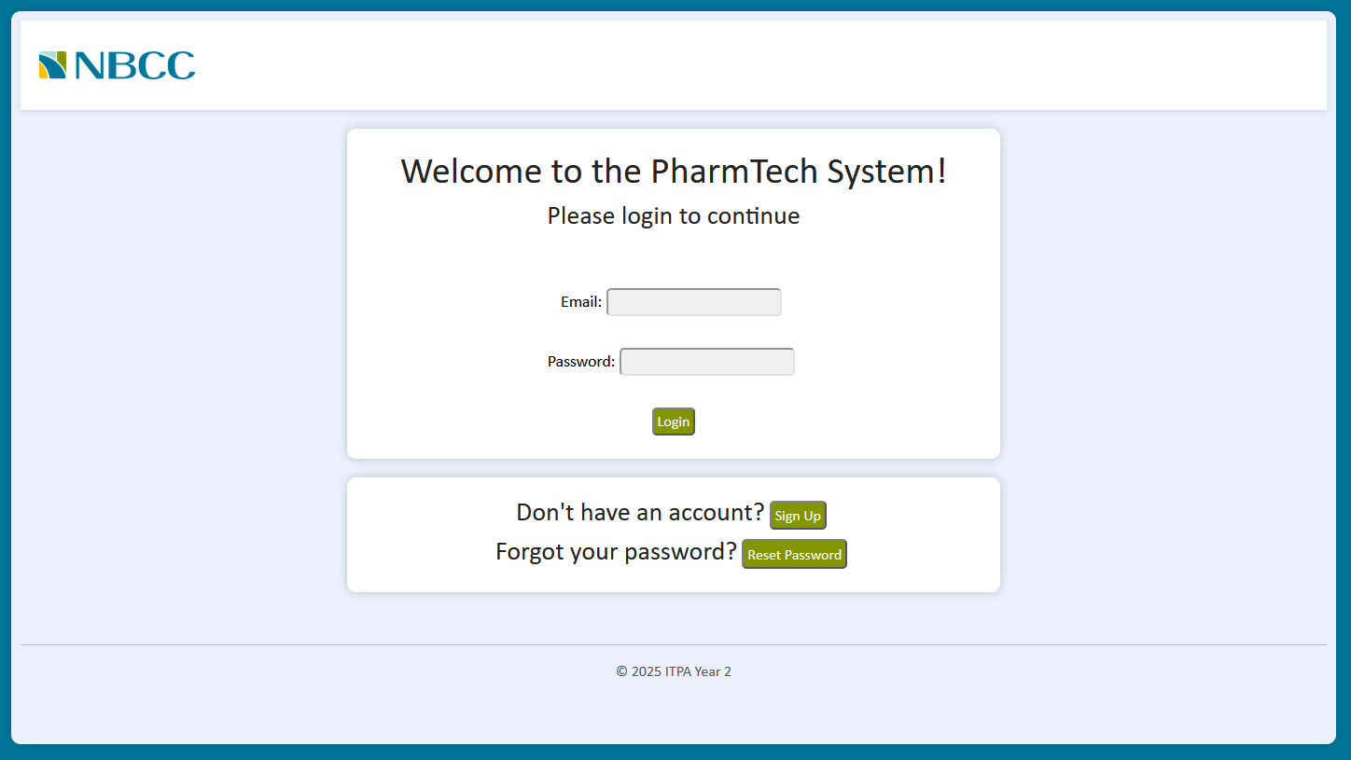

# INSTALLING VISUAL STUDIO CODE

This will go over how to install visual studio code with the Node NPM tool, as it is needed to accomplish certain tasks.

1. First go to <https://code.visualstudio.com/download> and download the version corresponding to your system (ex. Windows) A screenshot of a computer program

   AI-generated content may be incorrect.
2. Once downloaded run the installer and follow the installer instructions. (defaults are ok)
3. Next, we must download Node JS. To do this go to <https://nodejs.org/en>

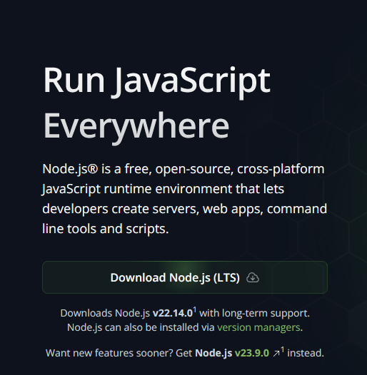

1. Once downloaded, run the installer and follow the instructions, making sure that npm package manager will be installed like below

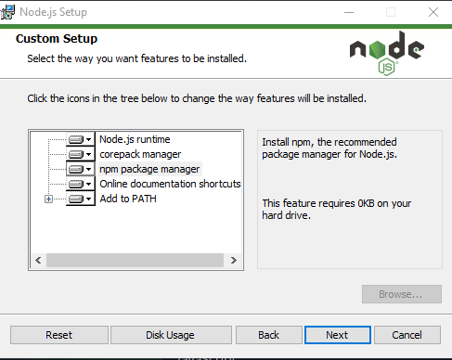

1. Once both are installed, launch visual studio code either through right-clicking and hitting “Open with Code”, or run the command below in the run box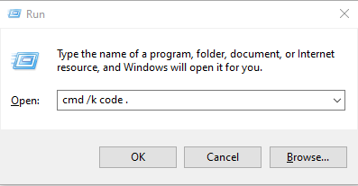
2. Then open a visual studio code terminal to verify npm is installed by pressing CTRL+SHIFT+`
3. Once open, enter “npm -v” to check if npm is installed, if it is installed it will display the npm version like below

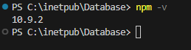

# INSTALLING VISUAL STUDIO

This will go over how to install Visual Studio with ASP.NET as it is required for certain tasks.

1. Go to <https://visualstudio.microsoft.com/> and install Visual Studio community edition

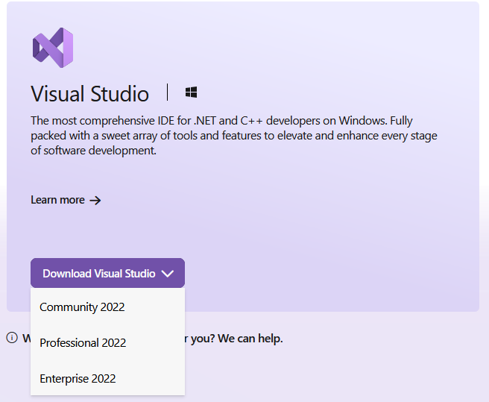

1. Once downloaded run the setup and select the following options

* ASP.NET and web development
* .NET desktop development

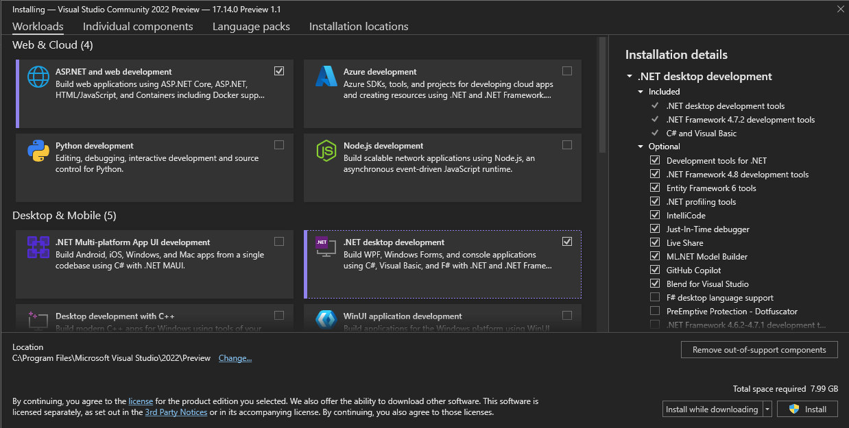

1. Once options have been selected hit install.

# SETTING UP FRONTEND

This will cover how to supply the files for the frontend of the application from nothing but the source code.

***NOTE:*** *To complete this task, you must have done INSTALLING VISUAL STUDIO CODE*

1. Navigate to where you have the source code stored; it will look something like this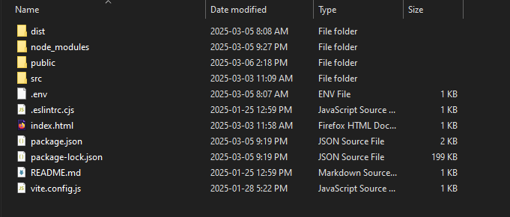
2. Right click on “index.html” and either click on “Open with Code” or hover over Open with and then select “Visual Studio Code”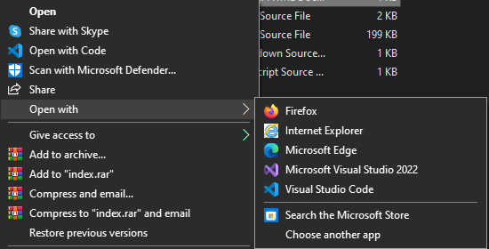
3. Once open, click on the explorer icon and than click “Open Folder”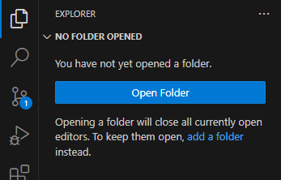
4. Once “Open Folder” is clicked it will bring up a file explorer, just click “Select Folder”

1. Look for a “.env” file inside the explorer window next and click on it.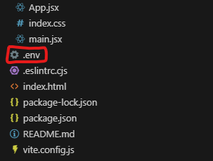
2. Once clicked, you should see a menu like below, ensure “VITE_BackendIP” is set to “pharmtech.nbcc.ca” like below

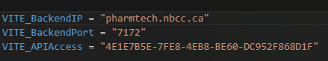

1. Once that has been verified, press CTRL+SHIFT+` to open a new terminal and than enter the command “npm run build”: if everything works you should get a result like this

***NOTE:*** *You may need to run “npm install” before running the command above*

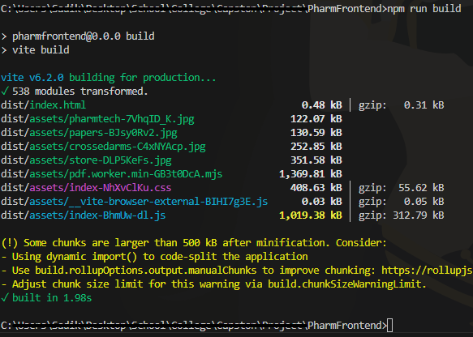

1. Next, navigate to the dist folder inside of file explorer

1. Copy the file contents and place them on the server at “C:\inetpub\wwwroot\NameOfFrontEndFolder”. When done, it will look something like this

***NOTE:*** *The web.config may not be there at first, IIS will create it once it is configured.*

*After uploading the frontend it is recommended to do “SETTING UP MSSQL DB” and “SETTING UP BACKEND”*

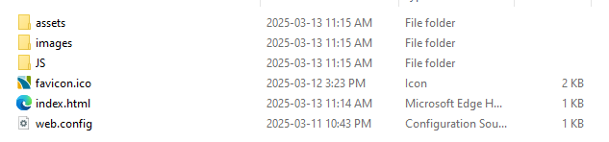

# SETTING UP BACKEND

This will cover how to supply the files for the backend of the application from nothing but the source code.

***NOTE:*** *To complete this task, you must have done INSTALLING VISUAL STUDIO*

1. Navigate to where you have the source code stored; it will look something like this

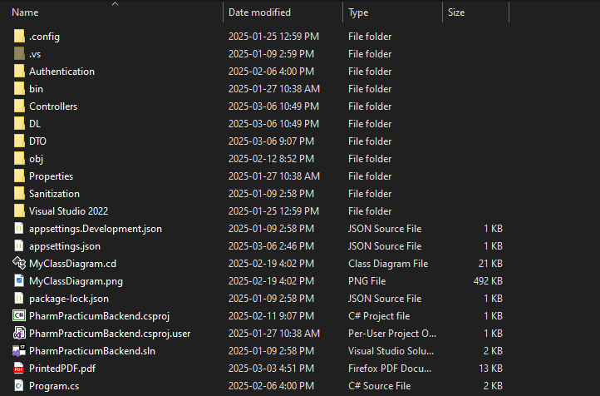

1. Open the .sln file, in the picture above it is named, “PharmPracticumBackend.sln”

***NOTE:*** *It may prompt you once open to install certain features or to trust the application, if that is the case than accept any prompts that may appear*

1. Next, click on build located at the top of the screen and then click on publish

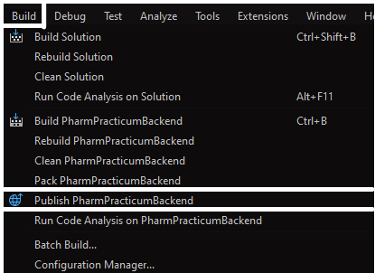

1. Next, if you see a FolderProfile, skip to step 7. otherwise click on new profile

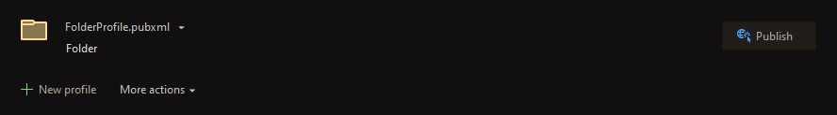

1. Once you click on new profile, select the Folder Option and then click on next

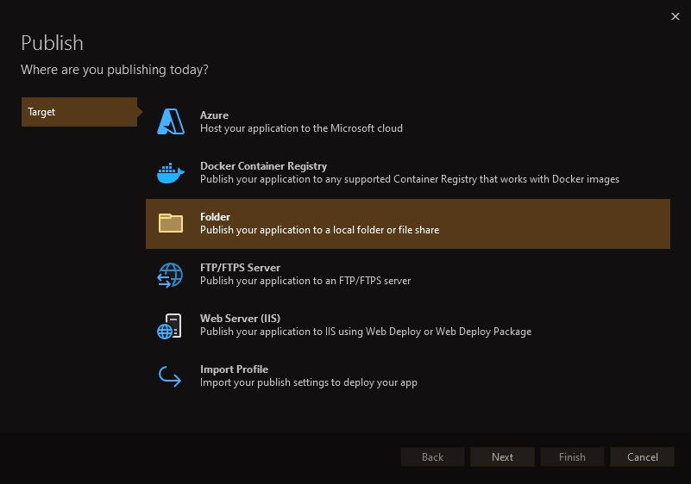

1. Then click on finish, the default path is ok

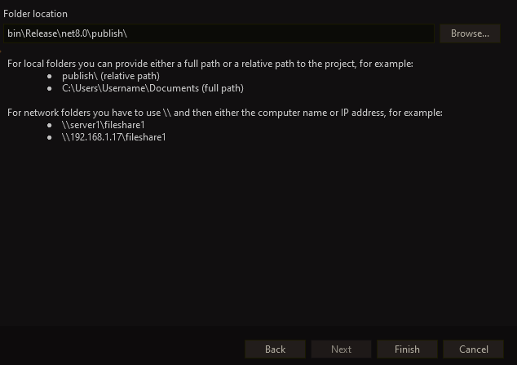

1. Click on publish

1. If everything succeeds you will get a notification like below, click the Navigate button provided

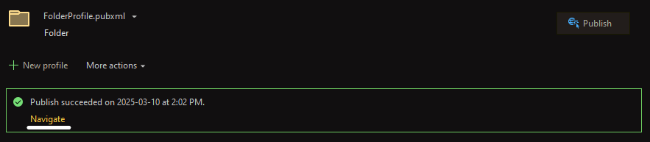

1. Copy the file contents and place them inside on the server at “C:\inetpub\wwwroot\NameOfBackEndFolder. When done, it will look something like this

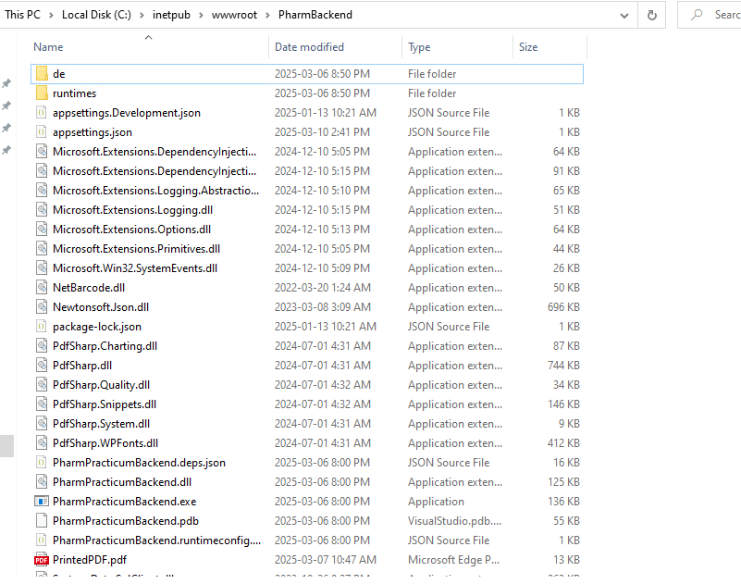

1. Next look for a file called “appsettings.json” and open it by double clicking on it.
2. Inside it will have a bunch of settings, make sure all settings properly correspond with what they should, and make sure the Status is set to “Deployed” like below

***NOTE:*** *the settings inside “appsettings.json” are case sensitive so make sure that lowercase and capital letters are written exactly as they should be*

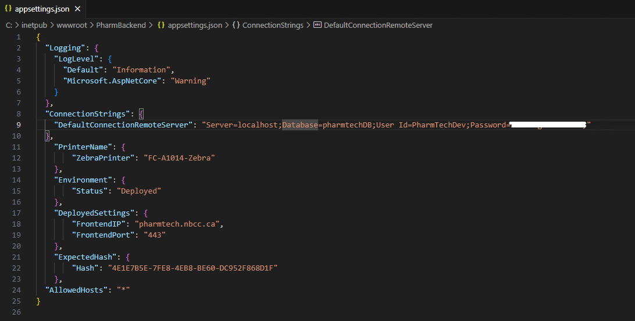

List of what each setting should contain

* DefaultConnectionRemoteServer – This should have the data base connection string, the server name can be found inside of SSMS (SQL Server Management Studio)
* ZebraPrinter – This should have the name of the zebra printer being used
* Status – This indicates the state the program should run in, Development or Deployed
* FrontendIP – The IP/DNS name of where the frontend is being hosted
* FrontendPort – The port the frontend is being hosted on, generally 443 is standard
* Hash – This is the hash that the backend expects when anyone tries to access it

# SETTING UP MSSQL DB

This goes over how to set up the pharmtechDB onto the MSSQL (Microsoft Structured Query Language) server instance using SSMS (SQL Server Management Studio)

***NOTE:*** *MSSQL Server and SSMS need to be installed to accomplish this, if they are not already pre-installed, install them here:* [*https://www.microsoft.com/en-ca/sql-server/sql-server-downloads*](https://www.microsoft.com/en-ca/sql-server/sql-server-downloads) *make sure the MSSQL Server is the developer edition, capable of executing scheduled jobs*

1. Navigate on the server to where the Folder Database is stored (default location is C:\inetpub\Database) it will look something like below

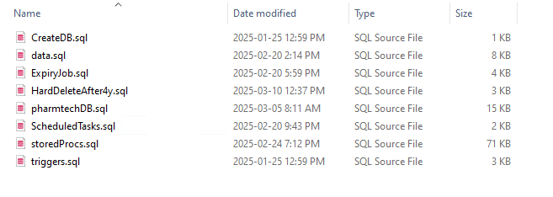

1. Open the first file named “CreateDB.sql” in SSMS

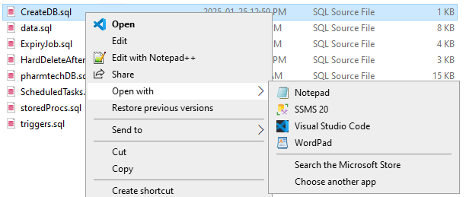

1. Next click on the execute button inside of SSMS

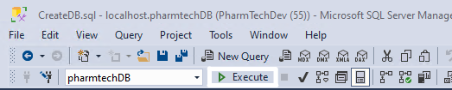

1. After you have done that, you should see confirmation inside the output like below

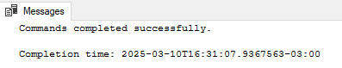

1. Repeat steps 2 and 3 for the following files in the listed order:

* pharmtechDB.sql
* data.sql
* ExpireyJob.sql
* HardDeleteAfter4y.sql
* storedProcs.sql
* triggers.sql

# CONFIGURING IIS

1. First you must search for the IIS Manager in the windows search bar and open it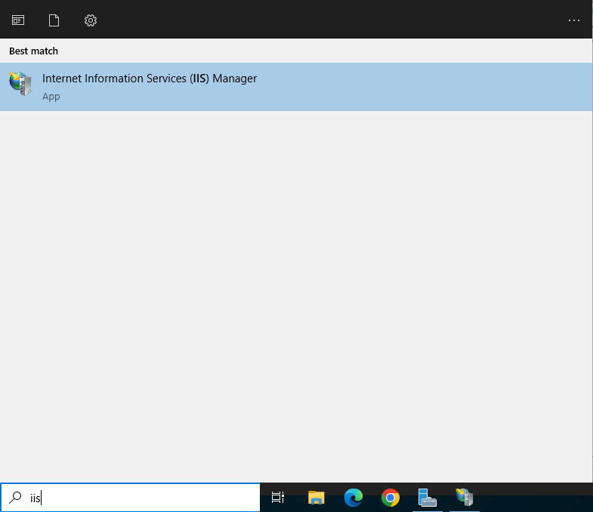
2. Next, you must add two application pools. To do this, click on “Application Pools” in the Connections menu.

1. Once there you can right click anywhere in the table section and click “Add Application Pool”. Make sure the “.NET CLR Version” starts with “v4.0” it may have other numbers after as well. Once you have finished adding them, you should have two application pools like below  
   ***NOTE:*** *You may also have a default application pool, that is nothing to worry about*

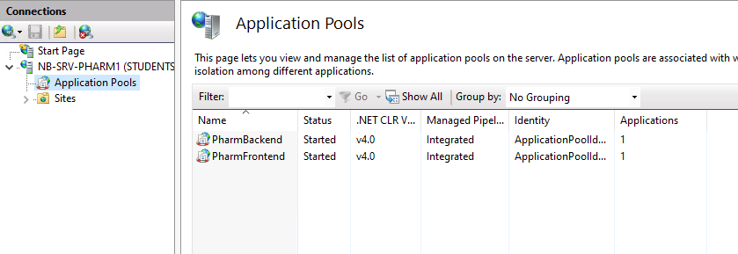

1. Next, you must configure an IIS website. To do this first go to the Sites Section:

1. Once there you must add the first site, lets start with the “PharmFrontend”. To add a website right click anywhere in the table section and click “Add Site”, then fill in the information like the image below:  
   ***NOTE:***

* *the IP address may be different depending on the servers IP address*
* *the Hostname should match the SSL certificate name.*
* *“PharmFrontend” in the physical path is just the folder holding the frontend server contents*

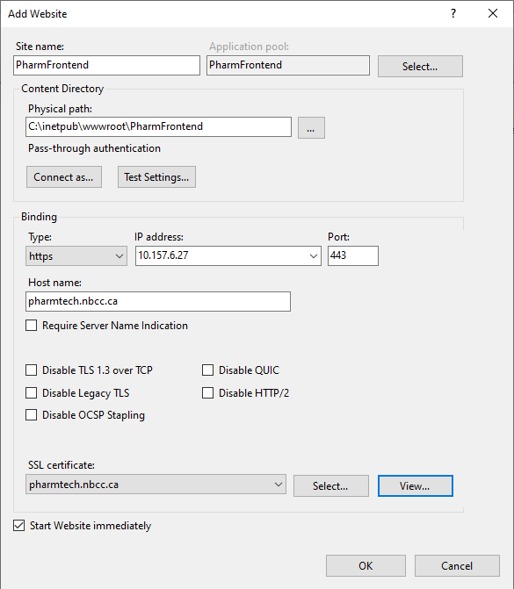

1. Next, we must add the second site, to do that right click anywhere in the table section and click “Add Site”, then fill in the information like the image below

***NOTE:***

* *the IP address may be different depending on the servers IP address*
* *the Hostname should match the SSL certificate name.*
* *“PharmBackend” in the physical path is just the folder holding the backend server contents*

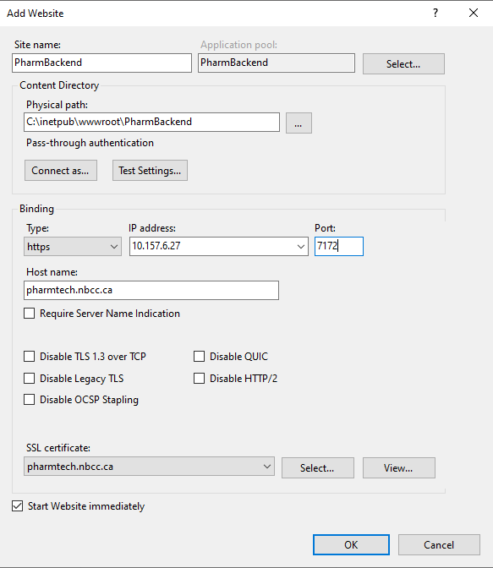

1. Next, we must configure the frontend site’s 404 status code. First click on “PharmFrontend” in the Connections menu.

1. After, find the 404 status Code in the main view section, right click on it and click “Edit”. Configure it to do the following as in the image.

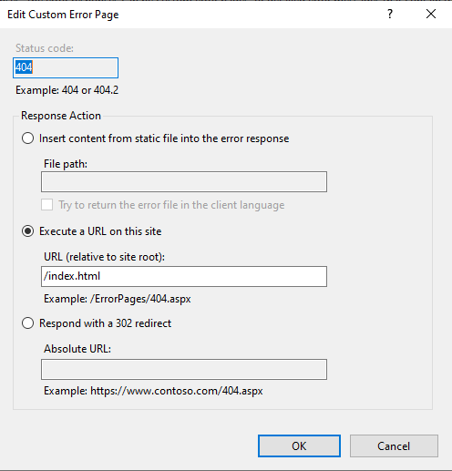

1. Next, we must configure the MIME types of the frontend, to do this first click on the “PharmFrontend” site in the connection’s explorer window

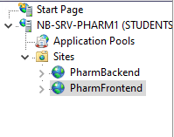

1. After, double click on the “MIME types” icon

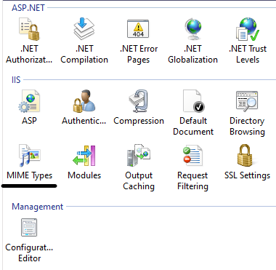

1. Then, right click anywhere in the table section and click on “add”. Once you do that, fill in the fields like below and click “OK”

