

NBCC Pharmacy User Manual  
2025 Programmer Analyst Team  
March 7, 2025

CONTENTS

INTRODUCTION 3

PURPOSE OF THE WEBSITE 3

CONNECTION GUIDE 4

HOW TO SIGNUP 4

HOW TO LOGIN 5

HOW TO LOGOUT 5

HOW TO RESET PASSWORD 5

USING THE NAVIGATION BAR 6

SEARCH FUNCTIONALITY - DRUGS 7

SEARCH FUNCTIONALITY – PHYSICIANS 7

SEARCH FUNCTIONALITY – PATIENTS 8

SEARCH FUNCTIONALITY – ORDERS 8

SEARCH FUNCTIONALITY - VERIFICATION 9

HOW TO SORT TABLES 9

HOW TO CREATE AN ORDER 10

HOW TO VERIFY AN ORDER AND PRINT 11

HOW TO PRINT 11

GLOSSARY 11

INDEX 11

# INTRODUCTION

Welcome to **NBCC PharmTech System!** This user manual is designed to help you navigate and utilize the features of the website efficiently. Whether you are a new or experienced user, this guide will provide step-by-step instructions to help you perform essential tasks. 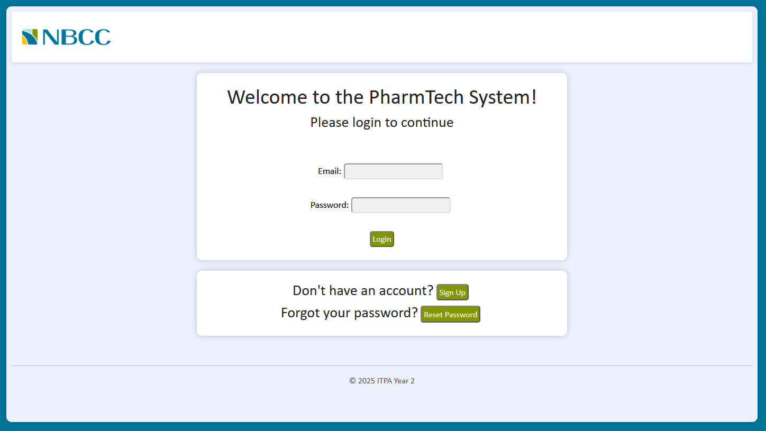

# PURPOSE OF THE WEBSITE

This website enables students to view patient records, drug information and physician details, as well as create and manage orders. Instructors have full administrative control, allowing them to add, delete and edit all aspects of the system. Designed for efficiency, the platform simplifies data management and streamlines operations.

# CONNECTION GUIDE

To connect to the website <https://pharmtech.nbcc.ca/login>, you must be on the NBCC Fredericton school campus network. Additionally, you will need a valid student or instructor email to gain access.

Examples of valid emails: John.Doe@mynbcc.ca, Mary.Jane@nbcc.ca  
  
**!!!!!!!!!!!!!!!!!!!!!!!!!!!!!!!!!! Important !!!!!!!!!!!!!!!!!!!!!!!!!!!!!!!!!!!**  
**Only accept emails from nbccpharmsystem@gmail.com  
!!!!!!!!!!!!!!!!!!!!!!!!!!!!!!!!!! Important !!!!!!!!!!!!!!!!!!!!!!!!!!!!!!!!!!!**

# HOW TO SIGNUP

1. From the main page of the website, click the Sign Up button located prominently on the homepage.
2. You will be directed to the registration form, where you will need to provide the following information:
   1. First Name: Enter your first name
   2. Last Name: Enter your last name
   3. Campus: Select a campus from the drop-down list
   4. Email: Enter a valid email address. Make sure it’s a student or instructor email (Joe.Bard@mynbcc.ca).
   5. Password: Choose a secure password (Password must contain at least 8 characters, one capital letter, one lower case, one number and a special character)
   6. Confirm Password: Re-enter the password to confirm it
3. After filling out the required fields, click on the Submit button to submit your information. You will be registered, and an email will be sent to you at your provided email address.
4. Once you receive the confirmation in the email, click the verification link inside to activate your account.
5. After verifying your email, return to the login page, enter your email and password, and click on Login to access your account

# HOW TO LOGIN

1. Navigate to the main page for the website. Refer to Connection Guide.
2. You will need to enter your account information in the required fields with the following information:
   1. Email: The email address you signup an account with
   2. Password: The password you made when signing up
3. After the required fields have been entered, click on the Login button.

# HOW TO LOGOUT

1. If needed, refer to How to Login to access website information.
2. Locate the user icon. It is in the top-right corner of the webpage. 
3. Click on the user icon to reveal a dropdown menu.
4. Select the Logout button from the dropdown menu to securely log out.

# HOW TO RESET PASSWORD

1. From the main page of the website, click the Reset Password button located prominently on the homepage.
2. A pop-up will appear, prompting you to enter your email associated with your account.
3. After filling out the required fields, click on the Send Reset Link. This will trigger an email to be sent to the address you provided.
4. Open your email inbox and find the email with the password reset link. Click on the link in the email.
5. You’ll be redirected to a page where you can enter your new password. Make sure to:
   1. Enter a new password: (Password must contain at least 8 characters, one capital letter, one lower case, one number and a special character).
   2. Confirm the new password: Re-enter the password to confirm it.
6. After entering and confirming your new password, click on the Change Password to complete the process.
7. After resetting your password, return to the login page, enter your email and your new password, and click on Login to access your account.

# USING THE NAVIGATION BAR

1. Refer to How to Login to access website information.
2. Once logged in, you will see a navigation bar at the top of the page containing important features.



* 1. **NBCC Logo**: Clicking the logo will always return you to the home page, no matter where you are on the website.
  2. **Bell Icon** (Notifications): This icon displays notifications, including alerts for rejected orders.
  3. **User Icon**: This icon represents the currently logged-in user with first and last name displayed. Clicking it will open a dropdown menu with the option to log out.

1. The navigation bar at the top of the screen will adjust based on the type of user logged into the system. The two available options are:
   1. **Student View**
      * Home
      * Drugs
      * Physicians
      * Patients
      * Orders
      * Verification



* 1. **Instructor View**
     + Home
     + Drugs
     + Physicians
     + Patients
     + Orders
     + Verification
     + User Management
     + Logs



1. Clicking any of the above buttons will take you to the corresponding page.

# SEARCH FUNCTIONALITY - DRUGS

1. Navigate to the drugs page.
2. Locate the search bar on the left side of the webpage.
3. Click on the small magnifying glass to reveal a dropdown menu.
4. Within this menu the following options are available:
   1. DIN
   2. Drug Name
   3. Dosage
   4. Strength
   5. Manufacturer
   6. Concentration
   7. Reference Brand
   8. Container Size
5. Click on the desired search category.
6. Type letters or numbers related to your search into the search bar.
7. Options will now appear in the table below based on the input provided.

# SEARCH FUNCTIONALITY – PHYSICIANS

1. Navigate to the physician’s page.
2. Locate the search bar on the left side of the webpage.
3. Click on the small magnifying glass to reveal a dropdown menu.
4. Within this menu the following options are available:
   1. Physician ID
   2. First Name
   3. Last Name
   4. City
   5. Province
5. Click on the desired search category.
6. Type letters or numbers related to your search into the search bar.
7. Options will now appear in the table below based on the input provided.

# SEARCH FUNCTIONALITY – PATIENTS

1. Navigate to the patient’s page.
2. Locate the search bar on the left side of the webpage.
3. Click on the small magnifying glass to reveal a dropdown menu.
4. Within this menu the following options are available
   1. Patient ID
   2. First Name
   3. Last Name
   4. Date of Birth
   5. Sex
   6. Address
   7. City
   8. Hospital
   9. Room #
   10. Unit #
   11. Allergies
   12. Conditions
5. Click on the desired search category.
6. Type letters or numbers related to your search into the search bar.
7. Options will now appear in the table below on the input provided.

# SEARCH FUNCTIONALITY – ORDERS

1. Navigate to the orders page.
2. Locate the search bar on the left side of the webpage.
3. Click on the small magnifying glass to reveal a dropdown menu.
4. Within this menu the following options are available:
   1. Rx Number
   2. Patient ID
   3. Last Name
   4. First Name
   5. DIN
   6. Physician ID
   7. Phys Last Name
   8. Status
   9. Date Submitted
   10. SIG Code
   11. SIG Description
   12. Form
   13. Route
   14. Prescribed Dose
   15. Frequency
   16. Duration
   17. Quantity
   18. Start Date
   19. Start Time
   20. Comments
5. Click on the desired search category.
6. Type letter or numbers related to your search into the search bar.
7. Options will now appear in the tables below based on the input provided.

# SEARCH FUNCTIONALITY - VERIFICATION

1. Navigate to the verification page.
2. Locate the search bar on the left side of the webpage.
3. Click on the small magnifying glass to reveal a dropdown menu.
4. Within this menu the following options are available:
   1. Rx Number
   2. Patient Name
   3. Drug Name
   4. Physician Name
   5. Status
   6. Initiator
   7. Date Submitted
   8. SIG Code
   9. SIG Description
   10. Form
   11. Route
   12. Prescribed Dose
   13. Frequency
   14. Duration
   15. Quantity
   16. Start Date
   17. Start Time
   18. Comments
5. Click on the desired search category.
6. Type letter or numbers related to your search into the search bar.
7. Options will now appear in the tables below based on the input provided.

# HOW TO SORT TABLES

1. Navigate to any table on the website
2. 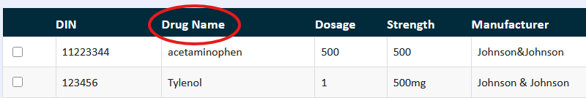Click on a column header to sort the data in ascending or descending order.
3. Click the same header again to switch between ascending and descending sorting.
4. Example:

1. To reset the table to its original order, refresh the page (F5).

# HOW TO CREATE AN ORDER

1. Navigate to the orders page.
2. Click the Add Order button.
3. A menu will appear with information being required to enter.
   1. Patient – Click Patient, select a patient from the window, then click Confirm.
   2. Medication – Click Drug, select a drug, then click Confirm.
   3. Dose
   4. Form
   5. Route
   6. Frequency
   7. Duration
   8. Quantity
   9. Physician – Click Physician, select a physician, then click Confirm.
   10. SIG – Click SIG Code, select a SIG code, then click Confirm.
   11. SIG Description – Auto filled based on the selected SIG.
   12. Start Date – Either manually or use the calendar button to select a date.
   13. Start Time – Format must follow HH:MM Format (24-hour Clock).
   14. Comments (Optional).
4. Click Submit.
5. A confirmation window will appear, indicating the order was successfully added.

# HOW TO VERIFY AN ORDER AND PRINT

1. Navigate to the verification page.
2. If required (Sort or search for the required order).
3. Select the order to verify.
4. A verification menu will appear.
5. Review all fields and check the boxes beside each verified field.
6. Click the Verify button.
7. A confirmation page will appear Click the Home button to return to the home page.
8. If printing is required, refer to “How to Print”.

# HOW TO PRINT

1. Click the Print button.
2. A new page will appear, click on the Print button for printing the verified order.
3. A pop-up will appear, click the Print Options button to open a drop-down menu with the following options.
   1. Print to PDF
      1. Select Print to PDF.
      2. Click the Print button.
      3. A PDF version will be saved to your downloads folder.
      4. File will be name (PrintedPDF-.pdf)
   2. Print from Printer
      1. Select Print from Printer.
      2. Click the Print button.
      3. A confirmation message will appear.
      4. After accepting, home page will display.

# GLOSSARY

* SIG Description – Directions for use
* Rx Number – Refers to the unique identification number assigned to a prescription.

# INDEX

**No index entries found.**