**ACADEMIC HONESTY STATEMENT**

I/We declare that all parts of this report are prepared by the below listed members and no uncited material from any external sources is included. I/We declare that this report genuinely reflects my/our activities and tasks performed as a part of assessments within the course **DECO6500 – Advanced Human-Computer Interaction**. The work contained in this report has not been previously submitted to any other courses offered by UQ or any other universities around the world.

Furthermore I/We declare that (place a cross in each box):

* I/We did not cut-and-paste information from others without appropriate use of quotation marks and direct reference to their work;
* I/We did not re-word the ideas of others without proper and clear acknowledgement;
* I/We did not write ideas or suggestions that originated from other students and claim these as my/our own;
* I/We did not include words from other students’ work unless this was explicitly permitted in the description of this assignment.

**We understand that any violation of the above will result in a possible:**

* ZERO mark for this assignment, and/or
* My/Our names will be recorded and will be forwarded to the faculty to handle.

For assessment purposes, we give the assessor of this assignment the permission to: reproduce this assignment and provide a copy to another member of staff; and take steps to authenticate the assignment, including communicating a copy of this assignment to a checking service (which may retain a copy of the assignment on its database for future plagiarism checking).

**Student Name & Number Signature**

Calvin Lee (47012026)



Heather Blakeway (45804423)

Zixuan Huang(46716747) 

**Entrepreneurship in**

**Australian University Makerspaces**

Calvin Lee (47012026); calvinjiho.lee@uqconnect.edu.au , Heather Blakeway (45804423); hblakeway@uqconnect.edu, Zixuan Huang(46716747);zixuan.huang1@uqconnect.edu

# 

# 

# 

# 

# 

# 

# 

# 

# **ABSTRACT**

# Due to the present day “maker movement”, Makerspaces are evolving from their traditional settings, further improving community learning and creative spaces. As universities facilitating makerspaces is a young concept, mainly being built in 2015 and onwards, there has been little academic research surrounding how university makerspaces contribute to entrepreneurship. Therefore, this paper summarises a study that focuses on how university makerspaces encourage entrepreneurship in students. Through the analysis of online resources and physical research with related makerspace members, we recognize the significance of makerspaces in an entrepreneurial journey physiologically, emotionally and physically to ultimately answer our research question. By participants highlighting their involvement and intention within their makerspace, our understanding of where and how university makerspaces can realistically aid students was improved. We conclude by discussing our findings to determine if makerspaces encourage entrepreneurship, and further present the VR Prototyping Makerspace Assistant as an original design concept in relation to our research.

# **KEYWORDS**

Entrepreneurship, Makerspaces, University, VR

# **1** **Introduction**

# A Makerspace is a collaborative work space inside a college, library or public facility for making, learning, and exploring. Generally speaking, the members of the makerspaces are people who have common interests, and they will use some high-tech tools or non-technical tools to make something together. High-tech tools commonly used in makerspaces include 3D printers, CNC machines, and laser cutters, while some no-tech tools like ruler, saw and utility knife are still being used [8]. Traditionally when makerspaces were formed, it was mainly focused on hobbies; however in the 21st century, makerspaces tend to need modern skills, like science, technology, engineering and maths[9]. Furthermore, makerspaces have also been modernised physically,with revolutionary technology and spaces, socially, fostering innovative brainstorming and culturally, providing a diverse environment.

With the modernization of makerspaces, the makerspaces in universities are constantly being developed. University makerspaces have especially a strong academic atmosphere and can be used to build physical prototypes, digital prototypes, software prototypes and/or electronic prototypes [10]. Furthermore, the participants in the makerspace of the university are all typically peers and alumni, so it is easy to eliminate barriers and benefit teamwork. These advantages are also beneficial for entrepreneurship, so this is an opportunity.

Therefore, we identified a gap in research regarding university's makerspaces and entrepreneurship. Through our collaborative research, we found that although makerspaces are able to support and complement entrepreneurship processes in the early stages, we determine that general university makerspaces don’t in fact encourage entrepreneurship. Based on this, we developed a design concept of a virtual reality-based device for assisting prototyping in the entrepreneurial process by combining what we learned about HCI and the challenges found in our research.

# **2** **Literature Review**

A review of relevant literature, categorised into the physical evolution, makerspace opportunities and entrepreneurship explores concepts to aid better understanding towards the influence of university makerspaces on entrepreneurship.

# **2.1** **Physical evolution of makerspaces**

Makerspaces have been evolving over the years moving away from traditional spaces, where the origin of makerspace was a Sewing club in Gowanda in 1973 [5]. Back then, most of the tools in makerspaces were sewing machines, rulers and scissors. However, with the rise of hackerspaces in the 1960s, various types of makerspaces have emerged one after another, such as carpenters and blacksmiths[5]. The tools were replaced with saws, files and iron felts. Subsequently, as technology developed, makerspaces were no longer limited to hobbies like sewing, woodworking, etc., but instead focused on science, technology, engineering, and mathematics, which is also known as STEM[5]. 3D printers and machine tools have become common tools in the modern makerspace. Especially 3D printers, which can accurately print what people need according to the blueprints entered in advance, and even make some other tools.

As the previous research mentioned earlier, modern makerspaces turn to focus on STEM, which leads to the extension of makerspaces into other fields, such as microfabrication[3]. A group of University of Central Florida academics propose a microfabricated makerspace that uses 3D printing, ink casting, and micromachined lamination to create biological devices, they called it 3D PICLμM. This makerspace is mainly shaped by ink casting with a 3D printer and then using micromachined lamination. They could use this technique to make integrated multi-electrode arrays of 30-micron size, which can be used in bioengineering, such as drug delivery, organ-on-a-chip and electrophysiology. And the makerspaces using this technique are ideal for low-resource environments[3].

These documents can roughly show the physical evolution of makerspaces due to the evolution of tools, from hobby to academic, from macro to micro. At the same time, materials also have an impact on the evolution of makerspaces. Scholars at Indiana University built a small makerspace and invited students to participate[1]. The makerspace started out with nothing but a 3D printer, but researchers gave participants materials and instructions for assembly and how to use 3D printers. Students not only need to install these 3d printers, but also design the location of new 3d printers according to different needs, and finally make the makerspace with only one 3d printer develop into a complete workstation. The utilisation of materials and reallocation of resources is an important part of modernised makerspaces. However, this document did not mention the impact of students on the evolution of makerspaces, especially since they were constantly optimising the layout of makerspaces. So our topic is focused on the impact on students in Australia.

# **2.2** **Opportunity and limitations for marginalised communities**

Makerspaces tend to be a place where people associate with the creation of ideas for both personal and business. However, in recent years, the evolution of makerspaces evolved into a place where people join for financial, social and health-related benefits [2,4,11]. Research has suggested that makerspaces are growing places from the “hacker/maker movement”, yet these places might tend to exclude people from low socio-economic communities since they tend to lack the capital to participate [4]. It was found that Makerspaces such as Substation33 balance four important aspects which are “the interdependence of activities, characteristics of the space, social relationships through peer learning, and community rules and expectations” to maintain control despite the varying number of people and materials [4].

Aside from the limitations stated above, a common limitation for people to participate in makerspaces is the internal communities in which some makerspaces have a flat hierarchy that new members have a difficult time adapting to either the lack of knowledge or skills. This could affect how the makerspaces work since it requires the involvement of most participants in the community to know and is willing to help one another [2].

In addition to the socio-economic limitations, people who are in different age groups have different priorities when participating in makerspaces. Younger members primarily focus on the work environment and resources and older members tend to consider the essential and emotional within the spaces. Older members tend to use makerspaces more similarly as a community centre rather than a place to work while the younger group look at them as a place to work rather than renting out a place [11].

Taking into consideration, makerspaces are places where people from different communities join to participate in their own activities. It is difficult to include people from all different backgrounds and ages since everyone has their own ideal conditions on what is the best choice for them, whether it would be the cost of participation, the activities, the people involved, and the overall communities and the rules that govern them [2,4].

Understanding the limitations of marginalised groups of people is a small part of a larger picture that enables us to prevent and reduce barriers to participation in makerspaces. As a result, if more people are able to join and create things, they may be able to overcome their own limitations, especially in the newer generation in universities and colleges.

# **2.3** **Growing interest in entrepreneurship**

Alongside the cultural and physical benefits that have been discussed, makerspaces also offer a space that houses the life cycle of an entrepreneurial process. Over time, makerspaces have developed into social, explorative spaces, which today are widely accessible to the general public. This shift often defined as the “maker movement” creates opportunities for innovation and entrepreneurship for regular citizens whereas, “historically this has been dominated by larger and better-endowed organisations,” [7]. Using makerspaces to gain a profit has typically opposed the traditional values of makerspaces however modern outlook has seen makerspaces, “fostering creative atmospheres” and “turning ideas into a reality” allowing a kickstart in entrepreneurial development [12].

Makerspaces have gained popularity due to one’s ability to hone and expand skills using industrial machinery. In the initial stages, makerspaces can be, “used to build physical prototypes, digital prototypes, software prototypes and/or electronic prototypes” [10] due to the extensive range of machinery and tools. Access to such physical assets allows a comprehensive iterative development phase which is crucial in a product's lifetime.

Furthermore, from another strategic point of view, makerspaces have increased in popularity for sites of entrepreneurship due to lowering start-up financial costs. This removes barriers, allowing unlimited prototyping as makers typically have free, or pay a small fee to access such a large range of materials and machinery [7].

Additionally, makerspaces offer sites for social support as both professional and amateur makers are able to share their knowledge and experiences. Over time, habits are built upon in the spaces, allowing the development of self-efficacy, confidence, and innovative thinking which are all skills essential to a successful entrepreneur [12]. Understanding the role that general Makerspaces can play towards entrepreneurship helped us focus our questions as to how specifically university makerspaces can impact university students in entrepreneurial ventures.

**3** **Methods**

This study utilised five different types of investigation - general surveys, focussed surveys, digital ethnography, contextual interviews and visual mapping to allow for thorough and diverse data. These specific methods were chosen in line with the say-make-do model, where we categorised surveys and interviews as ‘say’, digital ethnography as ‘do’ and visual mapping as ‘make’. Conducting these methods gave us the opportunity to attain a breadth of information and allowed us to engage university Makerspace members to understand how university makerspaces encourage entrepreneurial development.

# **3.1** **Surveys**

# **3.1.1** **General** **Surveys**

An online general survey was constructed, consisting of 12 general makerspace focussed questions and posted to several UQ servers and group subreddits with an outreach of over 200 engineering students (see Appendix 8.1.1). The 9 responses received from this survey were inconsistent and lacked significance in providing any insights towards our focus. From this we were able to reconsider our target audience and deemed it necessary to seek participants with direct association with respective Australian university makerspaces.

# **3.1.2** **Focussed** **Surveys**

Five “focussed” surveys were conducted to allow for a more comprehensive data set following the results of our general survey. To prepare for the surveys we constructed a list of structured survey questions in relation to entrepreneurship in makerspaces (see Appendix 8.1.2). Due to participants engaging from several widespread locations, each survey was conducted digitally for easy access and data collection. Survey questions that were created were meticulously created to avoid straight ‘yes’ and ‘no’ responses from participants, allowing each participant to add their own unique experience and opinions to widen the breadth of our data (see Appendix 8.1.2). We learnt that a more focussed survey offered more valuable data in relation to our research focus than our previous general survey and was a quick way to gain answers to the questions we wanted answered directly.

# **3.1.2.1** **Focussed Survey Participants**

In total our focussed survey achieved a comprehensive spread of Makerspace related individuals, with a student to staff ratio of 4:1. Our outreach to participants was very specific and was selected based on their willingness to participate in the study. As previously mentioned our target audience was narrowed down to people who were directly associated with university Makerspaces however there were no constraints on location, age, gender or ethnicity as these factors do not contribute to our focus. Table 1 shows the participant and their respective makerspace interviewed.

| **Participant** | **Role** | **University** |
| --- | --- | --- |
| A | Engineering Student | University of Queensland |
| B | Engineering Student | University of Queensland |
| C | Design Student | University of Melbourne |
| D | Engineering Student | University of Melbourne |
| E | Director | University of Queensland |

Table 1: Focussed survey participants

**3.2** **Contextual Interviews**

Six interviews were conducted to gain understanding of the viewpoint of makerspace members. In preparation we put together a list of semi structured questions in relation to our main focus; How has the development of Australian university makerspaces encouraged entrepreneurship (see Appendix 8.2)? We began each interview by gaining consent from the participant as well as taking note of their individual demographics. Following this, we asked questions relating to their respective makerspaces in regards to their personal goals and entrepreneurial use.

When conducting the interviews, questions were carefully asked in hopes of collecting some corroborating data as well as allowing each participant to contribute unique perspectives about their Makerspace (see Appendix 9). Due to participants' locations being widespread and in different time zones, all interviews were conducted on zoom for approximately half an hour to ensure consistency and convenience. We found that conducting interviews gave us access to qualitative and personal data quite quickly as well as facilitated peripheral discussions to support and diversify our findings. Diary studies was considered as an alternative method to gain a new level of personal data however we deemed this unsuitable for our research due to time frame constraints and would have been best suited if our participants were starting a new entrepreneurial journey to see the effect of the makerspace in the lifetime of the product.

# **3.2.1** **Participants**

Through our interviews we achieved an inclusive portfolio of participants with a student to staff ratio of 2:5 who were all members or directors that regularly attended or managed their respective makerspace in Australian Universities. Our outreach to participants were both targeted due to their status and connection with the makerspace as well as found through personal connections with our researchers. Our participants were also selected based on their availability and desire to be a part of the study. As we endeavoured to explore entrepreneurial development in Australian university makerspaces we focussed on choosing participants from a range of universities, having no restrictions on location, age, gender or ethnicity. This allowed us to complete a more inclusive and comprehensive study and therefore observe how different makerspaces in universities around Australia have encouraged entrepreneurship.

All participants had direct association with the makerspace and some form of insight to entrepreneurial processes in the Makerspace. All makerspaces were located at a university as we concluded that including makerspaces not based at a university to be insignificant towards our research focus. Table 2 shows the participant and their respective makerspace interviewed.

| **Participant** | **Role** | **University** |
| --- | --- | --- |
| A | Student User | University of Melbourne |
| B | Student PHD Researcher User | University of Queensland |
| C | Senior Researcher User | University of Queensland |
| D | Director | Australian National University |
| E | Director | Australian National University |
| F | Director | Griffith University |
| G | Director | University of New South Wales |

Table 2: Contextual interview participants

# **3.3** **Digital Ethnography**

# **3.3.1** **What is Digital Ethnography?**

The study of people in their natural digital environment is known as digital ethnography. It allows researchers to observe respondents in their natural setting, effectively turning research on its head by bringing the researcher to the participant rather than vice versa. So what makes it so popular? Observing people in their natural environment, on the other hand, paints a much more accurate picture of how they truly think and feel than asking them to fill out a questionnaire or talking to them on the phone. After all, what people say they do and how they actually behave can be rather different! [6]

# **3.3.2** **How we conducted digital ethnography?**

We conducted our digital ethnography using several different media types either by participating in existing maker space conversations or starting our own in order to get more precise data.

**Step 1:** Look through existing resources on several media types such as forums, videos, podcasts, etc.

**Step 2:** Engage with existing users via comments or group messages to understand the understanding of related research fields.

**Step 3:** Create more focused questions to ask on the same media type in order to reconfirm understanding of the research question.

**Step 4:** Once a good sample size has been collected, data would be analysed between several media types to find any relationships between them.

| **Makerspaces Sources** | **Media Type** |
| --- | --- |
| UQ Handcraft & Art Club | Facebook Page |
| r/Maker - Understanding Makerspaces | Reddit Forum |
| r/Hackerspaces - Understanding Hackerspaces | Reddit Forum |
| OpenGarage | Reddit Chat |
| South Side Hackerspace | Reddit Chat |
| OpenHouse | Reddit Chat |
| Makerspace Managers (Ep 1 - 5) | Spotify Podcast |
| Dr Dhaval Vyas on his study on the benefits of makerspaces (QUT) | Youtube |
| Why libraries in Australia are creating Makerspaces | Youtube |
| Makerspaces as Learning Spaces: Kerry Harmer @ Mount Royal University | Youtube |
| Exploring creativity while studying | Curtin Library Makerspace | Youtube |
| UNSW’s Makerspaces empower creative students and staff | Article/ Journals |
| MAKERSPACES AND STUDENT WELLBEING | Article/ Journals |

Table 3: Digital ethnography sources

**3.4** **Visual Mapping**

**3.4.1** **What is visual mapping and why do we choose to use it?**

Visual mapping is a method to visualise complex information, ideas, and components. This method allows the interviewee to draw according to the questions asked by the interviewer, and the interviewer then asks questions based on the picture and research project to conduct the interview. In this project, the reason we choose to use visual mapping is because we want to crystallise thoughts and memories, which is related to our earlier survey, we found that most of the students don't know much about makerspaces, so we interviewed these students by giving them some information about makerspaces and asking them to imagine if they participated in makerspaces what would it be like (see Appendix 8.4). For those students who attended a makerspace, we asked them to recall the makerspace they attended. ​​So we need a method to display thoughts and memories and visual mapping meets all the requirements.

# **3.4.2** **How did we use visual mapping to interview?**

**Step 1:** We showed those interviewees with materials of makerspace and asked them to draw a map of makerspaces in their imagination or memories and record them.(Not revealing information about Makerspace entrepreneurship to prevent unrealistic ideas)

**Step 2:** Invite them to do a video interview based on their drawings.

**Step 3:** Interview some questions related to the research project, focusing on their views on using makerspaces for entrepreneurship, etc.

**Step 4:** According to the opinions obtained in the interview, analyse the difficulties encountered in using the makerspace for entrepreneurship.

**Step 5:** Combine the results obtained with other research methods for data analysis.

| Participant | Role | University |
| --- | --- | --- |
| Interview1 | Student | University of Queensland |
| Interview2 | Student | Monash University |
| Interview3 | Student(makerspace experienced) | University of Queensland |
| Interview4 | Student(makerspace experienced) | Kumamoto University |
| Interview5 | Student | University of Queensland |

Table 4: Visual Mapping participants

**4**  **Results**

Over the period of our research we discovered and analysed three major themes that categorise common ideologies between participants, to then evaluate whether university makerspaces encourage entrepreneurship. University Makerspaces themselves foster a productive and innovative environment due to the ability to cross pollinate ideas between students and professionals. Simultaneously, members highlighted having a unique learning opportunity to use industrial equipment to build their desired projects. In such a collaborative space, participants find that makerspaces provide physiological benefits as well, exposing individuals to certain practices, techniques and attitudes in a work environment. However, as innovation develops as makerspaces become more established, those wanting to take the next step to entrepreneurship find some limiting factors in makerspaces.

**4.1. Unique Opportunity**

Primarily we found a significant consensus between participants, that motivation to work within a university makerspaces, was due to its invaluable opportunities such as providing access to industrial equipment, and an intellectual working environment, whether it be for university or personal projects. University Makerspaces are equipped with machinery and tools for free use to support members to produce projects. We found in the majority, members were students who used the space for their course projects as they are able to complete their projects safely and with the correct equipment necessary. Participant G explains:

*“Right now if you need something you just jump into a makerspace, but when I was doing my first year course to make a little robot for our first year engineering design challenge, I made it in some person’s garage 15 minutes down the road from university.”* (Participant G)

Participant G was a student themself and now manages their respective Makerspace and therefore elaborates on their opportunities when studying in comparison to students today. They express that, without being able to attend a makerspace, they felt as though they missed out on a significant part of their learning and reported that they were not able to properly produce projects due to a lack of resources. Participant G argues university makerspaces are essential in adding a practical component to a students course work, enhancing student opportunity. Participant E, another makerspace director, originally coming from a physics lecturer background upholds a similar stance, arguing how important it is to recognise that “people learn with their hands'' and “by doing”, which is enabled through the use of a makerspace. They draw their conclusions from having to teach a completely theoretical physics course which in their opinion lacked any opportunity to develop practical skills that would be necessary for a physicist later in their developed career. Now managing their own makerspace, they apply this philosophy, and through it, justify the importance of members having the practical opportunity in their time at university.

Another prevalent motivation for members to use university makerspaces is the inaccessible nature of machinery due to the costs associated with owning your own tools. Participant A makes a point of this:

*“For example in engineering, a lot of established companies have their own machinery, but if you are just starting off you need access to those machines but you generally don't have the budget to pay for a 1000 dollar milling machine.”* (Participant A)

Similarly, Participant B corroborates this point of view by stating:

*“It has the tools that I wouldn’t normally invest in or buy.”* (Participant B)

Contrasting this, it must be noted that the case of free use of machinery is dependent per university makerspace, as aside from these participants, some others expressed their concern regarding high costs associated with materials in makerspaces. Visual mapping Participant K elaborates:

*“We tried many times until we ran up the budgets. We could not afford the cost of materials..”* (Participant K)

Participants A and B both explore how owning their own 3D printer or CNC machine was very unrealistic, and therefore joined or used the makerspace to make use of this opportunity. Participant A being a student graduate expresses her first hand feelings, and identifies makerspace machinery as her main drawing point towards the makerspace. Participant B supports this, as a PHD student, by adding that her ventures and projects are not a result of the makerspace itself, rather it is made possible through its facilities.

**4.2 Prototyping**

Due to the known purpose of makerspaces, individuals are constantly testing models and being physically creative to make an idea come to life. Also suggested by literature discussed previously, prototyping is essential in any project - entrepreneurial or not and the open and wide range of accessible resources of a makerspace assist this process greatly. During interviews conducted, all participants were able to come to a solid consensus in regards to the great weight of prototyping in makerspaces where Participant F contributes heavily to this discussion point by saying;

*“That is why our bins are always full because of the iterations students make. Full of broken ideas and teaching them to do better on their next try..”* (Participant F)

In such an environment, members are able to adventure with their design concepts without being worried about making mistakes, giving the opportunity for a better final product. Participant G also expands in a similar nature stating;

*“If you help them build up ideas, help them develop a product that you know, that they have a better grasp of, better expertise over, instead of forcing them idea to business straight away, they actually have a product, they have a higher chance of actually succeeding because you know they actual have something concrete instead of a hairy idea.”* (Participant G)

Despite the two different participants agreeing that through makerspaces members are able to develop higher quality products, findings through digital ethnography on this topic shed light from a different direction. Interestingly, data suggests that limitless prototyping produces large amounts of waste. When speaking with participants who were directors of makerspaces, none of the participants mentioned the factor of waste and were extremely fixated on their vision for learning and growth, which hence seems to be at any cost, in their makerspace. Not only does this reveal the value makerspaces hold for prototyping but it is also a negative factor to consider in the proposed design concept.

**4.3 Behavioural Development in Makerspaces**

Makerspaces are often known for developing an open and creative community. When conducting research, the social and behavioural benefits obtained from working within a makerspace was regarded highly and acknowledged commonly between participants. Participant B summarises this concept well saying;

*“Yeah, the makerspace fosters a type of thinking, that even if you are the most genius person sitting in the room all by yourself. Being in that space, it fosters you to think differently. It’s like there is no box.”* (Participant B)

Participant B who is a PHD student, then further explains that the ability to work amongst others that aren’t in the same field is a major drawing point to work in the makerspace. This cross collaboration gives participants the feeling of self growth and makes the makerspace a place that students want to be a part of, as it gives them the opportunity to develop unique thinking processes. Participant B further expands their first hand experience of this;

*“So for example I’m HCI major and therefore it's more like designers in that space but then when you are in the makerspace you are meeting with lots of different experts in their own field. So your ideas evolve from being something your discipline to being interdisciplinary and it would be more adaptable to several cases rather than just a homogenous thought.”* (Participant B)

From another point of view, Participant G who is a director of their makerspace communicates a corroborating view, observing this from the makers in their makerspace.

*“So I think that there are people that come to us and by the time they have spent a couple years in traction with us would say that they have changed, they do things, they change the way they solve problems, they have more diverse approaches to problem solving.”* (Participant G)

Our digital ethnography findings also contribute, as we found 100% of students participating in a particular reddit thread to engage in makerspaces to learn a new skill or for self-benefit. As reinforced by Participant C;

*“It is more about self actualization. Getting things done, making something that is actually good for people's confidence rather than building up a company, making money out of it.”* (Participant C)

Therefore, participants are attracted to makerspaces due to the opportunity to expand themselves within the space and hence be in a diverse and open environment.

**4.4 Entrepreneurship in Makerspaces**

Providing the innovative and creative nature of modern day makerspaces, we were surprised to find entrepreneurship existing in makerspaces to be a minority. Unless the makerspace specialised in entrepreneurship specifically, we found that general university makerspaces did not necessarily encourage entrepreneurship directly, with several limiting reasons. The following sections explore both the benefits and challenges of entrepreneurship in university makerspaces.

**4.4.1 Entrepreneurship Benefits**

In some universities in Australia, precincts have been built directly for the purpose of entrepreneurship. In these cases, entrepreneurship is definitely encouraged and more so enforced in the makerspace. Students wanting to venture down this path are guided through an entire entrepreneurial process from the iteration phase to the commercialization and funding stage, allowing students to work in a space very focussed to their needs. Participant G specifies more details;

*“So its split into three sections, the makerspace, the design space and the event space and the whole idea is that you start in the design space with your ideation, with your workshops, you generate your ideas and come up with something and then you go to the makerspace as a prototyping area and then after that you go to the event space where you can pitch your ideas and that was why that space was very good for entrepreneurship.”* (Participant G)

Although Participant G does communicate the positives out of having such a specific and supportive environment for those curious in the entrepreneurship space, he also recognises that the majority of students at university are not looking to engage in entrepreneurship. This was a problem initially, as at the time of their involvement in this particular space, the university did not facilitate a regular university makerspace for those who just wanted to tinker, or make small projects for personal satisfaction. Participant G then goes on to explain how this prompted them to create their own universities general university makerspace, to fill this need;

*“So it would it be like, someone would come in and be like I want to print this part for this project I have at home and the first that we were told to ask them was, how do you plan on making this, what do you want to do with it, have you thought of making this into a start-up even though it could just be something you could buy from IKEA, like you know there’s no point.”* (Participant G)

Participant G then highlights that as their general makerspace embodies similar KPIs in relation to iterative processes, there are occasional students who find themselves wanting to see where a particular product can take them. From here, they are then guided onto the entrepreneurship specific makerspace to continue on their endeavours. From this, it can be seen that general university makerspaces do not encourage entrepreneurship; however more so, provide a space for individuals to learn and explore different avenues. Similarly, Participant E expands on this point of view;

*“I mean there are plenty examples of around the world of makerspaces that are set up to support entrepreneurship but I think entrepreneurship is often emergent from these sorts of environments where people didn’t really think of themselves as entrepreneurs”* (Participant E)

In ways the corroborating opinions of Participant G and E, shows that it is just as likely for students to not want to become entrepreneurs when engaging in an entrepreneurship space, as it is likely that a student in a general makerspace will find themselves wanting to explore entrepreneurship.

**4.4.2 Entrepreneurship Challenges**

Amidst our research we found general university makerspaces to be limited on facilitating an entire entrepreneurial process. To begin with, a major dilemma faced from a legal and ethical standpoint, aspiring entrepreneurs are not able to commercialise within the space, using makerspace resources. Participant D highlights:

*“There is a fine line between commercial activity and activity that is acceptable in the makerspace. So prototyping, totally fine, all about that kind of stuff but when it actually comes to starting to ramp up production or do higher quantity things it's not really suitable for the makerspace that we have.”* (Participant D)

Participant D is a director of their respective makerspace who shares that small personal projects that someone may sell on Etsy is acceptable in the makerspace; however, once someone wants to make that step outside of the iterative phase, it is not suitable for their university makerspace. They also discuss how some makers have asked to pay to commercialise in the space, however this raises ethical issues and conflicts with the values of the makerspace. Similarly, participant A states;

*“I think the main thing is with the rules of the makerspace, is that the free use is that you can’t just make a production line, like you can’t just make a business and keep doing it for free and use all their free resources and so that kind of idea is that you are allowed to do a couple prototypes but yeah you can't commercialise through.”* (Participant A)

When asked, both participant A and D both discuss how commercialisation does not align with the goals and values of their respective makerspace, being a place of learning and giving equal opportunity to all members. It was interesting to discover the limits of makerspaces as they are commonly known as a completely free use resource where the limits of creation are endless. Although this reason ultimately explains the lack of explicit encouragement from general university makerspaces, another interesting point brought up by several participants was regarding issues with conflict of ideas. Participant A explains this well, stating:

*“I think there can be collaborations but obviously people are quite protective over their ideas when they are entrepreneurs, so there is less of that interchanging of ideas unless they’ve signed an NDA.”* (Participant A)

Participant I also explores the fine line between inspiration in a makerspace versus plagiarism;

*“Entrepreneurship means innovation, and naturally, inspiration may bring problems such as plagiarism.”*(Participant I)

Ultimately, entrepreneurship is business related, and due to the collaborative nature of a makerspace, it is not able to completely protect individuals and the privacy of their own ideas which may lead to ongoing conflicts.

**4.4** **Design Concept**

Our design concept primarily aims to focus on aiding the prototyping phase, as this is the main entrepreneurial process that is able to occur in university makerspaces, in hopes to achieve encouragement of entrepreneurship through makerspaces. As shown in the following figures, through the VR goggles, users are able to have a fully digital iteration phase, reducing waste, cost and time associated in the process.

# 

# 

# 

# 

# 

# 

# 

# 

# 

# ***Figure 1:*** *User using VR goggles and set up to enter into a VR simulation where they can interact with creations they upload.*

# 

# 

# 

# 

# 

# 

# 

# 

# ***Figure 2:*** *The user is able to interact directly with a digital version of the creation, properties of the creation can be tweaked such as materials, lifespan, etc.*

# 

# ***Figure 3:*** *The user is able to simulate their creation in the virtual reality space and modify their creation on the go. Changes can be imported back into the computer so that they can either be 3D printed or be made with other methods.*

# **5 Discussion**

**5.1 Addressing Entrepreneurship in University Makerspaces**

Makerspaces are places that cultivate creativity and innovation while teaching members the process of product development. Looking at the general demographic of people participating in makerspaces we can identify three distinct groups of people; firstly people who are there for social and personal satisfaction, secondly people who are there to utilise resources and lastly people potentially looking to venture the entrepreneurial route. Understanding this demographic in makerspaces gives us insight into what technologies and services currently exist to assist with the growth and encouragement of young and motivated entrepreneurs in general university makerspaces.

From learning about people’s motivations to join and engage in makerspaces, it is clear that entrepreneurship is not a concept felt to be encouraged by general university makerspaces. Although in many peoples experiences we have seen makerspaces facilitate similar behaviours and habits that may be associated with entrepreneurship, this does not mean that the makerspace itself encourages entrepreneurship specifically. Skills associated with entrepreneurship such as open thinking, producing products on a certain machine or having experience completing an iterative design phase are applicable to various aspects in life, which general makerspaces aim to teach and leave up to the individual to use accordingly. General makerspaces are created with the intention of promoting creativity, community, and learning and therefore does not push students towards any certain direction. The open and collaborative space allows freedom and encouraging one ultimate path for students is contradictory to this. Furthermore, it must be addressed that the majority of students do not find makerspaces as a place to build a business but more of a place to build on themselves, make friends and be exposed to different perspectives and ways of thinking.

Taking into consideration our findings, we believe that makerspaces are places to learn and assist students in their journey to grow, rather than run an actual business specifically. The path someone might take out of a makerspace is dependent case by case, and unless the Makerspace is built directly for entrepreneurship, it does not fit most makerspaces goals to encourage entrepreneurship. In saying this, entrepreneurship is still minorly present in general makerspaces and therefore technology to help general makerspaces promote entrepreneurship without detraction from their goals should be considered and addressed in future development.

**5.2 Design Implication**

The design concept illustrated and described in section (4.4 Design Concept) shows the findings from our research from multiple sources of primary and secondary research. According to the research conducted, in and with various Makerspaces, prototyping is a very prevalent concept in both recreational and entrepreneurial cases.

From our findings on the general survey, we were not able to find any significant correlation between makerspaces and entrepreneurship since most of our participants were not aware of how makerspaces function. However, we got valuable data from our participants during our interviews and visual mapping sessions since those that are significantly involved in makerspaces suggested that the endgame for most makers is to produce something of value that can be sold to the market (*Transcript 9.6*). Furthermore, some of the participants suggested that the cost of materials in makerspaces is too costly and inefficient in creating a sustainable business. To put things into perspective the cost of 3D printing as of writing this paper is around $50 to $150 per kilo of filament excluding the cost of the printer.

The idea of using VR or AR is to encourage makers to get used to the latest technology as a new form of learning and easy linkage to the computer to import 3D models into the virtual reality simulation (Figure 1). The function of being able to simulate changes on the 3D model is used so that it will be more convenient and more streamlined for productivity for the makers in the prototyping phase since everything can be done virtually without on and off the computer (Figure 2). The primary reason for bringing the makerspace into a virtual space is due to the freedom of being able to create anything and simulate without waste hence reducing the cost of materials such as 3D printing for multiple iterations. Once the model has been refined, simulations of the environment can also be included such as the duration, environment and movement of the components (Figure 3).

Including a new form of computer-human interaction such as VR to the other makerspaces communities might be difficult since most of the existing makerspaces have members who are not very tech-savvy and might have a difficult time adjusting to the new changes. However, from the perspective of our use case which generally targets university students, who tend to be younger it might not be a big issue in comparison to the more expensive price for cost of materials and prototyping.

**6 Conclusion**

Based on our research, we conclude that makerspaces are beneficial in the early stages of entrepreneurship, however there are also disadvantages, such as waste of materials, costs in some cases and the fact that universities, unless specifically made for entrepreneurship, do not allow commercialization in their makerspace. In response to our specific research question, our research has shown that university makerspaces themselves do not encourage entrepreneurship and more so facilitate and foster behaviours in cases dependent on the individual. Our analysis of this, combined with our learning about HCI, led us to propose a basic design concept that utilises virtual reality to aid prototyping, to reduce material wastage, reduce development time, and test product performance in a virtual context. For any future endeavours, we would need to reconsider the wording to our research question according to our findings and perhaps explore more how makerspace “contributes to”, rather than “encourages” entrepreneurship. Furthermore, in this round of research we did not engage with any participants that had engaged in a makerspace for purely entrepreneurial use, which we would aim to seek to add a unique perspective to our data set.

# **7 REFERENCES**

[1] Anna Keune,Kylie Peppler: (24 September 2018). Materials-to-develop-with: The making of a makerspace.

[2] Austin L. Toombs, Shaowen Bardzell, and Jeffrey Bardzell. 2015. The Proper Care and Feeding of Hackerspaces: Care Ethics and Cultures of Making. In Proceedings of the 33rd Annual ACM Conference on Human Factors in Computing Systems (CHI '15). Association for Computing Machinery, New York, NY, USA, 629–638. https://doi-org.ezproxy.library.uq.edu.au/10.1145/2702123.2702522

[3] Avra Kundu ,Tariq Ausaf ,Swaminathan Rajaraman : (29 December 2017). 3D Printing, Ink Casting and Micromachined Lamination (3D PICLμM): A Makerspace Approach to the Fabrication of Biological Microdevices.

[4] Jennyfer Lawrence Taylor, Dhaval Vyas, and Tony Sharp. 2017. Diversity and coherence in a hackerspace for people from a low socioeconomic community. In Proceedings of the 29th Australian Conference on Computer-Human Interaction (OZCHI '17). Association for Computing Machinery, New York, NY, USA, 238–247. https://doi-org.ezproxy.library.uq.edu.au/10.1145/3152771.3152797

[5] Shanshan Yu:(19 December 2016). Makerspaces as learning spaces: An historical overview and literature review.

[6] Boughton, L. (no date) *What is digital ethnography?*, *Learn more about recruitment!* https://info.angelfishfieldwork.com/market-research-fieldwork-blog/what-is-digital-ethnography

[7] Browder, R.E., Aldrich, H.E. and Bradley, S.W. (no date) *Russell Browder | assistant professor | doctor of philosophy ..*https://www.researchgate.net/profile/Russell-Browder

[8] Makerspaces.com (2021) *What is a Makerspace? is it a hackerspace or a Makerspace?*, *Makerspaces.com*. https://www.makerspaces.com/what-is-a-makerspace/

[9] Metcalf, M. (2022) *Makerspaces and student wellbeing*, *National Education Summit*. National Education Summit. https://nationaleducationsummit.com.au/nes-blog/makerspaces-and-student-wellbeing

[10] Rieken, F. *et al.* (2019) *Corporate Makerspaces as innovation driver in companies: A literature review-based framework*, *Journal of Manufacturing Technology Management*. Emerald Publishing Limited. https://www.emerald.com/insight/content/doi/10.1108/JMTM-03-2019-0098/full/pdf?title=corporate-makerspaces-as-innovation-driver-in-companies-a-literature-review-based-framework

[11] Toombs, A.L., Bardzell, S. and Bardzell, J. (2015) *The proper care and feeding of hackerspaces: Care ethics and cultures of making*, *Penn State*. Association for Computing Machinery.https://pennstate.pure.elsevier.com/en/publications/the-proper-care-and-feeding-of-hackerspaces-care-ethics-and-cultu

[12] University, J.S.H.N. *et al.* (2017) *Developing makerspaces as sites of entrepreneurship: Proceedings of the 2017 ACM Conference on Computer Supported Cooperative Work and social computing*, *ACM Conferences*. https://dl.acm.org/doi/pdf/10.1145/2998181.2998264

[13] *UNSW's Makerspaces Empower Creative Students and staff* (no date) *Inside UNSW*. https://www.inside.unsw.edu.au/innovation-and-engagement/unsws-makerspaces-empower-creative-students-and-staff

# **Videos / Audio/ Forums**

**Youtube:**

**DIY and Making in Low Socioeconomic Communities - Dr Dhaval Vyas**

<https://youtu.be/mA_is0KDINY>

**Dr Dhaval Vyas on his study on the benefits of makerspaces**

<https://www.youtube.com/watch?v=Mh3h3vlJnMs>

**Why libraries in Australia are creating Makerspaces**

<https://www.youtube.com/watch?v=6GVEI8ISaLc>

**Makerspaces as Learning Spaces: Kerry Harmer @ Mount Royal University**

<https://www.youtube.com/watch?v=mGpGSqslyGI>

**Exploring creativity while studying | Curtin Library Makerspace**

<https://www.youtube.com/watch?v=iakWS2_sxX0>

**Spotify:**

**Makerspace Mangers’s Podcast**

<https://open.spotify.com/show/4rYkQjEAnHH059XuoJvOM6>

**Reddit:**

**r/maker**

<https://www.reddit.com/r/maker/comments/x7vqqp/understanding_makerspaces/>

**r/hackerspaces**

<https://www.reddit.com/r/hackerspaces/comments/x7vrg1/understanding_hackerspaces/>

**r/makerspace**

<https://www.reddit.com/r/makerspace/comments/bcx8xx/makerspaces_that_became_business_incubators_howd/>

<https://www.reddit.com/r/makerspaces/comments/x7vpwq/understanding_makerspaces/>

# **8 Appendix**

# **8.1 Survey Results**

# **8.1.1 General Survey Results**

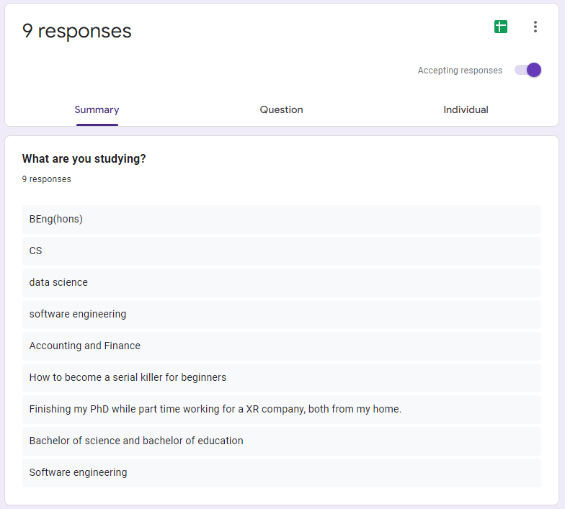

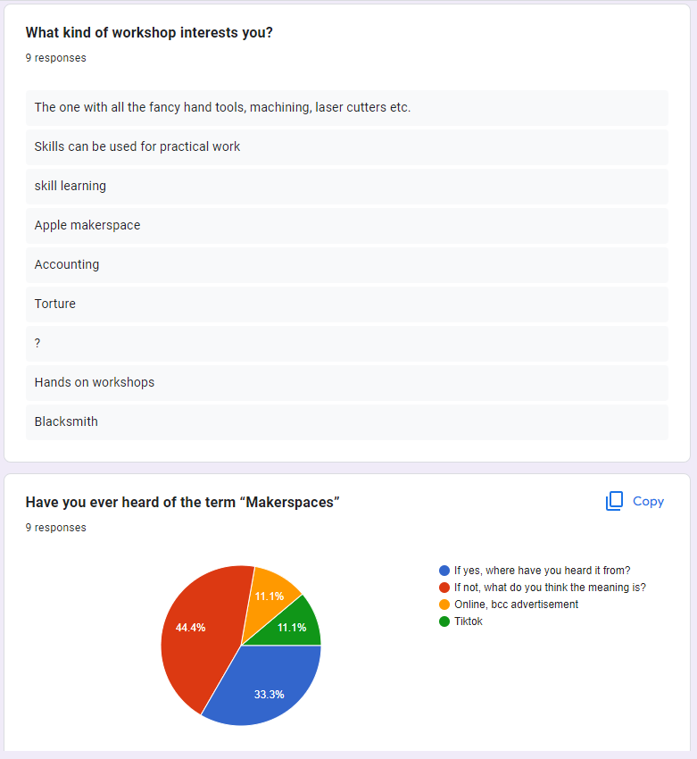

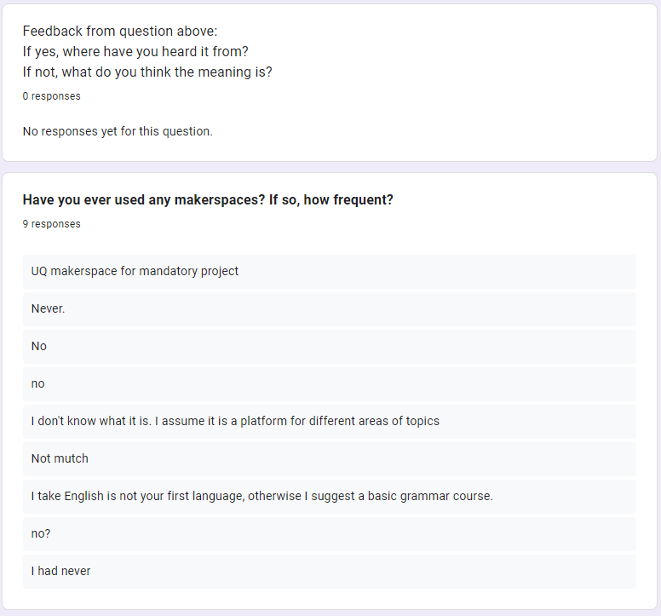

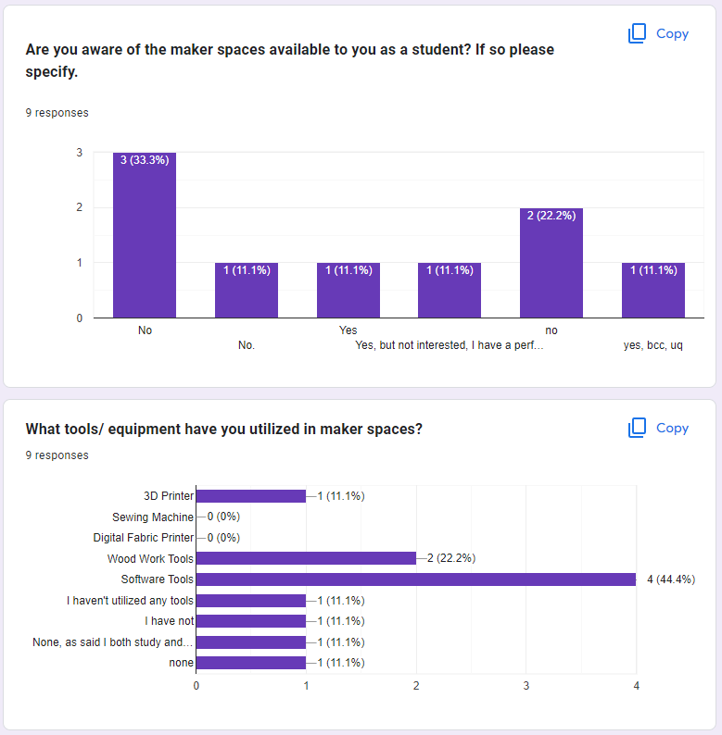

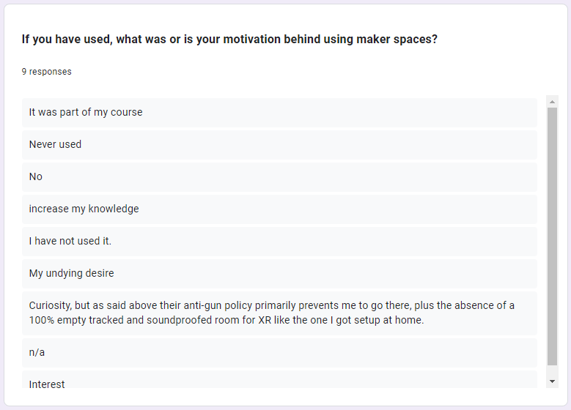

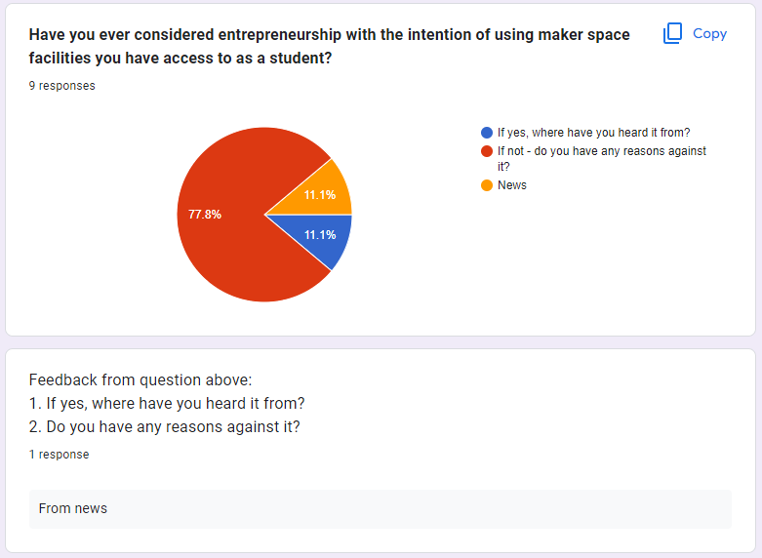

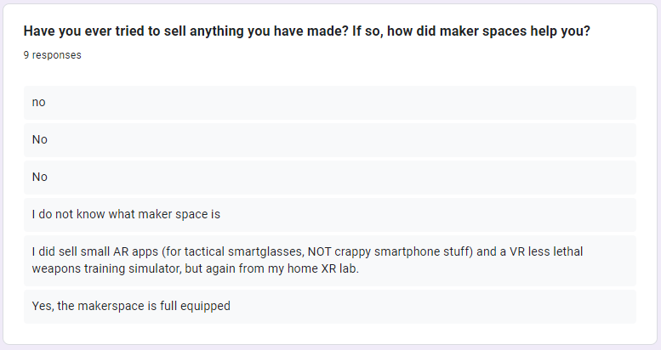

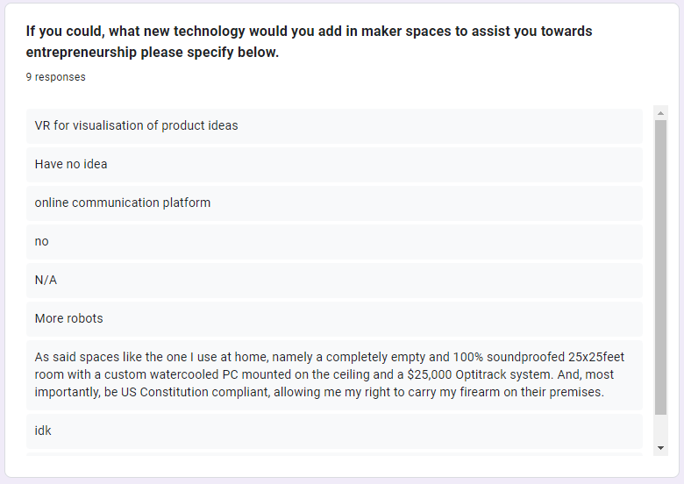

# **8.1.2 Focused Survey Results**

# 

# 

# 

# 

# 

# **8.2 Interview Questions**

A list of semi structured questions to base conversation off:

Makerspaces:

1. What involvement do you have in makerspaces?
2. What motivates people to join makerspaces based on your observations and experiences?
3. Among all the different makerspaces, what type of products are produced the most and why?
4. Have you noticed any changes to makerspaces over time? Has this impacted the products you have made/observed?
5. What type of products have you produced from makerspaces?
   1. If you have, did you ever consider selling or did sell these products?
   2. If you have not, do you know anyone who uses makerspaces to produce products? What do they produce and why?

Entrepreneurship:

1. Would you agree or disagree that the makerspace environment contributes to one's decision to sell/consider selling a product?
2. Do you know any students that use makerspaces that have endeavours in entrepreneurship? Alternatively, do you use makerspaces for entrepreneurial endeavours?
3. How have makerspaces helped and encouraged them/you in the entrepreneurial process?
4. Do you agree or disagree that makerspaces promote entrepreneurship in both a physical and cultural sense? Please state in what ways this does/does not happen.
5. Do you agree or disagree that makerspaces today promote entrepreneurship more than they did 10 years ago?

# 

# 

# 

# **8.3 Digital Ethnography Result**

# **8.3.1 Digital Ethnography Findings**

According to the findings, we can see that different media types have different problems regarding makerspaces issues but there are some similar patterns that can be observed. Although the main topic is regarding makerspaces, the questions surrounding it vary from the purpose of participating to the limitations.

The first and most common pattern we found tends to be participating in makerspaces to learn a new skill or for self-benefit. Initially, we thought that people who joined makerspaces would want to take advantage of the resources of the makerspaces since buying heavy machinery would be expensive to buy and maintain so that individuals can make a business from existing makerspaces. However, based on the replies and results we were surprised to learn that most people who join or create makerspaces do not join makerspaces with the intention of business as their priority.

The next most common pattern of people participating would be the sense of community within the makerspaces. Hence why new members tend to stay once they find the correct makerspace communities. The most common factor which makes people stick with a type of makerspaces is “Gender”. From several sources, the trends became apparent that there was no one type of makerspace where all genders are equally dispersed. It generally comes down to the type of technology that was involved, male participants tend to work using heavy and more technically complex machines and female participants would work on more creative and handicraft-related projects.

Another pattern we found would be one of the reasons why makerspaces members are not able to maintain or even participate in makerspaces in the first place due to the membership cost or makerspaces run by institutions. However, there are some free makerspaces that provide basic equipment but tend to have a condition where any inventions or innovation created in the makerspace would be the intellectual property of the makerspace which can both be a good and bad thing for the participant.

# 

# **8.3.2 Digital Ethnography Summary:**

Reddit

| People who participate in makerspaces for their own personal use compared to utilising it for a business.  **Personal Use**: **8**  **Optional Business Use: 4**  Exclusive Business Use: 0  A large **majority of people** participate in makerspaces for **their own personal use** and to explore their ideas, but a **small portion of people** tend to use it for starting up their **own businesses** but there isn't any that exclusively use it for business since it is not commercially viable. |
| --- |
| How do Makerspaces make money when providing equipment and help to participants?  **Non-Profit: 2**  **Membership: 2**  Based on research in forum chats, **there are basically a similar number of paid and unpaid makerspaces** that are created by people that want to help others create their idea. However, there are some makerspaces that tend to take **ownership of products** that are created in the maker space. |

Facebook

| People participate in makerspaces for their own personal use compared than utilising it for business.  Personal Use: 0  **Optional Business Use: 1**  **Exclusive Business Use: 1**  According to feedback, **people in clubs** tend to not care at the **beginning** but as they improve they usually **lean towards selling their product in the future**. |
| --- |
| When to decide if you want to join maker spaces for the experience or to earn money.  **Experience: 1**  **Optional Money: 1**  **Exclusive Money: 1**  According to the Facebook group, it is **purely based on the individual** if they want to join in the maker space so that they can sell their hand-crafted products, but the **majority of people tend to join without that motive** as well. |

Podcast

| People who participate in makerspaces for their own personal use compared to utilising it for a business.  **Personal Use**: **1**  **Optional Business Use: 1**  Exclusive Business Use: 0  People who tend to work in makerspaces makes use of the space to **improve their livelihood** in the form of creating nice-to-haves or to provide themselves with a **living in the form of money** depending on the **personal social status**. |
| --- |
| Makerspaces provide to the **greater community**  **Personal: 2**  **Community: 2**  **Both: 1**  Depending on the type of makerspaces, some makerspaces focus of **care work** in order to provide to **other communities** that require assistance or help. However some focus on **creating new products** out of **e-waste** which in turn helps the community. |

Youtube

| How do people start their **own makerspaces**, and how do they run them?  **Created: 2**  **Joined: 1**  According to the podcasts, it seems that different makerspace owners came up **joining and ended up managing** the makerspace or they created it out of their **own interest** or by **accident**. |
| --- |
| What are the majority of people that joined makerspaces?  **Male: 1**  **Female: 1**  **Other: 1**  According to the podcasts, it is highly dependent on the type of makerspace and the thing they focus on, makerspaces that use machines, and 3d printing technology tend to focus more on the male demographic. As for more creative projects such as art, handcrafting, etc, women tend to be the majority. In addition, people from LGBT communities tend to lean towards creative projects more than technical ones. |

# **8.3.3 Digital Ethnography Interactions:**

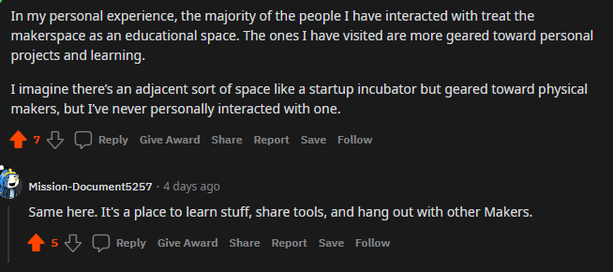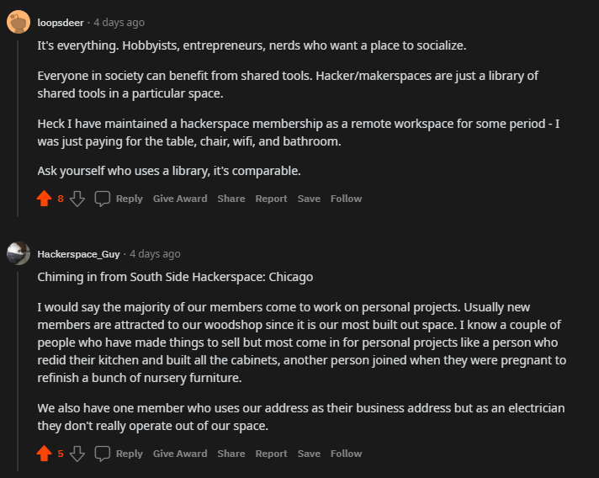

# 

# 

# 

# 

# 

# 

# **8.4 Visual Mapping Result**

# **8.4.1 Visual Mapping pictures**

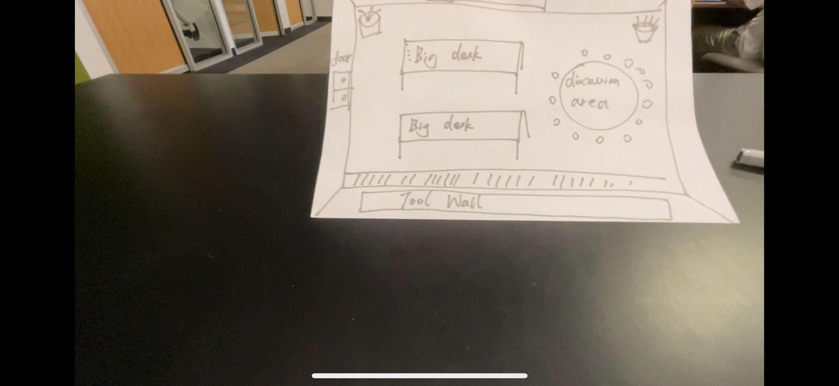

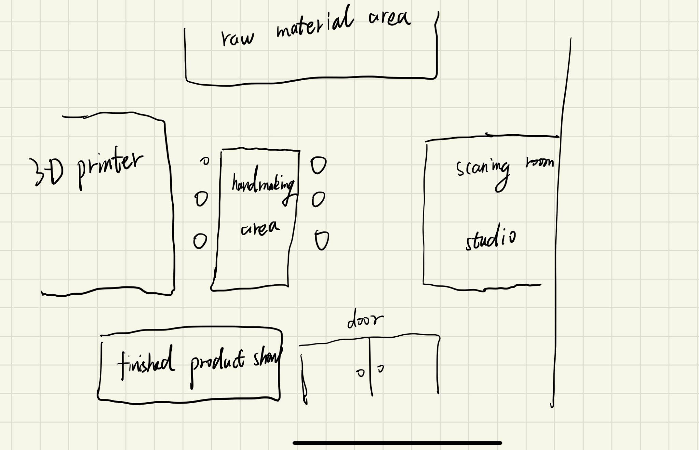

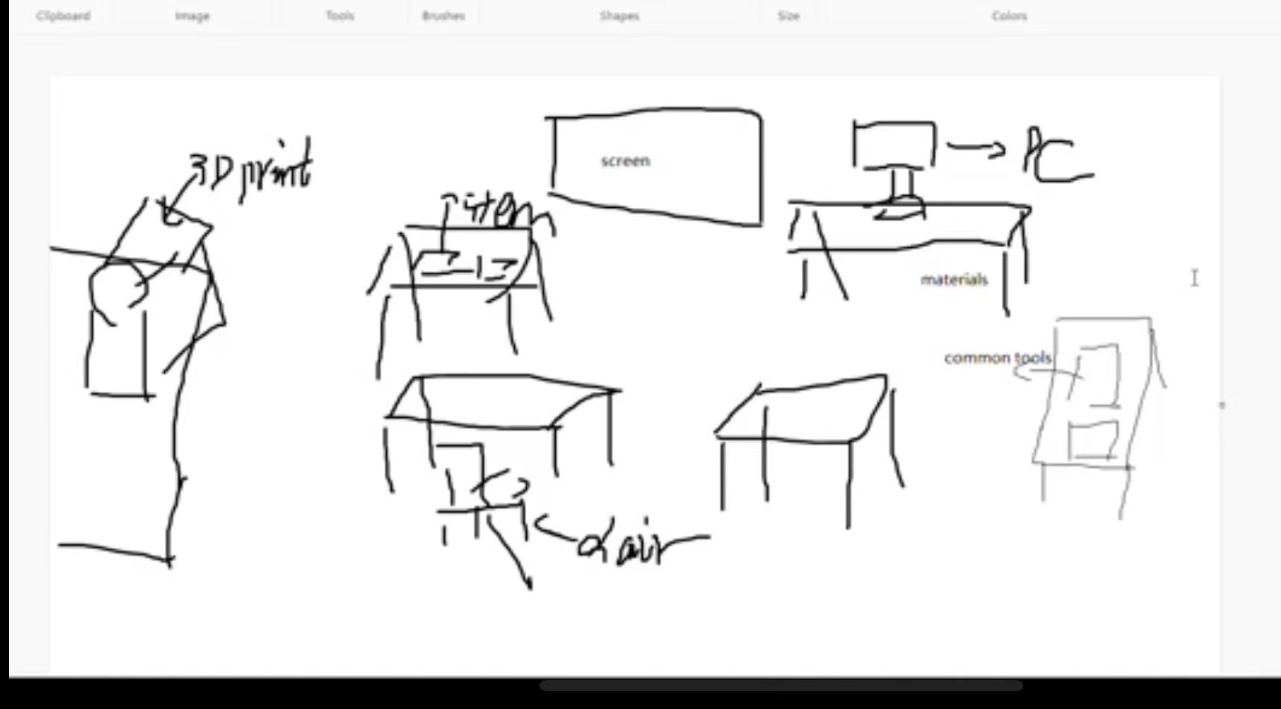

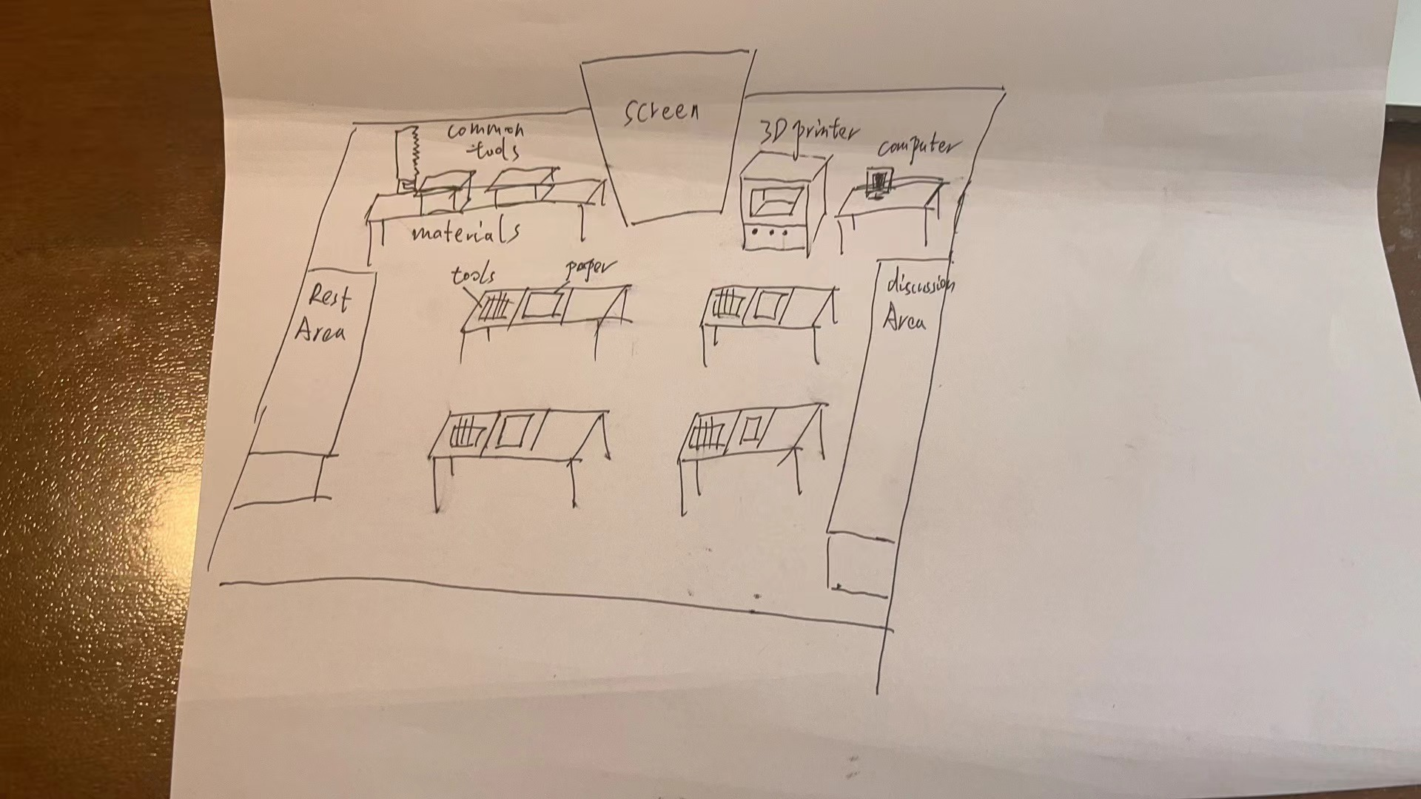

# **8.4.2 Visual Mapping findings**

According to the 3 pictures obtained by visual mapping, we can find that one thing in common is that all these five pictures have 3D printers, computers, large screens and workspaces, no matter whether or not these interviewees participated in a makerspace. Through the interview, we have noticed that two of five interviewees have participated in makerspace, one of five learned about makerspace before and two out of five have never heard of makerspaces.

Something interesting among all the results was interviewees' perceptions of the difficulties and challenges that using makerspace for entrepreneurship may encounter. There are three major challenges: promotion, materials and lack of inspiration. Almost all interviewees’ answers mentioned one or two of these three challenges. In addition to this, interviewee 5 considers the space and available time of makerspaces to be a challenge. Among other responses, Interviewee 3's point of view is novel, he thinks blueprints for prototypes can be sold instead of products.

By using the visual mapping method I also found a couple of its drawbacks. First of all, if the interviewee does not know enough about the subject, the map obtained is likely to be meaningless. Second, although the interviewer will provide some information before the interviewee is mapped, the information is relatively subjective, so it is very likely that some concepts will be implanted into the interviewee. For example, our topic this time is related to the concepts of makerspace and entrepreneurship. In order to ensure the objectivity of the data, we did not mention the use of makerspace to start a business in the given materials.

# **9 Transcripts**

| Participant | Type | Methodology | Transcript.no |
| --- | --- | --- | --- |
| A | Student User | Interviews | 9.1 |
| B | Student PHD Researcher User | Interviews | 9.2 |
| C | Senior Researcher User | Interviews | 9.3 |
| D | Director | Interviews | 9.4 |
| E | Director | Interviews | 9.5 |
| F | Director | Interviews | 9.6 |
| G | Director | Interviews | 9.7 |
| H | Interviewee 1 | Visual Mapping | 9.8 |
| I | Interviewee 2 | Visual Mapping | 9.9 |
| J | Interviewee 3 (Makerspace experience) | Visual Mapping | 9.10 |
| K | Interviewee 4 (Makerspace experience) | Visual Mapping | 9.11 |
| L | Interviewee 5 | Visual Mapping | 9.12 |

# 

# **9.1 Student User**

Interviewer: Can you start off with just your general involvement in makerspaces and your motivation, why you did it, was it uni based?

Participant A: So essentially the middle of last year, the university of Melbourne opened its new startup engineering precinct, so that's called Melbourne connect, and it’s a huge building, really fancy they spent heaps of money on it, you know the faculty splurged, basically all the offices at the top are for startups and the tech companies and on the bottom floor, telstra basically funded this massive engineering workshop makerspace that’s going to replace the current faculty of engineering. It means that the makerspace has all your laser cutters, 3d printers, all of your machinery, woodshop, metal shop, electronics and general makerspace stuff and all of it is free so that's really cool. Yeah, I basically started last year, they wanted to involve as many students as they could, so i was working as like a student guide and sometime I was working with concierge so like answering any questions, managing training for all the machinery, but at the same time we worked on improving the space, so working on different projects that e could like teach to students and improving operations, i was working a lot of work on python and r just doing data analysis usage of the different areas in the space. So there is a different mix of what we were doing but essentially we were doing the professional staff side of things

Interviewer: Ah yeah right so it wasn’t due to a uni project or anything

Participant A: Yeah no it was more paid employment.

Interviewer: Were people that used the makerspace there on their own time or was it people doing uni projects?

Participant A: It’s a bit of a mix, like we had some subjects that were based in, they had components, for example there was a master subject, and it was robotics system design and they were making chess playing robots, and the entire class would go to the basement and do their workshop sessions there. So there were periods of time where it was just masters students. There are also a lot of student engineering teams that spend a lot of time in space so like the Melbourne space program that I work with, they spend a lot of time doing their development there. There's also like the rocket team that did all their production there. There were also a lot of rover teams, parts of motor sports teams. All the engineering teams are based there because it's free and good for prototyping. So yeah all the student teams were there and also just people that were keen to do personal projects. Since everything is free you would come in like if you needed something - like a laptop stand or like you wanted a new pot or something - whatever it was because it was free engineering students would just come in and make it, like i made my own earring stand because I was like I need an earring stand, so yeah it's free and a good practice of your skills and we would go in to make our own stuff and make gifts, you would 3d print a present for someone.

Interviewer: That's so cool, yeah were people working together or just lots of people by themselves?

Participant A: Often not, most of the time there were small groups - not massive groups but small groups of like 2-5 working together, very rarely did i see people working alone unless they were like super nerds and working on their action project. You know someone's own complex electrical project that they could only do on their own. It depended on the particular task. Like if they were using machinery in the woodshop or metal shop, that's one person using only a machine so you can't really get other people's support. But on the general desks in the empty spaces there are usually a couple people collaborating on designs, working with each other but then they might go on and do their own little parts and then come back in?

Interviewer: Do you know anyone personally that has made something and considered making a business out of it or selling it?

Participant A: I’m trying to think? I think the main thing about that. We aren't the only people that use the space, like the people upstairs, they all have access to the space and obviously are intending to commercialise so i think they would fall into that category. I think the main thing is with the rules of the makerspace, is that the free use is that you can’t just make a production line, like you can’t just make a business and keep doing it for free and use all their free resources and so that kind of idea is that you are allowed to do a couple prototypes but yeah you can't commercialise through. You can do things early on. It's more i see friends making gifts and those types of things. Very much early prototyping happens.

Interviewer: Would you say in general that makerspaces contribute to an entrepreneurial route? Physically, culturally, emotionally?

Participant A: I think for me, at least in my experience it would be physical. For example in engineering, a lot of established companies have their own machinery, but if you are just starting off you need access to those machines but you generally don't have the budget to pay for a 1000 dollar milling machine. It’s very much providing access to the machines that are necessary for prototyping but you just don't have the budget to do it when you are starting off. I think there can be collaborations but obviously people are quite protective over their ideas when they are entrepreneurs, so there is less of that interchanging of ideas unless they’ve signed an NDA. Which is a main point when sharing innovation.

Interviewer: That's an interesting point - no ones mentioned that yet

Participant A: Yeah I think that is what a lot of startups are a bit careful of when they do come down. Just because they don’t want to show off to all these students.

# 

# **9.2 Senior PhD Researcher User**

Interviewer: Can you tell me more about your involvement in makerspaces?

Participant B: I just researched people with low socioeconomic background with their own DIY practices, so sometimes they do it by themselves or sometimes they are a part of a makerspace group, so yeah that’s the kind of research that I’ve done.

Interviewer: Have you kind of observed a pattern as to why people join makerspaces, or has it just been due to their low economic status?

Participant B: So their background is from both low socio economic and not, but I’ve found that they kind of have a natural inclination with tinkering with something or they just have that natural feel in making something, the fulfilment of making something themselves.

Interviewer: Yeah right, have you been a part of a makerspace yourself or has it been more observing?

Participant B: Yeah I am apart of UQ innovate

Interviewer: Oh yeah have you made anything yourself?

Participant B: Yeah I have made a couple things, um I’ve made stuff for research in particular but I just needed to use the cnc machine or milling machine or things like that to help fabricate things that I use.

Interviewer: Overtime in a makerspace what sort of products do you see being produced?

Participant B: For the one that I am a part of , it’s a lot like building and electrical engineering students, so they build gliders and things like that, so there's lots of gliders on display but that’s just because of the audience that that makerspace facilitates.

Interviewer: Yeah right, are they just building it for their assignment or there a lot of people there in their own free time?

Participant B: Both, yeah during the day time mostly it is students for courses and things like that but then you have some students that are intrinsically motivated to do it – so it's not for some grade or anything, they are just motivated to come in and try experiments. So sometimes I hang out with those guys and we make things as well.

Interviewer: And you would say that helps your thought process and that it is good to bounce off each other?

Participant B: Absolutely, that is one of the really cool things about being in a makerspace, it's almost like, you know when you are kids and you just get introduced at the sandbox or something and you have the building blocks and the little tractors. When your kids, that's one way of getting to know other people but at the same time you’re getting to do something you are in to. When I am being a part of a university makerspace that is what I feel the adult version is.

Interviewer: Yeah right, like a playground

Participant B: Yeah,

Interviewer: For you personally have you ever considered entrepreneurship out of a makerspace?

Participant B: Yeah I have

Interviewer: Would you say that the makerspace has encouraged you?

Participant B: No I think I would have had those thoughts, but the makerspace facilitates it?

Interviewer: In what way?

Participant B: Because it has the tools that I wouldn’t normally invest in or buy. But it also facilitates the thinking that you wouldn’t really get if you were surrounded by your own people. So for example I’m HCI major and therefore it's more like designers in that space but then when you are in the makerspace you are meeting with lots of different experts in their own field. So, someone is in aero engineering or some things like that. So your ideas evolve from being something your discipline to being interdisciplinary and it would be more adaptable to several cases rather than just a homogenous thought.

Interviewer: Do you think for example, do you think a makerspace in the 2000’s vs a makerspace now that has lots of new technology, do you think makerspaces now kind of gives you students an edge to go towards entrepreneurship?

Participant B: I wouldn’t say, but just what I’ve read about them, I don’t think specific technology or tools in a makerspace would be something that propels me towards entrepreneurship, the differences that I find is that as makerspaces evolve they become disciplinary eccentric which kind of supports the idea of having many experts in one, because if you have a software engineer in a hackerspace and then you have a workshop with architecture and building materials and they are also separated – it does not cause those minds to be joined in one pool to give you that unusual thinking and idea. But I wouldn’t say it’s a specific technology in a tool in a space to cause entrepreneurship. If any tool I would say the CNC machine because that tool helps me to fabricate my ideas much quicker because I can quickly fabricate my ideas and then plug in and then have the machine cut and I can just assemble. It's more the people.

Interviewer: Yeah so its more so the fostering of the idea rather than the physical space itself

Participant B: Yeah, the makerspace fosters a type of thinking, that even if you are the most genius person sitting in the room all by yourself. Being in that space, it fosters you to think differently. It’s like there is no box.

**9.3 Senior Researcher User**

Interviewer: So our research is regarding what maker space is, and the impact on entrepreneurship. So I kind of I've done a little bit of research and I've kind of seen your name pop up here and there, but I wanted to start off with. If you could just tell us a little bit more about your research specifically, and how and what your involvement in maker space has been.

Participant C: Yeah. So I came across the world of makerspace really late actually. You know makerspaces have been there since the 2000’s but I came to know about those places, I would say, during the mid 2010 or 2015 or something when I first kind of heard about those kind of spaces and a student who showed an interest with working with an e waste recycling space and we visited the space and it turns out that they were also in the process of converting that space into a makerspace because e waste recycling is not necessarily a makerspace per say, but they were seeing an opportunity there where whatever is actually left over they were trying to build something, some new technology using those things and I thought that was a nice way of doing some innovative work and yeah I guess since then, since 2016 onwards that has been my main research topic, I have been 2016 to now - 6 years I have probably visited around 8 to 9 makerspaces say in Australia and quite a few in the US and other parts of the world. Quite a lot in Australia in itself and they range from traditional educational orientated makerspaces to more like a informal spaces where people get together, retired women who have a group of a friends who knit together and crochet together vs men shed were older retired men would sort of come together and do wood working to e waste recycling to spaces where people with disability would get together a do light weight activities around those things. I think it has been 6 years so far.

Interviewer: Would you say there is a majority type of makerspace?

Participant C: I think this is the thing - not all makerspaces will have a facebook page or a website and you would not see those things in a public domain. It was a few months ago that the men in the mens shed were getting together on a Sunday morning. It turned out that the partners of those men were in the church to do crocheting. So you know it’s kind of a complimentary effect and you would only see these things if you came across them. I think they are common but you would only know if you know. A lot of the time they don't advertise it. The women's space that I went to, the knitting and art type of work, they did not have any type of presence, I only knew about them through a participant of mine. He was interviewing and said my mom goes to this space. So there are spaces like this and I think if i were to name quite a few - Mission Impossible is an art and craft type of space where older types of women get together and make blankets and beanies for kids with disabilities and say they would give to autism queensland. They were not only doing this to spend time, they were doing something good for society.

Interviewer: On the topic of motivation - have you seen a common pattern as to why people join makerspace?

Participant C: There are various reasons: Substation 33, e waste recycling space they converted into a makerspace, so in that particular space they were actually engaging with people who work for the doll. So they would come in because they had to get payments, so there was a bit of a force, in a sense they would only get payments if they visited those payments. Other aspects, in mens shed a lot of doctors actually prescribed a lot of men to go to the mens shed. You now in Australia a lot of people had jobs that required physical engagement and when they retire it is an abrupt change in their lifestyle to not doing anything - if you went to the mens shed you would be still be physically active and you can gradually move onto the retirement. A lot of people who are widows don't have that type of social companionship, makerspace will provide that social space to get engaged with others. Others are genuine innovators. We would see very young college graduates that would come up with an idea and they would try build a company around it. Those sort of people would be there that wanted to build a startup.

Interviewer: Would you say those sorts of people evolve over time?

Participant C: I think about the spaces that I have been to. The spaces are not considered traditional makerspaces because they are spaces where generally people from marginalised backgrounds or non-traditional makers would come in. They are not there to build a business. I mean there are possibilities, there are a few people who want to build their companies, but I think many of them are coming. You know there were a few school dropouts who thought this might be a way for them to turn their life around and learn life skills by going to those spaces. There were people who didn’t know what to do and they would end up in those makerspaces and they would learn about how to interact and work ethic, being on time, following rules, quite often people have struggled with that - they have mental health issues or family issues. Makerspaces are not just for learning skills they also help with building self skills, behaviour efficacies.

Interviewer: Would you say that making a space like would contribute to someone's decision to like, be an entrepreneur like to utilise and make space to be an entrepreneur like in a physical sense or cultural sense or social sense?

Participant C: No definitely, I think there are older people in those makerspaces that is not their particular aim in their life. But in spaces like sub station33 I have definitely seen strong patterns of people even when they are not sort of educationally there yet, they still learn from some of the experts in the space, see if they can actually do some sort of innovation. At sub station33 there were a couple of guys who were UQ graduates and they sort of created a company called Power Wells, this was a product they built using recycled batteries. What this does is that it is basically a power source for rural people who live in rural areas. The kids can charge their computers or phones where there is no electricity. Australia is a developed country but they would use this product in rural indonesia or other parts of south east asia to make sure when the electricity is not available, they will have powerwells and these things will have solar panels, and so it will self generate electricity. Looking at those projects, the people who are actually new to those spaces they were looking at making them into entrepreneurs is not something that I saw throughout. They definitely had these influences or tendencies where they thought maybe I could make something. In a couple of interviews we saw that there were people who showed some photos, they would have this old bottles being converted into some light bulb, electronic lights they were converting old eskies into a music player, they would have speakers inside - it's like a picnic pac, you could still use it as an esky but parts of it has solar power and music system and all of those things to an extent can go on with funding and so. As I said there were attempts and they were efforts to showcase that they can do it.

Interviewer: Kind of like the start fosters those behaviours

Participant C: Exactly, and I think having those experts in the space would trigger others to try out new ideas.

Interviewer: Would you say for example a makerspace in the 2000’s vs a makerspace now, there would be benefits towards that?

Participant C: I’m pretty sure, like in 20 years people have learnt, seen the trajectory of things happen, if there is a new idea there is probably a pathway to which it can be converted into an entrepreneurial effort. Those things are there, the point I was trying to make is that in 15-20 years that makerspaces, the major change has been inclusion, including marginalised people who aren't really a part of that space. When you think makerspace you would think oh there's an expert, an engineer, a designer who is using this space to create something new, to develop something new and those kind of things,compared to right now, who do not have the kind of expert skills but they know that their idea can get trained or get help or get help through some sort of support through the organisation and move them to that level where they can actually build something. Quite important - it is more about self actualization. Getting things done, making something that is actually good for people's confidence rather than building up a company, making money out of it. Yes, making money is obviously a good thing about it but at least being able to make a piece of software or a workbench at a mens shed would go a long way in boosting people's confidence.

Interviewer It gives them an opportunity that they didn't originally have

Participant C: Yeah

**9.4 / 9.5 Directors**

Interviewer: Our research is in regards to modern university makerspaces and so I have tried to reach out to as many university makerspaces as I can, to see if makerspaces encourage makerspace? So I just wanted to start off with maybe if you could both tell me about your involvement in makerspaces and your observations of it

Participant D: Well Participant E founded it so I think he is the best one to ask why it was founded.

Participant E: Um sure, I think the entrepreneurship, I mean we founded it for the purpose of more education was really what drove the philosophy about how people learn and people learn with their hands, and people learn by doing things, it comes off the back from teaching about 5 years of first year physics that way which is pretty unusual and also people learn alot from different perspectives, so having a space where people can come and solve problems is really important, and I think for me what has been interesting is that entrepreneurship sort of just finds it. I mean there are plenty examples of around the world of makerspaces that are set up to support entrepreneurship but I think entrepreneurship is often emergent from these sorts of environments where people didn’t really think of themselves as entrepreneurs or they actually need to solve a problem because they’v started a company or something - or they have an idea. Over the years we have slowly tried to, I wouldn't say we have not committed as much as we could and we don't have the resources to, but there are some small entrepreneurship programs in Canberra that we are formal partners of and if they are university students at the ANU then they can come and use it. We probably have three or four start up companies over the last few years that have really really benefited from access, particularly in the early stages. All of them have since folded as a lot of start up companies do or they have gone onto accelerated programs in Sydney and things like that - or in one case they became a much bigger company and moved off campus. They wouldn't say they used the space as much as I think they did, they benefited definitely from the broader resources and the technical part of the university

Interviewer: It's interesting lots of universities have mentioned that it kind of only helps in the initial prototyping phase in terms of entrepreneurship - or have you seen more of a development phase in your makerspaces?

Participant E: My opinion, this isn't based on hard evidence of anything, I look forward to reading your report if we have a copy, my opinion is that it really depends on how they are set up and where they are placed. I think that is a very reasonable statement that they obviously helped in the early stages, I mean the one startup that I am thinking of that only recently left Canberra, they all met because of their individual kind of interests that kind of brought them to the makerspace. They never sort of where a company, so I think you really do get that very beginning seed of idea, I do know of spaces that sit quite closely or apart of bigger startup support environments, so you can imagine that you've got co working spaces or accelerated programs that within those environments, you have a makerspace and so as you continue to grow and develop and i think again the university context, there is a company, liquid instruments that you know I’m sure they got stuff fabricated elsewhere, I’m sure they prototyped in the makerspace, they got a lot of prototyping done for them, but the fact that they were in embedded inside a highly technical physics research school meant that they could leverage a lot of the resource, and i don't know what people consider as early, but they got lots of funding before they actually changed their business address to a non university address.

Participant D: To give you a bit of context, our space has things like 3d printers, laser cutters, Cnc routers, hand tools, power tools, some more advanced 3d printers - a quarter jet, vinyl cutters but its not very highly technical things we dont train people on manual mills or the technical things. So those kinds of more sophisticated jobs they are not going to be doing themselves, they would go onto the technical workshops that we have on campus where it's fabricated for them, whereas our makerspace people do it themselves, so they have to develop the skills to prototype. The other thing to point out is that there is a fine line between commercial activity and activity that is acceptable in the makerspace. So prototyping, totally fine, all about that kind of stuff but when it actually comes to starting to ramp up production or do higher quantity things its not really suitable for the makerspace that we have. We have had people reach out in the past to have sort of commercial access to the makerspace but then there is a problem there with people paying for access because our makerspace is open - we don’t charge anyone for anything. If people are paying for access then they feel entitled to that access and that might disadvantage other makerspace users. So there is sort of a limiting factor to how much people can use it, past sort of the early stages.

Interviewer: Yeah which would limit the whole process of that

Participant D: Yeah the seedling stage, at the very beginning, but not when you start getting into commercial production

Interviewer: So when Participant E said before when the group came from different spaces, were they working individually? O

Participant E: Usage is really really varied and diverse, our mission was always to support anyone and everyone on campus with whatever projects they have. Over time that has meant that more and more courses have seen this as a valuable resource and so lecturers will set projects as a part of the course so that's one reason that people come because basically they are told that they should. They don't have to, they often find some other way to solve their problem, like they will do it out of cardboard or they will buy themselves an arduino and they will do it at home and then other people come because they are just interested or they are an individual researcher who has a problem they want to solve for their lab or their research project. Or it is a pistol project and they are repairing a tear in some jeans or something, so there's lots and lots of use cases, first come best dress, it's not linked to any particular discipline or program and in this case, I think they were all engineering students, they were all in the school of engineering and probably had been in courses together and stuff like that but each got involved for their own personal interests. Like you know one of them still hasn't graduated and he's just going to be forever at university - kind of one of those guys and he was in there all the time - he used to be really into building model planes. Another one was an electrical engineer who was really really capable and had lots and lots of personal projects that he was making. I think his first one was actually for the fancy club he was making - like they use electronic protectors for when the fencing sword contacts the suit, because it's all about timing - so that's what he was in there doing first and then I think the third one was just building gifts for friends. A couple of them then became really good friends and I remember they spent ages 3D printing and making a replica helmet and then at some point they had an idea. We have a program in canberra called innovation act and its basically a twelve week program that students of the act can sign up to kind of be walked through the ideation and pitching kind of entrepreneurship cycle and come up with an idea together, pitch it and they give out a certain number of 10,000 grants for people to start trying to build their idea out and so lots of the young student startup companies in the act go through that program and these guys had met in the space and they went with their idea and got that money and sort of built the first thing - they are now a company that does, I think they are pretty young and still trying to make it work but currently roadside assistance doesn't have a way to deal with electric vehicles that have run out of charge other than towing them to a charge point or to home. So their whole thing is that they off the shelf, put it in the back of a roadside truck that gives you 25km of charge to get you to the next stop, rather than calling a tow truck everytime and so that's what they've been building.

Participant D: And so they were engineers but we do get people from all across campus we are open to everybody so you get artist and designers and chemists in together so Participant E mentioned the innovation ACT program, we had one group that was a collaboration between a computer scientist and a designer and they both used the makerspace, I don’t know if they met through the makerspace but yeah they get that sort of cross collaboration, interdisciplinary work.

Participant E: Well then you also get like lots of artists that use the space and in the early days I know one of them had a little bit of a side business, he was a metal worker making different kind of pendants and trinkets and so he did a lot of his mould making on the 3d printers so then would go back to his gold and silver workshop and melt down you know, so there's also like that much smaller sort of side hustle, and that’s where the grey zone where do we support - i’m sure plenty of people have made stuff they have sold on etsy and we are okay with that.

Participant D: If you want to make 100 pairs of earrings that's totally fine.

Interviewer: That's interesting about DIY. Was that more common when the makerspaces was founded? Would you say the 3d printer is a drawing factor in your makerspace?

Participant D: Yeah I think the catchphrase is that people come for the 3d printer but they stay for the laser cutter. Or they stay for the more advanced stuff. It’s kind of the easy entry point that people understand of makerspaces, but once they are in the network, they have a better understanding about what is available and what other manufacturing techniques are actually better suited to what they are trying to make. It is a bit of a step stone into the spaces

Participant E: I have a real pet peeve with this narrative that 3d printing and makerspaces are synonymous. Like they are a cool little tool right, and especially in the early days I was pretty naive as well, of course the first thing you do is buy a couple of 3d printers - they were less common than they are now. But what I think is that they are probably not the thing that enables entrepreneurship. Well I mean, entrepreneurship is an emergent thing from communities, people having ideas, being creative, finding solutions, often it’s about how do I set up a website, - i think that attitude and that philosophy really aligns strongly with what makers are. The right tool to repair things and fix things and come up with a better way to solve a little problem at home - entrepreneurship is not just seen as a company and we are going to make lots of money - but actually entrepreneurship is about people who like to solve problems creatively. I think there is a huge overlap between good makerspaces and the communities that they build and activate and the entrepreneurship communities but there's also a good overlap with many other things so yeah 3d printers, often people come for 3d printers because their classes said they need to build a chaise for a car or make a mould for something. But it turns out that more than half of the time it’s the wrong tool for the job.

Participant D: I never put emphasis on the tools being the most important part of the makerspace, we try really hard to create a good community and a welcoming environment for people to come in to so having 3d printers in a room does not make a makerspace, a makerspace is a whole lot more

Interviewer: Would you guys agree that entrepreneurship fosters the correct behaviour for entrepreneurship?

Participant E: I think I would say- more the way about what I said before that there is a really large overlap between the genuine maker community and entrepreneurship community. I think that if you abstract it as a community place where people try to solve problems together then of course you are going to get some people who enjoy solving problems that lead to commercial and liable business models and then you have people who are solving for very very different reasons. I mean I would argue that the way we approach we - i don't know if you tracked any of our media but we did a project during the 2020 covid lockdowns, because they shut down the university there was all these technical staff that didn't have anything to do, we kind of reached out to our communities saw that there was in fact a need, for a supply of ppe, so we kind of prototyped some gigs, created a very manual human based factory line and had staff coming in and volunteering their time to build face shields over a couple of months. That was 17000 units of ppe to the sort of local canberra region, allied health industry. We didn't make money from that, we were just doing it out of social good. It was very much a social enterprise and a give back from the university, but the way that we approached that was very entrepreneurial. We sorted out what was the best way to solve these problems. There was lots and lots of media around people 3d printing face shields and we were like this is very dumb, why would you spend 2 hrs printing a tiny piece of plastic that you then insert a piece of plastic film in to when you could just get some foam and some staples and a piece of elastic. This is a classic example of why not to use 3d printers, and we had access to other tools in the university - so i think that that was quite an entrepreneurial in spirit project, but it wasn’t necessarily to make money whereas a lot of entrepreneurship is for social good and it might be non for profit - so i think for me it is really that - there a lots of makerspaces in universities especially as its become a popular thing and concept and word, that are set up totally with an image of tools, 3d printers, fancy looking space without any understanding of why they have it or with no mission statement , they start with, we want sexy digital fabrication in a room. There's a bit of wave with libraries incorporating them - and i think a lot of the time they don't really know their mission, whereas we started really from a, I had a one page pitch of what i wanted to achieve and what it was for, how we did that was very random walk - much like a startup, i’ve often say what we did was build a small startup within the university which was called a makerspace, and sort of invite everyone in and go a little bit with the flow , break the rules where we had to to get things done. Sorry that was a very long winded way of answering a simple question which is what I tend to do. I think that good makerspaces overlap strongly with good entrepreneurship communities and obviously they can support one another.

Interviewer: It is interesting what you said about the community

Participant E: But I don’t think that's at odds with what I said though like i do think what we effectively do having this focus on culture and community is promote that behaviour. And what is culture if not agreed upon behaviour or practice. So i do think that there are people that come to us and by the time they have spent a couple years in traction with us would say that they have changed they do things, they change the way they solve problems, they have more diverse approaches to problem solving and that's was one of my major goals, again coming from a physics background, people teach physics in schools atrociously, like here's a bunch of equations from a textbook and you need to memorise these and know what numbers to plug in. Whereas some physicists are some of the most entrepreneurial people around because they have to be really critical and ask questions and observe and break things. But we actually don't do that when we teach new physicists until they get to the point of doing research with us as a PHD student and so creating an environment where that is the starting point and where you have people with different training and different perspectives coming in, it of course generates a place where creative problem solving is learned by everyone through osmosis. So yes the behaviour is also something you get from having culture

Participant D: and the term makerspace is one of those terms that has just been decided to be slapped on anything that has any sort of digital fabrication in it so every makerspace we come across whether it is an academic library one, whether it is out in the community they are all very different. So ours being so open to everyone on campus is really different across others where they are focussed on a different faculty. We focus very heavily on being open to everybody. There is also a lot of info on our website in regards to our mission.

Participant E: I think a lot of people who study entrepreneurship do think more generally, there is a lot of discussion out there - what makes an entrepreneur - and its not really about starting a company and in fact entrepreneurs are very rarely end up being very good business people - they sort of start the companies and they are not really good at the operational stuff and make CEO’s and they move onto the next idea.

**9.6 Director**

Interviewer: What we are looking to find for this interview is about makerspaces. How has it involved people and encouraged people towards entrepreneurship?

Participant F: Definition of makerspaces, please?

Interviewer: Makerspaces is a place where people come together and create stuff. The first question is what involvement do you have towards makerspaces?

Participant F: I had extensive makerspaces in Ireland where I work as a lecturer in entrepreneurship. I assisted the university in establishing an incubator and accelerator program to help people and students to start their businesses. It's a place to co-create with others and for students to create their ideas. Then at Swinburne University where I was for 4 years in Melbourne, I assisted in the creation of something called the fire station, which was a fire station historically which was converted into a makerspaces for students and academic people and for young entrepreneurs. Moved to Griffith University as an associate professor of business innovation to create an ecosystem within the university and part of that ecosystem is an investment in a makerspace venue in the cohort space in the gold coast which is the health and knowledge precinct. We have a dedicated location with a makerspaces area with resources, movable furniture and a venue accessible for students to create by themselves or to co-create with others.

Interviewer: Is the gold coast makerspace owned by you?

Naomi: No, the makerspace is owned by the city council and the university rents that particular space from the city council and it's embedded within an existing entrepreneurial ecosystem by the health and knowledge precinct. It is for students, staff, and local community groups as well to come in here to listen to people who may give talks in the makerspaces and for them to use the area for them to be creative.

Interviewer: So this makerspaces is for students to get involved in entrepreneurship.

Participant F: Yes.

Interviewer: What is the main motivation in these sorts of makerspaces, based on your experience?

Participant F: They understand they are not confined by the usual venue where they learn. In a dedicated makerspace area, we make it not to replicate your traditional classroom. It is providing a venue. It encourages creativity to happen. Even the physical location of the space should not be your vanilla room in a sense. We have a beautiful image design in the room, all the desks are on wheels so that the students can move them away, as couches, and a huge television. The spaces make them feel safe and can talk with others. That is what is unique about makerspace. Having resources simply things such as pipes, post-it notes, and glue guns. These sorts of tools can allow them to create prototypes.

Interviewer: Okay, as you were saying, makerspaces is a place for prototyping and based on your observation what sort of products/ objects do they tend to make?

Participant F: Since there are students from undergrad and post-graduate, they can come here to create their prototype using their product idea or their wireframe.

Interviewer: So are these sort of places more for teaching the step-by-step process of development?

Participant F: It is not a linear process when developing a project or prototype, some people might skip steps based on prior knowledge or experience or because of the exercise they are working on during that time. We provide the resources to get the information on the process so that they can launch their idea from online people. Some feedback can be given to those that are able to showcase their idea so they can iterate to the next process with some guidance.

Interviewer: In short, makerspace provides guidance to those people in a flexible manner depending on the student’s progress.

Participant F: Correct, that is why our bins are always full because of the iterations students make. Full of broken ideas and teaching them to do better on their next try.

Interviewer: Among all the different makerspaces, what are the biggest differences between them?

Participant F: There are things called incubators and accelerators. The incubators are slow processes to help students develop their initial stage of development. The requirements for an incubator compared to an accelerator are different, an accelerator typically associated with an idea that has passed the initial testing.

Interviewer: Based on your years of experience, did you find any changes in makerspaces over those years?

Participant F: Initially makerspaces focus on technology. A lot of makerspaces are designed for technology-driven business, but now I'm seeing more spaces that have a focus on medical devices and services. That also aligns with covid and the growing ageing population. Makerspaces that are developed in the 1990s and 2000s you can see a lot of spaces created because of the dot com boom context and the increase in tech companies but now I'm seeing more tailored and focused companies, venues and locations.

Interviewer: Have you ever created a product in or out of makerspaces?

Participant F: No personally but I have consulates with others with successful businesses.

Interviewer: Do you agree or disagree that makerspaces contribute to one's decision to sell a product?

Participant F: The genesis of a makerspace is ultimately yes to create something that is valuable for the market but the sales happen later. The space itself is for the development of the concept.

Interviewer: Do you agree or disagree that makerspaces today promoted entrepreneurship 10 years ago?

Participant F: 10 years ago they did a good job but in America and Europe, Australia is still behind in comparison to them. Makerspaces now areas are fluid in their design that is not just for the arts but the variability of the need of the makerspaces. It can be used in any field whether it is for medicine, IT, etc.

**9.7 Director**

Interviewer: I’m doing research in uni in regard to entrepreneurial development in uni makerspaces and I just wanted to get your opinion, and talk about your experiences and just chat about that

Participant G: So, I am currently working in the engineering faculty makerspaces, so like, that’s why we were visiting Vince a few weeks ago because we were going around to the faculty-led makerspaces. So how this all came around was because around 4 years ago, around 2018 where I left my job in the Michael Crouch Innovation Centre which is the entrepreneurial makerspace. That was the first makerspace at the UNSW campus – it opened in 2015, I kind joined them because I was studying then, I joined them as a volunteer around 2016/2017 and then that became full time working closely with makerspace people there. By then, I got headhunted to create the engineering makerspace so we kind of left the entrepreneurial side of it and went and made the faculty because that there is a lot of demand for makerspaces for just workshops for students that don’t necessarily want – for classes for different things that don’t necessarily tie into entrepreneurship.

Interviewer: Okay so there was kind of like an opposite need?

Participant G: Yeah so we started with entrepreneurship and now we grew a branch out of it that is now bigger and has more stuff

Interviewer: oh wow that’s interesting

Participant G: Yeah kind of ironic

Participant G: So I can tell you a little bit about how it was run before. Michael Crouch Innovation centre – so that place actually has three separate sections, and it was designed at the start to be a place and it was Michael crouches vision to make cool shit. So its split into three sections, the makerspace, the design space and the event space and the whole idea is that you start in the design space with your ideation, with your workshops, you generate your ideas and come up with something and then you go to the makerspace as a prototyping area and then after that you go to the event space where you can pitch your ideas and that was why that space was very good for entrepreneurship-

Interviewer: Yeah it's very targeted

Participant G: Yeah it's very specific for that kind of entrepreneurial journey um and then they expanded a little bit during 2017 and 2018 to the point where we had a bunch of hot desks upstairs and that’s about when we left and there was a lot of internal university politics and In short the focus kind of became almost awkward. Because there was such a big push of entrepreneurship that people weren’t allowed to have ideas without it being –

Interviewer: Linked to the university?

Participant G: No forced into entrepreneurship. So it would it be like, someone would come in and be like I want to print this part for this project I have at home and the first that we were told to ask them was, how do you plan on making this, what do you want to do with it, have you thought of making this into a start-up even though it could just be something you could buy from IKEA, like you know there’s no point. So that’s kind of where it kind of spiralled down a little, that’s another reason why we left that makerspace. But since then, there’s been another 3 changes in personnel so it’s kind of stabilised into what you currently see. Which it is coming along perfectly fine but um there’s a balance between entrepreneurship and making.

Interviewer: Yeah right, do you think having it as just an entrepreneurial makerspace was restricting?

Participant G: It was that and that the makerspaces on campus would have different KPI’s. So if you think about that specific one – so I’m assuming you’ve been to the UQ on campus one – yeah so you’ve talked to …, you’ve talked to those guys-

Interviewer: Yeah yeah I have

Participant G: Yeah so you can see that they are manufacturing focussed and you know if you bring something they would be alright okay you can make it, and it is important that you don’t lose sight of that which is where that happened for a brief year or so. And it does generate niches where we kind of made a makerspace for education instead. Because we thought okay – if someone is just going in to do something for entrepreneurship that’s great, but not everything is entrepreneurial. And half of the ideas that people do, you can google it, or alternatively it’s something you google a set of ideas that – like the ideation journey of those kinds of things and someone else has already tried that exact design and failed. So yeah – just because it is an idea doesn’t necessarily mean it is a good idea. And I guess it kind of went from entrepreneurship to way too much entrepreneurship, way too quick.

Interviewer: Right year no balance

Participant G: Yeah and then it found a balance and a future but it was already over its glory, other makerspaces were popping up and then it kind of got overshadowed by us, we’ve got bigger tools, new tools. So it was quite restrictive but people are coming into the workshop or coming into the makerspaces – they don’t know what they want, and they don’t really know anything about their ideas yet so if you kind of foster those sort of relationships before asking if you want to make it into a start-up.

Interviewer: Yeah there’s so much more exploring to do in a makerspace I feel. From what I’ve researched about

Participant G: Yes

Interviewer: Because I’ve actually never been heavily involved in makerspaces – it was just a topic that I thought oh that’s really interesting – but yeah that’s one of the big things that it just seems like makerspaces have so many learning opportunities and its kind of like the underlying message I agues – would you agree with that?

Participant G: Yes, and I believe that it's such a beneficial thing for universities to have just because ultimately when I was studying at …, so I studied in 2013 to 2017, and –

Interviewer: Can I ask what you were studying by any chance?

Participant G: Ah Mechatronics Engineering

Interviewer: Oh nice, that’s awesome

Participant G: It wasn’t that great

Interviewer: Oh really?

Participant G: Yeah, it was a lot of programming and a lot of non hands-on stuff, yeah it wasn’t very practical and it was a lot of maths and physics. So when I started in my first two and a half years there wasn’t a makerspace on campus because the first one opened in 2015. So it was interesting because you had a bunch of university projects that required students to use tools without providing set tools.

Interviewer: Ah yeah that’s hard

Participant G: Yeah, it's hard but also it just doesn’t make sense. So, it was like, you were missing out such a big part of your degree, just by not having those tools – because right now if you need something you just jump into a makerspace, but when I was doing my first year course to make a little robot for our first year engineering design challenge, I made it in some dudes garage you know 15 minutes down the road from uni, which was one of my teammates garages. What other choice do you have?

Interviewer: Yeah exactly

Participant G: So that’s kind of how the evolution of the workshops in the makerspaces on campus kind of took a turn of yes, it is now a very good idea now that people have realised. It opens so many more opportunities, it makes students much more employable, it makes people have hands-on involvement in their courses, there's all these benefits that in retrospect it makes sense for us, I’m just surprised that it took so long to get here.

Interviewer: Yeah I didn’t realise that it was so recent, because 2015 isn’t that long ago

Participant G: Yeah so our first makerspace was 2015 and I was talking to … and he said that his one was 2018, like right before COVID hit, all of this maker movement has been within the last 5 to 10 years.

Interviewer: Yeah, it’s really evolving now. In your experience, you mentioned that you were making it at home, like I know the obvious answer is that in a makerspace you have access to technology and things like that, but what other benefits do you think there are?

Participant G: Safety, because we didn’t know, in our first year fresh out of high school, I had a little bit of electronics and solder experience because that’s what I was interested in, but I’ve never used a circular saw, or I’ve never used some heavy-duty equipment. So, the dude’s garage that we went to, his dad was a plumber – so he had all these fancy tools in his garage, and we were just using it- just winging it practically, so it’s a miracle that we kept all our fingers. So yeah, safety is a big one but also expertise, because there is a lot of different ways of using tools, a lot of them are dodgy ways that work, but you know its not best practice, so that’s we try to do – we try to teach you best practice and you know if want to do a dodgy way afterwards you know that’s on you. But this is the way we suggest you use the tools

Interviewer: Yeah, like guiding

Participant G: Yeah, exactly so that’s another benefit if you can teach the practices and if they use it the dodgy way that is your decision, you are an adult and we are going to treat you like one so here you go.

Interviewer: Yeah do you think the makerspace, even though the makerspace you are involved with right now isn’t entrepreneurial focussed, the things that they learn out of the makerspace like behaviours or you know techniques with tools that could be applied to an entrepreneurial process if they wanted to?

Participant G: Yes- the weird thing is despite them not being in the entrepreneurship makerspace a lot of the projects are still somewhat entrepreneurial, because we still have the same kind of ideation process, right? We still have the same kind of ways of generating ideas, we have the still have the same way of prototyping, it’s just that instead of being funnelled into the system where you have to be make it a business we go, if you want to make to make it into a business, go to Michael Crouch innovation centre which is an entire infrastructure to get funding and contacts in the start-up sphere, and I would say we mention that to people, and lot of the time they go oh that’s cool I’ll do it if I have time and then you never see them again or alternatively out of the 4/10 would actually go over and make a company, so it's not unheard of. So I think it’s just if you help them build up ideas, help them develop a product that you know, that they have a better grasp of, better expertise over, instead of forcing them idea to business straight away, they actually have a product, they have a higher chance of actually succeeding because you know they actual have something concrete instead of a hairy idea.

Interviewer: Yeah and they would also have the skillset

Participant G: Yeah exactly. I mean ultimately our goal is to make people learn so it works for us. Yeah so it's not just like we left that entrepreneurial makerspace, we are still under the same network, we run four different makerspaces under the same network. So we have people from the architectural faculty and the engineering faculty, we have entrepreneurial guys come to us sometimes. So it's meant to be if you do an induction you can go to each and every one of the other workshops.

Interviewer: They are all separate buildings?

Participant G: Most of them are separate buildings but they are all within a 15-minute walk. You’ve seen the UQ campus – our campus is about a third of the size of that, so not everyone has. River in their campus!

Interviewer: Yeah, a whole lake

Participant G: Yeah, that’s special to you guys, um yeah, our campus is probably a quarter of the size and so we had to build them up a little more and the biggest one we have is the architectural one. Because they do industrial design and making furniture. So yeah, we try to make it so we still work with them, it’s not explicit but our niches became education instead of entrepreneurships.

**9.8 VM Interviewee 1**

Interviewer: [00:00:02] There. I want to do an interview for The Map. You got the first question. Is that why you choose to use these tools in makerspaces?

Participant H: [00:00:18] Well, to be honest, I never attended any makerspace before, so I just simply divided it into four areas. The rest areas I need for all different workers. We need to rest and therefore the work area. I used to pick a table. I need to have enough space to work and then I have to show that big screen on the wall because I think that we need a place to ensure our work. And that's all my thinking of that space, because space.

Interviewer: [00:01:03] And have you ever joined any maker spaces before?

Participant H: [00:01:09] No. Let what I said before and they were trying to make a space for fine.

Interviewer: [00:01:15] Have you ever considered that used to make spaces for entrepreneurship?

Participant H: [00:01:21] Oh, sorry. I guess I can’t be a boss. So. Yeah, and then we can start by that.

Interviewer: [00:01:30] It's fine. And what difficulties would you meet if you were using the makerspace for entrepreneurship?

Participant H: [00:01:41] Well, a good question. I think the first challenge is the materials or if I want to design something that's new, I think using a 3D printer is a good way. But I know that a 3D printer is really expensive and it's well worth the high cost of the materials, and that's really hard for the early period to attain. And the second challenge, I think, yeah, absolutely. Is that lack of inspiration, because for makerspace we have to design and generate different ideas. But what if we can't? We can't think about anything new. So I always think about that. So I think that's a second challenge. And the last challenge, I think maybe how to find someone to invest in us or invest our ideas. And the most important is I think that's our inspiration. I always have no idea of how to generate new things.

Interviewer: [00:03:13] Okay. Thank you for joining the interview today. And I think enough. Thank you.

Participant H: [00:03:22] Thank you.

**9.9 VM Interviewee 2**

Interviewer: [00:00:02] Thank you for attend this interview. And I would ask you a few questions about the map. And the first question is that why you choose to use these tools in maker spaces?

Participant I: [00:00:18] Okay. In the picture, you can see areas of the raw material, there are some woodworking tools such as carving knife and wood. You can use these tools to make your own capture. In the centre of my picture. Is hand making area. You can design the design of your products on the drive. Then you can. You can take this paper into a scan room and upload this picture into the computer. Then you can go to a 3D printer area to print your own products. Yeah, I think this is true. This is very useful. Okay.

Interviewer: [00:01:24] And have you ever joined any makerspace before?

Participant I: [00:01:29] No, I have not really joined.

Interviewer: [00:01:33] So. And have you ever considered using maker spaces for entrepreneurship?

Participant I: [00:01:40] Oh, I have no idea. Yeah. No.

Interviewer: [00:01:47] And the next question is what difficulty would you meet if you would use it to maker space for entrepreneurship? That's part of.

Participant I: [00:02:01] Entrepreneurship. Yeah. In my opinion, one challenge is inspiration and on the one hand. Entrepreneurship means innovation, and naturally, inspiration may bring problems such as plagiarism. On the other hand, lack of inspiration could cause bad quality of products. So this may be the. One of the biggest challenges is that.

Interviewer: [00:02:35] Thank you for attending this interview. And that's all. Bye.

Participant I: [00:02:41] Okay.

**9.10 VM Interviewee 3**

Interviewer: [00:00:03] OK, Thank you for attending today's interview. And according to the map, your drawing, I would ask you a few questions. And the first question is why you choose to use these tools in makerspaces?

Participant J: [00:00:22] Because in the makerspace you only want to create something for today. If we want to design maybe a tool for us to use, firstly, we could use the works to create the 3D object and manned printers or the 3D printer. That's a very easy way to do this. But if we put the item to be a product produced from the industry, we will be very low and some ships will be hard to build. So that's why I want to use the marker space. Make a space well, next space, cause we just take some items like some materials for the 3D printer and then we rotate.

Interviewer: [00:01:25] Okay. Have you joined any makerspace before?

Participant J: [00:01:30] Yeah, actually, in the past I was in my bachelor's degree. I have attended the makerspace before because at the Times I am really interested in 3D printing and I want to create something by myself. So I usually go to class to create it, that's why. But yeah.

Interviewer: [00:02:02] Have you ever considered that you make a spaces for entrepreneurship like start a business?

Participant J: [00:02:10] Actually the draft. I come to the makerspace is just out of interest. I just be interested in creating something, but I haven't the consider to make it to entrepreneurship and another extension to to make to sell. Because in my opinion I think. It is quite a difference between your items and actually be used items. For example, like if we always use some cup to drink some water, the normal ones, it's really easy to produce. However, if I create a new one from my opinion, I will print a lot of my favourite because I really like some Japanese anime. Like some cartoon characters. I really love them, so I will print either in my cup or however for other people I do not like this object or taste test paintings, so they only use the items. So I think it is a very narrow market bag to press because it's only suitable for some people. If other people don't like it, they have to change it. So it's a will now. It will be hard to make a living. So. Ah, so I didn't use this to make money.

Interviewer: [00:04:00] And what difficult would you mean if you would use makerspace for entrepreneurship?

Participant J: [00:04:13] Yeah. For me I think they come from three parts. The first part is that if you just make a market yourself, we will have less money and you already didn't have too many customers. So maybe because for yourself, you'll have to buy a 3D print. It's very expensive and also for some materials because unlike the items done by the factory, it will go down one by one and it will cost a lot of time. So we should make it better, if I should say so. That's way too many customers and maybe not other people will be invested besides the cost of materials because unlike the. A good factory will produce billions of items in just about two days. But of all your 3D printers, if we want our printer, that's like I have said, if we all want to print a very special one, we will maybe cause your two or 3 hours to draw the painting. So it will cost a lot of time if we all want to make it bigger, more people will join, but the price will go higher. Maybe there are not not too many customers. And the cost of material is expensive. So the sort of path is that. if we want to make money. You could just already create some items in your computer. If someone wants it, they will buy it forever. If our customer cares, we have very complex questions. This is hard to resolve because your software is different from the customer's thoughts, so it is hard to exclude the product. That's why.

Interviewer: [00:06:56] See, that's enough. And this is all for today's interview. Thank you for attending.

Participant J: [00:07:02] Yeah. Bye.

**9.11 Interviewee 4**

Interviewer: [00:00:02] Okay. Thank you for attending today's interview and I would ask you a few questions about your joining. The first question is why you choose to use these tools in makeup spaces?

Participant K: [00:00:18] Well, to be honest, I draw this graph according to my memory. I joined Makerspace a few years ago. I developed a little remote car with my teammates.

Interviewer: [00:00:33] Okay. So you joined any space before and the next question is that. Have you ever considered that used to make a space for interpretation?

Participant K: [00:00:45] Yeah. A few years ago, the Society of Anime used to seek corporations with us. We were required to produce equipment for cosplay. We tried many times until we ran up the budgets. We could not afford the cost of materials. So I think it would be harder to start a business through makerspace.

Interviewer: [00:01:16] And what difficulties would you meet if you were using maker spaces for entrepreneurship?

Participant K: [00:01:25] As I said, I used to run all the budgets due to the waste of materials, the lack of investment, and it is hard to control the cost of materials are the true challenges I think I would make if I use make space to start a business.

Interviewer: [00:01:49] Okay. And that's all for today's interview. Thank you.

**9.12 Interviewee 5**

Interviewer: [00:00:02] Okay. Thank you for attending today's interview. And according to the map you are drawing, I would ask you a few questions. So first question, is that why you choose to use these two spaces?

Participant L: [00:00:17] I think that I can use the most concrete tools for free here. That's all.

Interviewer: [00:00:25] Yeah. Have you joined any makerspace before?

Participant L: [00:00:30] I've never joined Makerspace before.

Interviewer: [00:00:34] Okay. Have you ever considered that Youth Makerspace is for entrepreneurship?

Participant L: [00:00:40] If I have a chance. Of course I would try.

Interviewer: [00:00:44] Okay. What difficulties would you meet if you were using Makerspace for entrepreneurship?

Participant L: [00:00:52] First of all, the space size and number of machines in the maker are limited. So I have no way to make sure that I will have an opportunity to use them because there are so many people in the store who want to use these tools here. Secondly, my time is limited, so I may not be able to make the most innovative products. So that’s all my opinion.

Interviewer: [00:01:21] All. Okay. And that's all for today's interview. Thank you.