Jackson Week 13 IP Part 2

Jackson Kyalo

9/3/2021

# Define the Question

Kira Plastinina is a Russian brand that is sold through a defunct chain of retail stores in Russia, Ukraine, Kazakhstan, Belarus, China, Philippines, and Armenia. The brand’s Sales and Marketing team would like to understand their customer’s behavior from data that they have collected over the past year. More specifically, they would like to learn the characteristics of customer groups.

# The metric for success

This project will be successful if we are able to determine which individuals are most likely to click on the ads.

# The Outline context

The number of clicks an ad has helps understand how well the ad is being received by its audience. Ads that are targeted to the right audience receive the highest number of clicks. In our case determining the best audience for the ads will help company grow as well as increase the number of clicks and reach.

# Experimental design

1. Define the Questions.
2. Import, load and preview the data.
3. Data Cleaning.
4. Data Analysis.
5. Conclusion and Recommendation.

### Importing the libraries

#Import the data library  
library(data.table)

## Warning: package 'data.table' was built under R version 4.0.5

library(tidyverse)

## Warning: package 'tidyverse' was built under R version 4.0.5

## -- Attaching packages --------------------------------------- tidyverse 1.3.1 --

## v ggplot2 3.3.5 v purrr 0.3.4  
## v tibble 3.1.3 v dplyr 1.0.7  
## v tidyr 1.1.3 v stringr 1.4.0  
## v readr 2.0.1 v forcats 0.5.1

## Warning: package 'ggplot2' was built under R version 4.0.5

## Warning: package 'tibble' was built under R version 4.0.5

## Warning: package 'tidyr' was built under R version 4.0.5

## Warning: package 'readr' was built under R version 4.0.5

## Warning: package 'purrr' was built under R version 4.0.5

## Warning: package 'dplyr' was built under R version 4.0.5

## Warning: package 'stringr' was built under R version 4.0.5

## Warning: package 'forcats' was built under R version 4.0.5

## -- Conflicts ------------------------------------------ tidyverse_conflicts() --  
## x dplyr::between() masks data.table::between()  
## x dplyr::filter() masks stats::filter()  
## x dplyr::first() masks data.table::first()  
## x dplyr::lag() masks stats::lag()  
## x dplyr::last() masks data.table::last()  
## x purrr::transpose() masks data.table::transpose()

library(ggplot2)  
library(moments)

### Load the dataset

#Load our data  
ecomm=read.csv('http://bit.ly/EcommerceCustomersDataset')

### Preview the data

# preview the head  
head(ecomm)

## Administrative Administrative_Duration Informational Informational_Duration  
## 1 0 0 0 0  
## 2 0 0 0 0  
## 3 0 -1 0 -1  
## 4 0 0 0 0  
## 5 0 0 0 0  
## 6 0 0 0 0  
## ProductRelated ProductRelated_Duration BounceRates ExitRates PageValues  
## 1 1 0.000000 0.20000000 0.2000000 0  
## 2 2 64.000000 0.00000000 0.1000000 0  
## 3 1 -1.000000 0.20000000 0.2000000 0  
## 4 2 2.666667 0.05000000 0.1400000 0  
## 5 10 627.500000 0.02000000 0.0500000 0  
## 6 19 154.216667 0.01578947 0.0245614 0  
## SpecialDay Month OperatingSystems Browser Region TrafficType  
## 1 0 Feb 1 1 1 1  
## 2 0 Feb 2 2 1 2  
## 3 0 Feb 4 1 9 3  
## 4 0 Feb 3 2 2 4  
## 5 0 Feb 3 3 1 4  
## 6 0 Feb 2 2 1 3  
## VisitorType Weekend Revenue  
## 1 Returning_Visitor FALSE FALSE  
## 2 Returning_Visitor FALSE FALSE  
## 3 Returning_Visitor FALSE FALSE  
## 4 Returning_Visitor FALSE FALSE  
## 5 Returning_Visitor TRUE FALSE  
## 6 Returning_Visitor FALSE FALSE

### Preview tail

tail(ecomm)

## Administrative Administrative_Duration Informational  
## 12325 0 0 1  
## 12326 3 145 0  
## 12327 0 0 0  
## 12328 0 0 0  
## 12329 4 75 0  
## 12330 0 0 0  
## Informational_Duration ProductRelated ProductRelated_Duration BounceRates  
## 12325 0 16 503.000 0.000000000  
## 12326 0 53 1783.792 0.007142857  
## 12327 0 5 465.750 0.000000000  
## 12328 0 6 184.250 0.083333333  
## 12329 0 15 346.000 0.000000000  
## 12330 0 3 21.250 0.000000000  
## ExitRates PageValues SpecialDay Month OperatingSystems Browser Region  
## 12325 0.03764706 0.00000 0 Nov 2 2 1  
## 12326 0.02903061 12.24172 0 Dec 4 6 1  
## 12327 0.02133333 0.00000 0 Nov 3 2 1  
## 12328 0.08666667 0.00000 0 Nov 3 2 1  
## 12329 0.02105263 0.00000 0 Nov 2 2 3  
## 12330 0.06666667 0.00000 0 Nov 3 2 1  
## TrafficType VisitorType Weekend Revenue  
## 12325 1 Returning_Visitor FALSE FALSE  
## 12326 1 Returning_Visitor TRUE FALSE  
## 12327 8 Returning_Visitor TRUE FALSE  
## 12328 13 Returning_Visitor TRUE FALSE  
## 12329 11 Returning_Visitor FALSE FALSE  
## 12330 2 New_Visitor TRUE FALSE

### Check the info

str(ecomm)

## 'data.frame': 12330 obs. of 18 variables:  
## $ Administrative : int 0 0 0 0 0 0 0 1 0 0 ...  
## $ Administrative_Duration: num 0 0 -1 0 0 0 -1 -1 0 0 ...  
## $ Informational : int 0 0 0 0 0 0 0 0 0 0 ...  
## $ Informational_Duration : num 0 0 -1 0 0 0 -1 -1 0 0 ...  
## $ ProductRelated : int 1 2 1 2 10 19 1 1 2 3 ...  
## $ ProductRelated_Duration: num 0 64 -1 2.67 627.5 ...  
## $ BounceRates : num 0.2 0 0.2 0.05 0.02 ...  
## $ ExitRates : num 0.2 0.1 0.2 0.14 0.05 ...  
## $ PageValues : num 0 0 0 0 0 0 0 0 0 0 ...  
## $ SpecialDay : num 0 0 0 0 0 0 0.4 0 0.8 0.4 ...  
## $ Month : chr "Feb" "Feb" "Feb" "Feb" ...  
## $ OperatingSystems : int 1 2 4 3 3 2 2 1 2 2 ...  
## $ Browser : int 1 2 1 2 3 2 4 2 2 4 ...  
## $ Region : int 1 1 9 2 1 1 3 1 2 1 ...  
## $ TrafficType : int 1 2 3 4 4 3 3 5 3 2 ...  
## $ VisitorType : chr "Returning_Visitor" "Returning_Visitor" "Returning_Visitor" "Returning_Visitor" ...  
## $ Weekend : logi FALSE FALSE FALSE FALSE TRUE FALSE ...  
## $ Revenue : logi FALSE FALSE FALSE FALSE FALSE FALSE ...

### Check the shape

dim(ecomm)

## [1] 12330 18

Our code has 1000 rows and 10 columns

# Data Cleaning

### Missing values

#check for missing values  
sum(is.na(ecomm))

## [1] 112

Our data has 112 missing values

#check the missing values in each column  
colSums(is.na(ecomm))

## Administrative Administrative_Duration Informational   
## 14 14 14   
## Informational_Duration ProductRelated ProductRelated_Duration   
## 14 14 14   
## BounceRates ExitRates PageValues   
## 14 14 0   
## SpecialDay Month OperatingSystems   
## 0 0 0   
## Browser Region TrafficType   
## 0 0 0   
## VisitorType Weekend Revenue   
## 0 0 0

#We shall drop the missing values in each columns  
df <- na.omit(ecomm)  
colSums(is.na(df))

## Administrative Administrative_Duration Informational   
## 0 0 0   
## Informational_Duration ProductRelated ProductRelated_Duration   
## 0 0 0   
## BounceRates ExitRates PageValues   
## 0 0 0   
## SpecialDay Month OperatingSystems   
## 0 0 0   
## Browser Region TrafficType   
## 0 0 0   
## VisitorType Weekend Revenue   
## 0 0 0

### Duplicates

#Check for duplicates  
sum(duplicated(df))

## [1] 117

Our data has 117 duplicated rows. We shall drop all duplicates by selecting only the unique values

#selecting the unique values  
df_new <-unique(df)  
sum(duplicated(df_new))

## [1] 0

### Identify numeric cols  
nums <- unlist(lapply(df_new, is.numeric))   
y<- colnames(df_new[nums])  
y

## [1] "Administrative" "Administrative_Duration"  
## [3] "Informational" "Informational_Duration"   
## [5] "ProductRelated" "ProductRelated_Duration"  
## [7] "BounceRates" "ExitRates"   
## [9] "PageValues" "SpecialDay"   
## [11] "OperatingSystems" "Browser"   
## [13] "Region" "TrafficType"

### Check fo outliers

#Create a dataframe of numeric cols  
num <-df_new[y]  
head(num)

## Administrative Administrative_Duration Informational Informational_Duration  
## 1 0 0 0 0  
## 2 0 0 0 0  
## 3 0 -1 0 -1  
## 4 0 0 0 0  
## 5 0 0 0 0  
## 6 0 0 0 0  
## ProductRelated ProductRelated_Duration BounceRates ExitRates PageValues  
## 1 1 0.000000 0.20000000 0.2000000 0  
## 2 2 64.000000 0.00000000 0.1000000 0  
## 3 1 -1.000000 0.20000000 0.2000000 0  
## 4 2 2.666667 0.05000000 0.1400000 0  
## 5 10 627.500000 0.02000000 0.0500000 0  
## 6 19 154.216667 0.01578947 0.0245614 0  
## SpecialDay OperatingSystems Browser Region TrafficType  
## 1 0 1 1 1 1  
## 2 0 2 2 1 2  
## 3 0 4 1 9 3  
## 4 0 3 2 2 4  
## 5 0 3 3 1 4  
## 6 0 2 2 1 3

#Using boxplots to visulize the outliers  
for(i in 2:ncol(num)) {   
 boxplot(num[i], xlab=colnames(num[i]))  
}

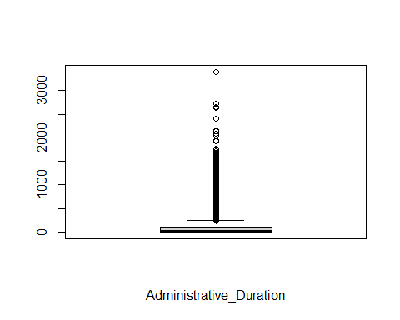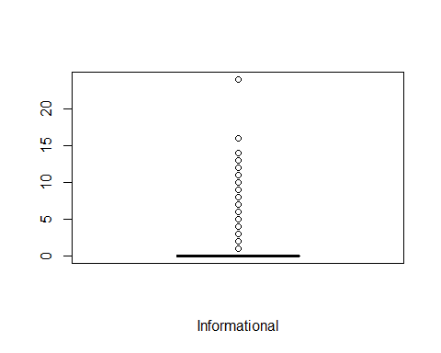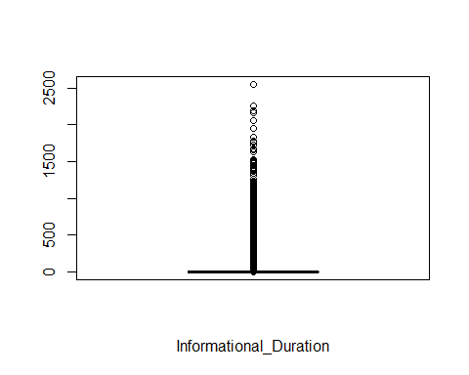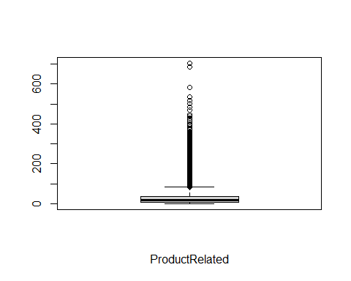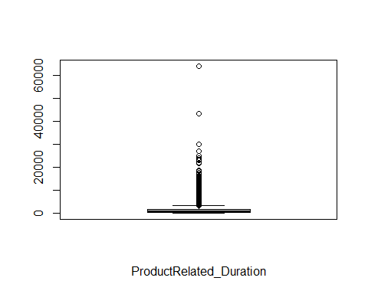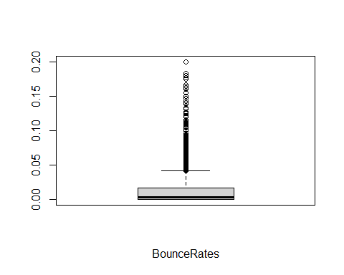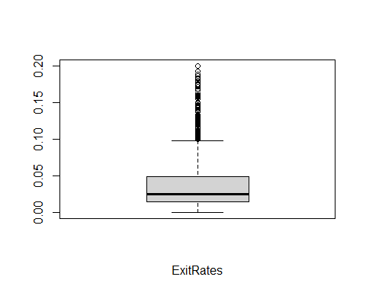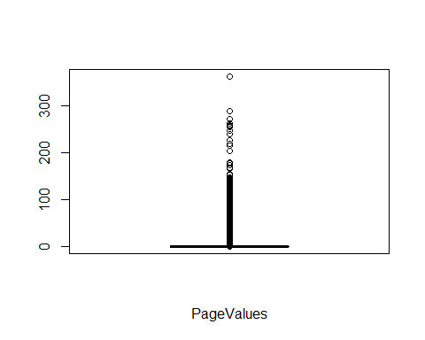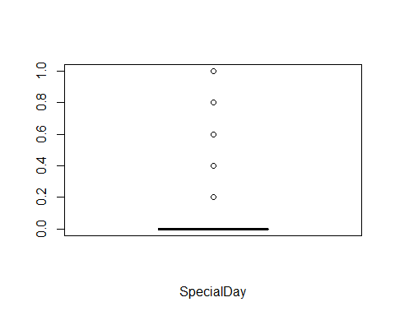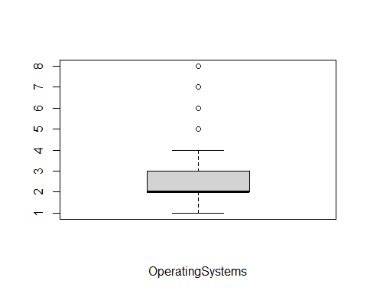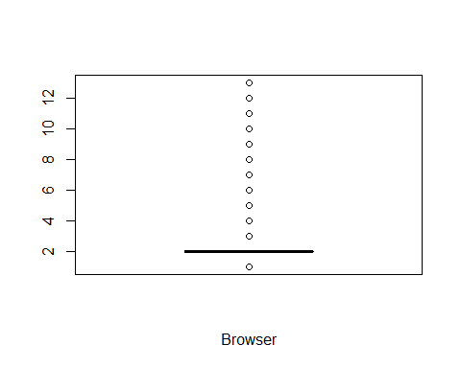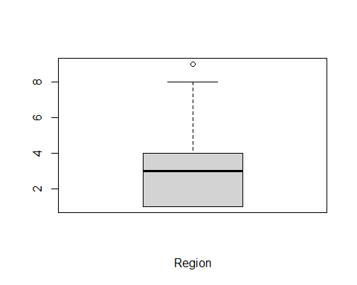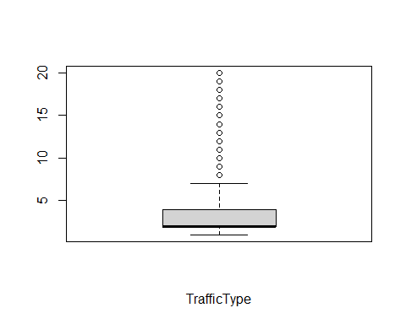

# Data Analysis

### Univarient Analysis

#Getting the statistical summaries of the data  
summary(df_new)

## Administrative Administrative_Duration Informational   
## Min. : 0.00 Min. : -1.00 Min. : 0.0000   
## 1st Qu.: 0.00 1st Qu.: 0.00 1st Qu.: 0.0000   
## Median : 1.00 Median : 9.00 Median : 0.0000   
## Mean : 2.34 Mean : 81.68 Mean : 0.5088   
## 3rd Qu.: 4.00 3rd Qu.: 94.75 3rd Qu.: 0.0000   
## Max. :27.00 Max. :3398.75 Max. :24.0000   
## Informational_Duration ProductRelated ProductRelated_Duration  
## Min. : -1.00 Min. : 0.00 Min. : -1.0   
## 1st Qu.: 0.00 1st Qu.: 8.00 1st Qu.: 193.6   
## Median : 0.00 Median : 18.00 Median : 609.5   
## Mean : 34.84 Mean : 32.06 Mean : 1207.5   
## 3rd Qu.: 0.00 3rd Qu.: 38.00 3rd Qu.: 1477.6   
## Max. :2549.38 Max. :705.00 Max. :63973.5   
## BounceRates ExitRates PageValues SpecialDay   
## Min. :0.00000 Min. :0.00000 Min. : 0.000 Min. :0.00000   
## 1st Qu.:0.00000 1st Qu.:0.01422 1st Qu.: 0.000 1st Qu.:0.00000   
## Median :0.00293 Median :0.02500 Median : 0.000 Median :0.00000   
## Mean :0.02045 Mean :0.04150 Mean : 5.952 Mean :0.06197   
## 3rd Qu.:0.01667 3rd Qu.:0.04848 3rd Qu.: 0.000 3rd Qu.:0.00000   
## Max. :0.20000 Max. :0.20000 Max. :361.764 Max. :1.00000   
## Month OperatingSystems Browser Region   
## Length:12199 Min. :1.000 Min. : 1.000 Min. :1.000   
## Class :character 1st Qu.:2.000 1st Qu.: 2.000 1st Qu.:1.000   
## Mode :character Median :2.000 Median : 2.000 Median :3.000   
## Mean :2.124 Mean : 2.358 Mean :3.153   
## 3rd Qu.:3.000 3rd Qu.: 2.000 3rd Qu.:4.000   
## Max. :8.000 Max. :13.000 Max. :9.000   
## TrafficType VisitorType Weekend Revenue   
## Min. : 1.000 Length:12199 Mode :logical Mode :logical   
## 1st Qu.: 2.000 Class :character FALSE:9343 FALSE:10291   
## Median : 2.000 Mode :character TRUE :2856 TRUE :1908   
## Mean : 4.075   
## 3rd Qu.: 4.000   
## Max. :20.000

#getting measure of dispersion fro each cols  
#Create a function  
library(moments)  
summary.list = function(x)list(  
 Mean=mean(x, na.rm=TRUE),  
 Median=median(x, na.rm=TRUE),  
 Skewness=skewness(x, na.rm=TRUE),  
 Kurtosis=kurtosis(x, na.rm=TRUE),  
 Variance=var(x, na.rm=TRUE),  
 Std.Dev=sd(x, na.rm=TRUE),  
 Coeff.Variation.Prcnt=sd(x, na.rm=TRUE)/mean(x, na.rm=TRUE)*100,  
 Std.Error=sd(x, na.rm=TRUE)/sqrt(length(x[!is.na(x)]))  
)

#Calling the function and applying the function  
sapply(df_new[,c(y)], summary.list)

## Administrative Administrative_Duration Informational  
## Mean 2.340028 81.68214 0.5088122   
## Median 1 9 0   
## Skewness 1.946248 5.59021 4.013451   
## Kurtosis 7.636106 53.09389 29.64254   
## Variance 11.09457 31516.25 1.62771   
## Std.Dev 3.330851 177.5282 1.275817   
## Coeff.Variation.Prcnt 142.3424 217.3402 250.7442   
## Std.Error 0.03015735 1.60733 0.01155118   
## Informational_Duration ProductRelated  
## Mean 34.83734 32.05845   
## Median 0 18   
## Skewness 7.537435 4.332134   
## Kurtosis 78.46409 34.04903   
## Variance 20010.51 1989.241   
## Std.Dev 141.4585 44.60091   
## Coeff.Variation.Prcnt 406.0543 139.1237   
## Std.Error 1.280758 0.4038142   
## ProductRelated_Duration BounceRates ExitRates   
## Mean 1207.508 0.02044674 0.04149678   
## Median 609.5417 0.002930403 0.025   
## Skewness 7.251403 3.152874 2.233125   
## Kurtosis 139.5908 12.25506 7.624252   
## Variance 3686121 0.002061387 0.0021388   
## Std.Dev 1919.927 0.0454025 0.04624716   
## Coeff.Variation.Prcnt 158.9991 222.0526 111.4476   
## Std.Error 17.38292 0.0004110718 0.0004187193  
## PageValues SpecialDay OperatingSystems Browser   
## Mean 5.9525 0.06197229 2.124354 2.358144   
## Median 0 0 2 2   
## Skewness 6.348663 3.284481 2.031955 3.215653   
## Kurtosis 67.94031 12.78605 13.26887 15.53659   
## Variance 348.1132 0.03988432 0.8226229 2.926075   
## Std.Dev 18.65779 0.1997106 0.9069856 1.710578   
## Coeff.Variation.Prcnt 313.4446 322.2579 42.69465 72.53914   
## Std.Error 0.1689266 0.001808169 0.008211799 0.01548748  
## Region TrafficType  
## Mean 3.153291 4.074596   
## Median 3 2   
## Skewness 0.9787304 1.958522   
## Kurtosis 2.840195 6.466127   
## Variance 5.771712 16.12675   
## Std.Dev 2.402439 4.015813   
## Coeff.Variation.Prcnt 76.18829 98.55732   
## Std.Error 0.02175155 0.03635895

#Plots

library(tidyverse)  
# Histograms for Area Income  
hist(df_new$Administrative,  
 main = "Administrative",  
 xlab = "Administrative",  
 col = "deepskyblue")

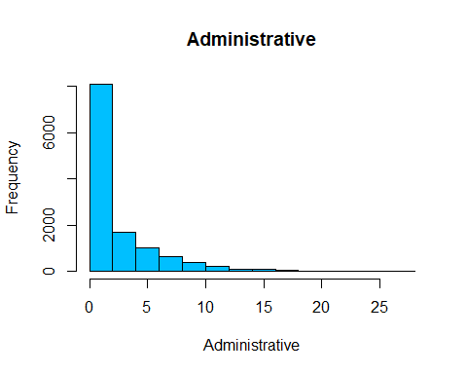 ## Bivarient Analysis

#We shall use loops to visuize how each column behave aganist revenue  
for(i in 2:ncol(num)) { # Printing ggplot within for-loop  
 print(ggplot(num, aes(x= num[ , i],fill = df_new$Revenue, color = df_new$Revenue, )) +  
 geom_bar()+labs(title = 'df_new[i]')+labs(title=colnames(df_new[i]), x=colnames(df_new[i])))  
}

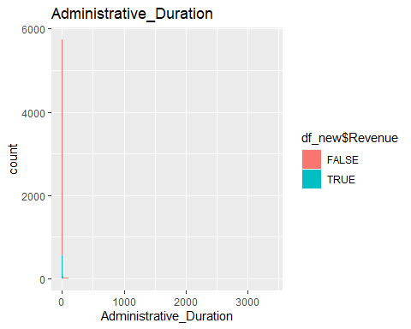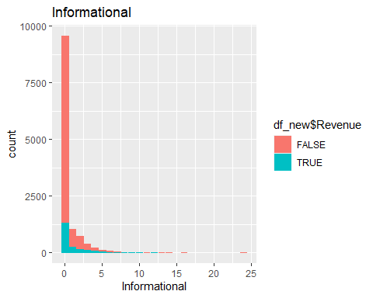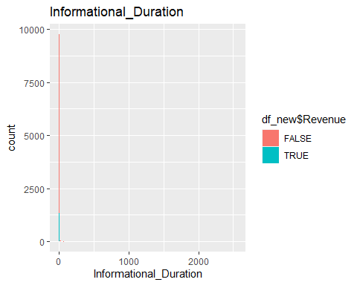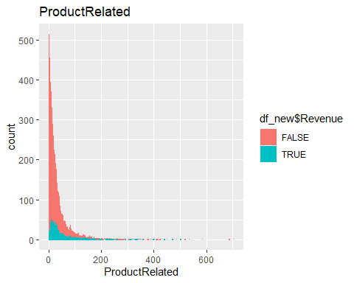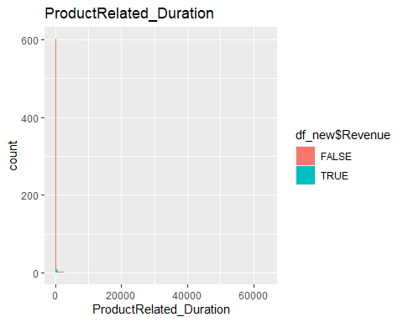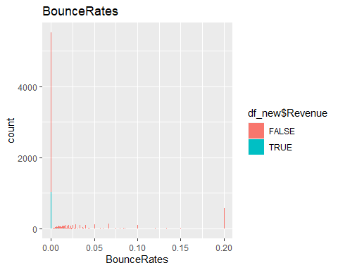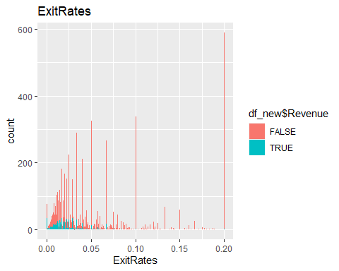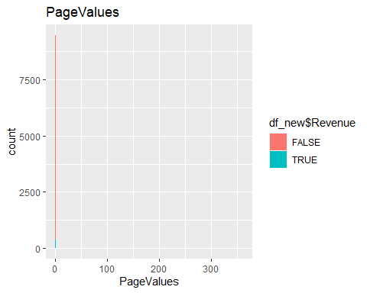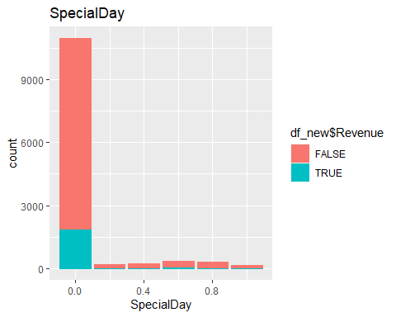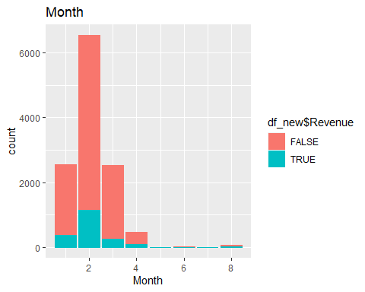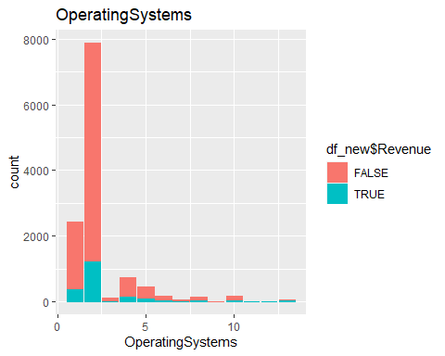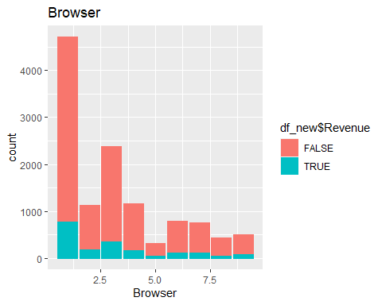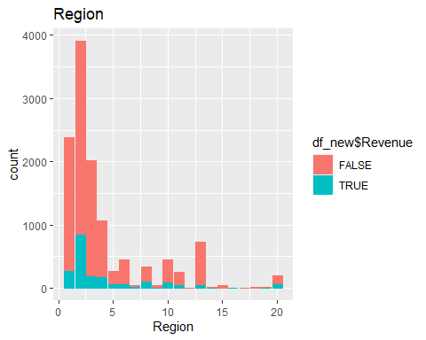

### Categorical months

# Visualize revenue against months  
barplot(table(df_new$Revenue, df_new$Month), main = "Revenue per Month", col = c("orange", "green"), beside = TRUE,   
legend = rownames(table(df_new$Revenue, df_new$Month)), ylab="revenue", xlab = "Month")

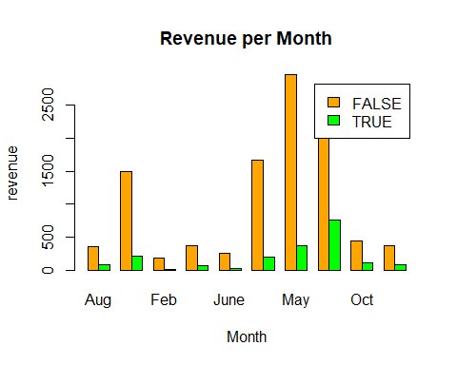 November returns the highest number of revenues while February returns the lowest.

# Visualize revenue against Operating System  
barplot(table(df_new$Revenue, df_new$OperatingSystems),   
 main = "Revenue per Operating System",   
 col = c('Orange', "green"), beside = TRUE,   
 legend = rownames(table(df_new$Revenue, df_new$OperatingSystems)),  
 ylab="revenue",   
 xlab = "Operating System")

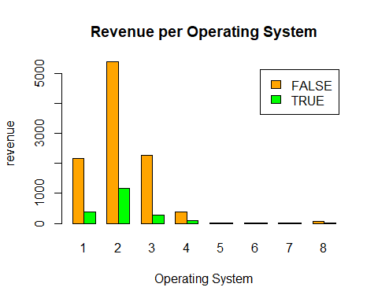 Operating System 2 returns the highest number of revenue while OS 5, 6, and 7 return the lowest.

# plotting the distribution of Revenue per Browser  
barplot(table(df_new$Revenue, df_new$Browser),   
 main = "Revenue per Browser",   
 col = c("orange", "green"),  
 beside = TRUE,   
 legend = rownames(table(df_new$Revenue, df_new$Browser)),  
 ylab="revenue",   
 xlab = "Browser")

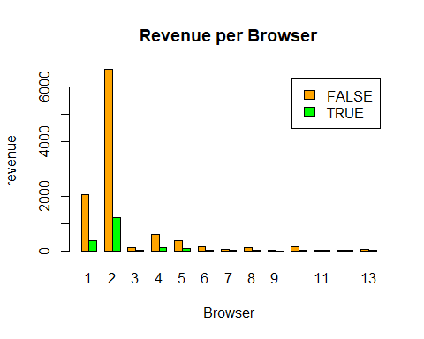 Browser 2 returns the highest number of revenue while 3, 7, 9, 11, and 12 return the lowest.

# plotting the distribution of Revenue per Region  
barplot(table(df_new$Revenue, df_new$Region),   
 main = "Revenue per Region",   
 col = c("orange", "green"), beside = TRUE,   
 legend = rownames(table(df_new$Revenue, df_new$Region)),   
 ylab="revenue", xlab = "Region")

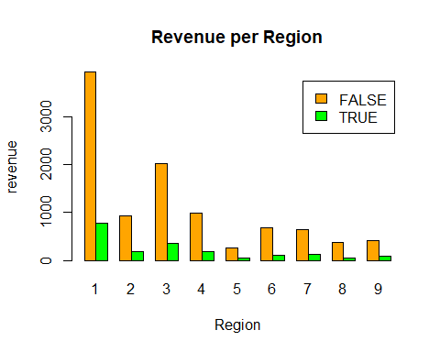 Region 1 returns the highest number of revenue, Region 5 and 8 returns the lowest.

# plotting the distribution of Revenue per Traffic Type  
barplot(table(df_new$Revenue, df_new$TrafficType),   
 main = "Revenue per Traffic Type",  
 col = c("orange", "green"), beside = TRUE,   
 legend = rownames(table(df_new$Revenue, df_new$TrafficType)),  
 ylab="revenue", xlab = "Traffic Type")

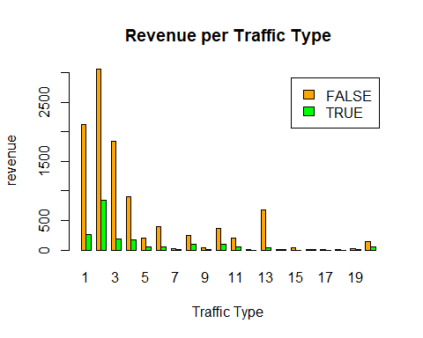 Traffic 2 has the highest number of revenues, 12, 14 and 18 return the lowest.

# plotting the distribution of Revenue per Visitor Type  
barplot(table(df_new$Revenue, df_new$VisitorType),   
 main = "Revenue per Visitor Type",   
 col = c("orange", "green"), beside = TRUE,   
 legend = rownames(table(df_new$Revenue, df_new$VisitorType)),  
 ylab="revenue", xlab = "Visitor Type")

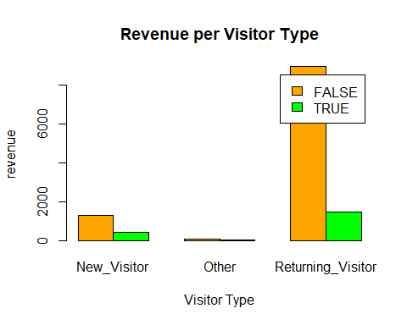 Returning visitors brought more revenue with new vistors generating around 1000.

# plotting the distribution of Revenue per Weekend  
barplot(table(df_new$Revenue, df_new$Weekend),   
 main = "Revenue per Weekend",   
 col = c("orange", "green"),beside = TRUE,   
 legend = rownames(table(df_new$Revenue, df_new$Weekend)),  
 ylab="revenue", xlab = "Weekend")

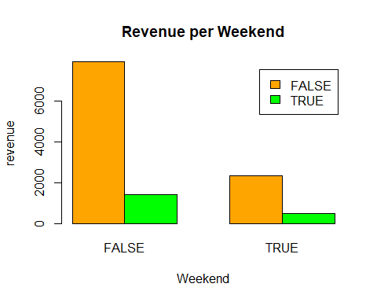 More revenue was generated during the weekdays than the weekends.

#check the correlation  
cor(df_new[,unlist(lapply(df_new, is.numeric))])

## Administrative Administrative_Duration Informational  
## Administrative 1.000000000 0.600409653 0.37528761  
## Administrative_Duration 0.600409653 1.000000000 0.30143630  
## Informational 0.375287611 0.301436296 1.00000000  
## Informational_Duration 0.254786021 0.237189860 0.61867795  
## ProductRelated 0.428191515 0.286783914 0.37260472  
## ProductRelated_Duration 0.371027224 0.353513793 0.38608372  
## BounceRates -0.213666635 -0.137333397 -0.10950530  
## ExitRates -0.311274132 -0.202024452 -0.15956681  
## PageValues 0.096920968 0.066168365 0.04739015  
## SpecialDay -0.097072098 -0.074736885 -0.04937677  
## OperatingSystems -0.006697922 -0.007610715 -0.00962587  
## Browser -0.025763658 -0.015833675 -0.03876681  
## Region -0.007262053 -0.006723711 -0.03047732  
## TrafficType -0.034784126 -0.015075015 -0.03518669  
## Informational_Duration ProductRelated  
## Administrative 0.254786021 0.428191515  
## Administrative_Duration 0.237189860 0.286783914  
## Informational 0.618677947 0.372604721  
## Informational_Duration 1.000000000 0.279061948  
## ProductRelated 0.279061948 1.000000000  
## ProductRelated_Duration 0.346580691 0.860308186  
## BounceRates -0.070159472 -0.193515772  
## ExitRates -0.102932678 -0.286163211  
## PageValues 0.030064160 0.054115494  
## SpecialDay -0.031293040 -0.025930622  
## OperatingSystems -0.009749983 0.004090351  
## Browser -0.019609349 -0.013706213  
## Region -0.027920098 -0.040106501  
## TrafficType -0.025163571 -0.044344333  
## ProductRelated_Duration BounceRates ExitRates  
## Administrative 0.371027224 -0.213666635 -0.311274132  
## Administrative_Duration 0.353513793 -0.137333397 -0.202024452  
## Informational 0.386083717 -0.109505298 -0.159566815  
## Informational_Duration 0.346580691 -0.070159472 -0.102932678  
## ProductRelated 0.860308186 -0.193515772 -0.286163211  
## ProductRelated_Duration 1.000000000 -0.174375499 -0.245334012  
## BounceRates -0.174375499 1.000000000 0.903358192  
## ExitRates -0.245334012 0.903358192 1.000000000  
## PageValues 0.050840624 -0.115991977 -0.173571542  
## SpecialDay -0.038210652 0.087839995 0.116783762  
## OperatingSystems 0.002775788 0.026839839 0.016482012  
## Browser -0.007838332 -0.016018380 -0.003565541  
## Region -0.034862498 0.001432015 -0.001837556  
## TrafficType -0.037506944 0.089199039 0.087386232  
## PageValues SpecialDay OperatingSystems Browser  
## Administrative 0.09692097 -0.097072098 -0.006697922 -0.025763658  
## Administrative_Duration 0.06616837 -0.074736885 -0.007610715 -0.015833675  
## Informational 0.04739015 -0.049376774 -0.009625870 -0.038766808  
## Informational_Duration 0.03006416 -0.031293040 -0.009749983 -0.019609349  
## ProductRelated 0.05411549 -0.025930622 0.004090351 -0.013706213  
## ProductRelated_Duration 0.05084062 -0.038210652 0.002775788 -0.007838332  
## BounceRates -0.11599198 0.087839995 0.026839839 -0.016018380  
## ExitRates -0.17357154 0.116783762 0.016482012 -0.003565541  
## PageValues 1.00000000 -0.064532709 0.018583782 0.045845065  
## SpecialDay -0.06453271 1.000000000 0.012757766 0.003465984  
## OperatingSystems 0.01858378 0.012757766 1.000000000 0.212244823  
## Browser 0.04584506 0.003465984 0.212244823 1.000000000  
## Region 0.01059087 -0.016452464 0.071953240 0.091889464  
## TrafficType 0.01223694 0.052827944 0.182874100 0.102886237  
## Region TrafficType  
## Administrative -0.007262053 -0.03478413  
## Administrative_Duration -0.006723711 -0.01507502  
## Informational -0.030477323 -0.03518669  
## Informational_Duration -0.027920098 -0.02516357  
## ProductRelated -0.040106501 -0.04434433  
## ProductRelated_Duration -0.034862498 -0.03750694  
## BounceRates 0.001432015 0.08919904  
## ExitRates -0.001837556 0.08738623  
## PageValues 0.010590868 0.01223694  
## SpecialDay -0.016452464 0.05282794  
## OperatingSystems 0.071953240 0.18287410  
## Browser 0.091889464 0.10288624  
## Region 1.000000000 0.04252523  
## TrafficType 0.042525234 1.00000000

#install.packages("corrplot")   
library(corrplot)

## corrplot 0.90 loaded

#  
## Let’s build a correlation matrix to understand the relation between each attributes  
corrplot(cor(num), method = 'number')

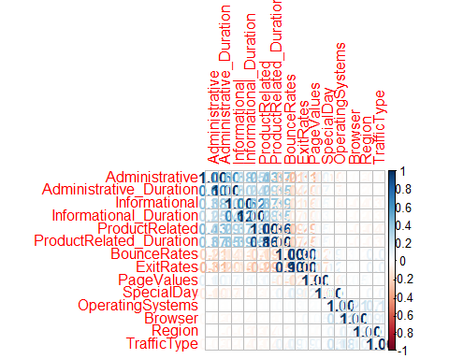

#drop cols highly correlated   
col_drop <- c("Administrative_Duration", "Informational_Duration", "ProductRelated_Duration", "ExitRates")  
df_new <- df_new[, !names(df_new) %in% col_drop]  
head(df_new)

## Administrative Informational ProductRelated BounceRates PageValues SpecialDay  
## 1 0 0 1 0.20000000 0 0  
## 2 0 0 2 0.00000000 0 0  
## 3 0 0 1 0.20000000 0 0  
## 4 0 0 2 0.05000000 0 0  
## 5 0 0 10 0.02000000 0 0  
## 6 0 0 19 0.01578947 0 0  
## Month OperatingSystems Browser Region TrafficType VisitorType Weekend  
## 1 Feb 1 1 1 1 Returning_Visitor FALSE  
## 2 Feb 2 2 1 2 Returning_Visitor FALSE  
## 3 Feb 4 1 9 3 Returning_Visitor FALSE  
## 4 Feb 3 2 2 4 Returning_Visitor FALSE  
## 5 Feb 3 3 1 4 Returning_Visitor TRUE  
## 6 Feb 2 2 1 3 Returning_Visitor FALSE  
## Revenue  
## 1 FALSE  
## 2 FALSE  
## 3 FALSE  
## 4 FALSE  
## 5 FALSE  
## 6 FALSE

# Modelling

#Check head  
head(df_new)

## Administrative Informational ProductRelated BounceRates PageValues SpecialDay  
## 1 0 0 1 0.20000000 0 0  
## 2 0 0 2 0.00000000 0 0  
## 3 0 0 1 0.20000000 0 0  
## 4 0 0 2 0.05000000 0 0  
## 5 0 0 10 0.02000000 0 0  
## 6 0 0 19 0.01578947 0 0  
## Month OperatingSystems Browser Region TrafficType VisitorType Weekend  
## 1 Feb 1 1 1 1 Returning_Visitor FALSE  
## 2 Feb 2 2 1 2 Returning_Visitor FALSE  
## 3 Feb 4 1 9 3 Returning_Visitor FALSE  
## 4 Feb 3 2 2 4 Returning_Visitor FALSE  
## 5 Feb 3 3 1 4 Returning_Visitor TRUE  
## 6 Feb 2 2 1 3 Returning_Visitor FALSE  
## Revenue  
## 1 FALSE  
## 2 FALSE  
## 3 FALSE  
## 4 FALSE  
## 5 FALSE  
## 6 FALSE

#selecting data without revenue  
data<-df_new[,-14]  
head(data)

## Administrative Informational ProductRelated BounceRates PageValues SpecialDay  
## 1 0 0 1 0.20000000 0 0  
## 2 0 0 2 0.00000000 0 0  
## 3 0 0 1 0.20000000 0 0  
## 4 0 0 2 0.05000000 0 0  
## 5 0 0 10 0.02000000 0 0  
## 6 0 0 19 0.01578947 0 0  
## Month OperatingSystems Browser Region TrafficType VisitorType Weekend  
## 1 Feb 1 1 1 1 Returning_Visitor FALSE  
## 2 Feb 2 2 1 2 Returning_Visitor FALSE  
## 3 Feb 4 1 9 3 Returning_Visitor FALSE  
## 4 Feb 3 2 2 4 Returning_Visitor FALSE  
## 5 Feb 3 3 1 4 Returning_Visitor TRUE  
## 6 Feb 2 2 1 3 Returning_Visitor FALSE

# Create custom function to fix data types and round  
to_numeric_and_round_func <- function(x){  
 round(as.numeric(as.character(x)),2)  
}  
# Mutate the columns to proper data type  
data <- data %>%  
 mutate_at(vars(-one_of("Month", "Region", "VisitorType", "Weekend")), to_numeric_and_round_func)

# create clean data with no NA  
clean_data <- data %>%  
 drop_na()

##Kmeans

# Set seed  
set.seed(1234)  
col.names<-c("Month", "VisitorType", "Weekend")  
  
# Cluster Analysis - kmeans  
kmeans_basic <- kmeans(clean_data[, !names(data) %in% col.names], centers = 5)  
kmeans_basic_table <- data.frame(kmeans_basic$size, kmeans_basic$centers)  
kmeans_basic_df <- data.frame(Cluster = kmeans_basic$cluster, data)  
# head of df  
head(kmeans_basic_df)

## Cluster Administrative Informational ProductRelated BounceRates PageValues  
## 1 4 0 0 1 0.20 0  
## 2 4 0 0 2 0.00 0  
## 3 4 0 0 1 0.20 0  
## 4 4 0 0 2 0.05 0  
## 5 4 0 0 10 0.02 0  
## 6 4 0 0 19 0.02 0  
## SpecialDay Month OperatingSystems Browser Region TrafficType  
## 1 0 Feb 1 1 1 1  
## 2 0 Feb 2 2 1 2  
## 3 0 Feb 4 1 9 3  
## 4 0 Feb 3 2 2 4  
## 5 0 Feb 3 3 1 4  
## 6 0 Feb 2 2 1 3  
## VisitorType Weekend  
## 1 Returning_Visitor FALSE  
## 2 Returning_Visitor FALSE  
## 3 Returning_Visitor FALSE  
## 4 Returning_Visitor FALSE  
## 5 Returning_Visitor TRUE  
## 6 Returning_Visitor FALSE

# Visulize the clusters per month  
ggplot(data = kmeans_basic_df, aes(y = Cluster)) +  
 geom_bar(aes(fill = Month)) +  
 ggtitle("Count of Clusters by Month") +  
 theme(plot.title = element_text(hjust = 0.5))

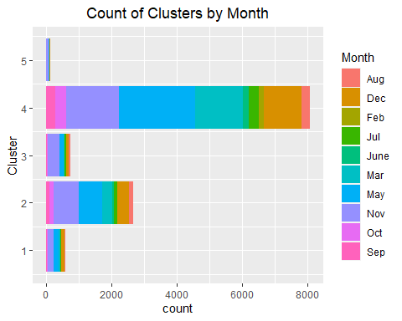

### elbow method

library(factoextra)

## Warning: package 'factoextra' was built under R version 4.0.5

## Welcome! Want to learn more? See two factoextra-related books at https://goo.gl/ve3WBa

data_norm <-scale(clean_data[, !names(data) %in% col.names])  
# Get the optimum number of clusters  
fviz_nbclust(data_norm, kmeans, method = "wss")

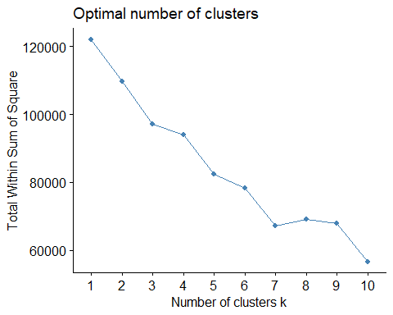

The optimum clusters from the above is 3.

#kmeans  
kmeans_fancy <- kmeans(data_norm, 3, nstart = 20)  
  
# plot the clusters  
fviz_cluster(kmeans_fancy, data = data_norm, geom = c("point"),ellipse.type = "euclid")

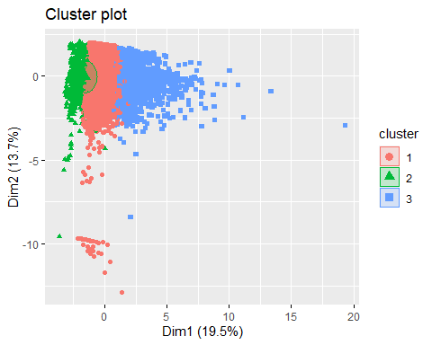

#Check the size of each cluster  
kmeans_fancy $size

## [1] 8885 1561 1753

The first cluster has 8885 values, second has 1561 and third has 1753 values

# check their response to revenue  
table(kmeans_fancy$cluster, df_new$Revenue)

##   
## FALSE TRUE  
## 1 7519 1366  
## 2 1506 55  
## 3 1266 487

data %>%   
 mutate(Cluster = kmeans_fancy$cluster) %>%  
 group_by(Cluster) %>%  
 summarize_all('median')

## # A tibble: 3 x 14  
## Cluster Administrative Informational ProductRelated BounceRates PageValues  
## <int> <dbl> <dbl> <dbl> <dbl> <dbl>  
## 1 1 1 0 16 0 0   
## 2 2 0 0 5 0.07 0   
## 3 3 7 2 70 0 2.09  
## # ... with 8 more variables: SpecialDay <dbl>, Month <chr>,  
## # OperatingSystems <dbl>, Browser <dbl>, Region <int>, TrafficType <dbl>,  
## # VisitorType <chr>, Weekend <lgl>

## Hierarchical clustering

library(cluster)

## Warning: package 'cluster' was built under R version 4.0.5

# compute the euclidean distance using euclidean metric  
eucl_dist<- dist(data_norm, method = "euclidean")  
#compute hierarchical clustering using the Ward method  
res_hc<- hclust(eucl_dist, method = "ward.D2")  
res_hc

##   
## Call:  
## hclust(d = eucl_dist, method = "ward.D2")  
##   
## Cluster method : ward.D2   
## Distance : euclidean   
## Number of objects: 12199

# plot the obtained dendrogram  
plot(res_hc, cex = 0.6, hang = -1)

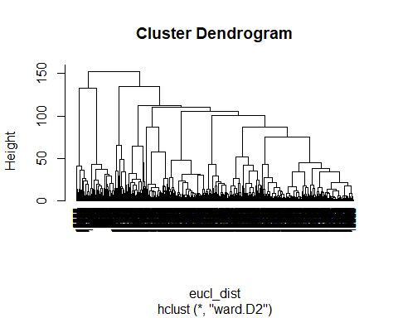

# compute the euclidean distance using manhattan metric  
eucl_dist_man<- dist(data_norm, method = "manhattan")  
#compute hierarchical clustering using the Ward method  
res_hc_man<- hclust(eucl_dist_man, method = "ward.D2")  
res_hc_man

##   
## Call:  
## hclust(d = eucl_dist_man, method = "ward.D2")  
##   
## Cluster method : ward.D2   
## Distance : manhattan   
## Number of objects: 12199

# plot the obtained dendrogram  
plot(res_hc_man, cex = 0.6, hang = -1)

