**[Initiative Title]**

**[Initiative Type]**

**Business Engineering Plan**



**[Company Logo]**

Executive Summary

Xxxxx Xxxxx Xxxxx

Core Value Proposition

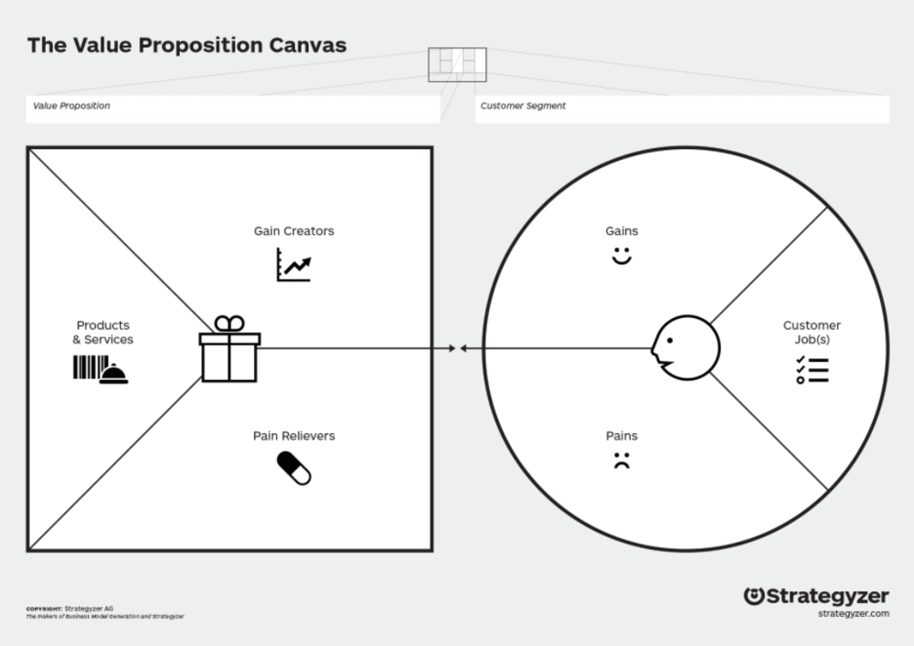

Sales of products

Delivery of services

Satisfying customers

Sub-optimal business processes

Late orders

Customers not served quickly

Profit

Customer relations

Customer base expansion

Analytics software

Training

Implementation of IT support

Analytics training

Control over business processes

Improve processes using analytics

Customer service process analysis

Table of Contents

Executive Summary I

Table of Contents II

List of Tables III

List of Figures III

I. The Business 1

The Market 1

The Future 1

II. Management Structure [Who] 2

Management Team (Key Personnel) 2

Organizational Structure 2

Staff Lifecycle (Recruitment, Responsibility & Accountability) 2

III. Manufacturing, Supply Chain & Operation [What] 3

Manufacturing or Service Plan 3

Supply Chain Plan 3

Operational Plan 3

IV. Financial Management [How] 4

Revenue Model 4

Cash to Cash Cycle 4

The Finances 4

V. The Industry [Where] 5

Macro-Forces 5

Competitive Landscape 5

Risk Mitigation Strategies 5

VI. Ethics, Society & Environment [Why] 6

Environmental Sustainability 6

Social Development 6

Customer Relationship Management 6

VII. Key Resources, Milestones and Partners [When] 7

Key Resources 7

Key Milestones 7

Key Partners 7

VIII. Initiative Investment 8

Start Up Capital 8

1 Million Rand Runway 8

Appendix A: Business Model Canvas 1

Appendix B: Financial Forecast & Plan 2

# List of Tables

**No table of figures entries found.**

# List of Figures

**No table of figures entries found.**

# The Business

Abstineatis Process Mining is a consulting firm focused on providing process mining analytics to medium sized companies looking to modernise, with specific reference to the context of the third world.

Process mining is a field of data mining which aims “to discover, monitor and improve real processes by extracting knowledge from event logs readily available in today’s information systems.” [1] It bridges the gap between traditional Business Process Management (BPM) techniques and data science, providing easily accessible and accurate (i.e. real world) information on the performance of processes.

It differs from traditional process modelling in that it fulfils the shortcomings of these techniques, namely cost and time requirements, along with a lack of objective validation techniques. [2]

Abstineatis aims to bring this technology, and with it advanced operating analytics, to the third world market, allowing businesses to save time and money and focus on what makes them great. This could, furthermore, assist in expansion efforts, therefore assisting in indirect job creation.

We offer three main services, revolving around the use of process mining. First, we offer process mining software which is customisable in consultation with clients. Next, we offer consultation on the development of the necessary IT infrastructure for the use of process mining. Finally, we offer training in the use and interpretation of process mining results, creating job opportunities for data analysts within the clients’ businesses.

This training element is essential to our business model. Since the use of process mining techniques is relatively new in industry, Abstineatis aims to play a major role in the establishment of process mining alongside more traditional Business Process Management (BPM) techniques.

Abstineatis is based in Potchefstroom, and focuses on the South African market, with plans for expansion into Africa.

## The Market

This specific technology is still in an early adoption phase, with much potential for expansion in the market. In 2018, Gartner [2] estimated the revenue from process mining initiatives to be roughly $160 million worldwide, with an expectation of major growth (roughly 300% - 400%) within the following two years. Gartner [2] also found that demand for this kind of analytics far outpaced supply, and the fact that this technology could be used alongside traditional BPM techniques means that adoption should be easy.

This market size, however, is largely focused in Europe and North America, with North American process mining initiatives only entering the market in 2018. As already shown earlier in this chapter, the potential uses vary greatly and could play a major role in managing business processes, and this is never truer than in the case of Africa, where efficient operations are essential in difficult economic climates.

Bringing the technology to the South African market, along with the expertise required to establish the necessary infrastructures in a South African context will make it possible for companies to take advantage of these advanced techniques.

Due to the wide range of potential applications, the South African market for process mining analytics could grow fast and become mainstream techniques in the management of business and even operational processes.

An important barrier to entry into the South African market is the fact that process mining is relatively unknown. We therefore aim to build proof of concept models showing the specific value to be gained from the application of process mining. These models would be presented to prospective clients as proof of the potential value to be gained.

Abstineatis’ marketing strategy is largely based on an online presence. Active social media engagement and the establishment of a high-quality website is a low-cost alternative to traditional marketing methods. These platforms also offer an opportunity to fuel engagement and education in the value of process mining. The power of word of mouth in the form of testimonials are also not to be discounted.

## The Future

Abstineatis’ vision is the democratisation of previously first-world analytics and the establishment of process mining as a mainstream BPM tool in the South African context.

We expect to measure initial growth of the business by the number of clients we service. Since Abstineatis works both on a consultation and subscription basis, the number of clients is a good indication of the growth of the venture.

### 3 Months

By the completion of the first financial quarter, it is expected that all business establishment steps should be completed. Software development is expected to take roughly one month. The venture is expected to sign its first client near the end of this term.

### 1 Year

At the end of year one, we expect all business establishment steps to be completed, and the first few clients to have signed on. We expect total number of clients to have grown to 6.

### 3 Years

By the end of the third year of business, we expect to have established ourselves in the South African market as a leading consultation firm. We expect to have brought process mining analytics to 18 loyal clients.

### 5 Years

By the end of five years of business, we expect name recognition to have grown in the South African market, and to be serving at least 35 clients. We expect at the end of the fifth year for expansion into Africa to be well away in the planning phase.

# Initiative Investment

Abstineatis Process Mining is looking for an investment of R750 000 to aid in the establishment of the business. In return, we offer a 30% equity share in the business, with yearly dividends equal to 15% of the net profit generated. This slightly lower dividend share is to be put in place with the goal of retaining a large share of the profits into the business, aiding in growth. This will also mean that the investment value (30% equity of the business) grows well. After the first five years of operation, there will be a buy-back option for the 30% equity at an amount to be negotiated at that time.

## Start Up Capital

Xxxx – How much money would you need to kickstart your dream? How would you use this money? (Make a table on the organs you would invest it to). What type of investor are you looking for? How much of company would you give them?

## 1 Million Rand Runway

Xxxx – How far along the process (both timewise and development wise) would 1 Million Rand get you. What is your burn rate?

# Appendix A: Business Model Canvas

|  |  |  |  |  |  |
| --- | --- | --- | --- | --- | --- |
| **Key Partners**  Software developers  Hardware suppliers  Business Analytics Trainers  Business Process Platforms (SAP, etc) | **Key Activities**  Software development  Hardware design and supply  Business Analytics Training | **Value Proposition**  Process Analytics  Training  Control over processes  Software  Direct contact with SA market | | **Customer Relationships**  Continuous support  Analytics interpretation  Customise a standard solution  Training | **Customer Segments**  IT logging  Manufacturing processes  Automated business processes  Medium sized companies |
| **Key Resources**  Business Process Platforms (SAP, etc)  Customer Relationships | **Channels**  Proof of concept models  Social media  Website  Testimonials |
| **Cost Structure**  Training staff  Software development  IT systems procurement and maintenance  Consulting staff  Customer Support | | | **Revenue Streams**  Training    System design and integration  Software sales  Consultation Fees | | |
| **Social and Environmental Cost**  Automation (job destruction) | | | **Social and Environmental Benefit**  Direct Job Creation  Indirect Job Creation | | |

# Appendix B: Financial Forecast & Plan

|  |  |  |  |  |  |  |  |  |  |  |  |  |
| --- | --- | --- | --- | --- | --- | --- | --- | --- | --- | --- | --- | --- |
| |  | | --- | |  | | **Initiative X**  **5Y - Overview Financials** | | | | | | | | |  | |
|  | **Year of 2019** | **%** | **Year of 2020** | **%** | | **Year of 2021** | **%** | **Year of 2022** | **%** | **Year of 2023** | **%** |
| **Revenue** |  |  |  |  |  | |  |  |  |  |  |
|  |  |  |  |  |  | |  |  |  |  |  |
|  |  |  |  |  |  | |  |  |  |  |  |
|  |  |  |  |  |  | |  |  |  |  |  |
| **Total Revenue** |  |  |  |  |  | |  |  |  |  |  |
| **Expenses** |  |  |  |  |  | |  |  |  |  |  |
| Cost of Sale | | | | | | | | | | | |
|  |  |  |  |  |  | |  |  |  |  |  |
|  |  |  |  |  |  | |  |  |  |  |  |
|  |  |  |  |  |  | |  |  |  |  |  |
| **Total Cost of Sale** |  |  |  |  |  | |  |  |  |  |  |
| Overheads | | | | | | | | | | | |
|  |  |  |  |  |  | |  |  |  |  |  |
|  |  |  |  |  |  | |  |  |  |  |  |
|  |  |  |  |  |  | |  |  |  |  |  |
| **Total Overheads** |  |  |  |  |  | |  |  |  |  |  |
|  |  |  |  |  |  | |  |  |  |  |  |
| Net Profit |  |  |  |  |  | |  |  |  |  |  |

[1] I. T. F. o. P. Mining, "Process Mining Manifesto," in *Proceedings Business Process Mining Workshops*, ed: Springer, 2011.

[2] Gartner, "Market Guide for Process Mining," ed, 2019.