📊
WEEK 3 TASK REPORT
Statistical Analysis and Hypothesis Testing in Python
Study Hours and Their Relationship with Exam Performance
Virtual Data Science with Python — Apprentice Intern
YuvaIntern

Prepared by
Rinsha Sherin
Dataset | Self-generated (120 students)
Test Used | Welch's Independent t-test
Result | Statistically Significant (p < 0.001)

1 · Introduction
Statistical analysis provides a systematic way to determine whether patterns observed in data are likely to represent genuine differences or could simply have occurred by chance. This Week 3 project applies hypothesis testing using Python to a common educational question: does the amount of time a student studies each day relate to their exam performance? A self-generated dataset was used so the full statistical workflow — from data creation to interpretation — could be demonstrated end to end.

2 · Problem Statement
The problem investigated in this project is whether students who study 5 or more hours per day achieve different average exam scores than students who study less than 5 hours per day. Visual inspection of the data can suggest a difference, but statistical testing is required to determine whether that difference is unlikely to have occurred by chance.

3 · Objectives
- Generate a structured educational dataset using Python.
- Calculate descriptive statistics for each study-hour group.
- Formulate null and alternative hypotheses.
- Test the equality of variances using Levene's test.
- Apply Welch's independent-samples t-test to compare group means.
- Calculate and interpret a 95% confidence interval for the mean difference.
- Create visualizations to support the statistical findings.
- Draw a conclusion based on the p-value and effect size.

4 · Dataset Description
The dataset is a self-generated educational dataset containing 120 student records. Each record includes a student ID, study hours per day, attendance percentage, exam score, and a study-hour group label (5+ hours or below 5 hours per day). The dependent variable selected for this hypothesis test is exam score.
Study-Hour Group | N | Mean Exam Score | Std. Deviation
5+ hours/day | 64 | 90.95 | 6.27
Below 5 hours/day | 56 | 81.68 | 7.19

5 · Hypothesis Formulation
Significance level: α = 0.05
H0 (Null Hypothesis): There is no significant difference in mean exam scores between students studying 5+ hours per day and students studying below 5 hours per day.
H1 (Alternative Hypothesis): There is a significant difference in mean exam scores between the two study-hour groups.

6 · Methodology
An independent-samples comparison was needed because the dataset has one continuous dependent variable (exam score) and one categorical grouping variable with two levels (study-hour group). Levene's test was first used to check whether the two groups have equal variances. Because sample sizes and variances were not assumed to be identical, Welch's t-test — a variant of the t-test that does not require equal variances — was used to compare the group means. A 95% confidence interval for the mean difference was calculated using the Welch–Satterthwaite approach.
The analysis assumes independent observations and approximately normally distributed exam scores within each group. Group sizes are reasonably balanced (64 vs. 56), which supports a fair comparison.

7 · Python Implementation
# Week 3: Statistical Analysis and Hypothesis Testing in Python
# Project: Study Hours and Their Relationship with Exam Performance

import numpy as np
import pandas as pd
import matplotlib.pyplot as plt
from scipy import stats

# 1. Load the dataset
df = pd.read_csv("student_performance_dataset.csv")
group_high = df.loc[df["study_hour_group"] == "5+ hours", "exam_score"]
group_low = df.loc[df["study_hour_group"] == "Below 5 hours", "exam_score"]

# 2. Hypotheses
# H0: No significant difference in mean exam scores between groups.
# H1: A significant difference exists between the two groups.

# 3. Levene's test for equality of variances
levene_stat, levene_p = stats.levene(group_high, group_low)

# 4. Welch's independent-samples t-test
t_stat, p_value = stats.ttest_ind(group_high, group_low, equal_var=False)
print("t-statistic:", t_stat, "p-value:", p_value)

# 5. 95% confidence interval for the mean difference
mean_diff = group_high.mean() - group_low.mean()
se_diff = np.sqrt(group_high.var(ddof=1)/len(group_high) +
group_low.var(ddof=1)/len(group_low))
ci = stats.t.interval(0.95, df=len(df)-2, loc=mean_diff, scale=se_diff)

# 6. Visualization
df.boxplot(column="exam_score", by="study_hour_group")
plt.title("Exam Scores by Study-Hour Group")
plt.xlabel("Study-hour group"); plt.ylabel("Exam score")
plt.show()

8 · Descriptive Analysis
The mean exam score was 90.95 for students studying 5+ hours per day, compared to 81.68 for students studying below 5 hours per day — a difference of roughly 9.3 points. The standard deviations (6.27 and 7.19 respectively) indicate that scores are somewhat more tightly clustered in the high-study-hours group.
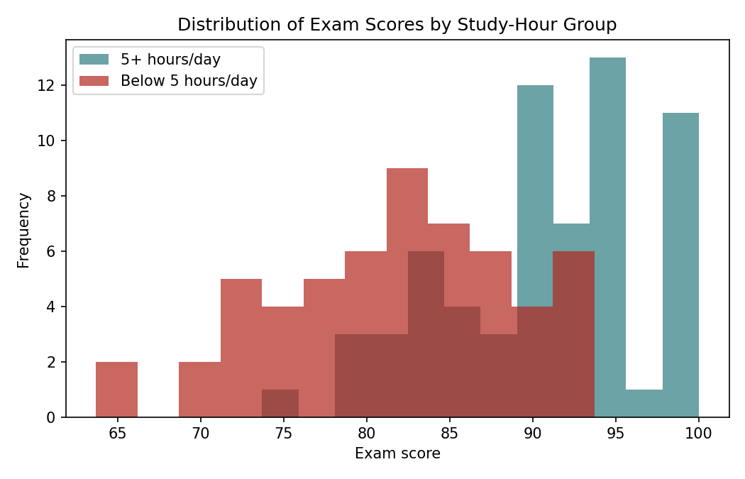
Figure 1 · Distribution of exam scores by study-hour group.

9 · Levene's Test and Welch's t-Test Results
Levene's test produced a statistic of 0.925 and a p-value of 0.338, indicating no significant difference in variances between the two groups. Welch's t-test was nonetheless used, as it is robust regardless of this outcome. The test produced a t-statistic of 7.476 and a p-value of 1.965 × 10⁻¹¹. Because the p-value is far below α = 0.05, the result is statistically significant, and the null hypothesis is rejected.
Welch t-statistic | p-value | Mean Difference | Decision
7.476 | 1.965 × 10⁻¹¹ | 9.27 points | Reject H0

There is strong evidence that mean exam scores differ between students who study 5+ hours per day and those who study below 5 hours per day.
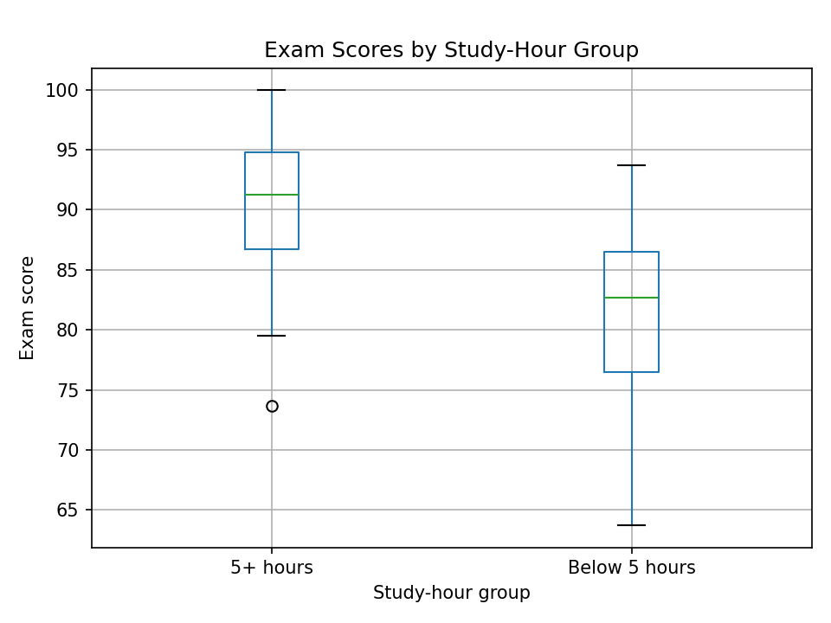
Figure 2 · Box plot comparing exam scores across study-hour groups.

10 · Confidence Interval
The 95% confidence interval for the difference in mean exam scores between the 5+ hours group and the below-5-hours group is [6.81, 11.73]. Because this interval does not contain zero, it confirms the statistically significant difference found by the t-test, and indicates that students who study 5+ hours per day are likely to score, on average, between about 6.8 and 11.7 points higher.
Metric | Value
Mean difference | 9.27 points
95% CI lower bound | 6.81
95% CI upper bound | 11.73

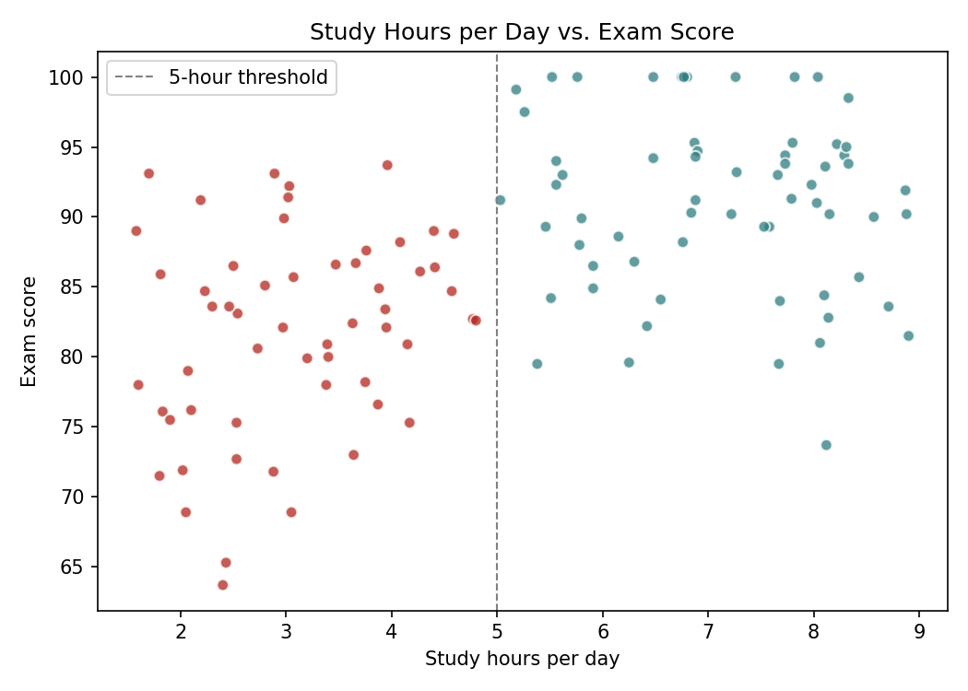
Figure 3 · Study hours per day vs. exam score, with the 5-hour threshold marked.

11 · Interpretation of Results
The statistical evidence strongly supports the alternative hypothesis. The Welch's t-test p-value is far smaller than 0.05, so the observed difference in mean exam scores between the two study-hour groups is very unlikely to be explained by random sampling variation alone. The scatter plot further illustrates that exam scores tend to rise as daily study hours increase, particularly beyond the 5-hour threshold, though scores vary noticeably at every study-hour level.

12 · Conclusion
The analysis demonstrates how hypothesis testing can convert an everyday assumption — that studying more improves exam performance — into a statistically supported conclusion. The null hypothesis that there is no difference in mean exam scores between the two study-hour groups was rejected. Students studying 5+ hours per day scored significantly higher on average than students studying below 5 hours per day. Because the dataset is self-generated, this result should be treated as a demonstration of statistical methodology rather than a real-world finding.

13 · Limitations
- The dataset is self-generated and is mainly useful for educational and demonstration purposes.
- Only study hours and exam score were analyzed; other factors such as sleep, prior academic performance, or subject difficulty were not modeled.
- Statistical significance does not by itself establish causation.
- The findings should not be generalized to real student populations.

14 · Tools and Technologies
Python, Pandas, NumPy, SciPy, Matplotlib, and Microsoft Word.

15 · References
- SciPy documentation: scipy.stats.ttest_ind (Welch's t-test).
- SciPy documentation: scipy.stats.levene for testing equality of variances.
- Pandas documentation: DataFrame.groupby and DataFrame.boxplot.

