**ACTIVITY DIAGRAM**

FOR ADMIN

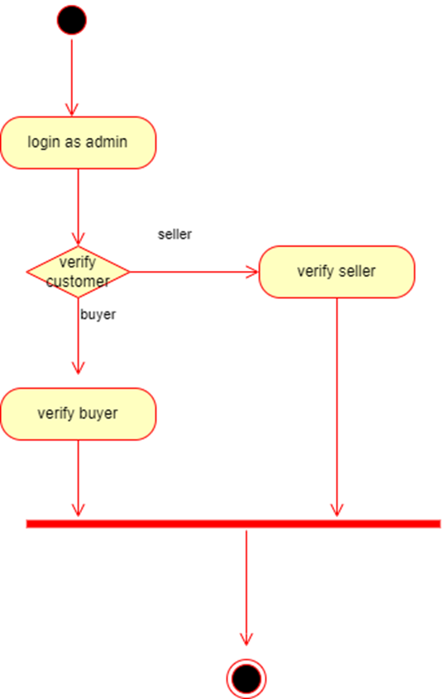

FOR USER (NOT CUSTOMIZED PRODUCT)

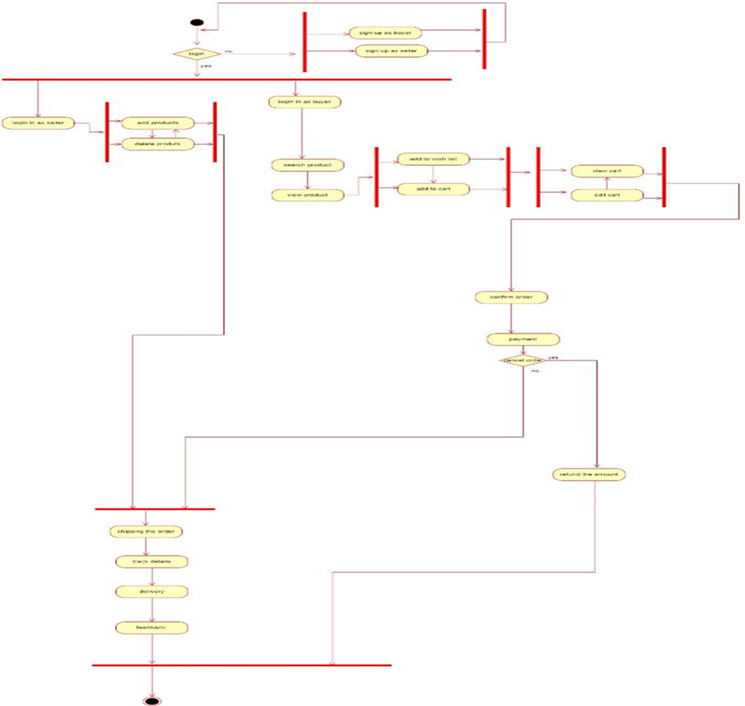

FOR CUSTOMIZED PRODUCT

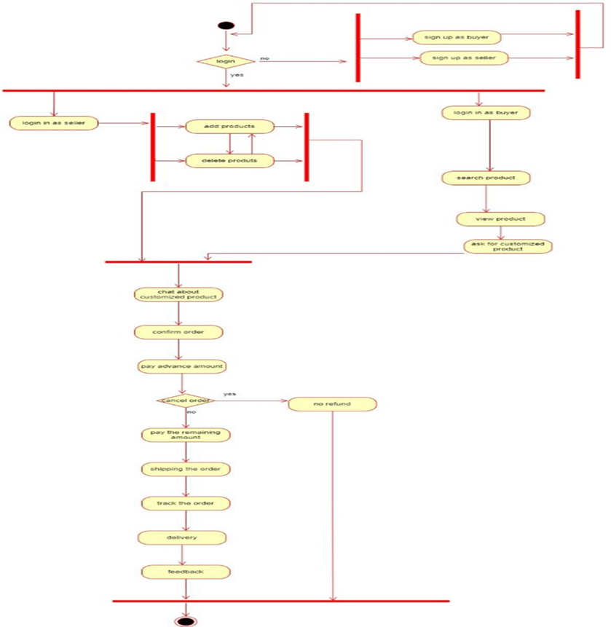

**USE CASE DIAGRAM**

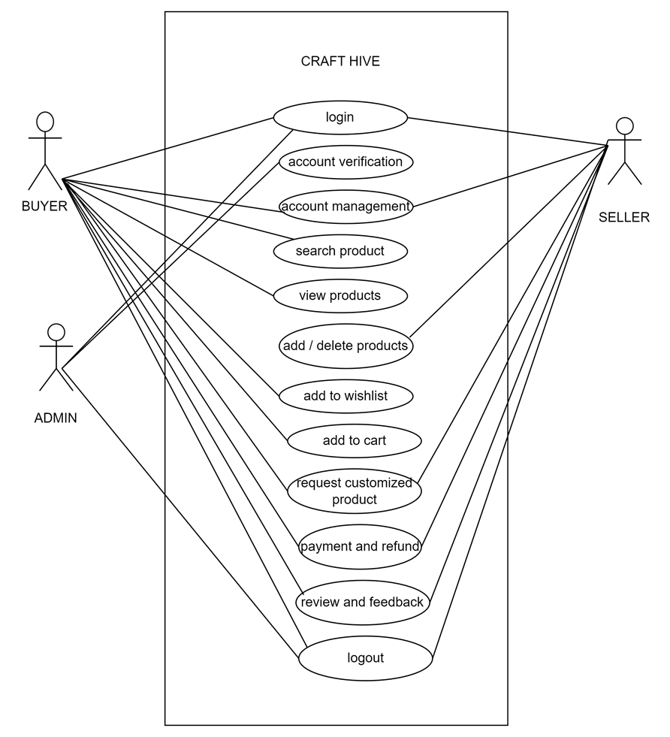

**ER DIAGRAM**

