15.

display.html

<html>
<head>
<title>Student Details</title>
</head>
<body>
<form action="st.php" method="post">
<table>
<tr>
<td>Name:</td>
<td><input type="text" name="name"></td>
</tr>
<tr>
<td>Department:</td>
<td><input type="text" name="class"></td>
</tr>
<tr>
<td>Age:</td>
<td><input type="text" name="age"></td>
</tr>
<tr>
<td>Admission no:</td>
<td><input type="text" name="admn_no"></td>
</tr>
<tr>
<td><input type="submit" value="submit"></td>
</tr>
</table>
</form>
</body>
</html>

st.php

<?php
$name=$_POST['name'];
$class=$_POST['class'];
$age=$_POST['age'];
$admn_no=$_POST['admn_no'];
echo"Name of student:$name <br> Department:$class <br> Age:$age <br> Admission number:$admn_no";
?>

Output:

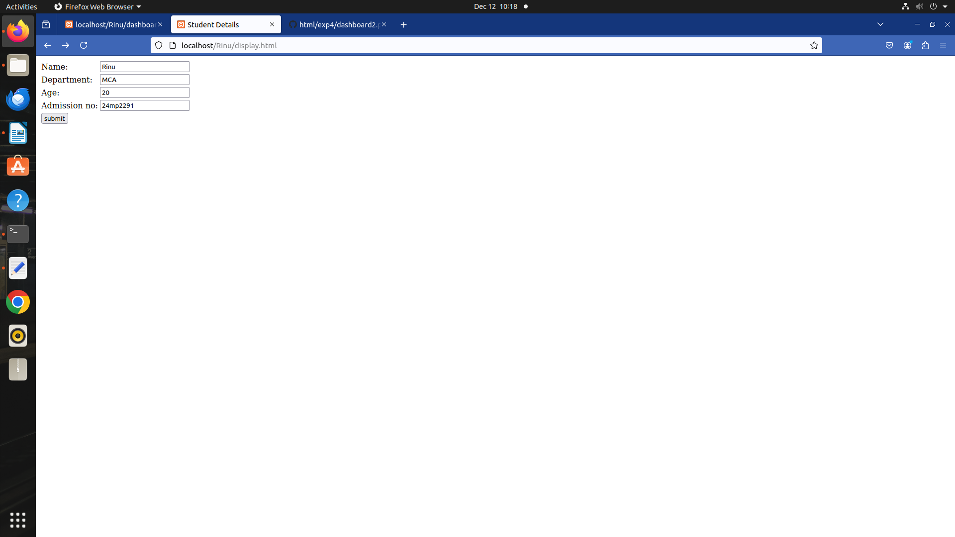

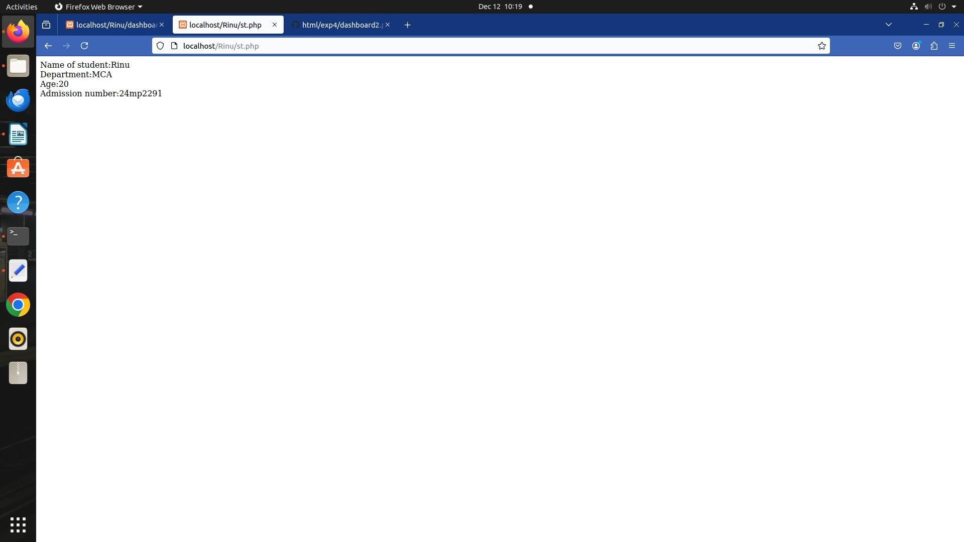

16.

Database Command:

create database user_db;
use user_db;
create table user(id int primary key auto_increment,username varchar(20),password varchar(10));
insert into table user(username,password)into values('rinu','123');

Welcome.html

<html>
<head>
<title>Login</title>
</head>
<body>
<form action="welcome.php" method="post">
<table>
<center>
<tr>
<td>username</td>
<td><input type="text" name="username" placeholder="Enter the username"></td>
</tr>
<tr>
<td>password</td>
<td><input type="text" name="password" placeholder="Enter the password"></td>
</tr>
<tr>
<td><input type="submit" value="login"></td>
</tr>
</center>
</table>
</form>
</body>
</html>

Welcome.php

<?php
include('db.php');
if ($_SERVER['REQUEST_METHOD'] == 'POST') {
$username = $_POST['username'];
$password = $_POST['password'];
if (empty($username) || empty($password)) {
echo "Please enter both username and password.";
} else {
$sql = "SELECT * FROM user WHERE username = ?";
$stmt = $conn->prepare($sql);
$stmt->bind_param("s", $username);
$stmt->execute();
$result = $stmt->get_result();
if ($result->num_rows == 1) {
$row = $result->fetch_assoc();
if ($password==$row['password']) {
echo "<h2>Welcome, " . htmlspecialchars($row['username']) . "!</h2>";
} else {
echo "Invalid password!";
}
} else {
echo "User not found!";
}
$stmt->close();
}
}
$conn->close();
?>

db.php

<?php
$servername = "localhost";
$username = "root";
$password = "";
$dbname = "user_db";
$conn = mysqli_connect($servername, $username, $password, $dbname);
if (!$conn) {
die("Connection failed: " . mysqli_connect_error());
}

?>
Ouput:

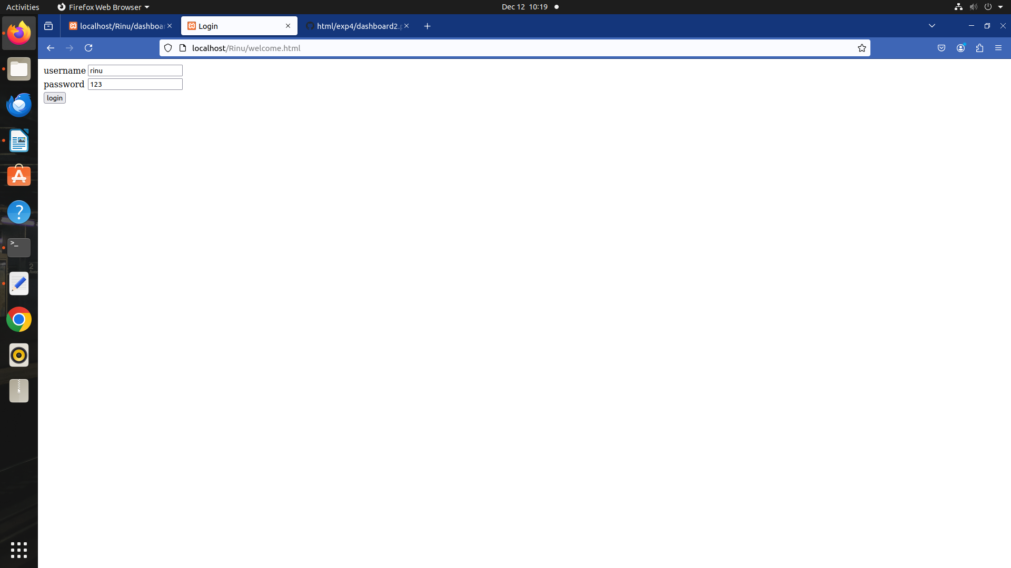

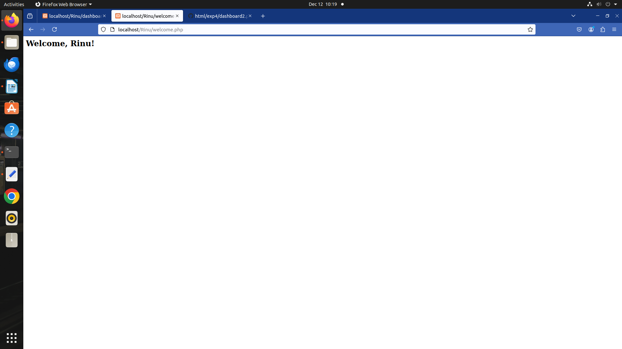

17.

database command:

create database studentdatabase;
use studentdatabase;
create table students(id int primary key auto_increment,first_name varchar(20), last_name varchar(20), email varchar(30), dob date, gender varchar(20), mobile_number varchar(10));

registration.html

<html>
<head>

<title>Student Registration</title>
</head>
<body>
<h2>Register Student</h2>
<form method="POST" action="registration.php">
<label for="first_name">First Name:</label><br>
<input type="text" id="first_name" name="first_name" required><br><br>

<label for="last_name">Last Name:</label><br>
<input type="text" id="last_name" name="last_name" required><br><br>

<label for="email">Email:</label><br>
<input type="email" id="email" name="email" required><br><br>

<label for="dob">Date of Birth:</label><br>
<input type="date" id="dob" name="dob" required><br><br>

<label>Gender:</label><br>
<input type="radio" id="male" name="gender" value="Male" required>
<label for="male">Male</label><br>
<input type="radio" id="female" name="gender" value="Female" required>
<label for="female">Female</label><br><br>

<label for="mobile_number">Mobile Number:</label><br>
<input type="text" id="mobile_number" name="mobile_number" required><br><br>

<input type="submit" value="Register">
</form>
</body>
</html>

registration.php

<?php

$servername = "localhost";
$username = "root";
$password = "";
$dbname = "studentdatabase";

$conn = new mysqli($servername, $username, $password, $dbname);

if ($conn->connect_error) {
die("Connection failed: " . $conn->connect_error);
}

if ($_SERVER['REQUEST_METHOD'] == 'POST') {
$first_name = $_POST['first_name'];
$last_name = $_POST['last_name'];
$email = $_POST['email'];
$dob = $_POST['dob'];
$gender = $_POST['gender'];
$mobile_number = $_POST['mobile_number'];

$sql = "INSERT INTO students (first_name, last_name, email, dob, gender, mobile_number)
VALUES ('$first_name', '$last_name', '$email', '$dob', '$gender', '$mobile_number')";

if ($conn->query($sql) === TRUE) {

echo "Registration successful! Redirecting to login...";
header("Location: login.php");
exit();
} else {
echo "Error: " . $conn->error;
}

$conn->close();
}
?>

login.php

<?php

$servername = "localhost";
$username = "root";
$password = "";
$dbname = "studentdatabase";

$conn = new mysqli($servername, $username, $password, $dbname);

if ($conn->connect_error) {
die("Connection failed: " . $conn->connect_error);
}

if ($_SERVER['REQUEST_METHOD'] == 'POST') {
$email = $_POST['email'];

// Query to fetch the user based on email
$sql = "SELECT * FROM students WHERE email = '$email'";
$result = $conn->query($sql);

if ($result->num_rows > 0) {
// Get the user details
$row = $result->fetch_assoc();

// Set a cookie to remember the user
setcookie('student_id', $row['id'], time() + (86400 * 30), "/"); // Cookie for 30 days

// Redirect to the dashboard page
header("Location: dashboard.php");
exit();
} else {
echo "No user found with that email.";
}

$conn->close();
}
?>

<!DOCTYPE html>
<html lang="en">
<head>
<meta charset="UTF-8">
<title>Student Login</title>
</head>
<body>
<h2>Login</h2>
<form method="POST" action="login.php">
<label for="email">Email:</label><br>
<input type="email" id="email" name="email" required><br><br>

<input type="submit" value="Login">
</form>
</body>
</html>

dashboard.php

<?php

if (!isset($_COOKIE['student_id'])) {
echo "Please log in to view your information.";
exit();
}

$servername = "localhost";
$username = "root";
$password = "";
$dbname = "studentdatabase";

$conn = new mysqli($servername, $username, $password, $dbname);

if ($conn->connect_error) {
die("Connection failed: " . $conn->connect_error);
}

$student_id = $_COOKIE['student_id'];
$sql = "SELECT * FROM students WHERE id = '$student_id'";
$result = $conn->query($sql);

if ($result->num_rows > 0) {
$row = $result->fetch_assoc();
echo "<h2>Welcome, " . $row['first_name'] . " " . $row['last_name'] . "</h2>";
echo "<p>Email: " . $row['email'] . "</p>";
echo "<p>Date of Birth: " . $row['dob'] . "</p>";
echo "<p>Gender: " . $row['gender'] . "</p>";
echo "<p>Mobile Number: " . $row['mobile_number'] . "</p>";
} else {
echo "No user found.";
}

$conn->close();
?>
Output:

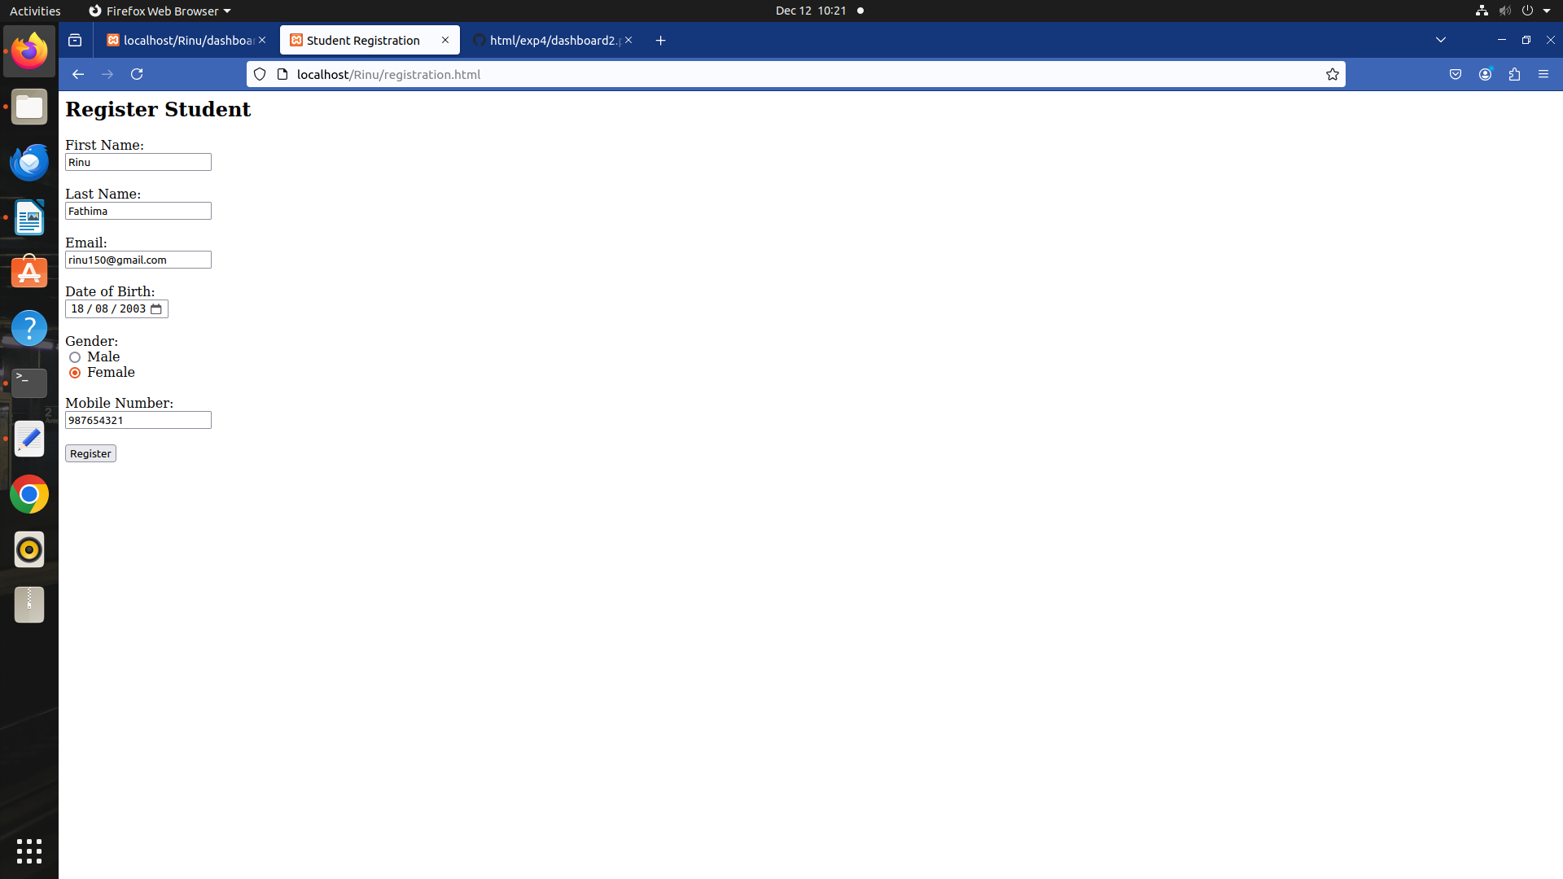

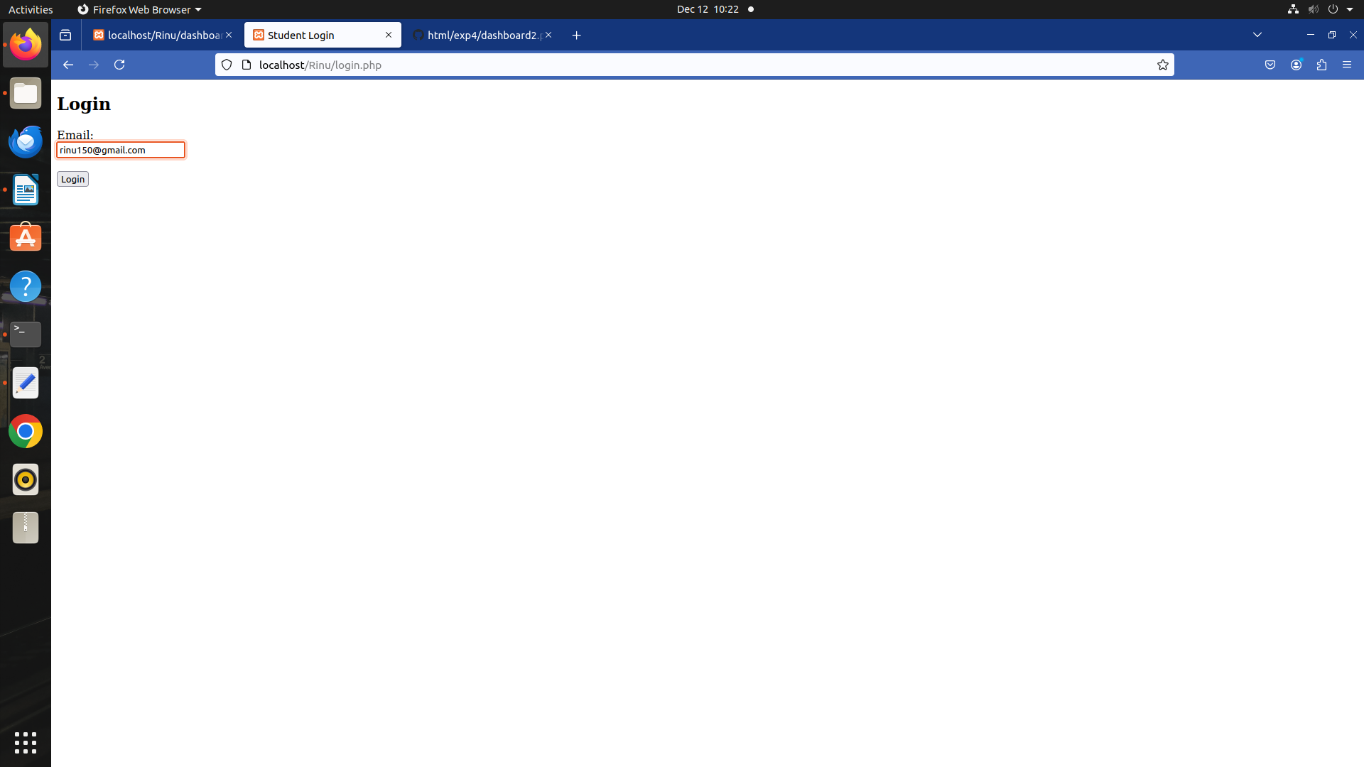

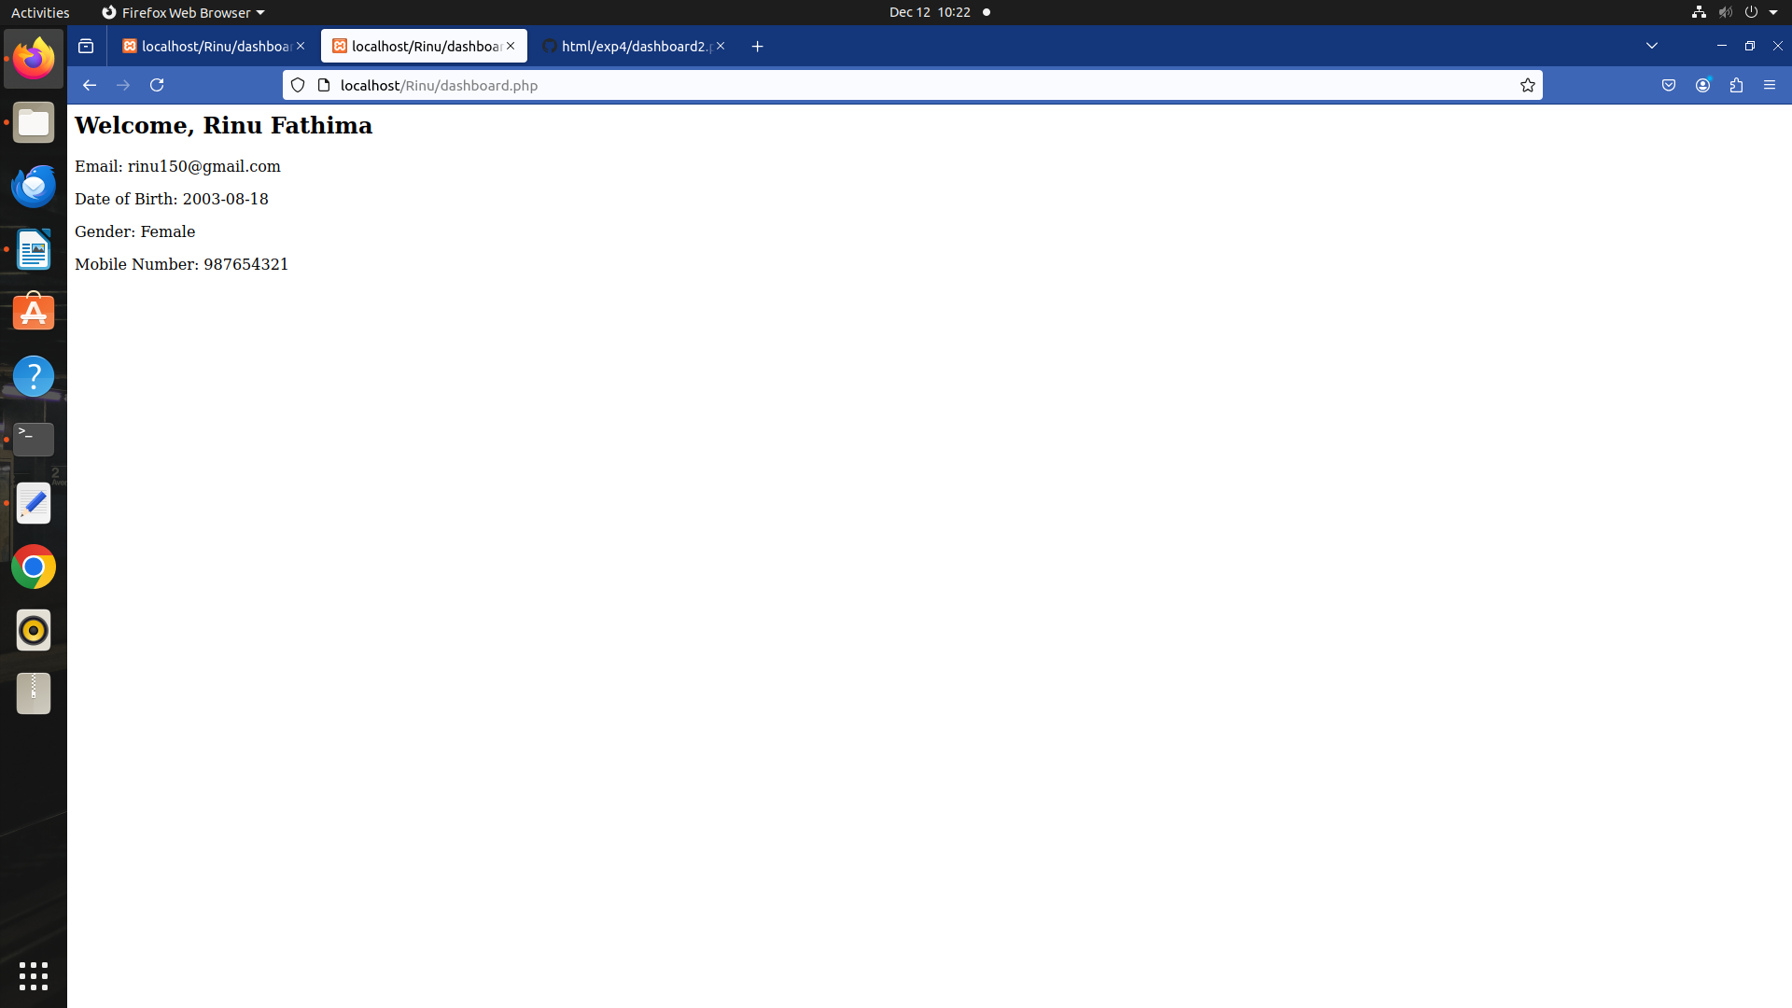

18.

database command:

create database studentdatabase;
use studentdatabase;
create table students(id int primary key auto_increment,first_name varchar(20), last_name varchar(20), email varchar(30), dob date, gender varchar(20), mobile_number varchar(10));

registration2.html

<html>
<head>

<title>Student Registration</title>
</head>
<body>
<h2>Register Student</h2>
<form method="POST" action="registration2.php">
<label for="first_name">First Name:</label><br>
<input type="text" id="first_name" name="first_name" required><br><br>

<label for="last_name">Last Name:</label><br>
<input type="text" id="last_name" name="last_name" required><br><br>

<label for="email">Email:</label><br>
<input type="email" id="email" name="email" required><br><br>

<label for="dob">Date of Birth:</label><br>
<input type="date" id="dob" name="dob" required><br><br>

<label>Gender:</label><br>
<input type="radio" id="male" name="gender" value="Male" required>
<label for="male">Male</label><br>
<input type="radio" id="female" name="gender" value="Female" required>
<label for="female">Female</label><br><br>

<label for="mobile_number">Mobile Number:</label><br>
<input type="text" id="mobile_number" name="mobile_number" required><br><br>

<input type="submit" value="Register">
</form>
</body>
</html>

registration2.php

<?php
session_start();

$servername = "localhost";
$username = "root";
$password = "";
$dbname = "studentdatabase";

$conn = new mysqli($servername, $username, $password, $dbname);

if ($conn->connect_error) {
die("Connection failed: " . $conn->connect_error);
}

if ($_SERVER['REQUEST_METHOD'] == 'POST') {
$first_name = $_POST['first_name'];
$last_name = $_POST['last_name'];
$email = $_POST['email'];
$dob = $_POST['dob'];
$gender = $_POST['gender'];
$mobile_number = $_POST['mobile_number'];

$sql = "INSERT INTO students (first_name, last_name, email, dob, gender, mobile_number)
VALUES ('$first_name', '$last_name', '$email', '$dob', '$gender', '$mobile_number')";

if ($conn->query($sql) === TRUE) {

header("Location: login2.php");
exit();
} else {
echo "Error: " . $conn->error;
}

$conn->close();
}
?>

login2.php

<?php
session_start();

$servername = "localhost";
$username = "root";
$password = "";
$dbname = "studentdatabase";

$conn = new mysqli($servername, $username, $password, $dbname);

if ($conn->connect_error) {
die("Connection failed: " . $conn->connect_error);
}

if ($_SERVER['REQUEST_METHOD'] == 'POST') {
$email = $_POST['email'];

$sql = "SELECT * FROM students WHERE email = '$email'";
$result = $conn->query($sql);

if ($result->num_rows > 0) {
// Get the user's details from the database
$row = $result->fetch_assoc();

$_SESSION['student_id'] = $row['id'];
$_SESSION['first_name'] = $row['first_name'];
$_SESSION['last_name'] = $row['last_name'];

header("Location: dashboard2.php");
exit();
} else {
echo "No user found with that email.";
}

$conn->close();
}
?>

<html>
<head>

<title>Student Login</title>
</head>
<body>
<h2>Login</h2>
<form method="POST" action="login2.php">
<label for="email">Email:</label><br>
<input type="email" id="email" name="email" required><br><br>

<input type="submit" value="Login">
</form>
</body>
</html>

dashboard2.php

<?php
session_start();

if (!isset($_SESSION['student_id'])) {
echo "Please log in to view your information.";
exit();
}

$servername = "localhost";
$username = "root";
$password = "";
$dbname = "studentdatabase";

$conn = new mysqli($servername, $username, $password, $dbname);

if ($conn->connect_error) {
die("Connection failed: " . $conn->connect_error);
}

$student_id = $_SESSION['student_id'];
$sql = "SELECT * FROM students WHERE id = '$student_id'";
$result = $conn->query($sql);

if ($result->num_rows > 0) {
$row = $result->fetch_assoc();
echo "<h2>Welcome, " . $row['first_name'] . " " . $row['last_name'] . "</h2>";
echo "<p>Email: " . $row['email'] . "</p>";
echo "<p>Date of Birth: " . $row['dob'] . "</p>";
echo "<p>Gender: " . $row['gender'] . "</p>";
echo "<p>Mobile Number: " . $row['mobile_number'] . "</p>";
} else {
echo "No user found.";
}

$conn->close();
?>

Ouput:
