CYCLE-7

Experiment-1

Aim:

Write a Python program to read a file line by line and store it into a list.

Program Code:

experiment1.py

def read_file_to_list(filename):
with open(filename, 'r') as file:
lines = [line.strip() for line in file]
return lines

filename = 'example.txt'
lines_list = read_file_to_list(filename)
print(lines_list)

example.txt

Hello, world!
This is a test.
Python is fun.

Output:

Experiment-2

Aim:

Python program to copy odd lines of one file to other

Program Code:

experiment2.py

def copy_odd_lines(source_file, destination_file):
with open(source_file, 'r') as src:
lines = src.readlines()

with open(destination_file, 'w') as dest:
for i in range(0, len(lines), 2):
dest.write(lines[i])

source = "sample.txt"
destination = "odd_lines.txt"
copy_odd_lines(source, destination)
print("Odd lines have been copied.")

sample.txt

Hello, this is the first line.
This is the second line.
Here comes the third line.
And finally, the fourth line.

Output:

Experiment-3

Aim:
Write a Python program to read each row from a given csv file and print a
list of strings.

Program Code:

experiment3.py

import csv

def read_csv_file(filename):
with open(filename, mode='r', newline='') as file:
reader = csv.reader(file)
for row in reader:
print(row)

csv_filename = "example.csv"
read_csv_file(csv_filename)

example.csv

Hello, this is the first line.
This is the second line.
Here comes the third line.
And finally, the fourth line.

Output:

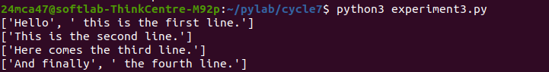

Experiment-4

Aim:

Write a Python program to read specific columns of a given CSV file and
print the content of the columns

Program Code:

experiment4.py

import csv

def read_specific_columns(filename, columns):
with open(filename, mode='r', newline='') as file:
reader = csv.reader(file)
for row in reader:
selected_columns = [row[i] for i in columns]
print(selected_columns)

csv_filename = "data.csv"
columns_to_read = [0, 2]
read_specific_columns(csv_filename, columns_to_read)

data.csv

Name, Age, City
John, 28, New York
Anna, 22, London
Peter, 34, Berlin
Maria, 25, Madrid
David, 30, Paris

Output:

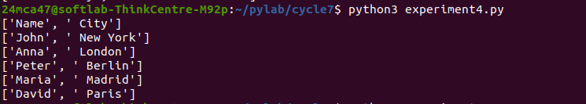

Experiment-5

Aim:

Write a Python program to write a Python dictionary to a csv file. After
writing the CSV file, read the CSV file and display the content.

Program Code:

import csv

def write_dict_to_csv(filename, data):
with open(filename, mode='w', newline='') as file:
writer = csv.DictWriter(file, fieldnames=data[0].keys())
writer.writeheader()
writer.writerows(data)

def read_csv_file(filename):
with open(filename, mode='r', newline='') as file:
reader = csv.DictReader(file)
for row in reader:
print(row)

dict_data = [
{'Name': 'John', 'Age': 28, 'City': 'New York'},
{'Name': 'Anna', 'Age': 22, 'City': 'London'},
{'Name': 'Peter', 'Age': 34, 'City': 'Berlin'}
]

csv_filename = "output.csv"
write_dict_to_csv(csv_filename, dict_data)
print("CSV file content:")
read_csv_file(csv_filename)

Output:

