CYCLE-6

Experiment-1

Aim:

Define a class to represent a bank account. Include the following details like name of the depositor, account number, type of account, balance amount in the account. Write methods to assign initial values, to deposit an amount, withdraw an amount after checking the balance, to display details such as name, account number, account type and balance.

Program Code:

class BankAccount:
def __init__(self, name, account_number, account_type, balance):
self.name = name
self.account_number = account_number
self.account_type = account_type
self.balance = balance

def deposit(self, amount):
"""Method to deposit an amount into the account."""
if amount > 0:
self.balance += amount
print(f"Deposited {amount}. New balance is {self.balance}.")
else:
print("Deposit amount must be positive.")

def withdraw(self, amount):
"""Method to withdraw an amount from the account."""
if amount <= 0:
print("Withdrawal amount must be positive.")
elif amount > self.balance:
print("Insufficient balance.")
else:
self.balance -= amount
print(f"Withdrew {amount}. New balance is {self.balance}.")

def display_details(self):
"""Method to display account details."""
print(f"\nAccount Holder: {self.name}")
print(f"Account Number: {self.account_number}")
print(f"Account Type: {self.account_type}")
print(f"Balance: {self.balance}")

print("Enter account details to create a new account:")

name = input("Enter account holder name: ")
account_number = input("Enter account number: ")
account_type = input("Enter account type (e.g., Savings, Current): ")
balance = float(input("Enter initial balance: "))

account1 = BankAccount(name, account_number, account_type, balance)

account1.display_details()

while True:
print("\nChoose an operation:")
print("1. Deposit")
print("2. Withdraw")
print("3. Display Account Details")
print("4. Exit")

choice = input("Enter your choice (1/2/3/4): ")

if choice == "1":
deposit_amount = float(input("Enter deposit amount: "))
account1.deposit(deposit_amount)
elif choice == "2":
withdraw_amount = float(input("Enter withdrawal amount: "))
account1.withdraw(withdraw_amount)
elif choice == "3":
account1.display_details()
elif choice == "4":
print("Exiting the program.")
break
else:
print("Invalid choice. Please try again.")

Output:

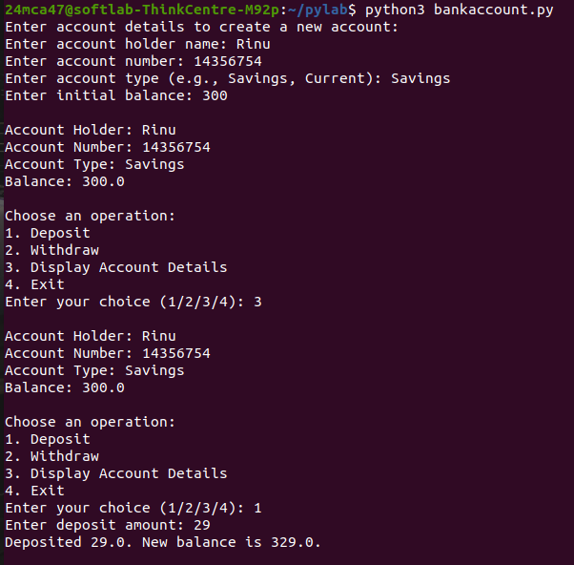

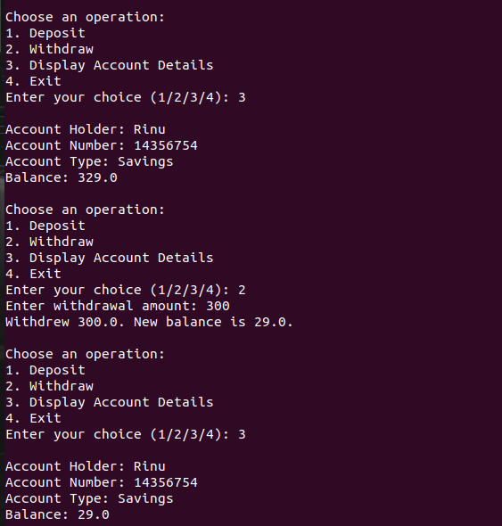

Experiment-2

Aim:

Create a class Publisher with attributes publisher id and publisher name. Derive class Book from Publisher with attributes title and author.
Derive class Python from Book with attributes price and no_of_pages. Write a program that displays information about a Python book. Use base class constructor invocation and method
overriding

Program Code:

class Publisher:
def __init__(self, publisher_id, publisher_name):
self.publisher_id = publisher_id
self.publisher_name = publisher_name

def display_publisher(self):
print(f"Publisher ID: {self.publisher_id}")
print(f"Publisher Name: {self.publisher_name}")

class Book(Publisher):
def __init__(self, publisher_id, publisher_name, title, author):

super().__init__(publisher_id, publisher_name)
self.title = title
self.author = author

def display_book(self):
print(f"Title: {self.title}")
print(f"Author: {self.author}")

class Python(Book):
def __init__(self, publisher_id, publisher_name, title, author, price, no_of_pages):
super().__init__(publisher_id, publisher_name, title, author)
self.price = price
self.no_of_pages = no_of_pages

def display_python_book(self):
print(f"Price: {self.price}")
print(f"Number of Pages: {self.no_of_pages}")

if __name__ == "__main__":
publisher_id = input("Enter Publisher ID: ")
publisher_name = input("Enter Publisher Name: ")
title = input("Enter Book Title: ")
author = input("Enter Author Name: ")
price = float(input("Enter Book Price: "))
no_of_pages = int(input("Enter Number of Pages: "))

python_book = Python(publisher_id, publisher_name, title, author, price, no_of_pages)
python_book.display_publisher()
python_book.display_book()
python_book.display_python_book()

Output:

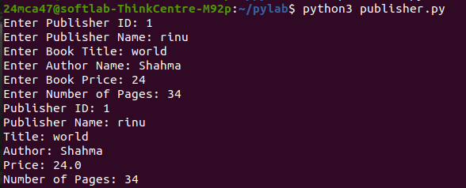

Experiment-3

Aim:

Write a program that has an abstract class Polygon. Derive two classes Rectangle and Triangle from Polygon and write methods to get the details of their dimensions and hence
calculate the area.

Program Code:

from abc import ABC, abstractmethod

class Polygon(ABC):
@abstractmethod
def get_dimensions(self):
pass

@abstractmethod
def calculate_area(self):
pass

class Rectangle(Polygon):
def __init__(self):
self.length = 0
self.width = 0

def get_dimensions(self):
self.length = float(input("Enter the length of the rectangle: "))
self.width = float(input("Enter the width of the rectangle: "))

def calculate_area(self):
area = self.length * self.width
return area

class Triangle(Polygon):
def __init__(self):
self.base = 0
self.height = 0

def get_dimensions(self):
self.base = float(input("Enter the base of the triangle: "))
self.height = float(input("Enter the height of the triangle: "))

def calculate_area(self):
area = 0.5 * self.base * self.height
return area

if __name__ == "__main__":
print("Choose a polygon to calculate area:")
print("1. Rectangle")
print("2. Triangle")
choice = input("Enter your choice (1/2): ")

if choice == "1":
rectangle = Rectangle()
rectangle.get_dimensions()
area = rectangle.calculate_area()
print(f"The area of the rectangle is: {area}")

elif choice == "2":
triangle = Triangle()
triangle.get_dimensions()
area = triangle.calculate_area()
print(f"The area of the triangle is: {area}")

else:
print("Invalid choice. Please select either 1 or 2.")

Output:

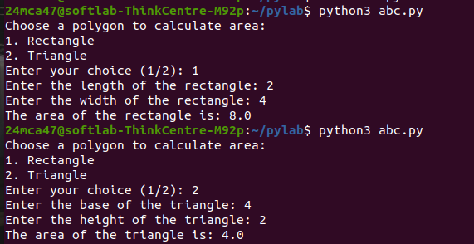

Experiment-4

Aim:

Create a Rectangle class with attributes length and breadth and methods to find area and perimeter. Compare two Rectangle objects by their area.

Program Code:

class Rectangle:
def __init__(self, length, breadth):
self.length = length
self.breadth = breadth

def area(self):
"""Method to calculate the area of the rectangle."""
return self.length * self.breadth

def perimeter(self):
"""Method to calculate the perimeter of the rectangle."""
return 2 * (self.length + self.breadth)

if __name__ == "__main__":
print("Enter the dimensions for Rectangle 1:")
length1 = float(input("Enter the length of the rectangle: "))
breadth1 = float(input("Enter the breadth of the rectangle: "))
rect1 = Rectangle(length1, breadth1)
print("\nEnter the dimensions for Rectangle 2:")
length2 = float(input("Enter the length of the rectangle: "))
breadth2 = float(input("Enter the breadth of the rectangle: "))
rect2 = Rectangle(length2, breadth2)
print(f"\nRectangle 1 - Area: {rect1.area()} | Perimeter: {rect1.perimeter()}")
print(f"Rectangle 2 - Area: {rect2.area()} | Perimeter: {rect2.perimeter()}")
area1 = rect1.area()
area2 = rect2.area()

if area1 < area2:
print("\nRectangle 1 has a smaller area than Rectangle 2.")
elif area1 == area2:
print("\nRectangle 1 and Rectangle 2 have the same area.")
else:
print("\nRectangle 1 has a larger area than Rectangle 2.")

Output:

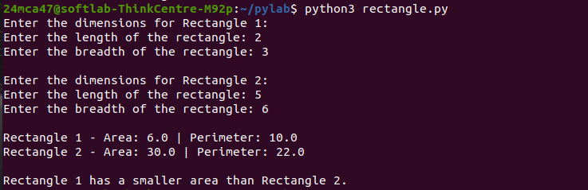

Experiment-5

Aim:

Create a class Time with private attributes hour, minute and second. Overload ‘+’ operator to find sum of 2 times.

Program Code:

class Time:
def __init__(self, hour=0, minute=0, second=0):
self.__hour = hour
self.__minute = minute
self.__second = second
def display_time(self):
print(f"{self.__hour:02}:{self.__minute:02}:{self.__second:02}")

def add_times(self, other):
total_seconds = self.__second + other.__second
total_minutes = self.__minute + other.__minute + total_seconds // 60
total_hours = self.__hour + other.__hour + total_minutes // 60
total_seconds = total_seconds % 60
total_minutes = total_minutes % 60
total_hours = total_hours % 24
return Time(total_hours, total_minutes, total_seconds)

def get_time_input():
hour = int(input("Enter hour (0-23): "))
minute = int(input("Enter minute (0-59): "))
second = int(input("Enter second (0-59): "))
return Time(hour, minute, second)

print("Enter the first time:")
time1 = get_time_input()

print("Enter the second time:")
time2 = get_time_input()

time3 = time1.add_times(time2)

print("The sum of the two times is:")
time3.display_time()

Output:

