**CT20141333394**

[**rinumichael94@gmail.com**](mailto:rinumichael94@gmail.com)

**Solution 1:**

**package** com;

**public** **class** StudentDemo {

**public** **static** **void** main(String[] args) {

// **TODO** Auto-generated method stub

Student one=**new** Student(1,"ravi",45);

Student two=**new** Student(2,"roy",50);

Student three=**new** Student(3,"raj",55);

System.*out*.println("Student with highest mark is "+ *compareStudents*(one,two,three));

}

**public** **static** String compareStudents(Student one, Student two, Student three)

{

Student st=one;

**if**(two.getMarks()>st.getMarks())

st=two;

**if**(three.getMarks()>st.getMarks())

st=three;

**return** st.getName();

}

}

**class** Student

{

**private** **int** rollNo;

**private** String name;

**private** **double** marks;

**public** Student(**int** rollNo, String name,**double** marks)

{

**this**.rollNo=rollNo;

**this**.name=name;

**this**.marks=marks;

}

**public** **int** getRollNo() {

**return** rollNo;

}

**public** String getName() {

**return** name;

}

**public** **double** getMarks() {

**return** marks;

}

**public** **void** setRollNo(**int** rollNo) {

**this**.rollNo = rollNo;

}

**public** **void** setName(String name) {

**this**.name = name;

}

**public** **void** setMarks(**double** marks) {

**this**.marks = marks;

}

}

**OUTPUT**

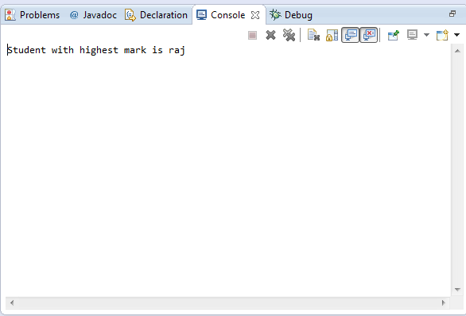

**Solution 2:**

**package** com;

**public** **class** ToyDemo {

**public** **static** String *c*;

**public** **static** **void** main(String[] args)

{

// **TODO** Auto-generated method stub

Toy a= **new** Toy ("apple","fruits",40,10);

Toy b=**new** Toy("banana","fruits",50,10);

Toy t=**new** Toy("tiger","animals",450,10);

Toy m= **new** Toy("monkey","animals",500,10);

System.*out*.println("the least priced toy is ="+ *getLeastPriceToy*(a,b,t,m,"animals"));

}

**public** **static** String getLeastPriceToy(Toy a,Toy b,Toy t, Toy m, String c)

{

**if**(c.equals("fruits"))

{

a.setDiscount(10);

b.setDiscount(10);

Toy lt=a;

**if**(lt.getPrice()-lt.getPrice()*lt.getDiscount()/100 > b.getPrice()-b.getPrice()*b.getDiscount()/100)

lt=b;

**return** lt.getName();

}

**else** **if**(c.equals("animals"))

{

t.setDiscount(20);

m.setDiscount(20);

Toy lt=t;

**if**(lt.getPrice()-lt.getPrice()*lt.getDiscount()/100 > m.getPrice()-m.getPrice()*m.getDiscount()/100)

lt=m;

**return** lt.getName();

}

**else**

{

**return** ("no specific category");

}

}

}

**class** Toy

{

**private** String name;

**private** String category;

**private** **double** price;

**private** **double** discount;

**public** Toy(String name, String category,**double** price,**double** discount)

{

**this**.name=name;

**this**.category=category;

**this**.price=price;

**this**.discount=discount;

}

**public** String getName() {

**return** name;

}

**public** String getCategory() {

**return** category;

}

**public** **double** getPrice() {

**return** price;

}

**public** **void** setPrice(**double** price) {

**this**.price = price;

}

**public** **double** getDiscount() {

**return** discount;

}

**public** **void** setDiscount(**double** discount) {

**this**.discount = discount;

}

}

OUTPUT

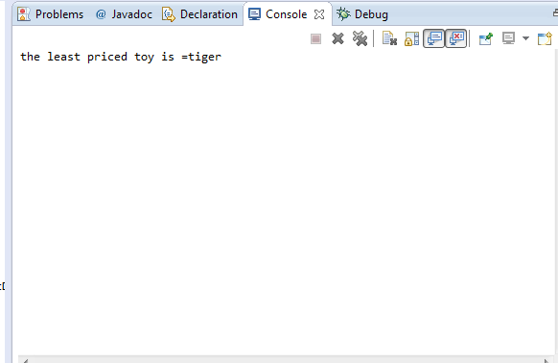

**Solution3:**

**package** com;

**public** **class** CarDemo

{

**public** **static** String *v*;

**public** **static** **void** main(String[] args)

{

// **TODO** Auto-generated method stub

Car a=**new** Car("Hyundai","Santro",5,600000.00);

Car b=**new** Car("Maruthi","Alto",4,450000.00);

Car d=**new** Car("Toyota","Innova",7,100000.00);

Car e=**new** Car("Volksvagen","Beetle",2,300000.00);

System.*out*.println(*getBestCar*(a,b,d,e,"c"));

}

**public** **static** String getBestCar(Car a,Car b,Car d,Car e,String ct)

{

**if**(ct.equals("c"))

{

Car ht=a;

**if**(ht.getPassengerCapacity() < b.getPassengerCapacity())

ht=b;

**if**(ht.getPassengerCapacity() < d.getPassengerCapacity())

ht=d;

**if**(ht.getPassengerCapacity() < e.getPassengerCapacity())

ht=e;

*v*=ht.getMake()+"-"+ht.getModel();

**return** *v*;

}

**else** **if**(ct.equals("p"))

{

Car lt=a;

**if**(lt.getOnRoadPrice() < b.getOnRoadPrice())

lt=b;

**if**(lt.getOnRoadPrice() < d.getOnRoadPrice())

lt=d;

**if**(lt.getOnRoadPrice() < e.getOnRoadPrice())

lt=e;

*v*=lt.getMake()+"-"+lt.getModel();

**return** *v*;

}

**else**

**return** "invalid";

}

}

**class** Car

{

**private** String make;

**private** String model;

**private** **int** passengerCapacity;

**private** **double** onRoadPrice;

**public** Car(String make,String model,**int** passengerCapacity,**double** onRoadPrice)

{

**this**.make=make;

**this**.model=model;

**this**.passengerCapacity=passengerCapacity;

**this**.onRoadPrice=onRoadPrice;

}

**public** **int** getPassengerCapacity() {

**return** passengerCapacity;

}

**public** **void** setPassengerCapacity(**int** passengerCapacity) {

**this**.passengerCapacity = passengerCapacity;

}

**public** **double** getOnRoadPrice() {

**return** onRoadPrice;

}

**public** **void** setOnRoadPrice(**double** onRoadPrice) {

**this**.onRoadPrice = onRoadPrice;

}

**public** String getMake() {

**return** make;

}

**public** String getModel() {

**return** model;

}

}

**OUTPUT**

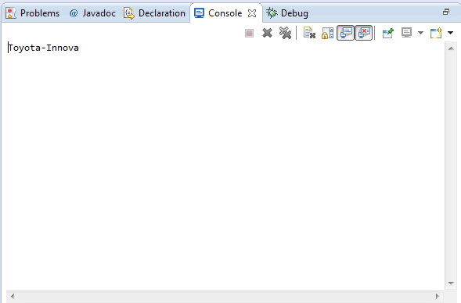

**Solution 4:**

**package** com;

**public** **class** CreditCardDemo

{

**public** **static** **void** main(String[] args)

{

// **TODO** Auto-generated method stub

Customer one=**new** Customer(1,01,400);

Customer two=**new** Customer(2,02,1400);

Customer three=**new** Customer(3,03,2000);

Customer four=**new** Customer(4,04,2600);

Customer five=**new** Customer(5,05,1000);

CreditCardCompany ccc=**new** CreditCardCompany();

System.*out*.println("payback amount for customer one is "+ ccc.getPybackAmount(one));

System.*out*.println("payback amount for customer two is "+ ccc.getPybackAmount(two));

System.*out*.println("payback amount for customer three is "+ ccc.getPybackAmount(three));

System.*out*.println("payback amount for customer four is "+ ccc.getPybackAmount(four));

System.*out*.println("payback amount for customer five is "+ ccc.getPybackAmount(five));

}

}

**class** Customer

{

**private** **int** custId;

**private** **int** accId;

**private** **double** creditCardCharges;

**public** Customer(**int** custId,**int** accId,**double** creditCardCharges)

{

**this**.custId=custId;

**this**.accId=accId;

**this**.creditCardCharges=creditCardCharges;

}

**public** **int** getCustId() {

**return** custId;

}

**public** **int** getAccId() {

**return** accId;

}

**public** **double** getCreditCardCharges() {

**return** creditCardCharges;

}

**public** **void** setCreditCardCharges(**double** creditCardCharges) {

**this**.creditCardCharges = creditCardCharges;

}

}

**class** CreditCardCompany

{

**public** **double** getPybackAmount(Customer g)

{

**if**(g.getCreditCardCharges() < 500)

**return** 0.25*g.getCreditCardCharges()/100;

**else** **if**(500 < g.getCreditCardCharges() && g.getCreditCardCharges() < 1500)

**return** (0.25*500/100)+(0.5*(g.getCreditCardCharges()-500)/100);

**else** **if**(1500 < g.getCreditCardCharges() && g.getCreditCardCharges() < 2500)

**return** (0.25*500/100)+(0.5*1000/100)+(0.75*(g.getCreditCardCharges()-1500)/100);

**else** **if**(g.getCreditCardCharges() > 2500)

**return** (0.25*500/100)+(0.5*1000/100)+(0.75*1000/100)+(g.getCreditCardCharges()-2500)/100;

**else**

**return** 0.00;

}

}

OUTPUT

