JENKINS GUIDE

# Please follow the below steps to install Jenkins

1. Download the Jenkins war file

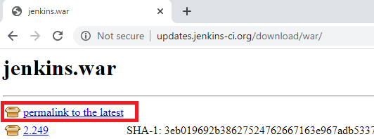

1. Place the Jenkins war file in the separate directory.
2. Open the CMD window and enter the below command

**Java -jar Jenkins.war**

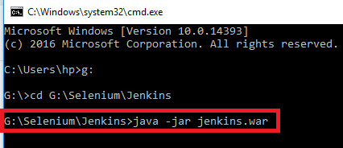

It will download all the necessary file and generate secrete password

1. Go to the browser and enter <http://localhost:8080/> and choose suggested plugins and give all your credentials.
2. Restart Jenkins
3. Sign in Jenkins by entering the **username** and **password**.

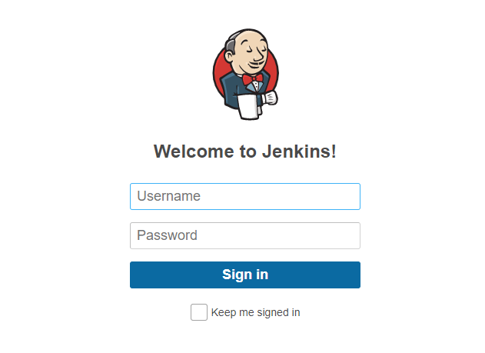

# Create Job in Jenkins

1. Click the **New Item** in Jenkins home page

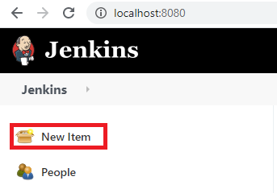

1. Enter the **Project Name** in the below filed and choose **Maven Project** and then click ok

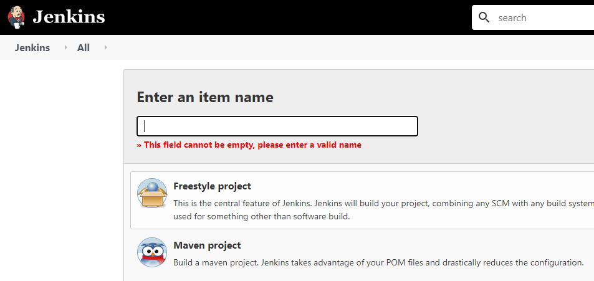

1. Enter the **Description Details** of the project

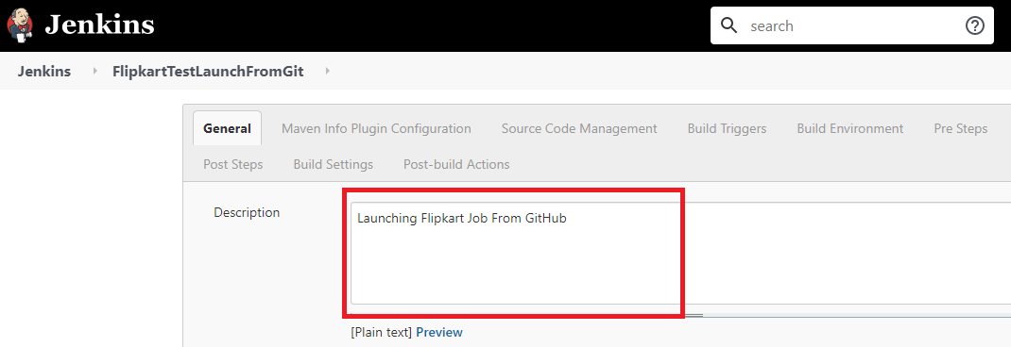

1. Choose **Git** and give the repository **URL**

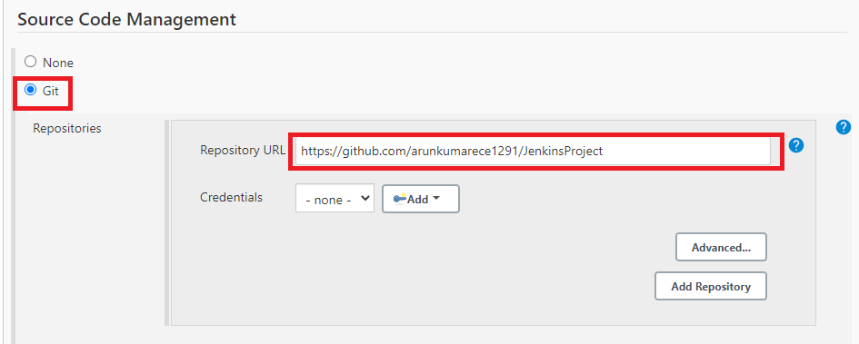

1. Since this is a maven project, enter root pom as **pom.xml** and set the goal as **clean install**

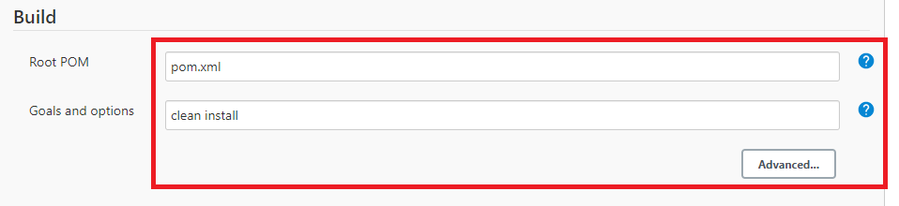

**Post Build Actions**

1. This is to generate to **Extent Report**

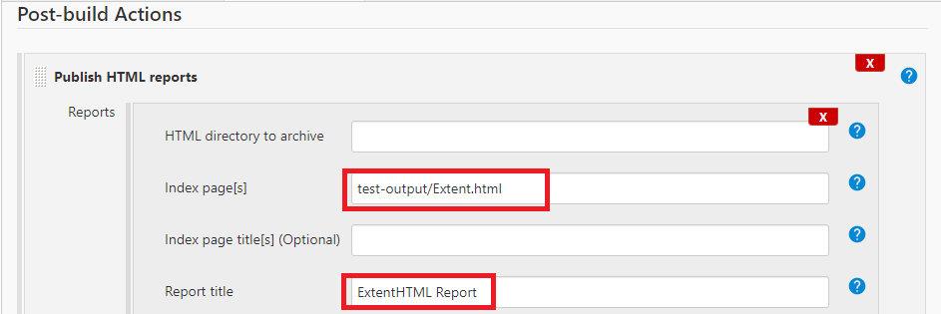

1. This is to generate **TestNG Report**

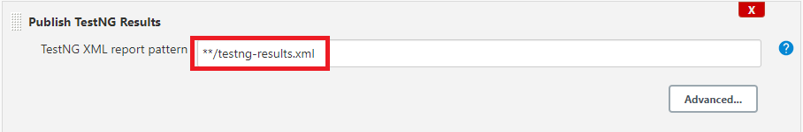

1. Now click **Apply** and **Save**

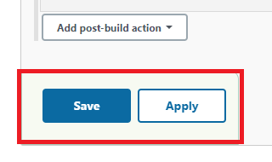

1. Now **trigger the Build**

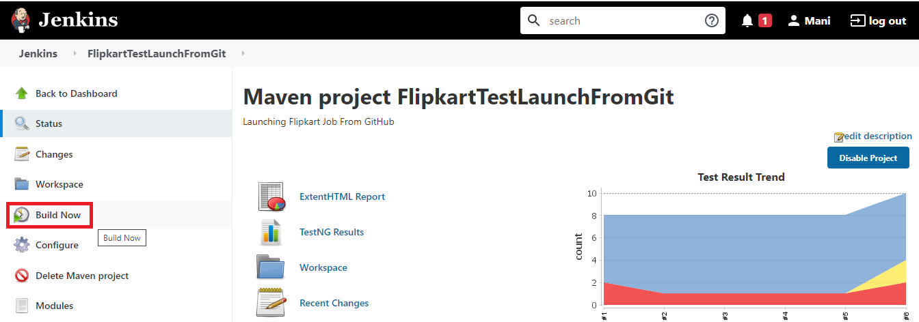

1. Click the icon to see the **Console Out**

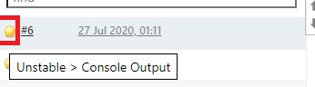

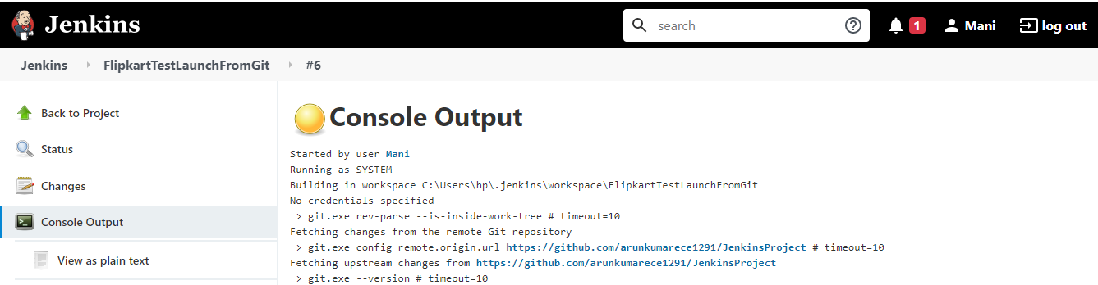

1. **TestNG Result**

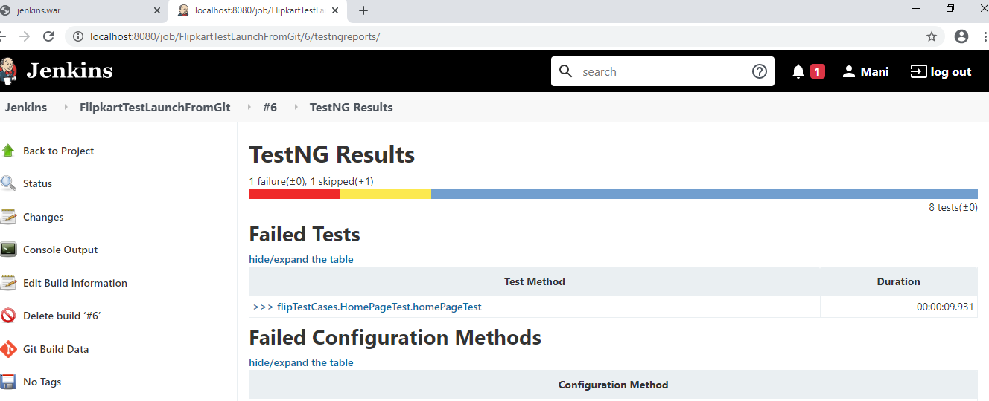

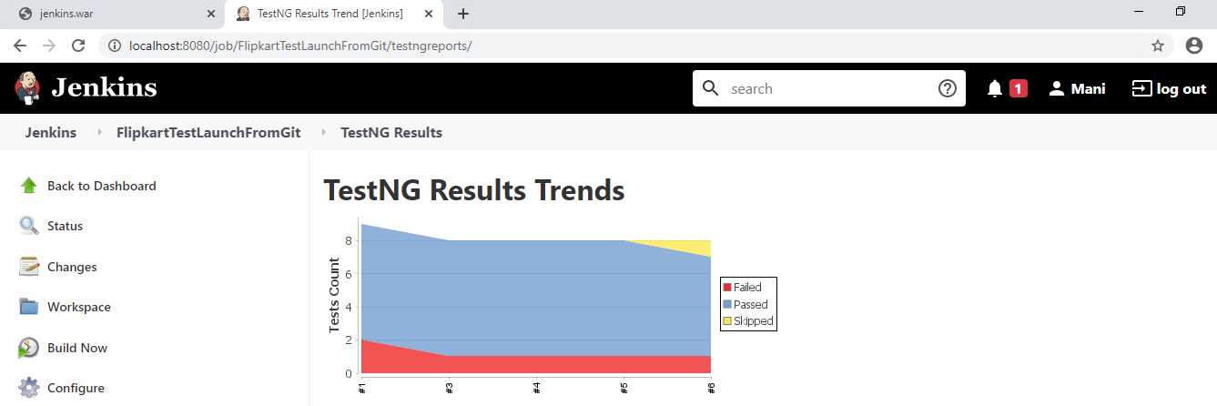

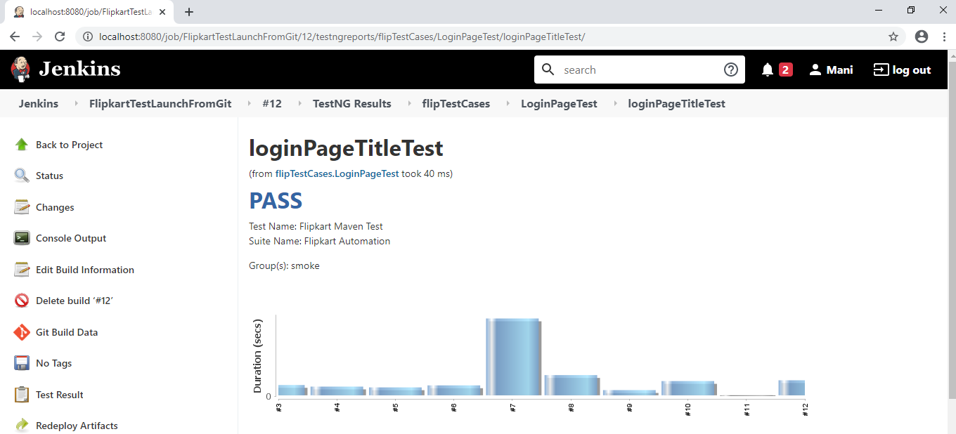

1. **Extent Report**

