Multiple Processes in C

In order to complete this lab, you have to use SSH tool to connect the server courses.brockport.edu. A portable version of Putty is https://the.earth.li/~sgtatham/putty/latest/w32/putty.exe

Create a folder under your login directory named csc414. For each lab, please create a separate folder to store the code.
- Parameter passing is one of important concepts in C/C++. Two techniques are involved in parameter passing: call by value and call by reference.
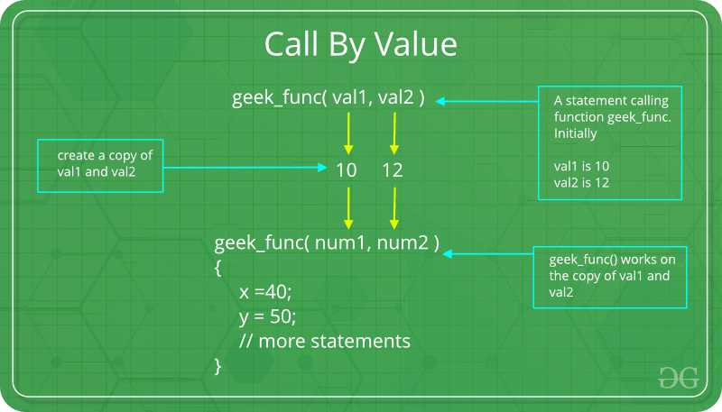
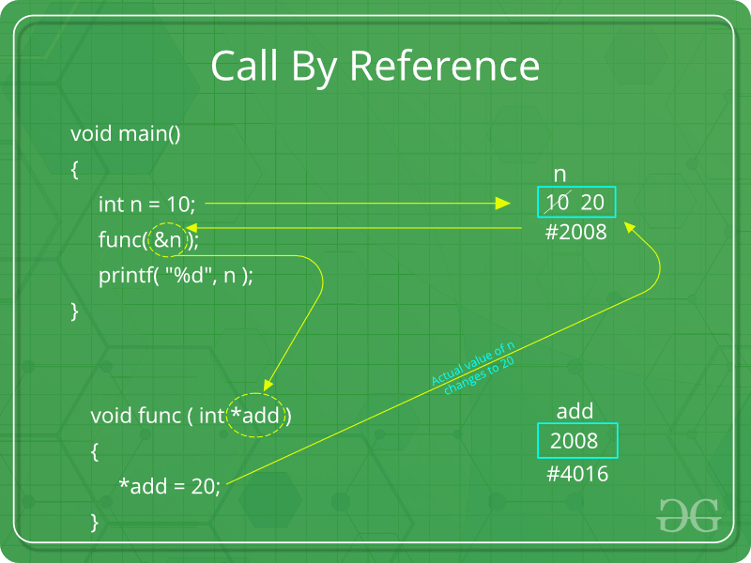
The subsequent code is about to swap value between two variables via passing parameters. Copy the below code to a file named pointer.c. Compile the code by using gcc pointer.c –o POINTER. You can run the program by type ./POINTER. There are some errors in the code. After using a similar idea as the above example, please correct them so that the program should be able to swap the values. Paste the screenshot of the corrected code and explain why.

#include <stdio.h>
int main (int argc, char *argv[])
{
void swap (int, int);
int a, b;

char str1 ="Please enter two integers: ";
printf ("%s", str1);
scanf ("%d %d", &a, &b);

swap (a, b);

printf ("a = %d b = %d\n", a, b);
return 0;
}

void swap (int x, int y)
{
int temp;
temp = x; x = y; y = temp;
return;
}

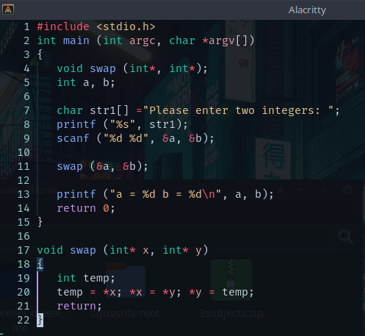

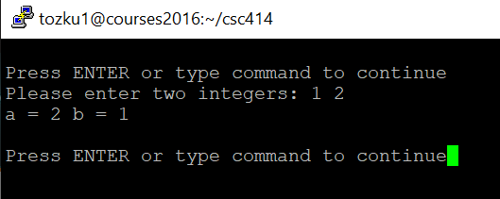

Strings in c are arrays of chars. To pass a variable by reference insert & in between var type and var name. In function declarations insert * in same location as &.
- Create a file named hellofork.c using the following code. Compile and run the below code and answer the following questions. Hint: gcc hellofork.c –o hellofork
- How many times is “Hello World!” printed? (2) Why? Give the explanation on your answer.

#include <stdio.h>
#include <unistd.h>
int main (int argc, char *argv[])
{
fork();
fork();
fork();
printf ("Hello World! My pid = %d and My parent pid = %d\n",
getpid(), getppid());
wait();
return 0;
}

The statement is printed 8 times because there are three forks. At each fork another fork is being done. Since there are 3 forks with 2 outcomes each time there are 2^8 processes and statements printed.

- Compile the below code and create an executable file named displayPID. Please (1) paste the screenshot to show the output, and (2) explain why this program can get those PIDs. Hint: What are stored in PCB?
/*
Program to illustrate UNIX
system calls getpid and getppid
*/

#include <stdio.h>
#include <sys/types.h>
#include <unistd.h>

int main(int argc, char *argv[])
{
pid_t mypid, parentpid;

mypid = getpid();
parentpid = getppid();
printf("Hi! I am a simple process. In this birth,\n");
printf("My pid is %d\n", mypid);
printf("My parent's pid is %d\n", parentpid);
printf("I will terminate when you press Enter key\n");
getchar();
return 0;
}

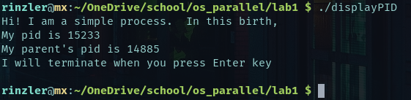
Each process has a PCB associated with it which is a data structure storing information related to that process. The process pid and parent pid is stored in the PCB.
- Compile and run the below program. (1) Describe what the output is. Paste a screenshot to show the output. (2) Explain how the code works.

/*
Program to illustrate UNIX system calls
fork, exec, wait, getpid, and getppid
*/

#include <stdio.h>
#include <stdlib.h>
#include <sys/types.h>
#include <unistd.h>

int main(int argc, char *argv[])
{
pid_t childpid, mypid;

mypid = getpid();
printf("Hi! I am a process about to fork\n");
printf("My pid is %d\n", mypid);
printf("I will proceed when you press Enter key\n");
getchar();

childpid = fork();

if (childpid == -1) {
printf("Error in fork; program terminated\n");
exit (-1);
}

if (childpid == 0) {
/* This code is exceuted only be the child */
execlp("./displayPID", "displayPID", (char *) NULL);
}
else {
/* This code is executed only by the parent */
int status;
/* Wait for the child to terminate */
wait(&status);
mypid = getpid();
printf("Hi! I am the parent process after fork\n");
printf("My pid is %d\n", mypid);
printf("My child had pid %d\n", childpid);
}
return 0;
}
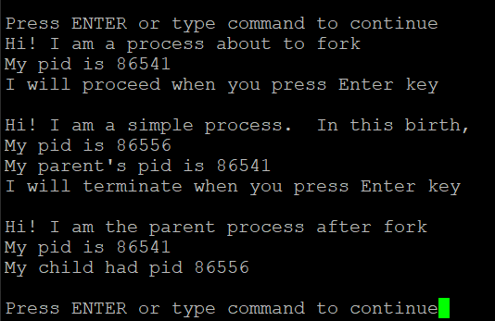
The parent process pid is stored in mypid by calling getpid(). It’s pid is printed. Then the childpid is set by calling fork(). Once forked and in the child process, it executes the displayPID executable we created earlier. Once the child process is finished, for that whole time the parent process has been waiting by calling wait() which holds the return value of the child process. The child pid and parent pid is printed.

- The exec() family of system calls replaces the current process image with a new process image. There are several functions – execl, execlp, execle, execv, execvp, and execvpe. Function prototype for execlp is
int execlp(const char *path, const char *arg, .. (char *) NULL);
Here are the descriptions for the family functions:
https://manpages.ubuntu.com/manpages/xenial/man3/exec.3.html
https://www.ibm.com/docs/en/aix/7.1?topic=e-exec-execl-execle-execlp-execv-execve-execvp-exect-fexecve-subroutine
The first argument provides the path to the new executable; if only a file name is provided the PATH environment variable is used to search for the executable. The subsequent arguments are passed as command line arguments to the new executable. The systems call returns only if an error has occurred, in which case the return value is -1.
Please answer: (1) Does the printf statement that follows the invocation of “execlp” print out anything? Try it and observe what happens. Paste the screenshot to show the output. (2) Explain why?

#include <stdio.h>
#include <unistd.h>
int main (int argc, char *argv[])
{
printf ("This will execute ls command\n");
printf ("Press Enter key to proceed\n");
getchar();
execlp ("/bin/ls", "ls", "-l", (char *) NULL);
printf ("Successful completion of ls\n");
return 0;
}

The last print statement does not print because the current process is replaced with the ls command. Nothing after the execlp() is executed unless it returns an error (-1). Since there was no error in our ls command or search for the path no error is returned hence we are not returned back to our original process.
