In-Class Lab 2. Multiple Processes
Use SSH to courses.brockport.edu and create a folder named lab2 under the directory of ~/CSC414.
NOTE: Please highlight your answer.
- Create a .c file named fork_wait.c using the below code. Compile the file as fork_wait and run it.
- Please paste a screenshot to show the output.
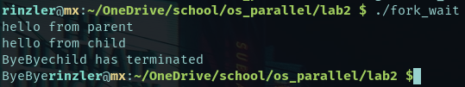

- Use a variable childpid in the main function to record the return value of fork(). Print out the childpid in the parent process and the child process respectively. What is the output? Please paste the screenshot.
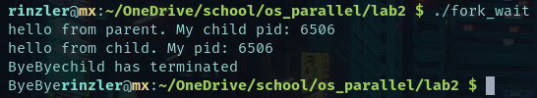

- Modify the code and print the childpid in printf("ByeBye") to show which process printed “ByeBye”. What is the output? Paste the screenshot.
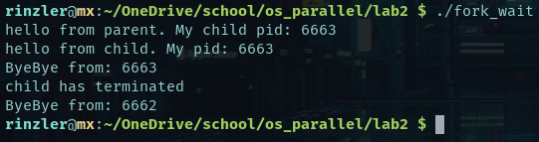

(4) Comment wait(NULL) and add sleep(10) in child process. Compile & run it. (A) Please show the output using a screenshot. (B) Please answer which process was “orphan” and what is the definition of an orphan process?
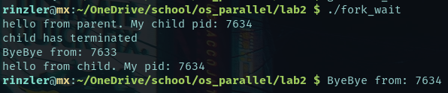
An orphan is a process that is still executing but whose parent has been terminated. This occurs when a parent is terminated without invoking wait(). The orphan in this case is pid: 7634.

#include<stdio.h>
#include<sys/wait.h>
#include<unistd.h>

int main()
{
if (fork()== 0) {
printf("hello from child\n");
}
else
{
printf("hello from parent\n");
wait(NULL);
printf("child has terminated\n");
}
printf("ByeBye");
return 0;
}

- Create a new file named wait_status.c using the below code. Compile it as wait_status and run the below code.
(1) What is the output (screenshot)? And explain why?
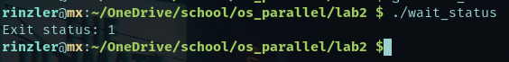
The child process returns 1 with exit(1) which the parent process is waiting to receive with wait(&stat). Then it matches the if expression so it prints.

(2) Change exit(1) to exit(1000)? Compile and run it. What is the output? Explain why?
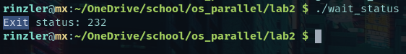
Wexitstatus() returns an 8 bit integer. 1000%256 = 232
#include<stdio.h>
#include<stdlib.h>
#include<sys/wait.h>
#include<unistd.h>

void waitexample()
{
int stat;
if (fork() == 0)
exit(1);
else
wait(&stat);
if (WIFEXITED(stat))
printf("Exit status: %d\n", WEXITSTATUS(stat));
else if (WIFSIGNALED(stat))
psignal(WTERMSIG(stat), "Exit signal");
}

int main()
{
waitexample();
return 0;
}

- In the system software development, most of the programs need to store the information. One such way is to store the fetched information in a file. There are several operations for file operations in C:
a. Creation of a new file (fopen with attributes as “a” or “a+” or “w” or “w++”)
b. Opening an existing file (fopen)
c. Reading from file (fscanf or fgets)
d. Writing to a file (fprintf or fputs)
e. Moving to a specific location in a file (fseek, rewind)
f. Closing a file (fclose)

Use the following code to create a file named writestring2file.c. Learn the code, compile, and run it. Paste the screenshot to show the output.
fopen function can be found:
https://www.tutorialspoint.com/c_standard_library/c_function_fopen.htm

- In the same way, please create a file named readfromfile.c. Learn the code, compile and run it. Paste the screenshot to show the output.
fgets function can be found here:
https://www.tutorialspoint.com/c_standard_library/c_function_fgets.htm

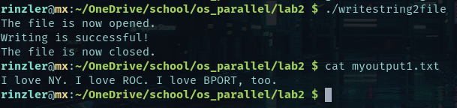

#include <stdio.h>
#include <string.h>

int main( )
{

// Declare the file pointer
FILE *filePointer ;
char fname[16] = "myoutput1.txt";

// Declare the variable for the data to be read from file
char dataToBeRead[50];

// Open the existing file myoutput1.txt using fopen()
// in read mode using "r" attribute
filePointer = fopen(fname, "r") ;

// Check if this filePointer is null
// which maybe if the file does not exist
if ( filePointer == NULL )
{
printf( "%s file failed to open.", fname ) ;
}
else
{
printf("The file is now opened.\n") ;

// Read the dataToBeRead from the file
// using fgets() method
while( fgets ( dataToBeRead, 50, filePointer ) != NULL )
{

// Print the dataToBeRead
printf( "%s" , dataToBeRead ) ;
}

// Closing the file using fclose()
fclose(filePointer) ;

printf("Reading from file %s is successful\n", fname);
printf("The file is now closed.") ;
}
return 0;
}

- Create a file named seekfile.c. Learn the code, compile and run it. Paste the screenshot to show the output.
fseek(FILE * stream, long int offset, int whence);
The first parameter stream is the pointer to the file. The second parameter is the position of the record to be found, and the third parameter specifies the location where the offset starts.
fseek function can be found more here:
https://www.tutorialspoint.com/c_standard_library/c_function_fseek.htm
fread function can be found here:
https://www.tutorialspoint.com/c_standard_library/c_function_fread.htm

First output:
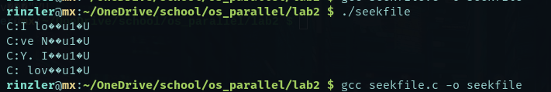
Revised output:
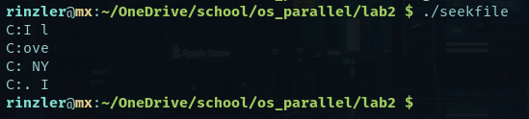
revised code below highlighted

#include <stdio.h>
#include <stdlib.h>

struct fourChar
{
char c[4];
};

int main()
{
int n;
struct fourChar myword;
FILE *fptr;

if ((fptr = fopen("myoutput1.txt","rb")) == NULL){
printf("Error! opening file");

// Program exits if the file pointer returns NULL.
exit(1);
}

// Moves the cursor to the beginning of the file
fseek(fptr, 0, SEEK_SET);

for(n = 1; n < 5; ++n)
{
//fread(&myword.c, sizeof(struct fourChar), 1, fptr);
fread(&myword.c, sizeof(struct fourChar) - 1, 1, fptr);
// sizeof(fourChar) – 1 to account for null terminator at end of read string
printf("C:%s\n", myword.c);
}
fclose(fptr);

return 0;
}

- Apply the knowledge you have learned in the previous lab. Create a .c file and compile it to an executable program named ForkRead. The program can create a new process and the new child process can successfully read a data file named regressor_data.txt and print out the file to the screen. The parent process should wait for the child process until the child’s task is done. Note that (1) you have to add the appropriate printout lines to (1) clearly indicate the IDs of processes and their role (parent or child) and (2) clearly show that parent waits child until child’s task is done.
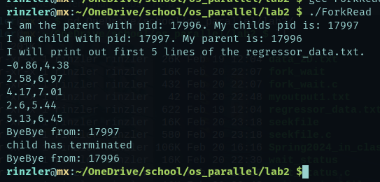
Please paste your code and show the screenshot of the output.

#include <stdio.h>
#include <stdlib.h>
#include <sys/wait.h>
#include <unistd.h>

int main() {
pid_t childpid = fork();

if(childpid == 0) {
FILE* file_ptr;
char input_file[] = "regressor_data.txt";
char string[100];

printf("I am child with pid: %d. My parent is: %d\n", getpid(), getppid());
printf("I will print out first 5 lines of the %s.\n", input_file);

if((file_ptr = fopen(input_file, "r")) == NULL) {
printf("cant open file %s", input_file);
exit(1);
}

int count = 0;
while(count < 5) {
fgets(string, sizeof(string), file_ptr);
printf("%s", string);
count++;
}

fclose(file_ptr);
}
else {
printf("I am the parent with pid: %d. My childs pid is: %d\n", getpid(), childpid);
wait(NULL);
printf("child has terminated\n");
}

printf("ByeBye from: %d\n", getpid());

return 0;
}

- Based on the previous code, please generate a new executable program named ForkExecSeekReadWrite. The program adopts fork() function to create a new child process. The child process should be able to execlp an independently compiled executable file named SeekReadWrite to read a data file named data_2D.txt, seek the file at the 4096th byte, copy 1024 bytes, and write the 1k bytes to a new file, named seekwrite.txt. The parent process should wait until the child process finishes its task. The appropriate printout should clearly indicate these indicators.
Please paste your code and show the content in seekwrite.txt using cat in linux.
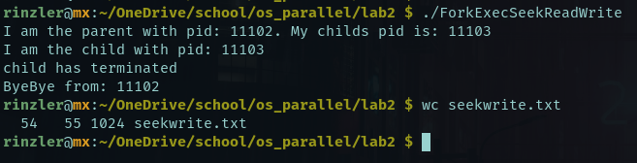
ForkExecSeekReadWrite.c --------------------------------------------
#include <stdio.h>
#include <sys/wait.h>
#include <time.h>
#include <unistd.h>

int main() {
pid_t childpid = fork();
char path[] = "/home/rinzler/OneDrive/school/os_parallel/lab2/SeekReadWrite";

if(childpid == 0) {
printf("I am the child with pid: %d\n", getpid());
execlp(path, (char *) NULL);
}
else {
printf("I am the parent with pid: %d. My childs pid is: %d\n", getpid(), childpid);
wait(NULL);
printf("child has terminated\n");
}

printf("ByeBye from: %d\n", getpid());

return 0;
}

SeekReadWrite.c ----------------------------------------------------------
#include <stdio.h>
#include <stdlib.h>

int main() {
char read_file_name[] = "data_2D.txt";
char write_file_name[] = "seekwrite.txt";
char str[1024];
FILE *read_file, *write_file;

if((read_file = fopen(read_file_name, "r")) == NULL) {
printf("Cant open file: %s\n", read_file_name);
exit(1);
}
if((write_file = fopen(write_file_name, "w")) == NULL) {
printf("Cant open file: %s\n", write_file_name);
exit(1);
}

fseek(read_file, 4096, SEEK_SET);

fread(str , sizeof(char), sizeof(str) - 1, read_file);

fwrite(str, sizeof(char), sizeof(str), write_file);

fclose(read_file);
fclose(write_file);

return 0;
}

