In-Class Lab 3. Message Queue
Note: Please use text highlight color to highlight your answer.
- SSH to courses.brockport.edu and create a folder named myipc under the directory of ~/CSC414.

- Message Queue is a queue of messages used for InterProcess communication, which is stored within the kernel and identified by a message queue identifier.
The following code is an implementation of message queue. Two source files, msgQ_write.c and msgQ_read.c, need to be created.

//msgQ_write.c
// C Program for Message Queue (Writer Process)
#include <stdio.h>
#include <sys/ipc.h>
#include <sys/msg.h>
#define MAX 10

// structure for message queue
struct mesg_buffer {
long mesg_type;
char mesg_text[100];
} message;

int main()
{
key_t key;
int msgid;

// ftok to generate unique key
key = ftok("progfile", 65);

// msgget creates a message queue
// and returns identifier
msgid = msgget(key, 0666 | IPC_CREAT);
message.mesg_type = 1;

printf("Write Data : ");
fgets(message.mesg_text,MAX,stdin);

// msgsnd to send message
msgsnd(msgid, &message, sizeof(message), 0);

// display the message
printf("Data send is : %s \n", message.mesg_text);

return 0;
}

//msgQ_read.c
// C Program for Message Queue (Reader Process)
#include <stdio.h>
#include <sys/ipc.h>
#include <sys/msg.h>

// structure for message queue
struct mesg_buffer {
long mesg_type;
char mesg_text[100];
} message;

int main()
{
key_t key;
int msgid;

// ftok to generate unique key
key = ftok("progfile", 65);

// msgget creates a message queue
// and returns identifier
msgid = msgget(key, 0666 | IPC_CREAT);

// msgrcv to receive message
msgrcv(msgid, &message, sizeof(message), 1, 0);

// display the message
printf("Data Received is : %s \n",
message.mesg_text);

// to destroy the message queue
msgctl(msgid, IPC_RMID, NULL);

return 0;
}

System calls used for message queues:

ftok(): is use to generate a unique key.
msgget(): either returns the message queue identifier for a newly created message queue or returns the identifiers for a queue that exists with the same key value.
msgsnd(): Data is placed into a message queue by calling msgsnd().
msgrcv(): messages are retrieved from a queue.
msgctl(): It performs various operations on a queue. Generally it is used to destroy the message queue.

- Please compile them using gcc sourcecode -o output. Run them respectively. Is it successful?
Yes.
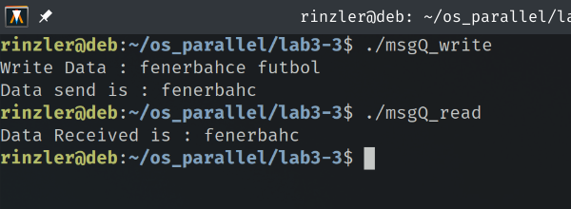

- Run msgQ_write.out three times with different inputs. And run msgQ_read.out twice. What are the results? Please paste the screenshots and explain why?
Once the first message is read the program destroys the queue hence why no other messages are being read and program hangs.
