In-Class Lab 3-2. Shared Memory
Note: Please use text highlight color to highlight your answer.
- SSH to courses.brockport.edu and create a folder named myipc under the directory of ~/CSC414.
- Shared memory between processes is an IPC communication method. The shared memory can be implemented in different ways. The below code illustrated on our slides is one of means. Create a producer file named shm_producer.c and another file named shm_consumer.c.
- Use the library rt to compile the source code. A dynamic link library can be compiled when –lrt is specified. Note that -l indicates that you are using the dynamic link library while rt is the library name that means RealTime extension library here. The syntax of the compilation should be gcc sourcecode –o output -lrt.
- Compile the source code shm_producer.c without -lrt. What is the error you have?
No error.

- Use find command to find out the dynamic library file named librt.so.1 (where the shared objects are provided by libc following POSIX.1b) in the folder of /usr/lib/. What is your command line? And what are your results?

- Run the output files in two terminals respectively. Paste the screenshots of the two terminals.

//This file is for producer process using shm_open and mmap.
// gcc sourcecode -o output -lrt
#include <stdio.h>
#include <stdlib.h>
#include <string.h>
#include <sys/shm.h>
#include <sys/stat.h>
#include <sys/types.h>
#include <unistd.h>
#include <fcntl.h>
#include <sys/mman.h>

int main()
{
/* the size (in bytes) of shared memory object */
const int SIZE = 4096;
/* name of the shared memory object */
const char *name = "OS";
/* strings written to shared memory */
const char *message0 = "Hello";
const char *message1 = "World!";
/* shared memory file descriptor */
int shm_fd;
/* pointer to shared memory obect */
void *ptr;
/* create the shared memory object */
shm_fd = shm_open(name, O_CREAT | O_RDWR, 0666);
/* configure the size of the shared memory object */
ftruncate (shm_fd, SIZE);
/* memory map the shared memory object */
ptr = mmap(NULL, SIZE, PROT_WRITE, MAP_SHARED, shm_fd, 0);
/* write to the shared memory object */
sprintf(ptr, "%s", message0);
ptr += strlen(message0);
sprintf(ptr,"%s", message1);
ptr += strlen(message1);
printf("producing is done.\n");
return 0;
}

//This file is for consumer process using shm_open and mmap.
// gcc sourcecode -o output -lrt
#include <stdio.h>
#include <stdlib.h>
#include <string.h>
#include <sys/shm.h>
#include <sys/stat.h>
#include <sys/types.h>
#include <unistd.h>
#include <fcntl.h>
#include <sys/mman.h>

int main()
{
/* the size (in bytes) of shared memory object */
const int SIZE = 4096;
/* name of the shared memory object */
const char *name = "OS";
/* shared memory file descriptor */
int shm_fd;
/* pointer to shared memory obect */
void *ptr;
/* open the shared memory object */
shm_fd = shm_open (name, O_RDONLY, 0666);
/* memory map the shared memory object */
ptr = mmap(0, SIZE, PROT_READ, MAP_SHARED, shm_fd, 0);
/* read from the shared memory object */
printf("%s\n", (char *)ptr);
/* remove the shared memory object */
shm_unlink(name);
return 0;
}

- Shared memory is a concept where two or more process can access the common memory. In the previous question, it was implemented in libc. The following code is implemented in a different way.
- Create two files shm_get_producer.c and shm_get_consumer.c respectively using the following code. Note that if you know C++, you will find that it is coded in C++ syntax, which is mostly compatible with c.
- Compile the files using the following syntax: g++ sourcecode -o outputfile

- Run shm_get_producer.out first and then run shm_get_consumer.out. Paste the screenshot to show the results.
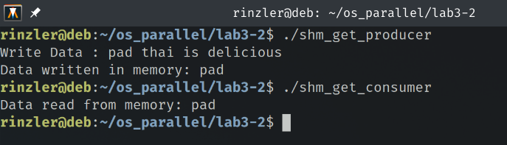

//shm_get_producer.c
#include <iostream>
#include <sys/ipc.h>
#include <sys/shm.h>
#include <stdio.h>
using namespace std;

int main()
{
// ftok to generate unique key
key_t key = ftok("shm_get_producer.c",65);

// shmget returns an identifier in shmid
int shmid = shmget(key,1024,0666|IPC_CREAT);

// shmat to attach to shared memory
char *str = (char*) shmat(shmid,(void*)0,0);

cout<<"Write Data : ";
cin >> str;
printf("Data written in memory: %s\n",str);
//detach from shared memory
shmdt(str);
return 0;
}

//shm_get_consumer.c
#include <iostream>
#include <sys/ipc.h>
#include <sys/shm.h>
#include <stdio.h>
using namespace std;

int main()
{
// ftok to generate unique key
key_t key = ftok("shm_get_producer.c",65);

// shmget returns an identifier in shmid
int shmid = shmget(key,1024,0666|IPC_CREAT);

// shmat to attach to shared memory
char *str = (char*) shmat(shmid,(void*)0,0);

printf("Data read from memory: %s\n",str);

//detach from shared memory
shmdt(str);

// destroy the shared memory
shmctl(shmid,IPC_RMID,NULL);

return 0;
}

Explanations about these functions.

ftok(): is use to generate a unique key that is significant for memory sharing.

shmget(): int shmget(key_t,size_tsize,intshmflg); upon successful completion, shmget() returns an identifier for the shared memory segment.

shmat(): Before you can use a shared memory segment, you have to attach yourself
to it using shmat(). void *shmat(int shmid ,void *shmaddr ,int shmflg);
shmid is shared memory id. shmaddr specifies specific address to use but we should set
it to zero and OS will automatically choose the address.

shmdt(): When you’re done with the shared memory segment, your program should
detach itself from it using shmdt(). int shmdt(void *shmaddr);

shmctl(): when you detach from shared memory,it is not destroyed. So, to destroy
shmctl() is used. shmctl(int shmid,IPC_RMID,NULL);

- In the source file shm_get_producer.c, shmget() has three parameters. In the last parameter 0666|IPC_CREAT, what is the meaning of 0666? Hint: you may find the answer from this link:
https://man7.org/linux/man-pages/man2/shmget.2.html
They are the file permissions for the shared memory segment. In this case the file is read and write for user, group and other.

- Unlike the pipe, shared Memory can be accessed by multiple users. Run shm_get_producer.out in a terminal and then run the same program in another terminal with different inputs. Run shm_get_consumer.out in the first terminal. What do you get? Paste your screenshot and explain why? Hint: different processes use different memory spaces; shared memory between processes needs to map to the corresponding virtual memory space for usage.
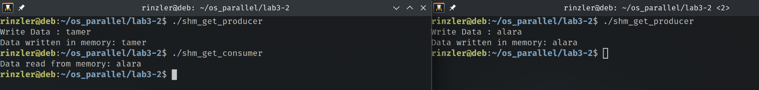
The text from terminal 2 is read from the shared memory. Since both terminals were using the shared memory segment I believe the second terminal overwrote the first.

