Semaphore in POSIX C
Note: Please use text highlight color to highlight your answer.
- Read the below source code, semaphore_thread.c and compile it. Note: please use the appropriate library in compiling.
// semaphore_thread.c
#include <pthread.h>
#include <semaphore.h>
#include <unistd.h>

sem_t mylock;

void* thread( void* arg)
{
sem_wait(&mylock);
printf("\nEntering the critical section..\n");

sleep(4);

printf("\nExiting the critical section...\n");
sem_post(&mylock);
}

int main()
{
sem_init(&mylock, 0, 1);
pthread_t t1,t2;
pthread_create(&t1,NULL,thread,NULL);
sleep(2);
pthread_create(&t2,NULL,thread,NULL);
pthread_join(t1,NULL);
pthread_join(t2,NULL);
sem_destroy(&mylock);
return 0;
}

- Run the program and describe what you have observed? Pastes the screenshot.
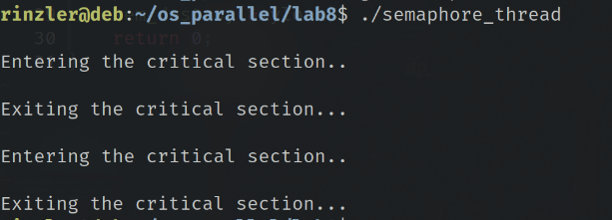

- Find the location of the file semaphore.h using either find or locate. Paste the screenshot of the results.
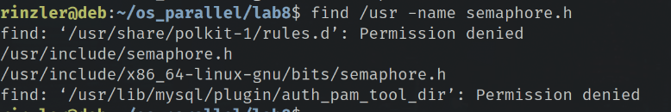

- What is the function of sem_wait()? Explain it including the purpose, parameters and return values in your own words.
sem_wait() serves can block the calling function if the value of the semaphore is currently 0. The calling thread will not return from sem_wait until the semaphore is greater than 0. If the sem_wait() call returns 0 then the semaphore is locked, if -1 is returned the lock has failed and the state of the semaphore is unchanged. The argument is a reference to a semaphore.

- What is the function of sem_post()? Explain it including the purpose, parameters and return values in your own words.
sem_post() unlocks the semaphore by incrementing the semaphore by one. If the semaphore is 1 then no thread was blocked, if 0 then the semaphore was blocking another thread.

- What is the function of sem_init()? Explain it including the purpose, parameters and return values in your own words.
sem_init() initializes semaphore. The arguments are a reference to a semaphore and two integers. The first int determines if the semaphore can be shared between processes, 0 is no, 1 yes. The second int is the value of the semaphore. The return value is 0 if ok and anything else is error.

- What is the function of sem_destroy()? Explain it including the purpose, parameters and return values in your own words.
sem_destroy() destroys the state of the semaphore but does not free the memory for the semaphore object. Destroying a semaphore when threads are waiting on it are undefined.

- What is the function of pthread_join()? Explain its functions in your own words.
pthread_join() blocks the calling thread, until the thread in argument 1 returns with pthread_exit(), the second arg may hold data from the exiting thread.

- Read the source code and consider if this binary semaphore in this code is equivalent to the mutex? Why do we use semaphore rather than the mutex?
In our code, it serves the same purpose as a mutex. We want to use a semaphore when you need other threads to notify eachother to wait or wake up unlike a mutex which can only be unlocked from the thread that locked it.

- Write a program named ABCD_Writer.c based on the source code semaphore_thread.c.
- The program should be able to fill an array of 100,000 characters via four threads. Threads one, two, three, four fill up the array with the letters ‘A’,’B’,’C’,’D’ respectively.
- The array should be shared between the four threads. Each thread has to compete with each other for modifying the array. Use a binary semaphore rather than mutex lock to synchronize their access to the critical section.
- Each thread is allowed to fill up one letter only when it enters the critical section. That is, if the thread wants to write one more letter, it has to re-enter the critical section and it is only allowed to write its own letter (e.g. thread three is only allowed to write a letter ‘C’).
- The four threads should keep the counter of how many characters they have written. Print out the corresponding counters.
- It is only after the four threads finish their job that the parent thread can leave. The parent should count how many ‘As’,’Bs’,’Cs’,’Ds’ in the array independent from each thread’s counter. Print out the statistics to see if they match thread’s own counters.
Submission Requirement: (1) the ABCD_Writer.c file (pasted or attached) and (2) the printout screenshot to show the thread’s counters and the main thread’s statistics.
