In-Class Lab 3. Pipes
Note: Please use text highlight color to highlight your answer.
Oiaersntoiearnstoiearnstoienrast
- SSH to courses.brockport.edu and create a folder named myipc under the directory of ~/CSC414.

- Ordinary pipe is a one-direction communication method. Create a new file named my_pipe.c using the below code. Compile it as my_pipe and run it. The code has a compile error and a running error. (1) Please indicate the errors and show the correct code. (2) It is supposed to display the messages via pipe(). Please show the output. Hint: if you use vim, you may type : set paste -> type i to start the editing mode -> right click to paste the code.
#include <stdio.h>
#include <unistd.h>
#include <stdlib.h> //make the warning gone.

#define SIZE_MSG 32

char msg[SIZE_MSG] ;

int main()
{
char buf[SIZE_MSG];
int pd[2], i;

printf("pipe here\n");
//first error is here
if (pipe(pd) < 0) {
printf("init failure. exit if failure.\n");
exit(1);
}

// the second error is here.
for (i = 0; i < 3; i ++) {
sprintf(msg, "message %d", i);
write(pd[1],msg, SIZE_MSG);
}

for (i = 0; i < 3; i++) {
read(pd[0], buf, SIZE_MSG);
printf("read % s\n", buf);
}
return 0;
}

The if statement needs to be enclosed in {}. msg should not be de-referenced in the argument.

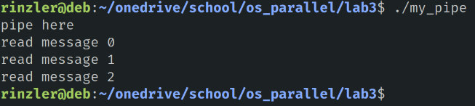

- The pipe() can establish a standard connection between two processes, so that the standard output of one process becomes the standard input of another process. Here is the syntax of pipe(): int pipe(int fds[2]). fds is an array that stores two file descriptors. fds[0] is for the read end of pipe; fds[1] is for the write end of pipe.
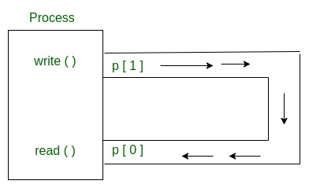
After fork(), the file descriptors are copied in child process. Both two processes can operate the fds[0] and fd[1] to read and write respectively.
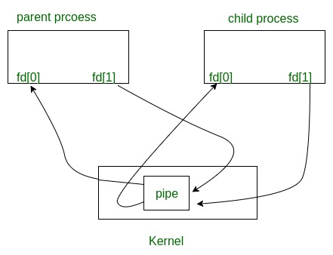
Create a new file name fork_pipe.c using the below code. Compile it as fork_pipe and run.
- Please describe what you have observed.
There was a long pause then the following was printed:
message 0
message 1
message 2
after while
reading Done

- Read the code and try to understand the pipe mechanism. Comment all close(pd[0]) and close(pd[1]). Compile and run it again. Please describe what you have observed.
The program prints 3 messages but then runs forever. Since we never closed the pipe, it is still listening for input so the program doesn’t end.

- Comment all close(pd[0]) only. Compile and run it again. Please describe what you have observed.
Same output as question 1. I think program finishes since the write end is eventually closed once everything is read there is nothing else to be written then read again so program terminates.

- Why do we need to close all pd[1]s?
If the write pipes are not closed you cannot begin to read from the pipes as they are synchronous.

(5) Using the knowledge we have learned in our class, what type of communication is pipe() belong to? Hint: Synchronous or asynchronous.
Since you can’t read from the pipe before it is written to, it would be synchronous.

#include <stdio.h>
#include <unistd.h>
#include <string.h>

#define SIZE_MSG 32

char msg[SIZE_MSG];

int main()
{
char buf[SIZE_MSG];
int i, pd[2], pid, nbytes;

if (pipe(pd) < 0)
exit(1);

if ((pid = fork()) > 0) {
sleep(5);

for( i = 0; i < 3 ; i++) {
sprintf(msg, "message %d", i);
write(pd[1], msg, SIZE_MSG);
}
close(pd[0]);
close(pd[1]);
wait(NULL);
}
else {
close(pd[1]);
while ((nbytes = read(pd[0], buf, SIZE_MSG)) > 0)
printf("% s\n", buf);

printf("after while\n");
if (nbytes != 0)
exit(2);
printf("reading Done\n");
close(pd[0]);
}
return 0;
}

- Named pipe is for a bidirection communication.

A named pipe (also known as a FIFO) is one of the methods for inter-process communication. Usually a named pipe appears as a file and generally processes attach to it for inter-process communication. A FIFO file is a special kind of file on the local storage which allows two or more processes to communicate with each other by reading/writing to/from this file. A FIFO special file is entered into the file system by calling mkfifo() in C. Once we have created a FIFO special file in this way, any process can open it for reading or writing, in the same way as an ordinary file.

The following code is for the code file namedpipe_p1.c.

// This process writes first, then reads
#include <stdio.h>
#include <string.h>
#include <fcntl.h>
#include <sys/stat.h>
#include <sys/types.h>
#include <unistd.h>

int main()
{
int fd;

// FIFO file path
char * myfifo = "./myfifo";

// Creating the named file(FIFO)
// mkfifo(<pathname>, <permission>)
mkfifo(myfifo, 0666);

char arr1[80], arr2[80];
// Open FIFO for write only
fd = open(myfifo, O_WRONLY);

// Take an input arr2ing from user.
// 80 is maximum length
printf("your message: ");
fgets(arr2, 80, stdin);

// Write the input arr2ing on FIFO
// and close it
write(fd, arr2, strlen(arr2)+1);
close(fd);

// Open FIFO for Read only
fd = open(myfifo, O_RDONLY);
// Read from FIFO
read(fd, arr1, sizeof(arr1));

// Print the read message
printf("Received: %s\n", arr1);
close(fd);
return 0;
}

The following code is for another code file namedpipe_p2.c.

// This program reads first, then writes
#include <stdio.h>
#include <string.h>
#include <fcntl.h>
#include <sys/stat.h>
#include <sys/types.h>
#include <unistd.h>

int main()
{
int fd1;

// FIFO file path
char * myfifo = "./myfifo";

// Creating the named file(FIFO)
// mkfifo(<pathname>,<permission>)
mkfifo(myfifo, 0666);

char str1[80], str2[80];
// First open in read only and read
fd1 = open(myfifo,O_RDONLY);
read(fd1, str1, 80);

// Print the read string and close
printf("Received: %s\n", str1);
close(fd1);

// Now open in write mode and write
// string taken from user.
fd1 = open(myfifo,O_WRONLY);
printf("your message: ");
fgets(str2, 80, stdin);
write(fd1, str2, strlen(str2)+1);
close(fd1);
return 0;
}

Compile the two files and run the files in two SSH terminals respectively. That is, run namedpipe_p1 in a terminal and run namedpipe_p2 in another terminal.
Hint: gcc sourcecode.c -o outputfile.out

What is the output you have observed? Please paste the screenshots.
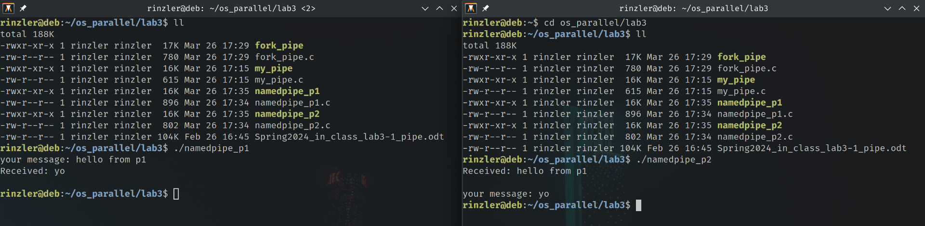
I can send one message from each terminal to the other.

- Add a piece of code to each file so that (1) each process shows its pid using printf and (2) then sends its pid to another side using the named pipe. Hint: use getpid() in previous labs.
What is your modified source code for namedpipe_p1.c only?
// This process writes first, then reads
#include <stdio.h>
#include <string.h>
#include <fcntl.h>
#include <sys/stat.h>
#include <sys/types.h>
#include <time.h>
#include <unistd.h>

int main()
{
int fd;

// FIFO file path
char * myfifo = "./myfifo";

// Creating the named file(FIFO)
// mkfifo(<pathname>, <permission>)
mkfifo(myfifo, 0666);

char arr1[80], arr2[80];
// Open FIFO for write only
fd = open(myfifo, O_WRONLY);

// Take an input arr2ing from user.
// 80 is maximum length
printf("your message: ");
fgets(arr2, 80, stdin);

// Write the input arr2ing on FIFO
// and close it
write(fd, arr2, strlen(arr2)+1);

// pid action
char msg[32];
pid_t my_pid = getpid();
sprintf(msg, "p1 pid: %d\n", my_pid);
printf(msg);
write(fd, msg, 32);

close(fd);

// Open FIFO for Read only
fd = open(myfifo, O_RDONLY);
// Read from FIFO
read(fd, arr1, sizeof(arr1));

// Print the read message
printf("Received: %s\n", arr1);

// read pid message
read(fd, msg, 32);
printf(msg);

close(fd);
return 0;
}

What are the results of the two SSH terminals? Please paste the screenshots?
