Peterson’s Synchronization Algorithm
Note: Please use text highlight color to highlight your answer.
Read the code, peterson0.c, and answer the following questions.
  - In the line 4, what header file is included?
sys/mman.h

  - What command in Linux is used to locate/find the header file from the file system? Hint: use locate or find.
Sudo find / -wholename “*/sys/mman.h”

  - Which command can be used to display the content of the header file?
Cat /usr/include/x86_64-linux-gnu/sys/mman.h

  - Is there any function in the header file called mmap?
extern void *mmap (void *__addr, size_t __len, int __prot,
int __flags, int __fd, __off_t __offset) __THROW;

  - Use man to find the meaning of the parameters in mmap? Write down the usage and explain how to use it in your own words.
Mmap creates a new mapping in the virtual address space. The first argument is the starting address for the new mapping. Len is the size of the map. Prot represents the protections for the mapping. Flags determines whether updates to the mapping are visible to other processes. Fd is the name given to the mapping. And the mapping begins from the address plus the offset.

  - Compile peterson0.c and make an executable file named peterson.out. Is it successful?
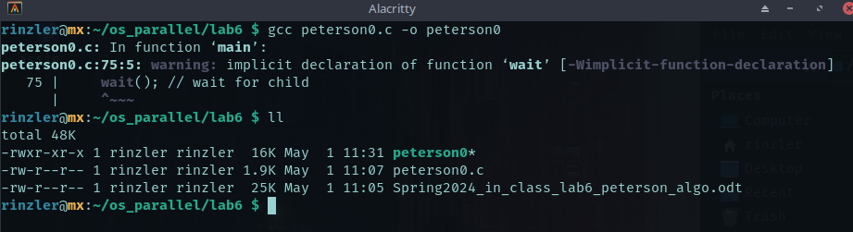

  - Run peterson.out and paste the screenshot.
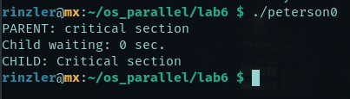

  - Explain how this program can run based on the software synchronization between two processes? Or why does the software synchronization work?
The parent never needs to wait since childs flag1 is 0 so parent enters critical section then ends by setting its flag0 = 0. While this is going on in the parent, the condition of the ready parent flag is true and it is flag 0’s turn is true for the loop, so child waits. Once child is done waiting it enters its critical section then ends by turning its ready flag1 to 0.

  - Add an extra loop at an appropriate place so that two processes can keep waiting-entering actions and compete with each other for entering the critical section. This is, each process runs the loop so that it continuously competes with another. For example, use ‘counter1’ as the loop control condition (counter1 < 10) to make the two processes compete. Show the output and paste your code.
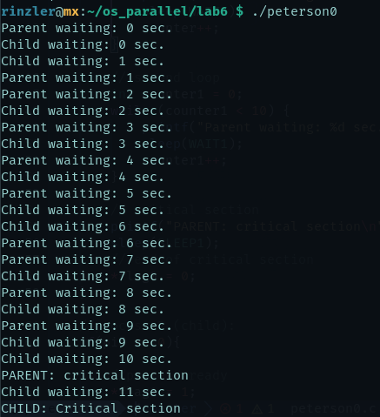
#include <stdio.h>
#include <unistd.h>
#include <sys/types.h>
#include <sys/mman.h>

//Shared Global variables to control processes
static int *flag0;
static int *flag1;
static int *turn;

const int WAIT1=1;
const int SLEEP1=1;

int main(int argc, char const *argv[])
{
flag0 = mmap(NULL, sizeof *flag0, PROT_READ | PROT_WRITE, MAP_SHARED | MAP_ANONYMOUS, -1, 0);

flag1 = mmap(NULL, sizeof *flag1, PROT_READ | PROT_WRITE, MAP_SHARED | MAP_ANONYMOUS, -1, 0);

turn = mmap(NULL, sizeof *turn, PROT_READ | PROT_WRITE, MAP_SHARED | MAP_ANONYMOUS, -1, 0);

*flag0 = 0;
*flag1 = 0;
*turn;

// creates child process
pid_t pid = fork();

//prcess 1 (parent):
if(pid > 0){
//process ready
*flag0 = 1;
// turn selector
*turn = 1;
int counter = 0;
//while to wait for turn change
while (*flag1 && *turn == 1)
{
// busy wait
printf("Parent waiting: %d sec.\n", counter);
sleep(WAIT1);
counter++;
}

// second loop---------------------------------------------------------------------------------------
int counter1 = 0;
while (counter1 < 10) {
printf("Parent waiting: %d sec.\n", counter1);
sleep(WAIT1);
counter1++;
}-------------------------------------------------------------------------------------------------------

// critical section
printf("PARENT: critical section\n");
sleep(SLEEP1);
// end of critical section
*flag0 = 0;
}

//process 2 (child):
if(pid == 0){

//process ready
*flag1 = 1;
// turn selector
*turn = 0;
//while to wait for turn change
int counter = 0;
while (*flag0 == 1 && *turn == 0)
{
// busy wait
printf("Child waiting: %d sec.\n", counter);
sleep(WAIT1);
counter++;
}
// critical section
printf("CHILD: Critical section\n");
sleep(SLEEP1);
// end of critical section
*flag1 = 0;
}

wait(); // wait for child
return 0;
}

  - Generate the random number of seconds (less than 5) to replace SLEEP1 in order to simulate a random competition between 2 processes. That is, each process repeats two actions: sleeping for random seconds and waking up to compete the critical section. Show the output and paste your code.

