Implementing Peterson’s Algorithm in pThread and Mutex
Note: Please use text highlight color to highlight your answer.

- Open the file pthreadcounter0.c.
  - In the line #18 of pthreadcounter0.c, there is a comment. Delete the comment sign ‘//’ and recompile pthreadcounter0.c. Please show what you have observed (paste the screenshot).
A job is started then once finished sleeps for some amount of time then next job starts.
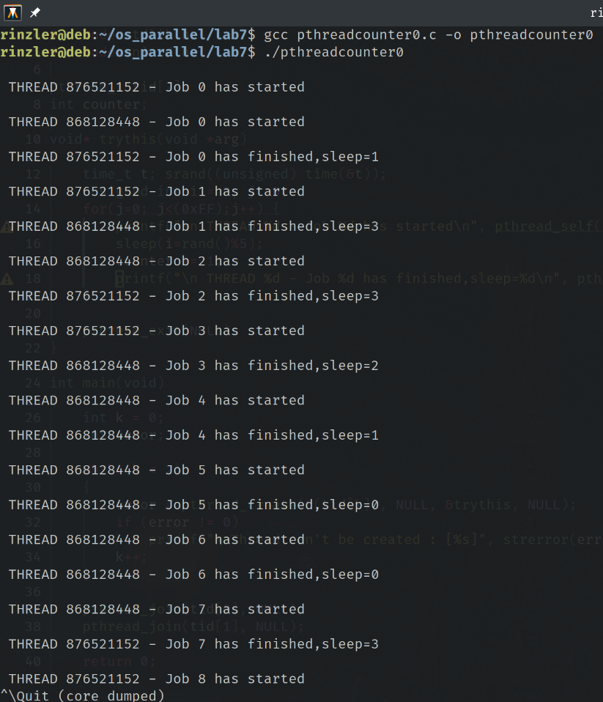

  - Observe the output. Is the printout appropriate or synchronized?
It is not synchronized since the job is not started and ended by the same thread.

  - Use the knowledge you have learned in Peterson algorithm. Implant the Peterson algorithm to threads based on pthreadcounter0.c. Copy pthreadcounter0.c to pthreacounter2.c and make sure the modification is on pthreadcounter2.c. Here is the requirement: (1) Shared variables are flag0, flag1 and turn. (2) Each thread has its own function to run, named trythis0(…) and trythis1(…) respectively. (3) Use the Peterson algorithm. (4) The critical section is in pthreadcounter0.c the lines #15-#18.
Compile the program and run it. Please show your code and paste the screenshot to see if the printout is as you expect.

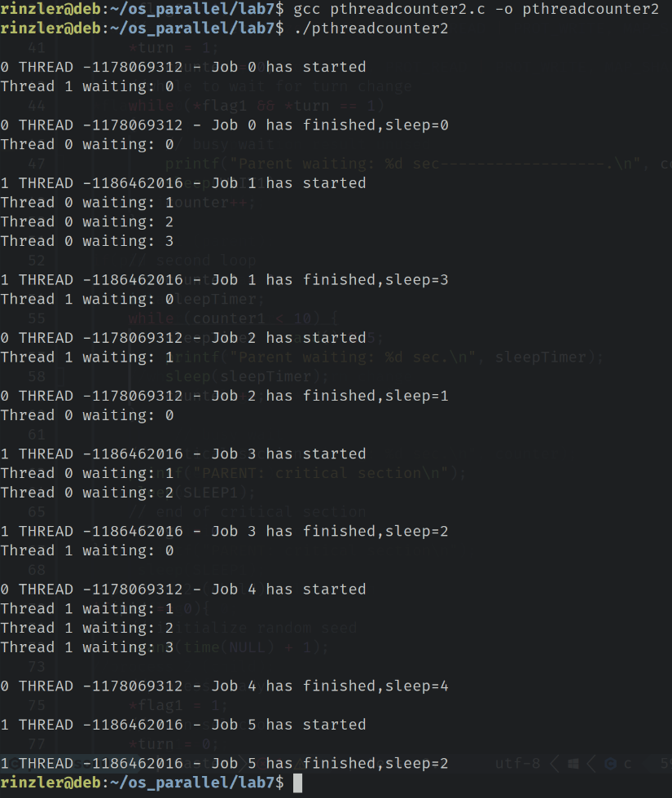

#include<stdio.h>
#include<string.h>
#include<pthread.h>
#include<stdlib.h>
#include<unistd.h>
#include<pthread.h>
#include<sys/mman.h>

pthread_t tid[2];
int counter;

// Shared variables for Petersons
static int *flag0, *flag1, *turn;

const int WAIT1=1;
const int SLEEP1=1;

void* trythis0(void *arg)
{

time_t t; srand((unsigned) time(&t));
unsigned int i = 0, j =0;
for(j=0; j<(0x3);j++) {
// thread 0 is ready
*flag0 = 1;
// after this turn it is thread 1 turn
*turn = 1;
int counter0 = 0;
// While its not thread 0 turn
while(*flag1 == 1 && *turn == 1) {
printf("Thread 0 waiting: %d \n", counter0);
sleep(WAIT1);
counter0++;
}
// Critical section
printf("\n0 THREAD %d - Job %d has started\n", pthread_self(), counter);
sleep(i=rand()%5);
//sleep(1);
counter += 1;
printf("\n0 THREAD %d - Job %d has finished,sleep=%d\n", pthread_self(), counter-1,i);
// End critical section
*flag0 = 0;
}
pthread_exit(NULL);
}

void* trythis1(void *arg)
{

time_t t; srand((unsigned) time(&t) + 1);
unsigned int i = 0, j =0;
for(j=0; j<(0x3);j++) {
// Thread 1 is ready
*flag1 = 1;
// After this turn it is thread 0 turn
*turn = 0;
int counter1 = 0;
// While its not thread 0 turn
while(*flag0 == 1 && *turn == 0) {
printf("Thread 1 waiting: %d \n", counter1);
sleep(WAIT1);
counter1++;
}
// Critical section
printf("\n1 THREAD %d - Job %d has started\n", pthread_self(), counter);
sleep(i=rand()%5);
//sleep(1);
counter += 1;
printf("\n1 THREAD %d - Job %d has finished,sleep=%d\n", pthread_self(), counter-1,i);
// End critical section
*flag1 = 0;
}
pthread_exit(NULL);
}

int main(void)
{
int k = 0;
int error;

flag0 = mmap(NULL, sizeof *flag0, PROT_READ | PROT_WRITE, MAP_SHARED | MAP_ANONYMOUS, -1, 0);

flag1 = mmap(NULL, sizeof *flag1, PROT_READ | PROT_WRITE, MAP_SHARED | MAP_ANONYMOUS, -1, 0);

turn = mmap(NULL, sizeof *turn, PROT_READ | PROT_WRITE, MAP_SHARED | MAP_ANONYMOUS, -1, 0);

*flag0 = 0;
*flag1 = 0;
*turn = 0;

int error0 = pthread_create(&(tid[0]), NULL, &trythis0, NULL);
int error1 = pthread_create(&(tid[1]), NULL, &trythis1, NULL);

if(error0 != 0 || error1 != 0)
printf("\nThread can't be created : [%s]", strerror(error));

// while(k < 2)
// {
// error = pthread_create(&(tid[k]), NULL, &trythis, NULL);
// if (error != 0)
// printf("\nThread can't be created : [%s]", strerror(error));
// k++;
// }

pthread_join(tid[0], NULL);
pthread_join(tid[1], NULL);

return 0;
}

- Read the source code, pthreadmutex0.c, and answer the following questions (https://randu.org/tutorials/threads/).
  - What is the purpose of pthread_mutex_lock()?
It is locking the shared data with the current thread and preventing other threads from modifying it.

  - Compile the source code and run. Paste the screenshot of running results.
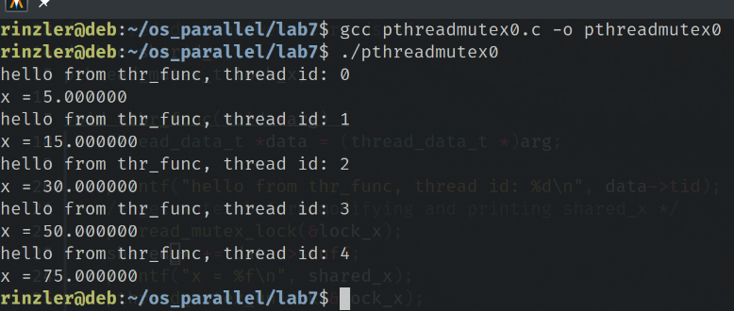

  - The variable shared_x is changed by threads. Can processes share variables? What is the difference between thread and process.
If a process is forked off another then yes they can share variables until they are written to, then they get copied to memory. If not forked then no. Threads however can share variables since they reside in the same process.

  - Does pthread mutex lock need to initialize before being used? What function is it invoked?
Not necessary as you can call macro:
pthread_mutex_t lock = PTHREAD_MUTEX_INITIALIZER;

- Copy the source code pthreadcounter0.c to pthreadcounter3.c. Use the pthread_mutex() to modify pthreadcounter3.c, so that it implements the thread synchronization, that is, the variable named counter can be synchronized (lines #15-18 in pthreadcounter0.c are the critical section). Additionally, the two threads should keep competing for the critical section until it runs away from for loop.

Please show your code and paste the screenshot to show the results.

