*** These are final instructions and images to help you have a smooth arrival into Los Angeles on Sunday!

1)  Please keep a look out for our SAF Welcom Greeter for UCLA summer students of SAF, named **Sushi.**

            a)  Sushi will be waiting for you standing at **"Pinkberry Smoothy Store"** located just outside the immigration **check-point** of the **International Terminal at LAX Airport**.

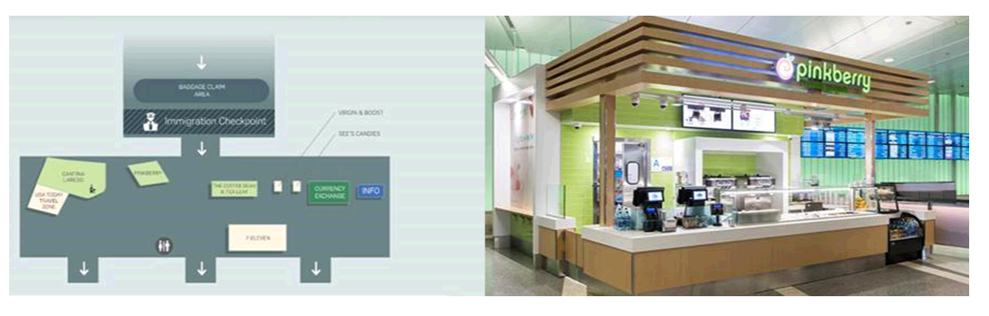

* **Sushi Colabucci’s Phone number: +1 760-277-4706**

Sushi will be holding **a blue SAF Flag** just like the one below and he will help you to get to your Super Shuttle or if you have any other issues:

You can meet Sushi after exiting the LAX International Arrival terminal, **right outside of the customs/border area.**  If he isn’t there, it may be because he is helping another SAF student, so please wait a few minutes before leaving. (Look for the SAF ‘Blue’ Flag!!)

You can always call the SAF emergency number at **+1 317-358-7025**if you run into any issues and we will be happy to assist you.

Rollin LUO, from SAF-Guangzhou, will also be available to greet you after you arrive at **Rieber Hall and help students during the check in process to your room.**

--- LUO Rollin - WeChat ID –**18826402119**

--- LUO Rollin - Phone number -  **(+)86 18826402119**

Please note that the Super Shuttle will drive you from LAX and you will arrive to ‘Rieber Hall’ UCLA Dormitory.

RIEBER HALL – UCLA Dorm for SAF Students: