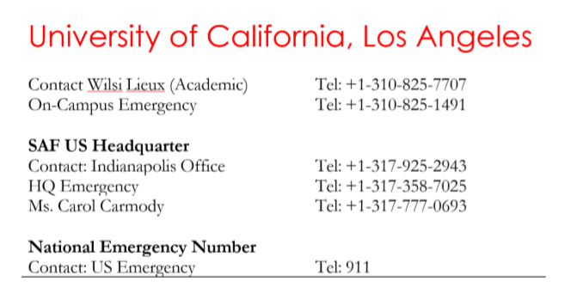



到机场接机信息：

**Transportation Information**

Date of Transport: **23 Jun 2019**

Transportation Type: **Airport Shuttle**

Transportation Provider: **SuperShuttle**

Provider Phone Number: **+1 800-258-3826**

Reservation Number: **1620017**

Arrival Phone Number: SAF Emergency Phone: +1 317-358-7025

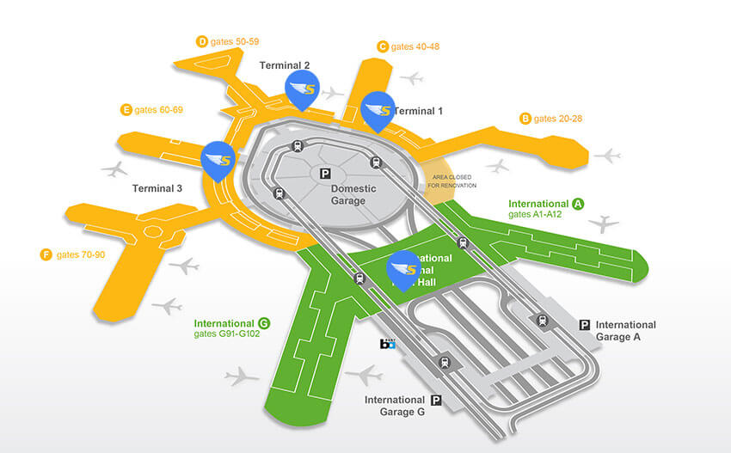

Address to where you are going: **310 Medical Plaza Driveway, Los Angeles, CA 90024**

Transportation Notes:**From baggage claim, follow the orange SHARED RIDE VANS signs and exit the terminal and turn left along the inner curb for pickup at the following pillars, listed below by terminal.** International Terminal: Turn right along the inner curb for the pickup location at pillar B9.国际到达在B9处取行李。

**Housing Assignment，住宿安排**

Type of Housing:**Residence Hall**

Move in date:**Jun 23 2019 2:00PM**

Building:**Rieber Hall**

Room/Apartment:**RIE-SOUTH-627**

Room Type: **Triple**

Mailing address**: 310 Medical Plaza Driveway, Los Angeles, CA 90024**

Mailbox number**:**