# 姜黄

## 拓展：

【郁金、莪术、姜黄、片姜黄】

https://www.bilibili.com/video/BV1qL411c7kw?spm_id_from=333.337.search-card.all.click

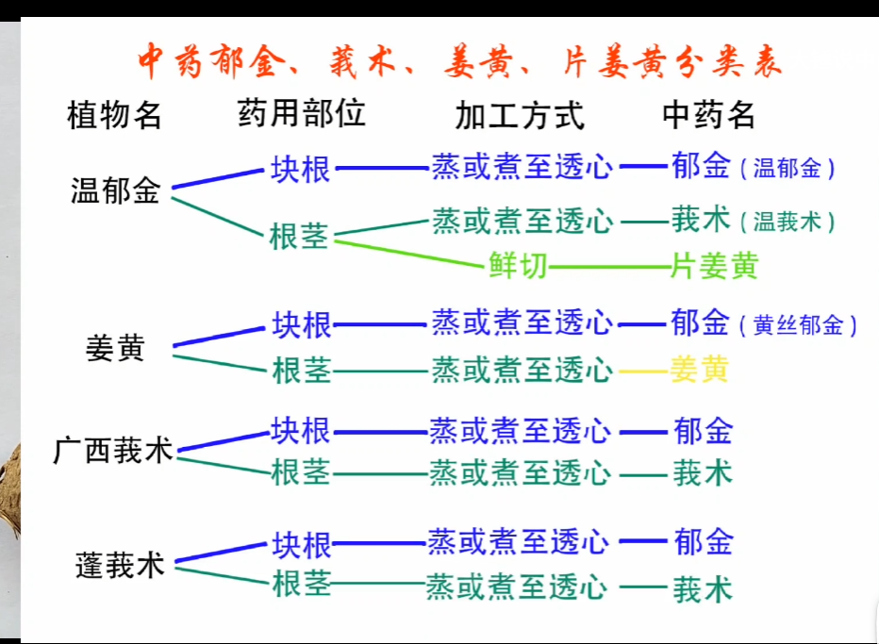

[2]【中药炮制 姜黄】https://www.bilibili.com/video/BV1Sy4y1r7mQ?spm_id_from=333.337.search-card.all.click