Smart Irrigation System
Machine Learning Component — Explanation & Presentation Guide
Electrical/Electronic Engineering Project
Prepared as viva / presentation notes

At a glance (your 60-second opener)
This project is the machine-learning “brain” of a smart irrigation system. A hardware prototype (sensors + microcontroller + water pump) reads the field; this software decides what to do with those readings. It reads three sensors and answers two questions using two machine-learning models:
- Model 1 — Should the field be irrigated right now? (Yes / No)
- Model 2 — How much water and sunlight are required? (numbers)
Model 1 is a classification problem solved with Logistic Regression. Model 2 is a regression problem solved with Linear Regression. Using a different algorithm for each is a deliberate design choice — the right tool for the type of answer each question needs.

1. The three inputs (sensor features)
Every prediction is based on exactly three sensor readings:
Feature | Unit | Sensor | Why it matters
soil_moisture | % | capacitive/resistive soil probe | Most important — how dry the soil already is
temperature | °C | DHT11/DHT22 | Hotter → faster evaporation → water lost quicker
air_humidity | % | DHT11/DHT22 (same chip) | Drier air → faster water loss → irrigate sooner
Rough importance order: soil_moisture ≫ temperature ≈ air_humidity. Temperature and humidity come from a single DHT11/DHT22 chip, so measuring both is very cheap for the hardware team.

2. Model 1 — the irrigate decision (Logistic Regression)
Goal:
Given the three readings, output Yes (turn the pump on) or No (leave it off).
Why Logistic Regression?
The answer is a category (Yes or No), not a number — so this is a classification task. Logistic Regression is the standard, explainable model for a two-class decision. It outputs a probability between 0 and 1 (via the sigmoid function) and predicts Yes when that probability is above 0.5. We encode the label as 1 = irrigate, 0 = don’t.
How it is trained (src/train.py):
- Load and clean the data; missing sensor values are filled with the column median (robust to outliers).
- Split 80% train / 20% test with a fixed random seed for reproducibility (stratified to keep the Yes/No ratio).
- Standardise features with StandardScaler — fitted on the training data only, to avoid ‘data leakage’.
- Train LogisticRegression on the scaled training data.
- Evaluate on the untouched 20% test set.
- Save the model and scaler with joblib so they can be reused without retraining.
The optional safety rule:
By default the decision is model-only. An optional hard safety rule (enabled with --safety) guarantees the pump never fires when the soil is already wet (soil_moisture ≥ 60%), regardless of the model — a sensible safeguard against over-watering.

3. Model 2 — water & sunlight estimator (Linear Regression)
Goal:
Given the same three readings, estimate two amounts:
- water_liters_per_m2 — recommended water to apply, in litres per square metre per day.
- sunlight_hours — advisory recommended daily sun-exposure, in hours.
Why Linear Regression?
These outputs are continuous numbers, not categories, so regression is the correct tool. One LinearRegression model predicts both outputs at once. This does not contradict the rule ‘don’t use linear regression for the irrigate target’ — that rule is about Model 1, whose answer is a category. Model 2’s answers are numbers. Right tool per target.
An honest note about ‘sunlight’ (good to raise before you’re asked):
In a field you can switch the water pump on, but you cannot switch the sun on. So sunlight_hours is treated as an advisory recommendation, not something the hardware actuates. If this were a greenhouse with grow-lights, it could become a real controlled output — the code is structured so that change is easy.

4. Turning ‘litres per m²’ into litres actually pumped
The model outputs an intensity (litres per square metre), which is the standard agronomic unit and is independent of field size — that is the correct thing for the model to learn. The total water to pump depends on the size of the plot and is obtained by simple arithmetic afterwards:
total_litres = water_liters_per_m2 × irrigated_area_m2
Area is deliberately NOT a model input: the soil/air sensors cannot measure it, and it is a fixed property of the installation. Feeding a constant into the model would teach it nothing and only add noise. The clean split is: the model predicts the per-m² requirement (which genuinely varies with weather and soil), then a deterministic step multiplies by your plot area (and, given a pump flow rate, converts to pump run-time).

5. Running both models together (recommend.py)
recommend.py is a single entry point: give it the three sensor values once and it runs both models and merges the answers.
python src/recommend.py 18 34 30
=== Irrigation recommendation ===
Irrigate? : Yes (P=0.999)
Water to apply : 6.67 L/m^2
Sunlight (advisory): 6.70 h
In the live system the hardware host calls one function:
from recommend import recommend
r = recommend(soil_moisture=18, temperature=34, air_humidity=30)
# {"irrigate": "Yes", "irrigate_probability": 0.999,
# "water_liters_per_m2": 6.67, "sunlight_hours": 6.70}

6. Understanding the results (what every number means)
Classification metrics (Model 1):
- Accuracy — overall fraction of predictions that were correct.
- Precision — of the times it said ‘irrigate’, how many truly needed it (few false alarms / little wasted water).
- Recall — of the times water was truly needed, how many it caught (the plant is rarely missed).
- F1 score — a single balanced score combining precision and recall.
- Confusion matrix — a 2×2 table of correct vs wrong predictions (saved as a plot).
Regression metrics (Model 2), reported per target:
- R² — fraction of the variation the model explains (1.0 = perfect, 0 = no better than guessing the average).
- MAE — average error size, in the target’s own units (e.g. litres).
- RMSE — like MAE but punishes large misses more heavily.
Typical results on the current (synthetic) data:
Model / target | Score | Reading
Model 1 — irrigate | Accuracy ≈ 0.93, F1 ≈ 0.93 | Strong, reliable decision
Model 2 — water | R² ≈ 0.88 | Strong — water is well explained by the sensors
Model 2 — sunlight | R² ≈ 0.48 | Weak — expected (see note below)
The low sunlight score is not a bug. How much sunlight a plant needs is mostly a property of the crop, not something these three sensors reveal. This actually demonstrates good understanding: a model can only learn relationships that genuinely exist in the data.

7. Why the models are explainable (the coefficients)
Because the features are standardised, the size of each coefficient shows how much that sensor matters, and the sign shows the direction. For the irrigate model:
Feature | Coefficient | Meaning
soil_moisture | large negative | wetter soil → pushes toward No (sensible)
temperature | positive | hotter → pushes toward Yes (sensible)
air_humidity | negative | drier air → pushes toward Yes (sensible)
soil_moisture has the largest coefficient, confirming it is the most important feature — exactly matching the physics. This is the kind of ‘the model agrees with real-world reasoning’ point examiners like to hear.

8. About the data (be ready for this question)
There is no real labelled field data yet, so both datasets are SYNTHETIC (computer-generated) but physically reasonable: dry soil + high temperature + low humidity leads to ‘irrigate’ and to higher water amounts. They are generated with a fixed random seed, so results are identical on every run.
When real measurements are available, replace the CSV files (same column names) and re-run the matching training script — nothing else changes. This is a strength to highlight: the pipeline is ready for real data today.

9. Evaluation plots
Model 1 — confusion matrix (correct vs wrong Yes/No predictions):
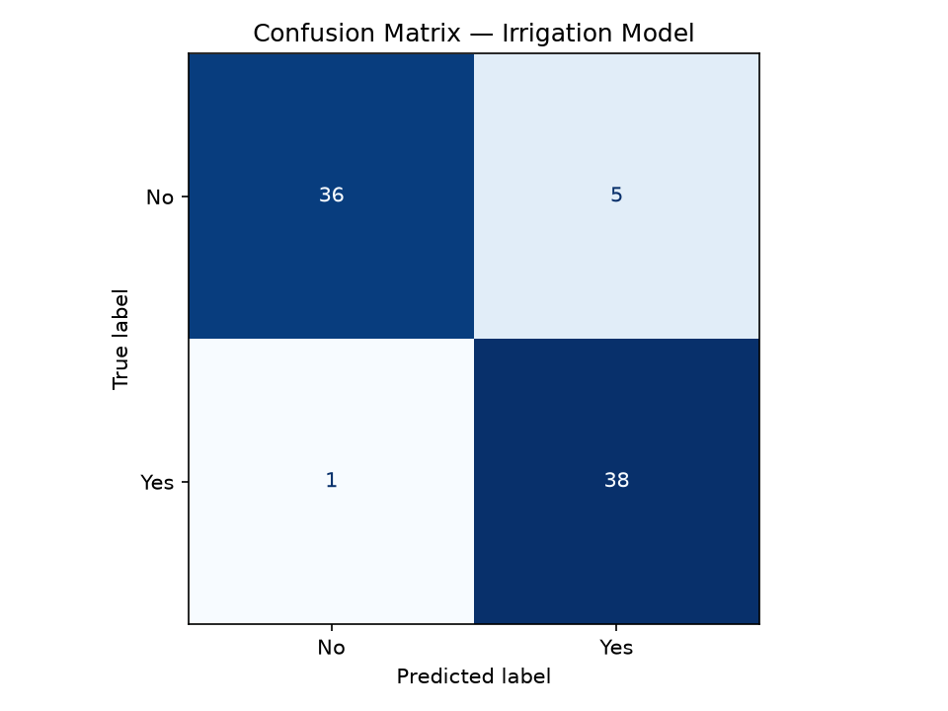
Model 2 — predicted vs actual (points on the red line = perfect):
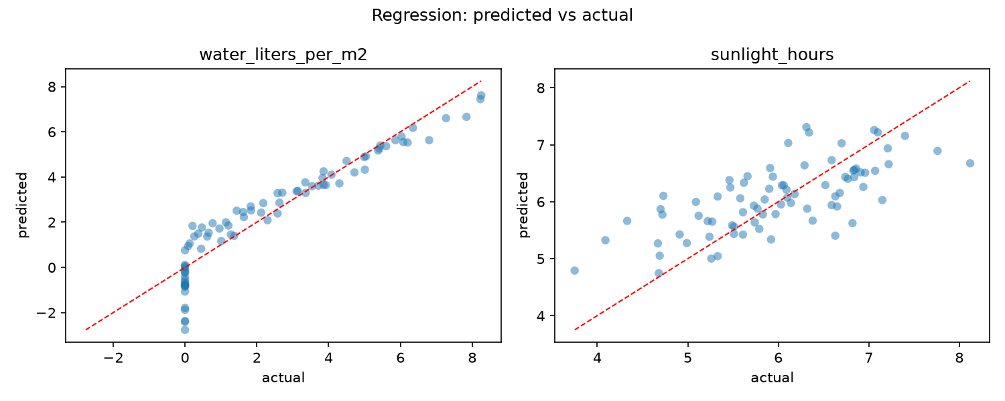

10. How to run it (demo steps)
On the presentation machine, from the project folder:
pip install -r requirements.txt # once
# Model 1 — irrigate decision
python src/generate_data.py # (re)create synthetic data
python src/train.py # train + evaluate + save
python src/predict.py 18 34 30 # -> Yes
# Model 2 — water/sunlight estimate
python src/generate_water_sunlight_data.py
python src/train_regression.py
python src/estimate.py 18 34 30
# Both models at once
python src/recommend.py 18 34 30
The trained models are already saved in the repo, so a fresh clone can run predict/estimate/recommend immediately — you only need the training scripts if you change the data.

11. Likely examiner questions (and short answers)
Q: Why logistic regression and not linear for the decision?
A: The target is a category (Yes/No). Linear regression predicts unbounded numbers; logistic regression predicts a probability and is the standard model for binary classification.
Q: Then why use linear regression at all?
A: For the second model, where the targets (water, sunlight) are continuous numbers. Regression is correct there. Different target type, different tool.
Q: Why is the sunlight R² low?
A: Sunlight need is mainly a crop property, not a function of soil moisture, temperature and humidity — so the sensors can’t explain it well. The model correctly reflects that there’s little real relationship.
Q: Why standardise the features?
A: So features on different scales are comparable, the solver converges reliably, and coefficient sizes can be read as importance. The scaler is fit on training data only to avoid leaking test information.
Q: How do you get the actual litres to pump?
A: Multiply the per-m² output by the irrigated area. Area isn’t a model input because the sensors can’t measure it and it never varies — it’s exact arithmetic done after the model.
Q: Is the data real?
A: Not yet — it’s synthetic but physically reasonable, generated with a fixed seed so the pipeline runs end to end. Swapping in real field data is a one-file change plus a re-run.

