Reports & Favorites — Clarifying Questions
Behavior questions raised by the Reports list, favoriting, the Dashboard favorites panel, the generate flow and the report viewer. Answers in blue are settled — built, decided or proposed; amber marks what is still open, with the tag on each answer saying which.
Screen: Reports & Dashboard · Design system: Repair 360 · Prototype: Reports.html
1. Favoriting
The star on each report row is the only way into the Dashboard favorites panel, so its semantics drive most of the rest. Favorites and run history are per-user — assume that throughout this document.
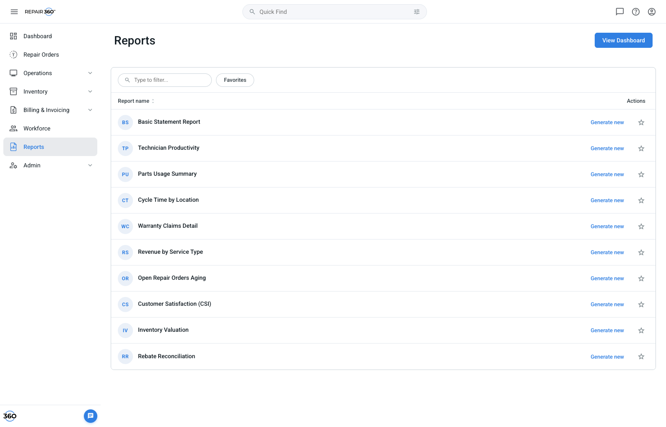
Reports list — each row carries a star, a “Generate new” action, and (once run) a “Create report - last N days” shortcut.
1. Is a favorite per-user or per-account? Two service managers at the same store may want different dashboards, but a shared store dashboard is also a plausible product.
DECIDED — Per-user. Favorites live on the user record, keyed by account so a user who switches accounts gets the right set. A second manager at the same store sees their own cards, not yours.
2. Does favoriting take effect immediately, or is there a save step? The star toggles instantly with no confirmation.
BUILT — Immediate — no save step. Tapping the star writes the favorite and the Dashboard reflects it on next visit. Confirmation is the filled star plus a snackbar in the top right (dark #343F46 surface, 8px radius, filled check, dismiss ×) reading “Report added to favorites”. It auto-dismisses; the × closes it early.
3. Does unfavoriting warn before removing the card? A favorite may carry a saved date range and run history that the user does not realize they are discarding.
NEEDS CLARIFICATION — No warning today. Recommend removing silently but keeping the run history server-side, so re-favoriting restores the previous range rather than starting blank.
4. Is the “Favorites” pill in the list a filter or a mode? It sits beside the search field and reads like a toggle chip.
BUILT — A filter on the list only — it narrows rows to starred reports and does not change the Dashboard. It combines with the search field (both apply at once) and has its own empty state with a “Browse all reports” escape.
5. Does the Favorites filter persist across sessions? A user who leaves it on may think reports have disappeared.
NEEDS CLARIFICATION — Resets on reload today. Recommend not persisting it, for exactly that reason.
6. Is there a cap on favorites? The Dashboard panel wraps cards in a flex row with no limit in the prototype.
NEEDS CLARIFICATION — Prior guidance was 10 on the Dashboard, first-favorited wins. Not yet enforced in the build. If a cap exists, decide what the star does at the limit: block with a message, or favorite anyway and leave the card off the Dashboard.
7. How is the favorites feature introduced to an existing user? Someone who has used Reports for a year has no reason to look for a star column that appeared overnight.
BUILT — A one-time “New Feature — Favorite Reports” modal, shown 2.2s after the user first opens the Reports page (never on the Dashboard, so it lands where the star actually is). Star mark, two lines of explanation, and two exits: View Dashboard and Ok, Got It. A localStorage flag suppresses it permanently after either exit or the ×. The header logo re-arms it for demos.
8. Should that modal be per-device or per-user, and does it need a version? It is browser-storage gated like the coach marks.
NEEDS CLARIFICATION — Device-local today, so the same person sees it again on a second machine. If feature announcements are going to be a pattern, this wants a per-user “announcements seen” record keyed by feature id, not a single boolean.
2. The Dashboard favorites panel
How favorites are presented, ordered and entered from the Dashboard.
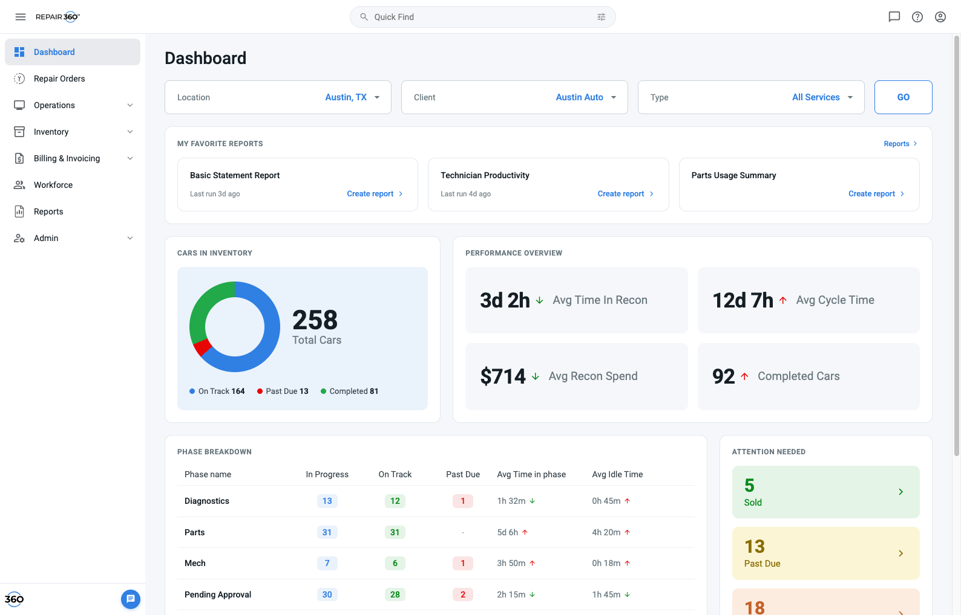
Dashboard — favorited reports appear as cards above inventory and performance, each with a “Create report” affordance.
9. How are cards ordered? Alphabetical, most recently favorited, most recently run, or manual?
BUILT — Favorite order — the sequence in which the user starred them. Drag-to-reorder is a stated nice-to-have and is not in the prototype; there are no drag handles.
10. What does the empty state do? A first-time user has no favorites and no way to know the panel exists.
BUILT — An illustrated empty state (star badge, “No favorites yet”, one line of explanation) with a Browse all reports › link that navigates to the Reports page.
11. What is the coaching bubble’s show logic? A dark tooltip slides in pointing at the browse link.
BUILT — Two separate coach marks, both persisted in localStorage. The first appears 2.4s after landing on an empty Dashboard, at most 3 times, and never again once a favorite exists. The second appears once a favorite exists, anchored to the first card, and shows once. Both dismiss on “Got it”.
12. Should coach marks reset per device or per user? They are stored in browser storage, so the same person sees them again on a second machine.
DECIDED — Once per person, per account — stored on the user record, not in browser storage. A user sees each coach mark one time regardless of device or browser, and the counter is scoped per account so someone working across two accounts is coached once in each. localStorage stays only as an offline fallback until the server flag syncs.
13. What does the “Reports ›” link in the panel header do? It only appears once at least one favorite exists.
BUILT — Navigates to the Reports page so the user can star more. Same destination as the empty state’s browse link — it is a navigation affordance, not an add-favorite action.
14. What does a card’s action say before the report has ever been run? A newly favorited report has no run history, so “Create report” implies a repeat of something that never happened.
BUILT — The label is state-dependent. Favorited but never generated &rarr; Generate report, which opens the date menu as a first run. Once generated at least once &rarr; Create report plus a “Last run Nd ago” timestamp, matching the Reports list’s “Create report - last N days” shortcut. Same run-history flag drives both surfaces, so the list and the Dashboard never disagree.
15. Do the Dashboard filters (Location / Client / Type + GO) scope the favorite cards? They sit directly above the panel, which implies they do.
NEEDS CLARIFICATION — They do not in the prototype — a generated report uses its own form values, not the Dashboard filters. This is a genuine ambiguity in the layout. Either scope the cards to those filters or move the filter row below the favorites panel.
3. Running a report from a card
The card’s date menu is the fast path; the modal is the full path.
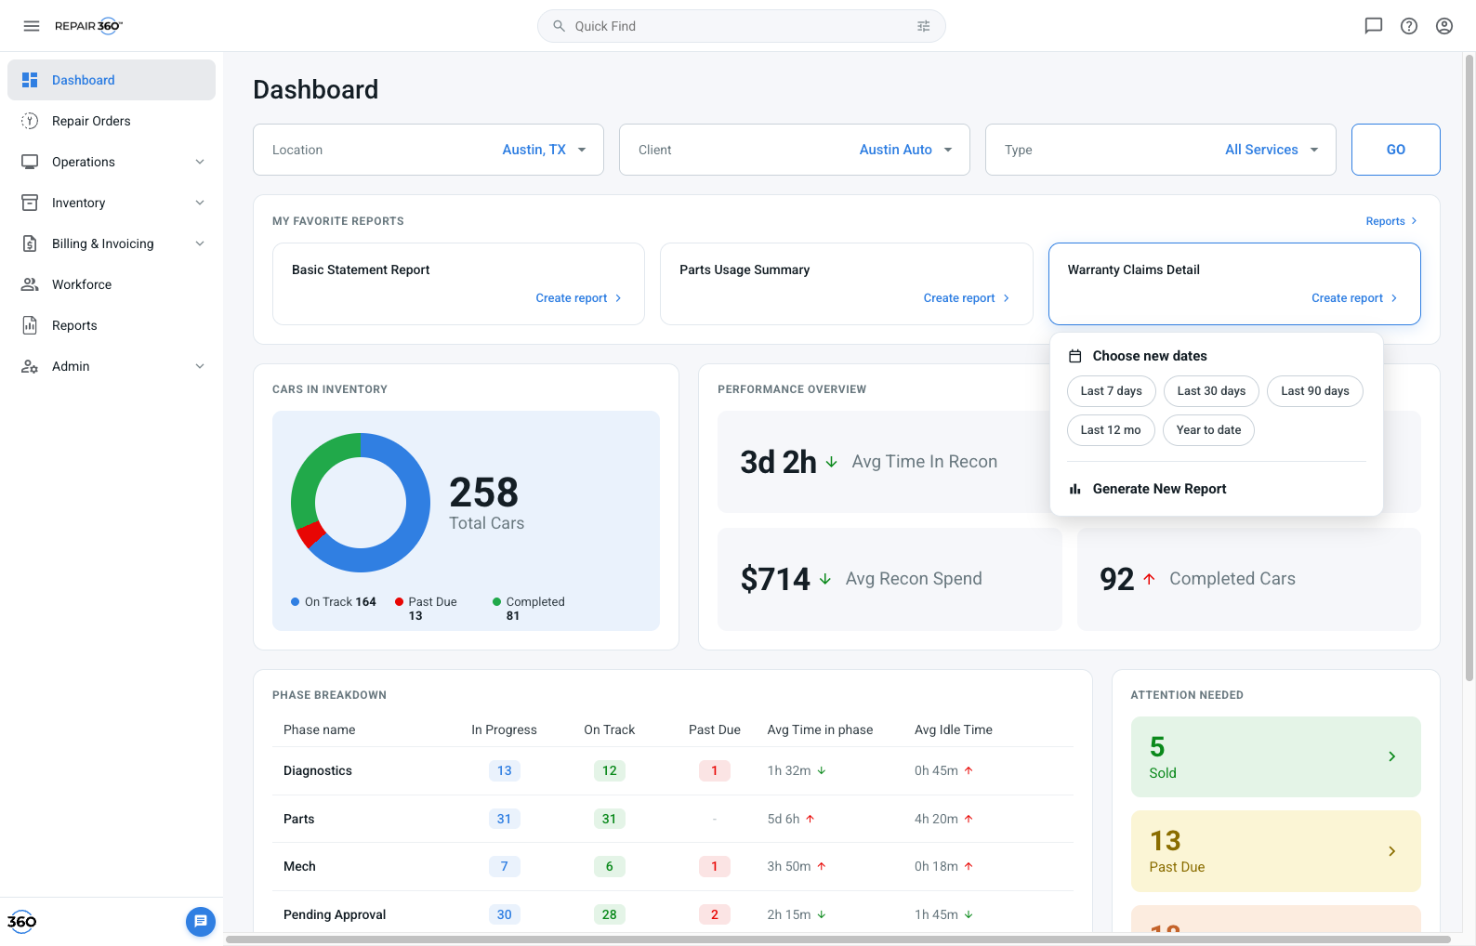
Clicking a card opens “Choose new dates” — five preset chips plus “Generate New Report”, which hands off to the full modal.
16. What are the preset ranges, and are they relative or absolute? The chips read Last 7 / 30 / 90 days, Last 12 mo, Year to date.
BUILT — Relative, computed at click time from today back N days (Year to date runs from Jan 1). Nothing is stored as a fixed June 1&ndash;30 window; the range always slides forward.
17. Does picking a chip change the card’s saved default? Or is it a one-off run?
BUILT — It updates the default. The card remembers the last preset range run for that report, which is what the list’s “Create report - last N days” shortcut then offers. Custom ranges are deliberately not remembered.
18. What parameters does a chip run use? The modal has location, client, dealership, client type, billing mode, rebate and invoice type — the chip run has none of them.
DECIDED — Inherit the parameters from the user’s last run of that report — everything except the date range. The first time a user generates a report they fill the parameters themselves. On generating, that parameter set is saved as their default for that report, so every later run — preset chip, list shortcut or a re-opened modal — arrives with those selections already applied. The date range is deliberately excluded: it is the one field that should always be an explicit choice, and a chip supplies it. Stored per user, per report, alongside run history.
19. Is a chip run live or cached? The card shows “Last run Nd ago”, which reads like a stored artifact.
BUILT — Live — every click generates fresh, with a ~750ms spinner then the report overlay. The timestamp is history, not a cached copy on offer.
20. Is that generation time realistic? Some of these reports span a year of multi-store data.
PROPOSED — Design to a 3-second p95 budget. Under 3s the current spinner overlay is right. Between 3 and 10s, keep the user on the page but replace the spinner with a determinate progress state naming what is being gathered. Past 10s, generate in the background: close the modal, snackbar “We’ll let you know when it’s ready”, notify on completion. Engineering to confirm real p95 per report at a 12-month range; any report that cannot meet 3s at its common range ships on the background path from day one.
21. Can a running report be cancelled? The spinner overlay has no dismiss.
PROPOSED — Follows the budget above: no cancel under 3s (the spinner is gone before a user could reach it), a Cancel button on the progress state from 3s, and on the background path the modal closes immediately so there is nothing to cancel — the run is abandoned by ignoring the notification.
22. What happens when generation fails? Timeout, permission loss mid-run, no data in range.
NEEDS CLARIFICATION — No error state exists in any of the three entry points. Needs a designed failure: message, retry, and whether an empty result is an error or a valid empty report.
4. The list’s run shortcuts
The Reports list shows a second action once a report has been run.
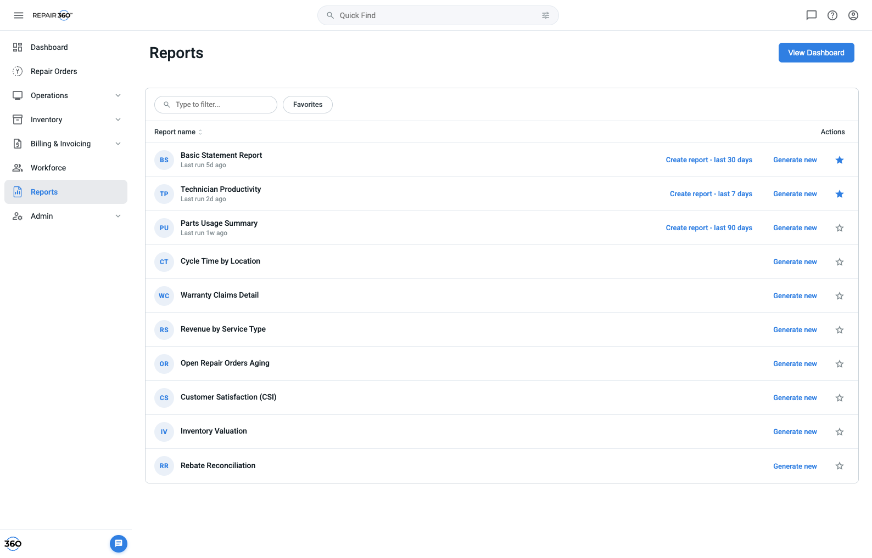
After a run, the row gains “Last run Nd ago” and a “Create report - last 30 days” shortcut beside “Generate new”.
23. When does “Create report - last N days” appear? It is absent on most rows.
BUILT — Only after the user has run that report with a preset range. Never run, or only run with a custom range, and the row shows just “Generate new”. Same rule governs the Dashboard card.
24. Is run history per user or per account? It drives whether the shortcut appears at all.
DECIDED — Per-user, following the favorites decision in Q1. Run history is stored against the user, so one manager’s run never puts a shortcut on another’s row.
25. Does the shortcut re-run with the previous parameters or just the previous range? The label only mentions days.
DECIDED — Both — the label’s range plus the saved parameter set from Q18. This is not a silent change: the parameters are the ones the user themselves last chose for that report, so the shortcut reproduces their own last run with a fresh window.
26. How long does run history live? A shortcut offering “last 7 days” from a run eight months ago is noise.
NEEDS CLARIFICATION — No expiry defined. Suggest hiding the shortcut after ~90 days of no runs and falling back to “Generate new”.
5. The generate modal
The full-parameter path, reached from “Generate new” on a row or “Generate New Report” on a card.
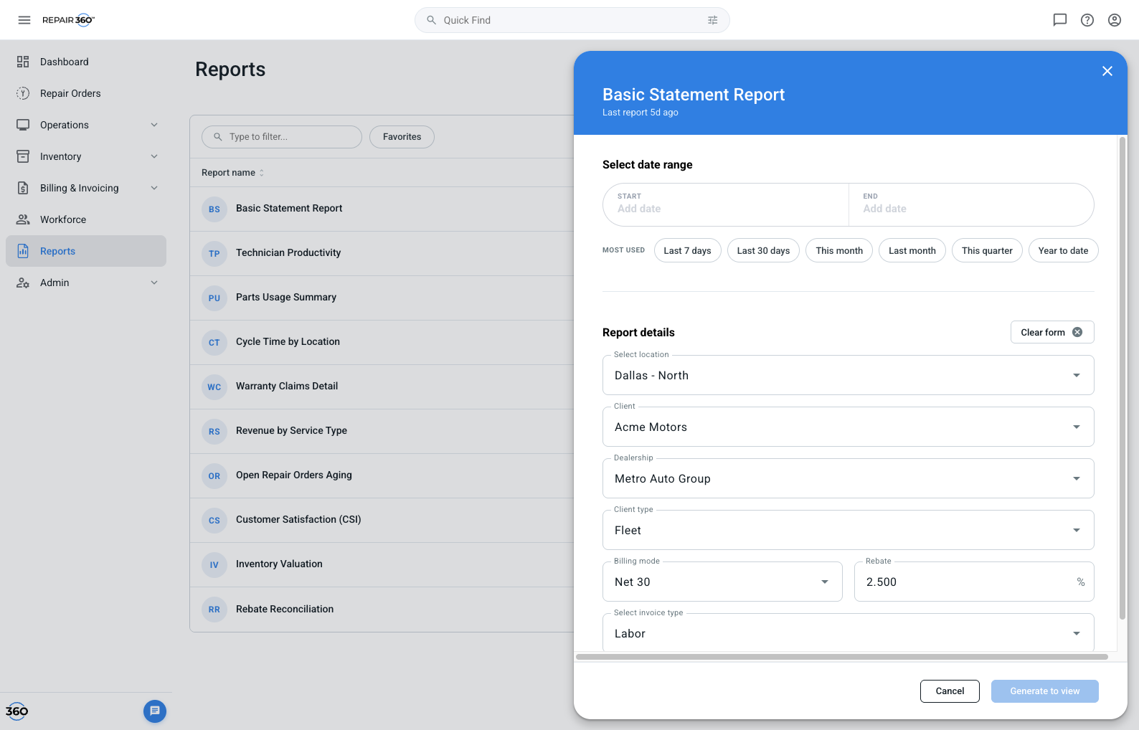
Generate modal — calendar range picker with preset shortcuts on the left, report parameters on the right, favorite toggle in the footer.
27. Does “Clear form” wipe the date range too? The button sits in the Report details column, beside the parameters only.
BUILT — Clears the whole form including the date range, per prior guidance — even though its placement suggests otherwise. Consider moving it to the modal footer so the scope reads correctly.
28. Which parameters are required? Generate is enabled with an empty form in the prototype until a range is chosen.
NEEDS CLARIFICATION — Only the date range is effectively required today. Need the real required set per report type, plus whether Generate should be disabled or should surface field-level validation.
29. Are the parameters the same for every report? All eleven reports open the same seven fields.
NEEDS CLARIFICATION — Almost certainly not — a Technician Productivity report and a Billing Statement need different inputs. Need a per-report parameter schema; the modal should render fields from it rather than a fixed form.
30. Is there a maximum date range? The picker allows arbitrary spans.
PROPOSED — Cap at 24 months, enforced in the picker — dates beyond the cap are disabled, with a hint rather than a post-submit error. Per-report overrides come from the parameter schema once it exists. Rationale: 24 months covers year-over-year comparison, which is the longest span anyone has asked for, and keeps generation inside the 3-second budget.
31. What does the star in the modal footer do? It reads “Report added to favorites”.
BUILT — Favorites the report as part of generating it — the same action as the row star, offered at the moment of intent. It is a live control, not a label.
32. Can a configured report be saved without running it? There is no “save these parameters” action.
DECIDED — No explicit save action — generating is the save. Per Q18, running a report stores its parameters as that user’s default for it, so there is nothing to save separately. A named, multi-parameter-set feature (“my East region view” vs “my fleet view”) is a later addition, not v1.
33. Can reports be scheduled or emailed on a recurrence? The most common request for any reporting surface.
NEEDS CLARIFICATION — Out of scope for the prototype. Flagging it because it changes the data model — a schedule needs a stored parameter set, which is the same object as Q29.
6. The report viewer
The full-screen overlay shown after any successful run. Sharing is the one area the prototype cannot settle — links, mail and file export all depend on infrastructure that only exists in the real environments, so the dev team will close these gaps in staging and production.
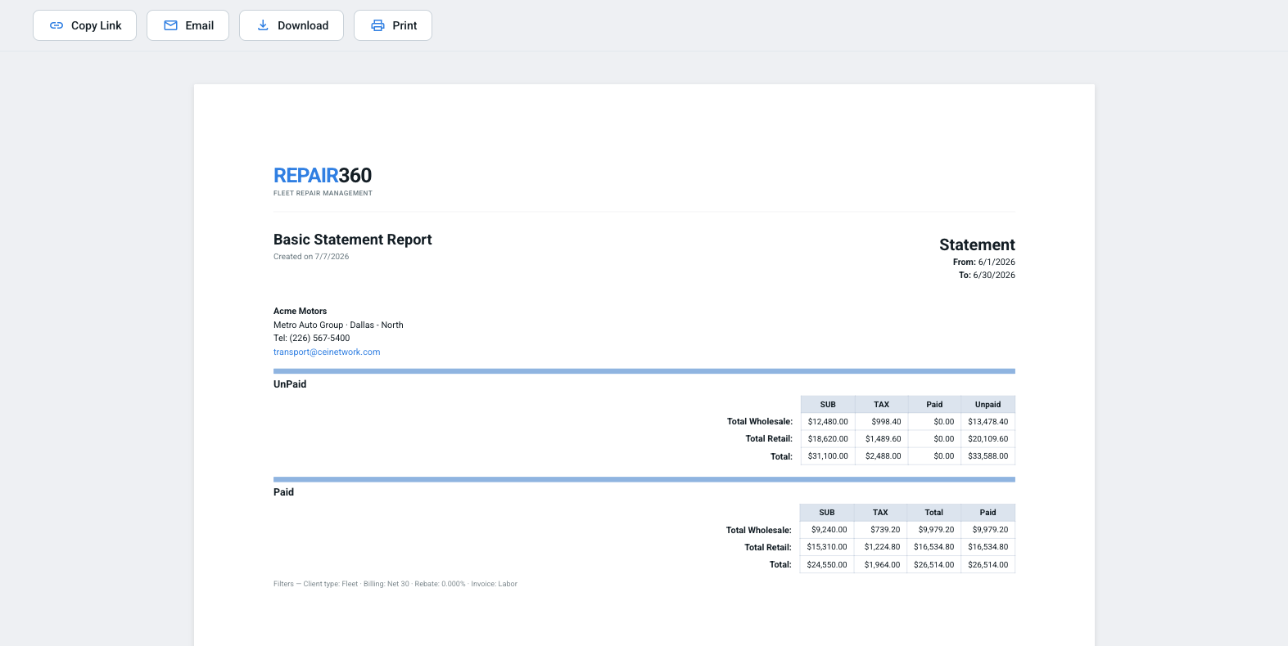
The generated report — a letter-width document rendered from the chosen range and parameters, with Copy Link, Email, Download and Print pinned above it. In the app it opens inside a full-screen overlay that also offers “Open in new tab”.
34. Who can open a “Copy Link” URL, and does it expire? The prototype copies the current page URL, which is not a report address.
DEV TO RESOLVE — Engineering owns the final answer here — the sharing gaps will be filled in against the real staging and production environments, where the URL scheme, auth and mail infrastructure actually exist. The note below is a design recommendation, not a constraint. Suggested: a saved report artifact with its own id, same-account access enforced server-side, no expiry for account members, and a separately generated expiring link for outside recipients.
35. Do Download and Print produce the same artifact? Both call the browser print dialog on the report iframe.
DECIDED — They separate. Print keeps the browser dialog. Download becomes a real server-generated file with a format choice: PDF for the formatted statement and Excel (.xlsx) for the underlying rows, so figures can be pivoted and reconciled rather than retyped. Offer the two as a small menu on the Download button, defaulting to PDF. Excel is required for every tabular report; PDF-only is acceptable for reports that are purely narrative. Delivery mechanics (generation service, file retention) sit with engineering.
36. What does Email send? It opens the user’s mail client with a link in the body.
DEV TO RESOLVE — Engineering owns the final answer here — the sharing gaps will be filled in against the real staging and production environments, where the URL scheme, auth and mail infrastructure actually exist. The note below is a design recommendation, not a constraint. Suggested: server-side send with the file attached — the mailto: stub inherits the unresolved link from Q31 and cannot work for a recipient without an account.
37. If access to a report is revoked after it is favorited, what happens to the card? Vanish, or stay visible but disabled?
NEEDS CLARIFICATION — Not handled. Recommend the card disappearing from the Dashboard while the favorite remains on the record, so it returns if access is restored — a disabled card that cannot be explained is worse than an absent one.

