Reports — Developer Handoff
The deterministic half of the Reports feature: what is stored, what each control does, and which conditions change the UI. Rationale, alternatives and unresolved decisions are deliberately not here — they live in Reports & Favorites — Clarifying Questions, cross-referenced by number — every Q# is a link into that document.
Screen: Reports & Dashboard · Design system: Repair 360 · Prototype: Reports.html
1. State model
Four things persist. Everything else is derived or transient. Two of the four are browser-local in the prototype and must move server-side.
State | Shape | Lives in (prototype) | Should live in
Favorites | Set<reportId>, insertion-ordered | Component state — lost on reload | Server, on the user record. Order matters: it drives card order. Q1
Saved parameters | Map<reportName, {client, dealership, location, clientType, billingMode, rebate, invoiceType}> — never the date range | Not implemented | Server, per user per report. Written on every successful generate. Q18
Run history | Map<reportName, days:int> — only preset ranges are recorded | Component state — session only | Server. Needs a timestamp too (the UI shows “Last run Nd ago”). Q24 Q26
Feature-modal flag | Boolean | localStorage['r360_feature_favorites_seen'] | Per-user announcements record keyed by feature id, not one boolean. Q8
Coach-mark flags | Two booleans + one counter | r360_coach_fav_done, r360_coach_fav_count, r360_coach_gen_done | Same as above — onboarding state belongs to the person, not the browser.
Derived, not stored
• Card list = favorites, in favorite order. No separate dashboard collection exists.
• “Last run Nd ago” = today minus the run-history timestamp.
• Shortcut label (“Create report - last 30 days”) = the days value in run history.
• Date ranges are always computed at click time, never stored as absolute dates.
Reset hook (demo only). Clicking the header logo clears favorites, run history and all four storage flags, returning the app to first-run state. This exists for internal presentations. Do not port it to production.
2. Rules
Every conditional in the feature, as if/then. These are the lines to unit-test.
Favoriting
IF a report is not favorited, the star is outlined; tapping it favorites immediately (no save step) and shows a snackbar “Report added to favorites”.
IF a report is favorited, the star is filled; tapping it unfavorites immediately, removes the card, and shows “Report removed from favorites”. No confirmation dialog.Q3
IF several stars are tapped in quick succession, one snackbar is reused and its dismiss timer restarts — they never stack.
IF the star in the generate modal footer is tapped, it behaves exactly as the row star. It is a control, not a label.
Snackbar
• Position: top right, tucked under the header. Surface #343F46, 8px radius, white filled check, 16px medium label, dismiss ×.
• Slides down on enter, auto-dismisses; the × closes it early.
Reports list
IF a report has never been run, the row shows one action: Generate new.
IF a report was last run with a preset range, the row also shows Create report - last N days and the text “Last run Nd ago”.
IF a report was run only with a custom range, no shortcut appears — custom ranges are deliberately not remembered.
IF the Favorites pill is active, the list narrows to starred reports. It combines with the search field; both apply at once. It does not affect the Dashboard.
IF the Favorites pill is active and nothing is starred, an empty state appears with a Browse all reports escape.
IF the page reloads, the Favorites pill resets to off.Q5
Dashboard favorites panel
IF there are no favorites, an illustrated empty state shows (star badge, “No favorites yet”, one explanatory line) with a Browse all reports › link to the Reports page.
IF there is at least one favorite, the panel header gains a Reports › link to the same destination.
IF a favorited report has never been run, its card action reads Generate report with no timestamp.
IF a favorited report has been run, its card action reads Create report and the card shows “Last run Nd ago”.Q14
IF a card is clicked, a “Choose new dates” menu opens with five preset chips plus Generate New Report.
Onboarding
IF the user opens the Reports page for the first time, 2.2s later the “New Feature — Favorite Reports” modal appears. Two exits: View Dashboard and Ok, Got It; either (or the ×) sets the flag permanently. Never shown on the Dashboard — it must land where the star is.
IF the user lands on an empty Dashboard, 2.4s later a coach mark points at the browse link. Shown at most 3 times total, and never again once any favorite exists.
IF the user lands on a Dashboard with favorites and has not seen it, a second coach mark anchors to the first card, shown once.
IF either coach mark's “Got it” is pressed, its flag is set and it never returns.
Generation
IF any generate path is triggered, a spinner overlay shows, then the report opens in a full-screen overlay. Generation is always live — the timestamp is history, not a cached artifact on offer.
IF a preset chip is used, run history is updated with that range, which changes the shortcut label on both the row and the card.
IF a custom range is used, run history records the run but no preset, so no shortcut appears.
IF a report generates successfully, its parameters — all seven fields, excluding the date range — are saved as that user’s defaults for that report, overwriting any previous set.
IF the generate modal is opened for a report the user has run before, those saved parameters are pre-selected; the date range opens empty and must be chosen.
IF the generate modal is opened for a report the user has never run, every field is empty — the user enters the parameters they want.
IF a preset chip or a list shortcut is used, the run applies the saved parameters with the chip’s range. No blank-parameter runs after the first.
IF Clear form is pressed in the modal, the entire form clears including the date range, despite the button sitting in the Report details column.Q27
3. Entry points &rarr; outcomes
Seven ways to start a report. What each one sends is the single most important thing to get right — and where the prototype is weakest.
Control | Opens | Date range | Other parameters
Row star | Nothing — favorites only | — | —
Row “Generate new” | Generate modal | User picks | Saved set pre-selected, or empty on first run
Row “Create report - last N days” | Report viewer directly | Last N days, relative | Defaults/blank — must change Q25
Card body | Date menu | — | —
Card preset chip | Report viewer directly | The chip's range, relative | Defaults/blank — must change Q18
Card “Generate New Report” | Generate modal | User picks | Saved set pre-selected, or empty on first run
Modal “Generate” | Report viewer | Form value | Form values
Preset ranges
• Last 7 days · Last 30 days · Last 90 days — today minus N days.
• Last 12 mo — today minus 365 days.
• Year to date — Jan 1 of the current year to today.
Modal parameters
A Technician Productivity report and a Billing Statement almost certainly do not take the same seven inputs. Plan for a per-report parameter schema the modal renders from, rather than one fixed form. Q28Q29
4. Screens
One image per state, with the component file that owns it.
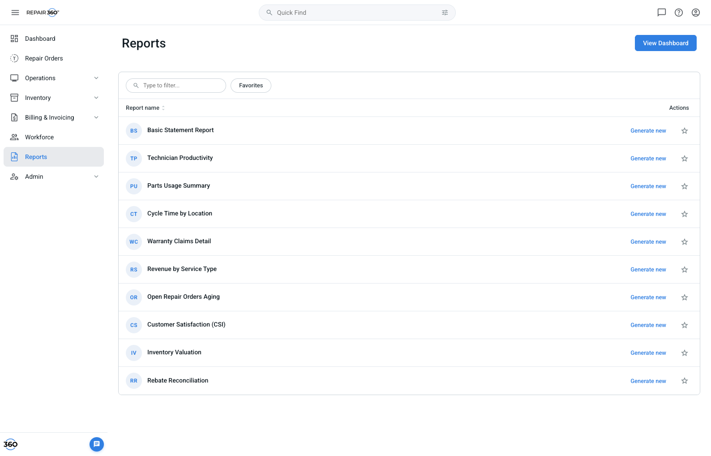
Reports list. Star column, search, Favorites pill, per-row actions. — ReportsList.jsx
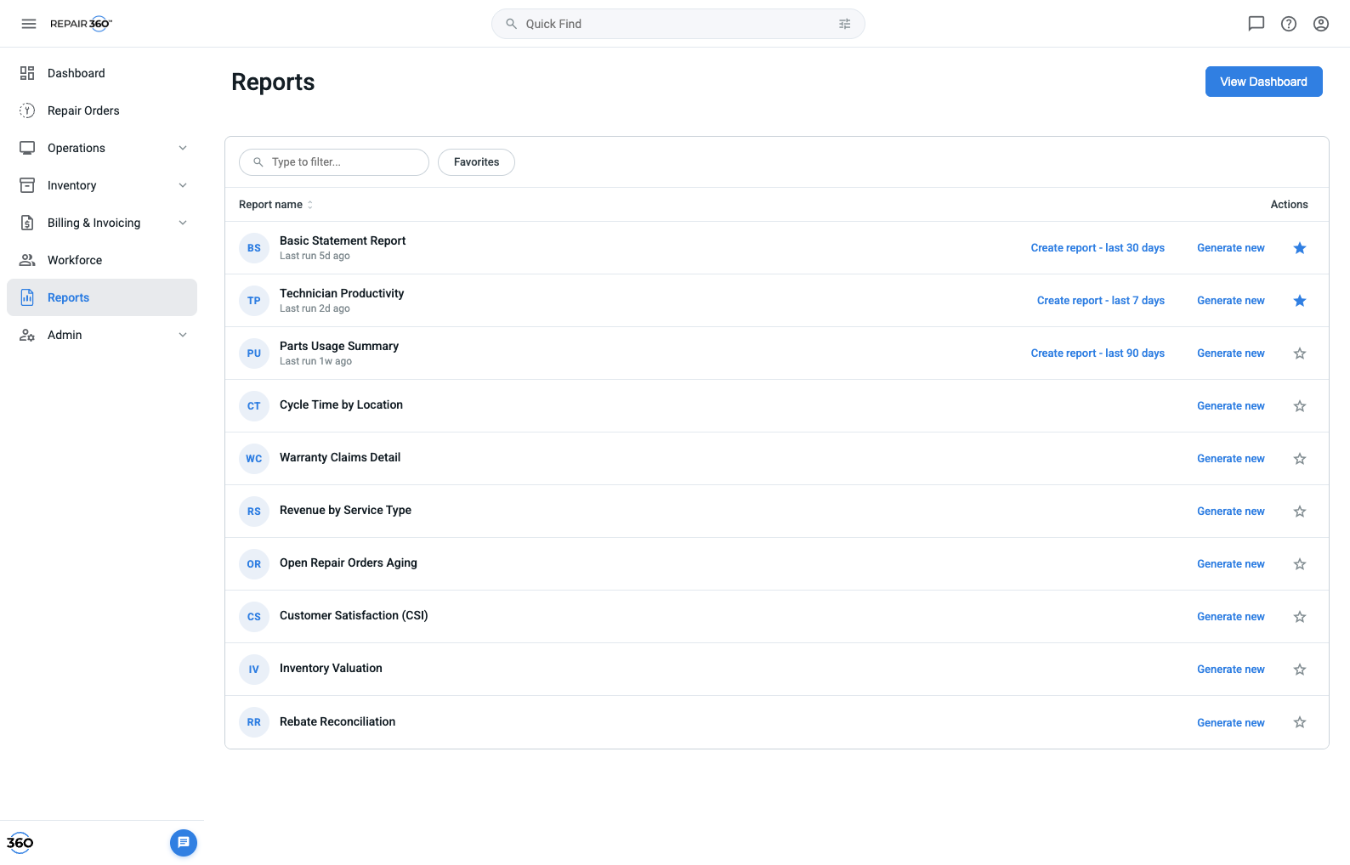
Reports list, post-run. Rows gain “Last run Nd ago” and a preset shortcut. — ReportsList.jsx
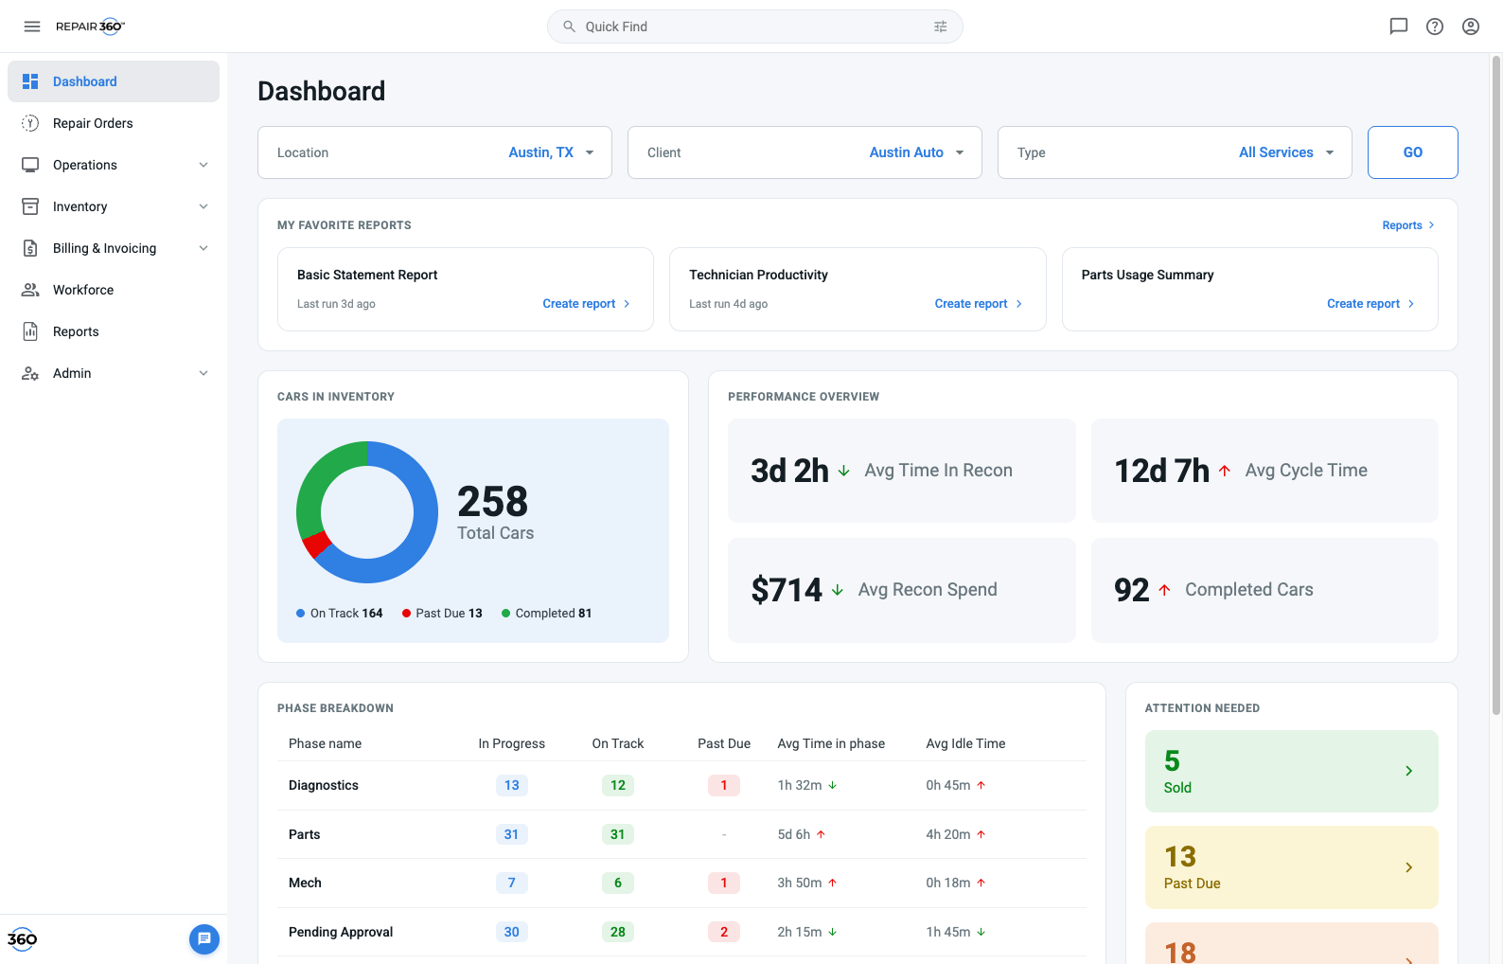
Dashboard favorites panel. Cards in favorite order; action label depends on run history. — ReportsDashboard.jsx
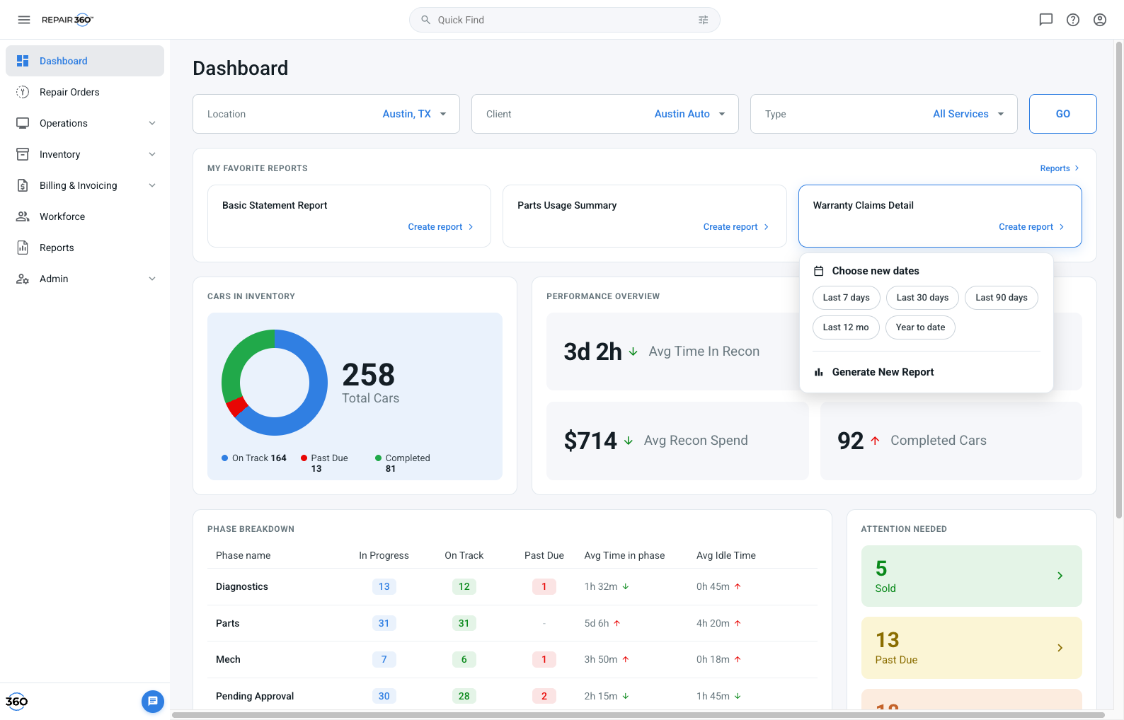
Card date menu. Five preset chips plus a handoff to the full modal. — ReportsDashboard.jsx
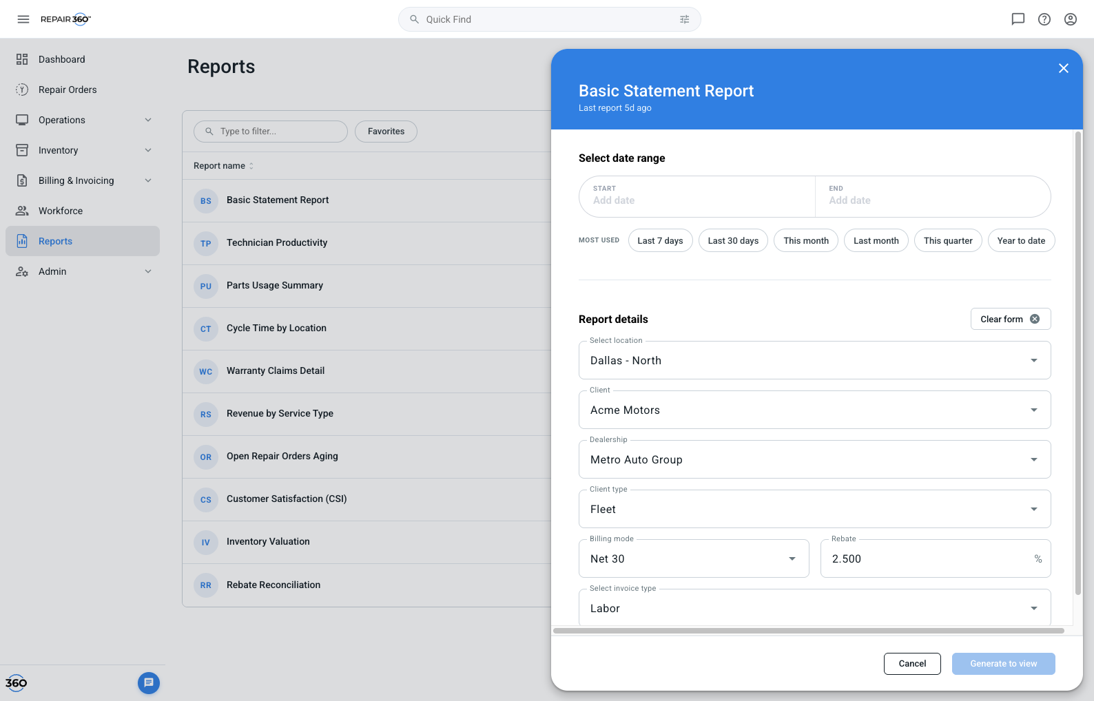
Generate modal. Calendar range with preset shortcuts, seven parameters, favorite toggle in the footer. — ReportsGenerateModal.jsx · DateRangePicker.jsx
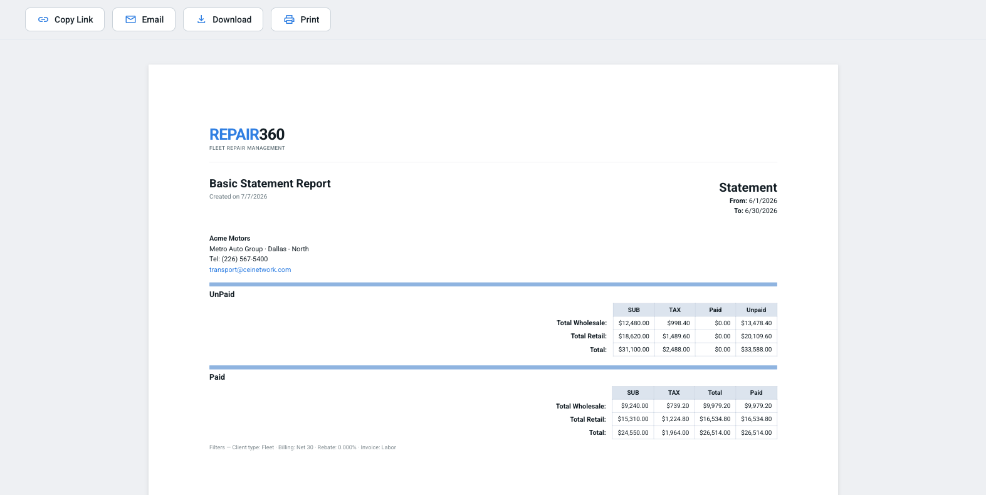
Report viewer. Letter-width document with Copy Link, Email, Download PDF, Download Excel, Print, Open in new tab. — ReportsApp.jsx
Report viewer actions
Action | Behaviour
Download PDF | Browser print dialog on the report document. The PDF is the printed sheet — same engine as Print, by design.
Print | Same as above.
Download Excel | Real .xls workbook: title, statement range, client block, both UnPaid and Paid tables as live cells with header styling, filter line. Named after its report. Also works in the standalone new-tab report, which exports itself. Q35
Copy Link | Stub Copies the current page URL. Not a report address.
Email | Stub mailto: with that same URL in the body.
Open in new tab | Opens the report as a standalone document with its own action bar.
5. Known stubs
Faked in the reference build. Each needs real implementation, not a port.
Stub | What is fake | Needs
Generation time | Fixed ~750ms spinner regardless of report or range. | Real p95 timings. Past ~5s the pattern must change. Q20 Q21
Failure states | None exist. No timeout, no permission loss, no empty-result state, in any of the three entry paths. | Designed failure + retry; decide whether empty is an error. Q22
Copy Link | Page URL, not a report URL. No access rule, no expiry. | Real report address, access scope, expiry. Largest gap. Q34
Email | mailto: handoff carrying the same broken link. | Decide mail-client vs server-side send with attachment. Q36
Persistence | Favorites and run history are session-only; onboarding flags are device-local. | Server-side per §1.
Chip-run parameters | Preset runs send blank/default parameters. | Decided: inherit the user’s saved parameters for that report, date range excluded. Needs the saved-parameters store in §1. Q18
Favorites cap | Unenforced. Guidance was 10 cards, first-favorited wins. | Enforce, and define what the star does at the limit. Q6
Revoked access | Unhandled — a card for a report the user can no longer see. | Hide the card, keep the favorite on the record. Q37
Reset hook | Header logo wipes all state. | Remove before production.

